Thermal Exploration, Investigation of Composite Slab
Venu S. Firake1 , Tushar Koli2 , Kishor Mahajan3 , Mayur Thakur4

1M Tech -Student, 2HOD, 3Professor, 4Professor
Department of Mechanical Engineering, Godavari College of Engineering, Jalgao, India
venufirake20@gmail.com

Received on: 15 May,2024 Revised on: 25 June,2024 Published on: 27 June ,2024

Abstract –It is very hard to inspect and calculate the thermal properties of the different materials used. For the determination of heat flow rate, heat flux, temperature distribution, and thermal conductivity study of composite material's thermal behavior is useful. These composite materials can be apply in various applications such as thermal protection systems, metallic multiwall, thermal ventilations, Insulators, metallic multiwall etc. In this thermodynamic study, we are analyze the thermic behavior and properties of four composites material. The another method that is finite element program method ANSYS is used, for finding heat flow rate, heat flux, temperature distribution, and thermal conductivity The actual experimental test is performed for calculate heat flux, heat flow rate, temperature distribution and thermal conductivity of four composite materials that we used. Then actual Experimental Results are compared with the ANSYS software finite element results and the done validation.
Keywords- Heat Flow Rate, Thermal Conductivity, Composite Materials, Heat Flux, Conduction, temperature distribution
INTRODUCTION
A composite material is defined as a combination of two or more materials that consists of at least two constituents (definite combination of phases) that are bonded together along the different chemical, physical and thermal composite properties, each of which proceed from a single separate material that pre-exists the composite. Heat is a another form of energy which move due to
temperature fluctuations. Heat transfer occurs due to temperature differences between them, so the transmission of energy is done. Heat transfer must occur within a media,

whenever there is a temperature difference in a medium. The amount of heat transferred from higher temperature to lower temperature per unit of time is called the heat transfer rate and is denoted by Q. The heat transfer coefficient h as unit J/s which is equivalent to watt. When the heat transfer rate Q, then the total amount of heat energy transferred ΔU during an interval of time Δt can be exist
. ∆U = ∫ Qdt = Q∆t ∆ (Joule)
The rate of heat transfer per unit area to the direction of heat flow is called heat flux and term is expressed as, q=Q/A.

ITERATURE REVIEW

The literature review dealing with the thermal analysis of composite have been studied. So many research study is going on to concentrate the study of the heat transfer through composite. Some of the research papers reviews are given below:
2J Raymond, et, studied: composite walls performance in wooden partitions. For a standard composite wall, thermal and ventilation performance is evaluated by varying its surface emissivity and the channel width which effect on the overall performance is calculated.
There is no ideal width to keep down heat transfer and to maximize the humidity flow
11MeralOzel, explained temperature transfer and heat flow in a composite material solar wall with a porous absorber. The porous absorber excess heat is stored in and there is a temperature gradient in the porous layer of the wall. Therefore, the porous absorber works like thermal insulator to a degree when no sun rays available.
1Abdulaziz Almujahid, et al,: studied the heat transfer in trombe wall systems is now a very important research topic globally that carry wide consequences on energy usage and consumption as well as conservation in malls, houses, buildings, etc.
10Patrick Glouannec et al: studied an experimental design of an insulation wall through numerical for refrigerated vans. The thermo physical properties of the insulating multilayer composite plates, the outer environmental impact as solar irradiation, temperature, etc, and durability are taken into account. By using different tools characterize the thermal performances of the insulation walls and the thermal properties of the insulation materials are measured. In addition, an experiment on the wall is carried out and a 2D FEM model of heat and mass transfer within the wall is formulated.
8Bjorn PetterJelle: explained in the composite solar wall to analyze the performance of the flow and temperature field the unsteady numerical simulation is employed. The porous absorber stored the excess heat, there is a temperature gradient in the porous wall layer. Therefore, the porous absorber works as a thermal insulator to a degree when no sun rays present. The impact of the porosity within the porous absorber on the airflow in the porous absorber is significant.

METHODOLOGY
In engineering applications, we deal with many problematic situations in different phase. In thermal heat transfer through composite walls is one of major from them. It is the supply of energy between multiple materials having different thermal conductivity arranged in series or parallel arrangement. For example, a fastener joining two mediums also acts as one of the layers between these mediums. Hence, the thermal conductivity of the fastener is also very much necessary in determining the overall heat transfer through the medium. A composite slab consists of a three different materials plates which are MS, fiberglass, and brick for one composite wall and another composite is MS, Hylum, and Wood. Slabs & heating sensor elements has circular cross-section. The experimental setup consists of three different materials discs of same diameters but different thickness arranged to form a composite slab of the same diameter plates and the heater was placed at near to one side of the composite wall. Each types of slabs are provided heater on plates which forms a composite structure of the wall. The varying input to the heater and to measure the volt meter and ammeter readings dimmer stat was used. Thermocouples are placed between every interfaces of the slabs, to record the temperature reading at the plates surface.

Composition of Materials

- MS-Hylum-wood

- MS-Concrete-Fiber

- MS-Fiber Glass-Brick

- MS-Wood-Fiber Glass

Specifications

Plate Dimensions:

Table 1: Plate materials and dimensions

Materials | Diameter (mm) | Thickness (mm)
Hylum | 300 | 20
Fiberglass | 300 | 19
MS | 300 | 16
Brick | 300 | 15
Wood | 300 | 15
Concrete | 300 | 15
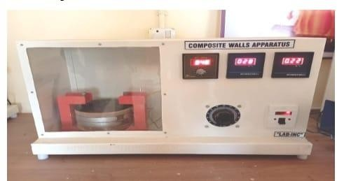
A schematic experiment setup of the project is shown in Fig. 1. It consists of different material wall bricks that have variations in thermal conductivity and thickness.

Fig. 1-Schematic setup of the composite wall bricks

DESIGN

There are four different plates materials composites wall. A each composite slab consists of a slab of three different materials which are MS, Hylum, & wood for one composite. Slabs & heating elements are circular in cross- section. The experimental setup instrument consists of three material discs having equal diameters but variation in thicknesses arranged to form a slab. The setup consists of a heater placed at one side of the composite wall and experimentation is done.

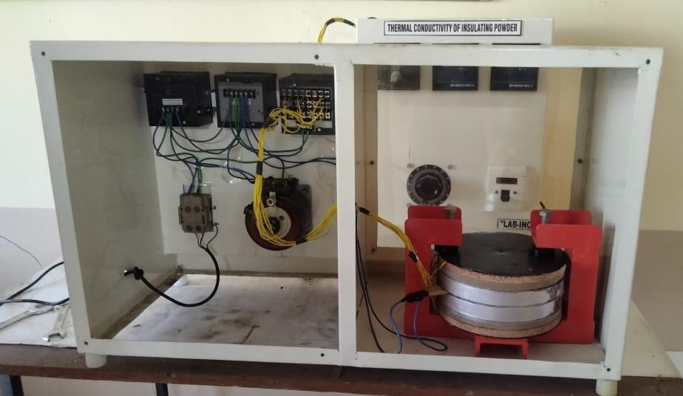

Fig. 2-Schematic representation of the composite wall bricks

- Instrumentations used for experiment

On both sides of the Heater Slab assembly arranged symmetrically

Heater coil – 250Watt capacity.

Dimmer stat (open type), 230v, 0-2 amp, single phase Volt meter- range 0-300V
Ammeter - range 0-20A
Digital temperature indicator- range 0-800°c
Thermo couple used: Teflon coated, Chromal-Alumal

RESULT & DISCUSSION

The graphical result as below:

- Graphical Experimental Results of Materials vs. Heat Flux for all Composite Materials
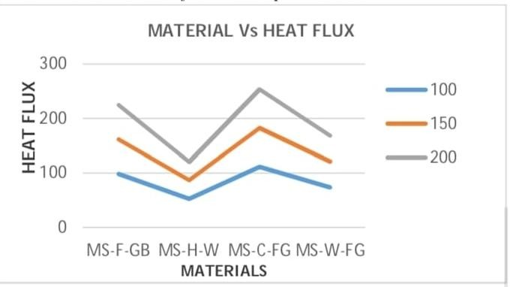

Graph 1 Materials Vs Heat Flux

- Graphical Experimental Results of Materials vs. Heat Flow Rate for all Composite Material
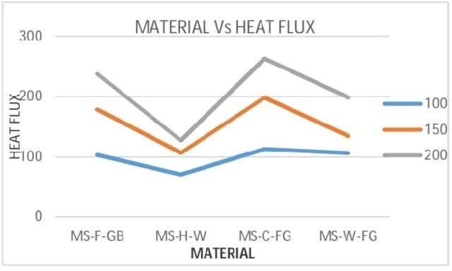

Graph 2 Materials Vs Heat Flow Rate

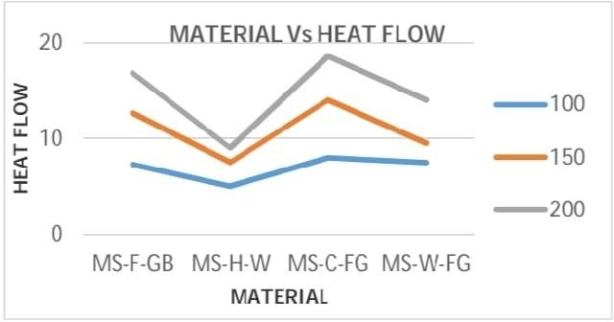
- Graphical Experimental Result of Materials Vs Thermal Conductivity for all Composite Materials

Graph 3 Materials Vs Thermal conductivity

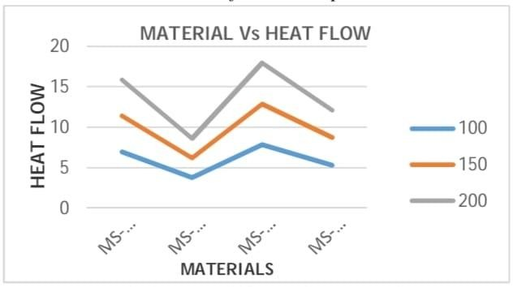
D Graphical ANSYS Results of Materials vs. Heat Flow Rate for all Composite Materials

Graph 5 Materials Vs Heat Flow Rate

CONCLUSION

Based on the analytical, ANSYS finite element and experimental exploration of the thermal behavior of different composites materials, it can be concluded that:

- The results of the followed analytical method are in near approximation with the FEM simulation ANSYS. values

- The results of the followed analytical method are in near approximation with the experimental values

- The reasearch study shows that the thermal conductivity of the composite material as:
MS-Concrete-Fiber Glass is 0.08711
MS-Fiber Glass-Brick is 0.07952
MS-Wood-Fiber Glass is 0.08172
MS-Hylum-Wood is 0.05441

- The research study shows result that the heat flow rate of composite slab MS-Hylum-Wood is approx. 5, composite slab MS-Concrete-Fiber Glass is 8 MS-Fiber Glass-Brick is approx.7.3& composite slab MS-Wood-Fiber Glass is approx. 7.5

- The research study shows result that the Heat flux of composite material MS- Hylum- Wood is 70.084, composite material MS-Concrete-Fiber Glass is 113.311 and composite material MS- FiberGlass- Brick is 103.388 & composite material MS- Wood-Fiber Glass is 106.232

- The temperature distribution of composite slab having three different material plates like MS- Hylum- Wood, MS-Concrete- Fiber Glass, MS- Fiber Glass- Brick & MS-Wood- Fiber Glass is 23.05, 370.21 , 29.48 & 32.06 respectively.
- It is seen that the Finite element method (FEM) can effectually work for the determination of thermal behavior characteristics like heat flux, heat flow rate, and temperature distribution of all composite slab.

- 7)Finally it can be concluded that the composite like MS- Concrete-Fiber Glass, MS- Fiber Glass- Brick & MS Wood-Fiber Glass have higher heat flux, temperature distribution, heat flow rate, and thermal conductivity values respectively than the other composites like MS- Hylum- Wood means composite MS- Hylum- Wood shows lower values of thermic behavior.

REFERENCES

- AbdulazizAlmujahid, ZakariyaKaneesamkandi, “Construction Of ATestRoom For Evaluating Thermal Performance Of Building Wall Systems Under Real Conditions'' IJIRSET Vol. 2, Issue 6, June 2013, pg. no.2000-2007.
- J. Raymond et al "Insulated Roof for Energy Saving and Thermal Comfort in Buildings", NBMCI, Central Building Research Institute. Roorkee, India, 2008.
- NavidEkrami, Anais Garat, Alan S. Fung, “Thermal Analysis of Insulated Concrete Form (ICF) Walls” Science Direct, Energy Procedia 75 ( 2015 )pg.no.2150 – 2156.
- Sawankumar E. Patil,N. N. Shinde, “Theoretical Analysis of Composite Roof with Respect to Comfort in Building Envelope” Current Trends in Technology and Science ISSN: 2279-0535. Volume: 3, Issue: 3 (Apr-May. 2014), pg.no.168-172.
- Dr.R.Uday Kumar, “Evaluation And Effect Of Convective Resistance And Convective Heat Transfer Coefficient On Heat Transfer Rate In Composite Structure" IJAREST, Volume 3, Issue 10, October – 2016 pg no.81-85.
- Adel A. Abdouand Ismail M. Budaiwi, “Measurements of Building Insulation Materials under Various Operating Temperatures”, Journal of BUILDING PHYSICS, 29(2), p.171, 2005.
- Amjed, A. Maghrabi, “Comparative Study of Thermal Insulation Alternatives for Building Walls and Roofs in Makkah, Saudi Arabia”, Journal of Sci. Med. Eng., 17(2), pp.273 -287, 2005.
- Bjorn PetterJelle, “Traditional, state-of-the-art and future thermal building insulation materials and solutions-Properties, requirements and possibilities", Energy and Buildings, 43, pp. 2549–2563, 2011.
- Cabeza, L.F., Castell, A., Medrano, M., Martorell, I., Perez, G.and Fernandez, "Experimental study on the performance of insulation materials in Mediterranean construction”, Energy and Buildings, 42, pp.630–636, 2010.
- Patrick Glouannec et al. (2019), A Medrano, M. Martorell, I. Perez, Gand Femandez I Experimental study the performance of insulation materials in medierraniun construction buildings and materials
- MeralOzel, Thermal performance and optimum insulation thickness of building walls with different structure materials Applied Thermal Engineering31,pp3854-3863,2011

