Design And Fabrication Of Multi-Operation Farming Machine
${Swapnil S.Khante }^{1}$,${Shubham S. Sayam}^{2}$,${Sagar A.Andurkar}^{3}$,${Vaibhav D.Bhajbhuje}^{4}$,${ Shivam S.Awachat}^{5}$
B.E Student, Mechanical Engineering, DMIETR, Wardha, Maharastra, India.

Abstract –Earlier farmers were using traditional farming method for “weeding and Feeding fertilizer” to the plant which is time consuming, hardworking and costly, hence we introduce a new machine which can perform both the above operation simultaneously. Generally, the machines are used for the farming purpose in India which is of higher level. All machines were used in farms are costlier and not affordable to farmers, hence to overcome this problem we are going to make this model. In this paper we can directly discuss its need, ,design, construction, working and conclusion.
Keywords- power tiller, chain and sprockets,engine, shaft, pulley.
INTRODUCTION

The device which we are going to make is nothing but a power tiller. Japanizes are the first one who introduce the concept of power tiller in the world in 1920, But they failed in 1947 the successfully made a good working power tiller.
In India about 67% percent of Indian farmers have farm land less than 1 hector and for performing various farming operation either they have to buy a tractor or they have to rent a tractor and this costs more money to them. So power tiller is the best option for them to reduce the costs of farming operation.
By the survey we found that before feeding fertilizer to the plant they have to perform weeding operation first and after that they have to feed fertilizer to the plant and separate performance of both these operation costs more money to them, so to eliminate this we are going to make a machine which perform

weeding as well as feeding fertilizer operation at the same time, so that the costs of operation get reduced.
This machine will run on petrol engine and by making this project the concepts of design of chain and sprockets, shafts, bell drives, bearings, chassis etc. can be learned.
METHOLOGY
According to the survey we carried out, we identify that farmers facing problem in weeding and feeding fertilizer to the plant. We discuss this problem with the project guide. We also studied no. of research paper based on this. After that we developed prototype solution and communicate result based on this. We discuss different components which being used in this project. We also visit different industries to find out what material we have to use to make this project.
Table 1- Title of table (10, Normal)
Sr. No. | Components | Materials
1. | Tiller frame | Mild steel 16G
2. | Fertilizer distributer pipe | Nylon pipe
3. | Ground wheel | Mild steel
4. | Bearings | Stainless steel
5. | Shaft | Mild steel , SAE 1045

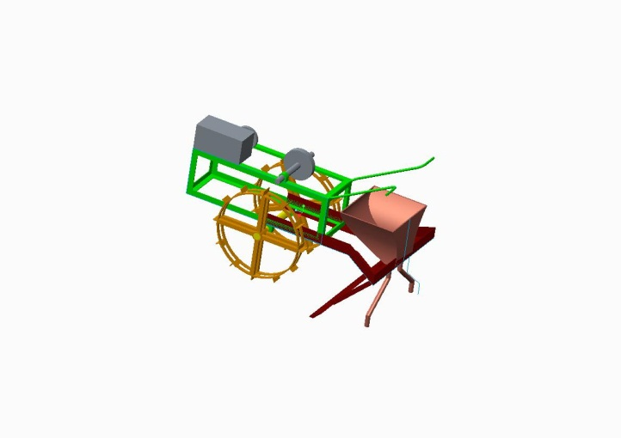Fig.- cadmodel of multi-operation farming machine

DESIGN
- Pd=$\frac{Sr×d×W×V}{75}$
Where,
Pd$→diggimg power$
Sr$→$ soil resistance
D$→$ depth of penitraton
W$→$ effective width of cut
V$→$ velocity
CONSTRUCTION
- The device is made up of mild steel 16G material.
- The machine runs on petrol engine through which power is transmitted on the wheel.
- For speed reduction we have use two mechanism i.e. belt and pulley drive and chain and sprocket mechanism.
- The ho
- This nylon pipe further attached to the weeder .
- For steering purpose handle provided which can be manually operated.
- pper is mounted on the frame with nylon pipe attached to it.
WORKING
- In this machine a petrol engine is used which rpm is reduced by belt and pulley mechanism.
- The small pulley is attached to the engine shaft and bigger pulley is mounted on the other shaft.
- Both the pulleys are connected by v-belt so that the rpm we get is less.
- On the second shaft along with bigger pulley one small pulley is there to transmit the motion to the third shaft.
- This procedure is repeated one more time to get the final output as a low rpm.
- On the other hand the contains the fertilizer which is transfer to the soil with the help of pipe.
CONCLUSION
The main advantage of this machine is that, farmer can perform both i.e. weeding and feeding fertilizer to the plant operation simultaneously. This can save the large amount of money of the farmer. For increasing the traction and torque we have reduces speed in three different stages as,
• By using V-belt drive
• By using two different chain sprocket mechanism.
The depth of 3-4 inch can be obtained which is sufficient to remove the unwanted plant and grass. Also by changing equipment we can perform other farming operation too. This machine is affordable to farmer and easy to use.
REFERANCES
- Deepak Thorat Sabaji , P.K. Sahoo, Dipankar De and Mir Asif Iquebal, “Design and Development of Ridge profile power weeder”, Indian council of Agricultural research, Journal of agricultural engineering, vol. 51(4): oct-dec 2014
- S. Kumar, B.P. Mishra, S.K. Patel and A.K. Dave, “Design and Development of po-drill power tiller operated seed-cum-ferti till- drill machine, vol9(51) p.p 3776-3781, 18 December.
- Hemand Zareiforoush , Mohammad Hasan Komarizadeh , Mohammad Reza Alizadeh , “ Rotary Tiller Design Proportional to a Power Tiller Specific Work Method”, Department of Mechanical Engineering of Agricultural Machinery, Faculty of Agriculture, University of Urmia,P.O. Box 165 Urmia 57135, Iran.
- D.K. computer Program for Mechanizing Hill Agriculture”, Department of Agricultural Engineering CSKHPU, Palampur-176062(HP) India, Department of Farm Machinery and Power Engineering AAI-DU,Allahbad-211007, (UP) India.
- Shabbir J. Karjatwala, Chetan L. Kurkute, Saurabh S. Lad,Hitesh K. Jadhav, Tejashree R. Daithankar, “Design, Development And Fabrication of Mini Cultivator And Tiller”, Assistant professor, production engineering konkan. Gyanpeeth college of enginerring karjat, Maharastra, India. UG student, Mechanical engineering, konkan Gyanoeeth college of engineering, karjat,Maharastra India. Vol-3,special Issue, March-2018
- Rajat Bhosale, Akshay Herkar, Avinash Herkar, Narayan Shinde, “ Design and Fabrication of Agricultural Rotary tiller” , Volume 3 Isuue 2 Print ISSN:2394-4099, Mechanical Engineering, Savitribai Phule Pune University, Pune Maharastra, India.
- Keyur Prajapati, Asstt.Prof. Parth Gajjar, Asst.prof.Brijesh Kayasth “A Research Paper on Design of Gear Used In Tiller Machine”, Department of Mechanical Engineering, Sal College of Engineering, Ahmedabad.
- Subrata Kumar Mandal, Basudeb Bhattacharya, Somenath Mukharji and Ashok Kumar Prasad , “ Design Optimization of Rotary Tiller Blade using
Specific Energy Requirement”, Central Mechanical Engineering Research Institute, Durgapur, India, Indian Institute of Engineering Scienceand Tecnology, howrah, India. Vol.6, No.4(Aug 2016)

AUTHOR DETAILS
Sr.No. | Photos | Name | Contact No.
1. |  | Swapnil Khante | 7709374131
2. |  | Shubham Sayam | 9834870235
3. |  | Sagar A. Andurkar | 9689689202
4. |  | Vaibhav Bhajbhuje | 8956366867
5. |  | Shivam Awachat | 8669154281

