Design and Analysis of Evaporator Used in Household Refrigerator Using Thermoelectric Module

Mr. Vaibhav Titarmare¹, Prof. Swapnil Choudhary² , Dr. Bharat Chede³, Prof. Sharayu Wasu⁴

¹M.Tech Student, 2M.Tech Coordinator ,³HOD, ⁴Lecturer,
Wainganga College of Engineering & Management, Nagpur, Maharashtra, India, 441108
vaititarmare@gmail.com

Received on: 25 March,2022 Revised on: 27 April,2022, Published on: 29 April,2022

Abstract – Growing global demand for refrigeration in refrigeration, air conditioning, food storage, vaccine storage, medical services, and electronic equipment cooling has led to increased global power generation and hence higher CO2 emissions due to global warming. Thermoelectric cooling is a new alternative because it can convert wasted electricity into usable cooling, which should play an important role in addressing today's energy challenges. Therefore, thermoelectric cooling is extremely necessary, especially for developing countries where service life is long, and maintenance is low. The objectives of this study are the design and development of an internal cooling volume of an operational 18-liter thermoelectric refrigerator that uses the Seed back effect to cool and maintain a temperature. The design requirements are to cool this volume to temperature and reach the COP within one hour. Design requirements, available options, and the final thermoelectric cooler design for the application are presented. An analysis of the ANSYS software is required. Therefore, find the optimum temperature to achieve maximum heat transfer and cooling rate.
Keywords- COP, See back effect, ANSYS Analysis, TER
- INTRODUCTION
Cooling or cooling process is the removal of unwanted heat from a selected object, substance or space and its transfer to another object, substance, or space. Heat dissipation reduces temperature and can be achieved through the use of ice, snow, cold water, or mechanical cooling. The term refrigeration refers to the cooling of a space, substance or system to reduce and/or maintain its temperature below ambient temperature (while removing waste heat at a higher temperature). Refrigeration has many applications including domestic refrigerators, industrial freezers, cryogenics and air conditioning. TER can also be used in a space or satellite application to control extreme temperatures encountered in components on the sunlit side and to heat components on the dark side. TERs are used to minimize thermal noise to optimize image sensitivity and contrast. The coefficient of performance (COP) of compression chillers decreases with decreasing performance. Therefore, the TER is always preferable when it is necessary to design a small-capacity refrigerator. In addition, the better control of the room temperature is the main benefit of the TER. Therefore, the TER is a good choice for food storage and pharmaceutical refrigeration applications. The increasingly global problem with the rapidly developing economy and the consequent shortage of energy for homes, some countries set minimum energy efficiency requirements. Air conditioning is a very important device to ensure human comfort even in industrial applications. But this device requires a larger amount of power. The constantly increasing demand for energy is a heavy burden on further economic development, since India is poor in energy resources, so that the power consumption when

operating air conditioning systems is minimal. How to reduce energy consumption The use of new energy-saving technologies and devices is an important task nowadays. Many methods and ideas such as evaporative cooling, thermoelectric cooling, ground heat exchanger, etc. They have been shown to minimize electricity consumption in air conditioning applications. energy saving is possible by using Peltier module and ground heat exchanger (heat pipe). Bottom temperature becomes more stable as depth increases; the soil temperature is almost constant around 2-3 m all year round. This unchanged temperature remains higher than the outdoor temperature in winter and lower than the outdoor temperature in summer. When atmospheric air flows through underground pipes, the air is cooled in summer and heated in winter. The Earth has a high heat storage capacity and low thermal conductivity. Due to its low thermal conductivity, it transports heat slowly; Its temperature evolves slowly on the order of months or even years, depending on the depth of measurement. Therefore, the earth is warmer than ambient air in winter and cooler than ambient air in summer. This constant earth temperature provides a free renewable energy source that can easily provide enough electricity to cool an average suburban home.

The thermoelectrically result is that the direct conversion of temperature variations into electrical voltage associated vice versa. Once it's been determined that the thermoelectric cooler ought to be thought of for the cooling system, ensuing step is to pick the thermoelectric module or cooler that may meet a particular set of needs. The modules are out there in a very kind of sizes, shapes, in operation currents, operating voltages and warmth pump power ranges. the warmth pipe consists of an evaporator section and a longitudinal condenser section. If geometric necessities are required, the outside makes it necessary; an extra adiabatic section will be installed to separate the evaporator and therefore the condenser. The cross section of the warmth pipe consists of the vessel wall, the wick structure and the vapor space. The performance of a heat pipe is commonly expressed in terms of “equivalent thermal conductivity”.

- LITERATURE REVIEW

Thermoelectric Cooler Fabrication” by Shaikh Sahil, et al.

and hold it for a minimum of consequent [*fr1] hour. the planning and fabrication of the thermoelectric cooler for the specified applications are presented. The system cannot method load fluctuations. intensive modifications should be incorporated before it is often released for economical Usage within the field. this can be one amongst the helpful comes that drives the white goods with low power. functioning on this project gave us a wonderful chance and skill to use our restricted knowledge. Refrigeration is one of the key spaces within which researchers have nice interest. a number of the recent advances during this area outweigh some of the inherent disadvantages, love B. the unfavorable COP. The cascading standard design has set new limits for your application. In addition, recent advances in organic molecules as a thermoelectrical material guarantee a bright future for TER.

Low price white goods mistreatment thermoelectrical impacts and natural process materials by Adithya Venugopal, et.al. This paper presents the mechanical design of contemporary refrigerators that use compressor-based refrigeration and can't maintain potency at reduced capacity. during this context, the project aims to produce an alternate and a lot of economical cooling possibility by using the thermoelectric effect compared to the traditional strategies prevailing today. they provide many benefits over compressor-based refrigeration systems, admire B. straightforward miniaturization, noise reduction, portability, etcetera

Design, Development of thermoelectric refrigerators by Dongare VK, et.al. The objectives of this study are the look and development of an 18-liter practical thermoelectrically white goods internal cooling volume that uses the Pettier impact to refrigerate and maintain a temperature of 33°C to 22°C. the look needs are to cool down this volume to temperature in a very amount of 1 hour and to get a COP between 0.2 and 0.6. the look requirements, offered options, and final design of the thermoelectric refrigerator for the appliance are presented. The system performance constant for TEC1 12706 is calculated by the common of the Lens. it's discovered that the thermoelectric refrigeration peace officer with TEC112706 is below the VIDETROR font.

PROBLEMS IDENTIFIED

The comparison of COP with simulation.

The Comparative analysis of thermoelectric refrigeration with household refrigeration.

There is an optimum temperature need to find where cooling rate must be maximum.

IV-MATERIALS REQUIRED

- Aluminum and tin foil: metallic element is that the world’s most overabundant metal and is the third commonest element comprising 8% of the earth’s crust. The ability of aluminum makes it the foremost wide used metal when steel. Pure metallic element is soft, ductile, corrosion resistant and includes a high electrical conduction. it's usually used for foil and conductor cables, however alloying with further components is important to afford the upper strengths required for alternative applications. metallic element is one among the nimblest engineering metals, having a strength to weight quantitative relation additional to steel. Thermal conductivity of metallic element is a hundred and eighty W/m-K.

SMPS: A switched-mode power offer (SMPS) is Associate in Nursing electronic circuit that changes power mistreatment shift devices that are twisted on and off at high frequencies, and storage elements comparable to inductors or capacitors to supply power once the switching device is in its non-conduction state. Swapping power provides have high potency and are wide employed in a diversity of electronic instrumentality, as well as computers and alternative sensitive equipment requiring stable and economical power supply.

Conductor: A heat sink may be a thermal semiconducting metal device planned to soak up associated diffuse heat left from a hot temperature object reminiscent of a laptop processor. sometimes heat sinks are prepared with inherent fans to assist keep each the hardware and therefore the heat sink at an appropriate temperature.

Fan: Blade Size is of 150mm having High Air Delivery Output 250 CMH and Speed of 1350 rate style is fashionable design that matches areas corresponding to room and keeps your home cool and blade is Aerodynamically designed blades guarantee a quicker speed of rotation. the facility Consumption: thirty watts; operational Voltage: 220V - 240V, range of Blades is 5.

- WORKING PROCEDURE

- As there are important members heat sink, SMPS and Thermoelectric Module are used, they only play a key role in working of this refrigerator. The procedure of working is given as:
- An Aluminum plate is used to make a box. An aluminum has maximum number of heat transfer capacity hence we use here this plate.
- This aluminum plate is covered with Puff so that there is no contact of heat must be entering through outside surrounding into the box. This box is worked as refrigerator. For getting maximum heat transfer an aluminum foil is used for the outer covering of aluminum box. It is covered as the outside heat must reflect as it comes in contact with the aluminum box.
- There are two thermoelectric plates are used here in conjunction with Heat sink. The thermoelectric plate is placed in such a way that the cooling side must be present inside the box and heating side must be present outside the box.

- A heat sink is used here with fans so that the heat inside the box must be rejected outside surroundings to the heat to the heat of thermoelectric plate is also rejected due to heat sink.
- The whole assembly works on SMPS. This SMPS powered through A.C. power supply. Connections are made so that it will connect Heat sink and thermoelectric plate.
- When we put on the power of SMPS, the power is supplied to the thermoelectric plate and heat sink. The thermoelectric plate start working and it lowers the temperature inside the box and the heat inside the box is rejects through heat sink.
- This process continues and it lowers the temperature of box (refrigerator).
- A CFD analysis is made here, and its results are explained below.

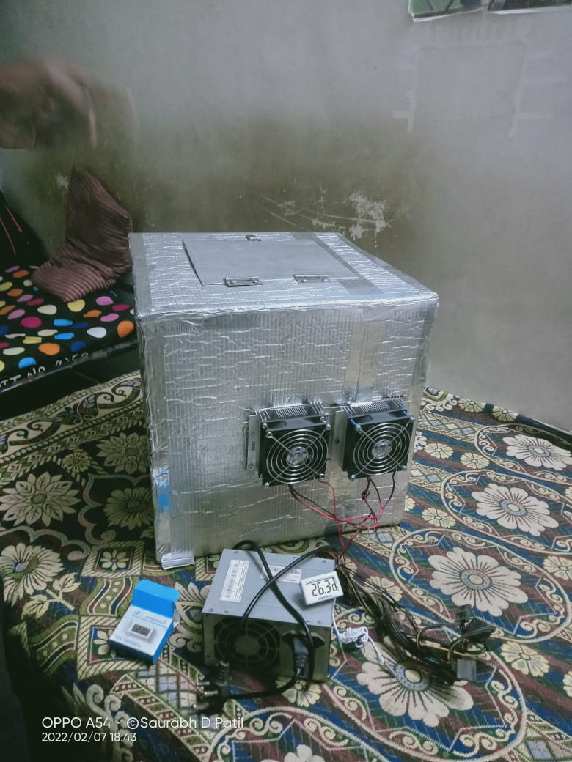

Fig 1: Fabricated Project.

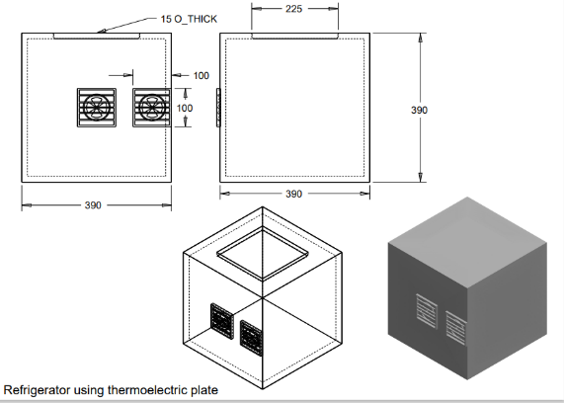
Fig 2:All Three Views of Refrigerator using thermoelectric plan

VI-ANSYS ANALYSIS OF TEMPERATURE DISTRIBUTION ON REFRIGERATOR USING THERMOELECTRIC PLAT
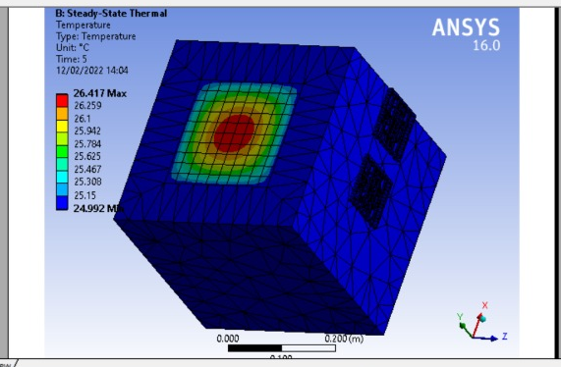
Fig 3 (A)
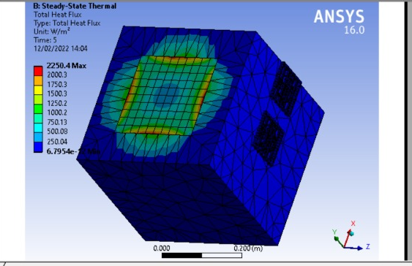
Fig 3 (B)
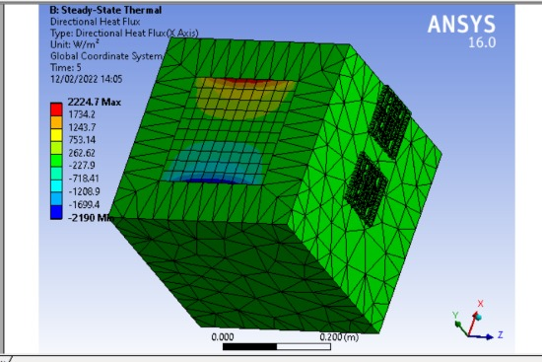

Fig 3 (C)

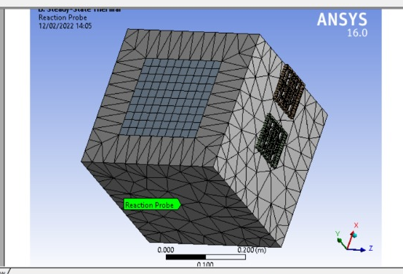
Fig 3 (D
Figure 3.a. Steady State Thermal Analysis of Maximum Temperature inside box
Figure 3.b. Steady State Thermal Analysis of Maximum Heat flux inside box.
Figure 3.c, Steady State Thermal Analysis of The Heat flow in X-axis.
Figure 3.d. Steady State Thermal Analysis of Reaction Prob

From figure 3.a. it's found that the most temperature within the box is started from two4.9 °c and ends to 26.49 °c in ten sec. and also the maximum heat flux is from 250.09 w/m 2 to 2250.4 w/m2 as shown in fig 3.b. conjointly in figure 3.c. the warmth flow in coordinate axis is exaggerated from -2190 w/m 2 to 2224.7 w/m 2 and figure 3.d. shows the reaction probe of box. It means that there's no adverse result of warmth on cooling box, and also the temperature and warmth increased apace as this analysis is of 10 sec. Thus, it'll offer in no time cooling in minimum time

CONCLUSION

From above result we can conclude that thermoelectric plate is effective in cooling which is used in cold storage by maintaining lower temperature as compared to atmospheric temperature. It means that, 10°C to 15°C less than atmospheric temperature. It has compact size with no refrigerant, so maintenance cost is low as compared to refrigerator.

REFERENCES
- Darshan Suryawanshi, Vaibhav Pokale, Nikhil Pokharkar , Akshay Walgude , Prashant Patunkar, “A Review of Performance Analysis & Potential Applications of Thermoelectric Refrigeration System”. IJRSI, Volume III, Issue III, March 2016 ISSN 2321 - 2705. Pp 29-32.
- Adithya Venugopal, Karan Narang, Ken Prakash, Mukund Joshi, “Cost-effective Refrigerator Using Thermoelectric Effect and Phase Change Materials”, International Journal of Scientific & Engineering Research, Volume 5, Issue 2, February-2014, ISSN 2229-5518 pp.624-627.

- 1.Shaikh Sahil , Mohammad Fahim , Gopal Naik , Pushpa Gadage , Sayyed Juned, “Fabrication of Thermoelectric Refrigerator”, International Journal of Innovations in Engineering and Science, Vol 4, No.10 ,2019 ISSN: 2456-34 pp. 125-127.
- Dongare V.K ,Kinare R.V, Parkar M.H, Salunke R.P, “ Design and Development of Thermoelectric Refrigerator”, International Research Journal of Engineering and Technology (IRJET), Volume: 05 Issue: 04 | Apr-2018, pp 2970-2974.
- Sudhanshu paul , raj prabhat , kevin varkey koshy , abhishek gaikwad & jude james, “fabrication and testing of thermoelectric refrigeration system”, International Journal of Mechanical Engineering (IJME) ISSN(P): 2319-2240; ISSN(E): 2319-2259 Vol. 5, Issue 4, Jun – Jul 2016; 85-92.
- Jincan Chen, Yinghui Zhou, Hongjie Wang, Jin T. Wang: “Comparison of the optimal performance of single- and twostage thermoelectric refrigeration systems” Applied Energy 73 (2002) 285–298
- X.C. Xuan,K.C.Ng,C.Yap,H.T.Chua: “Optimization of twostage thermoelectric coolers with two design configurations” Energy Conversion and Management 43 (2002) 2041–2052.
- Jun Luo,Lingen Chen,Fengrui Sun,Chih Wu: “Optimum allocation of heat transfer surface area for cooling load and COP optimization of a thermoelectric refrigerator” Energy Conversion and Management 44 (2003) 3197–3206.
- Wei He, Gan Zhang, Xingxing Zhang, Jie Ji, Guiqiang Li, Xudong Zhao “Recent development and application of thermoelectric generator and cooler” in Elsevier Journal of Applied Energy volume 143 (2015) pages 1–25.
- Wei He, Jinzhi Zhou, Jingxin Hou, Chi Chen, Jie Ji, “Theoretical and experimental investigation on a thermoelectric cooling and heating system driven by solar” in Elsevier Journal of Applied Energy volume 107 (2013) pages 89-97.
- S.B. Riffat, Xiaoli Ma, “Thermoelectrics: a review of present and potential applications” in Elsevier Journal of Applied thermal engineering volume 23 (2003) pages913–935
- Manoj Kumar Rawat, Himadri Chattopadhyay, Subhasis Neogi , “A review on developments of thermoelectric Refrigeration and air conditioning systems: a novel Potential green refrigeration and air conditioning technology” International Journal of Emerging Technology and Advanced Engineering Volume 3, Special Issue 3: ICERTSD 2013, Feb 2013, pages 362-367.
- Y.Y. Hsiao, W.C. Chang, S.L. Chen, “A mathematic model of thermoelectric module with applications on waste heat recovery from automobile engine” in Elsevier Journal of Energy volume 35 (2010) pages 447-1454.

- Jincan Chen, Yinghui Zhou, Hongjie Wang, Jin T. Wang: “ Comparison of the optimal performance of single- and twostage thermoelectric refrigeration systems” Applied Energy 73 (2002) 285–298
- X.C. Xuan,K.C.Ng,C.Yap,H.T.Chua: “Optimization of two stage thermoelectric coolers with two design configurations” Energy Conversion and Management 43 (2002) 2041–2052
- Jun Luo,Lingen Chen,Fengrui Sun,Chih Wu: “Optimum allocation of heat transfer surface area for cooling load and COP optimization of a thermoelectric refrigerator” Energy Conversion and Management 44 (2003) 3197–3206
- D.Astrain,J.G.Vian,M.Domınguez: “Increase of COP in the thermoelectric refrigeration by the optimization of heat dissipation” Applied Thermal Engineering 23 (2003) 2183– 2200
- Yuzhuo Pan, Bihong Lin, Jincan Chen,: “Performance analysis and parametric optimal design of an irreversible multi-couple thermoelectric refrigerator under various operating conditions” Applied Energy 84 (2007) 882–892
- Hongxia Xi, Lingai Luo, Gilles Fraisse: “Development and applications of solar-based thermoelectric technologies” Renewable and Sustainable Energy Reviews 11 (2007) 923– 936
- Suwit Jugsujinda, Athorn Vora-ud, Tosawat Seetawan: “Analysing of Thermoelectric Refrigerator Performance” Procedia Engineering 8 (2011) 154–159
- S.A.Omar,S.B.Raffit,Xiaoli Ma: “experimental investigation of thermoelectric refrigeration system employing a phase change material integrated with thermal diode (thermosyphons)”Applied thermal Engineering 21(2001)1265-1271 [9]"Thermoelectric cooling," [Online]. Available: www.wikipedia.org..
- D. Zhao and G. Tan, "A review of thermoelectric cooling: Materials, modeling and applications," Applied Thermal Engineering, vol. 66, no. 1–2, pp. 15-24, May 2014.
- Sagar D. Patil, Kiran D. Devade , “Review on Thermoelectric Refrigeration: Applications and Technology ” International Journal of Modern Trends in Engineering and Research (IJMTER), Volume 02, Issue 07,pp. 119-129, July– 2015.
- Mayank Awasthi and K V Mali, “Design and development of thermoelectric refrigerator”, Int. J. Mech. Eng. & Rob. Res. 2012, Vol. 1, No. 3, October 2012,

