Automated Attendance Management System Using Face Recognition and GPS Localization

Prof. Priyanka D. Lanjewar¹, Shruti S. Joshi^{2*}, Digambar B. Patil³, Harshada S. Patil⁴, Vikas D. Patil⁵
¹Assistant Professor, : 0000-0002-7226-9207
R. C. Patel Institute of Technology, Shirpur, India, 425405
^{2,3,4,5}UG Student, R. C. Patel Institute of Technology, Shirpur, India, 425405

Email of Corresponding Author: joshishrutis2003@gmail.com
Received on: 28 April, 2025 Revised on: 02 June,2025 Published on: 06 June, 2025

Abstract – The evolving digital landscape in educational and organizational settings demands a robust and efficient method for attendance tracking. This paper presents an automated attendance management system that leverages state-of-the-art face recognition algorithms alongside GPS localization. The proposed system captures live facial images to extract unique biometric features and compares them against a pre-registered database for accurate identity verification. Concurrently, GPS data is used to ensure that attendance is recorded only when individuals are within a designated geographical boundary, effectively mitigating risks of proxy marking. Developed using Flutter for the user interface, Firebase for real-time backend processing, and Python-based recognition algorithms, the system has been designed for scalability and reliability. Experimental evaluations indicate that the integration of these technologies not only enhances the accuracy of attendance records but also reduces administrative overhead. The paper discusses the system architecture, methodological framework, implementation challenges, and potential improvements, paving the way for future research in automated attendance solutions.
Keywords- Attendance Management, Face Recognition, GPS Localization, Real-Time Monitoring, Automated System
INTRODUCTION
Efficient attendance management is crucial in academic and corporate environments, yet traditional manual and even some biometric systems face significant limitations such as human error, scalability issues, and security vulnerabilities. This paper introduces an automated solution that combines face recognition and GPS localization to accurately track attendance. The motivation for this work arises from the need to streamline attendance recording processes, reduce administrative tasks, and prevent fraudulent attendance marking. By automating the identification and location verification processes, the system aims to ensure reliable data capture and real-time updates, thereby supporting better decision-making and resource allocation.
LITERATURE REVIEW
evolution of attendance systems has seen significant progress over the past decade. Traditional methods, which relied on manual registers or simple biometric devices, were fraught with issues like human error, time inefficiencies, and susceptibility to fraudulent practices. Early biometric systems attempted to address these issues, but they often failed to account for environmental variations or lacked the scalability required for large organizations.
Recent studies have explored the integration of multiple verification techniques to overcome these shortcomings. For instance, Sutar et al. (2022) proposed an Android-based attendance system that utilizes unique QR codes for each lecture. This method allows for quick scanning by students and offers a straightforward mechanism for attendance verification without the need for sophisticated hardware [1].
In contrast, Kumar and Kumar (2021) focused on incorporating GPS technology within an Android application. Their system ensures that attendance is only marked if the student is physically present within a designated area, thus reducing the incidence of off-campus attendance recording [2].
Another approach is demonstrated by Susanto et al. (2021), who developed a face recognition-based system using OpenCV on Android devices. By employing Local Binary Patterns Histograms (LBPH), their solution enables on-device facial feature extraction, which is particularly useful in scenarios with limited internet connectivity [3]. Additionally, Mardiana and Yessi Mulyani (2021) introduced a comprehensive library attendance system that integrates YOLOv5-based facial recognition with a modular API and visitor management service, effectively streamlining the check-in process [4] [5].
Collectively, these works illustrate the trend towards mobile and integrated solutions that combine biometric and geolocation data for enhanced accuracy. Building on these findings, our system merges facial recognition with GPS verification, creating a dual-layered security mechanism that minimizes proxy attendance and ensures reliable, real-time data logging.
METHOLOGY
All The development of the proposed attendance system follows a structured, multi-phase methodology. Each phase is designed to ensure both reliability and scalability.
- User Registration:
Users begin by submitting personal details along with a high-resolution facial image. This image undergoes preprocessing to enhance clarity and is then analyzed using advanced facial recognition algorithms [6][7]. The resulting biometric profile, generated by extracting unique features via FaceNet, is securely stored in a cloud-based database. This registration step is critical to establish a robust baseline for identity verification.
- Real-Time Facial Recognition:
When a user initiates attendance marking, the system captures a live image using the device’s camera. The image is processed in real time to extract biometric features, which are then compared with the stored profiles. The use of FaceNet in this stage is essential due to its high accuracy in generating discriminative facial embeddings, thereby minimizing false positives and ensuring precise matching.
- GPS Verification:
Simultaneously, the application retrieves the current GPS coordinates from the user’s device. These coordinates are then cross-referenced with predefined geofenced boundaries corresponding to the designated area (e.g., classroom or office). Only if the user is within the specified zone is the attendance marked. This GPS-based validation is fundamental for ensuring physical presence and preventing proxy attendance.
- Attendance Logging:
Upon successful verification through both facial recognition and GPS checks, the system logs the attendance along with a timestamp. This data is immediately stored in a cloud-based database, which facilitates real-time monitoring and data analysis by administrators.
- Monitoring and Alerts:
The system includes an administrative dashboard that displays attendance trends and highlights any discrepancies. Automated alerts are triggered if anomalies are detected, enabling administrators to take prompt corrective actions.
Start
Input Image

Face Detection

Face-Database
nce
Face Recognition

If Face is here

Exit

Take Attendance

Unknown-Faces

Attendance Database
Database
Database

Figure 1: Flowchart
DESIGN
A. Prototyping and Interface Design
The design process began with the creation of interactive prototypes using Figma. Figma is a cloud-based design tool that supports real-time collaboration, allowing designers, developers, and stakeholders to work concurrently on the project. By using Figma, we developed high-fidelity wireframes and interactive prototypes that simulated user interactions and validated the overall user experience. In Below Figures 2.1, 2.2 and 2.3 the use of reusable components and design systems in Figma ensured consistency across the application, while features like auto-layout and vector editing helped streamline the design process. This prototyping phase was critical in refining the user interface, ensuring intuitive navigation and responsiveness before development commenced.
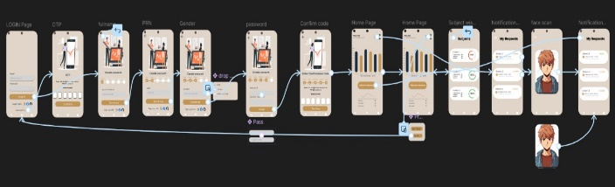
Figure 2.1: Page Linking
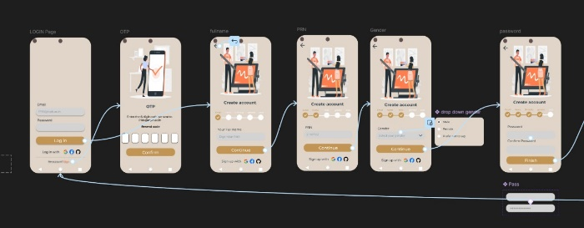
Figure 2.2: Registration Process
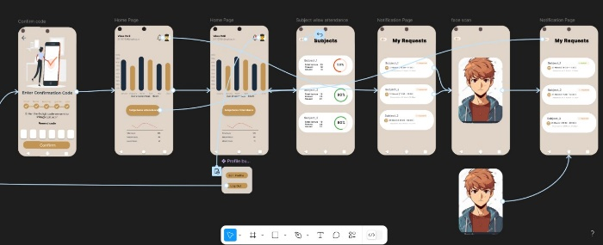
Figure 2.3: Student Profile
B. Front-End Development
For the front-end, Dart (Flutter) was selected as the development framework as shown in figure 3.1, 3.2 and 3.3. Flutter allows for the creation of high-performance, cross-platform applications using a single codebase,

thereby reducing both development time and maintenance costs. The UI components built in Flutter provide a seamless and consistent experience across both Android and iOS devices. [8] The front-end interacts with various backend services through secure APIs, ensuring that user inputs and real-time data are handled efficiently.
C. Back-End Development
The back-end of the system is primarily developed in Python, which is used to implement complex processing tasks including facial recognition and data management. The FaceNet algorithm, implemented in Python, is responsible for extracting unique facial embeddings from captured images. This process is optimized to handle real-time requests, ensuring swift and accurate identity verification. The back-end also manages data synchronization and storage in a cloud environment, ensuring that attendance records are updated in real time.
D. Cloud Integration and Automation
For cloud services, Firebase has been employed to provide a real-time database, secure authentication, and scalable storage solutions as in figure 3.4 Firebase’s robust backend infrastructure ensures that attendance data is readily available and secure, supporting high transaction volumes and real-time updates.
To further enhance operational efficiency, Google Apps Script is integrated into the system to automate routine tasks such as exporting attendance records to Excel sheets. This automation minimizes manual intervention, reduces errors, and facilitates easy data analysis and reporting.
E. GPS Localization and Security
The system uses a GPS localization service to retrieve real-time geographic coordinates from the user’s device. [9] These coordinates are then validated against predefined geofenced boundaries to ensure that the user is physically present in the designated area. This geofencing not only reinforces the reliability of the attendance data but also adds an essential security layer to the overall system.
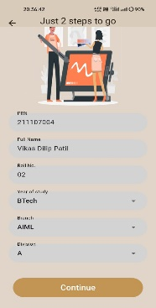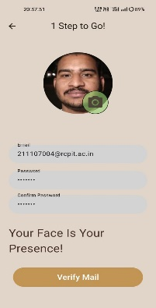
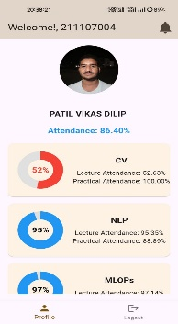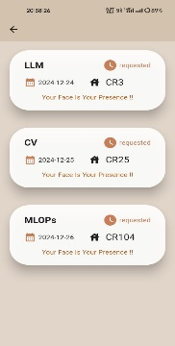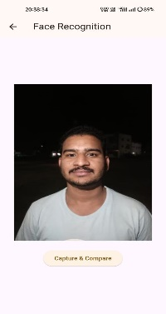

Figure 3.1: Student Profile
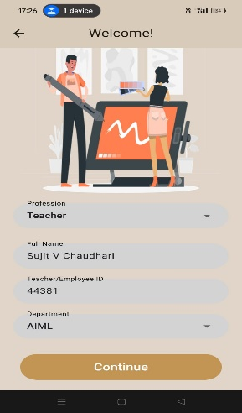
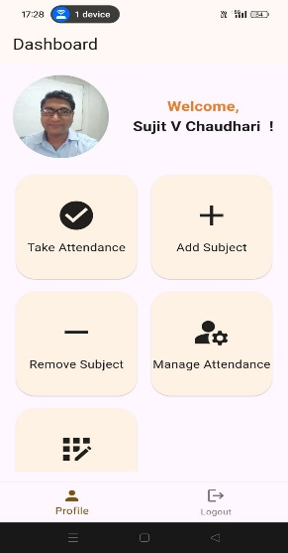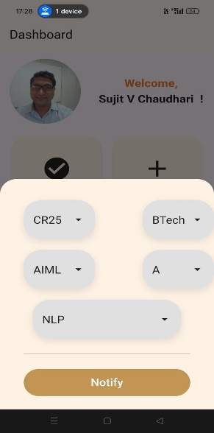
Figure 3.2: Teacher Profile

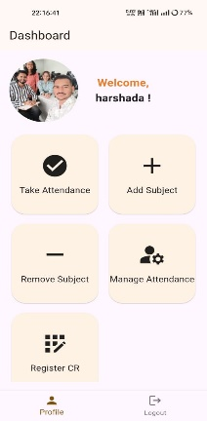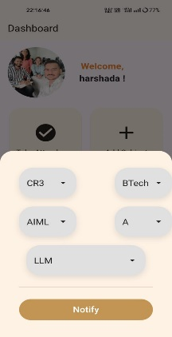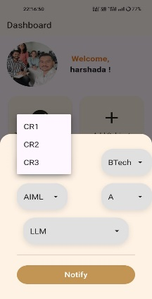

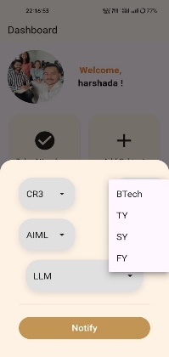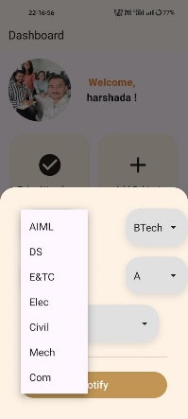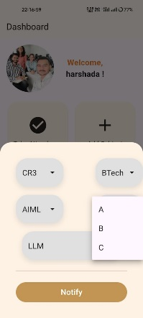
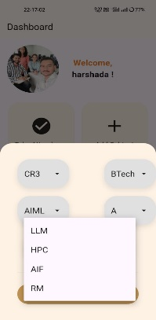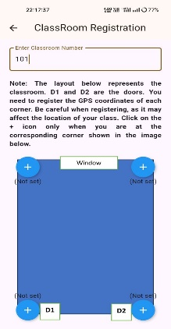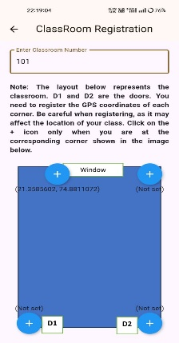
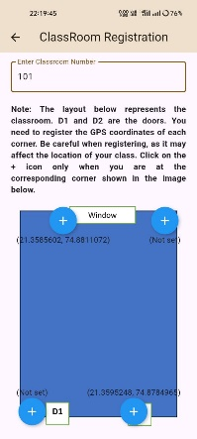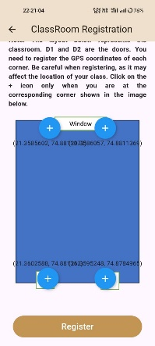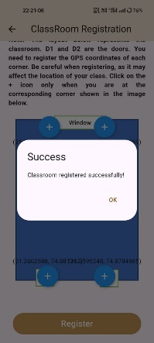
Figure 3.3: Classroom Registration

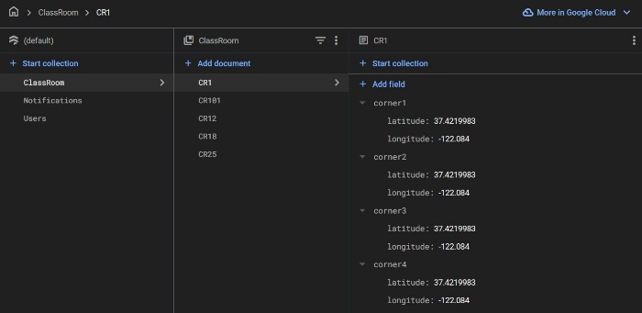
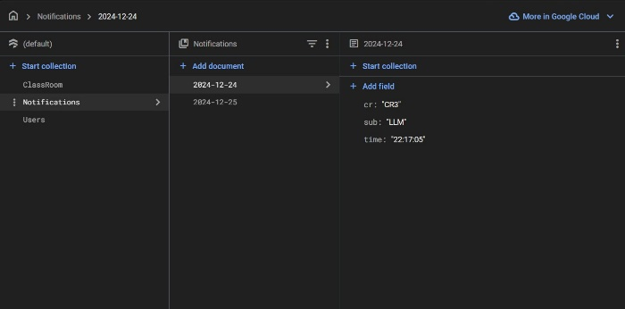
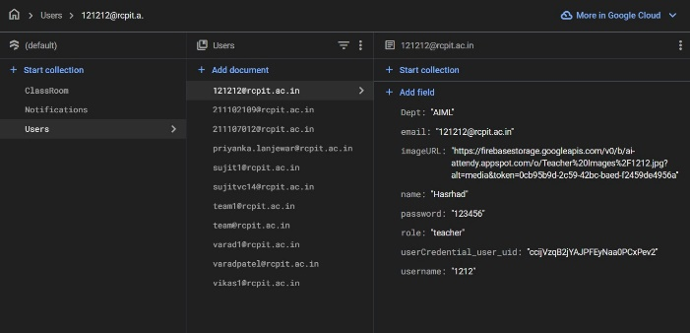
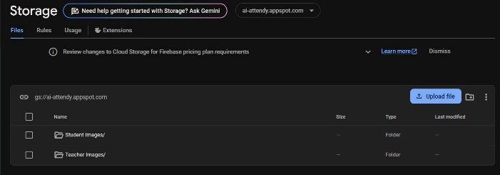
Figure 3.4: Backend Data Management
CONCLUSION
This paper has presented an automated attendance management system that successfully integrates facial recognition and GPS localization to address the limitations of conventional attendance methods. The system improves accuracy, minimizes administrative overhead, and enhances security by ensuring that attendance is recorded only when the user is physically present in the designated area. Future research will focus on refining the recognition algorithms, expanding scalability, and exploring additional biometric modalities to further enhance system performance.
ACKNOWLEDGMENT
The authors express their sincere gratitude to Prof. P. D. Lanjewar and the faculty at R. C. Patel Institute of Technology for their continuous support and guidance throughout this project. Special thanks also go to all team members and technical staff whose contributions were instrumental in the development and testing of this system.
REFERENCES
- H. Sutar, S. Chaudhari, P. Bhopi, and D. Sonavale, “Automated Attendance System,” Int. Res. J. Mod. Eng. Technol. Sci., vol. 04, no. 04, 2022
- Y. N. S, A. Kumar, and N. R. Kumar, “Location Based Smart Attendance System Using GPS,” Ann. Rom. Soc. Cell Biol., vol. 25, no. 2, pp. 4510–4516, 2021, [Online]. Available: http://annalsofrscb.ro
- F. Susanto, F. Fauziah, and A. Andrianingsih, “Lecturer Attendance System using Face Recognition Application an Android-Based,” J. Comput. Networks, Archit. High Perform. Comput., vol. 3, no. 2, pp. 167– 173, 2021, doi: 10.47709/cnahpc.v3i2.981.
- Mardiana, & Muhammad, Meizano & Mulyani, Yessi. (2021). Library Attendance System using. YOLOv5 Faces Recognition. 68-72. 10.1109/ICCTEIE54047.2021.9650628
- J. Redmon, “You Only Look Once: Unifed, Real-Time Object
Detection”, Ann. Med. Psychol. (Paris)., vol. 134 II, no. 1, pp. 59–61,2016
- Abhishek Jha, “Classroom Attendance System Using Face Recognition System”, The International journal of Mathematics, science, technology and Management, Vol. 2, ISSD: 2319-8125.
- KAWAGUCHI and Yohei, "Face Recognition-based Lecture Attendance System.," in The 3rd AEARU Workshop on Network Education. 2005., 2005.
- Kumbhar, A. A. Wanjara, K. S. Trivedi, D. H. Khairatkar, A. U. Sharma, D. (2014). “Automate Attendance Monitoring System using Android Platform.”, International Journal of Current Engineering and Technology, Vol. 4, No. 2, pp1096-1099
- Shermin Sultana, Asma Enayet and Ishrat Jahan Mouri, “A smart,
location based time and attendance tracking system using android application.” in International Journal of Computer Science, Engineering and Information Technology (IJCSEIT), Vol. 5, No.1,
February 2015.

