Performance and Sustainability of Hybrid Thermal Insulation Materials for Energy-Efficient Applications: A Review

Kazi Noaman Tarique¹, Thakur Mayur Prakashsing ², Dr. Saner Kapil Ashokrao ³
¹PG student,  0009-0005-8322-5137, ²Asstt.Professor, 0000-0003-1839-6499
^{1,2} GF’s Godavari College of Engineering, Jalgaon, India,425003, mayurthakur941@gmail.com
³Asstt.Professor, R C Patel Institute of Technology, Shirpur, India, 425405, saner.kapil@gmail.com
Email of Corresponding Author: kazinoaman@gmail.com

Received on: 28 April, 2025 Revised on: 02 June,2025 Published on: 06 June, 2025

Abstract –This review delves into the advancements of hybrid thermal insulation materials, emphasizing the integration of multiple components such as rockwool, ceramics, aerogels, and rockwool- vermicomposting blends. The combination of these materials is aimed at improving thermal efficiency, strengthening durability, and promoting environmentally friendly solutions in mechanical engineering. These materials are particularly useful in energy-efficient buildings and industrial systems. This review focuses on how they perform in terms of heat insulation, their strength, and their ability to withstand challenging environmental conditions like high humidity and extreme temperatures. At the same time, it addresses practical challenges such as the high cost of production, limited availability of raw materials, and their overall impact on the environment. It also suggests ways to make these materials more sustainable and cost-effective. By blending these materials, we can achieve better insulation, reduce energy use, and cut down greenhouse gas emissions, which translates into lower costs and a smaller environmental footprint. Overall, the findings show that these advanced materials have great potential to reduce energy usage in buildings and industrial operations. This makes them an important step toward creating more sustainable and energy-efficient practices in engineering.
Keywords- Rockwool, Asbestos, Vermicompost, Ceramic, Charcoal.

INTRODUCTION
The increasing global demand for energy and the need for sustainable solutions have underlined the importance of thermal insulation materials in designing energy-efficient systems. These materials play a vital role in reducing heat transfer, ensuring thermal comfort, and minimizing energy loss [1]. With recent advancements in material science, hybrid insulation materials have gained attention as they combine multiple components to optimize thermal, mechanical, and environmental properties [2]. Rockwool is one of the most commonly used inorganic insulation materials, valued for its thermal resistance, soundproofing qualities, and non-combustibility [14]. However, the environmental impact of its production has prompted efforts to modify it or blend it with more sustainable alternatives [4]. For instance, incorporating vermicompost, an organic material, into Rockwool has been proposed to improve its sustainability while maintaining desirable insulation properties [3]. Ceramic materials have also played a key role in advancing insulation technology, especially for high-temperature applications. Their excellent thermal stability, mechanical strength, and resistance to environmental degradation make them suitable for industrial and architectural use [18]. Current research focuses on optimizing ceramic composites to strike a balance between cost-effectiveness and improved performance [18].
Aerogels are recognized as some of the most efficient thermal insulators due to their extremely low thermal

conductivity and lightweight nature [11]. However, their brittle structure limits their standalone application, which has led to their integration with sturdier materials like Rockwool [11]. This combination leverages the exceptional insulation efficiency of aerogels while addressing their mechanical limitations, making them more practical for real-world use [15].
Recent advancements in thermal and acoustic insulation materials have also encouraged the development of hybrid composites. For example, blends such as Rockwool-vermicompost-cement-asbestos-charcoal represent an innovative approach to achieving superior thermal performance. Each component contributes specific benefits: Rockwool provides thermal resistance, vermicompost adds eco-friendliness, cement ensures structural integrity, and asbestos and charcoal enhance fire resistance.
These hybrid materials align with modern trends in sustainable construction, emphasizing energy conservation, environmental compatibility, and cost efficiency. By combining traditional materials with innovative solutions, these systems tackle challenges such as high production costs, environmental impact, and performance under varying climatic conditions. Such approaches not only optimize insulation properties but also support the global push toward more sustainable and energy-efficient construction practices.
Classification of Insulation Material
Thermal insulation materials vary in composition and efficiency, each offering unique benefits. Aerogels, with a porous nanostructure, provide an R-value of 10–20 [11], while cork and sheep wool offer moderate insulation (R-value 3.5–4.2) [9, 10]. Glass wool and mineral wool provide R-values of 2.2–3.3 [14]. Polyurethane foam stands out with 6.0–7.0 [12], while vacuum-insulated panels (VIPs) reach 25–50 [16]. Eco-friendly options like cellulose, rice husk, and agro-waste fibers range from 3.0 to 4.0. Nanostructured and ceramic materials offer specialized thermal properties [20].
This research focuses on studying the thermal and mechanical properties of several natural and hybrid insulation materials:
Rockwool-vermicompost hybrids: Developed for sustainable and efficient applications [3].
Ceramic insulation materials: Designed for high-temperature applications with enhanced longevity [18].
Aerogel-rockwool composites: Combining the exceptional insulation performance of aerogels with the structural robustness of Rockwool [11].

Rockwool-vermicompost-cement-asbestos-charcoal composites: Engineered to improve fire resistance, durability, and overall thermal performance.
These materials highlight the innovative potential of combining traditional and modern approaches to meet the growing demand for energy-efficient, sustainable, and durable insulation solutions.
LITERATURE REVIEW
1. Thermal insulation materials Thermal insulation materials include aerogel, basalt fiber, phase change materials (PCMs), fiberglass, inorganic materials, and natural alternatives. Aerogel, a nanoporous silica-based material, has ultra-low thermal conductivity (~0.013 W/(m•K)) and high-temperature resistance, making it ideal for aerospace, pipelines, and cryogenic systems, though its high cost limits wider use [11, 15]. PCMs, such as paraffin and salt hydrates, store and release heat, benefiting HVAC systems and electronics cooling. Fiberglass, with ~0.040 W/(m•K) conductivity, offers fire resistance but is moisture-sensitive[34]. Inorganic materials like rock wool and ceramic fibers provide high thermal resistance but have carbon-intensive production [7, 19]. Natural alternatives, such as sheep wool, cork, and rice husk, are sustainable but less efficient than synthetic materials [6, 10].
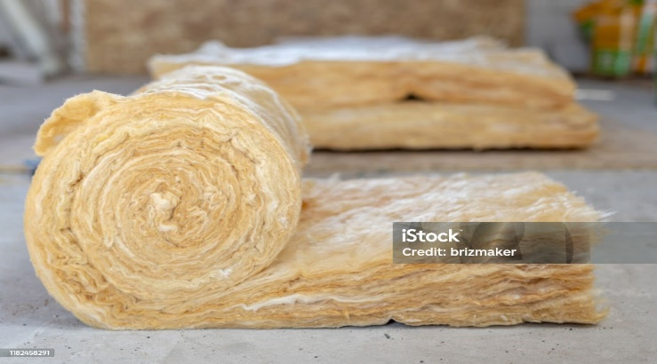Figure 1- Rockwool [33]
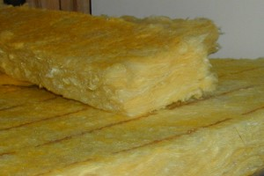
Figure 2- Glass Wool [34]
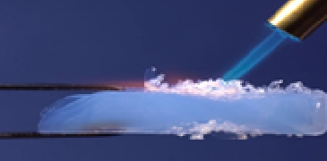Figure 1 3- Aerogels [35]

2. Impact of Insulation Positioning and Thickness the Proper insulation placement minimizes heat bridges, enhancing energy conservation. Thickness plays a vital role in reducing heat transfer in residential and industrial applications, optimizing thermal performance and energy savings [5, 30].

3. Composite Materials for Thermal Insulation
Composite materials, combining polymers, fibers (carbon or glass), and fillers like silica or ceramic, offer durability, lightweight properties, and superior thermal performance. They are widely used in aerospace, automotive, and industrial piping systems [8, 20].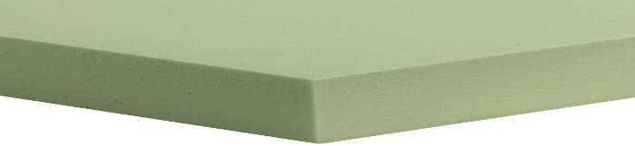
Figure 4- Polyurethane Foam [36]

4. Techniques for Assessing Thermal Conductivity Steady-state methods (e.g., guarded hot plate) ensure precise measurements, while transient techniques (e.g., laser flash analysis) enable quick testing. Choosing the right method is crucial for evaluating insulation materials under varying conditions [2, 27].

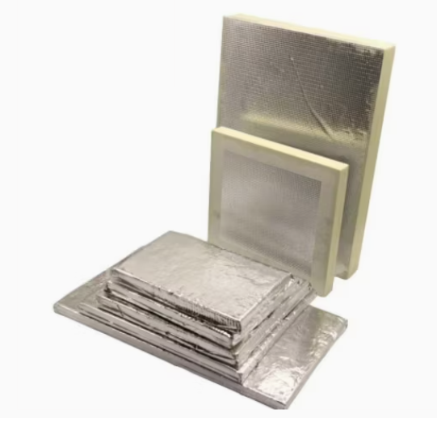
Figure 5- Vacuum Insulated panel [37]

5. Sustainable Insulation Approaches
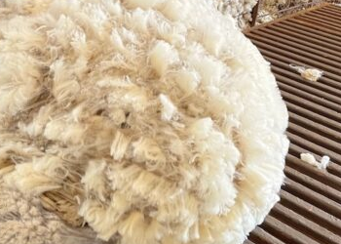
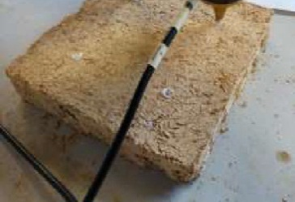
Eco-friendly insulation includes rice husk-earth composites, balancing insulation efficiency with mechanical strength [11]. Sheep wool (~0.035 W/(m•K)) is an effective acoustic and thermal insulator, absorbing indoor pollutants, making it ideal for green buildings [10].

Figure 6 Figure 7
Cellulose, Rice Husk[8] Sheep Wool [38]
6. Innovative and enhanced Insulation Materials Nano-aerogels (~0.012 W/(m•K)) provide superior insulation but remain costly [11]. Enhancements like polysiloxane coatings improve moisture resistance in traditional materials, benefiting marine and industrial applications [14, 31]. Aerogel outperforms rock wool in insulation efficiency, making it ideal for energy-efficient
buildings [15]. 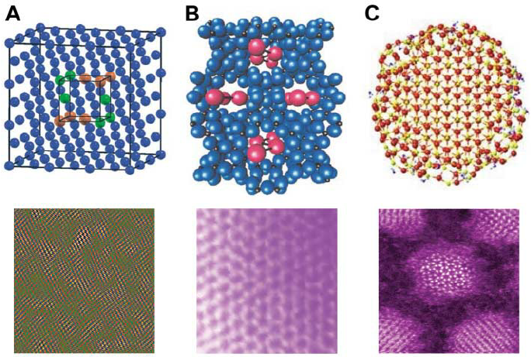
Figure 8 - 39

7. Applications and Challenges in Specific Fields Polymeric ablative materials (PAMs) withstand extreme heat in military applications [29]. High-strength adhesives (epoxy, polyurethane, silicone) are essential in aerospace and automotive industries [30]. Composite materials, including carbon fiber-reinforced polymers, enhance aircraft and space vehicle insulation, while nanocomposites further improve thermal performance 19, 20].
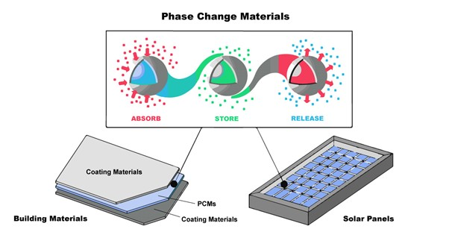 Figure 9- Phase Change Materials (PCMs) [40]
8. Recycling Challenges in Composite Materials

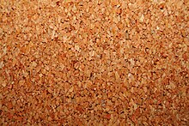
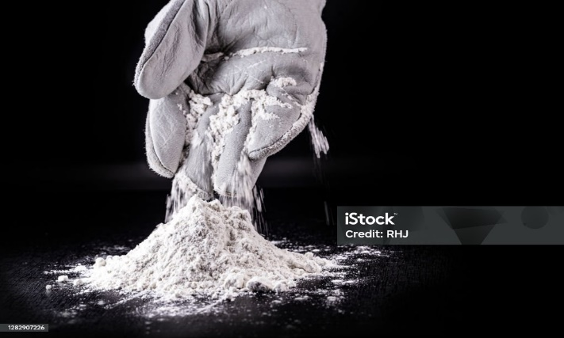
Recycling composites is complex, requiring mechanical grinding, chemical recovery, and thermal depolymerization. Innovations support sustainable reuse in secondary construction and thermal barriers [21, 22].
Figure 10 – Cork [41] Figure 11- Ceramic [42]

9. Ceramic Electrical Insulating Materials
Ceramic insulators (alumina, silica, zirconia) offer high dielectric constants and low thermal expansion, making them suitable for high-voltage systems and electronics. Advanced ceramics improve aging resistance and microstructural properties of ceramics. [9, 28].

10. Cryogenic Insulation Systems

Cryogenic insulation ensures efficiency in extreme low temperatures. Multilayer insulation (MLI) systems, using reflective foils and spacers, enhance performance. Standardized testing (ASTM C1774, C740) ensures reliability in liquefied gas storage, pipelines, and spacecraft insulation [27].

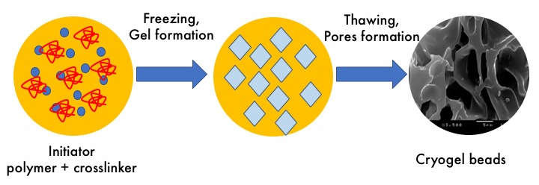 Figure 12- Cryogenic Insulation Systems [43]
Material with Key points and Findings
Material Properties & Performance: Aerogels offer exceptional insulation (~0.012 W/(m•K)), but high costs limit widespread use. Phase Change Materials (PCMs) are efficient for energy storage but require further optimization for broader applications. Fiberglass provides good insulation but is moisture-sensitive, while inorganic materials exhibit high thermal resistance but pose environmental concerns. Natural insulation materials are sustainable yet underutilized, requiring performance improvements.
Measurement & Standardization: Thermal conductivity measurement techniques include steady-state methods (e.g., shielded hot plate) and transient methods (e.g., laser flash). However, standardized procedures are essential to enhance measurement accuracy and reliability.
Sustainable & Alternative Materials: Vermicomposting enhances soil quality and promotes organic waste management, while recycled and natural insulation materials help reduce environmental impact, though further material characterization is needed. Rice husk-earth composites improve insulation but require structural optimization, and sheep wool offers a sustainable option with added benefits like pollutant absorption.
Innovative & Coated Materials: Nano-aerogels deliver superior thermal performance, but their high costs necessitate research into affordability. Coated insulation materials, such as polysiloxane-treated glass wool, demonstrate enhanced durability in humid environments. Hybrid insulation technologies, including aerogels, outperform Rockwool, leading to 8% energy savings in cooling and 11% in heating.
Industry-Specific Applications: In military settings, polymeric ablative materials (PAMs) provide extreme heat resistance, while in aerospace and automotive industries, lightweight composites improve efficiency and durability. Nanomaterials offer superior thermal and mechanical properties, making them ideal for advanced applications.
Recycling & Sustainability: Innovative composite recycling helps preserve material integrity and reduce waste, while advancements in ceramic insulators enhance thermal and electrical properties.

Cryogenic Insulation: Multilayer insulation (MLI) technologies ensure maximum performance in extreme conditions, with ASTM standards (C1774, C740) guiding material optimization for energy efficiency.
CONCLUDING REMARK
High-performance insulation materials such as aerogels, which are silica-based and nonporous, offer exceptional thermal resistance with an R-value of 10–20 per inch, though their high cost remains a challenge [11]. Similarly, vacuum insulated panels (VIPs), featuring an evacuated core and protective film, are highly efficient with R-values ranging from 25 to 50 per inch, making them ideal for advanced insulation systems [16]. Natural and sustainable materials like cork, derived from bark with a cellular structure, have an R-value of 3.6–4.2, providing a lightweight and eco-friendly option [9]. Sheep wool, a protein-based fiber, delivers R-values between 3.5 and 4.0, offering acoustic benefits and sustainability [10]. Agro-waste fibers from sources such as date palm leaves and wheat straw have R-values of 3.0–4.0, promoting sustainability through agricultural byproducts [7]. Recycled materials, including cellulose from waste paper and rice husk, emerge as sustainable alternatives with R-values between 3.0 and 3.5 [6, 8]. Among common insulation materials, glass wool and mineral wool, produced from melted glass, rock, or slag fibers, offer R-values between 2.2 and 3.3, but are moisture-sensitive [14]. Polyurethane foam, a widely used synthetic polymer, provides high efficiency with an R-value of 6.0–7.0 [13]. Phase change materials (PCMs), including paraffin and salt hydrates, have dynamic R-values, utilizing phase transitions to store and release energy [12, 13]. Specialized insulation materials like high-performance ceramics, such as alumina, mullite, and zircon, exhibit low thermal resistance (R-value: 0.8–1.2) but provide excellent durability and thermal shock resistance [19]. Lastly, nanocomposites and advanced coatings offer variable R-values, though they require specific testing for optimized performance [19, 20].
RESEARCH GAPS
A review of thermal insulation materials reveals several research gaps that present opportunities for further exploration and innovation. Addressing these gaps will enhance the effectiveness, sustainability, and economic feasibility of insulation technologies. Standardized Testing and Long-Term Performance Consistent R-value Testing: Current studies use varied testing methods and conditions, making direct comparisons difficult.

Standardized protocols under consistent conditions are needed for reliability [11, 14, 16]. Long-Term Durability Limited data exists on the aging, degradation, and performance of materials under real-world conditions, including moisture exposure, temperature fluctuations, and extreme climates [10, 25]. Environmental Impact and Sustainability affects Life-Cycle Assessments (LCAs): While materials like cork, cellulose, and agro-waste fibers are promoted as sustainable, LCAs for newer materials (e.g., nanocomposites, vacuum insulated panels) are insufficient, particularly regarding recyclability and disposal [6, 7, 21]. Cost Barriers like advanced materials such as aerogels and VIPs provide exceptional insulation but remain too expensive for widespread use. Research is needed to develop cost-effective production methods and hybrid solutions that balance performance and affordability [11, 16]. Regional Suitability and Material Integration with climatic Performance as Many insulation materials are tested in controlled laboratory environments, but real-world performance data in different climatic zones (hot, humid, extremely cold) is lacking [5, 30]. Phase Change Materials (PCMs) Integration of PCMs have potential for energy storage, but studies on their practical application within building envelopes and their interactions with other materials are limited [12, 17]. Innovation in Traditional and Bio-Based Materials Enhancing Traditional Insulation while mineral wool and ceramic insulators are well-documented, opportunities exist to improve their thermal performance, durability, and environmental impact through material innovations [14, 12]. Bio-Based Composites Optimization materials like rice husk-earth panels, charcoal composites, and agro-waste fibers show promise but require research on mechanical strength, pest resistance, and thermal stability for long-term viability [7, 8]. Fire Resistance and Safety is Limited research exists on improving fire resistance and thermal stability of materials like polyurethane foam and natural fibers without compromising insulation performance [13, 35]. Emerging Technologies and Scalability Thermal Metamaterials & Nanostructured Coatings These materials offer revolutionary potential but need further investigation into scalability, cost-efficiency, and multifunctional benefits [19, 20].
V. Future Study
The advancement of insulation materials is crucial for energy efficiency and sustainability. Among these, the Rockwool-Vermicompost-Ceramic-Asbestos-Charcoal

composite stands out for its high performance, cost-effectiveness, and eco-friendliness. This report explores research directions to optimize its properties and address existing challenges. With a thermal efficiency of R-4.2 per inch and temperature resistance up to 900°C, the composite ensures energy savings, fire resistance, and durability in industrial applications. Its eco-friendly composition reduces reliance on non-renewable resources, making it a cost-effective for insulation.
Future research should replace asbestos with basalt fibers for safety and compliance while optimizing the ratios of vermicompost, ceramic, and charcoal to improve thermal and mechanical properties. Adding recycled materials or bio-polymers could enhance performance and sustainability.
Long-term durability testing under humidity, temperature fluctuations, and chemicals is essential for validating reliability. Lifecycle assessments will quantify its environmental impact, while energy-saving studies in industrial furnaces and buildings will highlight its benefits.
To ensure wider adoption, streamlining production via automation can cut costs and improve scalability. Aligning with international safety and environmental standards and developing standardized testing protocols will support global commercialization.
CONCLUSION
Advancements in hybrid and sustainable insulation materials show great potential for improving performance and energy efficiency. While high-performance options like aerogels face cost challenges, eco-friendly alternatives need optimization for broader use. Future research should focus on cost reduction, standardization, and sustainability to promote energy conservation and reduce carbon footprints in construction and industry.
REFERENCES
- Ali, A., Issa, A., & Elshaer, A. (2024). A Comprehensive Review and Recent Trends in Thermal Insulation Materials for Energy Conservation in Buildings. Sustainability (MDPI).
- Numan Yüksel. (2016). The Review of Some Commonly Used Methods and Techniques to Measure the Thermal Conductivity of Insulation Materials. INTECH.
- Sarat Ganti, (2018). Vermicomposting. International Journal of Waste Resources
- Asdrubali, F., D'Alessandro, F., & Schiavoni, S. (2015). Sustainable Insulation Materials for Buildings: A Review. Sustainable Materials and Technologies (Elsevier).
- Sadineni, S. B., Madala, S., & Boehm, R. F. (2011). Passive Building Energy Savings: A Review of Building Envelope Components. Renewable and Sustainable Energy Reviews (Elsevier).
- Marín-Calvo, N., González-Serrud, S., & James-Rivas, A. (2023). Thermal Insulation Material Produced from Recycled Materials for Building Applications: Cellulose and Rice Husk-Based Material. Frontiers in Built Environment.
- Ali, M., Alabdulkarem, A., Nuhait, A., Al-Salem, K., & Iannace, G. (2021). Characteristics of Agro Waste Fibers as New Thermal Insulation and Sound Absorbing Materials: Hybrid of Date Palm Tree Leaves and Wheat Straw Fibers. Journal of Natural Fibers (Taylor & Francis).
- Antunes, A., Faria, P., Silva, V., & Brás, A. (2019). Rice Husk-Earth Based Composites: A Novel Bio-Based Panel for Buildings Refurbishment. Construction and Building Materials (Elsevier).
- Miranda, I., & Pereira, H. (2024). Cork Façades as an Innovative and Sustainable Approach in Architecture: A Review of Cork Materials, Properties, and Case Studies. Materials (MDPI).
- Bosia, D., Savio, L., Thiebat, F., Patrucco, A., Fantucci, S., Piccablotto, G., & Marino, D. (2015). Sheep Wool for Sustainable Architecture. Energy Procedia (Elsevier).
- Lu, L., Wang, H., Yun, S., Hu, J., & Wang, M. (2024). A State-of-the-Art Review of Novel Aerogel Insulation Materials for Building Exterior Walls. Energy Sources, Part A: Recovery, Utilization, and Environmental Effects (Elsevier).
- Madad, A., Mouhib, T., & Mouhsen, A. (2018). Phase Change Materials for Building Applications: A Thorough Review and New Perspectives. Buildings (MDPI).
- Amaral, C., Vicente, R., Eisenblätter, J., & Marques, P.A.A.P. (2017). Thermal Characterization of Polyurethane Foams with Phase Change Material. Ciência & Tecnologia dos Materiais (Elsevier).
- Jeon, C.-K., Lee, J.-S., Chung, H., Kim, J.-H., & Park, J.-P. (2017). A Study on Insulation Characteristics of Glass Wool and Mineral Wool Coated with a Polysiloxane Agent. Advances in Materials Science and Engineering (Hindawi).
- Danaci, H. M., & Akin, N. (2022). Thermal Insulation Materials in Architecture: A Comparative Test Study with Aerogel and Rock Wool. Environmental Science and Pollution Research (Springer).
- Alotaibi, S. S., & Riffat, S. (2014). Vacuum Insulated Panels for Sustainable Buildings: A Review of Research and Applications. International Journal of Energy Research (Wiley).
- William, M. A., Suárez-López, M. J., Soutullo, S., & Hanafy, A. A. (2021). Techno-economic evaluation of building envelope solutions in hot arid climate: A case study of educational building. Energy Reports (Elsevier).
- M. D. RlGTERlNK. (1958). Ceramic Electrical InsuIating Materials, Journal of The American Ceramic Society-Rigterink
- Sklan, S. R., & Li, B. (2018). Thermal metamaterials: Functions and prospects. National Science Review (Oxford Academic).
- Casini, M. (2016). Smart Buildings: Advanced Materials and Nanotechnology to Improve Energy Efficiency and Environmental Performance. Elsevier.
- Füchsl, S., Rheude, F., & Röder, H. (2022). Life cycle assessment (LCA) of thermal insulation materials: A critical review. Cleaner Materials (Elsevier).
- Schritt, H., & Pleissner, D. (2022). Recycling of organic residues to produce insulation composites: A review. Cleaner Waste Systems (Elsevier).
- Hossain, S. K. S., & Roy, P. K. (2019). Fabrication of sustainable insulation refractory: Utilization of different wastes. Boletín de la Sociedad Española de Cerámica y Vidrio (Elsevier).
- Ali, A., Issa, A., & Elshaer, A. (2024). A Comprehensive Review and Recent Trends in Thermal Insulation Materials for Energy Conservation in Buildings. Sustainability (MDPI).
- Künzel, H. M. (2022). Long-Term Thermal Performance of Insulations Under Moisture Loads. Green Energy and Technology (Springer).
- Awoyera, P. O., & Naser, M. Z. (2024). Construction Materials and Their Properties for Fire Resistance and Insulation. Elsevier.
- Fesmire, J. E. (2015). Standardization in Cryogenic Insulation Systems Testing and Performance Data. Physics Procedia (Elsevier).
- Ibrahim, M., Sayegh, H., Bianco, L., & Wurtz, E. (2019). Hygrothermal performance of novel internal and external super-insulating systems: In-situ experimental study and 1D/2D numerical modeling. Applied Thermal Engineering (Elsevier).
- Kumar, M., Ahmad, R., & Arif, R. (2024). Emerging Trends In Thermal Insulation Materials And Techniques. Propulsion Tech Journal.
- Dong, Y., Kong, J., Mousavi, S., Rismanchi, B., & Yap, P.-S. (2023). Wall Insulation Materials in Different Climate Zones: A Review on Challenges and Opportunities of Available Alternatives. Thermo (MDPI).
- Chan-Ki Jeon, Jae-Seong Lee, Hoon Chung, Ju-Ho Kim, and Jong-Pil Park (2016), A Study on Insulation Characteristics of Glass Wool and Mineral Wool Coated with a Polysiloxane Agent, Hindawi
- Jan Kosny., David W. Yarbrough., (2022). Increase Thermal Stability and reduce Flamability of polyurethane foams with applications. Green Energy and Technology, Springer
- https://www.istockphoto.com/photo/mineral-rockwool-lying-on-attic-floor-inside-house-under-construction-gm1182458291-332043932
- https://en.wikipedia.org/wiki/Glass_wool#/media/File:Glass_wool_insulation.jpg
- https://www.istockphoto.com/photo/airgel-and-experiences-with-it-aerogel-gm1166139532-321119141?searchscope=image%2Cfilm
- https://www.easycomposites.co.uk/high-density-polyurethane-foam-block
- https://qiyaomaterial.en.made-in-china.com/product/sdFficuKArtR/China-Wholesale-PU-Foam-Vacuum-Insulation-Panels-Vips-Insulated-Panels-for-Building-Construction.html
- https://www.segardmasurel.com/en/greasy-wool/
- https://www.researchgate.net/figure/Examples-of-nanostructured-materials-
- https://bisresearch.com/news/Phase-change-materials-the-new-age-energy-conservation-technique
- https://en.wikipedia.org/wiki/Cork_%28material%29#/media/File:Cork.jpg
- https://www.istockphoto.com/photo/powdered-calcite-industrial-mass-used-in-fiberglass-plastic-mass-agribusiness-civil-gm1282907226-380501634?searchscope=image%2Cfilm
- https://www.researchgate.net/figure/The-porous-cyrogel-beads-formed-during-the-freezing-and-thawing-process_fig2_334026521

