Design and Optimization of Gating System for Improving Yield of Casting For Cast Iron
Nikesh Y Awalekar¹ , Sagar R Chopde ², Hardik U Walde³ , Kaustubh B Nege⁴ ,
Dr. Pravin S Nerkar⁵

Mechanical Department
St. Vincent Pallotti College of Engineering & Technology, Nagpur Nagpur, India.
psnerkar3@gmail.com

Received on: 5 May,2024 Revised on: 25 June,2024 Published on: 27 June,2024

Abstract— The industry requires the yield provided by the client to be between 60% and 75%. Casting defect analysis is the process of determining the underlying cause of problems when a casting is rejected. Take the appropriate steps to decrease faults and increase casting yield. Most gate systems are designed. Casting is largely an individual art that draws on both casting experience and collective experience. Foundry workers are involved in the casting development process. This article discusses how to optimize casting yield. Modification and modification of existing gating systems to increase casting yield. Molten metal is placed into the casting cavity. As the metal enters and flows into the Mold, filling its cavities, it can solidify into the appropriate shape of the casting.
Keywords: - yield of casting, Gating improvement.

I Introduction

The entire part is made from metal casting. Main activities related to creation. Casting refers to forming, melting, pouring, solidifying, lining, cleaning, testing and removing defects. Casting Among various casting methods, green sand casting is a widely used method in manufacturing automobile products. Currently the casting for the production of ferrous and non-ferrous metals has a wide range of applications used in valves, pumps, engine blocks, aerospace and various automotive parts. Casting control is done during the casting process.

Casting process settings are critical; otherwise, casting errors will develop. For example, scabs, cracks and holes, malfunction, shrinkage, porosity, lump adhering, hot break, and so on. decreasing manufacturing difficulties, regulating the process, and decreasing casting defects Expert guidance on order lead time, defect rate, production cost, and optimization to eliminate trial and error. The gate system plays a pivotal role in regulating the flow of molten metal into the mold cavity, controlling variables like temperature and turbulence to ensure quality production. Designing an efficient gating system is paramount for achieving top-notch casting results. The main objective of the paper is to develop comprehensive strategies for both gating systems and risers, emphasizing their importance in the overall casting process.
For casting, lift tension weight. The design of typical gate elements must be manufactured with an optimal gate weight system. The modern competitive market always places high standards of requirements. It is a high-quality product with no defects and delivery is fast. This study is about the casting process which used to produce Lift tension weight castings.

II. Methodology

Ensuring project flow and attaining desired outcomes heavily relies on the chosen methodology. In essence, methodology serves as a structure integrating project objectives and scope-defined work components. A well-designed framework facilitates data gathering and offers a holistic view of the project. This encompasses employing flow process charts, analyzing jigs through 3D modeling, and conducting a thorough literature review.

III. Literature Review

Choudhary et al. [1] conducted a study where parts experienced premature failure due to shrinkage porosity defects and incomplete fillings caused by sudden thickness changes. Consequently, there was a necessity to redesign the parts without compromising functionality, ensuring adequate gradients and connection radii in the component geometry. The authors endeavored to execute all methodologies, modeling, and optimization within Auto Cast software. Sadekar et al. [2] emphasized the significance of yield in a foundry's ability to efficiently produce acceptable castings and enhance profitability. Effective yield management offers numerous commercial and financial advantages to foundries, including direct cost control and improved performance. Process control facilitates cost management enhancement, enabling the design of optimal gate systems through computer modeling to enhance casting acceptance. Consequently, research has been conducted to analyze casting defects, leading to a reduction in part defect rates from 10.60% to 1.52% and a decrease in box yield from 75.37% to 67.82%. Cantavel et al. [3] studied the cooling performance of metal cast (metal object valve). Studies were conducted to investigate the cooling effectiveness using the Department of Energy and responsive area methodologies. The parameters chosen include cool the distance, cool size, heat, and filling time. Manikanda [4] investigated riser design optimization with genetic algorithm optimization. The casting process and riser volumes have been given as input parameters. The yield of sand-casting products has been improved utilizing the GRA optimization tool. Zhao et al. [5] discovered latent faults within the casting that arise during production and use. This can lead to fatigue or stress-related corrosion cracking, resulting in catastrophic product failure. Hidden flaws must be eliminated. The proper diagnosis was determined. If not, new flaws may arise. Unfortunately, this is a challenging endeavor because of internal deficiencies. Bubbles, porosity, shrinkage, and cracks in castings are notoriously difficult to detect. Durability against inspection A sparse representation-based evaluation method for detecting and categorizing latent casting flaws in X-ray images. gaps, particles, shrink gaps, and shrinkage cavities are four of the most prevalent casting flaws. Considered. Jolly et al. [6] investigated a computerized simulation using FDM and FEM techniques, resulting in a strong analytical tool. Several occurrences arise in the casting process. Hade and Sawant [7] conducted an analysis and study of brake disc casting. That was carried out to fix the problem. Overdesigned gated system parts lead to decreased casting yields. To address this issue, they changed the gate system. Deliver high-quality castings that increase casting yields, profitability, and productivity. Magdum and Jadhav [8] describe the creation of a method for modeling the casting process. AutoCAST simulation software. They used simulation approaches to numerically develop a gating system in these dimensions. They created 3D representations for the core and the cavity these were subsequently used as simulated castings during the process to test simulation approaches. An enhanced gating mechanism has been completed. They utilized a modified gate system design. Samples were collected for the purpose of modeling, as well as casting samples to verify the modeling method's conclusions. This is what they overcame. When utilizing this strategy, loss along with optimization through trial-and-error results in cheaper production costs and improved quality.

IV. Gating and runner system design for sand casting
The gating system functions as a network of pipes responsible for channeling molten metal into the mold cavity during casting. This network facilitates the flow of liquid metal, allowing it to fill the mold cavity and take on the desired casting shape as it solidifies.
Key requirements for designing an effective gating system include:
I. Ensuring smooth and uniform flow to minimize turbulence, which helps prevent air entrapment, metal oxidation, and mold formation.
II. Directing metal flow in a manner that ensures the mold is filled before solidification occurs.
III. Preventing erosion of the mold and core by maintaining a relatively low metal flow rate.
IV. Facilitating the removal of slag and inclusions from the gating system before molten metal enters the mold cavity, thus maximizing casting yield.
a. Existing Gating System
The present gating system is shown in Figure 1 below. In this case, the sprue is attached to the runner, which is then attached to the casting via six ingates. Two ingates are linked to the feeding to accommodate for shrinkage. This design includes two ports on the outside in order to evacuate gases. Table 1 shows the process specifics for the current gating system.

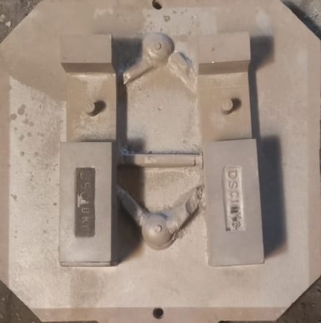
Figure 1. Pattern of Gating System

Details of Product
1. Mold material: Green sand.
2. Casting height is 75mm.
3. Tapping temperature (Tp) is 1475-1500 0C.
4. Pouring temperature: 1300-1400 0C
5. Pouring time: 8-12 seconds.
6. Material density: 7160 kg/m3.
7. The total weight of the casting in the mould box is 35 kg.
There are two cavities in the mould box
(8). The box is 670 mm x 670 mm, with a cope of 380mm and a drag of 380mm.
(9). The total dimensions of the mould box are 670 mm x 670mm x 760mm.
(11). Shape of mould box:- Rectangle
(12). Types of gating system: - Partition line gating system
(13). Existing casting yield=
$$\frac{volume of casting+volume of gating system }{volume of casting }×100$$
Existing casting yield= $\frac{2913750+2.63640}{2913750}$×100
Existing casting yield = 58.53

b. Updated Gating System
Small castings are typically poured on top and closed with just one sprue and gate. It is appropriate for large castings because there can be a risk of heating of the Mold near the casting point. This is due to the enormous flowing durations at the entrance and within the cavity of the mold. Thus it helps to use sophisticated gating mechanisms. The metal is transported to various sections of the Mold using discrete gating components. A gate design with several gates is: It is used to introduce metal at distant spots along the same horizontally plane. This method is used for extended plate casting. The metal continues to flow in a straight path unless an obstacle creates back pressure.
In this casting we reduce the gating area and reduce the pouring time of molten metal to an experimental level and, after the calculated reduced area is the result increase the yield of casting. Through a calculated area, we find the volume of casting or the volume of the gating system.

Modified yield of casting = $\frac{291375}{291375+1270640.47}×100$
Modified yield of casting = 69%
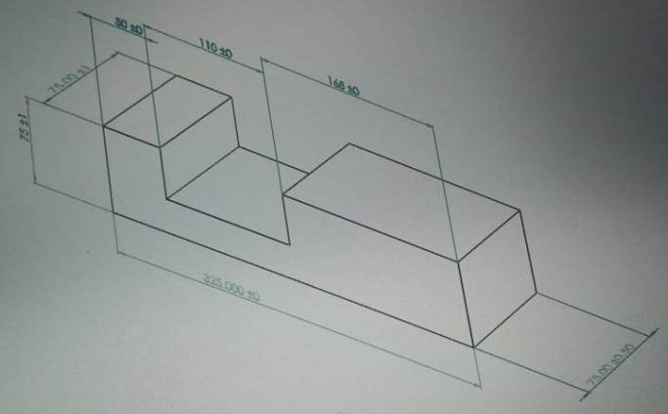
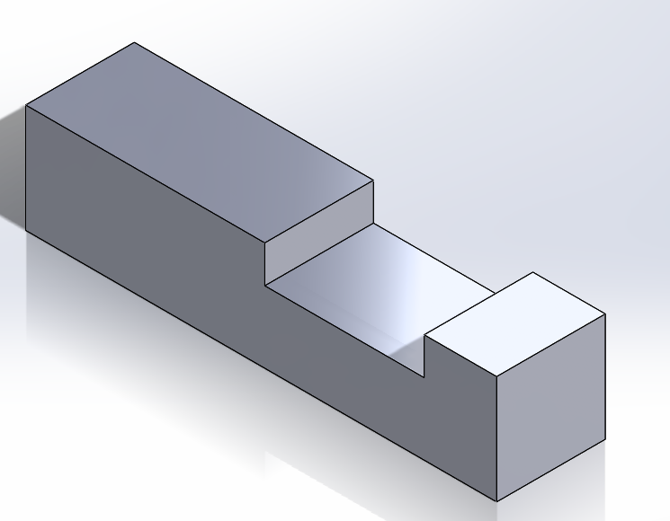
Fig 2- Final Product
V. Conclusions

- 1Optimizing gate design increases cast yield and helps reduce failure.
- 2. The present gating system yields 58.53%, whereas the modified gating system yields 69%, resulting in a 10.47% overall yield boost.
- 3. Good gate design promotes smooth, consistent metal flow while reducing turbulence and eliminating metal pinching. Air, metal oxidation, and fungal erosion.
- 4. An effectively designed gating system ensures smooth and steady metal flow with little turbulence, reducing air capture, metallic burning, and mold erosion.

VI. Future Work
Casting simulation is a highly successful technique for predicting process growth without actually doing the operation. The proper use of simulation tools like Pro Cast, Solid Cast, Auto Cast X, and MagmaSoft . assists foundries in lowering their garbage rate even when faults cannot be predicted. Simulation tools can help identify issue areas in casting, such as solidifying, filling patterns, and critical places. Simulation can also reveal problems such as shrinkage, porosity, and hotspots.

REFERENCES

[1] C. M. Choudhari, B. E. Narkhede and S. K. Mahajan, “Casting Design and Simulation of Cover Plate using AutoCAST-X Software for Defect Minimization with Experimental Validation”, ICMPC, 6, pp. 786 – 797, 2014.
[2] D. Sadekar, G.R. Bharath and S. Kumar, “Yield Improvement of Castings using Computer Aided Simulation – A Case Study”, International Journal on Theoretical and Applied Research in Mechanical Engineering, 3, pp. 1-4, 2014.
[3] K. Kanthavel, K. Arunkumar and S.Vivek, “Investigation of chill performance in steelcasting process using Response Surface Methodology,” Procedia Engineering,97, pp. 329 – 337, 2014. [4] ManikandaPrasath K., “Optimal Riser Design in Sand Casting Process Using GeneticAlgorithm,” International Journal of Scientific & Engineering Research, 5,pp. 371-374, 2014.
[4] P.N. Rao, Manufacturing Technology, Foundry, Forming and welding, third edition, The McGraw-Hill Company Limited, New Delhi, India, 2009, p. 128-138.
[5] Jain P.L., Principles of Foundry Technology, fourth edition, McGraw-Hill ed, New Delhi, India, 2003, p. 176-184.
[6] Jong Cheon Park and Kunwoo Lee,”Computer Aided Design of a Pattern and Risers for Casting Processes: Part 1”, Journalof Engineering for Industry, Vol. 113, February (1991), pp. 59.

