Simulation And Thermal Analysis Of A Fire Tube Boiler For A Food Industry
Atharva Dhankar ¹, Pranay Bhojne², Vaishnavi Gholse³, Harsh Rangari⁴, Harshanand Uikey⁵ , Prof. P.R.Bhagat⁶
Department of Mechanical Engineering
St Vincent Pallotti College of Engineering and Technology, Nagpur, India
pbhagat@stvincentngp.edu.in

Received on: 5 May,2024 Revised on: 25 June,2024 Published on: 27 June,2024

Abstract— A firetubed boiler, also known as fire pipes, is a simple and efficient heating system that uses hot oil to pass through pipes surrounded by water. It is a fundamental part of thermal engineering, providing reliability and cost-effectiveness. Thermal analysis is crucial for improving efficiency and effectiveness. This thesis focuses on a 5 ton per hour (TPH) fire tube boiler and its theoretical thermal analysis. The future of fire-tube boilers is expected to be in developing economies, where sustainability is increasingly important. Research could lead to hybrid boilers reducing carbon emissions and offering greater flexibility in installation, operation, and maintenance.

Keywords— Efficiency, Fire-tube boiler, simulation, thermal analysis, Heat transfer

Introduction
Boiler is an appliance that transfers heat under pressure to create steam for external use. It is usually an enclosed steel vessel that uses heat from burning fuel in order to generate water, which is employed in several processes in industry. Boilers are categorised according to the kind of tubes they include. As an instance, boilers with fire tubes serve in smaller industries, whereas boilers with water tubes are implemented in major power stations.
Burning fuel in a furnace, carrying gases that are hot to the nearby water, and then producing steam are the steps involved in the operation of a fire tube boiler. Following that, the steam accumulates in the exact same fire tube boiler vessel, and the boiler is moistened using the feed water input. But because the main boiler vessel is under pressure, it is challenging to produce steam at very high pressure.
Compact design, ease of adjustment to fluctuations in steam demand, and lower cost compared to water tube boilers are some of the benefits of fire tubed boiler. They do, however, have certain drawbacks, including the need for high steam pressure, limited steam pressure because of the combination of steam and water, the production of slightly wet steam, and the possibility of a catastrophic explosion because of the continuous strain on the steam drum.
The project aims to develop an elaborate mathematical model that accurately captures the processes of heat transport and thermal dynamics within a fire tube boiler, apply this model to investigate its thermal performance across multiple operating scenarios, and verify its accuracy and dependability by comparing the simulation output with experimental data or recognized theoretical relationships.

II - LITERATURE REVIEW

To simulate the given parameters of the boiler and perform thermal theoretical analysis on it, a literature review is written with the help of readily available knowledge concerning the topic. S. Gopalakrishnan, M. Makesh [1] explains that in The University of Iowa (UI) power plant's Unit 10 stoker boiler uses a moving grate that is thrown with ground coal on it. There has been previous work done to develop more basic models for use in CFD, but the modelling of the coal combustion on this moving grate is somewhat intricate. Fixed-bed types are the most popular. Using mathematical submodels developed by the Institutes of Environmental Process Engineering and Plant Design, Goerner and Klasen employed this method to approximate the temperature profile over the grate by integrating the heat generation profile over the grate and solving fundamental equations for the relationship between temperature and sensible and latent heat release[1].

Numerous computational techniques and mathematical models have been created to examine the thermal behavior of fire tube boilers. System-level simulations, finite element analysis, and computational fluid dynamics (CFD) are useful methods for forecasting boiler performance in various operating scenarios.
Prior research has concentrated on assessing fire tube boiler performance and increasing efficiency. Key performance parameters including thermal efficiency, heat transfer effectiveness, and fuel consumption rates are evaluated in these studies using techniques like energy balance analysis, heat exchanger modelling, and combustion optimization.
According to Bei Zhang, Minsheng Liu, and Yunhua Li [3], the original system operated with a high steam pressure set point that could be lowered in accordance with the real load side requirement as production fell It reduced the heat loss of the system when operating at a high system pressure. It was found that the boiler's efficiency was decreased while it was operating with a considerable amount of excess air at lower firing rates. In the way the system was running at the time, the two burner boiler configuration, which enables it to react to varying load conditions, was not completely exploited.
Ahmed S.Kh, Q. Alazazemi, Mohammad Yeakub Ali, Mohd. Radzi, and Che Daud [4] provide an explanation of the preventive measures using an analytical report and a technical research paper that refer to a case study on an industrial boiler in Kuwait. The following were some of the main and most important points—such as the advantages of preventive measures—that were noted in the technical report. One of them is a decrease in production disruptions.
[5] presents an interactive quadratic reference structure for a fire-tube boiler using models from the technical literature. Overall, the system model is considered a gray-box model that was validated using data from the real world. A hybrid cascade MPC-PI control structure is constructed by converting the nonlinear reference model into a control-oriented model. The control-oriented model is streamlined to minimise implementation in the hardware and software architecture of the MPC (Model Predictive Control) controller. In a test session on an actual fire-tube boiler, the performance benefits of a certain MPC-PI control structure configuration over the PI control are assessed.
[6] The goal of the inquiry is to enhance the performance of an industrial fire tube boiler by implementing various energy-efficiency strategies and improvement techniques. The study conducts an energy audit to identify and assess potential energy losses across various boiler components.

III -GENERAL MODELLING
A lot of technological designs are composed of intricate assemblages of pieces with angular shapes. Well-integrated part and assembly modelling capabilities can facilitate this kind of design effort.ANSYS is a prominent technical modelling software suite that offers a broad spectrum of resources for modelling multiple physical occurrences, including electromagnetic radiation, thermal, fluid mechanics, and structural dynamics. Analogous to CREO's 3D modelling methodology, ANSYS facilitates engineers in creating complex simulations through the formulation of geometry, materials, loads, and boundary conditions, thereby providing an exhaustive understanding of a product's behaviour. Thanks to its parametric features, users may quickly iterate through design options and optimise for reliability and efficiency. Furthermore, ANSYS is a master at integrating multiphysics simulations, which renders it practicable for analysing complicated connections between many physical fields. Given its level of accuracy and versatility, ANSYS is an invaluable instrument in the engineering community which encourages creativity, effectiveness, and excellent goods.

IV-METHODOLOGY

The objective and main goal of this project is to simulate a fire tube boiler from industrial parameters and analyse it thermally. Mainly the process includes gathering industrial data regarding the boiler, making a CAD model out of that data, import it and perform thermal analysis on the model. ANSYS software is used for CAD modelling, ANSYS Fluent is used for thermal analysis.

Boiler Modelling
A 3D CAD Model is made as follows

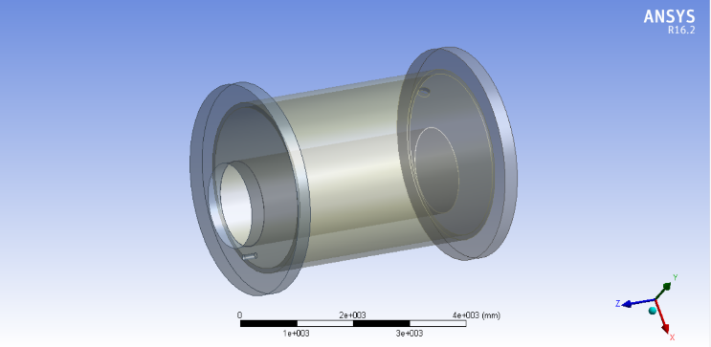

Fig.1. 3D CAD Model Boiler Geometry
The boiler is made from the dimensions from a real time industrial project. The tubes inside the boiler are designed but are kept suppressed.
The dimensions are as follows:

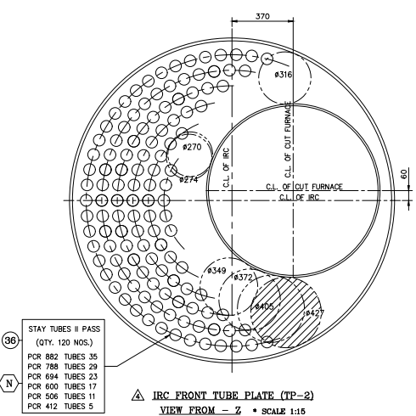
Fig. 2. Front View
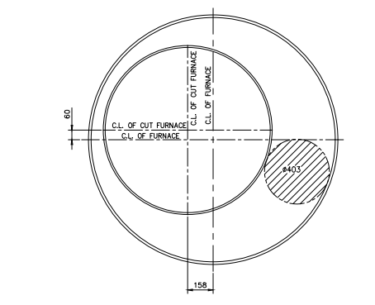
Fig.3. Furnace End Plate
Design Data is given as follows:
Table 1. Design Data
DESIGN DATA
Design Code | IBR 1950 with Latest Amendments
Design Pressure | 10.54 Kgf/sq.cm g
Working Pressure | 10.54 Kgf/sq.cm g
Hydraulic Test Pressure | 15.81 Kgf/sq.cm g
Final Steam Temperature | 185 Deg. C
Design Metal Temperature
Shell, Tube Plates, IRC Tube Plate, Stand Pipe, Smoke Pipe, IRC End Plate, Stay Bar | 213 Deg. C
Furnace | 264 Deg. C
Cut Furnace, Access Ring | 248/240 Deg. C
IRC Wrapper Plate | 235 Deg. C
Fuel Inlet Pipe | 270 Deg. C
Heating Surface area | 198 Sq. m
Evaporation Capacity | 5000 Kg/hr F&A 100 Deg. C
Grate Area | - q. m

V- THERMAL ANALYSIS
Thermal analysis is done using ANSYS Software. The CAD Model that is shown above is meshed.

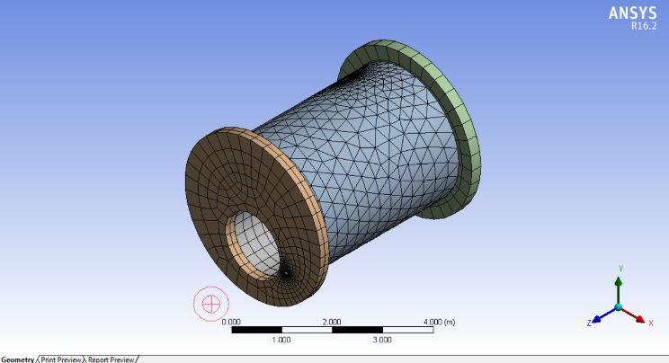

Fig.4. Meshing of Boiler Model
This meshed geometry of boiler is imported in ANSYS Fluent. After importing, boundary conditions are applied and simulation is carried out on multiple parameters studying static temperature, static pressure and static velocity.
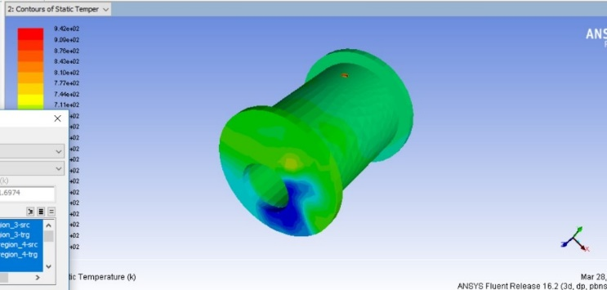
Fig.5. Static temperature distribution
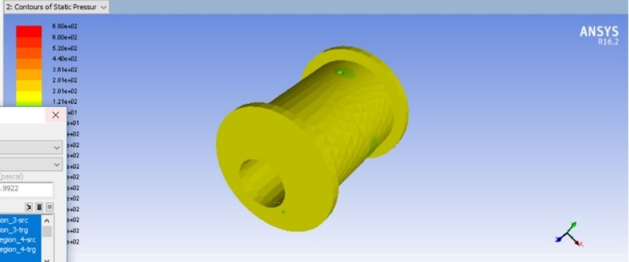
Fig.6. Static pressure

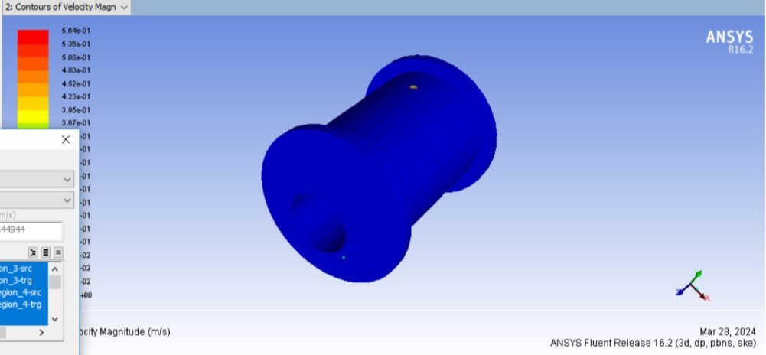

Fig.7. Velocity magnitude

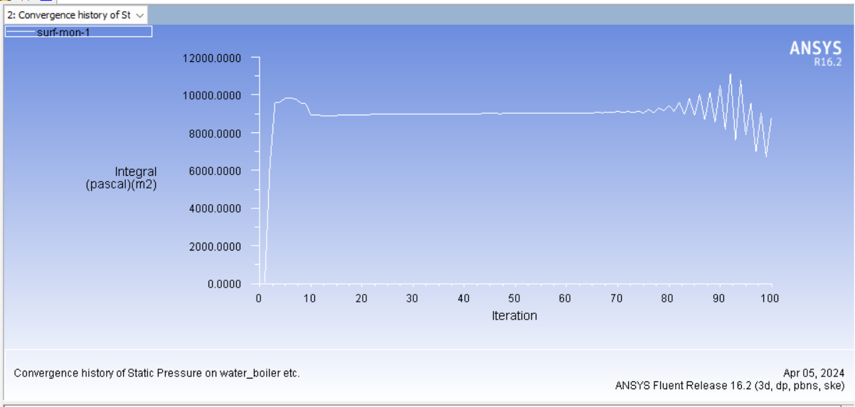
CONCLUSION
Using ANSYS Fluent, we conducted a simulated study of a 5TPH fire tube boiler to examine the effects of three different operating parameters on pressure distribution: 0.4 m/s inlet velocity, 567K furnace temperature, and 100K water temperature. After 100 repetitions, our investigation provided new information on the evolution of pressure, flow behaviour, and heat transfer processes. These findings emphasise the significance of comprehending the interaction between fluid dynamics and heat transport in fire tube boilers and provide useful suggestions for maximising boiler performance and computational efficiency.

References
- S. Gopalakrishnan, M. Makesh,“ Design And Analysis Of Fire Tube Boiler With Heat Flow Analysis” International Journal of Scientific & Technology Research Volume 8, Issue 07, July 2019, ISSN 2277-8616

- Abdulrauf A. Ibrahim, Bucham Osang, Ghali M.Jibril A Review of the Design and analysis of a Fire Tube Boiler, Volume 10, Number 1, 2018 Journal of Engineering and Applied Scientific Research ISSN: 2384-6569

- Bei Zhang, Minsheng Liu, Yunhua Li, “Case Study: Optimization of an Industrial Steam Boiler System Operation”, Conference Paper · July 2014.

- Ali Shahab, Sulton Amna, “Efficiency analysis of fire tube boiler type at refinery utility unit center for oil and gas human resources development”, 31 Mar 2023-Jurnal Cakrawala Ilmiah-Vol. 2, Iss: 7, pp 3109-3118

- Luca Ferrarini, Soroush Rastegarpour, Anthony Landi, “ Experimental model validation and predictive control strategy for an industrial fire-tube boiler”, 01 Oct 2022-Thermal science and engineering progress-Vol. 36, pp 101482-101482

- M. Z. Haq, Hafiz Miqdad Masood, “Performance enhancement of an industrial fire tube boiler”, 15 Nov 2022-Journal of the Pakistan Institute of Chemical Engineers-Vol. 48, Iss: 1, pp 43-48

