Plant Disease Detection Using Image Segmentation Methods
Manesh Prakashrao Patil¹, Prof. Dr. Indrabhan S. Borse², Prof. Dr. Balveer Singh³
¹Research Scholar,  0009-0001-2298-5731
Department of Computer Science and Engineering,
P. K. University, Shivpuri 473665, Madhya Pradesh, India
²Research Supervisor, 0000-0002-4516-0580
Department of Computer Science and Engineering,
P. K. University, Shivpuri 473665, Madhya Pradesh, India
indrabhan2000@gmail.com
³Professor,
Department of Computer Science and Engineering,
P. K. University, Shivpuri 473665, Madhya Pradesh, India
adm.pk@gmail.com

Email of Corresponding Author: maneshpatil07@gmail.com

Received on: 05 May,2025 Revised on: 04 June,2025 Published on: 07 June,2025

Abstract – Plant diseases pose a major threat to global farming and can greatly reduce crop production. To reduce their impact, it's important to detect and manage these diseases effectively. One key step in detecting plant diseases is dividing images into smaller parts to clearly identify and analyze the affected areas. This study focuses on the use of image segmentation in plant disease detection, discussing its uses, challenges, and recent improvements which looks at the state of the field. In addition to more sophisticated techniques utilizing machine learning (ML) and deep learning (DL), the study investigates more conventional techniques including thresholding and grouping. The capacity of methods like adaptive segmentation, multiscale analysis, and convolutional neural networks (CNNs) to improve segmentation accuracy across a range of datasets and environmental circumstances is highlighted. The article also covers the incorporation of picture preprocessing techniques, such as contrast enhancement and noise reduction, to increase segmentation results. Even with significant advancements, problems with illumination variability, surroundings difficulty, and plant morphology still exist. The creation of generalizable models is further hampered by the absence of standardized, publicly accessible datasets. These shortcomings are noted in this review, which also emphasizes the necessity of more research to fill in these gaps. This review attempts to direct future research in developing reliable, scalable, and effective image segmentation techniques for plant disease diagnosis by offering a thorough overview of current approaches and their potential. The knowledge acquired advances the more general objectives of global food security and sustainable agriculture.
Keywords- Convolutional neural networks, transfer learning, hybrid convolution, deep learning, and plant disease.
INTRODUCTION
In order to ensure adequate nutrition and satisfy the needs of a rising world population, farming is essential. Plant illness frequency, on the other hand, is a recurring problem which frequently results in lower crop yields and large monetary losses. Plant infections must be identified promptly and accurately in order to minimize harm and carry out prompt treatments. The subject of identifying plant illnesses has seen an upsurge in the past few years due to developments in machine vision and machine learning, which provide automatic and effective substitutes for human methods of examination. The report provides a comprehensive understanding of the most cutting-edge approaches and procedures used in this subject by including research done during 2016 and 2022. This paper looks at ML and DL methods for crop illness identification, including CNNs, DBNs, processing of images, and extracting features. This study also talks about the strengths and weaknesses of different methods used in plant disease detection. These include how well the methods can tell healthy and infected plants apart, how much information is available, and how good the image quality is. It is shown that machine learning (ML) and deep learning (DL) techniques can greatly improve how fast and accurately plant diseases are detected [1]. However, current models are still not reliable enough to correctly identify and classify plant diseases from images taken directly in the field. While the results from the Field Crop dataset are better than those from Plantdoc, the overall performance is still lacking. Therefore, better models are needed to help farmers identify plant diseases early and take proper action. One solution could be to separate individual leaves from full plant images using image segmentation techniques, especially in field conditions [2]. Although the suggested method works well for certain problems, more research is needed. Exploring different texture patterns within the same technique could help find the best setup for each case. It's also important to test how well this method works in real-life applications and with different types of crop diseases. This could improve the technique and increase its usefulness for real-world plant disease prediction [3]. Plants are at higher risk of getting diseases because they are surrounded by many viruses in their environment [9]. A plant disease is any unusual change in a plant’s structure or function caused by a living organism [10]. These diseases are often triggered by outside factors or harmful organisms, such as bacteria, fungi, or viruses [11]. Common causes include lack of nutrients, pest attacks, harmful microbes, and poor environmental conditions [12]. Bacterial infections are a major reason for reduced crop yield across the world. Plants may be infected by one or more types of viruses, which can make the disease worse [13]. Plant diseases also pose a serious risk to food security. They can damage crops, reduce food supply, and increase prices. As the global population grows, it is essential to protect crops to ensure enough food and income [14]. Traditional methods of identifying diseases often involve visually checking the plant, but this is slow, subjective, and not always reliable. Automated disease detection systems offer a promising solution [15]. Since manual diagnosis can be complex and time-consuming, modern tools are needed to help farmers monitor their crops effectively at every stage of growth [17]. To meet the demands of a growing population, farmers need automated technologies that can help them monitor their crops throughout all stages of growth. One of the key applications in smart farming is detecting plant diseases in leaves using image analysis. With the rise of photography and advances in agricultural technology, smart systems have become more common in farming and management, leading to better crop productivity [18]. Traditionally, experts inspect plant tissues by hand to assess the severity of diseases [19]. However, expert systems that analyze disease and pest features still rely heavily on human knowledge. This makes them less efficient and more expensive [20]. Common machine learning methods like logistic regression, K-nearest neighbors (K-NN), and convolutional neural networks (CNN) are now used along with image pre-processing techniques to help extract useful features [21]. K-NN is a supervised learning algorithm that classifies data based on similarity. It groups unknown data by comparing it to nearby labeled data. A decision tree is another method that works like a flowchart—each node represents a decision point, branches show outcomes, and leaves represent final classes. However, decision trees can sometimes have overlapping decision points and may overfit the data. Support Vector Machines (SVM) are also widely used; they are supervised learning models used for classification and regression, and have been applied in both text and image recognition tasks over the past decade [22]. In earlier systems, images of diseased plant leaves were processed using standard techniques like noise reduction, morphological operations, and image enhancement. Then, simple features like color, shape, and texture were extracted using manual algorithms [23]. Recently, deep learning has shown great potential for tasks such as object detection, classification, and segmentation [24]. CNNs are the most commonly used deep learning models for identifying plant diseases. Well-known CNN architectures like AlexNet, VGGNet, GoogLeNet, DenseNet, and ResNet have been widely used, but they come with drawbacks such as slow processing and needing many parameters. While deep learning methods are excellent at capturing both detailed and general image features, they still struggle with accurately representing fine spatial details in images [25].Collecting image data, preliminary processing photos, extracting characteristics from pictures, dividing images, categorizing images using a hybrid technique, and illness prediction are some of the most important processes in the study's approach. The plant image data collection includes photos of Normal, Gray-spot, Black-mold, Late-mold, Microbial spot, and the powdery mildew, as seen in Figure 1. The results of the hybrid strategy and CNN detection method are compared.
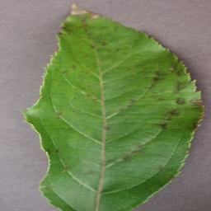 | 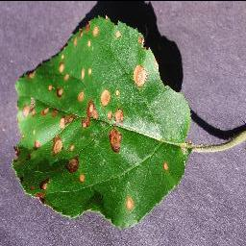
Apple scab | Apple Black rot
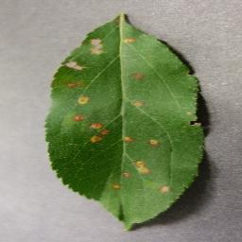 | 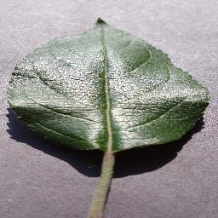
Apple Cedar apple rust | Apple healthy
Fig. 1 Figure 1: Dataset Images

LITERATURE REVIEW
In 2023, Moupojou et al. [1] introduced several deep learning models to help farmers quickly and accurately detect plant diseases, aiming to prevent drops in crop yield. These models were mostly trained using well-known plant disease datasets like PlantVillage and PlantDoc. The PlantVillage dataset contains lab images with single leaves on plain backgrounds. However, when models trained on this clean data were tested on real field images—where backgrounds are complex and multiple leaves are present—they performed poorly. To improve this, the PlantDoc dataset was created using 2,569 field images from the internet, with individual leaves labeled. Still, some of the images were lab-based, and since plant pathologists didn’t supervise the labeling, there’s a risk of incorrect classifications. To overcome these issues, a new dataset called FieldPlant was suggested. It contains 5,170 real-world images of diseased plants, and each leaf in the image was manually labeled with the help of plant pathologists, resulting in 8,630 labeled leaf samples across 28 disease categories. The proposed model was tested against top classification and object detection methods and showed better performance on FieldPlant compared to PlantDoc.
In 2022, Hosny et al. [2] presented a cost-effective deep neural network based on a convolutional neural network (CNN) to capture high-level hidden features. These features were combined with local binary pattern (LBP) features to extract detailed texture data from plant leaves. The model was trained and tested on three public datasets: Apple Leaf, Tomato Leaf, and Grape Leaf. The method achieved high accuracy—99%, 96.6%, and 98.5% in validation, and 98.8%, 96.5%, and 98.3% in testing, respectively—demonstrating its effectiveness in plant disease management.
In 2023, Rani and Gowri Shankar [3] proposed a method based on identifying the pathogens responsible for plant diseases. They used Keras-based transfer learning models to automatically detect and classify diseases and identify the pathogens causing them. This model was tested on images of sunflowers and cabbage leaves, bulbs, and flowers taken in natural field conditions, along with the Agri-ImageNet dataset. This helped address the limitations of the PlantVillage dataset, which used images taken under controlled settings with plain backgrounds. The study applied deep transfer learning to reuse knowledge from pre-trained models, aiming to find the best approach for plant disease classification. A total of 36 transfer learning models were tested to find the one with the highest classification accuracy, and a detailed report was created using the top-performing model on the Agri-ImageNet, cauliflower, and sunflower datasets.
In 2023, Shewale and Daruwala [4] created smart automated systems using a deep learning-based CNN method to quickly and accurately detect plant diseases with fewer inputs and less processing time. Their method identified diseases in plant leaves by analyzing patterns from images taken at specific time intervals using image processing techniques. The study focused on tomato plants to detect, classify, and diagnose different diseases. The data for this research was collected from actual farms located in Jalgaon city.
The proposed approach eliminated the requirement for feature engineering and segmenting thresholds by automatically obtaining features, allowing for very accurate illness classification. Spatial photos captured under difficult environmental conditions were adopted and used to grow the network. Recent developments in deep learning algorithms for computer vision have enabled automated illness detection. Overall, a clear route for crop disease detection on a gigantic global scale was made possible by the process of training deep learning models on ever bigger, publicly available, real-time picture datasets.
In 2023, Premananda et al. [5] proposed a customized CNN model designed to detect and classify common diseases in rice plants while using fewer parameters. The model was trained on a dataset containing four types of rice plant diseases. Additionally, the researchers included 1,400 real-field images of healthy rice plants to help the model distinguish between diseased and non-diseased plants. Separate experiments were carried out using both diseased and healthy leaf images. The performance of the model was tested using evaluation metrics and two optimization methods—Stochastic Gradient Descent with Momentum (SGDM) and Adaptive Moment Estimation (Adam). During the seventh training epoch, the model achieved a test accuracy of 99.86%. When using the Adam optimizer, the model reached a final accuracy of 99.62%, which was better than the 97.61% accuracy achieved with the SGDM method.
In 2022, Albattahet et al. [6] introduced a new model for plant disease detection based on a modified CenterNet architecture using DenseNet-76 as the backbone network. Their method involved three main steps: first, identifying the region of interest in the image; second, using DenseNet-76 for key point detection; and third, applying the one-stage CenterNet detector to classify plant diseases. The authors used the PlantVillage and Kaggle datasets, which contain a variety of plant diseases and challenges such as lighting changes, color variation, and differences in plant shapes and sizes. Both qualitative and quantitative evaluations showed that this new approach was more accurate and reliable than previous advanced methods for detecting and classifying plant diseases.
Nair et al. [7] in 2016 explored the use of Photochemical Reflectance Index (PRI) images to detect and assess different levels of Cassava Mosaic Disease (CMD) infection in cassava plants. They used multispectral imaging sensors to capture narrow band reflectance images at 531 nm and 572 nm wavelengths. Their study found that PRI values increased as the severity of CMD infection rose in the cassava samples. The image intensity was represented in a scatter plot, and the results showed that healthy plants could be distinguished from early-stage CMD with 85% sensitivity, while early-stage CMD could be separated from advanced CMD with 93% sensitivity and 79% specificity. The effectiveness of PRI imaging was evaluated using the AUC-ROC metric, achieving an AUC of 0.92 for detecting early-stage CMD and 0.99 for advanced CMD. A strong negative correlation was also observed between PRI values and both chlorophyll content (R² = 0.81) and net photosynthesis rate (R² = 0.77). These findings suggest that PRI imaging can effectively detect CMD and other plant stress conditions in outdoor environments.
Pradhan and Shrivastava [10] noted that thresholding methods are widely used in plant disease image segmentation due to their simplicity and fast processing. Techniques like the Canny and Sobel edge detectors help identify the boundaries between healthy and infected leaf regions. Zawbaa et al. [11] pointed out that region-based segmentation methods are suitable for identifying uniform disease areas by grouping pixels with similar features such as color or texture. In a related study, Zawbaa et al. [12] highlighted how clustering algorithms like K-Means and Fuzzy C-Means (FCM) are effective in classifying image pixels into different segments based on attributes like hue and intensity, making them popular for various types of image datasets.
In 2022, Saleem et al. [8] introduced a dataset called NZDLPlantDisease-v1, which includes diseases from five major horticultural crops in New Zealand: grapevine, pears, avocados, kiwis, and other fruits. They proposed a modified version of a deep learning model known as the Region-based Fully Convolutional Network (RFCN) to diagnose plant diseases using this new dataset. After selecting the best-performing deep learning model, they tested various data augmentation techniques, image resizing strategies, batch normalization, weight initialization, and optimization algorithms to improve results. The model’s performance was also refined through anchor box tuning and point-sensitive feature mapping, with further validation using a stratified k-fold cross-validation method. The final RFCN model achieved a mean accuracy of 93.80%, outperforming default configurations by 19.33%. Representative sample images from the grape leaf dataset used in PlantVillage were shown to illustrate these findings.
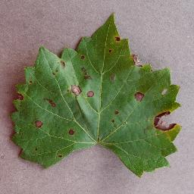 | 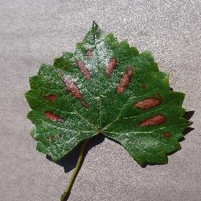
Grape Black rot | Grape Esca Spot
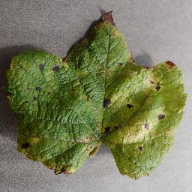 | 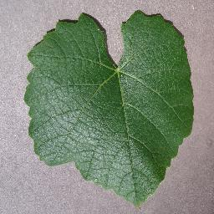
Grape Leaf blight Spot | Grape healthy
Fig 2. Few samples of grape leaf image dataset.

PROBLEM DEFINITION
Manually identifying and classifying plant diseases requires expert knowledge and sharp observation skills. However, this process is time-consuming and can be prone to human error. Because of this, there is a growing need to automate plant disease detection and classification. Traditional machine learning techniques are not ideal for managing large volumes of data, but deep learning models have shown better potential in identifying and categorizing plant diseases. Table 1 outlines some key features and challenges of current deep learning models used in agricultural disease diagnosis. Convolutional Neural Networks (CNNs) have been widely used for automatically detecting plant diseases [1]. Although these models can work with field-collected images, they are not always accurate in identifying and classifying diseases. To improve their effectiveness, CNNs can be combined with image segmentation techniques. Methods like CNN with Local Binary Pattern (LBP) provide faster results and high accuracy, but they are not universally applicable and lack scalability [2]. Transfer learning helps in identifying disease-causing pathogens accurately, making it easier to take preventive actions, though it struggles to extract all relevant features and may suffer from overfitting [3].
CNN is adaptable for different crops and performs well in real-world settings, but it still cannot always correctly identify the disease type or support decision-making on its own [4]. When paired with Adam optimization, CNN can operate with fewer parameters, giving farmers access to efficient tools for early diagnosis and prevention. However, the method may lack consistency and durability [5].
Advanced models like DenseNet and CenterNet are good at detecting and categorizing multiple types of plant diseases and are resilient even when image quality is poor. However, they are not yet suitable for mobile-based applications and can be computationally complex [6]. The Photochemical Reflectance Index (PRI) method effectively detects changes caused by CMD in plants, though it is not fully automated [7]. Region-based Fully Convolutional Networks (RFCNs) are capable of identifying diseases affecting various parts of the plant, but their overall performance still has room for improvement [8]. Considering these limitations, this study aims to develop a more reliable deep learning-based model to improve the identification and classification of plant diseases.
Table 1- Features and Challenges of Existing Deep Learning-Based Plant Disease Classification and Detection Model
Methodology | Features | Challenges
CNN | Plant illnesses may be automatically identified and categorized using this technology. | This approach is not the most effective for identifying and categorizing plant diseases if the incoming picture data comes directly from the field.
LBP and CNN | This method has a faster computing speed. | LBP and CNN
Transfer learning | This method has allowed for the precise identification of the viruses causing the illness in plants. thus, aids in adopting the proper safety measures. | These methods fail to effectively extract the important patterns and characteristics.
CNN | This method may be used in practical situations.  This tactic can be used in practical settings. | The identified plant disease cannot be diagnosed using this method.  This method does not facilitate decision-making.
Adam optimizer and CNN | Using this method requires less arguments.  Farmers can use this method to make proper preventative decisions and obtain efficient diagnostic tools. | This model is unreliable.  Additionally, this method's resilience is unsatisfactory.
CenterNet and DenseNet | This technique makes it possible to identify and categorize many plant diseases.  Even when there are artifacts present, this approach is very robust. | Mobile applications cannot employ this tactic.  This approach has problems with temporal complexity.
PRI | This technique makes it possible to pinpoint the variation within the CMD degree. | This process is not entirely automated.
RFCN | This method aids in the identification of plant diseases that affect any section of the plant. | This method does not provide adequate overall performance.

RESEARCH METHOLOGY
Agricultural productivity plays a major role in a country's economic development. However, plant diseases are a major barrier that reduces both the quantity and quality of food production. Detecting crop diseases early is essential for maintaining global food security and human well-being. Traditionally, plant disease detection involves on-site inspections where a pathologist visually checks each plant. This process is slow, not always reliable, and is limited by the availability of experts. With changes in farming practices and plant growth patterns, new diseases frequently appear on plant leaves. Therefore, early and accurate identification of leaf diseases is necessary to stop their spread and ensure better crop yields. But recognizing plant diseases is difficult due to issues like low image quality, background noise, similar colors in healthy and diseased areas, and differences in shape, size, and position of leaves. To address these challenges, this research proposes a strong deep learning-based method to detect and classify plant diseases. First, images will be collected from the internet. Then, the images will be segmented using Mask Region-Based Convolutional Neural Networks (RCNN) enhanced with Adaptive and Attention-based Masking (AAM-RCNN). To further improve segmentation accuracy, the Improve Golden Tortoise Beetle Optimizer (IGTBO) will be used to fine-tune the parameters of AAM-RCNN [26]. After segmentation, the images will be analyzed using a Hybrid Convolution model that combines 2D and 1D layers along with a Multiscale Dilated EfficientNetB7 network (HC-2D/1D-MDEB7). In this model, the 1D convolution layer processes color and shape-related features, while the 2D layer handles texture patterns. Finally, the HC-2D/1D-MDEB7 model will output the disease detection and classification results. The performance of this proposed deep learning model will be validated through experiments.
Fig 3. Deep learning-based model for plant disease

"Plant illness segmenting methods" refers to the methods and algorithms that are used to identify and isolate diseased regions in plant photographs. These techniques are crucial for identifying plant disease systems because they serve as the foundation for accurate plant health analysis and categorization. They focus on distinguishing unhealthy regions—such as spots, lesions, or discolorations—from both background elements and healthy plant tissue. A synopsis of these techniques is provided below: A computer vision technique called image segmentation separates a digital picture into discrete pixel groupings, or image segments, to help with tasks like object recognition. This method enables faster and more advanced image processing by segmenting an image's complex visual data into distinct shapes. Include a comment or a scale bar in the figure to highlight certain process phases, such as getting ready to display the image's size or quality. 4. Annotations are used for preparation, categorization, and output.

Types of image segmentation

Thresholding segmentation

The threshold segment is among the simplest segmentation methods. Setting a threshold value is necessary. The next step is to assign a background or foreground to each pixel in an image. This depends on whether its color value or intensity is higher or lower than that threshold. We employ thresholding segmentation in our apps. In some applications, the backdrop is not as colorful or strong as the focal points. It is often used in medical imaging to distinguish between soft tissue and bones in X-ray images or to extract text from documents in OCR systems.

Edge-based segmentation

By looking for variations in color or intensity, the Laplacian, Canny, and Sobel filters are popular methods for determining the borders of sick regions [39, 40]. High contrast photos work well, while ones with noisy or complicated backgrounds are troublesome.

Clustering-based segmentation

Utilizing clustering-based division, pixels are classified into clusters based on their similarity to the feature [35, 36]. People use popular clustering methods for this. Examples include hierarchical clustering and K-means. It is used for both image compression and content-based picture retrieval. It is also used when objects in a picture have distinctive qualities that feature vectors might pick up on.

Instance segmentation

Identifying and describing objects in an image is the aim of segmentation of instances. It distinguishes entities of the same class [30–38]. It combines segmentation and object recognition to generate a pixel-by-pixel mask for each item.

Region-Based Segmentation:

Groups pixels with comparable characteristics, such roughness or hue, although they might be highly computational, methods such as region growth and watershed algorithms are useful in homogenous regions [41, 42].

Conventional Techniques for Segmentations

Thresholding

Identifies unhealthy areas based on pixel color or intensity using a static or changing threshold. Despite being simple and computationally efficient, it is sensitive to variations in illumination and background [39].

CNN

Using tagged datasets, Convolutional Neural Networks (CNNs) can automatically extract features. Use the Deep-Lab, Mask R-CNN, and U-Net designs to provide accurate segmentation. need a lot of computing power and big datasets.

Adaptive segmentation:

Real-time segmentation parameter modification based on image attributes. Noise reduction and contrast enhancement are examples of preprocessing methods that are considered. Ideal for many climates and lighting situations by incorporating data at many scales, multistage analysis may be able to identify disease symptoms of varying sizes and improve the accuracy of image segmentation for complexly structured images [40].
Generative Models

Utilize techniques like generative adversarial networks (GANs), which provide lifelike depictions of diseased regions, to increase segmentation accuracy.
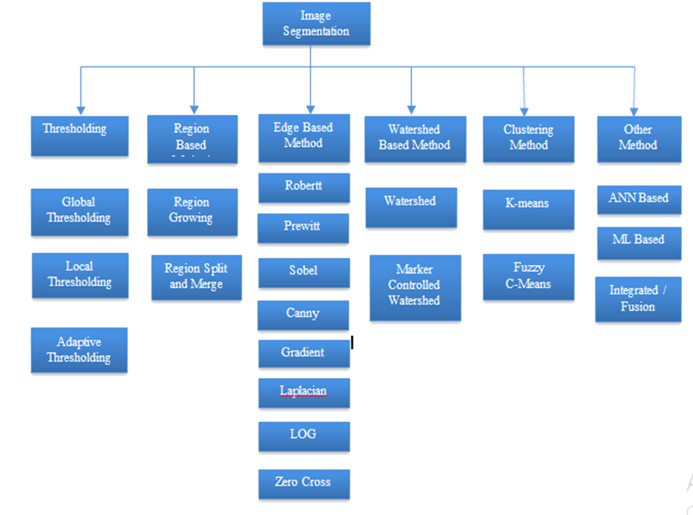
Fig 4. Shows Image Segmentation Methods

CONCLUSION
To validate the effectiveness of the deep learning-based plant disease detection and classification models, several tests will be conducted in Python. These tests will use various performance metrics, including sensitivity, precision, specificity, F1 score, negative predictive value (NPV), accuracy, and the Matthews Correlation Coefficient (MCC). Negative metrics such as the False Negative Rate (FNR), False Positive Rate (FPR), and False Discovery Rate (FDR) will also be evaluated. Additionally, the proposed method will be compared with existing techniques.
REFERENCES
- Muhammad Shoaib, Babar Shah, Shaker EI-Sappagh, Akhtar Ali, Asad Ullah, Fayadh Alenezi, Tsanko Gechev, Tariq Hussain and Farman Ali,” An advanced deep learning models-based plant disease detection: A review of recent research”, Frontires in Plant Science, 10. 0.3389/fpls.2023.1158933, 21 March 2023.
- Emmanuel Moupojou, Appolinaire Tagne, Florent Retraint, Anicet Tadonkemwa, Dongmo Wilfried, Hyppolite Tapamo, and Marcellin Nkenlifack, "FieldPlant: A Dataset of Field Plant Images for Plant Disease Detection and Classification with Deep Learning," IEEE Access, vol. 11, pp. 35398-35410, 2023.
- K. M. Hosny, W. M. El-Hady, F. M. Samy, E. Vrochidou and G. A. Papakostas, "Multi-Class Classification of Plant Leaf Diseases Using Feature Fusion of Deep Convolutional Neural Network and Local Binary Pattern," IEEE Access, vol. 11, pp. 62307-62317, 2023.
- K. P. Asha Rani and S. Gowrishankar, "Pathogen-Based Classification of Plant Diseases: A Deep Transfer Learning Approach for Intelligent Support Systems," IEEE Access, vol. 11, pp. 64476-64493, 2023.
- Mitali V. Shewale, and Rohin D. Daruwala, "High performance deep learning architecture for early detection and classification of plant leaf disease," Journal of Agriculture and Food Research, vol. 14, pp. 100675, December 2023.
- Sanasam Premananda Singh, Keisham Pritamdas, Kharibam Jilenkumari Devi, and Salam Devayani Devi, "Custom Convolutional Neural Network for Detection and Classification of Rice Plant Diseases," Procedia Computer Science, vol. 218, pp. 2026-2040, 2023.
- Waleed Albattah, Marriam Nawaz, Ali Javed, Momina Masood and Saleh Albahli , "A novel deep learning method for detection and classification of plant diseases," vol. 8, pp. 507–524, 2022.
- Sadasivan Nair Raji, Narayanan Subhash, Velumani Ravi, Raju Saravanan, Changatharayil N. Mohanan, Thangaraj MakeshKumar and Sukumar Nita, "Detection and Classification of Mosaic Virus Disease in Cassava Plants by Proximal Sensing of Photochemical Reflectance Index," Journal of the Indian Society of Remote Sensing, vol. 44, pp. 875–883, 2016.
- M. H. Saleem, J. Potgieter and K. M. Arif, "A Performance-Optimized Deep Learning-Based Plant Disease Detection Approach for Horticultural Crops of New Zealand," IEEE Access, vol. 10, pp. 89798-89822, 2022.
- P. Shrivastava and A. Pradhan, “Image Segmentation for Plant Disease Detection Using Thresholding Methods,” International Journal of Computer Applications, 2018.
- A. S. Zawbaa et al., “Automatic Plant Disease Detection System Based on Backpropagation Neural Network,” Procedia Computer Science, 2015.
- S. Arivazhagan et al., “Detection of Unhealthy Region of Plant Leaves and Classification of Plant Leaf Diseases Using Texture Features,” Agricultural Research, 2013.
- V. K. Vishnoi, K. Kumar, B. Kumar, S. Mohan and A. A. Khan, "Detection of Apple Plant Diseases Using Leaf Images Through Convolutional Neural Network," IEEE Access, vol. 11, pp. 6594-6609, 2023.
- Momina Masood, Marriam Nawaz, Tahira Nazir, Ali Javed, Reem Alkanhel, Hela Elmannai, Sami Dhahbi, and Sami Bourouis, "MaizeNet: A Deep Learning Approach for Effective Recognition of Maize Plant Leaf Diseases," IEEE Access, vol. 11, pp. 52862-52876, 2023.
- S. Barburiceanu, S. Meza, B. Orza, R. Malutan and R. Terebes, "Convolutional Neural Networks for Texture Feature Extraction. Applications to Leaf Disease Classification in Precision Agriculture," IEEE Access, vol. 9, pp. 160085-160103, 2021.
- Q. Zeng, X. Ma, B. Cheng, E. Zhou and W. Pang, "GANs-Based Data Augmentation for Citrus Disease Severity Detection Using Deep Learning," IEEE Access, vol. 8, pp. 172882-172891, 2020.
- H. Amin, A. Darwish, A. E. Hassanien and M. Soliman, "End-to-End Deep Learning Model for Corn Leaf Disease Classification," IEEE Access, vol. 10, pp. 31103-31115, 2022.
- Uferah Shafi, Rafia Mumtaz, Muhammad Deedahwar Mazhar Qureshi, Zahid Mahmood, Sikander Khan Tanveer, Ihsan Ul Haq, and Syed Mohammad Hassan Zaidi, "Embedded AI for Wheat Yellow Rust Infection Type Classification," IEEE Access, vol. 11, pp. 23726-23738, 2023.
- X. Zhu et al., "LAD-Net: A Novel Light Weight Model for Early Apple Leaf Pests and Diseases Classification," IEEE/ACM Transactions on Computational Biology and Bioinformatics, vol. 20, no. 2, pp. 1156-1169, 1 March-April 2023.
- M. S. H. Shovon, S. J. Mozumder, O. K. Pal, M. F. Mridha, N. Asai and J. Shin, "PlantDet: A Robust Multi-Model Ensemble Method Based on Deep Learning For Plant Disease Detection," IEEE Access, vol. 11, pp. 34846-34859, 2023.
- J. Chen, W. Chen, A. Zeb, S. Yang and D. Zhang, "Lightweight Inception Networks for the Recognition and Detection of Rice Plant Diseases," IEEE Sensors Journal, vol. 22, no. 14, pp. 14628-14638, 15 July15, 2022.
- R. Dwivedi, T. Dutta and Y. -C. Hu, "A Leaf Disease Detection Mechanism Based on L1-Norm Minimization Extreme Learning Machine," IEEE Geoscience and Remote Sensing Letters, vol. 19, pp. 1-5, 2022.
- Fengdi Li, Zhenyu Liu, Weixing Shen, Yan Wang, Yunlu Wang, Chengkai Ge, Fenggang Sun, and Peng Lan, "A Remote Sensing and Airborne Edge-Computing Based Detection System for Pine Wilt Disease," IEEE Access, vol. 9, pp. 66346-66360, 2021.
- N. Schor, A. Bechar, T. Ignat, A. Dombrovsky, Y. Elad and S. Berman, "Robotic Disease Detection in Greenhouses: Combined Detection of Powdery Mildew and Tomato Spotted Wilt Virus," IEEE Robotics and Automation Letters, vol. 1, no. 1, pp. 354-360, January 2016.
- M. Ahmad, M. Abdullah, H. Moon and D. Han, "Plant Disease Detection in Imbalanced Datasets Using Efficient Convolutional Neural Networks with Stepwise Transfer Learning," IEEE Access, vol. 9, pp. 140565-140580, 2021.
- X. Nie, L. Wang, H. Ding and M. Xu, "Strawberry Verticillium Wilt Detection Network Based on Multi-Task Learning and Attention," IEEE Access, vol. 7, pp. 170003-170011, 2019.
- U. P. Singh, S. S. Chouhan, S. Jain and S. Jain, "Multilayer Convolution Neural Network for the Classification of Mango Leaves Infected by Anthracnose Disease," IEEE Access, vol. 7, pp. 43721-43729, 2019.
- Z. Xiao, Y. Shi, G. Zhu, J. Xiong and J. Wu, "Leaf Disease Detection Based on Lightweight Deep Residual Network and Attention Mechanism," IEEE Access, vol. 11, pp. 48248-48258, 2023.
- Omid Tarkhaneh, Neda Alipour, Amirahmad Chapnevis, and Haifeng Shen, "Golden Tortoise Beetle Optimizer: A Novel Nature-Inspired Meta-heuristic Algorithm for Engineering Problems," Neural and Evolutionary Computing, 4 April 2021.

[30] Govind M. Poddar, Rajendra V. Patill, Satish Kumar N, “Approaches to handle Data Imbalance Problem in Predictive Machine Learning Models: A Comprehensive Review”, Int J Intell Syst Appl Eng, vol. 12, no. 21s, pp. 841–856, Mar. 2024.
[31] Suwarna J, Kirti N. Mahajan, Yogesh B. Pawar, Yogita D. Bhise, Bharti Jagdale, Rajendra V. Patil, “Plant Growth Analysis using IoT and Reinforcement Learning Techniques for Controlled Environment”, Advances in Nonlinear Variational Inequalities, 27(3), pp. 706–715, 2024.
[32} Sangeeta Kakarwal, Rahul Mapari, Pranoti Prashant Mane, Madhuri Pravin Borawake, Dhanraj R. Dhotre, Rajendra V. Patil, “A Novel Approach for Detection, Segmentation, and Classification of Brain Tumors in MRI Images Using Neural Network and Special C Means Fuzzy Clustering Techniques”, Advances in Nonlinear Variational Inequalities, 27(3), pp. 837–872, 2024.
[33] Sagar V. Joshi, Rajendra V. Patil, Manoj Tarambale, Balkrishna K Patil, Vinit Khetani, Yatin Gandhi, “Stochastic Processes in the Analysis of Electrical Load Forecasting”, Advances in Nonlinear Variational Inequalities, 28(1), pp. 15-29, 2025.
[34] Rajendra V. Patil., Dr. Renu Aggarwal, “Edge Information based Seed Placement Guidance to Single Seeded Region Growing Algorithm”,. International Journal of Intelligent Systems and Applications in Engineering, 12(12s), 753–759, 2024
[35] Rajendra V. Patil, Dr. Renu Aggarwal, Govind M. Poddar, M. Bhowmik. Manohar K. Patil, “Embedded Integration Strategy to Image Segmentation Using Canny Edge and K-Means Algorithm”, International Journal of Intelligent Systems and Applications in Engineering, 12(13s), 01–08, 2024
[36] Gaikwad, V. S.., Shivaji Deore, S.., Poddar, G. M.., V. Patil, R.., Sandeep Hirolikar, D.., Pravin Borawake, M.., & Swarnkar, S. K., “Unveiling Market Dynamics through Machine Learning: Strategic Insights and Analysis”, International Journal of Intelligent Systems and Applications in Engineering, 12(14s), 388–397, 2024.
[37] Tarambale, M.., Naik, K.., Patil, R. M.., Patil, R. V.., Deore, S. S.., & Bhowmik, M.., “Detecting Fraudulent Patterns: Real-Time Identification using Machine Learning” International Journal of Intelligent Systems and Applications in Engineering, 12(14s), 650, 2024
[38] Rajendra V. Patil, Dr. Renu Aggarwal, Dr. Shailesh Shivaji Deore, “Edge Segmentation based Illumination Invariant Feature Detector Phase Congreuncy”, 2024 5th International conference on Mobile Computing and Sustainable Informatics (ICMCSI), pp. 91-96, Jan. 2024
[39] R. V. Patil, K. C. Jondhale, “Edge Based technique to estimate Number of clusters in K-means Color Image Segmentation”, 3rd IEEE International Conference on Computer Science and Info Tech, Chegndu , China, 2010.
[40] Rajendra V. Patil, Dr. Renu Aggarwal” Comprehensive Review on Image Segmentation Applications”, Sci.Int.(Lahore), 35(5), pp. 573-579, Sep. 2023
[41] Rajendra V. Patil, Govind M. Poddar, Bhuvaneshwari Jolad, Bharati Devidas Patil, Dharmesh Dhabliya, Avinash M. Pawar, “Game Theory Applications in Smart Grid Energy Management”, Advances in Nonlinear Variational Inequalities, 28(1), pp. 46-60, 2025
[42] Rajendra V. Patil, Dr, Renu Aggarwal, Ritesh, Sonawane, Govind M. Poddar, Shailesh Shivaji Deore, Vaishali Turai, “Automatic Marker Generation to Similarity Based Region Merging Algorithm using Edge Information”, Journal of Electrical Systems, 20 (3s), pp. 2227-2240, 2024

