A Crowd-Sourced Approach to Enhancing Forestation in Bharat via the 'MGNREGA' Program

Pramod B Gosavi¹, Dr. Girishkumar Patnaik²
¹ Research Scholar,  0000-0003-0120-7647
SSBT College of Engineering and Technology, Jalgaon, Bharat, 425001,
² Guide &Professor, 0000-0002-0905-9178
SSBT College of Engineering and Technology, Jalgaon, Bharat, 425001,

Email of Corresponding Author: gosavi.pramod@gmail.com,

Received on: 05 May,2025 Revised on: 04 June,2025 Published on: 07 June,2025

Abstract –The role of humans within world is to acculturation, care for, innovate, and learn while understanding both the strengths and limitations of the biological world. Prioritizing these goals, humans can advantage technology effectively. The natural cycle is all-important for the survival of humanity and all living species. Among the most pressing issues touching nature is air pollution, and forestation stands as the only practicable solution.
Purpose - Crowd-Sourced approach to enhancing forestation in Bharat via the "MGNREGA", to reduce atmospheric pollution. How crowd-source is helpful to enhance forestation.
Design/methodology/approach - Crowd-source model designed and introduced for MGNREGA scheme.
Findings - The effective use of technology by humans can greatly conduce to social causes, promoting healthier lives for all forms of aliveness in nature.
Originality/Value - This paper introduced Crowd-source model and it\'s easiest implementation for MGNREGA scheme to increase forestation.

Keywords- MGNAREGA, Forestration, Crowd-sourcing, Trees, Plantation

- INTRODUCTION
Crowd-sourcing is the most effective and cumulative means of executing very large tasks, with the people of the Nation collaborating to find solutions to national challenges on a nationwide basis.

There are two major sources of air pollution: natural and man-made. Such include the volcanoes and forest fires, combustion of fossil fuels, the paper industry, petroleum refining, metal smelting, and agricultural activities as the sources of exposure to lung cancer and COPD or aggravation of ischemic heart disease and other respiratory and cardiovascular diseases. Other allergens from plants include pollen and fungal spores. In children, it can also cause acute lower respiratory tract infections and throat infections. Air pollution can disrupt ecosystems, leading to the loss of biodiversity, degradation of natural habitats, and alteration of ecological processes,also impact the earth's climate globally.

By releasing oxygen and filtering harmful pollutants, trees help to improve the overall quality of the air. Additionally, they provide ecosystems for wildlife, decrease rainwater runoff, and reduce the city-wide heat island effect. Mental and physical well-being can be enhanced by trees. In line with studies, being outside can lower blood pressure, ease anxieties, and strengthen the immune system. Trees furnish raw resources for a wide range of industries, including fuel, rubber, cosmetics, medicine, and furniture. By removing carbon from Earth's atmosphere, trees contribute to the fight against climate change.

Because they act as a buffer against vehicles, machinery, and other people, trees can help reduce noise pollution.

Through a variety of clauses in the Act, the Mahatma Gandhi NREGA provides job seekers significant legal rights. Even though the Act stipulates that each rural household must work for at least 100 days annually, the effective legal structure of rights and entitlements is what enables the 100 days of employment annually. Like previous iterations, the FY 2021–22 Annual Master Circular is structured on the primary rights of job seekers and the procedures that allow the implementing agency to carry out Mahatma Gandhi NREGS. As per Chapter 7 Entitlement V- Works under Mahatma Gandhi NREGA, section 7.6, Afforestation, Tree Plantation and Horticulture, mentioned tree plantation and horticulture activities can be taken up under Mahatma Gandhi NREGS on common, forest and private lands [1].

II. LITERATURE SURVEY

In recent years, crowdsourcing has emerged as novel research topic. Many scholars and practitioners have found it to be a particularly fascinating and fulfilling component to investigate because to its distinctiveness (Hirth et al., 2015). It is regarded as a brand-new, dynamic web-enabled service platform that is ideal for utilizing people's enormous online potential (Hossain and Kauranen, 2015). The concept of crowdsourcing can seem like a simple 21st-century innovation. The term "crowdsourcing" itself was first used in 2005 by editors Jeff Howe and Mark Robinson of Wired magazine. As a result, it gained popularity a year later when Jeff Howe used it in his piece. Surowiecki (2005) coined the term "crowdsource," and his concept is summed up in the phrase "Many hands make light work." His view that crowdsourcing yields better outcomes was also supported by Majchrzak and Malhotra (2013). Even though the phrase is actually new, project managers and companies are undoubtedly familiar with the idea, but his ability to complete large tasks quickly and effectively sets her apart from other online IT issue solvers [1].

MAHATMA GANDHI NATIONAL RURAL EMPLOYMENT GUARANTEE ACT, 2005

Act and Schedule

The Act : The National Rural Employment Guarantee Act was notified in 2005. As per an amendment to the Act, the words ‘Mahatma Gandhi’ were prefixed to National Rural Employment Guarantee Act (hereinafter known as “Act”). The Act covers the entire country with the exception of districts that have cent percent urban
population.

State/UT participation : States have notified their respective Mahatma Gandhi National Rural Employment Schemes, as per the requirement of the Act. The Scheme formulated by the State Government, should provide for the minimum features specified in Schedule I of the Act. Persons employed under any State Scheme made under the Act shall be entitled to minimum facilities listed in Schedule II of the Act. The Schemes prepared by the States have to be consistent with the amendments made,
from time to time, to the Act and its Schedules.

Amendment(s) : States are required to amend/ modify their Mahatma Gandhi NREG Schemes as per amendment(s) made, from time to time, to the Act and its Schedule.

Non-compliance of the Act will be an offence : Non-compliance of the provisions of the Mahatma Gandhi NREGA will be considered as an offence under the Mahatma Gandhi NREGA, thereby, attracting the provisions of section 25 of the Act [2].

VEDAS organizes and conducts Data Visualisation & Dissemination for different themes like Agriculture, Forestry, Desertification, Wetland, Snow & Glacier, Coastal zone studies, Marine Ecosystem, Polar Science, Hydrology. Atlases developed based on EO data like National Wetland Inventory, Desertification Status Mapping, Corel Reef Atlas, Shoreline Change, Planetary Science, Polar Science are provided to user community.

Few of the significant applications and web-analysis tool developed and served via VEDAS are, (i) Vegetation Monitoring, (ii) New & Renewable Energy, (iii) Urban Sprawl Information System, (iv) Hydrological applications, (v) Cryosphere Applications and (vi) Air Quality Monitoring.

Under Air Quality Monitoring application, data regarding Aerosol Optical Depth (AOD) retrieved from INSAT and MODIS, fire spots as derived from INSAT, MODIS, Suomi NPP and 72 hour forecast of wind, dust and RH are available. Facilities for viewing 30 and 60 day AOD profile and PM2.5 and PM10 at some locations of CPCB ground station in Delhi are provided.

VEDAS offers a platform (data, infrastructure and guidance) for utilization of information obtained over land using primarily Indian space-borne sensors to create tailor-made geo-spatial applications which can feed into or complement the decision making system [3].

Climate change is a result of an intricate set of processes that comprise emission of green-house gases resulting from industrial and farm based procedures, combustion of fossil fuels and biological material and industrial and man-made effluents that affect water bodies, including the seas.

The atmospheric CO2 levels have been consistently rising from pre-industrial times (middle of 18th century AD). The average global temperatures have already increased by a bit over 1 C compared to pre-industrial times(IPCC, 2021). IPCC in October 2018, published a special report of 'Global Warming of 1.5 C' and emphasized the effects of the same. For instance, the world population subjected to extreme heat will be 37% at 2 C compared to 14% at 1.5 C.

Forests are crucial in the mitigation of climate change. Forests are a carbon dioxide sink and they are the largest terrestrial carbon reservoir on Earth. They become source of CO2 and other GHGs if they are destroyed, cut or burned [4].

III. MATERIALS AND METHODS

In this paper Crowd-source architecture design to improve work process, workers profile updation, data availability, allocation of task, status of assigned work, days of attendance, payments to workers, etc. The application based on introduced crowd-source architecture helps to improve system fastly and accurately.

In figure Architecture of Crowd-source-model for Tree Plantation shows Crowd-source Architecture for Tree Plantation,

Module Functions:
Air Pollution Hot-Spot detection using Machine Learning: The real-time data were downloaded from the Indian Space Research Organization portal for the three cities of Nagpur, Mumbai, and Nasik in the state of Maharashtra. The data for SO3, O3, NO2, CO, and HCHO for six nearby locations in each city were downloaded in CSV format. Data were compared to the internationally recognised standards for Air Pollution Hot-Spot detection using machine learning algorithms [3].

Identify Types of Trees: Mother Nature has blessed Bharat with the whole variety of climate. It has different kinds of trees according to the geographical areas. Some of these trees give fruits to eat, while Peepal trees provide oxygen 24/7. Some trees emit, in particular, tons of oxygen-like neem, banyan, teak, rubber tree, sandalwood, and the like, thereby serving to clean air pollution [4].

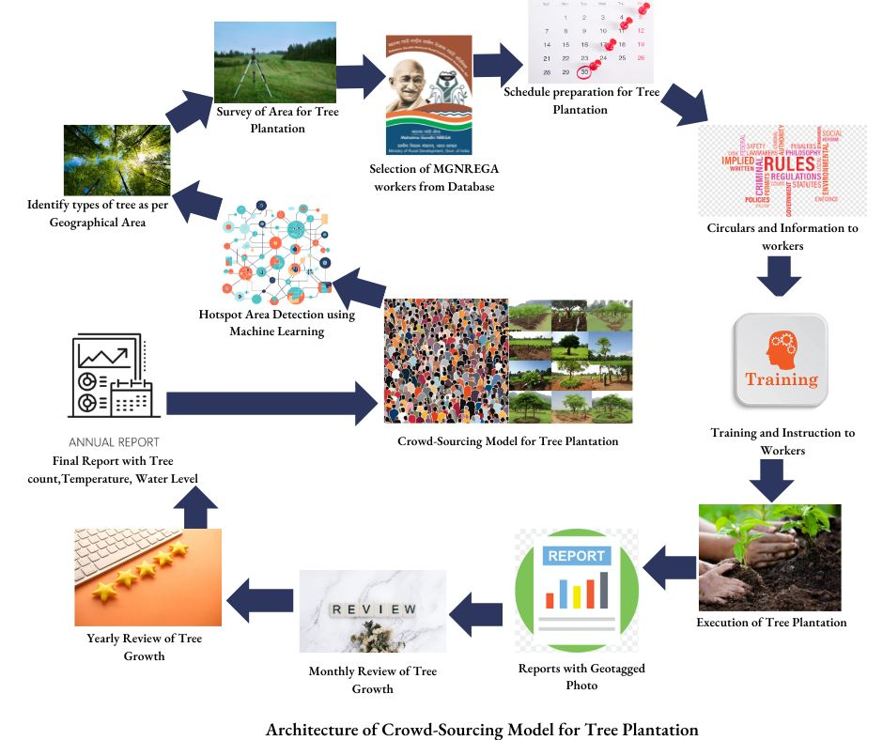
Survey of Area for Tree Plantation: Regarding air pollution, the trees that could be selected for that area need to be identified according to their growth process and suitability for that area. Among them are those producing fruits and oxygen.

Selection of MGNREGA Workers: The database on workers under the Mahatma Gandhi National Rural Employment Guarantee Act (MGNREGA), set up by the Department of Rural Development, selection on basis of residents within a range of 5 km of the area under conducive to air pollution.

Schedule Preparation: One labor schedule outlined by the remedies is prepared with the details of date and time for plantation, area, types of saplings to be purchased, observer, vehicles, plants, seed balls, and tools. A schedule is proposed and finalized.

Circular and Instruction Manual: In preparing and drafting circulars and instructions manuals, all details in relation to the workflow, schedule, training, instruction, rules and regulations, point of contact, transportation details, required accessories, problems and their solutions, safety precautions and the prepared flowcharts and diagrams to show the flow of work have been incorporated.

Training and Demo to Workers: As per schedule training and demo of tree plantation by experts, arrangement given in this module.

Execution of Tree plantation: This module shows the actual tree planting executed on a schedule under the supervision of a observer to conduct the task smoothly. Also note that these problems occur during execution which are not mentioned in the circulars.

Reports: The first step was to take geo-tagged photos, which served as evidence of successful completion of tree planting. Date, time, location, and type of tree are all recorded for observations made to monitor tree growth on a monthly basis; growth over a year's period is applied in one final report, which helps to observe increases in forestation, besides recording of air pollution index to be compared with previous pollution indices for calculating reductions in air pollution.

Audience & Stakeholders

- Technology is applied for social causes, such as for productivity enhancement, ease-of-use, and proper utilization of resources for the betterment of nations, nature, and our, generations to come.
- The researchers can identify different ways how those technologies can be utilized-to improve the nature first-and only then for commercial purposes.
- Time is always a basic need in this life cycle, and the effective uses of human power, the wise utilization of resources impact Nature's cycle, and with technology, things may go well towards a hopeful future.

IV. RESULT & DISCUSSION

A Crowd-Sourced Approach to Enhancing Forestation in Bharat through the 'MGNREGA' Program under this banner aims to develop the crowd-source model on data identified by a machine learning algorithm with parameters measuring SO3, O3, NO2, CO, and HCHO to improve the air quality of polluted areas. MGNREGA workers would be selected, based on their residential area and areas of high pollution, for tree plantations. It is suggested that the architecture of crowd-sourcing proposed would eventually reap the benefits of manpower during the process of afforestation and improve air quality in that area.

V. CONCLUSION

The In conclusion, this study examined the Mahatma Gandhi National Rural Guarantee Act of 2005 and investigated the Crowd-Sourcing Model concept for tree planting. The study shows that using ISRO service to detect air pollution hotspots The significance of efficiently using human resources for forestation is emphasized by the visualization of Earth observation data and the archival system for tree planting.

Although this study offers insightful information, it has limitations, including the collecting of data on hotspots for air pollution, the MGNREGA system, and climate change. Future studies should look more closely at waste management, water management, and plastic pollution control.
In the end, creating a crowd-sourcing model requires an understanding of the MGNREGA system, VEDAS, and the Manual of Forest Survey of India. We can create a model for climate change to create and preserve nature if we keep researching this subject.

ACKNOWLEDGMENT

The authors would like to express their sincere gratitude to Ministry of Rural Development, Department of Rural Development Krishi Bhawan, New Delhi, for Mahatma Gandhi National Rural Employment Guarantee Act, 2005, Annual Master Circular 2024-2025.

REFERENCES

- Henry Oluchukwu Ikediego, Mustafa Ilkan, A. Mohammed Abubakar, Festus Victor Bekun, Crowd-sourcing (who, why and what), Dogu Akdeniz Universitesi, Famagusta, Cyprus, International Journal of Crowd Science, Vol. 2 No. 1, 2018, pp. 27-41, Emerald Publishing Limited 2398-7294 DOI 10.1108/IJCS-07-2017-0005
- Mahatma Gandhi National Rural Employment Guarantee Act, 2005, Annual Master Circular 2024-2025. https://nregaplus.nic.in/netnrega/WriteReaddata/Circulars/AMC\_2024-25-English.pdf
- VEDAS (Visualization of Earth Observation Data and Archival System), https://vedas.sac.gov.in/air-quality-monitoring/index.html
- FSoIndia ISFR 2021, Published by Forest Survey of India, Ministry of Environment Forest and Climate Change, Chapter 11 Mapping of Climate Change Hotspot in India Forest. https://fsi.nic.in/isfr-2021/chapter-11.pdf

