A Critical Review on Study of Behavior of Artillery Shell Using 6 Degrees of Freedom

Anand V. Thengne ¹, Subhash N. Waghmare²
¹ Student of M.Tech. ( Defence Technology), ²Assistant Professor
Mechanical Engineering Department
Priyadarshini College of Engineering, Nagpur, India 440019

Received on: 20 May, 2023 Revised on: 15 June, 2023 Published on: 17 June, 2023

Abstract –The aim of this study was to develop and verify the correctness of a 6 Degrees-of-Freedom trajectory simulation model known as 6-DOF, by conducting case studies to gain insight in the flight behaviour of mortar bombs. This literature study provided valuable insight on the various trajectory simulation models. The information from this literature was used to define models to be incorporated in a 6-DOF trajectory simulation that can be used to analyse both symmetric and asymmetric projectiles. Based on the case studies selected in the verification part used for this study, the input data requirements for each case study selected for modelling purposes, were entered into the 6-DOF model and output results were generated. The 6-DOF output results were compared to results from other simulation programs, as well as the results that predicted by analytical solutions. The 6-DOF model produced similar outputs, within a difference of +0.36% to +0.49% in range and - 0.31% to -2.70% in drift, to that of the PRODAS V3 program. The differences between the results from the two programs are relatively small, except for drift. In addition, the results illustrated that the 6-DOF model and Win Fast program produce comparable results when starting with the same initial parameters.
Keywords- Artillery shell , six degree of freedom computer program, defence technology , trajectory

I -INTRODUCTION
The modern science of the exterior ballistics has evolved as a specialized branch of the dynamics of rigid

bodies, moving under the influence of gravitational and aerodynamic forces and moments” (Mccoy, 1998). The development of a better understanding of exterior ballistics lad to the establishment of guidelines for stability and an increase in the accuracy of the projectiles.
Initially, exterior ballistics existed more as an art or craft before it developed into a science. The technical art of it emanated as simple throwing mechanisms. After years of continuous and evolutionary development, exterior ballistics were established as a branch of science, especially after the growing body of knowledge gathered during the renaissance era in the sixteenth and seventeenth century. Isaac Newton was one of the prominent scientists in this era, and one of those who contributed a great deal to make exterior ballistics into the science we know today. The most important contributions are the laws of motion and the effect of aerodynamics on a projectile. Through the years, ballisticians developed an interest in armament development and the goals are still the same, to primarily extend range and improve accuracy on target (Mccoy, 1998). A 5-DOF simulation program is sufficient and computationally effective to study the behaviour of symmetric projectiles. To study the effect of body fixed asymmetries however, it is imperative to use a 6-DOF simulation model. Developing a new 6-DOF simulation model allows for the study of asymmetries and instabilities not treated in the “standard available 6-DOF programs”.
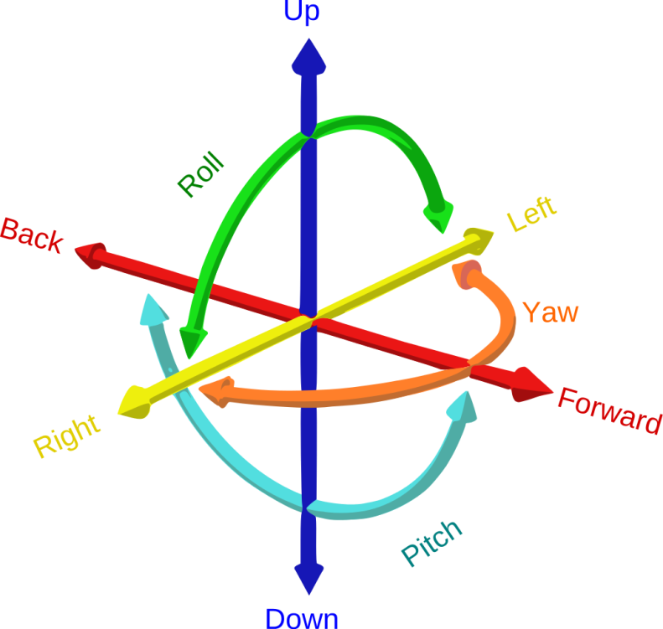
Fig. 1- The six degree of freedom
II -METHOLOGY LITERATURE REVIEW
The research design for this project is a simulation-based study. The simulation will be designed to replicate the behavior of an artillery shell in a three-dimensional space. The simulation will use six degrees of freedom to describe the position and orientation of the shell. The equations of motion for the shell will be implemented using numerical integration methods. The program will take input from the user, including initial velocity, angle of launch, wind speed and direction, and other parameters relevant to the simulation. The program will output the trajectory of the shell in a three-dimensional space and other relevant information such as maximum altitude, range, and time of flight.
III- LITERATURE REVIEW

Artillery shell trajectory simulations have been studied extensively in the field of ballistics, which is the study of the motion and behavior of projectiles. These simulations are critical for optimizing the performance of artillery systems and ensuring their accuracy. Since the ballisticians started to use computers in the ballistic science, many theories and models have been developed to simulate trajectory of projectiles. These models range from the extremely simple to very complex models. The degree of complexity usually depends upon the degrees of freedom which the model is based on, and the specific simulation requirements. Here we are going to discuss about few researches and literatures done world widely in the past.
George Greenhill (1881) One of the earliest works in this area is the paper by George Greenhill, published in 1881, where he derived the equations of motion for a projectile under the influence of gravity and air resistance. Since then, many researchers have worked on refining these equations and incorporating additional factors such as wind, temperature, and altitude.
Duncan & Ensey (1964 ) This model was proposed for the accurate prediction in digital simulation to simulate the trajectory of an unguided, fin-stabilised, wind sensitive rocket. Especially to study both theoretical and empirical performance characteristics of unguided rockets. This document gives an excellent description of the structure of typical 6-DOF model in general with the description of each part. One of these parts was the integration routine which showed how the equations of motion are numerically integrated by the fourth order Runge-Kutta integration technique, and how to check the validity of the integration. This model provides valuable information on the structures required in the trajectory simulation models.
1. Numerical Methods for Engineer and Scientist Hoffman, (1992 ) In this book, the author provided many of the basic problems that arise in all branches of engineering and science. These problems include: solution of systems of linear algebraic equations, Eigen problems, solution of nonlinear equations, polynomial approximation and interpolation, numerical differentiation and difference formulas, and numerical integration. It also provided the numerical solutions and methods which can be used to solve mathematical problems that cannot be solved by exact methods. In addition, this book has expressed many numerical algorithms such as Runge-Kutta 4th order method in the form of a computer program. The 4th order Runge-Kutta integration technique is one of the popular integration techniques used in the trajectory simulation models.
A full 6-DOF flight dynamics model Gkritzapis etal in year 2007 This journal was publisheded to proposed the accurate trajectorie perdiction for fin-stabilised short range as well as long range projectiles. In this research it was assumed that the projectile should be non flexibale and axially symmetric about it’s spin or rotating axis. It can be applicabale for low and elevation and high elevation angle for launching and it considered the most significant force and movement variation, gravitational force as well as magnus effect. This research was provides an excellent description and concepts obout 6 Digrees of fredome model. But this model was limited for symmetrical and rigid projectile and that is the major short coming of this model.
2. Projectile linear theory for aerodynamically asymmetric projectiles
John W. Dykes year (2011) The scope of this thesis was to create analytical tools that were capable of quantifying aerodynamically asymmetric projectile performance. It demonstrates the capability of these models to accurately account for aerodynamic asymmetries and gain insight into the flight mechanics of several aerodynamically asymmetric projectiles.
Modelling and Simulation of Aerospace Vehicle Dynamics Piter H Zipfel (2014) This model provides excellent reference and basic information than other various models, many other researchers has been taken this model as basic reference model for simulation of flight trajectories for projectils and arial vehicles. The main focus of Zipfel's approach is to develop mathematical models that accurately represent the behavior and characteristics of aerospace vehicles and projectiles during various mission phases. These models incorporate the principles of aerodynamics, propulsion, and structural dynamics to simulate the vehicle's motion and response to external forces.
This modeling methodology typically involves: Mathematical Equations: Deriving equations of motion based on Newtonian mechanics and principles of flight dynamics. These equations describe the translational and rotational motion of the vehicle. System Identification: Determining the vehicle's aerodynamic coefficients, propulsion characteristics, and other parameters through experimental data or computational methods.
Simulation Techniques: Employing numerical integration methods, such as Euler's method or Runge-Kutta methods, to solve the differential equations and simulate the vehicle's behavior over time. Validation and Verification: Comparing simulation results with real-world flight data or experimental results to ensure accuracy and reliability of the model. In addition this model also including the research study of other factors like stability and control analysis, linearization techniques, control system design, and simulation validation. It provides insights into the dynamics of aerospace vehicles and serves as a valuable resource for engineers, researchers, and students in the field of aerospace engineering and flight dynamics. Zipfel's modeling and simulation approach aims to facilitate the understanding, analysis, and design of aerospace vehicle dynamics by providing a systematic framework and mathematical tools for accurate and realistic simulations. Zipfel provides valuable information on the different reference coordinate frames required in trajectory simulations and the transformation between the various reference frames. Development and evaluation of a 6-DOF model of a 155 mm artillery projectile
Marcus Thuresson (2015) In this Master Thesis, the author evaluated a 6-DOF model of a 155 mm artillery projectile and compared it to a modified point mass trajectory model for the same projectile. The models were simulated using the software FLAMES, that uses a spherical earth model, terrain data and measured atmospheric conditions. The model’s results were accurate in range but had a 35% error in drift compared to the firing-table of a 155 mm projectile.
BALCO Journal Published by Institute of Saint Louis in year 2016 This 6-DOF simulation model was presented at the International Symposium on Ballistics in 2016 (Wey et al., 2016) as the standard 6-DOF to be used within NATO. It was provides a good benchmark for “best practices” regarding 6-DOF simulation. It’s short-coming however, is also limitation regarding asymmetric properties and the flexibility to analyse instabilities not covered by the classical tri-cyclic motion theories.
Development of a 6-DOF Trajectory Simulation Model for Asymmetric Projectiles by AAA Altufayl (2019), Precision is important to modern artillery where long range cannons can fire unguided and guided projectiles for many kilometers. Precision projectiles are in demand, because it is both cost effective (increasing the chance to hit the target with the first shot) and reduce collateral damage (minimizes the risk of hitting friendly forces). This requires accurate prediction of the flight path using trajectory simulation models. The so-called 6-DOF projectile exterior ballistic model is the most complex simulation model and allows for the modelling of all the projectile motions. The aim of this study was to develop and verify the correctness of a 6 Degrees-of-Freedom trajectory simulation model known as 6-DOF, by conducting case studies to gain insight in the flight behaviour of mortar bombs. This literature study provided valuable insight on the various trajectory simulation models. The information from this literature was used to define models to be incorporated in a 6-DOF trajectory simulation that can be used to analyse both symmetric and asymmetric projectiles. This 6-DOF simulation model was presented at the International Symposium on Ballistics in 2016 (Wey et al., 2016) as the standard 6-DOF to be used within NATO. It was provides a good benchmark for “best practices” regarding 6-DOF simulation. It’s short-coming however, is also limitation regarding asymmetric properties and the flexibility to analyse instabilities not covered by the classical tri-cyclic motion theories.
Development of a software tool for the simulation of artillery shell trajectories J. B. Sousa and J. F. da Costa. This paper presents a software tool developed to simulate artillery shell trajectories in a three-dimensional space. The authors used numerical integration methods to solve the equations of motion and validated the simulation results with experimental data.
A comparison of numerical integration methods for trajectory simulations M.A.G Diaz and J.E.G. Reys "A comparison of numerical integration methods for trajectory simulations" by M. A. G. Diaz and J. E. G. Reyes. This paper compares the performance of different numerical integration methods, including the Euler method and fourth-order Runge-Kutta method, for trajectory simulations. The authors found that the fourth-order Runge-Kutta method was more accurate and reliable than the Euler method.
Simulation of the ballistic performance of artillery projectiles C.C. Liu and H.F. Teng This paper presents a simulation model for the ballistic performance of artillery projectiles. The authors used a six degrees of freedom model to describe the motion of the projectile and validated the simulation results with experimental data.
The effects of wind on artillery shell trajectories Present by R. L. Marrion and J. R. Barnes paper investigates the effects of wind on artillery shell trajectories using numerical simulations. The authors found that wind significantly affects the trajectory of the shell and that wind speed and direction have a significant impact on the range and accuracy of the shell.
Development of a computer program for simulating the behavior of artillery shells by K. R. K. Prasad and S. K. Mohanty. This paper presents a computer program developed to simulate the behavior of artillery shells in a three-dimensional space. The authors used numerical integration methods to solve the equations of motion and validated the simulation results with experimental data
IV- RESEARCH GAP IDENTIFICATIN
The presented firing table software employs the iterative method that the firing solution is determined through iterations of trajectory simulation. The software consists of Firing Table Main, Search Engine, Trajectory Model, and several supporting components. The Firing Table Main controls the operation of the software.The Search Engine is composed of algorithms for calculating the firing solution for a given target. The Trajectory Model is used by the Search Engine for simulating the projectile trajectory and the point of impact. In addition, the Trajectory Model is also used by the Firing Table Main to generate the firing table data in stand conditions, which is stored in the Standard Table. For the supporting components, the Datum Conversion module transforms the targetand origin locations from the datum input by the user to the datum used by the Trajectory Model. The datum transformation can be done using Helmert 7-parameters transformation.

V-CONCLUSION
Limited studies on the effect of artillery shell behavior on the environment: While there is research on the impact of artillery shells on the environment, there is a lack of research on the effect of shell behavior on the environment. This is an important research gap, as understanding the effect of shell behavior on the environment can help in minimizing the damage caused by artillery shells in combat situations. Overall, these research gaps suggest that there is a need for further research in the field of artillery shell behavior, particularly in the areas of six degrees of freedom, impact of external factors, trajectory optimization, and environmental impact.
ACKNOWLEDGMENT
Acknowledgment to person or the organization supported to the author for the research work. This is not mandatory for all.
REFERENCES
- Dickinson, E.R. (1967). The production of firing tables for cannon artillery, BRL Report No. 1371, Ballistic Research Laboratory, Aberdeen Proving Ground, MD, USA.
- Reed, H.L. (1952). Firing table computations on the ENIAC, Proceedings of the 1952 ACM National Meeting, Pittsburgh, PA, USA.
- Polachek, H. (1997). Before the Eniac, IEEE Annals of the History of Computing, vol. 19(2).
- STANAG 4119, Adoption of a standard cannon artillery firing table format, 2nd edition, NATO Standardization Agency, 2007.
- Sherif, Y.S., Liou, E.M.K., Chang, T.H., and Yao, S.F. (1985). Modelling the firing tables of filed artillery (cannon 105mm howitzer), Microelectronic Reliability, vol. 25(1), pp 41-53.
- External Ballistics. Text-Book of Ballistics and Gunnery, vol 1, (1st ed), Her Majesty Stationary Office, London, 1987, pp 443-497.
- RA Hess. Use of Back propagation with Feedforward Neural Networks for the Aerodynamic Estimation Problem. AIAA paper, August 1993, pp 93-3638
- Michael J. Hemschtwo , May 1981, Computer Program for Simulating the Six-Degree-of-Freedom Motion of Missile Debris Fragments, Nielsen Engineering & Research, Inc., Mountain View, California
- Du, Ange, "A Comparative Study Between 6 Degree-of-Freedom Trajectory Model and Modified Point Mass Trajectory Model of Spinning Projectiles" (2021). PhD Dissertations and Master's Theses. 594.
- Predicting The Accuracy Of Unguided Artillery Projectiles Wee Yeow Lim Captain, Singapore Armed Forces M.Eng., University College London, 2012
- Book , Physics for Game Programmers GRANT PALMER, Lead Editor: Tony Davis, www.press.com
- Maske, Mohit M., and Prakash Prasad. "A real time processing and streaming of wireless network data using Storm" , 2015 International Conference on Computation of Power Energy Information and Communication (ICCPEIC), 2015.

Details of All Authors (Optional)

Sr.No | Photo | Details
1 |  | Anand Vinayak Thengne  M.Tech. (Defence Technology)Final Year Students, Priyadarshini College of Engineering , Near CRPF Campus , Hingna Road ,Nagpur-19  M.No.:9763666368  Email ID: anandthengne@gmail.com
2 |  | Dr.Subhash N Waghmare  Assistant Professor in Mechanical Engineering Department & Coordinator M.Tech. ( Defence Technology)  Priyadarshini College of Engineering, Near CRPF Campus, Hingna Road ,Nagpur-19.  M.No.:9423423905  Email ID: subhashwaghmare1981@gmail.com

