Testing Practical Applicability of 5-dimensional BIM using a Pilot Model
Soham P. Kolte¹, B. A. Konnur²
¹P.G. Student, Construction Management,
Government College of Engineering, Karad, India 415124
²Associate Professor, Civil Engineering Department,
Government College of Engineering, Karad, India 415124

Abstract— Any given construction and engineering project has three most important factors that is the quality, time and cost depending on the decision-maker and the decision-making process involved in the project. An emerging trend in construction industry is five-dimensional Building Information Model (5D BIM), that integrates all the data, detailed plans, and information, right from the start of the project, much before actual construction begins, until the end of the construction and further extends until the entire lifecycle of the building. In such case, the Building Information Modeling comes in handy with a precise decision-making process which can be accessed by using a Virtual Simulation Technique (VST). The main aim of this review paper is to simulate a pilot model of a G+1 building using the 5D BIM concept and record the steps required to do so. The model preparation starts with a simple line drawing in 2D Autodesk AutoCAD, then developing 3D model in Autodesk Revit and then adding 4th and 5th dimension as time and cost in Autodesk Navisworks. Irrespective of the model outcome, focus is concentrated on the main factor that interferes with the practical application of 5D BIM. The integration of information on a single platform makes the data to be organized, appear sophisticated, easy to interpret as well as help decision makers to have thorough information of all the parameters associated with the components. Not only 5D, but n-number of dimensions can be added to the same model depending on the technical details required by the project, but it is noted that increase in dimensions required increased information, components, parameters, which eventually increase the complexity of the model. But with appropriate filters and layers each dimension can be read easily without any complexity as per the requirement of the stakeholder.
Keywords— 5-Dimensional BIM, Building Information Modeling, Virtual Simulation techniques, Autodesk, AutoCAD, Revit, Navisworks, Oracle Primavera, AECO Industry.
I. INTRODUCTION
The success and failure of any construction project can be drawn down to these three factors, the quality of work, time required for completion and total cost spent building the structure. But also, there are other factors that influence the construction project that include, but not limited to, value for money, appearance of the structure, fit for the purpose it is built, free from any form of defect or inconvenience, supported by guaranteed components, low running cost and durability i.e. the life span of the structure. All these factors are integrated together and adjusted accordingly to the client’s requirement, which is unique in every case. As a result of these demands by the client, the data generated in order to make such project possible is in huge amount. Most of the time due to technical and managerial issues and obsolete methods, the data collected is redundant, inconsistent and misleading. This is mainly due to the vast amount of data required and accumulated for a single project that causes confusion and may mislead the stakeholders involved in the project. The client investing amount as low as for building a house or apartment, up till amount as high as to build the manufacturing factory or industry headquarters, does not concern with such difficulties, and expect only the final completed structure. If these factors are not properly managed and their effects are not mitigated, they might disturb the construction works and ultimately result in poor final outcome, which might not please the client. Due to this there is a huge load of responsibilities on a few stakeholders, while their decision is clouded by these inconsistent data. But in recent time, due to innovation and sophistication, this entire problem has been traced down to one simple solution i.e. Building Information Modeling (BIM).
BIM can be simply defined as integration of Design, Construction and Facility Management into a simple platform. BIM is also used to explore the architectural aspects of the building to make it more appealing. Therefore, research is being conducted to add more and more such aspects into a single model in form of additional dimensions for better project outcome. The five-dimensional BIM is one such experiment to change the entire construction management process. In a survey conducted by Chougule (2015), to know the practical application of BIM, showed that most of the stakeholders in the industry have the common misconception of BIM is only an extended version of 2D CAD software. While another major pool of individuals in the industry finds that BIM is much complex software needed only for large scale projects and not applicable to small projects, which is also a false belief. In both the cases BIM is seen as ‘over-rated’ concept overall. Therefore, this review paper aims to find the practical application of the BIM, and in particular the 5D BIM.
II. BUILDING INFORMATION MODELING
A. EVOLUTION OF BIM
If there is any text to be considered to be sacred in the field of architecture and engineering, that would be the ‘De Architectura’ written by the renounced Roman architect, engineer, designer and philanthropist Vitruvius in the 1st century AD. Many of Vitruvius work including the De Architectura have three main ingredients in common; there three qualities were Firmness, Utility and Beauty. Before the 20th century, building drawings and designs were prepared using ink and paper which was laborious work and any replication or copy, if required, caused even more manual efforts. In later of the 20th century there was a gradual change in copying the drawings by use of tracing paper and mechanical drafters, and this job was usually done by the draftsman or apprentices who were less skilled than the architects and engineers. Until the late 1980s the building drawings and designs were to be carried out using pen and paper, although there was a quite advancement in technique of drawings and use of standard symbols and scale, nothing much changed in those years.
Then in 1982, a breakthrough happened by Autodesk creating their first version of Computer Aided Designing (CAD) for Personal Computers, but it was until 1997 until this change made the impact, with appearance of R14 Version of AutoCAD. Later from those years, the mass usage of CAD become possible and the popularity of Autodesk only grew from there ever since until today. This was the time when paper and manual drawings started to be replaced by computer-based CAD. It was much efficient and easy to create copy and edit drawings in CAD by a few clicks. It was the first step that revolutionizes the architecture and engineering industry completely. Nowadays the use of CAD is completely generalized and mainstream in daily workings of all stakeholders involved in construction, architecture and engineering industry. In the recent years after 2000s another revolutionary step was taken in the field of architecture by introducing 3D modeling of a real building. Generation of a 3D model of a building virtually with the actual looking texture, shape and effect was a major accomplishment for architectural works. Now with growing use of Autodesk Revit by the AEC industry marks the beginning of another concept called the Building Information Modeling. We would discuss the BIM and its parameters in the following paragraphs, but it is worth mentioning that the growth and updating technology of BIM is slowly replacing the CAD technology for better, allowing an even more detailed and integrated modeling method for better understanding and functioning of a structure.
B. DEFINING BUILDING INFORMATION MODELLING
Bilai Succar (2008) defines BIM as ‘Building Information Modeling (BIM) is a set of interacting policies, processes and technologies generating a methodology to manage the essential building design and project data in digital form]at throughout the building's life-cycle’. While Mihindu et. al. (2008) writes, BIM can be said as a tool that transforms from two-dimension base computer aided designing system into a three-dimension base object information system. This transformation involves change in documentation process from manual paper based to digital computer based. The entire floor plans, activity schedules, billing order, facility management are all computer based. These individual elements add dimensions to the system. It is possible to create n-number of dimensions for n-number of elements involved in the project, and each can be accessed all together or individually depending on the requirement of the stakeholder. This system is called the digital building model. The digital building model consist of many layers and filters as Succar (2008), calls them the BIM lenses and filters in his paper that describes the BIM ontology in great depth. Also, describes about the BIM framework that help in research and delivery for the project stakeholders.

C. FOUR-DIMENSIONAL BUILDING INFORMATION MODEL
The first three-dimensions are the visual elements of the model, i.e. they can be seen, and visualized in geometric shape and form. But that phenomenon is not applicable to the fourth-dimension, time. Traditionally, time is perceived separately from the building model in form of gant-charts, spread sheets and construction schedule visualization, example CPM or PERT. Although attempts are made to make this time chart visualization more appealing and informative, by integrating it with the virtual simulation of building model to make a four-dimensional computer aided design (4D CAD). This might be sometimes restricted to scale the actual progress of the construction work up till that date. However, it is noticed that there was a large gap in between the information projected in the four-dimensional model and the requirement of the stakeholders was huge as it does not specify the details of the activity, stakeholders involved for that particular activity, as well as the cost required to carry out the activity. Also, time is given more due importance than other contributing factors.

D. FIVE-DIMENSIONAL BUILDING INFORMATION MODEL
As mentioned earlier, the three main components of the construction project are quality, time and cost and it is much clear that 4D BIM is not the complete building model. The cost of the project plays an important role in the successful and efficient completion of the project. Also, it is seen that unlike time, cost fluctuates influenced by the environmental and political scenario. Hence, five-dimensional Building Information Model (5D BIM) is to be perceived. It is important to accurately find the estimated cost of the project at the very beginning before the construction phase starts. The traditional method of estimating the cost of the project was based on the experience of the stakeholder or studying similar projects. A precise method is necessary, as cost estimation is nothing but the prediction of final cost of a process or material used for completion of project. Also, estimating is necessary in the decision-making process and poor cost estimate may lead to delayed process completion, excess expenditure on machines due to delay in the process and ultimately may cause the entire project to be delayed, which may cause penalty to the stakeholders by cost over-runs. Although such importance is associated with the cost of the project, it is not possible to draw a simple and straightforward method to calculate the cost, because of the unavailability of data. For a better project control, financial stability and cash-flow monitoring, 5D BIM can be used by the stakeholders right from the starting phase of the project. And such an integrated framework that combines scheduling process and the cost is now developed called as 5D BIM and is still under up-gradation and enhancements.

III. METHODOLOGY
This is a motion study type review paper on a pilot study with no actual field data collection but study on outputs such as drawings, designs, activity schedule and project timeline are made. The outputs by this pilot study are later sent for peer reviews. The pilot model is of a G+1 building, and the paper objective is to simulate a 5D model of the building focusing mainly on the modeling effort, exchange of information between software, output and difficulties in doing so. The reviews are divided into four stages as shown in figure 1 and observation are measured based on the practical application of BIM.
The first stage includes collection of building information and input into the 3D model. This process involves the interpretation of requirements laid by the client for the building. Architectures interpretations are included with engineers and a 3D model is formed in place. Then detailed information by mechanical engineer, electrical engineer and interior designer are input into the 3D model. This 3D model specifies information of each and every component.
The second stage is carried out only after the client requirements are met and architectural aspects are finalized. The second stage includes cost estimation of the building and is primarily done by costing engineers and quality surveyors. The cost estimation is carried out by assigning unit price per element of the component for all the components of the building. In this case 4D BIM is helpful for better cost estimation and precise cost budgeting.
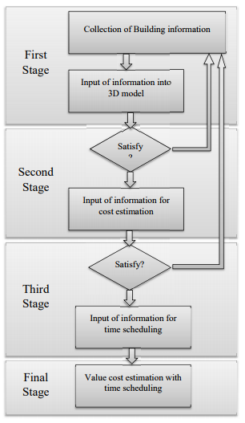
Figure 1- Workflow Diagram for 5D BIM (Source: Bilai Succar)
The third stage is carried out only after client is satisfied that the cost of the entire project justifies the use of building. Then for the third stage, the project manager or the construction manager prepare the work breakdown structure of the components in the building and creates an activity schedule for construction of these activities. Some factors like human labor availability, construction technique and raw material supply are taken into consideration before finalizing the activity schedule, to have a better control over the project. At this stage 5D BIM can be used for better information storage and precise clash detection in the schedule, as model help for actually simulating the construction of building that provides better overview on the activities and their schedule.
In the final stage, Virtual Simulation Technique (VST) will be used to present the 5D BIM model that include the 3D model along with the cost of project and the activity schedule (time).

A. INPUT OF BUILDING INFORMATION IN 3D MODEL
The practicability test for BIM also includes pre-BIM information such as 2D CAD Drawings. Although Revit is used in most BIM applications, but clients and some stakeholders still prefer working with 2D CAD drawings and methods. Therefore, primary data from Revit and CAD must match in aspects like grid lines, boundary lines and layout. Fig. 2 shows Revit layout that is easily interpreted by the general CAD users; showing grid lines, outer walls, column and beam placing and primary openings. Being a Revit model, the lines drawn automatically generates the virtual 3D components in place, putting less efforts of extrude lines and then generating 3D model.
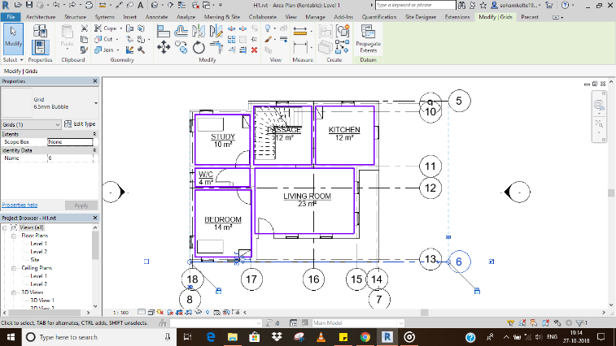
Figure 2- Layout showing Boundary wall and other preliminary data
B. INPUT OF INFORMATION FOR COST ESTIMATION
As per the Autodesk Official training Guide, BIM is one of the best and efficient methods to automatically generate the material take-off from a 3D model. The components placed by the Revit Architect will eventually belong to certain ‘Family’, which have pre-loaded information like family type, area, running length, volume also called as the ‘Property of Components’. Among one such is the ‘Cost’ of components which contain the information of cost of that particular item or material per unit length or area or volume whichever applicable. The quantity surveyor or cost estimator may then assign cost per unit to the component, as well as prepare formulae to calculate the same if necessary. Fig. 3 shows the dialogue box showing the cost per unit volume, as well as the formula needed to calculate the same.
Whereas fig. 4 shows the complete materials take-off schedule for the components used in the model with their respective cost estimation. Also, it totals the materials from the same components while separates the material from different components
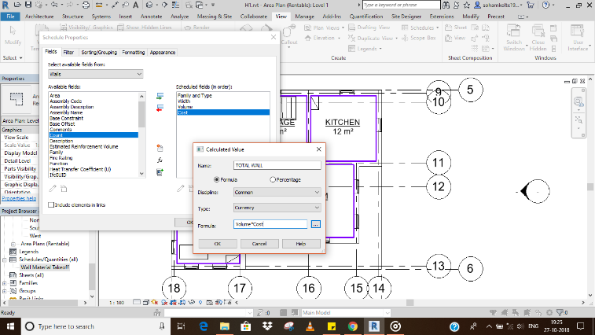
Figure 3- Dialogue Box showing Cost details and formula
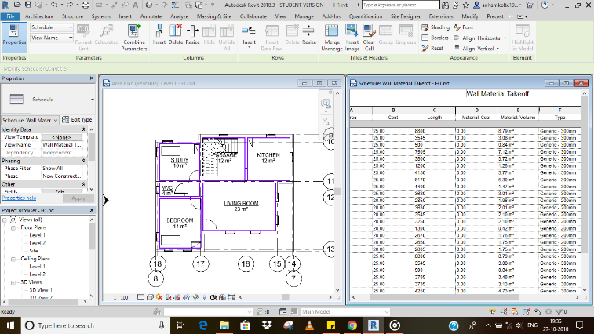
Figure 4- Material Take-off of the Model
C. INPUT INFORMATION FOR TIME SCHEDULING
With respect to the material take-off, a work breakdown schedule (WBS) can be extracted from a 3D Revit model, similar to that of cost estimation. Then following the conventional method activity schedule is prepared using tools like Oracle Primavera, Microsoft Project or Microsoft Excel pre-sets. This information from time schedule will then be linked to each and every individual component from the 3D model as per the WBS. This process of assigning time schedule to each component is carried out using Autodesk Navisworks software. Fig. 5 shows the dialogue box showing schedule activities linked with components.
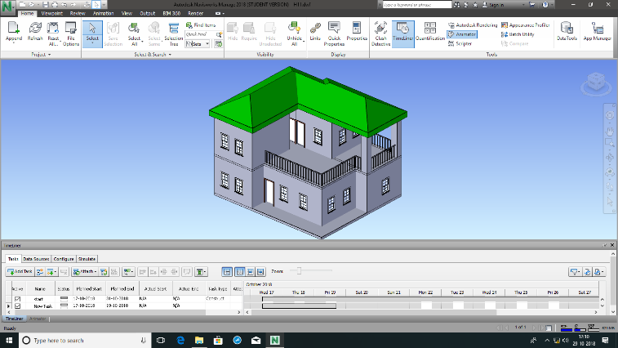
Figure 5- Timeline of scheduled activities
D. VISULIZATION OF 5D BIM MODEL
Working with Navisworks allows us to use the ‘Timeline’ tool to simulate the model. In the final stage, the 3D model and Activity schedule is imported in Navisworks to create the animated simulation of the 5D model. This procedure is also called the Virtual Simulation Technique (VST). Fig.6 shows all three aspects of model in a single window. This technique is necessary from client’s perspective, to help visualize the final outcome from the project as well for the decision makers that help them to have accurate clash detection through visual element and construct better activity schedule. This technique is important from the designers point as well as it help to have clear view of possible alternatives and troubleshoot minor problems if any. Another way to make this more applicable is to simulate various models with changes in construction methods, resource allotment or activity schedule. As the procedure of 5D VST is done before actually starting the construction project, it can be said that a building is built twice in BIM; once in the visualization phase and once in actual field.
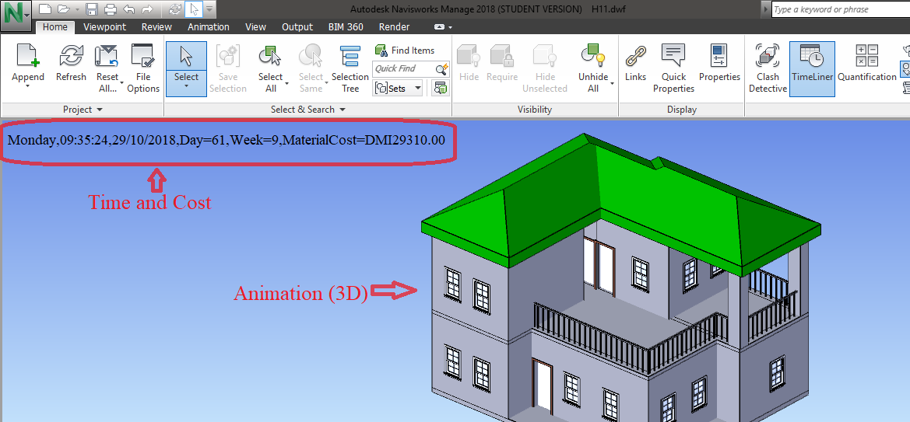
Figure 6- 5D model of the Building

IV. PRACTICAL APPLICABILITY TEST OF 5D BUILDING INFORMATION MODELLING
BIM makes sophisticated and schematic integration of 3D model, time and cost into a 5D model. As per the practicability review published by Xia Lee, Cheah Tsong, and Mohd Khamidi in the year 2016, the success of the integrated 5D model depends on modeling efforts, inter-operability, project output and limitations in doing so. The practability review published included questioner feedback from the professionals working in the industry especially using 2D CAD methods. Similar questioner was prepared for this paper and was circulated among the peers studying and working in the construction field. The parameters mentioned above are scaled in three groups as poor, neutral and good. And the results found by the questioner, it was again grouped according to the stages of the 5D BIM procedure. For the first stage, since the method was similar to that of 2D CAD the modeling effort were minimum, hence lies in good scale. The inter-operability was tedious in case of BIM so received poor rating. The project outcome was as per most of their expectations hence received good rating, while the limitations in this stage was huge, ranging from poor data interpretation to complete building information output so received poor rating. In the second stage, for the cost estimation since the WBS was readily available, the modeling efforts were again rated good and the inter-operability was neutral as both aspects are difficult compare. The data output from this stage was effective and accurate and rated good. For the third stage, in the activity scheduling, which lies completely different from the 2D CAD hence cannot be gauged based on these parameters hence received neutral rating in the modeling efforts and interoperability aspects. However, as the timeline produced by this method was much efficient to understand even by the non-technical stakeholder, hence was rated good. Finally, in the fourth stage, the modeling efforts required much thorough knowledge hence was rated neutral compared to 2d CAD, the interoperability and outcome was rated good due to animated presentations and easy to consume information. These observations are summarized in the table 1 given below:
Table 1- Observations from practical applicability test
Stage | Process | Scale | Feedback
First Stage | Input of building information in 3D model | Modelling Efforts | Good
First Stage | Input of building information in 3D model | Inter-Operability | Poor
First Stage | Input of building information in 3D model | Information Output | Good
First Stage | Input of building information in 3D model | Limitations | Poor data interpretation
Second Stage | Input of information for cost estimation | Modelling Efforts | Good
Second Stage | Input of information for cost estimation | Inter-Operability | Neutral
Second Stage | Input of information for cost estimation | Information Output | Good
Second Stage | Input of information for cost estimation | Limitations | Continuous cost updating needed.
Third Stage | Input information for time scheduling | Modelling Efforts | Neutral
Third Stage | Input information for time scheduling | Inter-Operability | Neutral
Third Stage | Input information for time scheduling | Information Output | Good
Third Stage | Input information for time scheduling | Limitations | Experienced personnel required for efficient scheduling.
Final Stage | Visualization of 5d BIM model | Modelling Efforts | Neutral
Final Stage | Visualization of 5d BIM model | Inter-Operability | Good
Final Stage | Visualization of 5d BIM model | Information Output | Good
Final Stage | Visualization of 5d BIM model | Limitations | Difficulty in adding all building information in a single model
V. CONCLUSION
BIM is a relatively new concept in the Architectural, Engineering, Construction and Operation Industry. As the paper concerns with only the 5D modeling, but it is possible to incorporate more than five dimensions. It is observed that by inclusion of more than five dimensions, the model becomes too complex and heavy to be processed for the necessary pieces of information. Therefore, it is advisable to stick to 5D BIM concepts for time being, until further sophistication and advancement is done in the area. Observations following the pilot study clearly indicate that practical application of BIM for actual field operations is possible. The availability of information on a single integrated platform enabled better project model understanding and also enabled the decision-making process much easier as compared to a 2D CAD schedule.
However, it is also observed that difficulties may arise for the stakeholders not familiar with the primary concept of BIM or CAD in general. It is advisable to the non-BIM inclusive members to gauge their potential and tries to understand the basic functioning of the BIM and also to familiarize themselves with the 5D BIM aspects that concern their area of workings in the organization. The visual representation of construction project should also help the client to have a better understanding of the project beyond the technical barriers. This help to fill gap in between the client and the stakeholders, as client is able to anticipate the project outcome and satisfactorily gauge the difference between initial prediction and actual project outcome. This will help in overall client satisfaction. With that said, more research and development are necessary in the field of BIM technologies and boundaries need to be pushed beyond five dimensions.
REFERENCES
- Michael Latham, “The Latham Report: Constructing the Team,” UK, pp. 1-7, July 1994.
- Linda Kestle, “Remote Site Design Management,” University of Canterbury, pp. 9-13, 2009.
- C. Eastman, P. Teicholz, R. Sacks, K. Liston, “BIM Handbook: Modeling for Owners, Managers, Designers, Engineers & Contractors,” John Wiley & Sons Publications, pp. 1-10, 2011.
- Vladimir Popov, Virgaudas Juocevicius, Darius Migilinskas, Leonas Ustinovichius, Saulius Mikalauskas, “The use of virtual building design and construction model for developing an effective project concept in 5D environment,” Automation in Construction, Elsevier Publications, Lithuania, Vol. 19, pp. 357-367, 2010.
- N. Chougule, B. Konnur, “A review of Building Information Modeling (BIM) for Construction Industry,” International Journal of Innovative Research in Advanced Engineering (IJIRAE), India, Vol. 2, pp. 98-102, April 2015.
- Morteza Alibadi, Seyed Mohd, “Evolution of BIM and Integrated Sustainable Design Process (From Hand-Drafting to ID Technology),” International Conference on Civil Engineering, Architecture & Urban Sustainable Development, Iran, pp. 1-14, November 2013.
- Vijay Kumar Sani, Sumedh Mhaske, “BIM based Project Scheduling and Progress Monitoring in AEC Industry,” International journal of Scientific Engineering and Research (IJSER), Vol. 1 Issue 1, pp. 94-96, September 2013.
- Vijay Kumar Sani, Dr. Sumedh Mhaske, “BIM an Emerging Technology in AEC Industry for Time Optimization”, International Journal of Structural and Civil Engineering Research (IJSCER), Vol. 2, Issue 4, pp. 195-200, November 2013.
- Gayatri Jadhav, Madhav Kumthekar, Jyoti Magdum, “Building Information Modeling (BIM) a New Approach towards Project Management”, International Journal of Engineering, Research and Technology (IJERT), Volume 10, Number 1, pp. 143-148, 2017.
- Gary Bertoline, Eric Wiebe, Nathan Hartman, William Ross, “Technical Graphics Communication,” McGraw-Hill Publication, Vol. 4, pp. 14-17, 2007.
- Guindis, E., Up and Running with AutoCAD 2016: 2D and 3D Drawing and Modeling, Elsevier: Amsterdam, 2015.
- Scheer, D.R., The Death of Drawing: Architecture in the Age of Simulation, Routledge: New York, 2014.
- Juan Carlos Pérez-Sánchez, Raúl Tomás Mora-García, Vicente Raúl Pérez-Sánchez & Beatriz Piedecausa-García, “From Cad to BIM: A New Way to Understand Architecture,” Building Information Modeling (BIM) in Design, Construction and Operation, WIT Press, Vol. 169, pp. 45-54, 2017.
- Davis, P., Introducing Autodesk Revit Architecture 2012, Wiley Publishing Inc.: Indianapolis, 2011.
- Bilal Succar, “Building Information Modeling Framework: A research and delivery foundation for industry stakeholders.” Automation in Construction, Elsevier Publications, Vol. 18, pp. 357-375, 2009.
- Sas Mihindu, Yusuf Arayici, “Digital Construction through BIM systems will Drive the Re-engineering of Construction Business Practices,” International Conference Visualisation, IEEE Xplore Digital Library, pp. 140-149, July 2008.
- Amanda Marshall-Ponting, Ghassan Aouad, Song Wu, Carl Abbott, “Developing a vision of nD-enabled construction,” University of Salford, 2005.
- K. Chau, M. Anson, J. Zhang, “Four-Dimensional Visualization of Construction Scheduling and site utilization,” Journal of Construction Engineering and Management, ASCE, Vol. 130 pp. 598-607, August 2004.
- Changmin Kim, Hyojoo Son, Changwan Kim, “Automated Construction progress measuring using a 4D building information model and 3D data,” Automation in Construction, Elsevier Publications, Vol. 31, pp. 75-82, December 2012.
- Lee, X. S., Tsong, C. W. and Khamidi, M. F., “5D building information modeling – a practicability review,” MATEC Web of Conferences, EDP Sciences, Vol. 66, 2016.
- Ismail Rahman, Aftab Memon, Ahmad Karim, “Significant Factors causing Cost overruns in Large Construction Projects in Malaysia,” Journal of Applied Sciences Vol. 13, pp. 286-293, 2013.
- Ricardo Antunes, Vicente Gonzalez, “A production model for Construction: A theoretical framework,” Buildings, MDPI, Switzerland, Vol. 5, pp. 209-228, 2015.
- Jakob Nielsen, “Usability Inspection Methods,” Conference Companion CHI’94, April 1994.

Details of author

Author, Mr. Soham Kolte is a student of Masters Program at Government College of Engineering, Karad with specialization in Construction Management. This paper is a product of preliminary investigation and pilot study done for his dissertation work.

