Connection and Control Strategy for Direct Injection of Railway Platform Rooftop Solar Power into Traction Network

Nagesh Pande¹, Dr. Atul Phadke², Dr. Prashant Gaidhane³

¹Research Scholar, Research Laboratory, Govt. College of Engineering
KBC North Maharashtra University, Jalgaon (MH) India 425001
²Asso. Professor Govt. College of Engineering Karad Dist Satara (MH) India 415124
³Asso. Professor Govt. College of Engineering, Jalgaon (MH) India 425001

Received on: 16 July, 2021 Revised on: 14 August, 2021 Published on: 16 August, 2021

Abstract –Indian Railways has the largest transportation networks in the world with 66,000 route kms of track, of which 42% (28,000 route kms) is electrified. Railways have a fleet of 10,000 locomotives (5000 diesel and 5,000 electric). 2.5 lakh freight wagons and 68,000 passenger coaches operate to carry 23 million passengers and 3 million tones daily. For sustainability of environment and to reduce dependence on fossil fuels, Indian Railways has taken a number of initiatives to harness green energy. Vision 2020 document of Railways envisages at least 10% energy use from RE sources. Indian Railways has a total requirement of about 2100MW and the annual traction energy consumption is about 18.25 billion units. Energy is harnessed in two ways - Solar Thermal and Solar Photovoltaic. In the area of solar photovoltaic applications, Railways have planned to harness about 1000MW solar power in next 5 years out of which 500MW on rooftops, stations and other buildings to meet non traction loads. Roof top spaces are being provided at no costs .This paper explores the ever tried model of direct solar power feed from railway platform rooftops to 25 kV AC traction supply with all associated balance of equipment’s.
Keywords- RE (Renewable Energy), OHE(Overhead Electric Equipment), IR(Indian Railway), RPO (Renewable Purchase Obligation), RESCO (Renewable Energy Service Company), RES (Renewable Energy Source
I - INTRODUCTION
In the area of solar photovoltaic applications, Railways have planned to harness about 1000MW solar power in next 5 years out of which 500MW on rooftops, stations and other buildings to meet non traction loads. Roof top spaces are being provided at no costs It is therefore imperative to explore the options that facilitate the solar green power to meet the traction load demand directly connecting it to 25 kV AC Power supply system. TSS in Railway Traction power supply is placed for each 50 to 90 km segment along railway track for UP & DOWN routes. It is possible to design suitable scheme that can be interfaced for direct connection to 25 kV AC system at TSS locations. On 4 to 5 average Railway platforms from Bhusawal via Jalgaon, Pachora Nandgaon, Manmad, Lasalgaon, Niphad, Nashik Road, Igatpuri & Kasara Stations. Considering roof top area of 1000 to 5000 sq-metre, it is possible to install solar panels which can generate 100 kW to 500 kW. This sustainable green power can contribute for saving in conventional Energy intake from utility to the tune of 30 to 40 %. It has been physically seen on live train passing that the load varies from few hundred kW to 3 or 4 MW for duration of few seconds to minutes. Neutral sections facilitate balanced loading on all three phases of utility as the phases R, Y & B are loaded in sequence. National Government set an ambitious RE target of 175 GW by 2022 and requested various government agencies to consider deploying solar energy. IR took the leadership role by setting up a 50 MW solar rooftop program, with the primary goal of reducing the cost of energy in the long term.
II. LITERATURE REVIEW
National Government set an ambitious RE target of 175 GW by 2022 and requested various government agencies to consider deploying solar energy. IR took the leadership role by setting up a 50 MW solar rooftop program, with the primary goal of reducing the cost of energy in the long term IR further decided to procure more solar rooftop power for its railway stations, for which the Program provided technical assistance for the second tranche of 100 MW through RESCO and 8 MW under CAPEX model (for small railway stations). With the significant fall in solar prices and response of the initial solar procurement, IR set an objective to meet its 8% Renewable Purchase Obligation (RPO) by 2022 and alternate decarburization strategy. It can be seen that IR has ventured in to various RE Models to meet 8% RPO but the major chunk of Traction power using Solar Roof Top still remained untouched due to commercial & Technical complexities. Intermittency of RE has been a barrier to cast its effective role in feeding the traction load. Traction load too is of cyclic nature as can be seen when the train commutes entering a station or accelerating further out of station Lot of previous work on using solar power for traction power has been done as under. In UK there is an attempt to use solar power directly to DC Traction but nowhere in the world there is any such model which interfaces solar source directly to 25 kV AC which is now global standard for railway traction.
In [1] Author attempted for power quality issues in 25 kV Traction. In [2] Author explained Plugging solar power into our railways, mostly this study is confined to interfacing solar power directly to DC system without converting it in to AC. In [3] the Author narrated effects on distribution voltages due to SPV resource. In [10] authors contributed for the applicability of solar PV systems that can generate enough energy to supply AC and DC Electrical Locomotives & to integrate the solar PV as an alternative energy supply to mitigate the overloading of Traction Substation. In [12] it is proposed that the design and control of PV solar and two single-phase five level inverters associated with LeBlanc transformer to supply two single phases’ loads and generate a 750 V for utilities for the train. In [16] mentioned about novel control strategy in which the renewable energy source is interfaced with TPSS. The Wind Energy system is synchronized with the grid and this grid network supplies power to the locomotive loads connected to the traction line fed by their substation. In [19] explained the Transient Overvoltage Study of Auto-passing Neutral Section in High-speed Railway. Impact Investigation of Rooftop Solar PV System: A Case Study in India proposed in [21].
- Techno-Economic feasibility
Indian Railways (IR) is the country’s biggest energy consumer and energy is the second biggest expenditure item for the organization after wages and pensions. Managing energy costs is thus a priority for IR. Currently, Indian Railways pays Rs. 6.5 - Rs.7 for each unit of electricity, primarily because it has relied on state DISCOM’s that charge more than other customers. Again the universal obligation of reducing carbon footprint suggests to maximize using clean green power like solar for consumer like traction Railway has sufficient potential to utilize space on track siding as well as platform rooftops It is technically feasible to utilize Average 4 platforms (650 meter length facilitating 650 x 20 = 13000 sq-metre Area) on each Railway stations such as Bhusaval, Jalgaon, Pachora, Nandgaon, Manmad, Lasalgaon, Niphad, Nashik Road, Deolali, Igatpuri & Kasara platform roof tops generating 100 to 200 kW solar power & then interface it directly to 25 kV AC OHE system of traction. It is seen on practically visiting Igatpuri 132 kV EHV station of MSETCL that a commuting train at just rolling state draws 13A i.e. 325 kW on 25 kV side & further the load increases to 250A consuming 6.25 MW. It implies that solar penetration can save utility conventional power intake by 30%.
Two Traction Transformers as shown in figure 1 were viewed as welding transformers & loaded with water load to get drooping characteristics with water load. It is seen that the voltage varies from 50 to 46 volts at current from 0A to 80A as shown in Table 1. In next attempt phase angle in secondary phase was checked with respect to primary as 60 degrees and with respect to neutral it implies that the angle between phasors will be 120 degrees as per figure 2.
Table 1: Transformers load variation with voltage
Sr. No. | Transformer 1 |  | Transformer 2
Sr. No. | Load Amps | Voltage | Load Amps | Voltage
1 | 0 | 45.6 | 0 | 50
2 | 15 | 45.6 | 15 | 49.5
3 | 30 | 34.3 | 30 | 49
4 | 48 | 34.2 | 48 | 47.5S
5 | 60 | 34.5 | 60 | 46.9
6 | 65 | 34.7 | 65 | 46.7
8 | 80 | 34.3 | 80 | 46

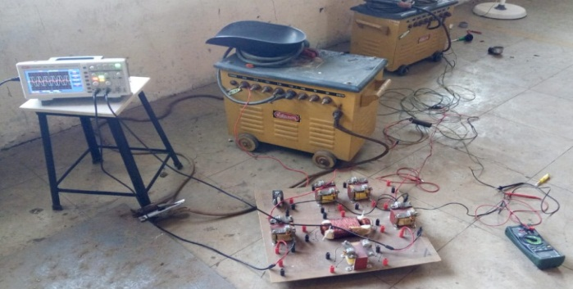
Fig 1-Experiments Setup

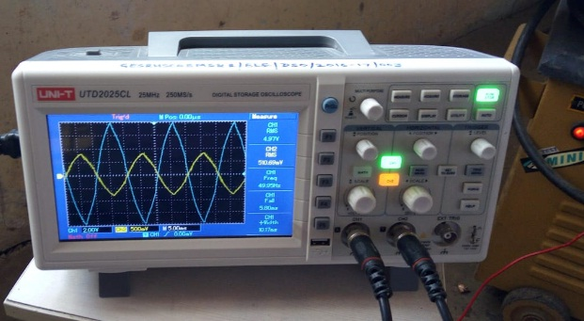
Fig 2-Experiment results which shows phase shifts

- Components of a Electric Traction System

- Transformer And Rectifier Substation
Commonly, Indian Railway system uses supply to run electric trains comprises only two phase of three phase electric power supply. Feeding the two phases at different feeder switched between A-B, B-C, and C-A, maintains the complete balance of the system. This might imbalance the three phase supply but is better than single phase supply [9]. In this paper, two substations are used and each substation having two locomotive and both substations are identical to each other. The major components of Microgrid are Distributed Generations (DGs), Loads, Storage devices, Control center, Point of Common Coupling.
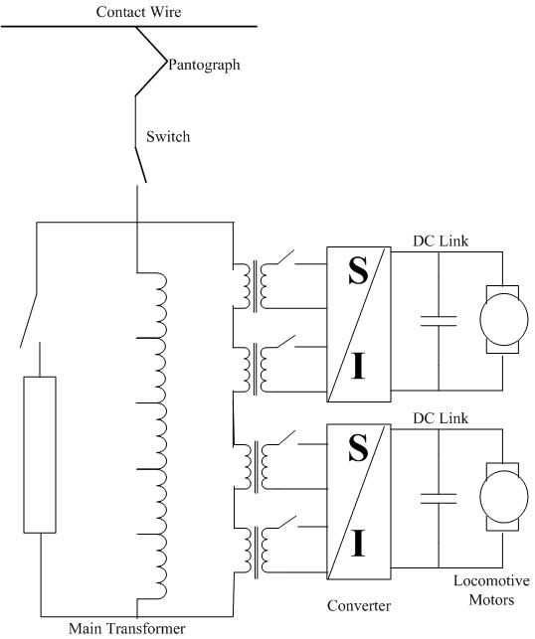
Fig. 3-Representation of traction supply to locomotive[16]
- DC-link
The DC-link is used to maintain the voltage across the traction motor using variable capacitor. Now, output of rectifier is supplied to DC-link then it is supplied to the locomotive motor [11].
- Locomotive Design
In traction system several locomotives are used to drive the wagons. In this model DC series motor as locomotive having rating of 2.5MW is implemented. A step-down transformer (single phase three winding saturable transformer) which step down 25kV to 750V supplying two half controlled Thyristor-Diode bridge rectifier as shown in the figure 3.
- Implementation of solar Energy System with Traction Power Supply
These models have been implemented so that the energy from the RES system (Solar energy system) can be interfaced with grid by power electronic converter through DC link. Now power from the grid can be used to serve the locomotive model connected to the Traction line by their substation. The AC power in the transmission line in converted into DC by using rectifier and fed to the DC series motor (DC Traction system). The Solar energy system is supplying power to Traction system through back to back converter consist of rectifier and inverter. The power developed by the Wind energy source is fed to the DC link capacitor then it is fed to the grid interfaced inverter, from where the developed power is injected to the grid which is already been connected to the traction system.
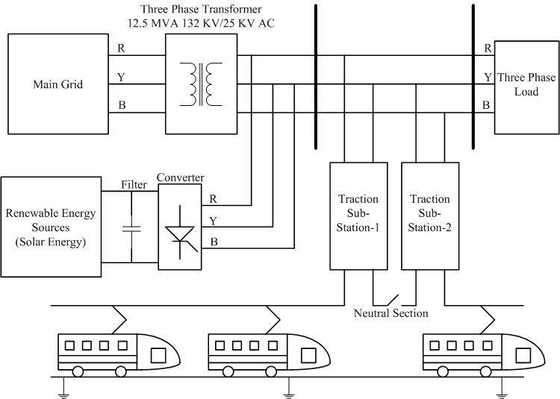
Fig.4- Implementation of Solar energy system supplying power to Traction system [16]
Figure 4 indicates the various components & system of connections Solar PVs are employed which can be mounted on platform rooftops at every strategic station. Neutral section as usual serves the phase balancing on AC side. It will be an independent source forming a railway 25kV AC Grid as per conventional system.
IR has ventured in to various RE Models to meet 8% RPO but the major chunk of Traction power using Solar Roof Top still remained untouched due to commercial & Technical complexities. Intermittency of RE has been a barrier to cast its effective role in feeding the traction load. Traction load too is of cyclic nature as can be seen when the train commutes entering a station or accelerating further out of station.
- Modes of Solar power Traction
Modes of Solar Electrical Traction are Solar Panel DC to Traction DC or to Traction AC. On the basis of Locomotives OHE Equipment set up can be classified as AC or DC Traction. The intended system consists of renewable energy source connected to grid-interfacing inverter via DC-link as shown in Fig. 4. The voltage source converter is a dominant component of a distributed generation system as it connects the RES to the grid and supplies the developed power. The RES can be AC source or a DC source with rectifier fixed to a DC-link. The RES is separated by DC-capacitor from grid and maintains the self-regulation of converters on each side of DC-link. Due to irregular nature of RES system, variable power generation takes place from Renewable energy to grid through DC link, where renewable energy source act as current source feeding grid interfaced inverter [12]. As the development of the many locomotive loads like steam, diesel engine they become competent with each other results in electrification of railway system, and these results in need of a system called Traction Power Supply System (TPSS). Indian railway system having is mostly an electrified network as we already aware of the fact that electric locomotive is major part of the railway system and due to this electric locomotive technology it results in widespread rise in speed. For analyzing the power quality, 25kV Indian railway substation model has been considered. Two substations each having rating of 25kV is supplied by three phase system of 220 KV, 50Hz as shown in fig 1. The simulation models given in this paper are modeled for a transmission line having length of 40 KM fed by their substation with several locomotive loads (DC motor/Induction motor).DC network with trackside rectifiers and transmission voltage between 600 V and 1.5 kV are standard for urban and regional lines upto 100 km long. The DC series motors can be started and run in resistance control mode when switched from series to parallel connection as speed increased. With the development of power electronic devices it reduces the size and weight of inverter and chopper drives due to which DC supply is still beneficial for use [9].
- Challenges
- Off-take of RE power is a challenge due to price competitiveness with conventional sources of power considering net value of off-take. It is imperative to develop market driven mechanism in addition to regulatory interventions in order to foster higher shares of renewable into the grid.
- Low cost financing mechanism and adequate financial instruments are needed to foster increased share of renewable into the grid.
- Significant amount of RE share to be traded over the Power Exchanges (PXs) in the long run.
- Ancillary and balancing reserve products to be traded on the PXs.
- Introduction of reserve products derived from flexible loads.
- Incentivising grid discipline by introduction of generator and or consumer Balancing Groups/ DSO and Aggregators.
- Challenges for Balancing and Integrating RE in India need to be addressed:
  - Limited ability to back down generation.
  - Low availability of hydro power for balancing – multi-purpose of hydro plant also restricts flexible dispatch; low pumped storage capacity and location in states with lower RE shares;
  - Low availability of gas-fired thermal power – shortage of fuel availability and high cost of natural gas Uncertainty of RE supply – absence of forecasting RE
- Rate of change of power contribution from RE – fast change in radiations
- Commercials Challenges
- The Grid connected Roof top is less dependent on fossil fuel and reduces requirement of land, for addition of capacities. It also reduces dependency on grid power, and provides ease of connectivity, particularly in net metering arrangements. Govt has accorded Income Tax benefits as one time investment provides 25 years of clean energy generation. 80% solar generation off-sets normal hours and 20% off-sets peak hour demand.

For settlement of excess generation:

- For consumers in the ambit of Time of Day tariff, the electricity consumption in any time block peak, off-peak or normal shall be first set off with the solar generation in same time block.
- Any excess generation over consumption in any time block shall be moderated as per the relevant rebate/surcharge percentage of ToD tariff applicable as per Regulator Guidelines.

- The Consumer shall be paid for net energy credits which remain unadjusted at the end of the financial year at the rate of Average Power Purchase Cost (APPC) of DISCOM.
- Technical Challenges
Presently, grid tied PV penetration in India is very low
compared to European countries. The severities of challenges posed will gradually increase as penetration rises. Thus, precautionary measures need to be taken to address the future issues. Following are the challenges envisaged and need to be addressed by utility during grid integration.
Safety, Power quality, Load Masking, Voltage rise, Protection Mis-cordination, Fault Level Increase Cascade tripping.
III- METHODOLOGY
Direct Solar interface to 25kV Railway Traction System
Connecting distributed renewable energy generators to alternating current railway traction systems remains a promising possibility, particularly where connections can be integrated during new electrification works. This opportunity should be factored into future rail electrification planning. Each ac traction substation covers a large length of the track and could connect a large solar PV array to the grid supply point. On AC electrified routes, there are also auto-transformer sites, typically spaced every 10 km to boost the ac voltage. The traction load on the railway and solar generation are both intermittent, so they need to be matched as closely as possible for solar traction power to be effective: the intermittency of the dc load needs to be reconciled with the intermittency of the DC generation.
A train travelling at 100 km/hr will take just under five minutes to travel between each traction substation, and each train may consume up to 4 MW of electricity. This causes large changes in the power supplied at the substation as the traction load is only supported for a short duration while the train is travelling past. If there are no other trains in the area, the demand will quickly fall to zero once the train has passed. In sections of track where there is a high frequency of trains, the substations can be said to have a base load. As per data collected from Igatpuri 132 KV MSETCL receiving station the base load is approximately 1MW, with frequent peaks between 3MW and 5MW. The pattern of the trains and location of the traction substations will affect the base load and the load peak observed.
Our government has the most aggressive solar deployment target in the world, aiming for 100 GW of installed solar PV generating capacity by 2022. But energy analysts have identified inadequate distribution and transmission infrastructure as a major obstacle to realizing this ambition.
Meanwhile, India already has over 25,000 km of electrified rail tracks. In spring 2017 the Rail Minister announced a 50% increase in investment in electrification, and an increased target of 2000 km of new routes to be electrified annually. Indian Railways is already working with the UN Development Programme to deploy solar PV on 8,500 stations, while the Delhi Metro has contracted developers to build the “world’s largest single-site solar project”, which will supply 90% of its daytime operating electricity needs-albeit via the standard distribution network.
Solar traction power is both technically feasible and commercially attractive under today’s market conditions. It offers important cost, engineering and efficiency advantages over other models of renewable energy generation and supply. It represents a new route to market for unsubsidized solar energy in the country and a means to circumvent grid capacity constraints that are now a major barrier to new renewable energy. Hundreds of megawatts of new solar generation could be connected to India’s AC traction networks, with vast potential on electrified railways. Plans for new electrified rail routes in the tropics could be rolled out exclusively via solar with no need for local power grids to keep up.
IV- RESULT & DISCISION
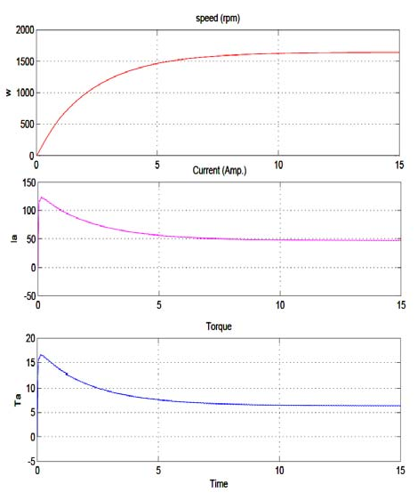
It is concluded from the figure 5 that, when solar energy system interconnected with the traction power supply, the required power for the load results in drastic increase which is a useful results for growing energy demand. Half controlled converter is used in DC traction system. Output result of rectifier is shown in figure 5 produces the required voltage for the dc traction. The sinusoidal supply applied to the half controlled rectifier giving the 750V required voltage which is fed to the DC series motor to drive the locomotives. The traction system using the series motors for driving the locomotive, as the DC series motor has capability of developing high starting torque and current, which helps to attain the speed. By simulating DC motor it results in high starting torque and smooth variation in speed of locomotive and after some time it gets stable.

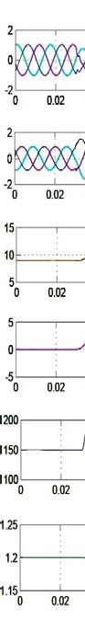
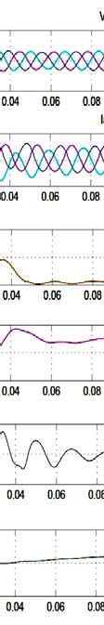
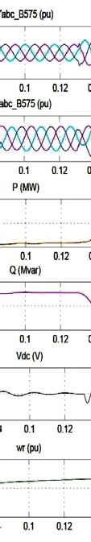
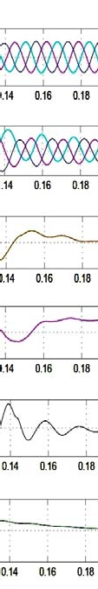

Fig. 5: DC traction system output response when fed through Solar Energy system [16].
V- FUTURE SCOPE
As the study process is still on, it is imperative to advance research work further such as:
- Simulating the interface model shown in figure 6 to find out:
- What would be the phase difference between R1, Y1 and B1?
- What would be voltage between R1, Y1 and B1?
Next to this will be modelling the components with design values for customized units for each railway station from Bhusaval to Igatpuri for Technical commercial feasible viable aspects.
- To establish Station specific solar interface models for its capacity hosting factor & allied parameters like Gen load balance voltage & current & frequency profiles interphase load Transfer etc..

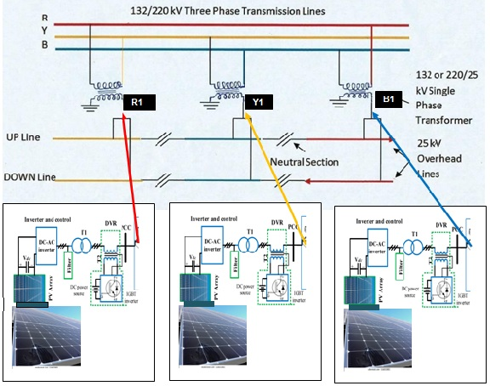
Fig. 6-Actual solar Generation direct interface can be realized with the connection set up
VI- CONCLUSION
This paper represents the effective technique of interconnection of Solar Energy with Traction power supply system, The RES is synchronized with the grid and it doesn’t have an impact on the output results of the traction line, and the reliability and availability of supply is maintained due to RES, as it is a important source of supply. The simulation model of Solar energy system interconnected with Traction power supply system is given along with the output waveform of torque, speed, current, voltage etc. show locomotive parameters are not affected by interconnection.
REFERENCES
- Radovan Doleček, OndřejČerný, Zdeněk Němec and Jan Pidanič , (2017). The Behavior of the Traction Power Supply System of AC 25 kV 50 Hz During Operation, addressing transients © Springer International Publishing AG.
- Dr Nathaniel Bottrell, (2017). Plugging solar power into our railways research associate at Imperial College London (ICL), RTM July 2017.
- Titiksha Joshi, Gerald Heydt and Raja Ayyan, (2014). High Frequency Spectral Components in Distribution Voltages and Currents due to Photovoltaic Resource North American Power Symposium (NAPS), USA.
- Sabah Mashaly, MokhtarHussienAbdallah, (2016). Low Voltage Ride through and fault ride through Capability of 40 kW PV Model grid connected, Conference on Saudi Arabia Smart Grid (SASG).
- Neel Mathews, NarendarRao, Gowrisankar, BiswajitPattnaik, G. Siva Prasad, (2016). Grid tied Roof top solar: problems, learning’s and Solutions tapping the ‘power cut’, First International Conference on Sustainable Green Buildings and Communities (SGBC).
- Ashutosh V Pailwan, IndranilChatterjee and K. Rajamani, (2016). Roof Top Photovoltaic Grid Integration: Utility Approach, International Conference on Electrical Power and Energy Systems (ICEPES).
- RohithVarier, and Naran M. Pindoriya, (2014). A Novel Active Anti-Islanding Protection Scheme for Grid-Interactive Roof-Top Solar PV System, Eighteenth National Power Systems Conference (NPSC).
- Abhishekh K. Singh, Amitabh Sinha , Asheesh K. Singh&R. Veeraganesan, (2016). Solar PV fed Grid Integration with Energy Storagesystem for Electric Traction Application” 10th. International Conference on Intelligent Systems and Control (ISCO).
- Hitoshi Hayashiya, Shinya Kikuchi, Kazushi Matsuura, Masami Hino, MasateruTojo, Tetsuya Kato, (2013). Possibility of energy saving by introducing energy conversion and energy storage technologies in traction power supply system, 15th European Conference on Power Electronics and Applications (EPE) France.
- M. J. Lencwe; S. P. Chowdhury; H. M. ElGohary, (2016). Solar Photovoltaic Integration on Locomotive Roof Top for South African Railway Industry, 51st International Universities Power Engineering Conference (UPEC).
- Ming Meng1*, Yaning Yuan1, Mingwei Guo1, Li Jiang2, Jian Liu2, Dalong Hu2, Haiyang Cong3, and Dan Hao4, (2014). A Novel DC Microgrid Based on Photovoltaic and Traction Power Supply System, IEEE Conference and Expo Transportation Electrification Asia-Pacific (ITEC Asia-Pacific).
- Mohamed Rageh, AugusteNdtoungou, Abdelhamid Hamadi and Kamal Al-Haddad , (2018). Railway Traction Supply with PV integration for Power Quality Issues, 44th Annual Conference of the IEEE Industrial Electronics Society.
- Ming Meng1*, Yaning Yuan1, Mingwei Guo1, Li Jiang2, Jian Liu2, Dalong Hu2, Haiyang Cong3, and Dan Hao4, (2014). Hybrid Bidirectional Interactive DC Traction Power Supply System with Microgrid ”IEEE Conference and Expo Transportation Electrification Asia-Pacific (ITEC Asia-Pacific).
- Weijie Pan, Surya Chandan Dhulipala and Arturo Suman Bretas, (2017). A Distributed Approach for DG Integration and Power Quality Management in Railway Power Systems, IEEE International Conference on Environment and Electrical Engineering.
- Kenji Sato, Masakatsu Yoshizawa, and Takafumi Fukushima, (2010). Traction Systems Using Power Electronics for Shinkansen High-speed Electric Multiple Units, International Power Electronics Conference - ECCE ASIA.
- Laxman Singh; Chandan Vaishnav; Vivek Shrivastava, (2016). Performance Analysis of Hybrid Network of Indian Traction Power System using Renewable Energy Sources, International Conference on Micro-Electronics and Telecommunication Engineering (ICMETE).
- Yevgen Sokol; Volodymyr Zamaruiev; Volodymyr Ivakhno; Bohdan Styslo, (2018). Improving the Quality of Electrical Energy in the Railway Power Supply System, IEEE 38th International Conference on Electronics and Nanotechnology (ELNANO).
- Satoru Sone, (2010). Improvement of traction power feeding/ regeneration system by means of energy storage devices, Electrical Systems for Aircraft, Railway and Ship Propulsion.
- Qian Wang; Jun Lu; Qingfeng Wang; Jiandong Duan, (2017). Transient Overvoltage Study of Auto-passing Neutral Section in High-speed Railway, IEEE Transportation Electrification Conference and Expo, Asia-Pacific (ITEC Asia-Pacific).
- Fulin Zhou; Qunzhan Li; Daqiang Qiu, (2010). Co-phased traction power system based on balanced transformer and hybrid compensation, Asia-Pacific Power and Energy Engineering Conference.
- Kalpesh A. Joshi; N. M. Pindoriya,(2012). Impact Investigation of Rooftop Solar PV System: A Case Study in India,,3rd IEEE PES Innovative Smart Grid Technologies Europe (ISGT Europe).
 | Nagesh S. Pande received his AMIE degree in Electrical Engg. in 2003 from Institutes of Engineers Kolkata, MTech in Power Systems from COEP Pune, in 2012.

He is Persuing his Ph.D degree at KBC North Maharashtra University Jalgaon. He is working as an Emeritus Professor at GES’s College of Engineering, Nashik. He has track of MSEB Services at Zimbabwe (Africa), Parli, Bhusaval & Nashik Thermal Power Plants from 10th of June 1976 to 31st of July 2014.

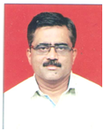
Dr. Atul R. Phadke received his BE degree in Elecrical Engineering from Walchand College of Engg. Sangli, India, in 1988, his ME degree in Electrical Power System, in 2001 from COEP Pune, India.
He has done Ph.D in Electrical Power System from Malaviya National Institute of Technology Jaipur, India in 2010. He is working as an Associate Professor at Government College of Engineering, Karad, Dist Satara.
He was the Head of Electrical Engineering Department and Chairman, Board of Studies (Electrical Engineering) at Government College of Engineering, Jalgaon.

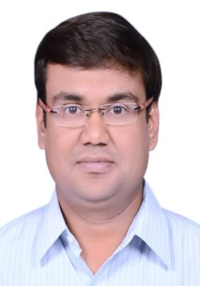 | Dr. Prashant J. Gaidhane received his BE degree in instrumentation engineering from SGGSCE&T, Nanded, India, in 1998, his MTech degree in instrumentation, in 2009 from Indian Institute of Science (IISc), Bangalore, India.
He is working as an Associate Professor at Government College of Engineering, Jalgaon. He has done Ph.D in Electronics & Communication Engineering Department at IIT Roorkee, India. His research area is evolutionary algorithms and their applications in control system design.

