College Placement Management System

Aditya Wandile^{1,} Deepak Agashe², Mehul Chaodhari³, Abhishek Yadav⁴, Prof. Komal Jaisinghani⁵

^{1, 2, 3, 4}Student, ⁵Assistant Professor
Department of Computer Engineering, SVPCET, Nagpur, Maharashtra, India

adityawandile12@gmail.com

Received on: 12 May, 2024 Revised on: 20 June,2024, Published on: 22 June ,2024

Abstract—This paper describes the design and development of a College Placement Management System (CPMS), a transformative platform that ushers in a new era of streamlined and efficient campus recruitment. The CPMS tackles the inherent roadblocks of traditional, manual methods, characterized by sluggish processing, inconsistency, and information bottlenecks. By leveraging a modern technology stack, the system fosters a user-centric environment that empowers students, placement administrators, and companies to seamlessly navigate the placement journey, from initial registration to successful job placement. The interactive frontend, built with ReactJS, provides an intuitive user experience. The robust backend, powered by NodeJS, handles complex data processing and business logic. The flexible MongoDB database serves as the central repository for all placement-related data. This synergy between frontend, backend, and database empowers all stakeholders to actively participate in the placement process. Students can effortlessly manage their profiles, submit applications, schedule interviews, and track job offers. Placement administrators gain a centralized hub for managing company data, facilitating communication with recruiters, streamlining job postings, and analyzing placement statistics. Companies, through an optional secure interface, can efficiently post jobs, access student profiles that match their requirements, and manage the recruitment process with greater transparency and ease. Ultimately, the CPMS streamlines tasks, facilitates clear communication, and enhances transparency for all stakeholders, leading to a more efficient and effective campus recruitment ecosystem.

- INTRODUCTION
The manual process of conducting training and placement activities at colleges often involves extensive

human intervention, leading to a higher likelihood of errors. One of the significant challenges faced in this process is the management and updating of student data. For instance, at a typical college, a placement officer may have to handle profiles and documents for hundreds or even thousands of students. This includes maintaining records of academic achievements, resumes, cover letters, and other relevant documents. Placement officers are tasked with gathering information from various sources, including students themselves, faculty members, and external recruiters. They must categorize student profiles based on different academic streams, such as engineering, business, or liberal arts, and match them with relevant job opportunities. This requires meticulous attention to detail and organizational skills to ensure that each student’s profile is accurately rep- resented. Moreover, the process of notifying students about job opportunities and scheduling interviews also relies heav- ily on manual intervention. Placement officers often have to send out mass emails or announcements through college portals, which can be time-consuming and prone to errors. Additionally, updating student profiles or making changes in the database requires manual input, increasing the risk of data entry mistakes and inconsistencies. As the number of students and companies participating in campus recruitment programs continues to grow, the manual approach becomes increasingly unsustainable. It not only consumes valuable time and resources but also leaves room for errors that could potentially impact students’ career prospects. Therefore, there is a pressing need for colleges to explore more efficient and automated solutions for managing training and placement activities.

- LITERATURE SURVEY
The current methods and projects employed by placement cells are laborious and time-consuming, often beset by human error and analytical challenges. These shortcomings in the system result in significant maintenance issues and dropout rates among students. The manual nature of the work makes documentation and categorization exceptionally challenging, leading to intricate administrative processes and substantial analytical expenses, rendering the system inefficient and costly [4].
To address these issues, a simplified interface is proposed for the effortless organization and upkeep of student information. Accurate and up-to-date information concerning students’ academic journeys is essential for both students and faculty members [6]. However, the predominant reliance on manual labor in the existing system introduces significant delays in procedures. Records stored in modified access sheets exacerbate sorting and searching difficulties, making updates and management cumbersome and ambiguous. Duplication of files further complicates data management, potentially resulting in missed training and placement opportunities for students due to inadequate communication channels between students and the training and placement department.
As the number of users grows, managing user data becomes increasingly burdensome and time-intensive. A proposed solution is an online system accessible via secure login credentials, serving as a central repository for student
system could streamline recruitment processes for the college’s Training and Placement department [5]. Students could easily assess their eligibility for upcoming placement drives based on their CGPA for specific organizations. However, manual processes such as administrator-created user accounts and subsequent user actions introduce delays and complexities [4]. Users, including students, have limited functionalities such as updating their information, querying data, and communicating with the administrator, all subject to approval processes and system restrictions. The paper proposes a site-based, paperless College Management System aimed at reducing manpower requirements and facilitating remote monitoring and control. It emphasizes the importance of accurate information avail- ability and highlights the benefits of web-based information management systems in educational institutions [1]. The study introduces a web-based application for college management and timetable generation, streamlining scheduling tasks for students, staff, and invigilators. It emphasizes the reduction of manual work and errors through automated scheduling processes [2].

- ARCHITECTURE
The architecture of the proposed system is depicted in Figure 1. The system is devised to streamline interaction between

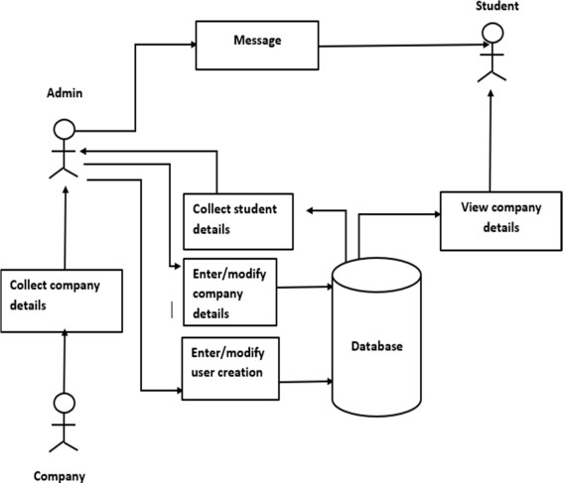

Fig. 2: Process Flow of the System

- PROPOSED METHODOLOGY
The proposed College Placement Management System (CPMS) aims to address the inefficiencies and challenges associated with manual placement processes in educational institutions. The methodology involves the development of a comprehensive system that automates key tasks, streamlines communication, and provides data-driven insights to improve placement outcomes.

- System Design
The system design encompasses the architecture, functionalities, and user interfaces of the CPMS. It involves the following steps:

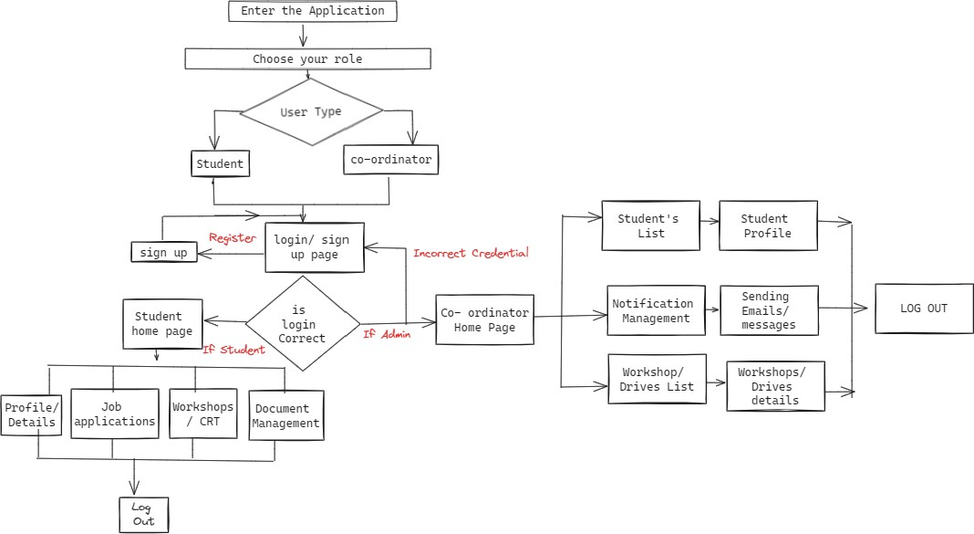

Fig. 1: Proposed System Architecture

administrators and students. Administrators bear the responsi- bility of gathering and organizing company details, student information, and notifications. They possess the authority to create new user accounts, adjust existing user profiles, and dispatch messages or notifications to students. Conversely, students can utilize the system to access pertinent company information and details regarding placement drives.

  - PROCESS FLOW
The process flow of the system is illustrated in Figure 2.
  - Requirement Analysis: Understanding the specific requirements of educational institutions, placement officers, and students regarding placement management.
  - System Architecture Design: Designing the architecture of the CPMS, including the frontend, backend, and database components. This involves selecting ap- propriate technologies such as ReactJS for the frontend, NodeJS for the backend, and MongoDB for data storage.
  - Database Schema Design: Designing the database schema to efficiently store and manage student profiles, company details, placement records, and other relevant information.
  - User Interface Design: Designing intuitive and user- friendly interfaces for students, placement officers, and administrators to interact with the system.

- System Implementation
The implementation phase involves the development and integration of various system components. It includes the following steps:
  - Frontend Development: Developing the frontend inter- face using ReactJS to provide a dynamic and responsive

The process flow diagram outlines the sequential steps involved in managing the placement process within the educational institution. Starting from the collection of company and student details by the administrator, to the dissemination of notifications and access to placement drive information by students, each stage is essential for the smooth functioning of the system.
user experience.
  - Backend Development: Implementing the backend logic using NodeJS to handle user requests, process data, and interact with the database.
  - Database Integration: Integrating MongoDB as the database backend to store and retrieve placement-related data efficiently.
  - Functionality Implementation: Implementing core functionalities such as student registration, profile management, company registration, placement drive scheduling, and communication features.

- System Testing and Deployment
The testing and deployment phase ensures the reliability, performance, and security of the CPMS before its deployment in educational institutions. It includes the following steps:
  - Unit Testing: Conducting unit tests to validate the functionality of individual system components.
  - Integration Testing: Testing the integration of frontend, backend, and database components to ensure seamless operation.
  - User Acceptance Testing (UAT): Involving stakeholders, including placement officers and students, in UAT to validate the system against real-world scenarios.
  - Security Testing: Performing security audits and penetration testing to identify and address potential vulnerabilities.
  - Deployment: Deploying the CPMS in educational institutions, ensuring proper configuration, data migration, and user training.
The proposed methodology aims to deliver a robust, user- friendly, and efficient College Placement Management Sys- tem that addresses the unique requirements of educational institutions and enhances the overall placement experience for students and placement officers.
    - RESULT
Certainly! Here’s a more concise and direct version of the results section focused on incorporating screenshots of the login/signup pages, dashboard pages, job management features, and other relevant aspects of the College Placement Management System (CPMS)
- Login Page
The CPMS provides a straightforward and user-friendly interface for user registration and login.
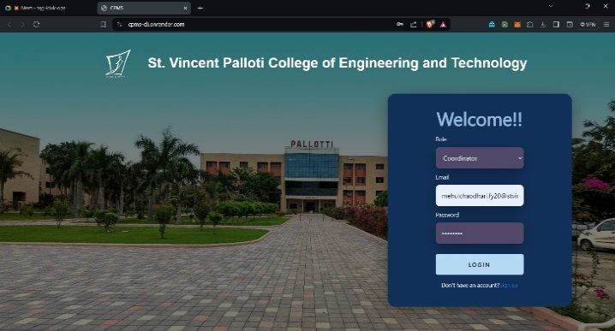

Fig. 3: Signup/ Signin Page

Dashboard Page
The dashboards in the College Placement Management System (CPMS) provide users with critical information and functionalities at a glance. The Student Dashboard displays previous placement history, the total number of students placed, and information on upcoming and past company drives, allowing students to track their progress and explore new opportunities. The Employer Dashboard offers employers insights into job postings, application statuses, and engagement metrics, facilitating efficient management of the recruitment process and interaction with potential candidates.
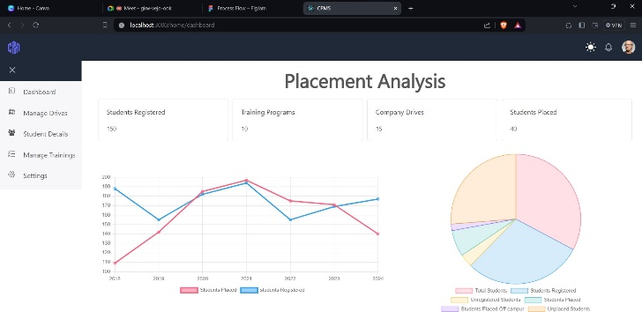
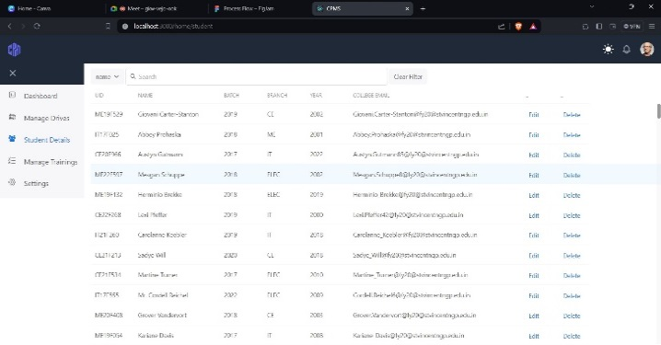
Job Post Management
The job management module facilitates efficient posting, viewing, and application processes for job opportunities. Employers can create and post new job openings by completing a detailed form, while students can browse and search for job opportunities that match their skills and interests. Additionally, students can submit applications and track their progress, and employers can review applications and contact candidates, streamlining the entire recruitment process.

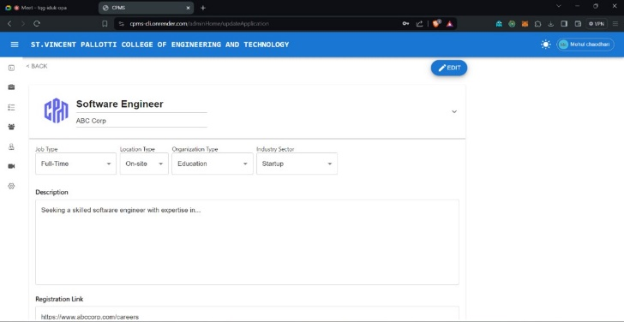

Fig. 4: Dashboard Page

