Smart Traffic Safety and Enforcement System

Kunal Wadibhasme¹, Diksha Ladke², Gunjan Rokade³, Gajanan Fulzele⁴, Dr. Sunil Wanjari⁵

^{1, 2, 3, 4}UG Engineering Students, ⁵Associate Professor
Department of Computer Engineering, St. Vincent Pallotti College of Engineering and Technology, Nagpur, Maharashtra,

kunalwadibhasme27@gmail.com

Received on: 12 May, 2024 Revised on: 20 June,2024, Published on: 22 June ,2024

Abstract— Due to the increasing population and increasing people's needs, people are buying more cars, especially motorcycles. The increase in the number of cars will cause accidents, and to avoid accidents, people will try to break the law and encounter problems, which will cause many people to die. In recent years, we have observed an increase in accidents that injure people due to not wearing helmets, mostly on motorcycles. We can reduce accidents and injuries by using helmets. Law enforcement is often inadequate. More power and electronic standards are needed to control these violations and manage traﬃc problems and attainment issues. Therefore, a security and traﬃc management policy needs to be created. The system detects motorcycle riders who are not wearing helmets, then verifies the driver's license sets up an electronic call system for the driver, and notifies the driver via email. The system is faster and more eﬃcient than humans because traﬃc police take images of people who violate traﬃc rules and issue warnings, but traﬃc police cannot catch many crimes at the same time.

I-INTRODUCTION

Motorcycle accidents have increased rapidly over the years in many countries. Helmets are important safety equipment for cyclists. But many drivers do not use it. A report published by The Times of India stated that 87 percent of deaths in road traﬃc accidents (RTA) involving two people are due to not wearing a helmet. 87% of people killed in two-wheeler accidents are due to not wearing a helmet; 70% of them are drivers and 30% are passengers. The main purpose of the helmet is to protect the driver's head in the event of an accident. In this case, not wearing a helmet could be fatal. It also prevents serious injury to the

head by aﬀecting the impact force over a wide area. More importantly, it acts as a link between the head and the objects the driver encounters. It is not easy for the police to monitor all motorcycles and find those who are not wearing helmets. Capturing images manually is a tedious task and cannot guarantee 100% coverage of all vehicles.
Therefore, by analyzing traﬃc rules, we aim to create a special model for such situations and punish passengers or citizens who violate traﬃc rules. Direct images taken from CCTV cameras will be examined accordingly and penalties will be determined based on the presence of helmets and phone numbers detected. The video was cut into frames and transferred to the model. Computer vision cv2 is used to detect and identify whether people are wearing helmets. Yolov5 is used to check if the helmet is present and if not, to detect the license plate. A simple OCR extracts the number from the plate and issues a Challan to the passenger.

- RELATED WORK
There are many applications for computer vision, image processing, and image recognition, including remote sensing, defect detection, path detection, decision-making, and pose detection. A model of automatic helmet detection in a real-time environment has been developed by numerous researchers using various approaches and techniques to address the issue.

Cheverton [1] created a system to distinguish between bikers wearing helmets and those who do not, utilizing background subtraction and support vector machine (SVM) techniques. The system has been trained using the self-generated dataset. There are two key shortcomings with the system, though.
- It raises the total computational cost by scanning the entire frame for helmet detection.
- The number of heads without a helmet was misclassified. A system based on the K-nearest neighbor (KNN) classifier was developed to help distinguish between motorcycle riders who are wearing helmets and those who are not, Waranusast et al. [2]. The self-created dataset has been used to test the system. An input webcam provides the image. According to the experimental findings, the system correctly detected 68%, 84%, and 74% of the far lane, near lane, and both lanes, respectively.

A summary of traffic violation detection and monitoring systems is given in "An Overview of Traffic Violation Detection and Monitoring Systems" by S. Ghose, S. Sarkar, and S. Das [3] (2021). It also covers the different methods for object detection and categorization. The writers go on to address the difficulties of putting these procedures into place: The necessity for precise data and the challenge of finding infractions in intricate traffic scenarios. To increase the precision and effectiveness of traffic infraction detection systems, they recommend further study in this area.

R. Gupta and P. Anand [4] (2020) created a system called "Real-Time Traffic Rule Violation Detection and Alert System using Deep Learning" that makes use of deep learning methods. To generate alerts in real time, developers employ an LSTM network and the YOLOv3 algorithm for object identification and categorization. A traffic rule violation detection system based on deep learning approaches was proposed in "Traffic Rule Violation Detection System using Deep Learning Techniques" by R. Jain and V. Jain [5] (2019). The authors employ an SVM classifier for traffic rule violation detection and a YOLOv3 algorithm for object recognition and categorization.

- PROPOSED METHODOLOGY
The first step in the development of helmet detection and number plate recognition is to take input video and then extract frames from the regions of interest. The extracted frames are then processed for object detection. YOLOv5 is designed to be fast, accurate, and easy to use, making it an excellent choice for a wide range of object detection, instance segmentation, and image classification tasks. It is a one-stage proposal-free algorithm and performs all the predictions using a single fully connected layer in a single iteration.

Figure 1. Flow Chart of model

Even though YOLO struggles with the identification of small objects present in clusters and may not give good accuracy in such a situation YOLOv5 is good for finding an object but not for dividing an object. Therefore, ResNet50 is used as an image classification algorithm for better results. ResNet stands for Residual Network and is a specific type of convolutional neural network (CNN).ResNet-50 is a 50-layer convolutional neural network (48 convolutional layers, one MaxPool layer, and one average pool layer). Residual neural networks are a type of artificial neural network (ANN) that forms networks by stacking residual blocks. ResNet is a convolutional neural network that enables the use of extremely deep neural networks by overcoming the vanishing gradient problem of CNN. ResNet uses Skip Connection to overcome the problem. Once the image is detected and classified as wearing a helmet or not, if not wearing a helmet then the number plate is extracted. Using Easy OCR the number present on the number plate is extracted. This number is then found in the database and issued an E-Chalan on the rider's mail. For object detection, the current model uses YOLOv5 pre-trained model and Resnet50 is used as an image classification algorithm for better accuracy of results.
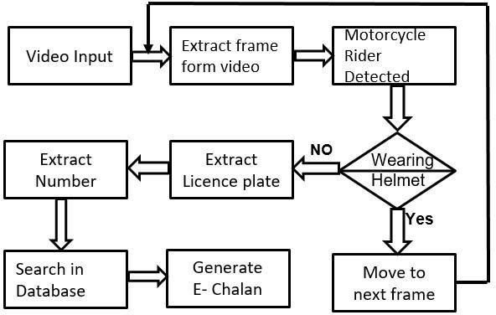
- YOLO
YOLO stands for You Only Look Once, a convolutional neural network (CNN) that identifies real-time objects with significant accuracy. This method uses a single neural network to process the whole image, then divide it into sections and predict binding boxes and opportunities for each component. These binding boxes are weighted with the expected possibilities. YOLOv5 is fast, which makes it an immensely powerful model for finding objects.

1) YOLOv5

YOLOv5 is a single-stage object detector made of three major components, the backbone, neck, and head. Similar to the convolutional layers of a CNN, the backbone's primary purpose is to extract key features from the input image. This project used the YOLOv5 Oriented Bounding Boxes (YOLOv5_OBB) based on the YOLOv5 architecture. YOLOv5 (You only look once) is built on a system that divides the input image into a grid. Each region is accountable for detecting the objects inside itself within the grid system.YOLOv5 further by allowing for more accurate bounding boxes. The boxes produced by YOLOv5_OBB have an additional factor, orientation. Oriented bounding boxes allow the model's output to fit the objects of interest more closely and provide additional information about the object.
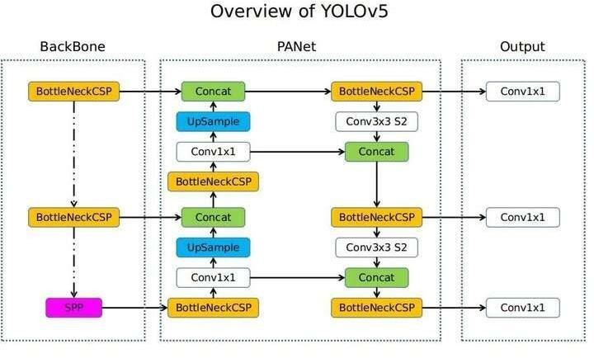

Figure 2. YOLOv5 Architecture

The model backbone is formed by Cross Stage Partial Networks (CSP), Wang et al. (2019), used to extract important features from the input image. The model neck’s main function is to generate feature pyramids which help with object scaling generalization. To do this, YOLOv5 uses Path Aggregation Networks (PANet), Liu et al. (2018). Finally, the head performs the final detection part and generates output vectors with the class, score, and bounding box. The activation function used is a very important part of any neural network. YOLOv5 uses a combination of Leaky ReLU and Sigmoid functions. The Leaky ReLU function is used in the hidden layers while the sigmoid function is used for the final detection layer.

- Resnet50
ResNet50 is a cutting-edge deep convolutional neural network architecture that was developed by Microsoft Research in 2015. It is a variant of the popular ResNet architecture and comprises 50 layers that enable it to learn much deeper architectures than previously possible without encountering the problem of vanishing gradients. The architecture of ResNet50 is divided into four main parts: the convolutional layers, the identity block, the convolutional block, and the fully connected layers. The convolutional layers are responsible for extracting features from the input image, the identity block and convolutional block process and transform these features, and the fully connected layers make the final classification.

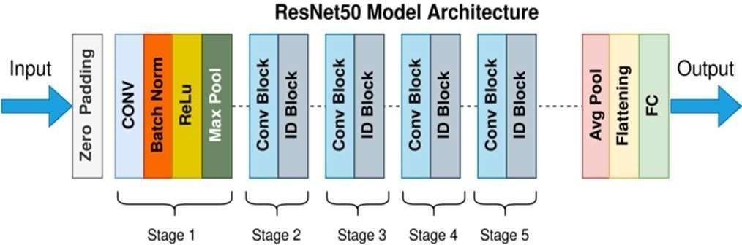
Figure 3. Resnet50 Architecture

- IMPLEMENTATION
We have used the YOLOv5 pre-trained model for object detection. The first step is to use YOLO for real-time object detection in a video stream or a series of images. As YOLO processes each frame, it identifies and draws bounding boxes around the detected objects, including the bike and its number plate.

Non max suppression function has been used on the predictions to suppress the less likely bounding boxes and keep only the best one. We choose those predictions with high confidence and suppress all the other predictions that overlap with the selected predictions, greater than a threshold. To identify if the rider is wearing a helmet or not ResNet50 has been used. The classified images are further then passed for number plate recognition. If a helmet is missing on the rider’s head, then that frame is further processed for number plate recognition.

Firstly a person riding a two-wheeler will be detected and enclosed in a bounding box. Now the scope of search for a helmet is limited in the bounding box itself. If the helmet in the bounding box is detected then detection moves to the next frames but if the head is detected then it further detects the number plate inside the bounding box. The detected number plate is then sent to Easy OCR to extract the number from it. The Extracted number is then verified in the database and E-Challan is issued to riders through EMail.

- RESULT

- Bounding boxes around ROIs
This figure shows the detection of regions of interest i.e., riders, helmets, and number plates. The region of interest is enclosed in bounding boxes with their respective confidence score.

Case 1:
When the Rider is wearing a helmet, the model detects the rider, helmet, and number plate and the model moves to the next frame.

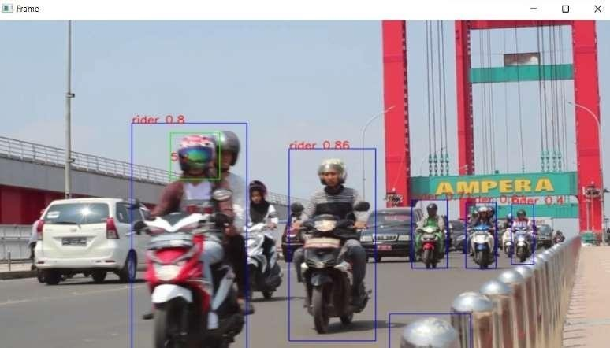

Case 2:
When the Rider is not wearing a helmet, the model detects the rider, head, and number plate.
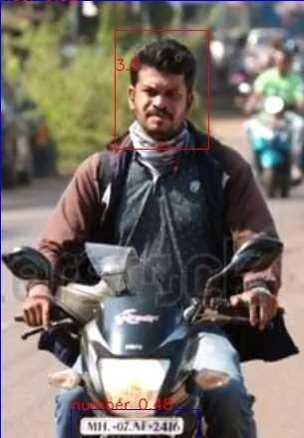
Number plate:

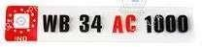
Recognition of a number plate:

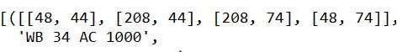
- Location of ROIs
This figure depicts the location of regions of interest i.e., riders, helmet, and number plate along the location in terms of x and y coordinates

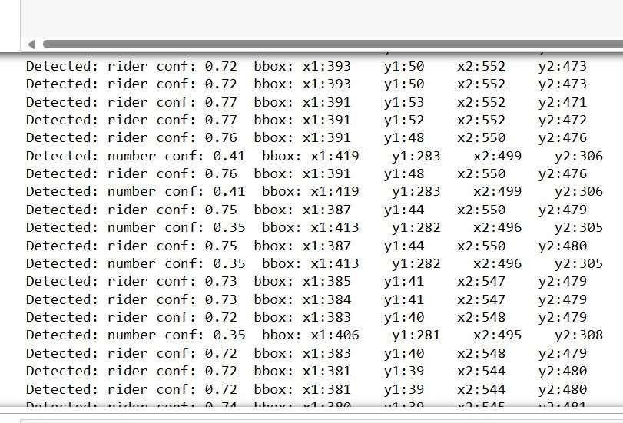
Fig. 9. Location of ROIs

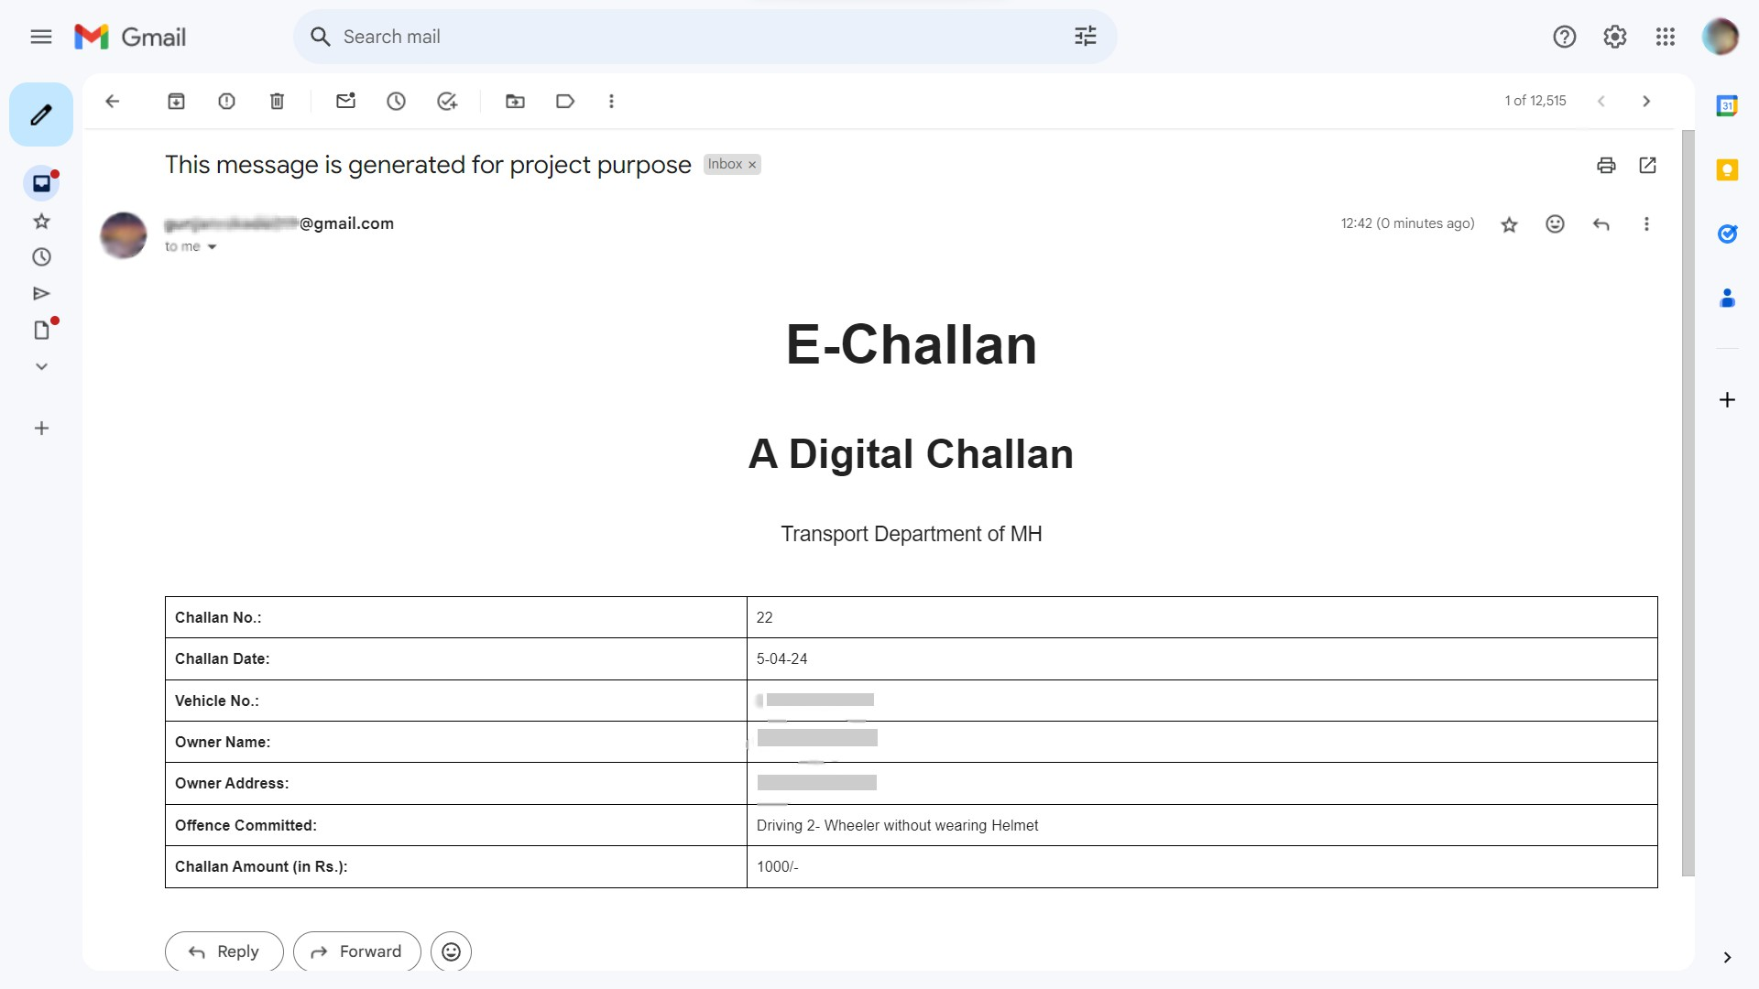
Generation of E-Challan: E-Challan was sent using Python’s SMTP library, which facilitates email communication in Python scripts. The process involved importing necessary modules such as smtplib, MIMEMultipart, MIMEApplication, MIMEText, MIMEBase, and email.utils, and encoding attach- ments when required.
Fig. 10. E-Challan via Email

- CONCLUSION AND FUTURE SCOPE

In conclusion, the integration of helmet and number plate detection using YOLOv5, number plate extraction using EASY OCR, and ISSUING E-Chalan to riders without helmets provides a robust and effective solution for promoting road safety and enforcing regulations. The advanced capabilities of YOLOv5 enable accurate and real-time detection of helmets on motorcyclists and bicyclists. A video file is used as the input for a system being developed to detect non-helmet riders. The motorcycle’s license plate number is retrieved and issued chalan on email if the rider in the video clip is not wearing a helmet.

To detect motorcycles, people, helmets, and license plates, the YOLOv5 architecture is used for object detection, and resnet50 is used for the classification of objects.
Future Scope: There are potential future advances geared Specifically at addressing the problem of triple riding to improve the current capabilities of identifying helmets and number plates. Algorithms and models will be developed to recognize cases in which three people ride on a two-wheeler designed for just two users.
REFERENCES
- J. Chiverton, “Helmet presence classification with motorcycle detection and tracking,” IET Intelligent Transport Systems, vol. 6, no. 3, pp. 259–269, 2012.

- R. Waranusast, N. Bundon, V. Timtong, C. Tangnoi, and P. Pattanathaburt, “Machine vision techniques for motorcycle safety helmet detection,” in Proceedings of the 2013 28th International Conference on Image and Vision Computing New Zealand (IVCNZ 2013), pp. 35–40, Wellington, New Zealand, November 2013.

- "An Overview of Traffic Violation Detection and Monitoring Systems" by S. Ghose, S. Sarkar, and S. Das (2021)

- "Real-Time Traffic Rule Violation Detection and Alert System using Deep Learning" by R. Gupta and P. Anand (2020)

- "Traffic Rule Violation Detection System using Deep Learning Techniques" by R. Jain and V. Jain (2019)

- P.Srinivas Reddy, Ramesh O., "A Video-Based Traffic Violation Detection System," Sep 2019.

- Miyim, Abubakar & Muhammed Alhaji, Mansur. (2019). Smart Traffic Management System.
1-6.10.1109/ICECCO48375.2019.9043219.

- "An Overview of Traffic Violation Detection and Monitoring Systems" by S. Ghose, S. Sarkar, and S. Das (2021)

- "Real-Time Traffic Rule Violation Detection and Alert System using Deep Learning" by R. Gupta and P. Anand (2020)

- "An Overview of Traffic Violation Detection and Monitoring Systems" by S. Ghose, S. Sarkar, and S. Das (2021)

