Waste Management System of Villages in Chandgad Taluka
Nikita Kanbarkar*¹, Shivaji Pujari², Pankaj Kalel², Aarti Kanase², Santosh Kolape², Akanksha Asawale², Tanaya Barde², Amol Kolekar², Pradip Langale²
¹Assistant Professor
Mahadevrao Wandre Institute of Technology Turkewadi Maharashtra India
²B Pharm Final Year Students
Mahadevrao Wandre Institute of Technology Turkewadi Maharashtra India

Received on: xxxx,20xx, Revised on: xxxx,20xx, Published on: xxxx,20xx

Abstract – A properly managed household solid waste can increase the health of the people as well as environmental quality. Thus, this study was conducted in 12 rural villages of chandgad Taluka to assess the Solid Waste Management practices followed at rural area. Data was collected through personal interviews with the help of the structured questionnaires were asked at 240 homes, based on the analysis, general waste management problems of peoples was studied. Finally in data analysis based on the responder’s information we found that majority of the respondents were aware of SWM (solid waste management) knowledge and they practice in their daily life. The waste disposal system among the 240 houses were found that 90% of people follow own disposal method and 10% dispose waste in municipal dustbin but 85% of people are agreed with lack of public dustbin in their area. Also some people are facing odour pollution in their areas which is more significantly found during rainy seasons. Improper disposal of solid wastes pollutes all the vital components of the living environment (i.e., air, land and water) at local and global levels.
Keywords- Solid waste management, dry waste, wet waste, rural area waste disposal, pollution
INTRODUCTION
Waste is defined as unwanted and unusable materials and is regarded as a substance which is of no use. Waste present in our surroundings known as garbage. The disposal is environmental problem and proper consideration should be taken to reduce environmental pollution[2]. Waste management is important as it saves the environment from the toxic effects of inorganic and biodegradable element. Mismanagement of waste can cause water contamination, soil erosion and air contamination. Waste can be recycled if collected and managed efficiently. Waste materials such as plastic, glass and paper can be segregated into individual part in order to process them which will save the natural resources[5]. Waste management will not only save natural resources, biodiversity, and human life, it will also impact the economy. In developed countries waste is disposed into garbage disposal sites while in developing economies the waste usually ends up on streets and vacant areas, recycling the materials can reduce environmental problem and would help to decrease waste disposal costs. Moreover, having knowledge about the different waste disposal methods or techniques would make the waste collection easier. Also proper waste disposal management services minimize transportation costs[6] .
Solid waste management is a difficult work because it utilizes a number technologies and disciplines. In this study, we visited 12 villeges comes under Chandgad Taluka. Maharashtra to investigate waste management process at these villeges. A questionnaire-based survey was conducted and collected data on waste management system in rural area of Chandgad Taluka.

METHOLOGY
We selected tweleve villages in Chandgad Taluka, to study waste management system of rural area. Total 20 houses were chosen for the evaluation from each village. The name of the listed villages given below:
- Turkewadi
- Yashwant Nagar
- Vaitakwadi
- Majre Karve
- Murkutewadi
- Mandedurg
- Halkarni
- Tadshinhal
- Mandwale
- Shinoli
- Sundi
- Devkarwadi
Following questioners were asked to the people:
- Which is the major part of waste in your home?
- What is the visiting frequency of waste collection vehicle in your area?
- Are you collecting the dry and wet waste separately?
- Are you facing any odour pollution due to road side waste disposal?
- In what type of container, you collect the waste?
- Where do you usually put away collected wastage?
- Are there any public dustbins near you house?
- Are you aware of biodegradable wastes?
- Do you face any specified problem with waste management near your home?
- Do you have any specific suggestion in current waste management process?

RESULTS AND DISCUSSION

Table 1- Method of waste disposal at home
Sr.No | Component | Percentage
1. | Own disposal method | 90%
2. | Disposal in municipal dustbin | 10%

Table 2- Major part of waste in your home
Sr.No | Component | Percentage
1. | Plastic | 20%
2. | Food waste | 25%
3. | Paper | 15%
4. | Dust | 40%

Table 3- Frequency of waste collection vehicle in your area
Sr.No | Component | Percentage
1. | Daily | 17%
2. | Alternate day | 20%
3. | Weekly | 23%
4. | Rarely | 40%

Table 4- Are you collecting the waste separately
Sr.No | Component | Percentage
1. | Yes | 85%
2. | No | 15%

Table 5- Type of container you collect the waste
Sr.No | Component | Percentage
1. | Cartoon | 7%
2. | Haste basket | 13%
3. | Old bucket | 35%
4. | Plastic bag | 18%
5. | Tin / Con | 5%
6. | Other | 22%

Table 6- The wastages is collected
Sr.No | Component | Percentage
1. | In the public bin | 8%
2. | By the valley/ lake side | 15%
3. | By the road /street side | 25%
4. | On an open space | 21%
5. | In a hail of own compound | 13%
6. | Other | 18%

Table 7- Availability of public dust bin near house
Sr.No | Component | Percentage
1. | Yes | 15%
2. | No | 85%

Table 8-type of waste come out from household
Sr.No | Component | Percentage
1. | Paper and carton | 5%
2. | Plastics (bags and bottle) | 11%
3. | Food waste | 42%
4. | Tins/ Cans | 10%
5. | Fiber bags | 6%
6. | Glass | 8%
7. | Other | 18%

Table 9-Evaluation of solid waste collection in house
Sr.No | Component | Percentage
1. | Good | 35%
2. | Fair | 45%
3. | Not good | 15%
4. | Don’t have | 5%

Table 10- Awareness about biodegradable waste
Sr.No | Component | Percentage
1. | Yes | 95%
2. | No | 5%

It was observed that 42% waste generated as domestic waste contains food waste and rest of part like plastic, paper and other accumulating 11%, 5% & 18% respectively. It is observed that 85% of people are aware among about separate collection of waste. The waste disposal system among the 240 houses were found that 90% of people follow own disposal process and 10% dispose waste in municipal dustbin but 85% of people are agreed with lack of public dustbin in their area. Also some people facing odour pollution in their areas which is more significant during rainy seasons. Improper disposal of solid wastes pollutes all the vital components of environment (i.e., air, land and water) at local and global levels.
CONCLUSION
A systematic management of waste and proper utilization new approach will help in maintaining rural areas clean. Also it will provide sufficient energy, manure and raw material for many industries. The sustainable waste management technologies brought about a positive change in the rural people; using public dustbin, segreegation of wet and dry waste, recycling plastic, glass and wooden waste materials can save the environment. This survey revealed that rural areas have the potential for proper biodegradable waste management, which is beneficial in improving soil quality, and supporting sustainable agricultural practices.

ACKNOWLEDGMENT
The authors are thankful to Mr. Mahadevrao Wandre, Chairman, and the Principal Dr. M. C. Mahanthesh; Mahadevrao Wandre Institute of Technology, Turkewadi Maharashtra; for their kind support.
REFERENCES
- Ilon, B. E. (1975). Wheels for a Course Stable Selfpropelling Vehicle Movable in any Desired Direction on the Ground or Some Other Base. U.S. Patent. U.S.A.
- Everett, H.R. (1995). Sensors for Mobile Robots: Theory and Application. A K Peters, Ltd, MA, USA.
- Diegel, O.; Badve, A.; Bright, G.; Potgieter, J. & Tlatle, S. (2002). Improved Mecanum Wheel Design for Omni-directional Robots, Proc. 2002 Australian Conference on Robotics and Automation, Auckland, 27-29 Nov. 2002, pp. 117-121.
- Borenstein, J.; Everett, H.R. & Feng, L. (1996). Navigating Mobile Robots: Sensors and Omni directional Mobile Robot – Design and Implementation Ioan Doroftei, Victor Grosu and Veaceslav Spinu “Gh. Asachi” Technical University of Iasi Romania Techniques. A K Peters, Ltd, MA, USA.
- Ioan Doroftei; Victor Grosu and Veaceslav Spinu; “Omnidirectional mobile robot- Design and Implimentation” from “Gh.Asachi” Technical university of lasi, Romania.
- Olaf Diegel, Aparna Badave, Glen Bright, Johan Potgieter, Sylvester Tlale, (2002) “Improved Mecanum Wheel Design for Omni-directional Robot”, Australasian Conference on Robotics And Automation, Auckland.
- Ilon, B. E. (1975). Wheels for a Course Stable Selfpropelling Vehicle Movable in any Desired Direction on the Ground or Some Other Base. U.S. Patent. U.S.A.
- Everett, H.R. (1995). Sensors for Mobile Robots: Theory and Application. A K Peters, Ltd, MA, USA.
- Diegel, O.; Badve, A.; Bright, G.; Potgieter, J. & Tlatle, S. (2002). Improved Mecanum Wheel Design for Omni-directional Robots, Proc. 2002 Australian Conference on Robotics and Automation, Auckland, 27-29 Nov. 2002, pp. 117-121.
- Borenstein, J.; Everett, H.R. & Feng, L. (1996). Navigating Mobile Robots: Sensors and Omni directional Mobile Robot – Design and Implementation Ioan Doroftei, Victor Grosu and Veaceslav Spinu “Gh. Asachi” Technical University of Iasi Romania Techniques. A K Peters, Ltd, MA, USA.

Sr.N | Photo | Details
1. | 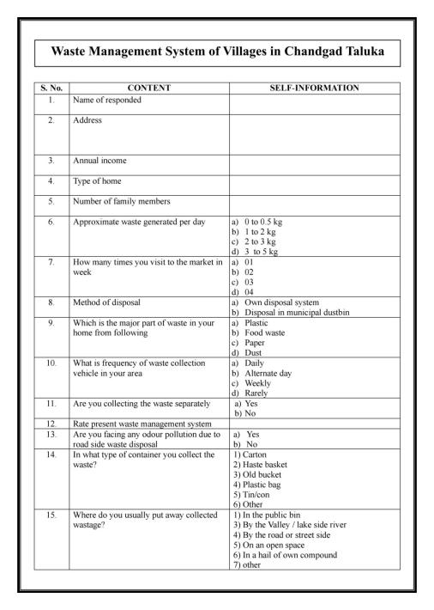 | Questionnaire survey form Page 1.
2. | 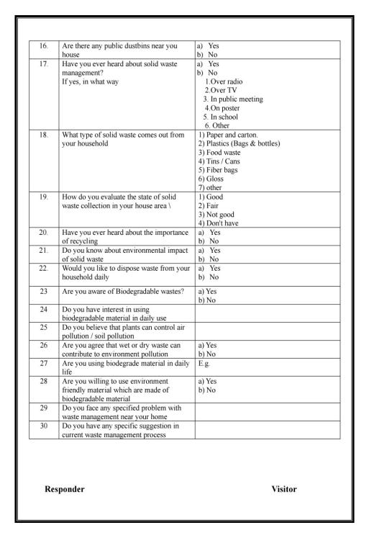 | Questionnaire survey form Page 2.

