A New Appraisal - Role of Lab Technician

Dr. Ujjwala Supe ¹, Prof. Dolly John²
^{1,2} Assistant Professor
Department of Biotechnology, St. Thomas College, Bhilai, C.G-490006

Email of corresponding Author: ujsupe@gmail.com
Received on: 15 February,2025 Revised on: 18 March,2025 Published on: 20 March,2025

Abstract – The purpose of this study is to determine the knowledge, attitude and practices of precautionary measures for laboratory technicians at among university laboratory technicians in academic institutions of Durg district, Chhattisgarh, India
The exact responsibilities of a laboratory technician depend on the specific field in which they work. They are responsible for a variety of tasks, including recording information, processing data, taking inventory, and maintaining laboratory equipment, work stations, and instruments. Laboratory workers typically face many occupational hazards on the job, as well as health and safety risks when working with chemicals and gas burners.
The main aim of this study was to find out who these technicians were, what types of jobs they were hired for, what training they received, how specialized skills and training were developed and assessed, and how technical careers developed; and try to identify the changing roles and contributions that technical staff make from time to time in routine management and experimental research in laboratories.

Keywords-Chemicals, Flame, Workshops, Instruments, Stocks, Laboratory

INTRODUCTION
Recent views from scientists, non-academics, and others involved in medicine and health care have provided valuable contrasts with analytical explanations of more traditional practice. These historiographical movements have greatly improved and expanded our understanding of development and diversity. During the twentieth century, "scientific medicine" also became more diversified and specialized, and professional medical research encompassed a wide range of collaborators. These achievements were synergistic: as laboratories acquired specialized equipment and developed new methods, they required a pool of specialized personnel to create, maintain, and operate the equipment, and when these new types of personnel entered the laboratories, they in turn contributed to the development of new equipment and technologies (Tansey, 2008). Now is the time to acknowledge and historically consider the role of some of these other actors who are often considered peripheral, especially as research increasingly recognizes the importance of teams rather than individuals.
In general, the modern laboratory assistant developed from the tradition of personal laboratory servants, assistants and secretaries who worked in the laboratories of 17th century naturalists.
The principles of Good Laboratory Practice (GLP) define a set of rules and quality system criteria related to the organizational process and environment in which nonclinical health studies are planned, performed, controlled, recorded, reported and archived, as well as environmental safety.
HISTORY

According to the Oxford English Dictionary, the first use of the term laboratory technician was in 1896. Historically, laboratory technicians worked in discrete areas within the environment. Nurses are responsible for patient care, treatment administration, and emotional support, while laboratory technicians focus on performing diagnostic tests and analyzing samples (Crick, 2015). However, developments in technology and changes in health care delivery models and changes in healthcare delivery models have blurred these boundaries. Today, healthcare organizations increasingly value professionals with a diverse set of skills spanning both clinical and laboratory settings. Nurses with laboratory technician skills bring a unique perspective to patient care because they can easily integrate clinical observations with laboratory results. This integration improves diagnostic accuracy, facilitates timely intervention, and ultimately improves patient outcomes. From the screening process of the types of hazards and risks that occur in the laboratory, there are 3 types of laboratories that have a risk of danger. The types of laboratories are
- Calibration laboratories,
- Test laboratories
- Educational laboratories.

A calibration laboratory that is ISO 17025: 2018 certified. This laboratory serves calibration testing of equipment on several parameters.
Other types of laboratories are educational laboratories and testing laboratories. These two laboratories are located in different laboratory departments of the faculty. Both laboratories are conducted in the same room, the difference lies in the user of the laboratory. In teaching laboratories, laboratory users include teachers, students and technicians. The number of users of this practice can reach 30-40 people per session. Students knowledge and behavior also remain low. Thus, the risk of accidents is very high

ROLE OF LAB TECHNICIAN

Lab technicians spend their days testing and analyzing samples for scientists. They also play an important role in recording the results so that when the time comes, they can report back what they have found (Odusanya, 2003).
Laboratory technicians are responsible for obtaining, testing, and analyzing samples. They use this information to create reports that help their superiors decide how the scientist or chemist should proceed.
Laboratory technicians supervise and train more and more people to do the same work they do every day.
The exact responsibilities of a laboratory technician depend on the specific field in which he works. They are responsible for a variety of tasks, including recording information, processing data, taking inventory, and maintaining laboratory equipment, work stations, and instruments as shown in figure 1. For example, a technician can collect blood, urine, and stool samples and analyze them for pathogens in healthcare settings. If they work for a food and drink manufacturer, they may test food and drink samples for contamination or quality assurance. Some of the typical duties performed by a laboratory technician include:
- Adjusting and calibrating equipment to ensure smooth functioning of the laboratory
- Ordering lab supplies, stocking them and making inventories
- Gathering data to conduct basic investigations and experiments
- Discussing workflows with superior technicians
- Cleaning and disinfecting lab equipment and workspaces
- Identifying and collecting samples for studies and tests
- Storing and organizing collected samples
- Documenting experiments
- Performing risk evaluations when necessary
- Staying updated on technological developments in their respective fields
- Receiving, labeling and analyzing samples (blood, toxic, tissue etc.),
- Designing and executing laboratory testing according standard procedures.
- Conducting experiments under defined conditions to verify/reject various types of hypotheses using refined scientific methods.

The ultimate responsibility for laboratory safety in an institution rests with the facility manager, who, along with all direct employees, must have an open and ongoing commitment to the safety program. Perceived senior management support for security programmers has been shown to be the most important factor influencing infection control compliance and infection reduction ^{8,9,10}. It has been reported that laboratory technicians generally do not know what preventative measures to take. Many injuries from needles and sharp objects can be avoided with the right knowledge and best practices (Barley & Bechky 1994).

A medical laboratory technician is trained to work in hospitals or independent laboratories. At work, they have to perform many tasks, working with infectious diseases, smoke-producing materials, analyzing body fluids and studying blood samples. They are ready to use appropriate protective materials for doing your job. They use safe materials such as safety glasses, gloves and masks. Medical laboratory technicians must use specific equipment to perform their daily tasks. They use laboratory equipment, such as cultures, to find out if there is an infection or bacteria in a person's body (Albishi, 2023). Medical laboratory technicians supervise and train more and more people to do the same work they do every day.

One of the jobs and responsibilities of a pharmacy technician is to assist pharmacists in dispensing prescription medications. They also take the information needed to fill the prescription. They also measure the amount of medication. They label medications and package prescriptions for patients. Another job of a pharmacy technician is to organize inventory and alert the pharmacist to any shortages. They accept payments for medications and answer phone calls and questions from patients. Pharmacy technicians do not require any education beyond high school; Most of the time they need on-the-job training. They must also pass an exam and sometimes undergo a formal education program.

RISK OF LIFE

The government employs laboratory technicians in the departments of health, social welfare, education, and science and quality assurance. Laboratory technicians may be employed by pharmaceutical companies, chemical companies, food and beverage manufacturers, hospitals, diagnostic laboratories, colleges, universities, and companies that conduct extensive research and development. Universities and institutes can hire experienced and highly qualified laboratory technicians as teachers. Some laboratory technicians also become technical writers to develop manuals for students and research and diagnostic laboratories.
Although they use the same equipment and space as the teaching laboratory, the users of the laboratory are only 1 or 2 laboratory assistants. The specialist's knowledge and skills are very good. Therefore, the risk of accidents at work is low. When dangerous films were projected in laboratories, data was obtained that there was an electrical hazard in all laboratories.
In some laboratories, there is a necessary electrical hazard in some equipment requiring up to 2500 watts of electrical power. There were no fatal accidents. Although no fatalities have ever occurred, even when using AS/NZS 4360 the electrical hazard represents a moderate risk.
Chemical hazards in laboratories using chemicals were always occurred. This risk can be exploited through the use of chemicals or during storage. Some chemicals can cause irritation and poisoning. The most common type of industrial accident is exposure to strong acids and alkalis.
The laboratory reported no toxicity. Each laboratory performs different activities depending on the type of laboratory and the research program in which it is used. But in some laboratories there is a big source of danger. It refers to activities that use equipment, materials or processes occurring in the laboratory. The existence of hazards / potential hazards in each room needs to be identified and analyzed so that the potential hazards do not become a risk that results in accidents / incidents in the laboratory.

Education
A laboratory technician career can be rewarding and meaningful as it helps doctors and surgeons determine a patient's diagnosis. This can be an exciting challenge for anyone who enjoys solving problems. Laboratory technicians are trained to act as investigators, finding clues and answers that can help patients receive more accurate diagnoses and treatment.
All laboratory assistants must have a higher education (https://www.betterteam.com/). They must have a bachelor's degree in medical technology or life sciences. His education includes many courses in chemistry, microbiology, biology, physics and DMLT (Diploma in Medical Laboratory Technology).
Laboratory scientists work behind the scenes on important research to advance medicine and help others. Few other professions allow you to work in the community in this way. Laboratory work is very hands-on, so no day is boring.
It’s possible to get an entry-level role as a laboratory technician without a four-year degree, making it an appealing option for those looking to quickly and affordably enter the workforce.

Pharmacy technicians do not require any education beyond high school; Most of the time they need on-the-job training. They must also pass an exam and sometimes undergo a formal education program.
Technicians have undergone a further transformation in recent years, and graduate and postgraduate technicians can now be found holding such positions for short periods of time, as a step towards another professional assignment rather than as a career in it (Hansen-Suchy, (2011).
The level of awareness about universal work precautions amongst laboratory technicians is low as only 20.8% of them had heard about the term and only 37.5% of these could correctly state the objectives.

Skills required being a lab technician
Interpersonal skills are equally important for laboratory technicians. Attention to detail, good organizational skills, oral and written communication, the ability to multitask, and the ability to work in a team are valuable interpersonal skills for laboratory technicians.
The laboratory assistant must have the following skills:

Problem Solving Skills
A laboratory technician may encounter a number of problems in his work. Possessing exceptional problem-solving skills can help them find quick and realistic solutions to unexpected problems such as heat runoff, pollution, exposure and injury (https://resources.workable.com/).
To find solutions to problems, they must think critically and evaluate the situation objectively before acting.

Analysis capabilities
Laboratory technicians must be able to use analytical approaches to identify correlations and gain insights from raw data. They often process large amounts of data and may have to use computer software to process and analyze that data before a supervisor or senior technician sees it.

Organization skills
Laboratory technicians benefit from the ability to maintain well-organized records and work stations. Upon request, they may have to search for samples, files, and large amounts of data. Well-organized files and workspaces can save you a lot of time and speed up laboratory processes. Safety is also an issue in a laboratory environment. Organizing equipment, instruments, and samples systematically can reduce the likelihood of accidents and failures in the laboratory.

Communication skills
Laboratory technicians need good oral and written communication skills as they regularly interact with multiple people. They are often required to record details of experiments, perform important documentation tasks, and comprehensively collect information. They rarely work in isolation and may need to work collaboratively with other specialists and technicians. Good communication skills reduce the likelihood of confusion and errors during critical laboratory work.

Time management skills
Laboratory technicians perform many tasks every day and require time management skills to ensure a good work-life balance. It is useful to systematically plan routine tasks and stick to a fixed schedule. Lab technicians often perform timed tests that require them to watch a clock and perform the steps without making mistakes. They must be able to manage their time well for important procedures. Lab technicians can also multitask if they have good time management skills.

Qualities of laboratory technician

1. Medical Laboratory
A medical laboratory is a facility that provides clinical laboratory services to assist in the diagnosis and treatment of diseases. Medical laboratory technicians use a medical laboratory to perform a variety of tests and procedures, including blood tests, urinalysis, and microbiology. They work in various laboratory areas such as hematology, chemistry, and coagulation studies to provide laboratory data to healthcare professionals. They also supervise and train other technicians, develop standard operating procedures, and ensure compliance with regulatory requirements and accreditation standards.
Here's how medical laboratory technicians use medical laboratory:
- Developed medical laboratory automated data processing.
- Trained new employee medical laboratory technicians in laboratory equipment, computer operations, releasing results, and preparing quality controls.

2. Patients
Patients are the people receiving medical care or treatment. Medical laboratory technicians employ patients by collecting body fluids for clinical laboratory tests, verifying their eligibility for Medicaid, and reporting laboratory results. They also help with bone marrow procedures, administer medications and IV therapy to inpatients, and communicate with patients to remind them about appointments.
Here's how medical laboratory technicians use patients:
- Report Antibiotic Resistant Organisms/Critical Values for all patients whom laboratory results exceed normal limits/standards.
- Screened patients for Medicaid eligibility and other government programs with eligibility criteria.

3. SCP
SCP stands for the Society for Clinical Pathology. Medical laboratory technicians use the SCP to implement standard operation procedures, resolve complex problems, and stay in compliance with regulations. They also use it to develop and lead study sessions for new recruits to prepare for the SCP certification exam
Here's how medical laboratory technicians use ascp:
- Implemented Standard Operation Procedures to resolve complex problems and to stay in compliance with SCP regulations.
- Developed and Lead study session for new recruits to prepare for SCP certification exam.

4. Clinical Laboratory

Clinical laboratory testing is the process of analyzing and identifying patient test results. Medical laboratory technicians use clinical laboratory tests to determine the presence of infections, monitor the effectiveness of medications, and identify and diagnose diseases. They perform a variety of manual and automated clinical laboratory tests, maintain the accuracy and quality of processes and equipment, and communicate with caregivers. There are many physical skills that need to be honed to become an efficient and quality laboratory worker.

Here's how medical laboratory technicians use clinical laboratory:
- Perform various manual and automated clinical laboratory testing, maintain accuracy and quality of processes and equipment, communicate with caregivers.
- Performed all aspects of testing within clinical laboratory sections, including blood bank, Hematology, Microbiology, chemical pathology.

5. MLT

MLT stands for Medical Laboratory Technician. Medical laboratory technicians use MLT to perform procedures and test equipment for new laboratory employees. They also use MLT in the hematology and coagulation department and perform quality control and maintenance in the laboratory. They perform MLT tasks for physicians, including processing whole blood, serum, and body fluid samples.

Here's how medical laboratory technicians use MLT:
- Demonstrated testing procedures and equipment to new laboratory personnel and MLT students.
- Perform duties as a MLT in the Hematology/Coagulation department

6. Patient Care

Patient care is the prevention, diagnosis and treatment of disease and illness, and the promotion of overall well-being. Medical laboratory technicians care for patients by performing laboratory tests and reporting results to health care providers to ensure appropriate treatment. They also interact with patients, doctors, and other health care professionals to solve patient care problems. Graduates joining the workforce in the coming years will need advanced skills and clinical experience, particularly in patient care.

Here's how medical laboratory technicians use patient care:
- Report reference laboratory results and document critical laboratory results, outstanding communication skills and patient care while working in call centers.
- Call all established critical values to appropriate patient care personnel and document all called critical values according to established laboratory protocol.

7. Hematology
Hematology is the study of blood and blood disorders. Medical laboratory technicians use hematology when performing and analyzing blood and urine samples, including manual readings. They also use it in the areas of chemistry, immunology, and microbiology. Students are currently trained in the classical areas of microbiology, immunology, immunohematology, hematology, and analysis of urine and body fluids.
Here's how medical laboratory technicians use hematology:
- Weekend Generalist Technologist in Chemistry and Hematology/Coagulation/Urinalysis Departments of the Laboratory.
- Performed twelve proficiency tests and completed 160 hematology checklists required by College of American Pathologists, contributing to continuous laboratory accreditation.

8. Microbiology
Microbiology is the study of microorganisms like bacteria, fungi, and parasites. Medical laboratory technicians use microbiology to identify and analyze microorganisms in body fluids. They prepare specimens and perform tests to diagnose infections and diseases. They also analyze cultures and perform sensitivity tests to determine the best treatment options
Here's how medical laboratory technicians use microbiology:
- Updated microbiology standard operating procedures to reflect current practices and improve identification and susceptibility of bacteria, parasites and fungi.
- Served as rotational general laboratory technician in urinalysis, serology, chemistry, hematology, coagulation, microbiology, and shipping.

9. CLIA
CLIA stands for Clinical Laboratory Improvement Amendments. Medical laboratory technicians use CLIA to evaluate laboratory quality controls by utilizing standardized laboratory test controls. They also maintain CLIA and OSHA safety guidelines and assist laboratory managers with safety inspections and preparation of core and satellite laboratories for CLIA inspections. They operate CLIA-approved lab equipment in various areas, such as Chemistry, Hematology, Coagulation, and Urinalysis.
Here's how medical laboratory technicians use CLIA:
- Evaluated laboratory quality controls by utilizing standardized laboratory test controls, and maintained CLIA and OSHA safety guidelines.
- Work closely with CLIA Consultant, laboratory directory and upper management to keep labor running effectively and efficiently.

10. Phlebotomy
Phlebotomy is the process of collecting blood for laboratory tests. Medical laboratory technicians use phlebotomy to collect blood from patients and process it for testing. They perform various specimen collection procedures, including phlebotomy, and ensure the proper handling and processing of samples. They also perform phlebotomy duties for inpatients and outpatients and adhere to safety procedures during phlebotomy work.
Here's how medical laboratory technicians use phlebotomy:
- Selected by senior management to provide training and orientation in phlebotomy and other specimen collection procedures to new staff members.
- Perform phlebotomy, laboratory testing rotating in chemistry, hematology, urinalysis, coagulation, serology and Forensic Toxicology.

11. Laboratory Procedures

Laboratory procedures are established protocols for the collection, processing, and analysis of patient samples. Medical laboratory technicians use these procedures to ensure the accuracy and reliability of test results. They perform standard procedures in chemistry, hematology, serology and urinalysis, as well as routine instrument maintenance and quality control. They recognize deviations from expected results and use scientific principles to analyze and correct problems. They also supervise laboratory operations and personnel, establish written operating standards for all laboratory procedures, and ensure compliance with government requirements and hospital policies.

Here's how medical laboratory technicians use laboratory procedures:
- Preformed standard laboratory procedures in chemistry, hematology, serology, and urinalysis * Performed routine instrument maintenance and routine quality control
- Demonstrated skills in laboratory procedures in Urinalysis, Hematology, Blood Bank, Coagulation, Chemistry and Special Chemistry departments.

12. Proficiency Testing
Proficiency testing is a process that checks the accuracy and reliability of a test. Medical laboratory technicians use proficiency testing to ensure the accuracy of their test results. They do this by analyzing patient samples and reporting the results, as well as participating in annual and quarterly proficiency testing programs. They also use proficiency testing to maintain quality control and quality assurance, and to follow regulations.
Here's how medical laboratory technicians use proficiency testing:
- Help with administrative duties including writing and maintaining procedures, completing proficiency testing, and maintaining supply inventory as needed.
- Documented and maintained quality control, proficiency testing, quality assurance, and other records to meet regulatory requirement.

13. Customer Service

Customer service is the provision of assistance and support to customers before, during and after a purchase. Medical laboratory technicians use customer service to facilitate communication with internal and external customers, answer questions from customers and laboratory staff, and provide excellent customer service and teamwork. They also use customer service to maintain interdepartmental relationships interact with physicians, office staff and patients, and train other technicians in basic laboratory rules and procedures.

Here's how medical laboratory technicians use customer service:
- Facilitate communication with internal and external customers in order to exceed customer service standards of the organization.
- Provided customer service through initiation and/or response to client inquiries regarding test results or specimen requirements.

14. Specimen Collection

Specimen collection is the process of obtaining a sample from a patient for diagnostic testing. Medical laboratory technicians use specimen collection by verifying the integrity of specimens, receiving various types of requests for specimen testing, and educating patients on proper collection procedures. They also perform routine hematology, chemistry, and coagulation testing, as well as manage laboratory processes, sample collection, and evaluation.
Here's how medical laboratory technicians use specimen collection:
- Demonstrated proper specimen collection, verified specimen integrity and received different types of specimen testing requests via sun quest computer.
- Conducted patient in-processing prior to specimen collection, including review of paperwork accompanying patients and cordial guidance and assistance.

15. Specimen Handling
Specimen handling refers to the proper management and handling of samples for testing. Medical laboratory technicians use specimen handling, including following Laboratory guidelines, making decisions on result reporting, and problem specimen handling. They also perform STAT testing for various clients with different turn-around-times and specimen handling procedures. They manage specimen handling, receiving, storage, and inventory. They also use computer programs to ensure proper specimen handling and testing.
Here's how medical laboratory technicians use specimen handling:
- Followed Laboratory guidelines for specimen handling and all medical lab procedures.
- Work with little or no supervision in making decision on result reporting, problem specimen handling, technical issues.
Services and places of appointment
- Laboratory Technologists are usually employed by:
- Central Government Hospitals/ institutions
- State Government Hospitals
- Railway Hospitals
- Medical colleges
- Municipal Corporations, NDMC and other local statutory bodies
- C.G.H.S. Dispensaries
- Medical and Health Institutions in private/ public sector
- E.S.I. Corporation Hospitals and Dispensaries
- Research Institutions like CSIR, ICMR, ICAR, BARC, IOP, NACO etc.
- Institutions of international fame like Central Research Institute, Kasauli (H.P), BCG Guindy, Central Drug Laboratories, National Institute of Serology, National Institute of Immunology, Institute of Public Health & hygiene, National tuberculosis Institute, Central Institute of Psychiatry, Port & Airport Health Organizations, NVDCP and NICD etc.
- Autonomous & other bodies like AIIMS, PGI Chandigarh, Red Cross Blood Bank etc.
- Public undertakings hospitals and Dispensaries.
- National health Institutions.
- Trauma Centers.
- Private Hospitals/Health institutions, Medical colleges etc.
- Private Health centre/dispensaries
- Clinical/Diagnostic and research Laboratories

CONCLUSION
It is necessary to study the situational awareness and capital that influence the performance of the laboratory assistant and are mediated by his hard work. Thus, to improve the performance of laboratory technicians, we need to improve their knowledge of situation awareness, which can be done through dedicated technician guidance and training. Increased equity, mediated by work engagement, can be achieved through regular motivation as an attempt to connect the laboratory technician's work with the work environment as well as with his colleagues.

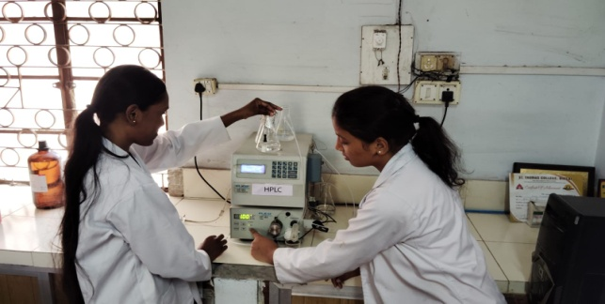

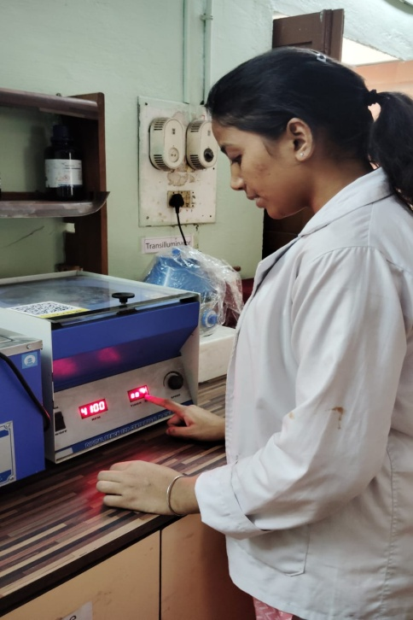

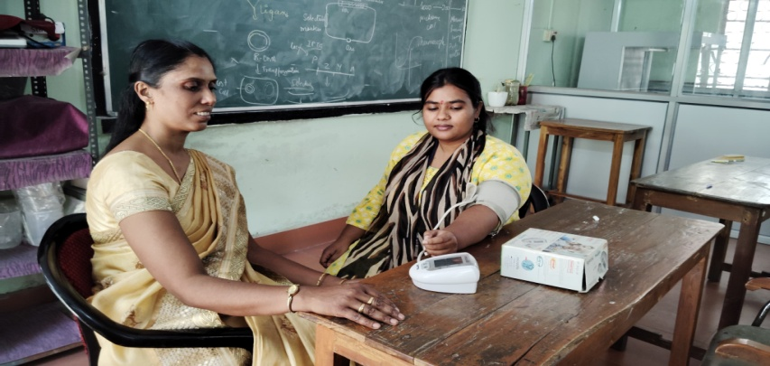

Figure 1: Task to be done A) Calibrating instrumentation B) performing practical C) Observing Blood pressure of students

REFERENCES
- Albishi, H. Z. A., Albeshi, A. Z. A., Almutairi, M. L., Alyami, F. H. H., Al Omar, A. H. A., Alomar, S. H., & Alhareth, S. M. S. (2023). Associating The Gap: The Role Of Medical Nurses With Lab Technician Skills In Healthcare. A New Appraisal. Journal of Namibian Studies: History Politics Culture, 39, 30-39.
- Barley, S.R. and Bechky, B.A., (1994). ‘In the backrooms of science: the work of technicians in science labs’, Work Occup. 21, 85–126
- Crick, F. (2015). Laboratory Technician. History, 27, 5-2016.
- Hansen-Suchy, K. (2011). Evaluating the effectiveness of an online medical laboratory technician program. American Society for Clinical Laboratory Science, 24(1), 35-40.
- https://resources.workable.com/
- https://www.betterteam.com/
- Odusanya O.O. (2003). Awareness and compliance with Universal work precautions amongst health workers at an emer-gency medical service in Lagos, Nigeria, Niger Med J, 44(1), 40-43
- Tansey, E. M. (2008). Keeping the culture alive: The laboratory technician in mid-twentieth-century British medical research. Notes and Records of the Royal Society, 62(1), 77-95.

