Radar Data Analysis Using Correlation Heatm

Mayank Tambe, Sunil M. Wanjari, Brijesh Kanaujiya, Dewanshu Satpute, Aadarsh Jain ,
Daisy Francis

Dept. of Computer Engineering, SVPCET, Nagpur, India, 441108
Corresponding Author Email: mayanktambe16@gmail.com

Received on: 5 May,2024 Revised on: 30 June,2024 Published on: 04 July ,2024

Abstract- The ever-changing nature of weather and atmospheric conditions has underscored the significance of weather forecasting as a pivotal area of research. Over recent decades, scientists have innovated various techniques to enhance model precision, particularly in handling complex nonlinear statistical datasets, aiming to mitigate environmental risks and global crises. Artificial intelligence and machine learning have introduced a transformative aspect to weather forecasting, simplifying intricate mathematical equations. The objective of this study is to delve into radar data analysis, aiming to provide valuable insights that can contribute to the advancement of climate prediction and the refinement of weather forecast models.
This model serves to further elucidate the complexities of weather phenomena, enhancing our understanding and predictive capabilities in weather forecasting. By revealing the interdependencies between different parameters, our model significantly enhances our ability to predict weather conditions accurately.
Keywords- Weather forecasting, Radar data and Weather parameters
INTRODUCTION
Weather forecasting is useful to the military, airports, and agricultural industries, among other agencies. Precise forecasts facilitate troop deployments, mission scheduling, and strategy planning in the military, hence enhancing operational preparedness and efficiency. Weather predictions are crucial to airport operations as they help schedule flights, control air traffic, and guarantee passenger safety while reducing inconveniences from inclement weather. Forecasts help farmers maximize yields and minimize losses by guiding their decisions about crop planting, irrigation, and insect control.

The process of deciphering data gathered by radar devices is called radar analysis. It entails examining the echoes that come back from targets within the radar's range of vision as well as the signals that radar transmitters send out. Determining the distance, direction, speed, size, and other details of identified targets, such as ships, airplanes, weather systems, or other objects, is part of this study. Radar analysis
is a useful tool for deriving insights from radar data for a variety of applications, including military operations, weather forecasting.
There are several reasons why radar analysis is significant:
- Weather forecasting: It helps meteorologists deliver precise forecasts and alerts by giving real-time information about precipitation, storm systems, and other weather phenomena.
- Aviation Safety: Radar assists air traffic controllers in keeping an eye on aircraft movement, identifying possible dangers such as turbulence or storms, and ensuring a safe distance between planes.
- Military Operations: By identifying and monitoring airborne and surface targets, radar analysis helps military defense, reconnaissance, and surveillance systems.
- Navigation: By identifying surrounding ships, landmasses, and obstructions, radar helps boats and ships navigate across water bodies securely.
- Security: Radar is employed in border monitoring, perimeter surveillance, and the detection of unauthorized entry into sensitive areas.
Overall, radar analysis is an essential piece of technology in today's world since it improves productivity, security, and safety in a multitude of areas.
LITERATURE REVIEW
Radar systems are essential for meteorology, providing critical data for weather forecasting. Parameters extracted from radar data, including reflectivity, velocity, power, and geographical coordinates (longitude and latitude), play key roles in understanding atmospheric phenomena. Here's a concise summary of their significance:
- Power in Meteorology:
Power refers to the intensity of radar signals returned from precipitation particles. It's crucial for estimating precipitation intensity, with higher values indicating heavier rainfall. Smith et al. (2018) emphasized accurate power measurements for improving precipitation estimation.
- Reflectivity in Meteorology:
Reflectivity, measured in dBz, quantifies radar return signal strength and provides information about precipitation size and distribution. High reflectivity values indicate intense precipitation. Johnson et al. (2019) highlighted its significance for rainfall estimation and precipitation type identification.
- Velocity and Spectrum Width:
Velocity indicates particle speed and direction detected by Doppler radar. Spectrum width measures velocity variability, useful for identifying storm intensity and precipitation types.
- Py-ART (Python ARM Radar Toolkit):
Py-ART is a powerful open-source toolkit for working with weather radar data in Python. It provides tools for reading, processing, and visualizing radar data, including reflectivity, velocity, and spectrum width. Py-ART is widely used in meteorological research and applications, enabling scientists to analyze radar data and develop algorithms for precipitation estimation and storm analysis. Reflected by precipitation particles. It helps identify precipitation types, estimate rainfall rates, and track storm movement and intensity. Reflectivity is crucial for rainfall estimation, storm tracking, and issuing timely weather warnings.
- Heatmap
A heatmap employs color gradients to visually represent data values on a two-dimensional grid, effectively spotlighting patterns, trends, and correlations present in the dataset. It offers an intuitive method for examining spatial relationships and pinpointing areas of significance. Through color spectrum mapping, heatmaps facilitate rapid identification of both high and low values, empowering users to analyze correlations and spatial distributions with precision.
METHODOLOGY
We propose a model that addresses the limitations encountered by various meteorological centers in meteorological analysis. The model aims to enhance the accuracy of weather condition predictions using radar data. It utilizes characteristics such as reflectivity, power, spectrum width, and velocity. A model has been developed to analyze current weather conditions and, utilizing the trained model, forecast the weather for the upcoming period.
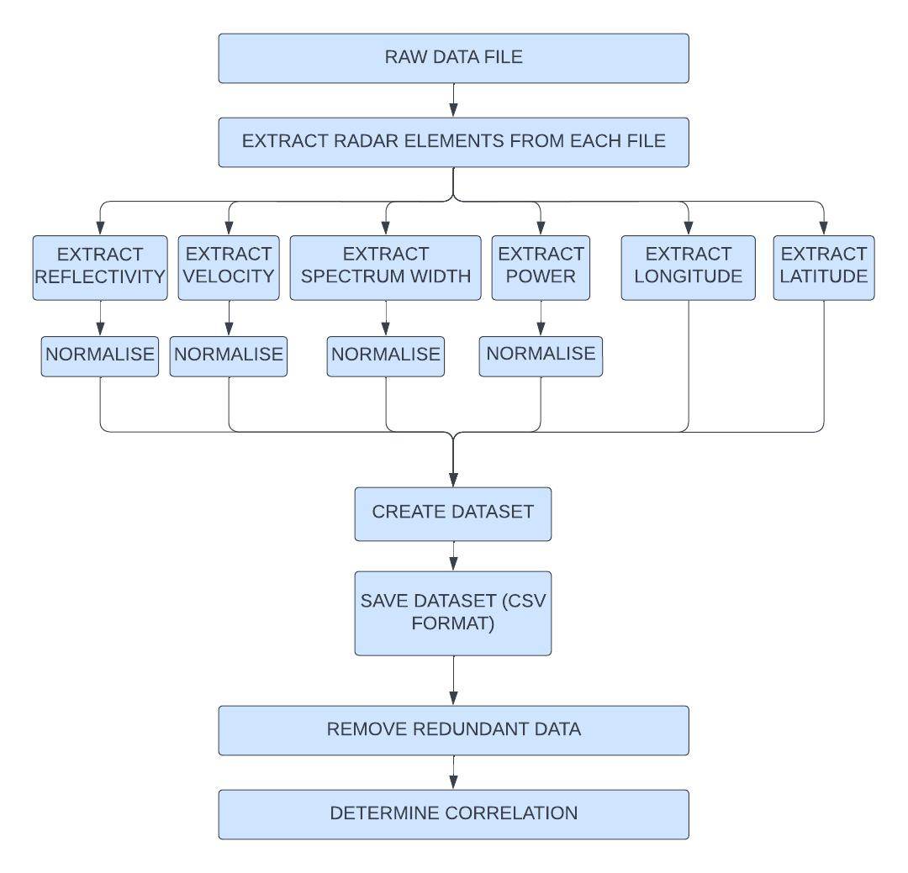
Fig 1. Dataflow Diagram
Users can monitor radar data and download the necessary data components using the web-based platform. The downloaded radar data then can be utilized as input by the meteorologists to forecast future weather conditions. The outcomes we obtain are stored in csv file.
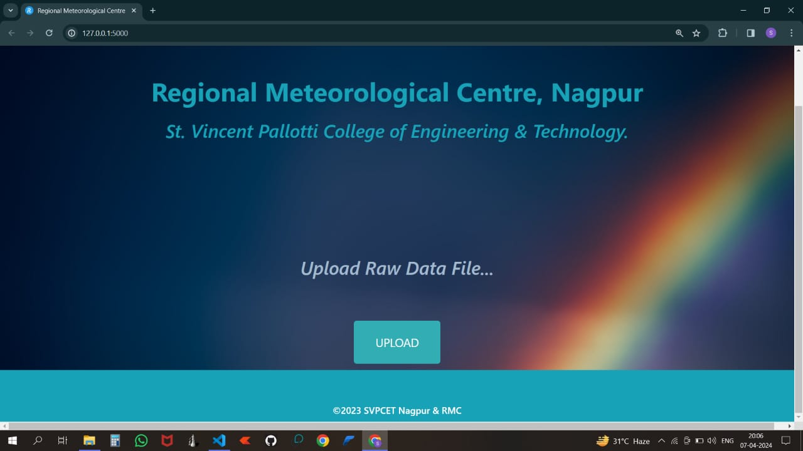
Fig 2. User-Interface for uploading the folder containing raw radar files
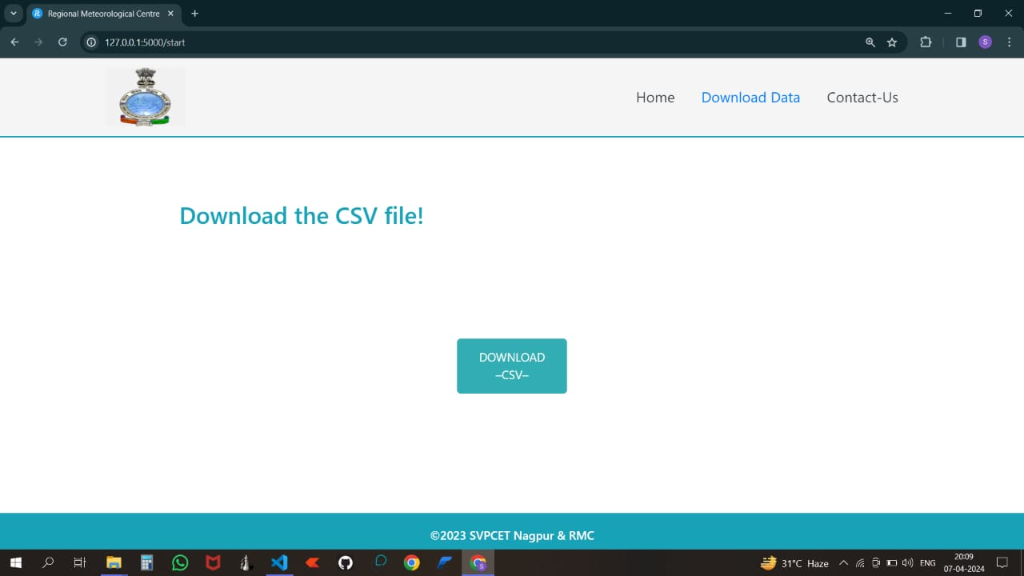
Fig 3. Downloading the csv file
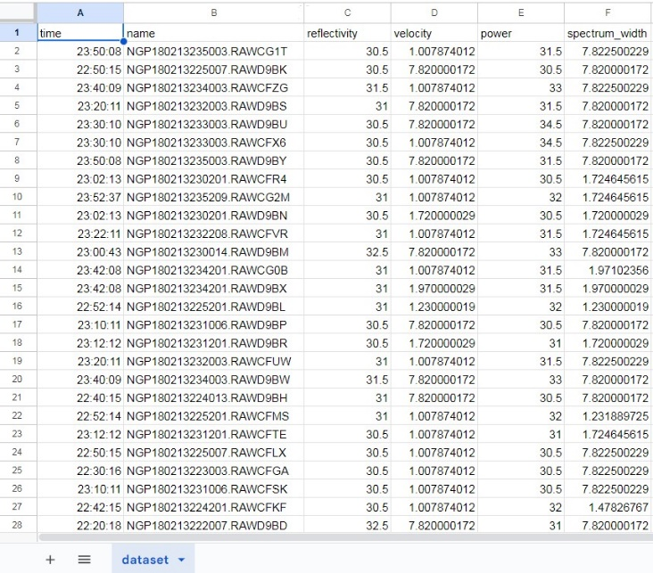
Fig 4. Extracted final CSV file
The model uses a Heat map, which illustrates various correlations between the parameters utilized in our model, ranging from -1 to +1. A positive value implies a direct relationship, whereas a negative value denotes an indirect relationship. Consequently, all of these correlations seem to have interpretations. Such interpretations improve radar analysis efficiency, which is beneficial for meteorologists anticipating weather.
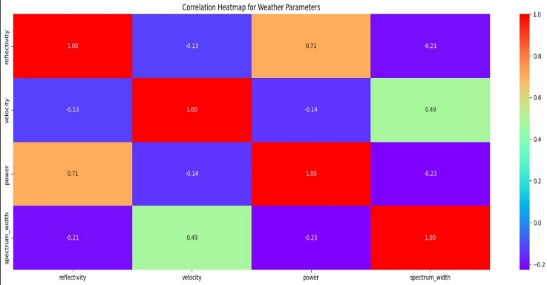
Fig 5. Correlation Heatmap for Weather Parameters
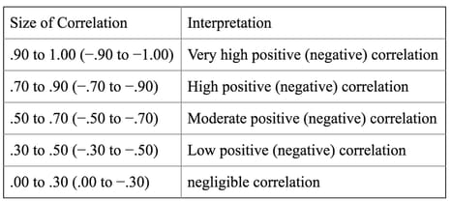
Fig 6. Correlation Value and its Interpretation

DESIGN
The User Interface and Neural Network backend form the core components of the model, playing pivotal roles in creating an efficient system. Our project involves building an application that converts raw files into CSV format and extracts radar components.
Several observations have been noted:
- Spectrum width denotes the distribution of velocities within a single radar pixel.
- The power spectrum depends on the mean radial velocity and radar reflectivity factor.
- Raw files are significantly more intricate than CSV files due to challenges related to storage and accessibility.
- Batch transformation of files offers a more convenient and efficient method of conversion.
- Reflectivity is directly correlated with power.
- Velocity is directly proportional to spectrum width.

CONCLUSION
In Conclusion, there exists a robust relationship between radar power and reflectivity, where higher power yields a more intense reflected signal and heightened sensitivity to targets. However, achieving precise target identification and measurement through radar technology entails meticulous consideration and control of various complex factors.
It's crucial to recognize that interpreting radar data requires careful consideration of various intricate factors, emphasizing the importance of rigorous analysis and meticulous attention to detail in meteorological research endeavors.
ACKNOWLEDGEMENT
As a collective, we extend our heartfelt appreciation to the Indian Meteorological Department (IMD), Delhi, for generously supplying the essential resources pivotal to our research endeavors. Additionally, we express our sincere gratitude to our industry mentor and esteemed college department for their invaluable guidance and unwavering support throughout the challenges encountered during our research journey. Their constructive feedback has been instrumental in refining and shaping our study.
REFERENCES
- Nayan Agrawal, Jasneet Kaur Saini, Aditya Sharma, Moin Sheikh, Dr. Sunil M. Wanjari “Weather Forecasting: Era of Artificial Intelligence” IRJET2020: Technology, vol. 07, Issue 04, April,2020
- Sarvesh Landge, Brijesh Kanaujiya, Dr. Sunil M. Wanjari, Aditya Taksande, Rachit Khandelwal, Shienell Amair, “Radar Vision - Weather Forecasting Using CNN-LSTM ” ICCAE2021:International Conference on Computing and Applied Engineering Grand Inn,2021. GOA-INDIA GOA, India, July 23-24,pp. 354–364, 2015.
- Radar Data Analysis Using Linear Regression - Anjali Banerjee Dr. Sunil M. Wanjari Mr. Brijesh Kanaujiya, Ashwin George, Harshali Hood, Ryan Chettiar, INTERNATIONAL JOURNAL FOR RESEARCH PUBLICATION & SEMINAR ISSN:2278-6848,2023.
- EXTRACTION OF RADAR ELEMENTS - Rahul Deshmukh, Sebi James, Shreyas Kumar, Akhil Benny, Dr. Sunil Wanjari, Brijesh Kanaujiya, © international journal for research publication & seminar issn: 2278-6848,2023.
- https://training.weather.gov/nwstc/NEXR AD/RADAR/3-1.html
- Tage Andersson and Karl-Ivar Ivarsson, “A model for probability nowcasts of accumulated precipitation using radar,” Journal of Applied Meteorology, vol. 30, no. 1, pp. 135–141, 1991.
- W Schmid, S Mecklenburg, and J Joss, “Short-term risk forecasts of severe weather,” Physics and Chemistry of the Earth, Part B: Hydrology, Oceans and Atmosphere, vol. 25, no. 10-12, pp. 1335– 1338, 2000.
- Alan W Seed, Clive E Pierce, and Katie Norman, “Formulation and evaluation of a scale decomposition-based stochastic precipitation nowcast scheme,” Water Resources Research, vol. 49, no. 10, pp. 6624–6641, 2013.
- Aitor Atencia and Isztar Zawadzki, “A comparison of two techniques for generating nowcasting ensembles. part i: Lagrangian ensemble technique,” Monthly Weather Review, vol. 142, no. 11, pp. 4036–4052, 2014.
- Raw radar images dataset retrieved from web site http://www.imdnagpur.gov.in/

