Multiport Dc-Dc Converter For

Dc Microgrid Applications

Sharvari Zade, Teresa Francis, Nitin Kshirsagar, Om Vihirghare

Electrical Engineering department, St. Vincent Pallotti College of Engineering and Technology, Nagpur

Received on: 5 May,2024 Revised on: 30 June,2024 Published on: 04 July ,2024

Abstract—In this paper, a new multiport DC-DC converter is proposed for DC Microgrid applications. Besides, the proposed configuration has several benefits for the design and operation of DC microgrids such as reducing multiple power conversions, reducing number of elements and voltage boosting capability. The bidirectional buck-boost structure of the proposed topology allows for enhanced flexibility to connect sources and loads with different voltage and power levels. The control strategy is developed to achieve power control for renewable sources such as MPPT for PV, in addition to a certain degree of resilience for DC sources availability while maintaining boosted DC link voltage. The key feature of the proposed configuration is that it offers full control over DC link voltage regardless of resource availability (PV). A detailed steady state analysis is conducted to derive the voltage relations between all ports
Keywords— battery, multiport converter , microgrid ,solar cell.
- INTRODUCTION

The Multiport DC-DC Power Supply System is a comprehensive solution designed to manage and distribute electrical energy efficiently from the grid to various devices or systems with different voltage requirements. This system is crucial in modern technology-driven industries where reliable and stable power sources are essential.
The "Multiport DC-DC Converter for DC Microgrid Application" Power Supply System stands at the forefront of modern power distribution technology, offering a highly versatile and efficient solution for managing electrical energy sourced from the grid. With its ability to transform and distribute power across multiple output ports, this system plays a pivotal role in delivering precise and reliable voltage levels to a variety of applications. In this comprehensive introduction, we will delve into the fundamental components and functionality of this groundbreaking system, highlighting its significance in diverse industrial and commercial settings.
Power supply systems are the backbone of countless modern technologies and industries, providing the essential energy needed for the operation of electronic devices, manufacturing processes, telecommunications infrastructure, and more. The reliability, stability, and precision of the power supplied to these applications are critical, as deviations from specified voltage levels can lead to equipment malfunctions, data loss, or even catastrophic failures.
The Multiport DC-DC Power Supply System is engineered to address these challenges by enabling the efficient transformation and distribution of electrical energy. It commences with an incoming power feed from the grid, which is initially subjected to a step-down transformer. This transformer reduces the grid voltage to a standardized 12V level, thereby ensuring a consistent and safe input for the subsequent stages of the system.
The next phase involves rectification and filtering processes. The rectifier converts the alternating current (AC) into direct current (DC), eliminating unwanted voltage fluctuations and delivering a more stable electrical source. This clean DC power is then channeled through a filter, which further refines the waveform and minimizes any residual noise or interference, guaranteeing a smooth and reliable supply of electricity.
- LITERATURE REVIEW

- A New Multi-Input Multi-output DC-DC Bidirectional Converter with MPPT Control Applicable for PV, December 2018, Seyed Hossein Hosseini, Zahra Saadatizadeh, Pedram Chavoshipour Heris; The following paper introduces a non-isolated multiport bidirectional DC-DC converter. Its multiport design enhances its reliability, particularly in applications with sensitive loads. The converter achieves efficient current distribution among its paths, resulting in reduced losses in the semiconductor components on the primary side. Moreover, it outperforms buck-boost converters with cascaded or series topologies in terms of conversion ratio. The proposed converter also exhibits lower input current ripple compared to conventional bidirectional converters. Its straightforward control scheme, coupled with minimal input current ripple, makes it well-suited for integration in photovoltaic systems. Consequently, it enables the extraction of maximum power from photovoltaic modules using a Maximum Power Point Tracking (MPPT) controller, even under varying radiation conditions. The paper provides a thorough analytical analysis of the proposed bidirectional DC-DC converter for all operational modes, along with the necessary equations. To validate the theoretical framework, simulation results are obtained using PSCAD/EMTDC.
- A Single Input Dual Output Multiport DC–DC Converter with Minimal Switches, August 2019, P. Priyanka, S. Muthubalaji; This paper introduces a novel topology for a multiport DC-DC converter that achieves dual output capabilities from a single input source. Traditionally, a buck converter provides lower output voltage than the input, while a boost converter yields a higher voltage. A buck-boost converter, on the other hand, can output either higher or lower voltage compared to the input. However, the unique feature of the proposed converter lies in its ability to simultaneously provide both step-up and step-down outputs. Unlike the current topology of the multiport DC-DC converter that employs four switches, the proposed design utilizes fewer switches while achieving higher efficiency. This also leads to a reduction in switching losses. The converter's efficiency is enhanced, output voltages are effectively regulated, and circuitry costs are reduced due to its streamlined design. Additionally, a closed-loop PI control strategy is implemented. The results have been validated using MATLAB Simulink software.

- Multiport DC-DC Converters and its Applications, June 2020, Divyanshi Yadav; This paper advocates for the utilization of an integrated multi-port converter in lieu of multiple individual DC-DC converters each with its dedicated input source. By doing so, it reduces the overall component count. Multi-port converters, in comparison to conventional power processing solutions employing numerous independent two-port converters, entail fewer components and conversion stages. The paper delivers an extensive overview of multiport DC-DC converters along with their categorization. Furthermore, it conducts a comparative analysis between traditional DC converters and multiport DC converters. The examination extends to the types of input and output currents in various DC-DC converters. The paper also outlines the potential applications of these converters.
4. Design a Multiport DC-DC Converter for Hybrid Renewable Nano-grid System, November 2021, Afshin Balal, Farzad Shahabi; This paper addresses the necessity for multiple renewable DC sources to collaborate within a DC Nano-grid to ensure a dependable power supply to loads. A Nano-grid, akin to a compact version of a smart microgrid, can also function autonomously as a power generator. When amalgamating diverse energy sources with varying voltage profiles, multiport converters emerge as a highly suitable solution. They are gaining significant attention in research due to their compact size, minimal switch requirements, and high operational efficiency. The paper introduces a multiport DC-DC converter designed to seamlessly integrate fuel cells, solar panels, and batteries within a DC Nano-grid. This proposed converter stands out for its cost-effectiveness, reduced switch count, and heightened reliability. Additionally, it enables bidirectional power flow between batteries and the DC grid.

- METHODOLOGY

The Multiport DC-DC Power Supply System is a sophisticated electrical infrastructure designed to efficiently manage and distribute power from the grid to multiple output ports, each with specific voltage requirements. This comprehensive system undergoes a series of precise stages to ensure the reliable delivery of regulated DC voltage to connected devices or systems.
- Input from the grid:

The process begins with the input of electrical power from the grid. This power typically arrives in the form of alternating current (AC) at a standard voltage level. The grid-supplied AC power is the primary energy source for the system.

- Step-Down Transformer:

The incoming AC voltage is then directed to a step-down transformer. The transformer is a vital component that serves to reduce the voltage level to a standardized 12V. This reduction in voltage is achieved through the principle of electromagnetic induction. The primary coil of the transformer is connected to the grid's AC supply, while the secondary coil is linked to the subsequent stages of the system.As AC current flows through the primary coil, it generates a varying magnetic field, inducing a voltage across the secondary coil. The turns ratio between the primary and secondary windings determines the voltage reduction, allowing for a consistent and manageable 12V output.

- Rectification and Filtering:

The 12V AC output from the transformer is then subjected to rectification, converting it into direct current (DC). This process ensures that the power supply is unidirectional, which is typically required for most electronic devices and systems.
Following rectification, the DC output undergoes a filtering process. This refines the waveform, smoothing out any remaining ripples or fluctuations in voltage. The filtered DC power is now in a clean and stable form, ready for distribution.

- Output Ports and Converters:

The multiport functionality of the system comes into play at this stage. The clean DC power is distributed to three distinct output ports, each with specific voltage requirements.
- The first port is designed to deliver a regulated 6V DC output. This is achieved through the implementation of a dedicated buck converter. The buck converter reduces the voltage while maintaining high efficiency.
- The second port provides a reliable 9V DC output. Another specialized buck converter is employed to regulate the voltage to meet this specific requirement.
- The third port utilizes a boost converter to elevate the voltage to a stable 24V DC output. The boost converter increases the voltage while ensuring efficiency and stability.

- Voltage Regulation and Control:

Each converter is equipped with control circuitry that regulates the voltage output to match the precise requirements of the connected devices or systems. This meticulous control ensures that each output maintains its designated voltage level, providing a reliable and consistent power source.

- Final Output:

The regulated outputs from the converters are now ready for distribution to the respective devices or systems. The system ensures that the connected equipment receives the exact power levels they require for optimal performance.
In conclusion, the Multiport DC-DC Power Supply System embodies a carefully orchestrated process of voltage transformation and regulation. Beginning with the grid-supplied AC power, the system employs a step-down transformer, rectification, and filtering stages to create a clean and stable DC supply. Specialized converters then fine-tune the voltage to meet the specific requirements of connected devices. This precision and efficiency make the system invaluable in a wide range of industries reliant on stable and precise power sources.

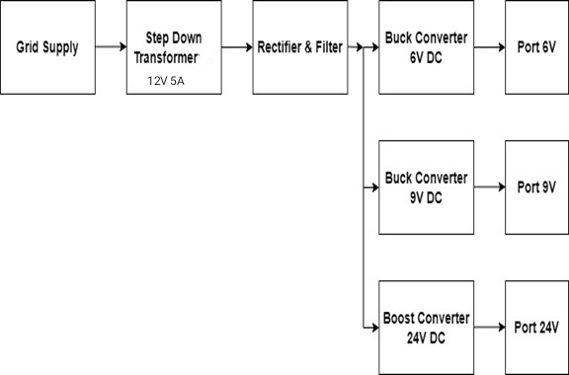
Fig 1. Circuit diagram of multiport DC-DC converter

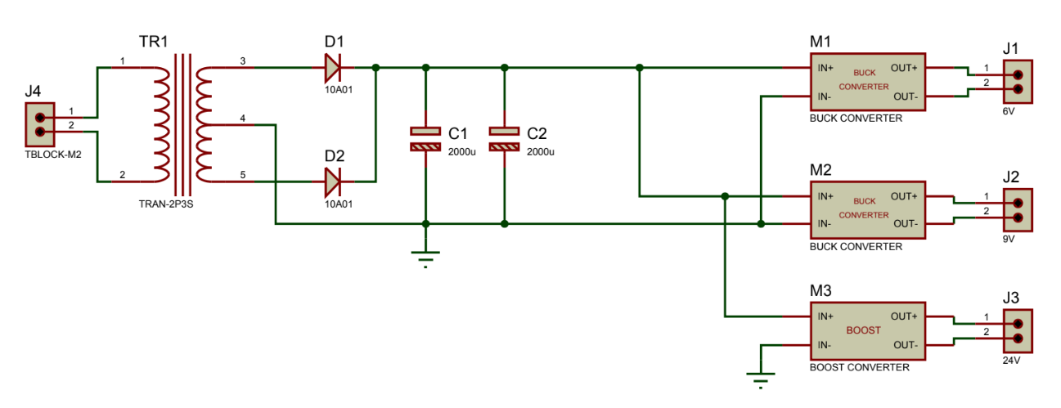
Fig 2. Block diagram
- RESULT

The Multiport DC-DC Power Supply System is a sophisticated electrical infrastructure designed to efficiently manage and distribute power from the grid to multiple output ports, each with specific voltage requirements. The system begins by taking in alternating current (AC) from the grid, which is then directed through a step-down transformer. This transformer reduces the voltage to a standardized 12V level, providing a consistent and manageable input for subsequent processing.
Following the transformer, the power undergoes rectification and filtering processes. The rectifier converts AC to direct current (DC), ensuring a unidirectional flow of electricity. The filtered DC power is then ready for distribution to the three distinct output ports. These ports are equipped with specialized converters - buck converters for 6V and 9V outputs, and a boost converter for a 24V output. These converters play a critical role in fine-tuning the voltage levels for precise distribution to connected devices, ensuring optimal performance.
- CONCLUSION

In conclusion, the Multiport DC-DC Power Supply System represents a remarkable advancement in power distribution technology, addressing the ever-growing demand for efficient, reliable, and adaptable electrical energy management. Through a systematic process involving a step-down transformer, rectification, filtering, and specialized converters, this system ensures that power from the grid is transformed and distributed with precision. The ability to cater to specific voltage requirements for different devices and systems makes this technology invaluable across a wide array of industries, from telecommunications to automotive electronics, and renewable energy integration.
One of the system's key strengths lies in its meticulous control over voltage levels, ensuring that connected devices receive the precise power they need for optimal performance. This level of precision not only enhances the operational efficiency of devices but also prolongs their lifespan, ultimately leading to cost savings and increased One of the system's key strengths lies in its meticulous control sustainability. Additionally, the incorporation of safety features and galvanic isolation safeguards against potential hazards, further enhancing the reliability of the system.
Furthermore, the adaptability of the Multiport DC-DC Power Supply System to grid variations and its integration with renewable energy sources underscore its potential to revolutionize the way we manage and distribute electrical power. By efficiently converting and regulating energy, this system aligns with the global shift towards sustainable energy solutions, making it a valuable asset in the pursuit of a greener future.
As technology continues to evolve, further research and development in this field hold the promise of even greater efficiency, reduced footprint, and expanded applications for multiport DC-DC power supply systems. The potential for advancements in semiconductor technology, control algorithms, and materials science offers exciting opportunities for future innovation in this critical area of electrical engineering. With continued refinement and adaptation, the Multiport DC-DC Power Supply System stands poised to play an increasingly pivotal role in the modernization of power distribution worldwide.
REFERENCES

- E. B.a. Z. Saadatizadeh, "New high voltage gain dc-dc converters based on coupled inductors", IET Power Electronics, 2017.
- F. Kardan, R. Alizadeh and M. R. Banaei, "A New Three Input DC/DC Converter for Hybrid PV/FC/Battery Applications", IEEE Journal of Emerging and Selected Topics in Power Electronics, vol. 5, no. 4, pp. 1771-1778, 2017.
- Y. Zhang, Y. Gao, L. Zhou and M. Sumner, "A Switched-Capacitor Bidirectional DC-DC Converter with Wide Voltage Gain Range for Electric Vehicles with Hybrid Energy Sources", IEEE Transactions on Power Electronics, pp. 1-1, 2018.
- Y. Yang, T. Guan, S. Zhang, W. Jiang and W. Huang, "More Symmetric Four-Phase Inverse Coupled Inductor for Low Current Ripples & High-Efficiency Interleaved Bidirectional Buck/Boost Converter", IEEE Transactions on Power Electronics, vol. 33, no. 3, pp. 1952-1966, 2018.
- P. Kolahian, H. Tarzamni, A. Nikafrooz, and M. Hamzeh, “Multi‐port DC–DC converter for bipolar medium voltage DC micro‐grid applications,” IET Power Electron., vol. 12, no. 7, pp. 1841–1849, 2019, doi: 10.1049/iet-pel.2018.6031.
- S. Vahid and A. El-refaie, “Multi-port Power Converter with a Multipurpose Hybrid Energy Storage System,” 2020 IEEE Energy Convers. Congr. Expo pp. 1259–1266, 2020.
- T. Jalilzadeh, N. Rostami, E. Babaei, and S. H. Hosseini, “Bidirectional multi-port DC-DC converter with low voltage stress on switches and diodes,” IET Power Electron., vol. 13, no. 8, pp. 1593–1604, 2020, doi: 10.1049/iet-pel.2019.0525.
- M. M. Savrun and A. Atay, “Multiport bidirectional DC-DC converter for PV powered electric vehicle equipped with battery and supercapacitor,” IET Power Electron., vol. 13, no. 17, pp. 3931–3939, 2020, doi: 10.1049/iet-pel.2020.0759.
- R. Faraji and H. Farzaneh Fard, “Fully Soft-Switched Multiport DC DC Converter with High Integration,” IEEE Trans. Power Electron., vol. 36, no. 2, pp. 1901–1908, 2021, doi: 10.1109/TPEL.2020.3010412.
- B. N. Alajmi, M. I. Marei, and I. Abdelsalam, “A Multiport DC-DC Converter Based on Two-Quadrant Inverter Topology for PV Systems,” IEEE Trans. Power Electron., vol. 36, no. 1, pp. 522–532, 2021, doi: 10.1109/TPEL.2020.3002504.
- I. Biswas, D. Kastha, and P. Bajpai, “Small Signal Modeling and Decoupled Controller Design for a Triple Active Bridge Multiport DC-DC Converter,” IEEE Trans. Power Electron., vol. 36, no. 2, pp. 1856–1869, 2021, doi: 10.1109/TPEL.2020.3006782.

