Modernizing Agriculture with PLC Automation: Irrigation and Crop Protection

Tanuja Suryawanshi , Prakash Khobragade , Palash Ambulkar , Yash Jaikar,
Yash Chakole , Kunal Onkar
Electrical Engineering, St. Vincent Pallotti College of Engineering & Technology, Nagpur, India
tanujasuryawanshi2020@gmail.com

Received on: 5 May,2024 Revised on: 30 June,2024 Published on: 04 July ,2024

,
ABSTRACT – Agriculture plays a vital role in the economic growth and development of a country. This paper describes an automation model developed for irrigation and crop protection using a Programmable Logic Controller (PLC). The brain of the system is PLC which is used as a controller. Different types of sensors are used to measure various parameters. A moisture sensor will be used to measure the moisture of the soil. PLC will be programmed to complete the entire process.
KEYWORDS: PLC- Programmable Logic Controller, PIR- Passive Infrared Sensor, Solenoid valve, pump, level switch, etc.

I. INTRODUCTION
Agriculture is the backbone of the Indian Economy. At present the modern technologies have great evolution. We use modern technologies to have much development in the agricultural field. The purpose of this project is to develop an effective irrigation system for different farm fields by using a Programmable Logic Controller (PLC). Crop damage caused by animal attacks is one of the major threats in reducing the crop yield. Here, we have planned to use PLC based techniques to a vast
agricultural land and it will reduce manpower. It is difficult to continuously monitor the crops until the period of harvesting, so we can use sensors to monitor the vast land. Climatic conditions may be one of the biggest challenging factors for the farming lands. The crops should get adopted for different climatic conditions. The overflow of the water during the rainy season can be controlled in a proper manner with this proposed system. In the network of smart farming systems each sensor is fixed to the right place for monitoring and it increases productivity. The PLC based system provides efficient and reliable maintenance of the whole farming land.

II. PROBLEM STATEMENT
- The excessive running of a motor, where water is not needed, leads to the wastage of water and electricity. Providing excess water to the field can harm the crops.
- Animals which damage the crops by feeding on crops or simply by running over the field and trampling over the crop fields.
- Agriculture godowns store different crops and materials, some of which can create specific fire risks, leading to potential financial and environmental losses from fire incidents.

III. BLOCK DIAGRAM
A PLC-based water irrigation system is an efficient method for controlling the flow of water. The block diagram illustrates the system overview. Four moisture sensors are deployed to monitor the entire area and transmit signals to the PLC. Upon receiving a signal from the moisture sensor, the PLC effectively manages the motor and solenoid valve to regulate the irrigation process.

- PLC Operated water irrigation system.
A PLC-operated fencing system designed for crop protection from animals, utilizing the sound of a buzzer and blinking LEDs, offers an efficient solution to mitigate agricultural damage. In this setup, the PLC functions as the central control unit, receiving input from sensors embedded within the fencing wire. When an animal makes contact with the wire, the sensors trigger the PLC to send signals activating the buzzer and causing the LEDs to blink. it minimizes the need for physical barriers or constant human monitoring, offering a cost-effective and sustainable solution for farmers.
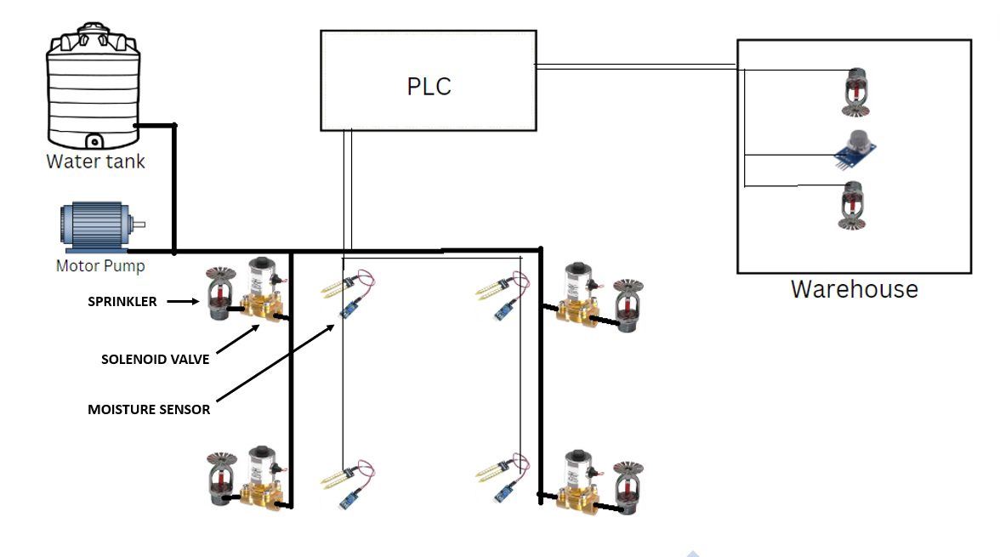
Fig A
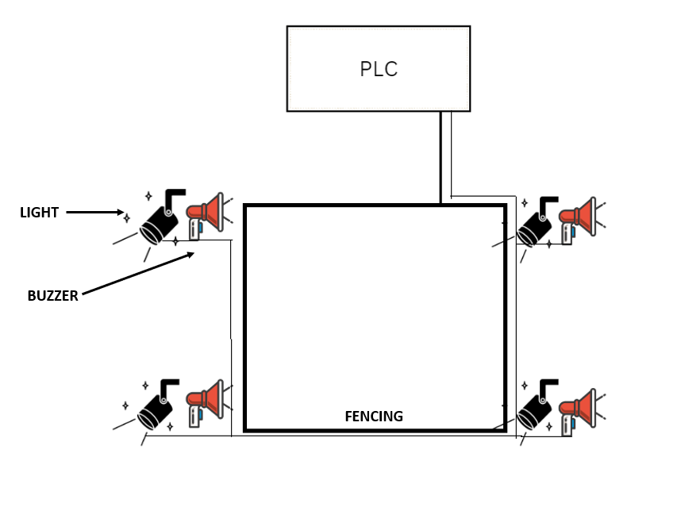
Fig B

Hardware Used
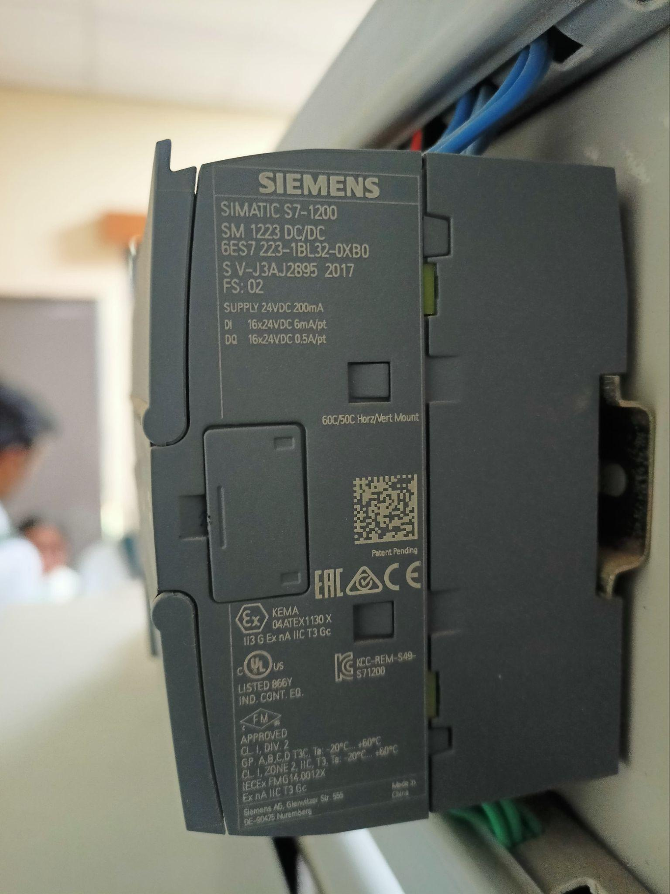
- Siemens PLC S7-1200

Fig c :-
- Soil moisture detector
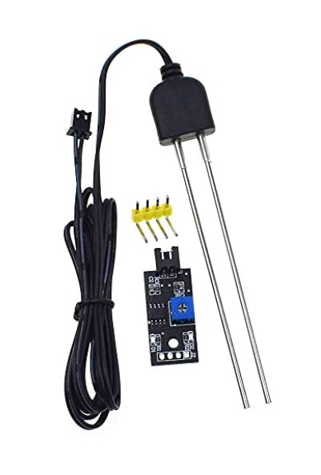
Fig d

1.Soil moisture detection kit with adjustable sensitivity and digital analog dual signal output
2.Equipped with waterproof sensor probe with high corrosion resistance ensure long lifetime up to 6 months after plugged into the soil
3.On-board power and signal indicator to display the module working status
Working Voltage: DC 3.3-5V

- Solenoid Valve
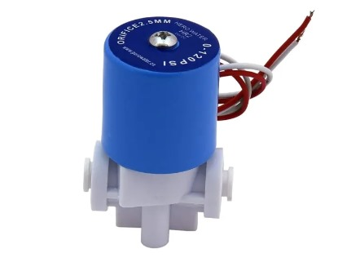
Fig e
Working Pressure:0–120 PSI High Quality Product
Orifice: 2.5mm Voltage:12v DC, 24v DC.
This valve is primarily used with RO Systems.
The valve works with the solenoid coil which operates electronically with DC 12-24v volt supply.

- 4 Channel Relay Module
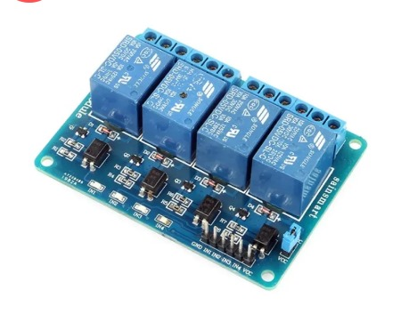
Fig f
- One normally closed contact and one normally open contact
- Channel: 4 channel
- Relay Operating Voltage: 3.3V to 5V
- Triode drive, increasing relay coil
- High impedance controller pin
- Pull-down circuit for avoidance of malfunction
- Power supply indicator and Control indicator lamp
- Power supply and relay instructions, lit, disconnect is off
- Input signal, signal, common Terminal and start conducting
- Useful for appliance control
- DC or AC signal, control, you can control the 220V AC load
- There is a normally open and one normally close contact
- The module is compliant with international safety standards, control and load areas isolation trenches.
- Water pump
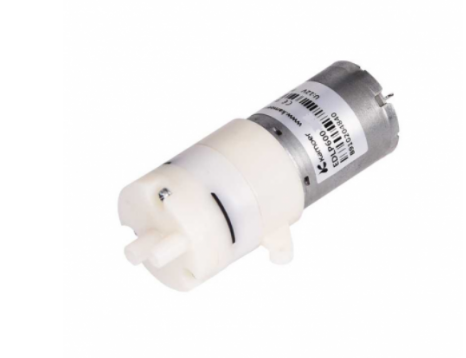
Fig g
24V 0.15A 600ml/min diaphragm pump Model EDLP600-24A
- Operating Voltage (VDC)-24
- Operating Current (A)-0.15
- Operating Temperature ©-0 to 40
- Flow Rate (ml/min)-600
- Noise Level (dB) <65
- Fire Detection sensor.
The sensor has an operating voltage from 3V to 5.5V and has both digital and analog output. The sensitivity of the digital output can be controlled by the on-board potentiometer. Detection angle of sensor is 60 degree and range is theoretically 100cm but practically you can get upto 20-30cm
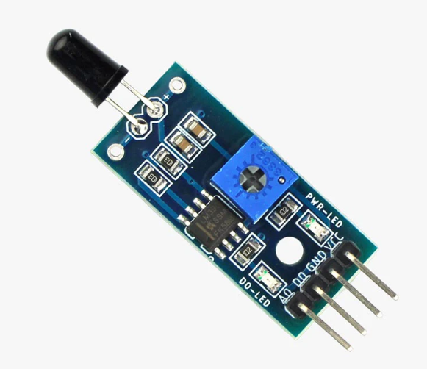
Fig h
IV. METHODOLOGY
In the proposed methodology we can monitor and maintain the vast agricultural land by using PLC. Those are the CAD files for an overall prototype project, where all the devices and components are managed and placed in a specific manner. All the components mentioned above are included in the CAD model. The overall dimensions are 75 cm in length and 45 cm in width.
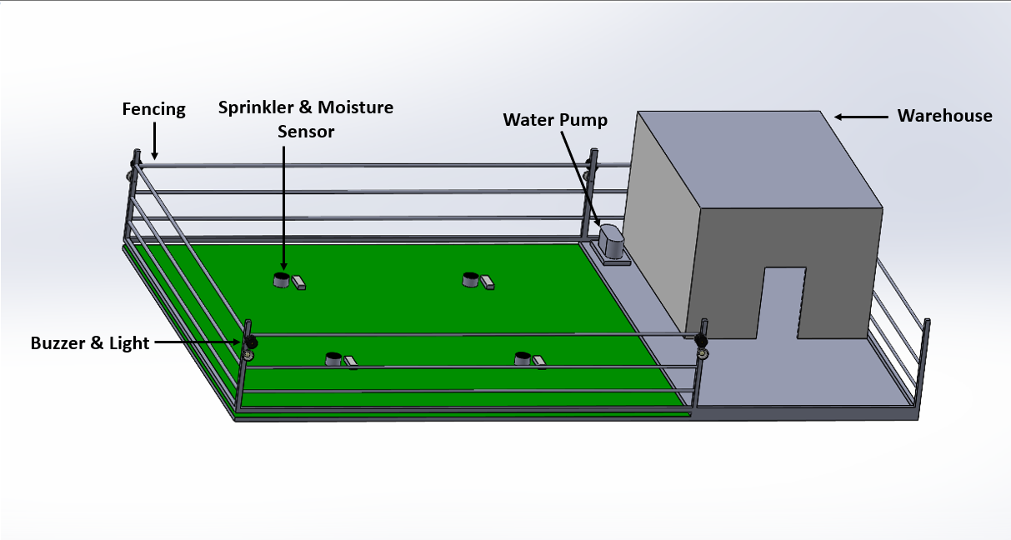
Fig i
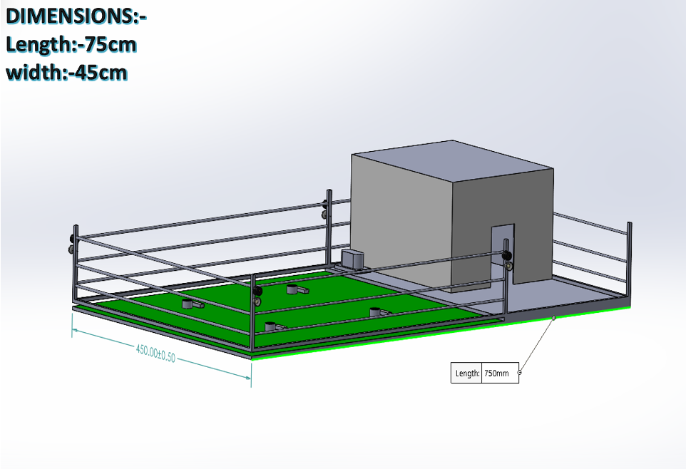
Fig j
In our process we interface the PIR sensors, water level sensors, moisture sensors with PLC, so inputs are given to the input modules of PLC. The output modules are also connected with a pump, alarm. So at first we can measure the moisture of the soil by using a moisture sensor, whenever the temperature (or) the moisture of sensor value becomes below the setpoint, the pump will turn ON and the water flows into the land. Then the moisture (or) temperature of the soil will be maintained at the setpoint. The level sensor will sense the water level maintained in the tank for continuing the supply of water for irrigation. Whenever the water level becomes low, the water pump gets turned ON automatically and the water will be filled in the tank. Once the water level in the tank reaches the set point, the water pump will be turned off automatically. We use passive infrared sensors for sensing the movements of unknown persons (or) animals which enter into the agricultural field. Whenever the sensor detects the movement the alarm gets turned ON and when there is no detection the alarm remains in OFF condition. The entire process is controlled by PLC.
V. ANALYSIS
- Improved field management.
- Proper water level system leads to avoidance of short circuits.
- Reduce run off water and nutrients.

VI. RESULT

The result of PLC based farm automation is that it is providing proper irrigation and crop protection to the farm. PLC the heart of the system is providing interlock facility to the system. Dehydration to the crops is avoided. The moisture sensor provides accurate humidity of soil. Solenoid valves provide flow of water. The system provides timely work.

VII. CONCLUSION

This results in a new development of automation in the agriculture field. It plays a major role in the development of a nation's economy. This system is very helpful for the farmers during the time of irrigation to the cultivable lands of different types. It automatically switches on and off based on the water flow due to the presence of Flow Sensor. This System brings the new revolution of irrigation to the cultivable lands not only for the present generation and also the future generation for the people who are newly entering into the field of Agriculture.

REFERENCES

- PLC Based Smart Farming System with Scada
- M. Ajay; M. Rakesh; M. Hrithik Roshan; G. Revat 2020 IEEE International Conference on Advances and Developments in Electrical and Electronics (ICADEE)
Year: 2020

- Smart Village Monitoring and Control Using PLC And SCADAT Thaj Mary Delsy; K Haritha; Betty Martin; G Karthika
- 2021 International Conference on Innovative Computing, Intelligent Communication and Smart Electrical Systems IC(SES)
Year: 2021

- Design and Implementation of Smart Agricultural Systems Based on Networked PLC and Mobile App
Chen Chiu; Jin-Shyan Lee; Hsin-Han Chiang
2021 IEEE International Conference on Consumer Electronics-Taiwan (ICCE-TW)Year: 2021

- Agricultural Monitoring System with Zigbee Network and PLC based on Modbus RTU Protocol Wittaya Koodtalang; Thaksin Sangsuwan 2020 International Conference on Power, Energy and Innovations (ICPEI)
Year: 2020

- Solar Operated PLC Based Automated Irrigation System With Fault Preventer, M. Kowsalya; A. Elakya; R. Pradeep 2021 7th International Conference on Advanced Computing and Communication Systems (ICACCS) Year: 2021

