Design and Fabrication of an Automated Coconut Scrapper Machine

¹Prof. Saifullah khan, Vaishnavi Ambatkar , Chetan Gabhane-, Vinayak Goswami

^{*1} Assistant Professor, Department of Mechanical Engineering, St. Vincent Pallotti College of Engineering and Technology, Nagpur, Maharashtra, India.
^{*2,3,4,}Student, Department of Mechanical Engineering, St. Vincent Pallotti College of Engineering and Technology, Nagpur, Maharashtra, India.
skhan@stvincentngp.edu.in

Received on: 5 May,2024 Revised on: 30 June,2024 Published on: 04 July ,2024

Abstract— Coconuts are widely recognized worldwide for their widespread appeal as a fruit and its multifarious applications, including anything from cosmetics and skin care to fuel and cancer prevention. Coconuts are quite versatile, but scraping them by hand requires a lot of work and time, and it can be dangerous for the workers. Although there are commercial coconut scraping equipment available, they usually include some physical labour, so there is always space for development. In order to solve the problems with coconut grating, this study presents a mechanical coconut scraping machine. In contrast to semiautomated and manual processes, this completely automated machine greatly lowers human effort and danger. The novel characteristics of the suggested design essentially minimize all the risks associated with scraping coconuts. The system is equipped with an adjustable blade that can move in two directions, as well as a mechanism for clamping that enables movement in three dimensions. In little more than fifteen seconds, the coconut half-shell may be mounted onto the clamp. At the touch of a button, the scraping procedure starts automatically after it has been secured. The article describes the working model's creation and creation process and emphasizes how it revolutionized the field of coconut scraping technology.
Keyword: - Automated, Coconut, Design, Development, Scraper, High torque dc motor etc.

INTRODUCTION
Coconuts are very popular fruits that have many uses, including different nutritional and health advantages. These uses cover everything from eating to cooking to skin care, preventing cancer, making cosmetics, and even producing fuel [1].
Using instruments like hammers or knives, coconuts break open in traditional coconut methods of processing. After that, the kernel is removed manually or with the aid of coconut scrapers that are mounted. But peeling coconuts

by hand is time-consuming and demands a lot of work [1][2].
Even if they are portable, manual coconut scraping machines still need work to be properly used. Usually, they include firmly clamping the device onto a surface and turning a manual handle in order to scrape the inside of the coconut. Because a fall might result in catastrophic injuries, the operator must pay close attention to this operation to avoid mishaps[2].
Apart from the advent of motorized blades, there hasn't been a lot of creativity in coconut grating technology over recent decades. But a recent innovation has surfaced that might completely change the process of shredding coconuts. With its revolutionary design, this coconut grater promises to improve both safety and convenience while cutting down grating time to a matter of minutes[4].
The recently introduced coconut scraper equipment is very useful and profitable since it provides increased convenience and safety. From fresh coconuts, it creates fresh, moist coconut, satisfying the demands of both home and business consumers.
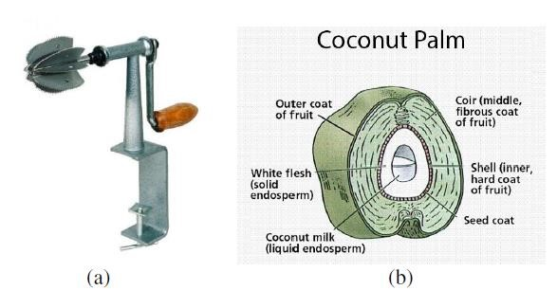
Fig. 1: (a) Typical manually-operated coconut scraper machine and (b) Coconut section showing a structure [5]

PROBLEM IDENTIFICATION
- Physically scraping coconuts is a labor-intensive, timeconsuming, and often dangerous process. This operation is done manually, which not only reduces productivity but also puts workers' safety at risk. The scraping of the coconut shells by hand can be very labor-intensive and time-consuming when cooked in big quantities.
- This inefficiency is exacerbated when utilising common coconut scrapers that are sold in stores. An automated solution is therefore desperately needed to enhance the coconut scraping procedure. A great answer is provided by the coconut grater, which turns fresh coconuts into moist, fresh coconuts. It's the perfect cooking tool for making all kinds of coconut dishes.

AIM AND OBJECTIVES
Aim: The necessity for a completely automated coconut scraping equipment to minimise effort and operator dangers is highlighted as the driving force for this study. The dearth of prior research on completely automated coconut scrapers is brought to light by this endeavor.

Objectives:
- Design and Fabrication: Create a functional prototype of an automated coconut scraper device that is both user-friendly and efficient.
- Safety: Verify that the device has safety measures in place to stop mishaps and injuries while it's in use. • Efficiency: Increase the coconut scraping process's efficiency to save time and manpower. • Versatility: Design a device that can accommodate different kinds and sizes of coconuts, so it can accommodate a range of user requirements.
- User-Friendly Interface: Provide an intuitive and simple-to-use control mechanism for users.

LITERATURE REVIEW
- KedarDeokar et al (2014), have suggested that the three processes involved in designing and producing a coconut dehusking, chopping, and grating machine are as follows: Coconut fibres being peeled, or the coconut being dehusked and split in two, or the coconut being chopped and grated, or the copra (white, edible component) being taken out. In the dehusking procedure, toothed shafts with spiky pins inserted into the coconut's fibrous layer are used to remove the fibres by the opposite motions.

- Ketan K. Tonpe et al (2014), have talked about the coconut deshelling apparatus that uses a belt-driven cutter. The machine successfully de-shelled the fruit without breaking any nuts, and its average de-shelling capacity and efficiency are 195 coconuts per hour and 90%, respectively, according to performance test analysis. Additionally, the device removed our rural areas' reliance on the unreliable public electricity supply, which was a major barrier to the adoption of other mechanized coconut deshelling equipment there.

- Jerry James et al (2016), have detailed the Coconut
Breaker Extractor Grater, a machine that is being suggested. It has the ability to split a dehusked coconut into two parts, gather coconut water, and shred the coconut pieces into dried coconut. The primary feature is that the user's hands remain free from touch with the instrument throughout the breaking and grinding of the coconut.

- Naveen.J et al(2016), have spoken about designing and building a machine which can do tasks like chopping vegetables, scraping coconuts and grinding rice flour. Because it doesn't require any specialized knowledge to operate, it will benefit society by cutting down on work hours and manpower.

BLOCK DIAGRAM
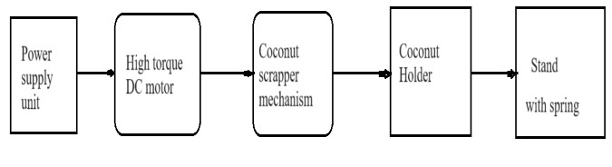
Fig.2. Block Diagram of system

WORKING
- This project describes the criteria and needs for a machine that scrapes coconuts, with a focus on portability, automation, little labour, safety, and durability. It explores the inner workings of the scraper and clamp mechanisms as well as the parts that make them up. It also covers the use of different bushings, coconut holding mechanisms, and DC motors to create a scraping blade mechanism that can adjust on its own.
- The mechanism makes use of a shaft that has a holder on it to hold the partially chopped coconut in place. Specially made mounts keep this holding shaft in place, and a frame is built to support the complete device. Another shaft, with a motor fastened to one end and a scraping tool connected to the other, is positioned horizontally on the other side. The electrical circuit powers this motor, which allows the scraping tool to move. With the coconut pushed up against it, scraping is done quickly and effectively with little effort on the part of the hand.

The developed machine consists of the following parts:
- Frame
- Scraper head
- Flexible shaft
- DC High torque Motor (12v, 500 RPM)
- Power Supply unit (12v DC)
- Coconut holder
- Stand • Others.

CAD MODEL
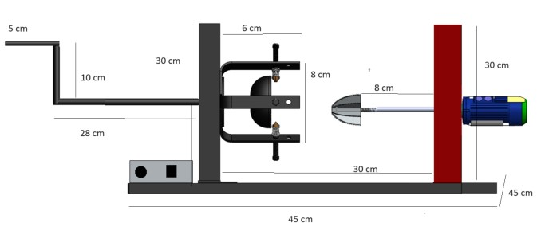
Fig. 2. Cad Model of Machine.

CALCULATION
Calculation for 500 RPM DC High Torque Motor :
- Calculate Angular Velocity (ω):
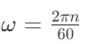
where n is the rotational speed in RPM.

- Calculate Power (P):

where τ is the torque and ω is the angular velocity.
Now, DC motor with the following specifications:
Operating voltage (V): 12V
Rotational speed (n): 500 RPM Torque (τ): The torque is expressed in Nm.

- Calculate the angular velocity (ω):
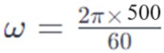
ω = 52.33 rad/s
The torque is expressed in Nm ,
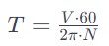
Given:
V=12V=12 volts
N=500N=500 RPM
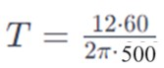
T≈0.229Nm
So, the torque of the 12V DC motor at 1000 RPM is approximately 0.229 Nm.

Next, calculate the power (P):
- P=τ ω
- a torque of τ =0.229Nm,
- power (P) calculate:
- P=0.229 * 52.33
- P =11.983 W
So, the power exerted on the coconut is approximately 11.983 W.

RESULT AND DISCUSSION
- Working Prototype: An automated coconut scraper device that has been successfully designed and built. • Efficiency Gains: Compared to manual techniques, coconut scraping requires a significant reduction in time and labour.
- User-Friendly Interface: An interface that is simple to use and adaptable to a variety of people, enabling a broad user base.
- Safety Compliance: By integrating safety elements, machine operating incidents are less likely to occur.
- Cost-Effective Solution: Research demonstrates that the automated device saves money for both residential and commercial customers by reducing labour and waiting times.
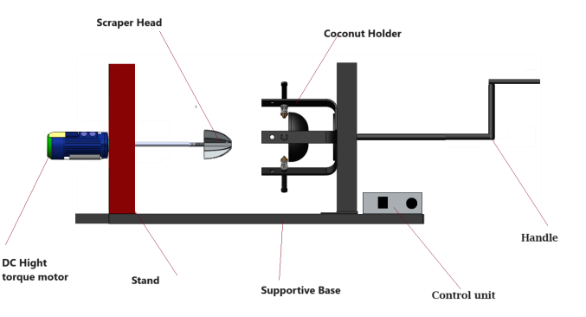
Fig.3. Parts used in this project model

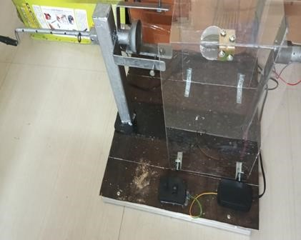
Fig.4. Project model

The manufactured scraping machine can be worked just by DC power supply. It is in this manner adaptable and straightforward machine with Single sharp edges. The aggregate cost of generation of a unit is assessed to be about 5000 Rs. including both assembling and work costs. This is moderate for a normal clients. The execution tests directed showed that high benefits of scrapping efficiencies are achievable when contrasted with existing machines with single scratching sharp edges.

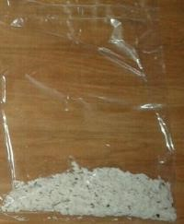
Fig.5.Samples collected during test of machine

- The performance evaluation of the developed models was carried out on the basis of time of operation, i.e. the time taken to scrap one half of the coconut were found out. The average time required was found to be 15 min.
- The efficiency of the models based on the amount of the coconut scraped from the coconut and also with respect to the amount of coconut obtained considering the spillage were found out. Efficiency of Model was 97.5 %, but considering the spillage occurred during scraping, efficiency reduced to 93.5 %.
- The design and fabrication of an Automated Coconut Scrapper Machine using a DC high torque motor have shown promising results in terms of efficiency, automation, and usability. However, ongoing research and development efforts are necessary to further optimize the machine's performance, enhance its commercial viability, and address environmental considerations effectively.

ADVANTAGES
- Fast Coconut Scraping
- Easy To Use
- Automated Scraping.

CONCLUSION
Scraping is done in quick process than the conventional machines and time and power consumption is very less. Man power needed is very less and thus this machine is now implemented in several mass food production areas. The man power and time consumption for scraping of coconut can be reduced by using multi blade system using single drive. The fabrication of a Coconut Scrapper Machine utilizing a DC high torque motor presents a promising avenue for innovation and advancement in the field of food processing technology. Through ongoing research and development, this technology holds the potential to revolutionize coconut scraping processes, offering enhanced efficiency, automation, connectivity, and sustainability.

REFERENCES
- KedarDeokar, Kevin Malaviya, Karan Mistry, PrathameshChaudhari, Madhumita Dutta, “Design and Manufacturing of Coconut De-Husking, Cutting and Grating Machine”, International Journal of Engineering Science and Computing, VII (4),pp., 2014.
- KetanK.Tonpe, Vinod P.Sakhare, C.N.Sakhale ,“Design & Performances of Coconut De-Shelling Machine”, International Journal of Engineering Research and Applications, IV(7),pp., 2014
- Jerry James, Jacqwin Joy, AbinShaji, Basil Chandy,
Vinay Mathew John, “Design & Fabrication of Coconut Breaker, Extractor Grater Machine”, International Journal for Innovative Research in Science &
Technology, II (11), pp., 2016.
- J.Naveen , A Manikandan, P Maheshkumar,
M.Selvaraj,”Design And Fabrication Of Low Cost
Multi-Purpose Kitchen Equipment” International
Journal of Engineering Research-
Online,IV(4),pp.,2016.
- Abi, V. and J. Jippu. 2014. A review of coconut husking machines. International Journal of Design and Manufacturing Technology. Volume 5, Issue 3, September - December (2014), pp 68-78.
- Khurmi, R. S. and J. K. Gupta. 2005. A Textbook of Machine Design (S.I. Units), Eurasia publishing House (PVT) Ltd., Ram Nagar, New Delhi.

- Ohler, J.G.. Coconut, Tree of Life. FAO Plant Production and Protection Paper 57. FAO, Rome, Italy, 1984.
- Rethinam, P. (2003). Prospects for the coconut industry. J. Planta. Crops. 31(1): 17.
- Rey, H.O. (1955). Device for removing meat from coconut. Philippine Patent No. 793.
- Thampan, P.K. (1981). Hand Book of Coconut Palm, Oxford and IBH Co. Pvt. Ltd., New Delhi. Pp. 311.
- Shiwalkar B.D., Design Data for Machine Elements, Dattatraya Publications, Nagpur (India).
- Sharma, P.C. and Aggarwal, D.K. Machine Design. S.K. Kataria and Sons, Nai Sarak Dechi. Katra books @yahoo.com, 2006.
- Khurmi, R.S. and Gupta, J.K.. A Textbook of Machine Design (S.I. Units), Eurasia publishing House (PVT) Ltd., Ram Nagar, New Delhi-11005s, 2005
- IS 2494-1974. Indian Standards. Indian StandardsI institute, New Delhi, 1974. [15] Rajput, R.K. Strength of Materials, S. Chand &Company Ltd, Ram Nagar, New Delhi, 2006.

