Designing and Implementing a System for Automation of E-Yantra Lab Using Iot and Computer Vision

Rohan Vaidya, Aryan Narde, Himanshu fanibhare, jay kohle, Piyush khonde,
Abhya Sharma, Prathmesh Siddhamsittiwar

Electronics and telecommunication, St Vincent Pallotti collage of engineering, Nagpur India
aryannarde1@gmail.com

Received on: 5 May,2024 Revised on: 30 June,2024 Published on: 04 July ,2024

Abstract -
A face recognition attendance system uses facial biometrics based on monitor camera image capture to identify faces while recording attendance. the CPU (central processing unit) will be able to locate and recognize human faces as part of the smart attendance system. The suggested solution uses face recognition to keep track of attendance. The attendance is updated with the appropriate student’s name, date and time. The recognized students are recorded as present.
In recent years, computer vision has concentrated more on developing methods formonitoring humans, comprehending their appearance, actions, and behaviour, offering sophisticated user interfaces for communicating with humans, and developing models for diverse uses. They need techniques for identifying persons in a given input image or video in order for the system to work. Recognizing the moving humans is reliably for properly identified. This technique will assist in reducing high electricity and eliminating wasteful electricity use. The suggested approach operates quickly, precisely, and works for both the simultaneous detection of persons and facial recognition. Such a device would be capable of offering secure laboratory monitoring
The system's integration of voice command and facial recognition extends its functionality beyond attendance tracking. By incorporating voice commands, users can control devices like fans seamlessly, enhancing comfort and energy efficiency in the monitored environment.
Additionally, the ability to recognize faces in specific areas facilitates targeted interactions, ensuring that devices respond appropriately based on the presence of individuals. This multi-functionality not only streamlines operations but also enhances user experience and optimizes resource utilization. Moreover, the emphasis on security underscores the system's suitability for applications such as laboratory monitoring, where precise identification and access control
are paramount. Overall, the proposed solution showcases the potential of computer vision technologies to revolutionize traditional processes, offering efficiency, precision, and versatility in various settings.

INTRODUCTION

As the world is stepping into the 21st century, it is becoming more advanced digital.In this digital revolution, there is growing interest in a smart security system in the various fields such as Schools, colleges,industries,and many more corporate areas. There are many types of research done in order to design various types of automated security systems. Besides, there are many methods available to identify a person through biometric systems such as fingerprint, retina, voice, and face identifications,etc. All these methods which are often practiced in many places have some advantages and many disadvantages. In order to avert any risk, this biometric system is designed and developed which contains reliability, flexibility, and accessibility. In this, physical contact with scanning devices and other parameters is necessary.Person detection is a computer vision technique that involves identifying and locating human beings in digital images or videos. The goal of person detection is to accurately recognize the presence of human bodies, faces, and other
features within an image or video stream. This technology is essential for a wide range of applications, from security and surveillance systems to retail analytics and human-computer interaction. Person detection algorithms use machine learning techniques such as deep neuralnetworks to extract features from images and classify them as containing a person ornot. As computer vision technology continues to advance, person detection is expectedto become even more accurate, reliable, and versatile, enabling new applications and improving existing ones. In our project, we have some separate models so as to automate the lab in such a way that each model should work perfectly. The Face recognition model will allow the entry of only recognized persons in the lab to enter and avoid unwanted people entering the lab. The people count model will count the number of people present in the cubicles periodically, in such a way as to turn ON/OFF the fan and light of that particular cubicle by counting the population density of that particular area.and it can be control by the voice commads also.

LITERATURE SURVEY

Face recognition: Currently, we call out each student's name, and there is always a risk that a proxy will show up. The amount of time required for this activity is staggering, and mistakes made by people are rare and cannot be noted. The outdated method of recording student attendance on attendance sheet will no longer be considered. In many different places, facial recognition technology can be used to identify people. Access to sensitive places, such as computer systems or research labs, can be facilitated by the technology. Identity verification and other operations can be made more efficient by using facial recognition technology, which can also accurately identify people in congested locations. The technology can be utilized for security applications and usesdeep learning algorithms to analysis facial traits. Face recognition software has drawn an excessive amount of study attention and is progressively replacing alternative biometric security systems Future technology is called IOT, or the Internet of Things. IOT-based automation uses a CPU and esp boards to automate appliances so that customers may simply control them online. By tying together, the physical objects such as machinery, appliances, and other things equipped with hardware, software, sensors, and network connectivity, all of which are capable of gathering and exchanging data and working towards shared objectives.

METHODOLOGY

The system depicted in the block diagram operates as follows: first the Initially, a camera used to collect a dataset of each individual's face. This dataset is then utilized to train a Face Recognition Model, which is executed on a central processing unit (CPU). When a person's face is recognized, the system stores relevant information such as the person's name, along with the date and time of recognition. This data is stored in Google Sheets, which is linked to the attendance system. Using this data also provides control over the automatic functions of fans and lights.
For person detection, a live streaming camera is installed. Upon booting up, CPU runs the model and checks the frame for the presence of individuals.If persons are detected, the model sends a signal to the esp8266 and esp control the appliances based on signals
, activating the relay and turning on the fans and lights. In additional we can control the tubelight and fan by using the voice command ,the cpu collect the voice command from the microphone connected to the cpu after collecting the command it will process and based on than it sent data to the esp8266 and esp take action based on the received signals
And DHT11 is connect to the esp8266 it collect the current room temperature and humidity and send to cpu to speak out the current value of temperature and humidity.
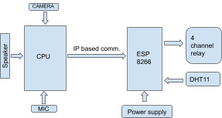

FIG 1: Block Diagram of Automation of E-yantra lab
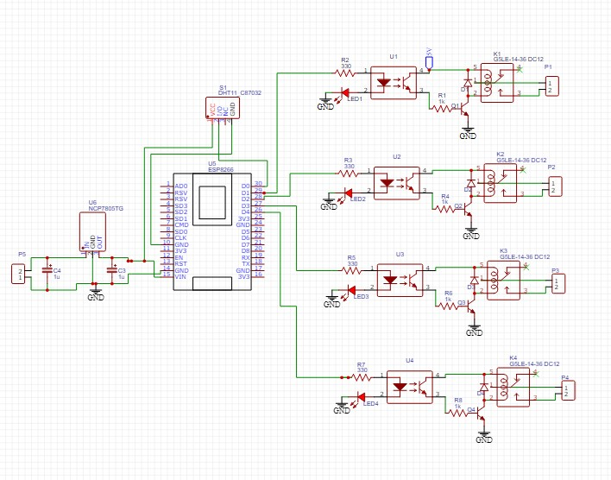
FIG 2: Circuit diagram
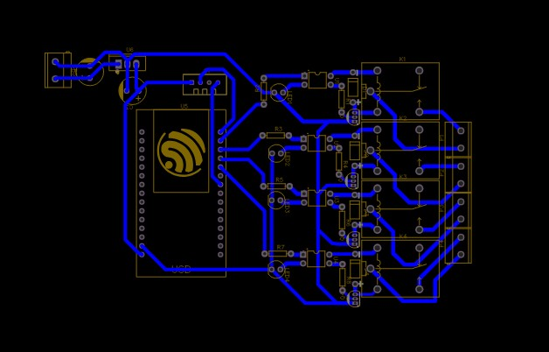

FIG 3: PCB diagram

Circuit Elements 1. ESP8266
The Microcontroller ESP8266 (Wemos) serves as the vital processing unit of this project. Its number one utility lies in dealing with various duties essential for the device's operation. Specifically, the ESP8266 is responsible for handling sensor statistics processing, communique with peripherals, and executing decision-making algorithms. With its built-in Wi-Fi abilties, it manages all networking components, facilitating seamless interaction with other gadgets and offerings. Additionally, the ESP8266's processing energy allows it to execute firmware answerable for data acquisition, transmission, and control good judgment.
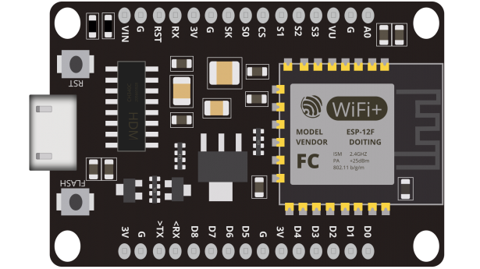

Fig 4: esp8266

Relay Module

A 4-channel relay module is a versatile component commonly used in electronics projects for controlling multiple devices or circuits. Each module typically controlled
separately. These relays allow users to turn on or off four different circuits using digital control signals from a microcontroller or other control devices. The module provides isolation between the control signal and the high-power circuits, enhancing safety and reliability. It is commonly used in applications such as home automation projects.Its ability to handle moderate to high currents and voltages makes it suitable for a wide range of applications, including controlling lights, motors, pumps, and solenoids. Additionally, status LEDs on the module indicate the activation of each relay, providing visual feedback to user.
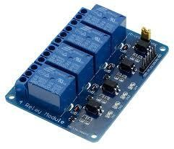
Fig 5 :Relay Module

DHT11

The DHT11 is a popular digital temperature and humidity sensor module used in various applications for monitoring environmental condition
The DHT11 sensor module is a compact and cost-effective device designed for measuring temperature and humidity. It features a built-in sensor element that accurately detects temperature in the range of 0 to 50 degrees Celsius with a precision of ±2 degrees Celsius. Additionally, it can measure relative humidity in the range of 20% to 90% with a precision of ±5%. The module communicates with external microcontrollers or other digital devices using a single-wire digital protocol, making it easy to integrate into projects.
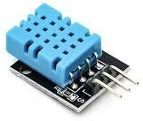

4 Hilink power supply module

The HiLink 5V converter, also known as a voltage regulator or step-down module, is a compact electronic device used to convert higher input voltages to a stable 5V output The HiLink 5V converter is a small, efficient module designed to step down higher input voltages to a steady 5V output. The module typically accepts input voltages ranging from 6V to 24V and converts them to a regulated 5V output with high efficiency. Its compact size and built-in heat sink make it suitable for integration into tight spaces and environments with limited airflow. The HiLink 5V converter features over-current and over-temperature protection mechanisms to safeguard connected devices and ensure reliable operation.
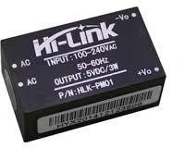

Fig 7 : Hilink 5v power supply
REFERENCES

- Dr. J. Preetha, M. Manirathnam, A. Chaitanya, R. Prakash Raj “Raspberry Pi based Face Recognition System” , IJERT, Issue 2020.
- Rupali S.Rakibe , Bharati D.Patil “Background Subtraction Algorithm Based Human Motion Detection”, International Journal of Scientific and Research Publications, Volume 3, Issue 5, May 2013 1 ISSN 2250-3153
- Mr. Bhuvanagiri Viswanadh, Dr. Ashish Singh” Monitor and Control of Remote Appliances using Raspberry Pi through IoT”
- Arihant Kumar Jain, Richa Sharma, Anima Sharma, “A Review of Face Recognition System Using Raspberry Pi in the Field of IoT”, 2018
- Ashish Ernest Rahul, “Face Detection and Recognition System Using Raspberry Pi”, International

