RF MEMS Based Tunable Circuit for Wireless Communication
V.G.Umale S.N.Ganorkar
Department of Electrical ENgineering
P.I.G.C.E.
Nagpur (Maharashtra), India

Abstract-Modern wireless systems have an increasing need for multiband and tunable microwave and millimeter wave components. The Wireless communication system has several tunable circuits, which reduces the number of the circuits, size, and cost of the front-end. The application of micro electromechanical systems (MEMS) technology to RF systems enables production of components with low power consumption, high linearity, low insertion loss and high isolation. RF MEMS components are particularly attractive due to their tunable properties. The recent dramatic developments of personal communication devices forced the market to acquire miniaturized efficient devices, which is possible only by the development of radio frequency (RF) MEMS.
Keywords- MEMS, Coplanar waveguide (CPW)
I. INTRODUCTION
During the past decade, several new fabrication techniques have evolved which helped popularize micro electro-mechanical systems (MEMS) [1] and numerous novel devices have been reported in diverse areas of engineering and science. One such area is microwave and millimeter wave systems. MEMS technology for microwave applications should solve many intriguing problems of high-frequency technology for wireless communications. The recent and dramatic developments of personal communication devices forced the market to acquire miniaturized efficient devices, which is possible only by the development of radio frequency (RF) MEMS. The term RF MEMS [7] refers to the design of MEMS for RF integrated circuits. It should not be interpreted as the traditional MEMS devices operating at RF frequencies. MEMS devices in RF MEMS are used for actuation or adjustment of a separate RF device or component such as variable capacitors switches and filters.
II. MEMS AND RF MEMS SWITCH
RF switches [3] are the most common and basic circuit elements. Current solid state RF technologies (PIN diode- and FET- based) are utilized for their high switching speeds, commercial availability, low cost and ruggedness. This technology reached its maturity in areas such as device design, fabrication, packaging, applications/system insertion and consequently, high reliability and well-characterized performance. Some parameters such as isolation, insertion loss and power handling can be adjusted via device design to suit many application needs. In spite of this great design flexibility, there are two major bottlenecks with solid-state switches: breakdown of linearity and frequency bandwidth upper limits, and the degradation of insertion loss and isolation at signal frequencies above 1-2 GHz. By utilizing electromechanical architecture on a miniature- (or micro-) scale, RF MEMS switches [3] combine the advantages of traditional electromechanical switches (low insertion Loss, high isolation, extremely high linearity) with those of solid-state switches.
.
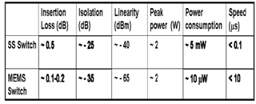
Table 2.1 Performance comparison between solid-state switches and MEMS switches for RF applications.
Parameters for the design of MEMS Switch
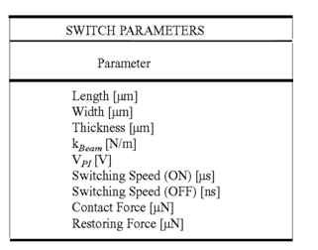
Table 2.2 Switch Parameters of MEMS switch
The pull in voltage (V_{PI} ) required to defect the beam in the MEMS switch can be determined with the equation
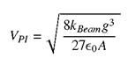
Where A is the actuation area, g is the gap between the beam and biasing structure in the neutral position, ε₀ is the permittivity constant of free space and K_{Beam} is the spring constant of the beam. Assuming a nearly uniform electrostatic force on the cantilever beam, the spring constant (K_{Beam}) is determines with equation
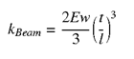
Where E is Young’s modulus of the material, w is the width, t is the thickness, l is the length of the beam. The restoring force and the contact force will vary depending on the application and design of the MEMS switch. The restoring force F_{r} is determined with equation
And contact force F_{c} is determined with the equation
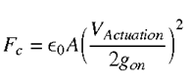
Where V_{Actuation} is the applied switch bias and g_{on} is the separation between the MEMS device and the biasing pad in the ON state. The applied switch bias V_{Actuation} may be higher than the pull in voltage V_{PI} to achieve the desired contact force value. The sacrificial layer thickness and the operating voltage can be varied as needed for the desired restoring force and the contact force of the specific application. RF MEMS devices mainly consist of four different designs viz. metal- contact switches, capacitive switches, switched capacitors and analog varactors. The metal contact switches utilize physical contact of metal with low contact resistance to achieve low insertion loss when actuated and can be operated from DC to RF frequency [4]. An RF MEMS switch with a capacitance ratio of 30-150 is commonly used for routing purposes (SPNT, DPDT, NxN matrices) and phase shifter designs. RF MEMS switches result in low- loss phase shifters with high linearity and provide 3-4dB improvement (6-8dB in two way telecommunication systems) over on- wafer designs using GaAs FET switches. An RF MEMS switched capacitor with a capacitance ratio of 2-6 is mostly used in tunable filters and reconfigurable networks. The analog varactors with a continuous tuning range of 1.5-8:1 can be used as tuning devices from 500MHz to 100GHz .Owing to the advantages of near-zero power consumption, very high isolation, very low insertion loss and low inter modulation products and very low cost.

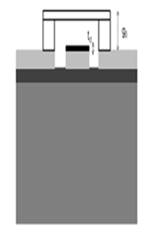
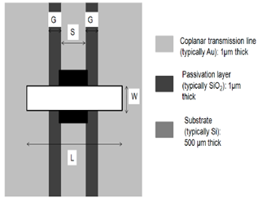
Fig 2.3 Cross-section and top view of a typical RF MEMS
Capacitive shunt switch and CLR model

III PHYSICAL DESCRIPTION OF MEMS CAPACITIVE SWITCH

A MEMS shunt capacitive switch is shown in Fig 2.3. It consists of a substrate which can be silicon, GaAs, alumina, LTCC or a quartz dielectric, which houses a RF transmission line; typically a CPW t- line. The CPW t-line is typically made of gold owing to its low conductor losses and ease of plating. The CPW is so chosen that the values of G/S/G correspond to 50ohm characteristic impedance. A shunt membrane is suspended at a height g0 above the dielectric layer on the transmission line where the dielectric thickness is t_{d}, with a dielectric constant ∑ rd. The shunt membrane is Lμm long, Wμm wide, Tμm thick.. Typical values of the switch geometry are a dielectric thickness of 1000-1500 Å, a relative dielectric constant of 5.0-7.6 depending on the nitride material used, a bridge height of 2.5-5μm, a length around 200- 300μm, and a width between 25 and 180μm depending on the switch capacitance required. The length is rarely shorter than 200μm due to the sharp increase of the actuation voltage with decreasing bridge length. The width is practically limited to 200μm so as to result in a flat contact area between the MEMS Bridge [13] and the t-line. The thickness of the shunt membrane is between 0.5-2μm depending on the length and width of the membrane geometry to obtain an acceptable value of spring constant of the membrane.

IV. A PARAMETRIC MODEL OF MEMS CAPACITIVE SWITCH

Published example of the electromagnetic model which shows shunt capacitive MEMS switch consists of a thin metal membrane bridge suspended over the center conductor of a coplanar waveguide (CPW) [5] and fixed on the ground conductor of the CPW, The parameters L and H indicate the length and the height of the membrane bridge. The full wave electromagnetic simulation of the switch can be done using a soft High Freq Structure Simulator (HFSS). In the simulation a box size 1200 x 600 x 600 μm can be used and boundary radiation conditions can imposed on the six sides of the box. After the full wave analysis is performed, S-parameters can extract in the frequency range going from 1 GHz to 60 GHz for different heights of the switch. The substrate can assume to be lossless with relative dielectric constant of 9.8 (correspondent to Alumina). The thickness of the substrate is 600μm and the CPW conductors and MEMS switch can treat as perfect conductors. The central conductor of the CPW can assumed to be coated with silicon nitrate (Si3N4) having relative dielectric constant of 7 and thickness of 0.1 μm. Fig 4.1 (b) presents the first order equivalent circuit model obtained for the capacitive MEMS switch.
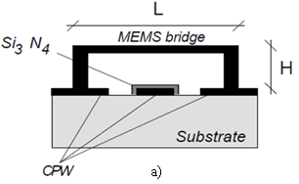
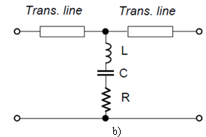
Fig 4.1 (a) Cross section of the capacitive MEMS switch over CPW line. (b) Equivalent circuit model of the capacitive MEMS switch

The parameters of the model can optimized to fit the S-parameter obtained from the full wave Electro-magnetic simulation. Fig 4.2 shows the EM simulated and circuit model S-parameters of a 300 μm by 200 μm membrane suspended 5 μm over a CPW transmission line having a center conductor width of 100μm and a gap of 50μm. Since the capacitance is very small and it dominates the shunt impedance, it is very difficult to determine the resistance and inductance associated with the model in this state (off-state).The capacitance in the circuit model for this state is 0.0493pF.

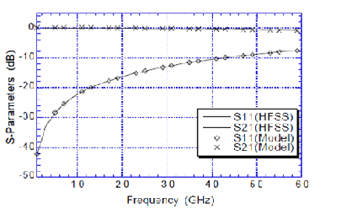
Fig 4.2 S-parameters of the EM simulated and circuit modeled for 300μm long, 5μm gap switch off-state

When the switch is in the on-state, similar procedure can be used and S-parameters can be obtained from the full wave analysis can compared with those obtained using model in Fig. 4.3

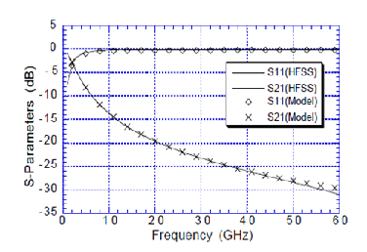
Fig 4.3 S-parameters of the EM simulated and circuit modeled for 300μm long 5μm height switch in the on state

V. CONCLUSIONS
Thus the RF MEMS switch can be use as a tunable circuit for various applications and the MEMS Switch can provide better performance over solid state switch. Thus the use of RF MEMS switches makes deliberate changes in wireless communication. A parametric model based on full wave analysis capable of predicting the performance in the off state of MEMS capacitive switches can be developed by this way.
REFERENCES
- G. M. Rebeiz: "RF MEMS, Theory, Design and Technology," John Wiley & Sons, 2003
- RF-MEMS based tunable matching network Qin Shen; Barker, N.S.; Radio and Wireless Conference, 2003. RAWCON '03. Proceedings Digit Object Identifier: 10.1109/RAWCON.2003. 1227955 Publication Year: 2003
- RF MEMS SWITCH: “An overview at- a-glance Lahiri”, S.K.; Saha, H.; Kundu, A. Computers and Devices for Communication, 2009. CODEC 4th International Conference on Publication Year: 2009
- A 2-Bit Ka-Band VRF MEMS Frequency Tunable Slot Antenna Van Caekenberghe, K.; Sarabandi, K.; Antennas and Wireless Propagation Letters, IEEE Volume: 7 Digital Object Identifier 10.1109/LAWP.2008.921390 Publication Year: 2008
- J. Y. Qian, G.P. Li, F. De Flaviis “A Parametic model of MEMS capactive switch operating at microwave frequencies”
- Qing Ma, Quan Tran, Tsung-Kuan A. Chou, John Heck, Hanan Bar, Rishi Kant and Valluri Rao Intel Corporation, Santa Clara, CA 95054 “Metal contact reliability of RF MEMS switches” united states, US 2010/0263999A1
- R. Hiremane, L. Swanson, M. Chartier, Q. Ma, “Radio Renaissance,” Portable Design October, 2005.
- J. Weiser, “Switching contacts in relays,” ICEC '98. 19th International Conference on Electric Contact Phenomena.
VDE -Verlag, Berlin, Germany; 1998; 507 pp. p.15-21
- T. Yano, “Across-the-board improvements give reed relays intro into communications/control applications,” JEE-(Japan-Electronic-Engineering). no.116; Aug. 1976; p.22-5
- D. Trowbridge , “Switching with the mercury-wetted-contact relay,” Electronics-and-Power.-Journal-of-the- Institution-of-Electrical-Engineers. vol.22, no.8; Aug. 1976; p.523-5
- F.A. Pieters, “Quality-dry reed switches,” Electronic-Components-&-Applications. vol.8, no.2; 1987; p.87-94.
- H. P. Koidl, W. F. Rieder, and Q. R. Salzmann, “Influence of Physical/Chemical Characteristics of Organic Vapors and Gas Mixtures on their Contact Compatibility,” IEEE Transactions on Components and Packaging Technology, vol.22, NO. 3, September 1999
- A.H.M. Zahirul Alam, Norsuzlin Bt. Mohd Sahar and Norasyikin Bt Zamani” TRIPE BAND RECONFIGURABLE ANTENNA USING RF MEMS” International Islamic University Malaysia,

