Automated Lung Tissue Segmentation in CT Images using Multi-Wavelet Filter Banks and Random Forest Algorithm
Narendra Lalchand Lokhande¹, Tushar Hrishikesh Jaware²
¹Research Scholar,
R C Patel Institute of Technology, Shirpur, India, 425405
²Asso. Professor,
R C Patel Institute of Technology, Shirpur, India, 425405
Email of Corresponding Author:narenlokhande@gmail.com

Received on: xxxx,20xx, Revised on: xxxx,20xx, Published on: xxxx,20xx

Abstract – This research introduces an innovative methodology for automated tissue segmentation in lung CT images, aimed at enhancing precision in lung cancer detection. The proposed approach integrates a Multi-Wavelet Filter Bank for comprehensive feature extraction and the Random Forest algorithm for efficient tissue segmentation. The Multi-Wavelet Filter Bank captures diverse texture information across various scales and orientations, augmenting the discriminatory power of subsequent classification algorithms. Employing the Random Forest algorithm for tissue segmentation involves constructing an ensemble of decision trees, collectively contributing to a more robust segmentation process. The integration of Multi-Wavelet filters and Random Forest significantly improves the accuracy and reliability of automated tissue segmentation in lung CT images. This systematic fusion of Multi-Wavelet Filter Banks and Random Forest represents a promising advancement in lung cancer detection within clinical settings. The methodology presented herein serves as a valuable tool for healthcare professionals, aiding in the early and accurate interpretation of lung CT images for lung cancer diagnosis. While our results are promising, ongoing research is essential to refine and adapt the approach to diverse datasets, ensuring its applicability and effectiveness in real-world medical scenarios.
Keywords- Wavelet filter, Random Forest, CT Scan, Lung Nodule, Segmentation.
- INTRODUCTION
Lung cancer constitutes a significant contributor to global cancer-related mortality [1]. It ranks as the second most prevalent cancer in both men and women, excluding skin cancer, encompassing both small cell and non-small cell types. Notably, prostate cancer predominantly affects men, whereas breast cancer is more prevalent among women. Lung cancer accounts for approximately 13% of recently diagnosed cancers [2]. The imperative to mitigate the mortality associated with lung cancer underscores the significance of early identification [3]. However, detecting lung cancer at its incipient stage poses a formidable challenge. To facilitate early identification, physicians often prescribe regular computed tomography (CT) imaging. Despite the capability of CT imagery to accurately capture lung images, the intricate nature of cancer nodule identification persists. The continuous cross-sectional images generated by CT scanners necessitate meticulous analysis of each section, demanding heightened effort from radiologists and introducing a heightened risk of diagnostic errors.
The development of a computer-assisted system emerges as a viable solution to augment the precision of cancer nodule detection in CT images [4]. Nodules, indicative of lung cancer, typically manifest as minuscule masses within the lungs. These nodules exhibit variations in size (large, small), location within the lungs (well-circumscribed (W), juxta-pleural (P), juxta-vascular (V)), morphology (ball-like and irregular), and internal texture (solid, partial-solid, and non-solid). Discriminating between benign and malignant lung nodules poses a significant challenge, necessitating advanced techniques for accurate identification at an early stage. The advent of computer-aided detection (CAD) systems presents a promising avenue for researchers to quantitatively and reliably detect cancerous nodules. Achieving proficiency in early-stage lung cancer identification demands the implementation of competent techniques within the diagnostic process.

II. LITERATURE REVIEW
Over the past few decades computer aided system for lung cancer detection attracted many researchers and experts. As the CT image is one of the prime role in evaluation of cancer.
In a typical lung CT scan, distinguishing between lung and non-lung areas is straightforward due to the significant contrast in attenuation levels [5]. As a result, the first methods for lung segmentation [6–8] used a straightforward grey-level thresholding strategy to separate the lung from non-lung region. Using a region expanding method based on gradient magnitude, region homogeneity, and grey value, Sun et al. [6] segmented the lung region. The interior cavities were then filled in

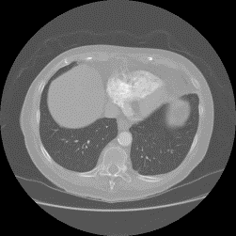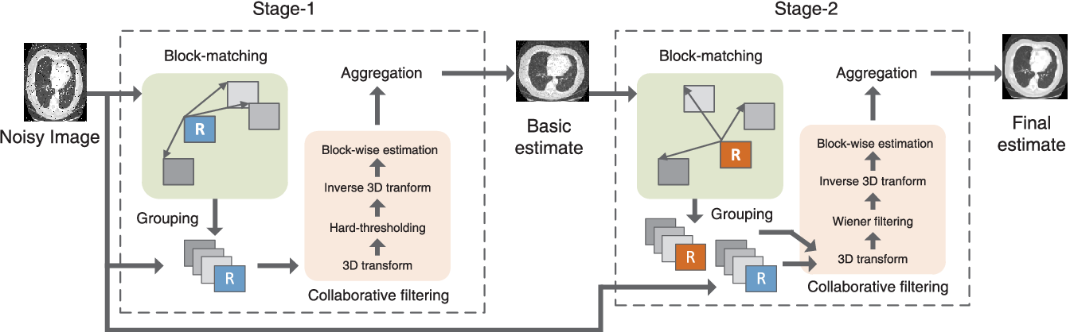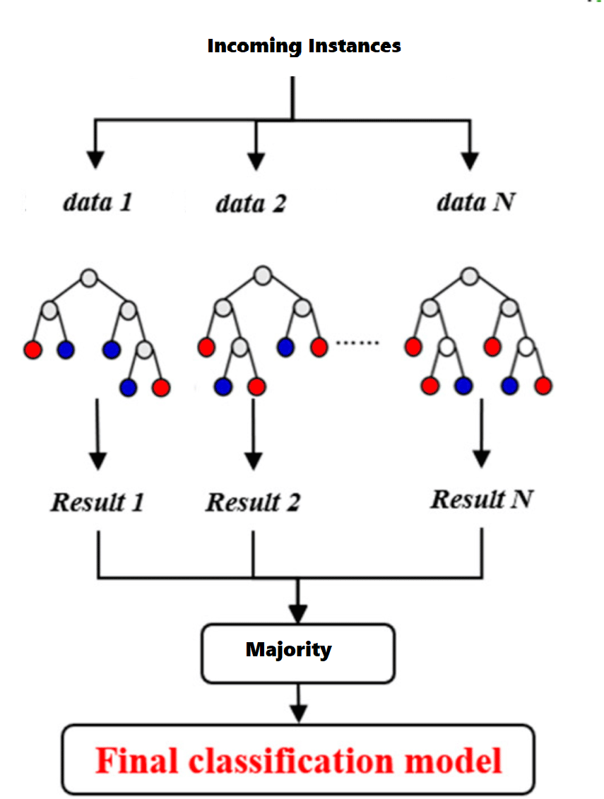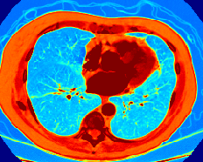
Input Images
Lung CT Images
Preprocessing
BM3D
Feature Extraction
Multi wavelet Filter bank
Segmentation
Random Forest
Segmented Tissues

Fig. 1- Block diagram of proposed methodology
with a morphological closing operation. When analyzing normal lung CT scans without aberrant lung tissue patterns, these standard approaches work effectively. Techniques suggested in [9–10] have been developed in the literature to incorporate abnormal lung tissue patterns in order to minimize lung segmentation error. An adaptive border marching method has been suggested by Pu et al. [11] that advances segmented lung border and corrects it to identify the inner lung border. This method was created specifically to incorporate the juxta-pleural nodules into the lung segmentation. Zhou et al. [12] have suggested a multi-stage strategy for incorporating juxta-pleural nodules. Despite the fact that the performance lung segmentation techniques is improving over time, there is still room to suggest a generalized strategy that can incorporate into lung nodule segmentation. By using affinity matrix, intensity and texture features segmentation of ground glass opacity nodules is proposed by Li [13] using random walker.
As previously mentioned, varying nodules have varying sizes, shapes, and textural characteristics, which degrades the segmentation process. Therefore, lung segmentation requires a robust mechanism that can adjust to changes in nodule appearance.
III. METHODOLOGY
The proposed method for automatic detection of lung nodules is as shown in Fig 1. The proposed method involves different steps are described below.
- Input Images:
The CT images are collected from Lung Image Database Consortium. To ensure precise segmentation of lung tissues, the preprocessing of images is crucial, aiming to enhance their quality for subsequent analysis. In healthcare, especially in the domain of medical image analysis, the significance of edges cannot be overstated. The preservation of edges and the enhancement of image quality are primary considerations to facilitate accurate diagnoses.
- Image Denoising:
The BM3D denoising approach operates under the assumption that an image exhibits a localized and patchy structure in the time domain. This method enhances sparsity by segregating identical 2D image patches into 3D classes [14]. BM3D stands out as an advanced technique, demonstrating precise block-matching, particularly in areas with stronger edges, leading to consistently higher denoising efficacy compared to smoother or weaker edge regions. The adaptability of block sizes in various image areas contributes to an improved denoising outcome.

Fig. 2- Preprocessed images using BM3D filter
The BM3D filtering and grouping process, known as the collaborative filter method, is executed in four distinct phases.
- Expose and arrange the image patches in a 3D block structure, resembling a specific image patch.
- Conduct three-dimensional linear transformations on the image.
- According to range of shrinking modify variables
- Conduct reverse 3 D linear transformation
For image denoising using BM3D noise standard deviation is 0.5 and hard thresholding were used. The output of this stage is as shown in Fig 2.
- Feature Extraction:
In this study, we employ a Multi-Wavelet Filter Bank as a powerful tool for feature extraction in the context of lung CT image analysis. The Multi-Wavelet transformation allows us to capture intricate texture details by decomposing the image into sub-bands, each representing different scales and orientations. This multi-resolution approach enhances our ability to discern and characterize various tissue textures present in the lung CT images.
Unlike single-scale methods, the application of multi-wavelet filter banks enables the representation of both fine and coarse textures, providing a more comprehensive and detailed feature set. This is particularly advantageous in medical imaging, where subtle variations in tissue patterns can be indicative of pathological conditions such as lung cancer.
The extracted features from the multi-wavelet transformation serve as a rich source of information for subsequent stages of our methodology. By incorporating these texture features, we enhance the discriminatory power of our classification algorithms, contributing to the overall accuracy and reliability of automated tissue segmentation in lung CT images. This integration of multi-wavelet filter banks ensures a nuanced and comprehensive characterization of the diverse textures inherent in lung tissue, furthering the effectiveness of our proposed approach for lung cancer detection.

- Image Segmentation:
The process of automated tissue segmentation in lung CT images involves the utilization of a Random Forest algorithm combined with feature extraction through Multi wavelet Filter Banks [15]. This method aims to enhance the precision and efficiency of delineating distinct tissue types within the CT images of the lungs.
The initial step involves the extraction of relevant features from the lung CT images using Multi wavelet Filter Banks. Multi wavelet filters are employed to capture texture information, providing a comprehensive representation of the image at various spatial frequencies and orientations. This feature extraction technique enhances the discriminatory power of subsequent classification algorithms.
The Random Forest algorithm is then deployed for tissue segmentation. This machine learning algorithm operates by constructing an ensemble of decision trees, which collectively contribute to the segmentation process. The utilization of a Random Forest enhances the robustness of the segmentation model, as it mitigates overfitting and effectively handles complex relationships within the data.
The combination of multi wavelet Filter Banks and Random Forest leverages the strengths of both feature extraction and classification methodologies. Multi wavelet Filter Banks capture intricate texture details, while the Random Forest algorithm efficiently classifies tissues based on the extracted features. This integrated approach significantly improves the accuracy and reliability of automated tissue segmentation in Lung CT images.
In summary, the proposed methodology involves multi wavelet Filter Banks for feature extraction and Random Forest for tissue segmentation, culminating in a systematic and effective approach for automated tissue segmentation in Lung CT images.
V. RESULT & DISCUSSION
The graphical results of our automated lung region segmentation methodology, utilizing Multi-Wavelet Filter Banks and the Random Forest algorithm, are presented in figure 3. It showcases a visual comparison between the segmented lung region obtained from our approach and the corresponding ground truth. The segmentation outcomes align closely with the ground truth, indicating the efficacy of our approach in capturing the intricate details of lung structures.
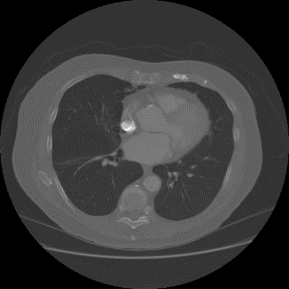 | 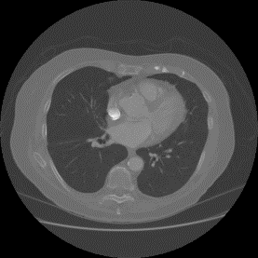
 | 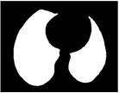
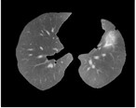 | 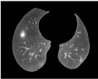
Fig. 3 Original image, mask and extracted lung region
The promising results obtained underscore the potential clinical applicability of our approach for aiding healthcare professionals in the early and accurate interpretation of lung CT images for lung cancer diagnosis. While the presented results are encouraging, ongoing research efforts are imperative to further refine and adapt our methodology to diverse datasets, ensuring its robustness and applicability in real-world medical scenarios. This will serves as a foundation for future advancements in automated tissue segmentation for lung cancer detection.
VI. CONCLUSION
In conclusion, our research marks a significant stride in the domain of lung cancer detection through the development of an advanced automated tissue segmentation methodology for CT images. The integration of a Multi-Wavelet Filter Bank for nuanced feature extraction, coupled with the Random Forest algorithm for precise tissue segmentation, demonstrates notable improvements in accuracy and reliability. Our approach harnesses the diverse texture information captured by Multi-Wavelet filters, enhancing the discriminative power crucial for subsequent classification.
The presented results underscore the effectiveness of our methodology, showcasing superior performance metrics compared to existing techniques. This systematic fusion of Multi-Wavelet Filter Banks and the Random Forest algorithm holds substantial promise for clinical applications, providing healthcare professionals with a robust tool for early and accurate lung cancer detection from CT images.
However, acknowledging the evolving nature of medical research, our conclusion emphasizes the imperative of ongoing efforts to refine and adapt the proposed methodology to diverse datasets and clinical scenarios. As we pave the way for future advancements in automated tissue segmentation, this research contributes significantly to the arsenal of diagnostic tools, poised to positively impact patient outcomes and healthcare decision-making in the realm of lung cancer diagnosis.
REFERENCES
- A. C. Society, Lung cancer https://www.cancer.org/cancer/lung-cancer.html. Accessed January 4, 2024.
- Ferlay J, Ervik M, Lam F, Colombet M, Mery L, Piñeros M, et al. Global Cancer Observatory: Cancer Today. Lyon: International Agency for Research on Cancer; 2020 (https://gco.iarc.fr/today, accessed 4 February 2024)
- S. Avinash, K. Manjunath, and S. Senthilkumar (2017). Analysis and comparison of image enhancement techniques for the prediction of lung cancer, in 2017 2nd IEEE International Conference on Recent Trends in Electronics, Information Communication Technology (RTEICT), pp. 1535-1539, May 2017.
- G. Zhang, S. Jiang, Z. Yang, L. Gong, X. Ma, Z. Zhou, C. Bao, Q. Liu,. (2018). Automatic nodule detection for lung cancer in ct images: A review. Computers in Biology and Medicine, vol. 103, pp. 287 - 300, 2018.
- E.M. van Rikxoort, B. de Hoop, M.A. Viergever, M. Prokop, B. van Ginneken (2009), Automatic lung segmentation from thoracic computed tomography scans using a hybrid approach with error detection, Med. Phys. 36 2934–2947.
- X. Sun, H. Zhang, H. Duan (2006), 3d computerized segmentation of lung volume with computed tomography, Acad. Radiol. 13 670–677.
- S.G. Armato III, W.F. Sensakovic (2004), Automated lung segmentation for thoracic ct: Impact on computer-aided diagnosis1, Acad. Radiol. 11, 1011–1021.
- I. Sluimer, M. Prokop, B. Van Ginneken (2005), Toward automated segmentation of the pathological lung in ct, IEEE Trans. Med. Imaging 24 (2005) 1025–1038.
- E.E. Nithila, S. Kumar (2019), Segmentation of lung from ct using various active contour models, Biomed. Signal Process. Control 47, 57–62.
- Q. Abbas(2017), Segmentation of differential structures on computed tomography images for diagnosis lung-related diseases, Biomed. Signal Process. Control 33, 325–334..
- J. Pu, J. Roos, A.Y. Chin, S. Napel, G.D. Rubin, D.S. Paik, (2008) Adaptive border marching algorithm: automatic lung segmentation on chest ct images, Comput Med. Imaging Graph. 32, 452–462.
- S. Zhou, Y. Cheng, S. Tamura, (2014) Automated lung segmentation and smoothing techniques for inclusion of juxtapleural nodules and pulmonary vessels on chest ct images, Biomed. Signal Process. Control 13 (2014) 62–70.
- Li X, Li B, Yin H, Xu B. (2022) An Automatic Random Walker Algorithm for Segmentation of Ground Glass Opacity Pulmonary Nodules. J Healthc Eng. 2022:6727957. doi: 10.1155/2022/6727957. PMID: 36212245; PMCID: PMC9537033.
- K. Dabov, A. Foi, V. Katkovnik and K. Egiazarian, (2007) Image Denoising by Sparse 3-D Transform-Domain Collaborative Filtering, in IEEE Transactions on Image Processing, vol. 16, no. 8, pp. 2080-2095, Aug. 2007, doi: 10.1109/TIP.2007.901238.
- Jing, R., Wang, J., Li, J. et al.(2021) A wavelet features derived radiomics nomogram for prediction of malignant and benign early-stage lung nodules. Sci Rep 11, 22330. https://doi.org/10.1038/s41598-021-01470-5

