International Innovations in Engineering and Science

[IJIES]

Design and Analysis of Earthquake Resistant Building (Three Story RCC School) Using STAAD Pro.

Ritik Badghare[1] Ishaan Talhar[2] Prajwal Bhoyar[3]

Principal : DR. P.S.Lanjewar
Guide:DR. P.S.Lanjewar Department Of Civil Engineering, SRPCE, Nagpur, India 440009

Abstract - With the advent of advanced technology, civil structures such as high-rise buildings and long span bridges are designed with increased flexibility, increasing their susceptibility to external excitation. Therefore, these structures are vulnerable to excessive modes of vibration under the effect of a strong wind and earthquake. To protect such civil structures from significant structural damage, the seismic response of these structures is analyzed along with wind force calculation and forces such as support reactions and joint displacement are calculated and included in the structural design for a vibration resistant structure. The primary objective of this paper is to create an earthquake resistant structure by undertaking seismic study of the structure by static equivalent method of analysis and carry out the analysis and design of the building using STAAD. Pro software. For this purpose, a ‘Three Story School plan in Nagpur’ is considered. Seismic calculations are conducted for earthquake zone 3, Response reduction factor 3, for ordinary moment resistant frame and Importance factor 1. The structural safety of the building is ensured by calculating all acting loads on the structure, including the lateral loads caused due to wind and seismic excitation.

Key Words: STAAD. Pro, analysis, seismic force, ordinary moment resisting frame, fundamental period, inter-story drift, equivalent static analysis, IS code.
INTRODUCTION:
Structural design is the science of analyzing and designing any structure with ultimate strength, safety, serviceability and economy. It not only requires conceptual thinking and imagination but also the discipline to maintain design standards specified by the respective country design code, for example IS Code. Any building project initiates from the planning stage to meet the specified requirement of the client. Although the client may be unaware of the impracticable conditions existing within the site and have unprecedented expectations, it is the sole responsibility of the structural engineer to undertake
The challenge and meet the design requirements for strength, durability, economy and safety.

The existing shortage of land due to the human population out-burst is constantly demanding the construction of high-rise structures. As the floor count of these multi-story buildings increase, the structure gets vulnerable to external lateral forces subjected by earthquake excitation and wind pressure, thus leading to structural instability and subsequently complete failure of the structure. To enable tall structures resistant to such lateral forces, analysis of the forces due to earthquake and wind must be undertaken and included in the ultimate design of the buildings.

Stages in Structural Design

Every structure follows a specific path from its initiation to ultimate design as follows:

Structural planning of the building.
Calculation of applied loads.
Structural analysis of the building
Design of the building as per analysis.
Drawing and detailing of the structural members.
Preparation of schedule.

It is the sole responsibility of the design engineer to construct the building structurally sound, considering all the loads acting on the building. There are multiple methods of conducting these design procedures, one of which is the use of STAAD. Pro software.

Introduction to STAAD. Pro

STAAD. Pro provides the design engineer with excellent user interface and tools required to impose dead load and imposed load along with external acting loads on the structure. It has a powerful engine to undergo advanced dynamic analysis considering multiple loading combinations and generate an appropriate design of the structure. The software gives easy access to view reaction forces, joint displacement, shear force and bending moment acting on different beams and columns in the post-processing mode due to the applied loading condition on the structure.

STAAD. Pro provides a vast interface to carry out timber, aluminum and concrete design of building, bridge and water tank. From model generation to ultimate design, the software provides accurate results and submits the final output which contains the structural design of every individual beam and column within the building.
Getting Started

This paper contains detailed information on the methodology to analyze and design a structure on STAAD. Pro from model generation, fixation of supports, load analysis and finally building design. Step by step procedure has been explained with the help of diagrams. Further, load calculations have been explained in depth and manual seismic and wind calculations have also been undertaken.

OBJECTIVES

The primary objective of this paper is to undergo lateral load analysis and design an earthquake resistant structure on STAAD. Pro. The objectives have been specified as follows:

Generation of building model on STAAD. Pro.
Load calculation due to different loading conditions.
Application of loads on STAAD. Pro model.
Analysis of the structure on STAAD. Pro.
Study of the reaction forces, shear force, bending moment and node displacement.
Design of the building.
METHODOLOGY TO UNDERTAKE ANALYSISAND DESIGN OF THREE STOREY SCHOOL ON STAAD. PRO

Step-1: Nodal point generation.
With respect to the positioning of the column on the building plan we, respective nodal points have been entered on the STAAD model.

Step-2: Beam and column representation.
Based on the nodal points, with the help of add beam command on STAAD. Pro, beam and columns have been generated.

Step-3: Assign support and member property.
After column generation, supports have been provided
below every column as fixed support.

Subsequently, based on load calculations, the beam and column cross-sections have been assigned.

Step-4: 3D View.
After assigning the member property, the 3D view of the structure can be shown.

Step-5: Dead Load assignment.
According IS: 875 (Part 1) – 1987, the dead loads have been assigned based on member load, floor load and self- weight of the beams.
Step-6: Live Load assignment.
According to IS: 875 (Part 2) – 1987, live load of 2KN/m2has been assigned to the members.

Step-7: Seismic load assignment.
After creating suitable seismic definition as per the requirement of IS 1893 (Part 1): 2002, the seismic load has been assigned with respect to +X, -X, +Z and
-Z directions with appropriate seismic factor.

Step-8: Wind load assignment.
After entering the wind intensity and creating the wind definition as per IS: 875 (Part 3) – 1987, the wind loads have been assigned with respect to +X, - X, +Z and -Z directions.

Step-9: Load combination assignment.
Different load combination cases have been assigned to the model based on specified loading combinations provided in the IS CODES that are also available in STAAD. Pro.

Step-10: Analysis of the structure on STAAD. Pro.
With the help of the Run Analysis Command, the structure is analyzed and detailed study of forces and bending moment is undertaken through the Postprocessing mode.

Step-11: Structural Design on STAAD. Pro and
Output Generation.
The design is undertaken as per IS 456:2000. M25 concrete and FE415 is used as design parameters. Percentage steel of 4% has been specified as per IS Code standards and the design parameters have been assigned to respective beam and column. After

the final design of the structure, the output file is generated containing the structural design of every individual beam and column member.

4: ANALYSIS OF THREE STOREY SCHOOL

Equivalent static coefficient method of analysis is chosen for the following structure. This approach defines a series of forces acting on the building to represent the effect of earthquake ground motion, typically defined by a seismic design response spectrum. It considers that the building vibrates in its fundamental mode. For this to be true, the building must be low-rise and must not twist significantly when the ground moves. The seismic zoning map of India is given below categorizing every zone as zone I, II, III and IV
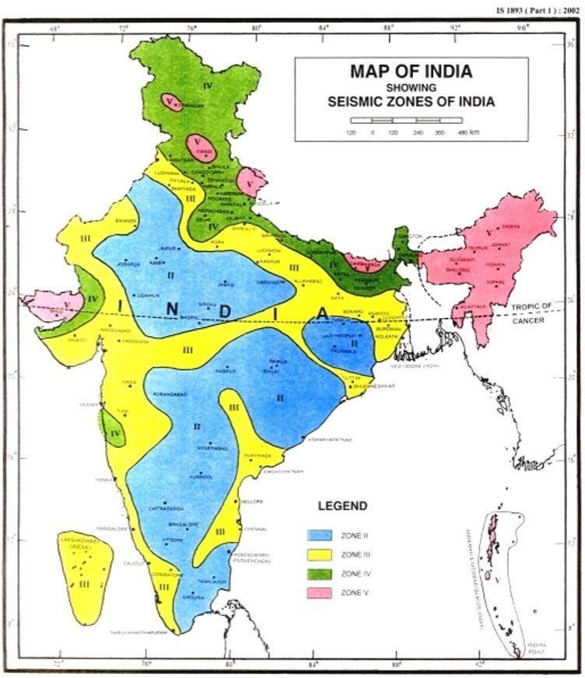.
Fig – 1: Seismic zoning map of India

The response spectrum coefficient considered as per Indian Standards for design, is shown in the figure for different soil type based on suitable natural periods and damping ratio of the structure. The spectral acceleration coefficient (Sa/g) considered as per IS 1893 (Part 1): 2002 is as follows.

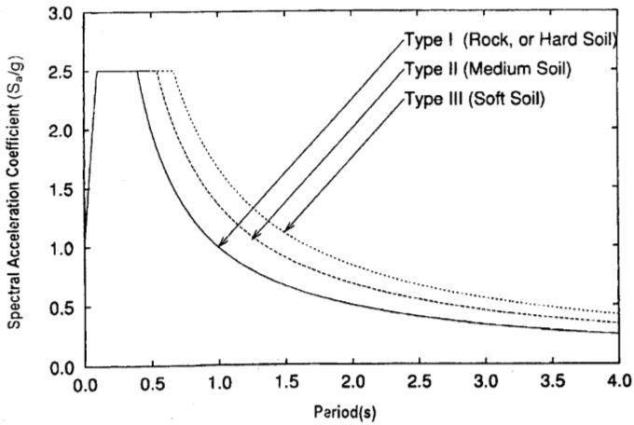
Fig-2 Response spectra for 5% damping

The response reduction factor for different building systems is considered as per the table below

Project Statement
The building is designed for the following parameters:

Site location: Nagpur in Seismic Zone – II
Type of the soil: Medium soil.
Allowable bearing pressure: 150KN/m2
Response Reduction factor(R) – 3 for OMRC.
Number of Floors: 2
Floor Height: 3.3m
External thickness of wall: 230mm
Internal thickness of wall: 150mm
Beam Size: - 230x250 mm

- 230x300 mm
- 230x350 mm
- 230x400 mm
Column Size: - 230x400 mm
- 230x500 mm
- 250x600 mm
- 300x1000 mm (staircase).
Slab Thickness: 120
Live Load: 2KN/m2
Wind Load: IS: 875-(Part-3).
Earthquake Load: IS: 1893- 2002(Part-1).
Grade of Concrete: M25
Grade of Steel: FE415

The STAAD. Pro plan and model for the considered Three Story School is shown below.



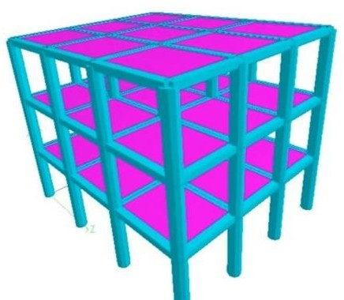
Fig – 5: STAAD. Pro Line Plan

CONCLUSION

The Three Storey School building has been analyzed and deigned using STAAD. Pro. Seismic and wind forces have been considered and the structure is designed as an earthquake resistant structure. Earthquake and Wind oriented deflections must be limited for multiple reasons and hence abundant structural stiffness is important. As a result, the inter-story drift must be obtained within the specified limits. For minimum specified lateral force with partial load factor of 1.0, the inter-story drift should be under 0.04 x Hs, where (Hs) is the story height (Clause 7.11.1, IS 1893 (Part 1): 2002). For 3300 mm floor height, inter-story drift = 0.04 x 3300 = 13.2 mm. The actual relative displacement between every story in the structure is below the inter-story drift limit and hence safe.

REFERENCES

[1] D.R. Deshmukh, Yadav, A.K., Supekar, S.N.,
Thakur, A.B., Sonawane, H.P., Jain, I.M., (2016).
Analysis and Design of G+19 Storied Building
Using Staad-Pro”. Int. journal of engineering
research and application (IJERA), ISSN: 2248-
9622, Vol 6, Issue 7.
[2] Anoop. A., Fousiya H., Neeraja. R., Rahul, C.,
Shabina, S., Varsha, S., (2016). “Planing Analysis
and Design of Multi Storied Building by STAAD.
Pro. V8i”. Int. Journal of Scientific &
Engineering Research (IJSER), ISSN 2229-
5518, Vol 7, Issue 4.
[3] Bedabrata, B., Nagender, A.S.V, (2007).
Computer aided analysis and design of
multistoreyed buildings”. Ethesis at NIT
Rourkela.
[4] IS 1893 (Part 1): 2002 “Criteria for
Earthquake Resistant Design of Structures”.
[5] IS: 875 (Part 2): 1987 “Imposed Loads”.
[6] IS: 875 (Part 3): 1987 “Wind Loads”.
[7] Dr. V. L. Shah and Dr. S. R. Karve, (2010).
“Illustrated design of Reinforced Concrete
Buildings”. 5th ed.

