DEVELOPEMENT OF AUTOMOTIVE FUEL ENHANCEMENT SYSTEM
Vivek M. Sonde¹, Shubhankar Pawshe²
¹Assistant Professor
Mechanical Engineering, Priyadarshini College of Engineering, Nagpur, India
²Graduate Student
Mechanical Engineering, Priyadarshini College of Engineering, Nagpur, India

Abstract – We have studied the basic properties of gas generated through electrolysis of water and then used it in an Internal Combustion Engine of an automobile as a fuel supplement with petrol, by mixing it with air. This resulted the increase in mileage and power of the vehicle and reduction in the polluting contents from the exhaust gases. The threat posed by climate change and the striving for securities of energy supply are issues high on the political agenda these days. Governments are putting strategic plan motion to decrease primary energy use, take carbon out of fuels and facilitate modal shifts. Taking a prominent place in these strategic plans is hydrogen as a future energy carrier. Hydrogen gas combined with the standard air/fuel mixture increases the mileage of an automobile. This form of supplementary fuel is provided by a hydrogen generator mounted in the vehicle. It is actually an electrolysis unit having high grade stainless steel/graphite semiconductors as electrodes in a closed container and mixture of distilled water & suitable ionic solution(KOH or NAOH) as electrolyte. Power for electrolysis is taken from an additional battery provided (12V).This battery can be recharged from a dynamo/alternator/motor provided on the vehicle.
Keywords- KOH, NAOH, IC engine, electrolysis, hydrogen generator.

INTRODUCTION

INTRODUCTION TO HYDROGEN CELL
This process uses hydrogen and oxygen gases as a partial fuel source when utilized together with a fossil-based fuel to power conventional internal combustion

engines. Hydrogen and oxygen gases are produced by electrolysis in an electrolyser units, on-demand and on-board a vehicle, or in stationary applications, eliminating the need of highly-pressurized hydrogen storage tanks. When said gases are introduced into the combustion chamber of the engine, via the air intake assembly, they increase the efficiency of the combustion burn by enriching the air to fuel ratio. Resulting in a reduction of the fossil-based fuels required for optimum engine performance, said gases effectively becoming a partial hybrid fuel source. As an additional benefit, in direct correlation, this process reduces carbon dioxide emissions, and, in varying quantities, other greenhouse gas emissions.

INTRODUCTION TO ELECTROLYSIS
A DC electrical power source is connected to two electrodes, or two plates (typically made from some inert metal such as platinum, stainless steel or iridium) which are placed in the water. Hydrogen will appear at the cathode, and oxygen will appear at the anode. Assuming ideal faradic efficiency, the amount of hydrogen generated is twice the amount of oxygen, and both are proportional to the total electrical charge conducted by the solution. However, in many cells competing side reactions occur, resulting in different products and less than ideal faradic efficiency.
Electrolysis of pure water requires excess energy in the form of over potential to overcome various activation barriers. Without the excess energy the electrolysis of pure water occurs very slowly or not at all. This is in part due to the limited self-ionization of water. So the efficiency of electrolysis is increased through the addition of an electrolyte (such as a salt , an acid or a base) and the use of electro catalysts.
METHOLOGY

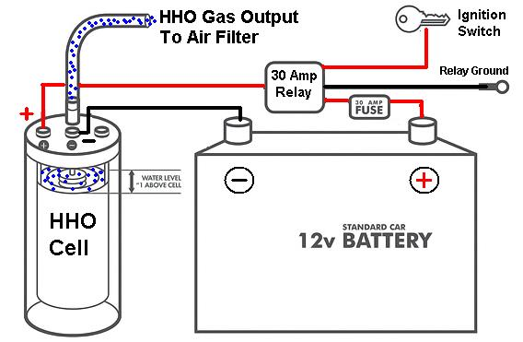
Fig. 1- Method Diagram

This works on the principal of electrolysis process. The electrical supply for the process is used from the Vehicle battery or alternator. An electrical power source is connected to the two electrode materials which are placed in the water. Hydrogen will appear at the cathode, and oxygen will appear at the anode. That is reduction at cathode and oxidation at anode occurs according to ideal faradic efficiency. The amount of hydrogen generated is twice the number of moles of oxygen and both are proportional to the total electrical charge conducted by the electrodes solution.
The hydrogen and oxygen generated in the hydrogen cell is fed to the inlet manifold that is in air hose pipe of the carburetor. This gas then gets mixed with the air intake which is then supplied to the engine. The mixture of air, gasoline and HHO gas is sucked inside the cylinder of the engine during suction stroke. And at the end of compression stroke the spark is generated from the cold rated spark plug and the combustion of gasoline and HHO gas occurs. HHO itself contains 1/3 oxygen by volume and 2/3 hydrogen (which has an octane rating of 130). The hydrogen explosion is so fast that it fills the combustion cylinder at least 3 times faster than the gasoline explosion and subsequent ignites the gasoline from all directions. Hence more power is generated consequently the mileage of the vehicle gets increased. The burn speed of hydrogen is 0.098 to 0.197 ft/min (3 to 6 cm/min) compared gasoline´s 0.00656 to 0.0295 ft/min (0.2 to 0.9 cm/min).
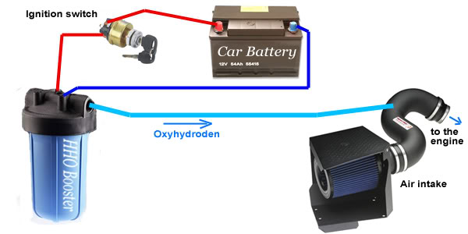
Fig. 2 – Actual Method

DESIGN OF COMPONENTS
ELECTRODES
We have used 316L stainless steel plates in our HHO Dry Cells and HHO generators.
Grade 316 is the standard molybdenum-bearing grade, second in importance is 304 amongst the stainless steels. The molybdenum gives 316 better overall corrosion resistant properties than Grade 304, particularly higher resistance to pitting and crevice corrosion in chloride environments.
Grade 316L is the low carbon version of 316 and is immune from sensitization (grain boundary carbide precipitation).
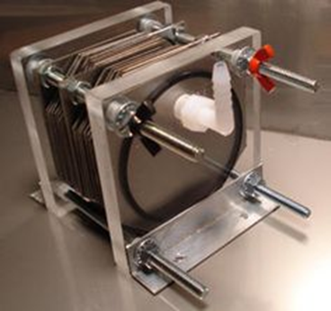
Fig. 3- Electrodes

ELECTROLYSIS EQUATIONS
Reduction at cathode:
2 H+(aq) + 2e− → H2(g)
Oxidation at anode:
2 H2O(l) → O2(g) + 4 H+(aq) + 4e−

Cathode (reduction):
2 H2O(l) + 2e− → H2(g) + 2 OH−(aq)
Anode (oxidation):
4 OH−(aq)→O2(g) + 2 H2O(l) + 4 e−
Overall reaction:
2 H2O(l) → 2 H2(g) + O2(g)

RESULT
Conducted emission analyzing on petrol HHO engine with the help of exhaust analyzer by supplying petrol and petrol + HHO fuel respectively. Result from this emission test shows that an appreciable amount of pollutants are reduced by using HHO gas as a supplemental fuel with petrol.

Gases | Content
Hydrocarbon | 1034ppm
Carbon monoxide | 1.230%
Carbon dioxide | 1.90%
Oxygen | 15.95%
Table 1 –Emissions Regular Engine Without HHO setup

Gases | Content
Hydrocarbon | 70ppm
Carbon monoxide | 0.032%
Carbon dioxide | 2.90%
Oxygen | 15.92%
Table 2 – Emissions with HHO setup

Hydrogen can be used as the primary fuel in an internal combustion engine or in a fuel cell. A hydrogen internal combustion engine is similar to that of a gasoline engine , where hydrogen combusts with oxygen in the air and produces expanding hot gases that directly move the physical parts of an engine. The only emissions are water vapor and insignificant amounts of nitrous oxides. The efficiency is quite less.

CONCLUSION
It is advantageous to use hydrogen gas enriched air as a fuel in internal combustion engines. Significant impact on brake thermal efficiency and brake power is observed upon the addition of hydrogen gas enriched air. Fuel consumption and other emissions viz: NOx and smoke emissions are reduced to considerable amount.
With the help of this setup engines with higher efficiency can be designed. We also conclude that the use of petroleum is reduced resulting into less pollution and emerging into a next generation of automobiles which are pollution free.
Hydrogen is a fuel with heat content nearly three times that of gasoline. From our work we experimentally found out that the efficiency of an IC engine can be rapidly increased by mixing hydrogen with gasoline. We conducted two tests. Experiment with test rig and a road test with two wheeler. In both cases we observed reduction in fuel consumption. It is a clear evidence that addition of hydrogen along with petrol can results in increase in the power of the engine or increase in mileage. Moreover the various emissions normally produced from IC engines can also be reduced. Thus use of hydrogen in IC engines as a fuel can be considered a huge leap in the field of automobile engineering.

REFERENCES
- Cripp H. Energy and the environment. http://eco.gn.apc.org/pubs/energy/_and_ environment.html.
- US Department of energy, EIA/IEA International energy annual, energy information administration, US Department of energy, Washington, DC, 2002,http://www.eia.doe.gov
- Sumit Prasad, Er, Subodh Prasad, Er. And Ashish Saxena, Er., alternatively electricity generation in an automobile An alternative Fuel”, IJTEMT, 2012, Vol.1, Issue6.
- Yousef S.H, Najjar,”alternative fuel for spark ignition engines”. The open fuels and energy science journal, 2009, Vol. 2, PP: 1-9.
- Ruggero Maria Santilli, “ a new gaseous and ombustible form of water”, IJHYDENE, 2005,PP:1-16.
- Suleiman, Q, Abu-ein, an Sayel M. Fayyad, 2011, “experimental hydrogen booster model” , orld applied Sciences Journal, 15 (8): 1168-1171.
- Karthik, T.S, murali, ganesh.s” impact of green transportation in todays economy”, APJMER,, November 2012, VOl . 1,Issue3.
- yukselF., Ceviz M.A., “thermal balance of four stroke SI engine operating on hydrogen as a supplementary fuel,” energy, vol.28 pp 1069-1080,2003.
- Ji changwei, wang shuofeng, effect of hydrogen addition on combustion and emissions performance of spark ignition gasoline engine at lean conditions.” International journal of hydrogen energy , vol.35, pp.1453-1462,2010 10. Ji changwei, wang shuofeng ”experimental study on combustion and emission performance of a hybrid hydrogen gasoline engine at lean burn.

DETAILS OF AUTHORS
Sr.No | Photo | Details
1 |  | Prof. Vivek M. Sonde  Department of Mechanical Engineering  Priyadarshini College of Engineering  Email: mailtovivekms@gmail.com
2 |  | Shubhankar Y. Pawshe  Department of Mechanical Engineering,  Priyadarshini College of Engineering  Email: Shubhankar.p@gmail.com

