The Solid Model Development by Point Cloud and Planar Counter Fitted Curves for Medical Images of Knee Joint

Jitesh Madhavi¹, Jayesh Dange², Vivek Sunnapwar³

¹ Research Scholar, Mechanical Department, Lokmanya Tilak College of Engineering, Mumbai, 400708.
² Professor, Mechanical Department, Lokmanya Tilak College of Engineering, Mumbai,400708.
³Principal, Lokmanya Tilak College of Engineering, 400708

Received on: 05 January,2022 Revised on: 02 February,2022 Published on: 04 February,2022

Abstract – Presently three-dimensional digital model developments of anatomical structures are in much interest of bio-medical praxis. Application of computers helps for pre-planning surgery, optimized implant in terms of geometry and fixture or surgical templates development for accurate positioning and orientation of implant. Lack of image processing technology in extracting the boundaries and inherent complexities of tissue anatomical structure, the software’s developed for 3D construction is not much effective to convert CT/MRI images to solid models. This paper presents the problems of image processing technology and inefficiency of CAD to develop models with a proposed solution to remove unwanted curves by reducing the noise level of the curve to make it suitable to reconstruct solid model.

Keywords- Bio-CAD, reverse engineering, CAD, noise, Bio-modeling.
- INTRODUCTION

CT/MRI data are used to construct 3D CAD model. There are pros and cons for CT/MRI depending upon the

tissue which is used for the study. Software’s like 3D Doctor by Abel software, USA, and Mimics by Materialize, Belgium, etc., are developed to build the CAD model directly from Dicom images. The output of this software is either in point cloud data, surfaces or in stl. This output data, when imported into any CAD packages, have problems of data loss in terms of holes, spikes, and noise which make the quality of CAD model poor. This makes the most difficult task to mature the CAD to Solid model. High expertise and time are required to remove holes and, spikes and noise. The Software can build the stl (Stereo lithography) model quickly which can be imported in any CAD software. Since stl data is in the faceted model, the surface needs to be fitted to these data. The operation to fit the surface is very tedious and losses its accuracy. The data can be cleaned and NURBS can be fitted applying tangency and Curvature continuity but the geometry deviates with actual bone geometry. The below Figure shows the various ways to construct solid based model from CT/MRI scan data. The output data from each method have different application.
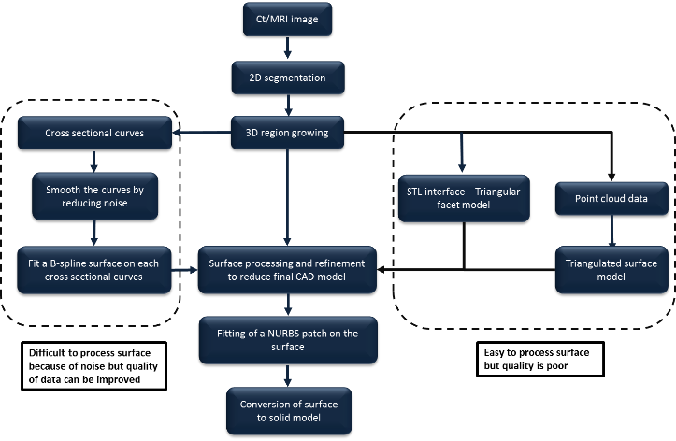
Fig. 1- Flowchart of various ways to build Solid based model from image processing
II - RELATED WORK
Curve Reconstruction: A Curve can be reconstructed either by edge extraction algorithm or by a fitting curve on the point clouds. Various techniques have been employed such as image processing, Voronoi diagram, spectral analysis and optimal transport (de Goes, 2011)
In image processing, there are certain operators which are designed to certain types of edges. Mainly the edge detection is categorized in two groups, Gradient and Laplacian. There are many operators designed to perform edge detection in Gradient methods like First Order Derivative Based Edge Detection, Sobel Operator, Prewitt’s operator and Robert’s cross. The experimental study has been made for edge detection using all these operators in Matlab by (Ameddah, et al., 2013)
Voronoi diagram is used to reconstruct the curve from given sample of point dataset. The advantage of this method is used to reduce the noise and the accuracy can be improved if appropriate sampling density is satisfied (Amenta, 1998). Amenta et al. proposed the crust method which utilized the β skeleton and Voronoi diagram (Dey, 1970) and (Pengbo Bo, 2016). Wang et al. proposed a curve reconstruction method based on circular normal-based smoothing and neighboring projection (Pengbo Bo, 2016). The result of reconstruction is a structure of curves instead of independent curves. Optimal transport is used to reconstruct 2D shapes with polyline structures which perform well for data points with shape features and large noise.
Recently some works have been made on recovering multiple curves or with a self-intersecting curve with point cloud data (Ruiz, 2011), (Zhu D, 2013) and (J. Einbeck, 2015). Ardeshir proposed a method for fitting multiple curve and grouping of curves to point clouds with simpler shape (Goshtasby, 2000). Furferi et al. proposed a method using PCA analysis by fitting weighted B-spline curves using PCA analysis (Furferi R, 2011). Yan et al. presented a method for curve fitting based on the fuzzy C-means clustering method (Yan, 2001). Zhao et al. proposed a method for fitting non-simple curves using skeleton extraction and refinement (Y.-d. Zhao, 2011). Jitesh et al. described the challenges faced in orthopedic product development. (Jitesh Madhavi, 2017). Jayesh Dange et. al. The anatomical functionality and morphological analysis of human joints are better understood by 3D CAD models(Jayesh Dange, 2013)
Curve fitting is very important task in modelling. Curve fitting is a mathematical function or process of constructing the curve on the series of point data. Curve can be fitted with the parameters like degree and segment, degree and tolerance and template curve. For shape reconstruction of a point cloud parametric curve is often used. Levin presented the moving least squares method (LMS) for curve fitting (Lee, 2000). Lee proposed some improvements by introducing the Minimal Spanning Tree (MST) in a pre-processing phase and discussed the deficiencies of direct application of MLS in curve fitting (Pottmann H, 2002). More focus and efforts are put to improve the speed of Curve fitting of minimizing squared orthogonal distance. The methods is categorized into PDM (point distance minimization) method SDM (Squared distance minimization), and TDM (tangent distance minimization) method (W. Wang, 2006) and (M. Melhi, 2001). These methods are the improvement done on the traditional methods but new initialization needed to optimize and overcome on the problems experienced. Fitting multiple curves to a point cloud of complex shape these methods cannot be directly applied. Jitesh et al. described the computer aided technique with case study (Jitesh Madhavi, 2017).
III - PROBLEM STATEMENT
The curve extracted from Medical imaging software is always closed, jaggy and noisy which makes difficult to construct the surface. This becomes difficult to smooth the curve without loosening the accuracy. To a certain limit noise can be reduced the noise and surfaces can be constructed. This becomes a task to construct the model with determining the limits till its acceptable geometrical tolerance.
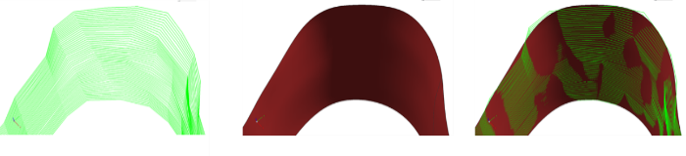
Fig. 2- A noisy curve extracted from Dicom images b. Surface extrapolated on the curves. Superimpose of the surface on the curves
Medical imaging software’s are automated to select the required threshold frequency for the selected tissue. It gives the histogram for the range of threshold frequencies selected. Even after these activities we get some unwanted or garbage curves which are connected with the required curves. To separate these unwanted curves is very hard and tedious.
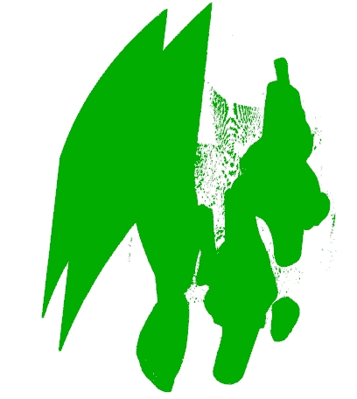
Fig. 3- Curves imported into CAD environment.
IV- METHOLOGY
To resolve the problem of unwanted curves removal and reduce the noise on the curve or to make it smooth the below solution is proposed.
Divide the planar curve with points of 0.1mm spacing or below it depending upon the quality of the curve.
Hide original curve.
Remove all the noisy points simply dragging the curser.
Fit new curve maintaining its tolerance within deviation limit.
Extrapolate surface on these network curves.
Convert surface model to solid model.
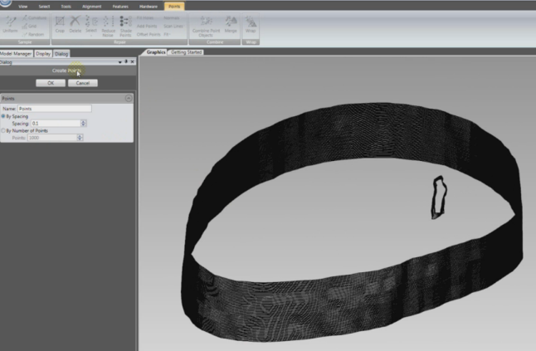
Fig. 4- Creating Points with 0.1 mm spacing on the curve
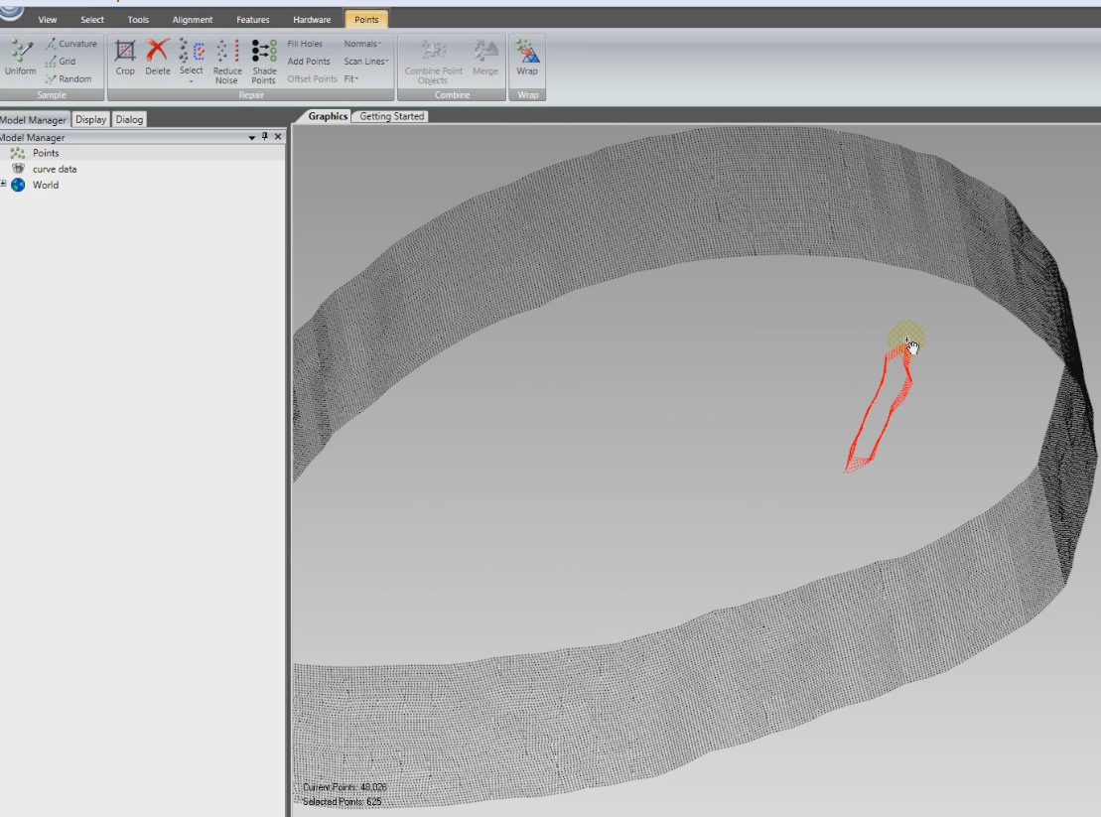
Fig. 5- Deletion of unwanted curves

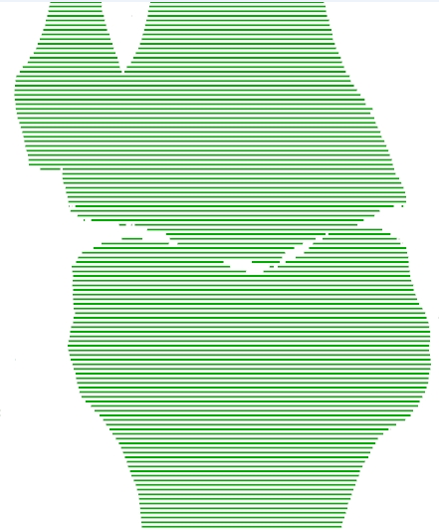
Fig. 6- Fitting curve on the planar point data set and recreate the counter curve network

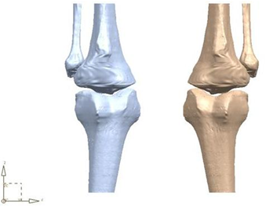
Fig.7- Constructing surface on the network curves and transforms it to solid model.
V- RESULTS

The CAD models were constructed with the above proposed methodology. This method helps to reduce the noise, eliminate unwanted curves and construct the model within acceptable geometrical tolerance. The below table shows the comparison between the model constructed with stl based and proposed method.
Table 1- Results comparison of Stl. based with respect to proposed method
Parameters | Stl. based model | Proposed method
Time required to clean noise | 2Hrs. | 15 min.
Skills for fitting surface | High | Low
Time to create model | 6 Hrs. | 2 Hrs.
Geometrical Deviation | 0.5 mm | 0.2 mm
Application | 3D printing and prototype | Surgical template, CAE analysis

VI -CONCLUSION
The CAD model constructed from proposed method helps to reduce the noise on the curves quicker.
The proposed method can be used to build the 3D solid models in any CAD packages very easily with low CAD skills. The CAD model formed the database of customized artificial joints applied in clinic medicine, in which we can select a suitable kind of artificial knee joint model to customize for the patient.
The application of CATE to tissue engineering also allows, for example, controlling and designing the overall shape of the scaffold to match a patient’s CT or MRI data; the internal architecture (pore size, porosity, and interconnectivity) by using the power of CAD techniques; heterogeneous scaffold with different mechanical and geometrical properties, and to freeform fabricate the designed scaffolds.
This case study represents the first step of a wider experimental protocol regarding implant creation for bone regenerative medicine and tested the CAD/CAM elaboration of the scaffold external complex surface.
VII-APPLICATION FOR FUTURE USE
There is still much scope for learning and discussing in the field of computer-aided tissue engineering. Many researches are made in imaging technology and biological system. Database of human anatomies are collected and published in CT/MRI form in terms of gender, age and region based. Software’s are improved for user-friendly interface and tools to increase the efficiency to reconstruct the model with respect to geometric deviation and time.
Once CAD models are generated and saved in an IGES or STEP format, these can then be used for a variety of other different design applications. For example, the reconstructed femur bone can be used to design patient-specific knee implants using CAD software. These CAD models can also be used for FEA or dynamic force analysis using a CAD based software.
Stress analysis performed on the femur bone using FEA software model for reconstructed from CT/MRI images. Complications may arise during the generation of meshes for FEA analysis and these can only be corrected by stronger surface refinement techniques and also ensuring that a closed model is always maintained.
Cartilage replacement is complex issues, cartilage cells can be reproduced and cloned in a lab but the problem for the body is to accept new cartilage, and allow the cartilage to adhere to the surface of the joint. Preservation of MRI scan of the whole body of humans by age and sex can give very useful database for making fracture implants. Development of application program for finding geometric (position orientation, shape size etc.) differences between left and right bone joint.
ACKNOWLEDGMENT
I like to acknowledge and appreciate greatly the help provided by Mohammad Ali Ansari in collecting and processing some of the data included in this paper.

REFERENCES

- Ameddah Hacene and Assas Mekki Three-Dimensional (3D) Bio-Cad Modeling of Human Knee [Journal] // Advanced Science Letters. - [s.l.] : American Scientific Publishers, March 2013. - 3 : Vol. 19. - pp. 932-936(5).
- Amenta Nina The Crust and the beta-Skeleton: Combinatorial Curve Reconstruction. [Journal] // Graphical Models and Image Processing. - 01 01, 1998. - Vol. 60.
- de Goes Fernando An Optimal Transport Approach to Robust Reconstruction and Simplification of 2D Shapes [Journal] // Computer Graphics Forum. - 2011. - 5 : Vol. 30. - 0167-7055.
- Dey Tamal A Simple Provable Algorithm for Curve Reconstruction [Journal] // Proc. 10th Ann. ACM-SIAM Sympos. Discr. Algorithms. - 02 01, 1970.
- Furferi R Governi L From unordered point cloud to weighted b-spline-a novel pca-based method [Journal] // American Conference on Applied Mathematics. - 2011. - pp. 146-151.
- Goshtasby A.A. Grouping and parameterizing irregularly spaced points for curve fitting ACM [Journal] // Transactions on Graphics. - 2000. - 3 : Vol. 19. - pp. 185-203.
- J. Einbeck G. Tutz Evers Local principal curves Statistics and Computing [Journal]. - 2015. - 4 : Vol. 15. - pp. 301-313.
- Jayesh Dange Ali ansari, Jitesh Madhavi Extraction and Analysis of Knee Joint Parameters by using CAD base Solid Modelling Techniques [Conference] // International Journal of Computer Applications (0975 – 8887). - 2013.
- Jitesh Madhavi Jayesh Dange Computer Aided Technique for knee implant : Case study [Journal] // International Journal of Engineering Research and Technology (IJERT). - 2017. - Vol. 6.
- Jitesh Madhavi Jayesh Dange, Vivek Sunnapwar Challenges for Product Development of Orthopedic Implants [Conference] // International Conference on Advances in Thermal Systems, Materials and Design Engineering (ATSMDE2017). - Mumbai : [s.n.], 2017.
- Lee I.-K. Curve reconstruction from unorganized points [Journal] // Computer Aided Geometric Design. - 2000. - 2 : Vol. 17. - pp. 166-177.
- Levin D. The approximation power of moving least-squares [Journal] // Mathematics of Computation of the American Mathematical Society. - 1998. - pp. 1517-1531.
- M. Melhi S.S. Ipson, W. Booth A novel triangulation procedure for thinning hand-written text Pattern Recognition Letters [Journal]. - 2001. - 10 : Vol. 22. - pp. 1059-1071.
- Pengbo Bo Gongning Luo, Kuanquan Wang, A graph-based method for fitting planar B-spline curves with intersections, [Journal] // Journal of Computational Design and Engineering,. - 2016. - 1 : Vol. 3. - pp. 16-23.
- Pottmann H Leopoldseder S, Hofer M. Approximation with active b-spline curves and surfaces [Journal] // Computer Graphics and Applications. - 2002. - pp. 8-18.
- Ruiz Oscar Ellipse-based principal component analysis for self-intersecting curve reconstruction from noisy point sets [Journal] // Visual Computer. - 2011. - Vol. 27.
- W. Wang H. Pottmann, Y. Liu Fitting b-spline curves to point clouds by curvature-based squared distance minimization ACM [Journal] // Transactions on Graphics. - 2006. - 2 : Vol. 25. - pp. 214-238.
- Y.-d. Zhao J.-j. Cao Efficient reconstruction of non-simple curves [Journal] // Journal of Zhejiang University—SCIENCE C. - 2011. - 7 : Vol. 12. - pp. 523-532.
- Yan H. Fuzzy curve-tracing algorithm [Journal] // IEEE Transactions on Cybernetics, Systems, Man, and Cybernetics, Part B: Cybernetics. - 2001. - Vol. 5. - pp. 768-780.
- Zhu D Bo P, Zhou Y Fitting multiple curves to point clouds with complicated topological structures [Journal] // Computer-Aided Design and Computer Graphics. - 2013. - pp. 60-70.

