POWER GENERATION FROM ROTORS INSTALLED ON HIGHWAYS
Shubham A. Patil¹, Manish A. Supe², Devendra A. Thakur³, Nandlal S. Bichkule⁴ ,
Ganesh S. Rajput⁵
^{1,2,3,4,5} Department Of Mechanical Engineering, GF’s Godavari College Of Engineering, Jalgaon ,
425003. India
¹ shubhampatil16121994@gmail.com

Abstract –
This project use of air on highway divider with the help vertical axis wind turbine. When the vehicle passed on the highway it produces a considerable amount of air due to its speed. This air tangentially strikes on the blade of the vertical axis wind turbine and its makes a rotation of the turbine in only one direction. The solar system is used to generate electrical energy and also installed in a way that it diverts the vehicle air towards the turbine. The generator with the gear mechanism is connected to the shaft of the vertical axis wind turbine to generate electricity. The electrical output of vertical axis turbine and the solar system is stored in a battery. This stored energy which can be further used for street lighting, toll gates, etc.

- Introduction
In a day to day life, the demand for the electricity is much higher than the production of electrical energy. One of the major problems ever since the natural resources are going to finish one day. The fossil fuel major role in production global warming, a greenhouse gas, etc. currently 68 percent of the electrical energy produced by the thermal power plant and remaining 22 percent included hydropower plant, nuclear power plant, gas power plant and as we realized the fossil fuel is finished in one day. Solar and wind both are renewable energy sources. Solar energy available begins of day and the wind energy is maximum on the highway due to the speed of the vehicle. The motivation of this project contributes the global trend toward clean energy. The main motive behind this project is to design a vertical axis wind turbine which effectively uses the wind energy generated by the vehicle speed on the highway. So the maximum wind energy can be extracted by the vertical axis wind turbine as compared to the horizontal axis wind turbine. We have designed modified savonius vertical axis wind turbine which is more efficient than old savonius design. in modified vertical axis turbine we twisted the blade of the turbine to gain maximum spin on low pressure of the wind, we also try to achieve less vibration at gear moment .This turbine works under all the environmental condition and cyclone also. This design of the blade enables the turbine to rotate in clockwise and anticlockwise directions. The arrangement of solar plats is in such a way that they divert the vehicle air towards the turbine for effective use of vehicle air. The solar system generates the electrical energy by sun radiation in day mode and from vehicle headlight during night mode the generated electrical energy we can use street lighting, toll gates etc.
1.1 Current Scenario -:
As of 31 March 2014, total installed capacity in India is 255.012 GW. Most of the energy requirement is served by the conventional sources, a major part of which is contributed by thermal power plants. In India almost 177.742 GW of energy is generated by thermal plants, 40.799 through hydroelectric power plants, 4.78 GW through Nuclear power plants and remaining 31.692 GW through other renewable source. India’s electricity sector is amongst the world’s most active players in renewable energy utilization. India stands 5th in wind power generation with an installed capacity of 21.136 GW. Even though, we are facing a deficit of electrical energy due to lack of resources as well as the increased power demand. Currently, we are trying to incorporate more renewable sources into the grid to support the increased power demand. As a part of it a lot of researches are going on in the field of wind power generation and the researchers are trying to exploit the field of highway wind power generation as highway is one of the potential source of wind energy.
1.2 Objective Of The Project -:
- Incorporation of more renewable energy to the power system.
- Design of a new method of generation of electricity using the wind energy generated by the moving vehicles on the highways.
- Development Stand-alone system for providing the power to the highways.

2. LITERATURE SURVEY
2.1 Vertical Wind Turbine -: The first aerodynamic vertical axis wind turbine was developed by Georges Darrieus in france and first patented in 1927. Its principle of operation depends on the fact that its blade speed is a multiple of the wind speed, resulting in an apparent wind throughout the whole revolution coming in as a head wind with only a limited variation in angle. From the prospective blade, the rotational movement of the blade generates a head wind that combines with the actual wind to form the apparent wind. If the angle of attack of this apparent wind on the blade is larger than zero, the lift force has a forward component that propels the turbine. An angle of attack between zero and 20 degrees requires a sufficiently high blade speed. A Darrieus turbine can’t self starting; it needs to be brought to a sufficiently high blade speed by external means.
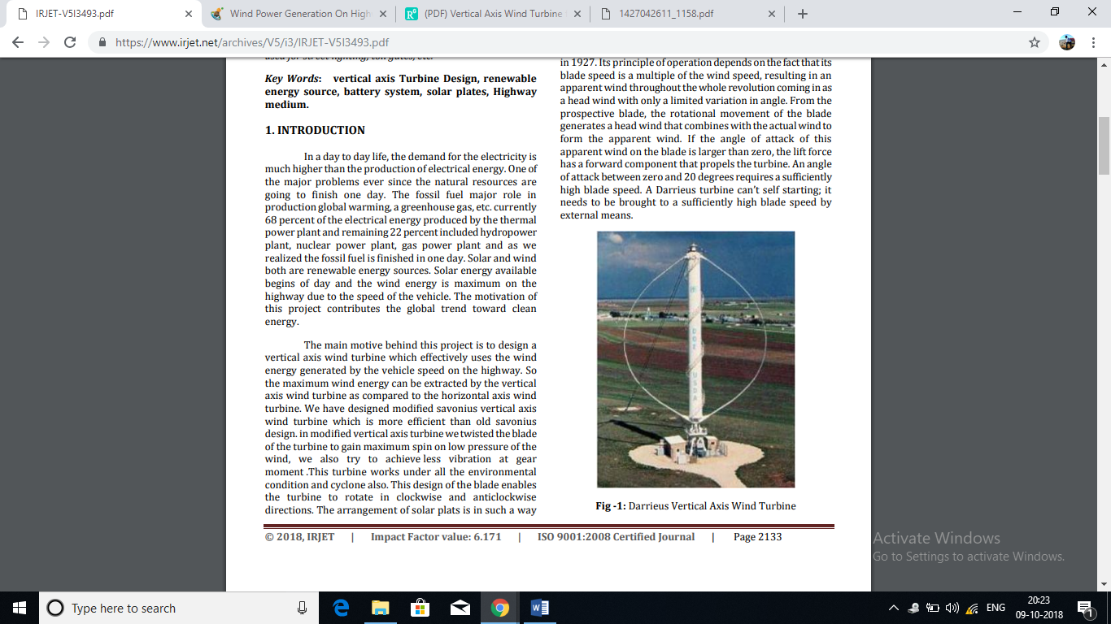
Fig2.1. Darrieus Vertical Axis Wind Turbine
2.2 Variable Geometry Vertical Axis Wind Turbine -: P. J. Musgrove in 1975 led a research project at reading University in the UK whose purpose was to attempt to rationalize the geometry of the blades by straightening out of the blades of a Darrieus type wind turbine. This led to design of straight blade vertical axis wind turbine designated as the H rotor blade configuration. At the time it was though that simple H blade configuration could, at high wind speeds, over speed and become unstable. It was thus proposed that reefing mechanism be incorporated into the machine design thus allowing the blades to be feathered in high winds. These machine earlier machines with feathering blades were known as Variable Geometry Vertical Axis Wind Turbines.
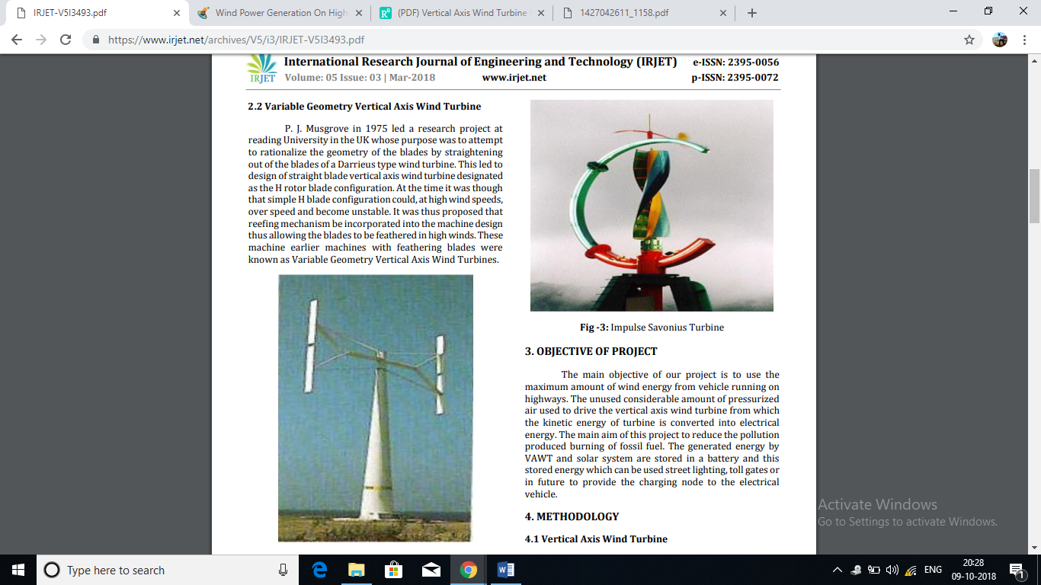
Fig .2.2 variable axis vertical axis wind turbine
2.3 Impulse Savonius VAWT -: The savonius turbine is a vertical axis machine which uses a rotor that was introduced by Finnish engineer S. J. Savonius in 1922. In its simplest form it is essentially two cups or half drum fixed to a central shaft in opposing direction. Each cup or drum catches the wind and so turns the shaft, bringing the opposing cup or drum into the flow of the wind. This cup or drum then repeats the process, so causing the shaft to rotate further and completing a full rotation. This process continues all the time wind blows and turning of the shaft is used to drive a pump or small generator. These types of windmills are also commonly used for wind speed instrument such as the anemometer. Modern savonius machine have evolved into fluted bladed device, which have a higher efficiency and less vibration than the older twin cup or drum machine.
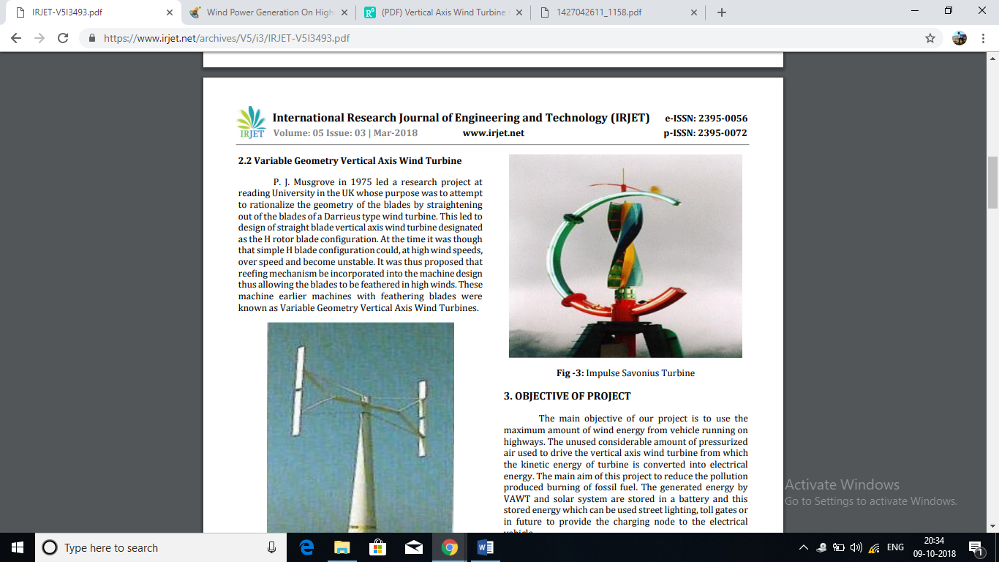
Fig 2.3 Impulse Savonius VAWT
3. METHODOLOGY
3.1 Vertical Axis Wind Turbine -: The vertical axis wind turbine is used to convert the kinetic energy into mechanical energy. The light weight blade materials (mica sheet) are used for making the vertical axis wind turbine. The height of blade is 1.09 meter and width of blade is 0.33 meter. The whole turbine is assembling with collar and blades which is fitted by nut bolts. To achieve the unidirectional motion of the turbine the blades are bended by 300 angle curve shape and shaft of the turbine connected to the shaft of generator.
Turbine Specification
- Height of blade= 43 inch= 1.09 meter
- Height of shaft= 60 inch= 1.52 meter
- Helix angle= 300
- Vertical shaft diameter= 27 mm
- Overall outer diameter= 27 inch= 0.68 meter
- Blade weight (mica sheet) = 4 kg
- Shaft weight= 1.5 kg
- Width of blade= 13 inch= 0.33 meter
- Area = diameter * height = 0.68 * 1.09
- Area = 0.7412 m2
3.2 Generator Design
3.2.1 Stator -: In generator mechanism, 4 coils are used as a stator. The coils are connected in series to achieve desirable voltage from each coil. When the rotor is rotated across winding then the EMF induced on it. The generated EMF is an alternating quantity.

Coils Specification
- Winding Conductor Gauge = 35
- Turns of each coil= 2200 turns
- Number of coil= 4
- Output voltage= 60-85 volts (Depending on speed of rotation)
3.2.2 Rotor
In generator mechanism, a rotor is consisting with permanent magnet placed around the stator. The shape of this permanent magnet is a square . When a rotor is rotated it produced a rotating magnetic field which link with the stator coil and generate EMF in stator coil. The type of magnet used for rotor circuit is neodymium strong magnet.

Specification of Permanent Magnet
- Neodymium strong magnet= 4 (square magnet)
- Plating= Nickel + copper
- Size= 25mm*25mm*12mm

3.2.3 Battery -: A valve regulated lead acid battery sometimes called sealed lead-acid (SLA), gel cell, or maintenance free battery. Due to their construction, the Gel and Absorbent Glass Mat types of VRLA can be mounted in any orientation, and do not require constant maintenance. They are widely used in large electrical devices, off-grid power systems and similar roles, where large amounts of storage are needed at a lower cost than other low-maintenance technologies like lithium-ion. Batteries operate by converting chemical energy into electrical energy through electrochemical discharge reactions. Batteries are composed of one or more cells, each containing a positive electrode, negative electrode, separator, and electrolyte. Cells can be divided into two major classes: primary and secondary. Primary cells are not rechargeable and must be replaced once the reactants are depleted. Secondary cells are rechargeable and require a DC charging source to restore reactants to their fully charged state. Examples of primary cells include carbon-zinc (Leclanche or dry cell), alkaline-manganese, mercury zinc, silver-zinc, and lithium cells (e.g., lithium-manganese dioxide, lithium-sulfur dioxide, and lithiumthionyl chloride). Examples of secondary cells include lead-lead dioxide (lead-acid), nickel-cadmium, nickel-iron, nickel-hydrogen, nickel-metal hydride, silver-zinc, silver-cadmium, and lithium-ion. For aircraft applications, secondary cells are the most prominent, but primary cells are sometimes used for powering critical avionics equipment by CRC Press LLC Batteries is rated in terms of their nominal voltage and ampere-hour capacity. The voltage rating is based on the number of cells connected in series and the nominal voltage of each cell (2.0 V for lead acid and 1.2 V for nickel-cadmium). The most common voltage rating for aircraft batteries is 24 V. A 24-V lead-acid battery contains 12 cells, while a 24-V nickel-cadmium battery contains either 19 or 20 cells (the U.S. military rates 19-cell batteries at 24 V). Voltage ratings of 22.8, 25.2, and 26.4 V are also common with nickel-cadmium batteries, consisting of 19, 20, or 22 cells, respectively. Twelve-volt lead-acid batteries, consisting of six cells in series, are also used in many general aviation aircraft. The ampere-hour (Ah) capacity available from a fully charged battery depends on its temperature, rate of discharge, and age. Normally, aircraft batteries are rated at room temperature (25°C), the C-rate (1-hour rate), and beginning of life. Military batteries, however, often are rated in terms of the end-of life capacity, i.e., the minimum capacity before the battery is considered unserviceable. Capacity ratings of aircraft batteries vary widely, generally ranging from 3 to 65 Ah.

Specification of Battery
- Voltage Range= 12 Volt.
- Current Range= 12 Ah.
- Capacity 7 ah
- Type rechargeable battery
- Length 5.95”
- Width 2.56”
- Height 3.7”
- Shipping weight 7.00 lbs
- Warranty 6 month

3.2.3. D.C. GENERATOR -: A generator is a device that converts motive power (mechanical energy) into electrical power for use in an external circuit. Sources of mechanical energy include steam turbines gas turbines water turbines, and internal combustion engine
Voltage Production -: DC Circuits, that there are three conditions necessary to induce a voltageinto a conductor.
1. A magnetic field
2. A conductor
3. Relative motion between the two.
A DC generator provides these three conditions to produce a DC voltage output.It produces current of 1 Ampere and voltage of 12 Volts
Theory of Operation -: A basic DC generator has four basic parts: The magnetic field may be supplied by either a permanent magnet or an electromagnet. For now, we will use a permanent magnet to describe basic DC generator.
- A magnetic field;
- A single conductor, or loop;
- A commutator and
- Brushes
4. Advantages , Disadvantages and Application -:
Advantages -:
- A long life cycle since it can provide power for more than 20-25 years
- Zero operation cost, because it does not consume fuel or materials.
- Maintenance cost is low.
- Energy conservation.
Disadvantages -:
- Influenced due to random changing of air density
- Requires proper investigation for site selection
- Problems of facing lack of vehicles sometimes
Application -:
- On national highways to supply power
- In remote areas with proper storage
- In rural electrification
- To recharge battery of electrical vehicle
- In traffic signaling system
- Off grid applications
5. EXPECTED OUTCOME (CONCLUSION) -:
This system is environmental friendly. The working model of our project is combined energy source with solar system and vertical axis wind turbine system which is a good and effective solution for power generation, basically this system involves the combination of two energy system, suppose anyone source fails to generate another source will keep generating the electricity and will give the continuous power to the load. The renewable energy sources such as solar and wind energy are used to generate the electricity.
6. FUTURE SCOPE -:
Our project idea can be extended to trains and metro trains as their speed is very high as compared with on road vehicles. This stored energy can be further utilised for agricultural fields and rural electrification. And , also as a future scope we can use Vortex blades in the form of a new radical way to generate wind energy. Further, with other improvements overall efficiency of model can be increased by using piezo-electric material in place of blades of wind turbine, setting turbines near tunnels ,etc
REFERENCES
[1] Mithun K K and Ashok S “Wind Turbine for Highway Wind Power Generation” IJEEE, Volume 07, Issue 01, Jan- June 2015.
[2] Dhiraj Varma and Ajitabh Pateriya “VAWT and Solar Panel Combine System Based Generation of Electricity through Highway" IJRISE, Vol.3, 2017. pp: 137-140.
[3] S.Selvam, Edison Prabhu .K, Bharath Kumar M.R, & Andrew Mathew Dominic “Solar and Wind Hybrid power generation system for Street lights at Highways” International Journal of Science, Engineering and Technology Research (IJSETR), Volume 3, Issue 3, March 2014.
[4] Scheurich, Frank, and Richard E. Brown “Modelling the aerodynamics of vertical axis wind turbines in steady wind conditions" Wind Energy 16.1 (2013): 91-107.
[5] Shweta Singh, Sarita Singh and Priyank Srivastava “Vertical Axis Wind Turbine for Generation of Electricity through Highway Windmill” S-JPSET: Vol. 7, Issue 2, ISSN: 2229-7111
[6] Krishnaprasanth.B , Akshaya.P.R , Mr.Manivannan.L, Ms.Dhivya.N “A New Fangled Highway Wind Power Generation” International Journal for Research in Applied Science & Engineering Technology (IJRASET) Volume 4 Issue I, January 2016.
[7] 2012 IEEE Global Humanitarian Technology Conference paper on “Stand-Alone Renewable Hybrid Power Generation System” published by P. Freddy Simon ,B. Anand ,A. J. Antony enus of jepiar Engineering College, Chennai, Tamil Nadu, India.
[8] International Journal of Advance Engineering and Research Development Volume 4, Issue 4, April -2017 @IJAERD-2017, All rights Reserved 125 Scientific Journal of Impact Factor (SJIF): 4.72 e-ISSN (O): 2348- 4470 p-ISSN (P): 2348-6406 paper on “Hybrid Energy Generation on National Highway 6”, India Parth Desai1, Mayank kumar Mahida2, Kevin Patel3, Atulsinh Chauhan
[9] Joanne Hui, Alireza Bakhshai, and Praveen K. Jain, “A Hybrid Wind-Solar Energy System: A New Rectifier Stage Topology,” IEEE Conference, February 2010.
[10] Trishan Esram, and Patrick L. Chapman, “Comparison of Photovoltaic Array Maximum Power Point Tracking Technique,” IEEE Trans. on energy conversion, vol. 22, no. 2, june 2007. [5] Hao Qian, Jianhui Zhang and Jih-Sheng Lai, “a grid-tie battery energy storage system,” IEEE Conference, June 2010.

