Real Time Industrial Asset Monitoring
Runmai Kalamkar¹, Devanshi Chawda², Pranay Choudhary³, Shantanu Vaidya⁴, Dr. Gauri Dhopavkar⁵
1,2,3,4 – Students of Computer Technology | 5 – Asst. Prof., Computer Technology Dept.
Yeshwantrao Chavan College of Engineering, Nagpur, India, 441110

rmk.runmai@gmail.com, devasnhichawda@gmail.com, pranayc1997@gmail.com, snv.shantanu@gmail.com, gauri.ycce@gmail.com

Abstract – Industries are the biggest workplace all over the world, also there are large number of people involves as a worker and most of them works as a machine operator. There are many systems developed for industrial workplace some of them monitors machine processes and some do monitoring and control of machine parameter. Industrial Internet of Things (IIoT) is the world of smart machines which can communicate with humans for increasing their productivity and thus increasing their profit in long run. No matter which industries we are talking about, assets will always remain an integral part of the overall efficiency and productivity of the company, thus affecting the revenue generation in one way or another. These asset-intensive industries try to rely on smart asset management and monitoring solutions to track and handle asset operations. This paper proposes the monitoring of operators and machines in such a way that, an asset monitoring solution will collect real-time machine data, based on this data, the solution will create real-time dashboards to offer truly situational awareness and help in making informed decisions during the downtime of machines. This directed decision making capabilities provide entirely new dynamics to the entire asset monitoring environment.
Keywords- Industrial Internet of Things (IIoT), smart machines, asset-management, real-time dashboards, asset-monitoring.
INTRODUCTION
What is Asset Monitoring System? Asset monitoring, also known as asset tracking or asset management, is a system of hardware and software that logs information about tangible assets, allowing a business to verify its assets’ location and status. In addition to asset location, an asset monitoring system might also track an asset’s name, type, usage, engine hours, maintenance schedule,

or other information, and may send alerts to managers when anything goes amiss [1].

One of the main application of the IIoT seen across the industries is for physical asset management, monitoring and predictive maintenance. The asset intensive industries like Manufacturing, Industrial Machinery,

Logistics and Transportation, Oil and Gas, Heavy Machinery and Construction, Equipment Rental, etc. are constrained by lack of visibility of assets and try to track return of assets (RoA).

With industrial asset monitoring, the companies monitor their assets, that is, they try to find out what work each asset is doing, weather it is overworked or under-utilized, the lifetime of asset, downtime of machines, manage asset lifecycle, control processes etc. It also helps to give real-time alerts and the user can receive the alert irrespective of his location, adds intelligence to workflow, dynamic edge control of assets, cross domain analytics, real time visibility [2].

In today’s times, industrial monitoring solutions play a vital role in controlling the industrial applications or equipments. Direct benefits include fast processing, lower power consumption, lesser equipment down time, improved workplace safety, reduced environment hazards etc.

To build the foundation of an effective asset monitoring solution, companies would need the right tools, integrated with the right systems and the right applications. Collectively, this will create an asset tracking solution that enables us to streamline data collection and analysis. Our main aim is to build a platform that will process the acquired machine data in real-time and display on a real time data monitoring dashboard. With capabilities to communicate with the different types of automated machines and convert the machine data into human understandable form. So, here we will mainly perform data acquisition ^{[1]}, data transformation ^{[2]} and data presentation ^{[3]}.

The most common issue that asset monitoring service providers face is to scale up when they need the ability to support assets from different manufacturers. Nowadays, assets come with a range of monitoring functionalities, but when your enterprise is using assets from different manufacturers, you will surely face a challenge in controlling a number of assets with different formats [3]. Before choosing an asset monitoring solution, any business should ensure that their solution can scale up no matter how many assets are added and include a variety of assets. The system should be able to manage, register, and understand different attributes and formats to make a feasible solution that fits with your existing infrastructure.

The International Standard, ISO 55000, provides a introduction and requirements specification for a management system for asset management [4].
IDENTIFYING THE VARIOUS PROBLEMS IN ASSET MANAGEMENT
Unfortunately, however far too many engineering organizations cannot answer the following questions with a certain acceptance degree –
- Can I come to know my machine’s performance?
- How can my plant’s productivity increase?
- Which are the most troublesome breakdown causes in my manufacturing process / robotic process?
- Can I monitor my assets online or offline?
- Can I identify the current location of the asset?
- Can I know the configuration of my asset?

Organizations cannot answer any or all of the above questions due to problems in departments responsible for reporting data regarding the assets. Hence, Real-time asset monitoring has become the need of today.
METHODOLOGY
A. Machine Data Acquisition
In this step, consider two types of CNC^{[4]} machines which have inbuilt PLCs^{[5]} and same machine data is to be acquired from both the machines but both store there data in two different databases i.e. one stores in SQL^{[6]} database and other stores in NoSQL^{[7]} database. Both machines make use of different modes of communication.

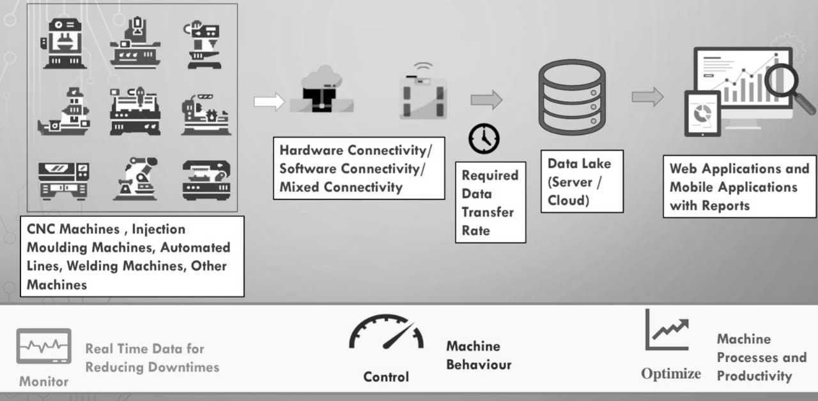
Fig. 1 – Project Schema

Machine 1 - CNC Machine with an inbuilt PLC - Protocol A.
Machine 2 - CNC Machine with an inbuilt PLC - Protocol B.
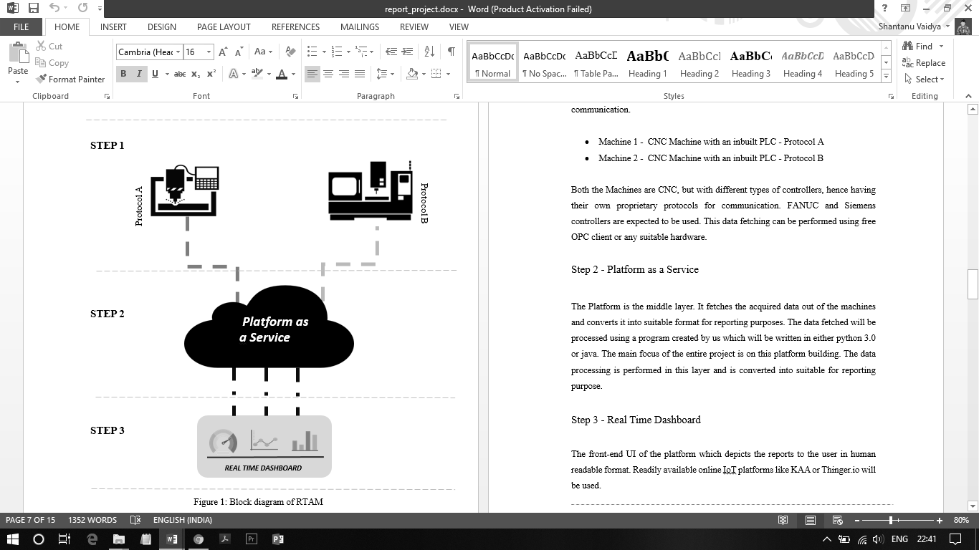
Fig. 2 - Block Diagram of the Model

Both the machines being of the same type but with different types of controllers, hence having their own proprietary protocols for communication. FANUC ^{[8]} and Siemens ^{[9]} controllers are to be used. This data fetching can be performed using free Open Platform Communication ^{[10]} client or any suitable hardware.

B. Platform as a Service
The platform is the middle layer. It fetches the acquired data out of the machines and converts it into one suitable format for storing the complete data into one database i.e. either of the SQL or non-SQL databases for reporting purposes. The data fetched will be processed using a program which is written in either python 3.0. The main focus of the entire paper is on developing this configuration tool.

The output table’s columns have the names which are ontological to the various column names on the input columns, used further in the application.

The input column(s) of various machines are to be equated to the data column(s) of the final output database, by a custom designed configuration tool.
Given below are the names of input column(s) of the various machines and last field denoting the equated output column(s) names.
Table 1 - Database Columns
Machine 1 | Machine 2 | Output Table
Operate | Auto_Operate | AutoOperateMode
Disconnect | Power_Off | MachinePowerOff
Alarm | Alert | MachineBreakdown
Emergency | Emergency Indicator | MachineEmergency
Suspend | Suspend | OperationSuspend
Stop | Stop | MachineStop
Manual | Auto_Manual_Mode | MaualMode
Warmup | Warmup | MachineWarmup

Functionality of the custom configuration tool -
- Connecting the Databases
- Reading Database Information
- Mapping Source & Target Tables
- Dropping Tables
- Creating Tables
- Copying Data

C. Real Time Dashboard
In this step, based on the data, the solution can create analytical reports to offer truly situational awareness to the entire asset monitoring environment. Your asset monitoring solution can bring real value to your business if it provides a no-code or low-code setting, which makes it easier to integrate with third-party applications.

Google Cloud^{[11]} services are used here to store the data as well as it provides with many additional features like Google IoT Core, Big Query Analytics and Security with inbuilt functions, makes it convenient and efficient for implementation.

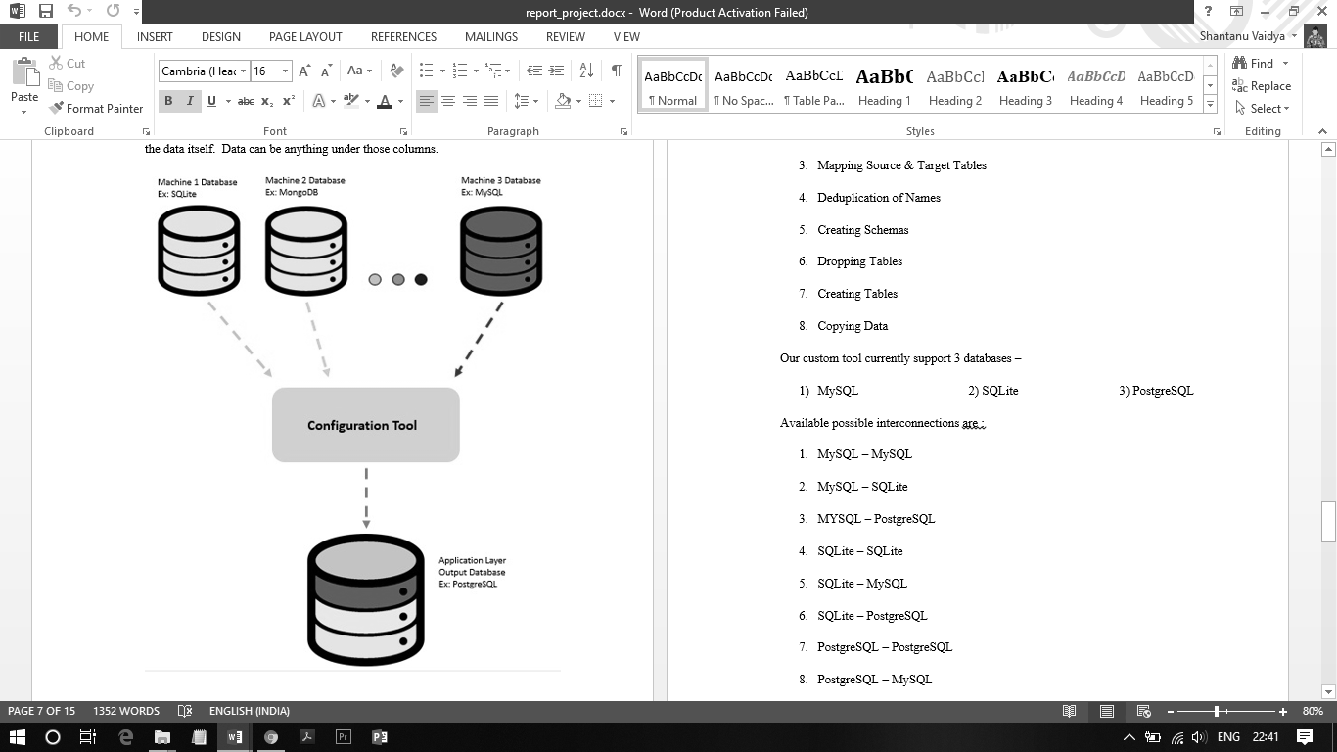
Fig. 3 - Database Configuration Tool
RESULTS
In this section, the actual results after implementation are proposed. Consider here 3 databases – MySQL, PostgreSQL (SQL Databases) and MongoDB (No SQL Database). Therefore, the clients are provided with three choices, into which database they want to store their data. This leads to the fact that the custom designed configuration tool performs six conversions out of the nine possible combinations over the databases before storing the complete data into a single output database.

The nine possible combinations are –

- MySQL – > MySQL
- MySQL – > PostgreSQL
- MYSQL –> MongoDB
- PostgreSQL –> PostgreSQL
- PostgreSQL –> MySQL
- PostgreSQL –> MongoDB
- MongoDB –> PostgreSQL
- MongoDB –> MySQL
- MongoDB –> MongoDB

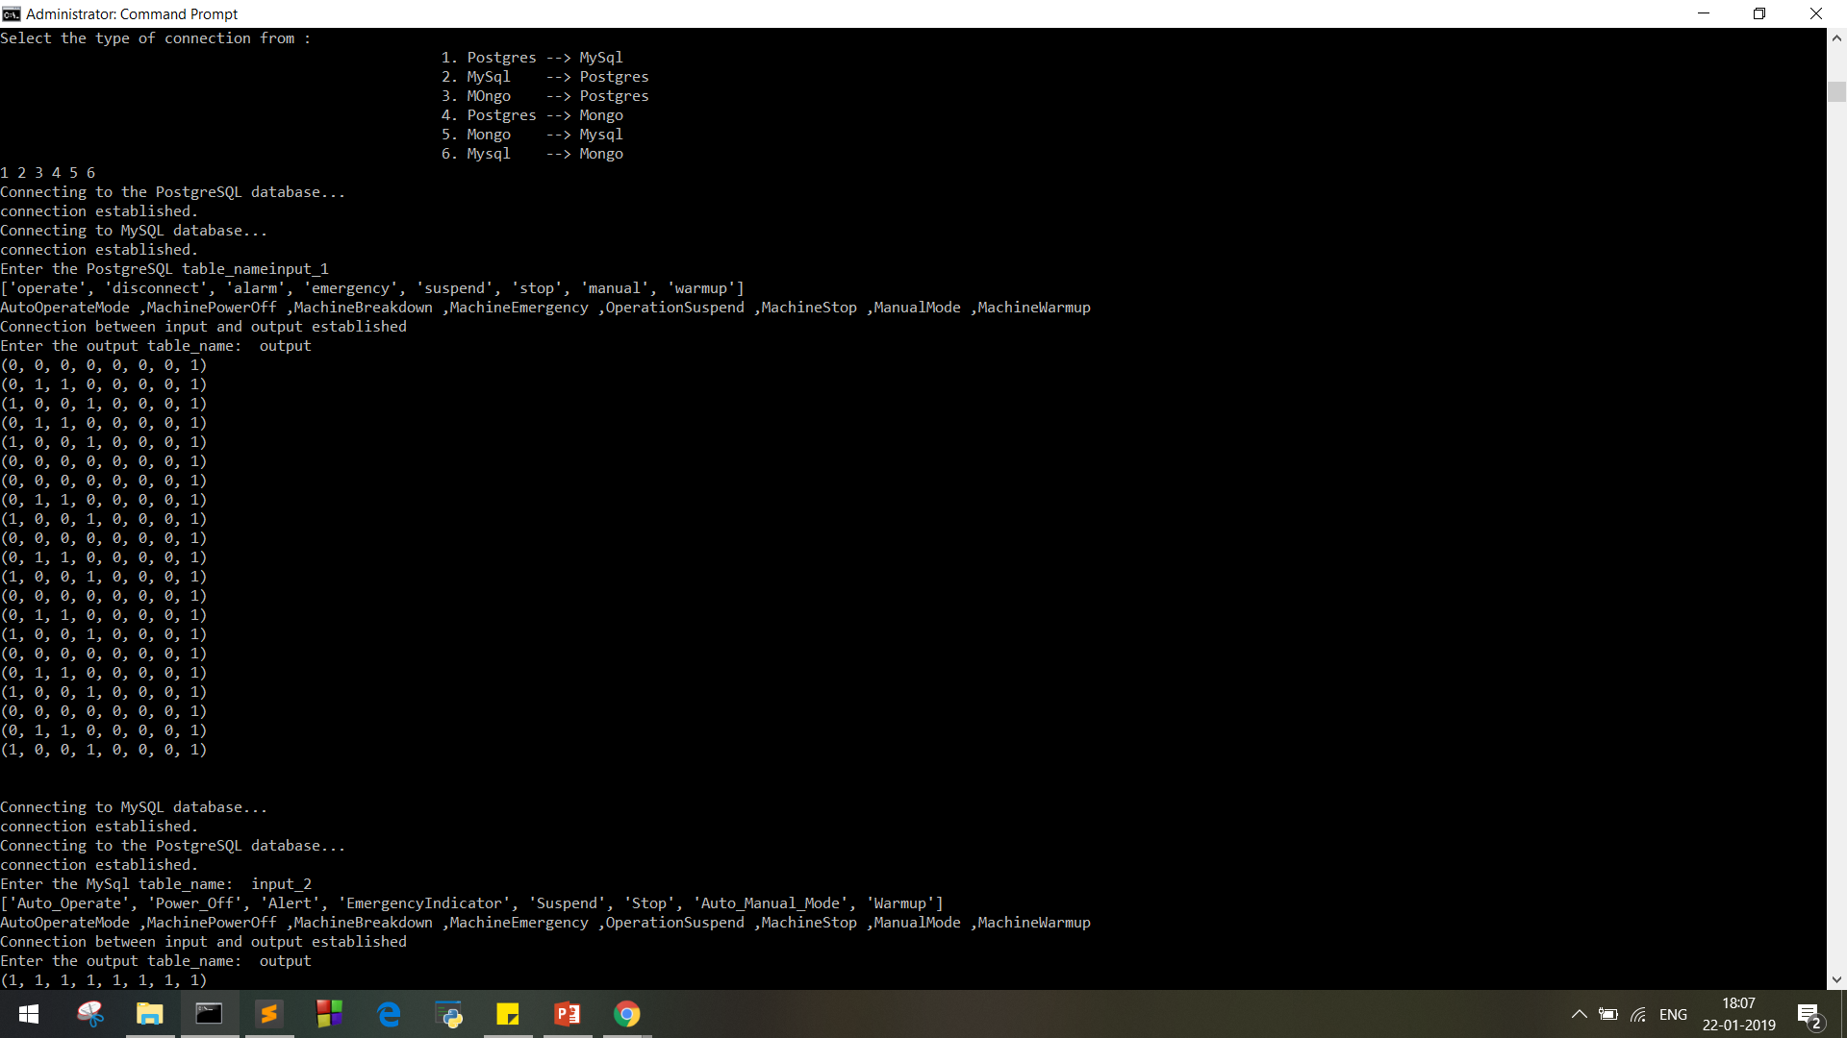

Fig. 4 - Six Possible Conversions
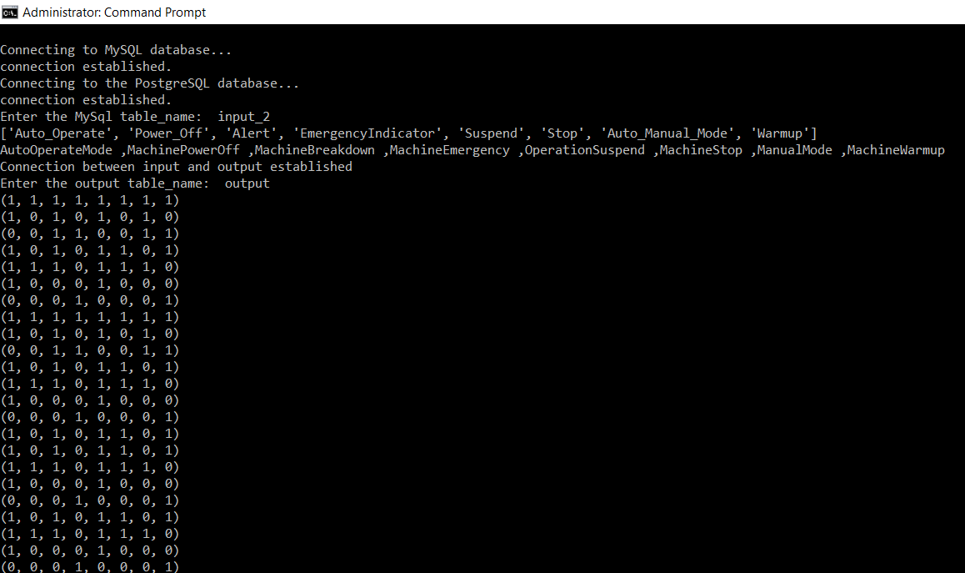

Fig. 5 - MySQL – PostgreSQL Conversion
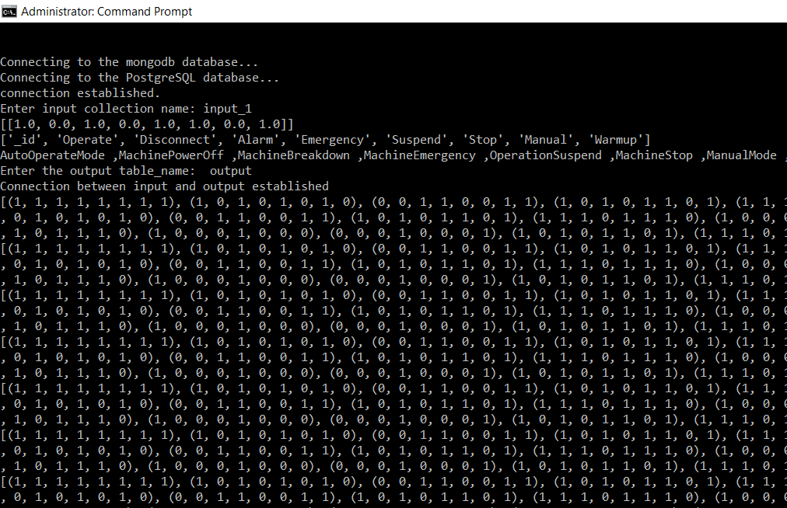
Fig. 6 - MongoDB – PostgreSQL Conversion
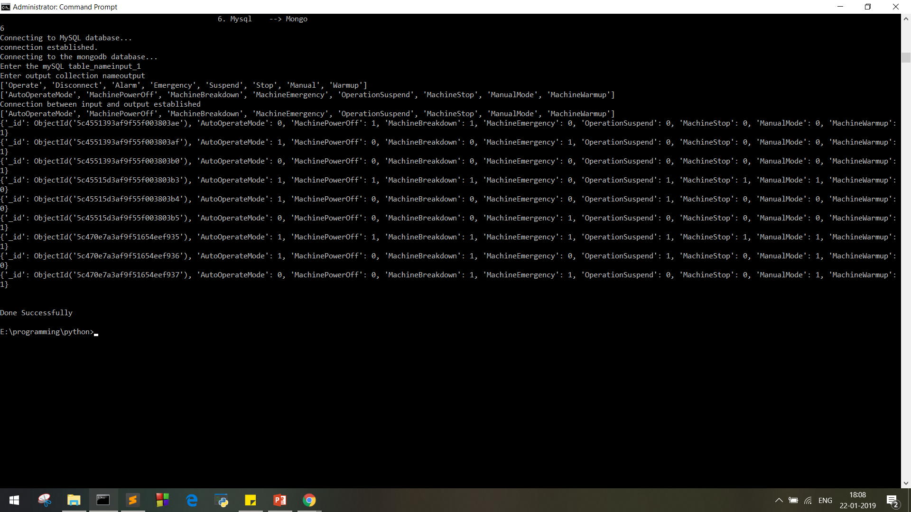
Fig. 7 - MySQL – MongoDB Conversion
CONCLUSION
One of the most important factor any asset monitoring is supposed to keep at the core of the entire ecosystem is asset tracking, it goes into details such as where any particular asset is located, i.e. collecting real-time sensor data and keeping continuous track on the machines. Based on this data, the solution can create analytical reports in the form of dashboards to offer truly situational awareness to the entire asset monitoring environment. Asset monitoring solution will thus bring real value to the industries, which makes it easier to integrate with third-party applications. Thus, building a platform which can communicate with different types of automated machines and generate reports based on the acquired machine data in the human readable format, involving three steps, data acquisition, data transformation, and data representation and thus building a custom tool. A generic tool to input various kinds of data columns to be matched with output data columns.

REFERENCES
- Adam Rowe, “What Is Asset Monitoring? | Asset Tracking Guide,” TechCo, 07-Dec-2018. [Online]. Available: https://tech.co/asset-tracking/asset-monitoring-explained. [Accessed: 10-Feb-2019].
- Raakesh Rajan, “Re-imagining Asset Management with Internet of Things (IoT),” RapidValue. [Online]. Available: https://www.rapidvaluesolutions.com/whitepapers/re-imagining-asset-management-with-iot/. [Accessed: 12-Nov-2018].
- Riya Savjani, “IoT Asset Monitoring Solution | Remotely Asset Monitoring,” Softweb Solutions, 25-Jan-2019. [Online]. Available:https://www.softwebsolutions.com/resources/IoT-powered-asset-remote-tracking-solution.html. [Accessed: 10-Nov-2018].
- International Organization for Standardization, “Asset management,” Wikipedia, 07-Dec-2018. [Online]. Available: https://en.wikipedia.org/wiki/Asset_management. [Accessed: 10-Feb-2019].

Details of All Authors

Photo | Details
 | Miss. Runmai Kalamkar  B.E – Final Year Student, Computer Technology Dept.  Yeshwantrao Chavan College of Engineering, Nagpur.
 | Miss. Devanshi Chawda  B.E – Final Year Student, Computer Technology Dept.  Yeshwantrao Chavan College of Engineering, Nagpur.
 | Master. Pranay Choudhary  B.E – Final Year Student, Computer Technology Dept.  Yeshwantrao Chavan College of Engineering, Nagpur.
 | Master. Shantanu Vaidya  B.E – Final Year Student, Computer Technology Dept.  Yeshwantrao Chavan College of Engineering, Nagpur.

