Application of Line Balancing Method For Manual Assembly Line

Prof. Ajay N. Motiwal¹, Mr. Vishwajit B. Madankar², Mr. Shubham K. Sarve³, Mr. Chetan M. Mohurle⁴, Mr. Akshay P. Kullarkar⁵, Mr. Atul Ambildhuke⁶

¹AssitantProfessor,²⁻⁶ Students,
Dept. of mechanical Engineering, MIET Bhandara, MAHARASHTRA-441904

Abstract: In the present economic scenario, the competition is increasing significantly. The global competition, poor responsiveness, low flexibility to meet the uncertainty of demand, and the low efficiency of traditional assembly lines are responsible for certain undesirable processes and various parameters. Line balancing is an effective tool to improve the throughput of assembly line while distributing the equal amount of work content time to the various work stations to achieve required demand. In this report, Ranked Positional Weight balancing methods is studied on the assembly line in which 6SGB is assembled. The output represent the cycle time 4.752 minute, improved line efficiency is 94.63% and increase production rate from 86.56 units to 89.04 units per day.
Keywords- Assembly line balancing, Ranked positional weight method.
I. INTRODUCTION
Most manufactured consumer products are assembled. Each product consists of multiple components joined together by various assembly processes. These kinds of products are usually made on a manual assembly line [7].Balancing assembly

lines becomes one of the most important parts for an industrial manufacturing system that should be supervised carefully. The success of achieving the goal of production is influenced significantly by balancing assembly lines. Since then, many industries and researchers, attempt to find the best methods or techniques to keep the assembly line balanced and then, to make it more efficient. Furthermore, this problem is known as an assembly lines balancing problem [4].
An assembly line consists of workstations that produce a product as it moves successively from one workstation to the next along the line, which this line could be straight, u-line or parallel until completed. To balance an assembly line, some methods have been originally introduced to increase productivity and efficiency [4]. In this paper, Ranked Positional Weight assembly balancing methods were studied.

Ranked Positional Weight Method:

Ranked positional Weight Method (RPW) was introduced by Helgeson and Birnie in 1961, which it’s a value to be computed for each element in the system. The RPW_{ek} accounts for each T_{ek} and its position on the raw chain in the precedent diagram. T_{ek} is a time to perform work element k, minute and hence these values of T_{ek} are additives [4].

II. LITERATURE REVIEW
Balancing assembly lines is a very important mission for manufacturing industries in order to improve productivity by minimizing the cycle time or the number of workstations. The balancing problems manage the assignment of tasks to workstations to achieve the purpose objectives. The general practice in the assembly line balancing is to assign tasks to workstations in such a way that each total time of assigned tasks to each workstation has an equal line cycle time[4].

Dr. Sidheswar Patra, Anil Jaggi and Prof. (Dr.) D. S. Chaubey (2015): The key outcome of this paper is the reduction in cycle time for single model assembly line when line is balanced; efficiency increases by reducing non value added activities and other outcomes were that assembly line balanced by recommending new layout [1].

Naveen Kumar & Dalgobind Mahto (2013): This paper presents the reviews of different works in the area of assembly line balancing and tries to find out latest developments and trends available in industries in order to minimize the total equipment cost and number of workstations [2].
Riyadh Mohammed Ali Hamza & Jassim Yousif Al-Manaa (2013): A study imitating a procedure of a Two Stages Gear Box (2SGB) assembly line layout is presented. Three balancing methods are studied in which 2SGB is assembled. These methods are Rank position weight, larger candidate rate, and Column method. The selection criterion was based on minimum assembly time for all method. Three assembly line processing layouts were developed based on output of assembly methods which are the single straight line, circle and mixed (circle + straight) processing. The best layout was found to be the line stations layout by Ranked Positional Weight Method with 4 stations and total assembly time of 4.25 minutes per gearbox. Each station has one worker, the service time of 1.1 minutes, line balancing efficiency was 0.964, and labour efficiency was 0.8884[4].

Sandip K. Kumbhar, Niranjan M. R & Sanjay T. Satpute (2014): In this paper focus given on the optimization of cycle time and reduction of non-value added activity. Improvement in the productivity achieved and elimination of non value added activities has been done. The cost of operation is reduced considerably. Optimization of cycle time study is helpful for low cost automation and bench marking activity at industry production improvement level [5].

Muhammad Razif Abdullah Make, Mohd Fadzil Faisae Rashid, Muhamad Magffierah Razali & Manugari Perumal (2017): In this paper, a real industrial data of simple ALB problem is optimized and simulated for minimizing the number of workstation. Three proposed heuristics in order to improve the efficiency of the production are reviewed before a discrete simulation approach is used to compare the optimized performance. The anticipated performance of computational result is obtained from the problem comprising the workstation and labour performance output [3].
Israa Dhiaa Khalaf, Dr. Sawsan Sabeeh Al- Al-Zubaidy & Dr. Mahmoud Abbas Mahmoud (2015): In this paper, new heuristic method for solving single model assembly lines balancing problem are described. The objective of balancing in this paper is increasing the efficiency of the line by assigning the tasks to stations such that the number of stations is minimized for a given cycle time [6].

Vrittika V Pachghare & R. S. Dalu (2012): This paper present the application of assembly line balancing method. The methods namely Rank position weight, larger candidate rule, and kill bridge and wester methods are used. The selection criterion was based on minimum assembly time for all methods. Three assembly line processing layouts were developed based on output of assembly methods The output that represent Cycle time 10 min improved line efficiency to 82.33%,idle time 10.6 min, smoothness index 7.10 and increase production rate from 40 units to 48 units per day[8].
III. OBJECTIVE
The main objective of the present paper is to improve productivity and reduce production cost as well as to determine number of feasible workstations.

IV. ASSEMBLY LINE BALANCING
Assembly is a manufacturing process in which interchangeable parts are added in a sequential manner using certain material flow and design layouts. The line assembly is the efficient utilization of facilities with minimum material handling as well as easy production control. Since different workstations have different working capacity it is then important to apportionment the sequential work activities in to workstations in order to achieve a high utilization of labour, equipments, and time [4].

The important parameters in Line Balancing are:
Line Efficiency (LE) = (Total Station Line Time ÷ Cycle time x no. of workstations) x 100%........................ (1)
Balance Delay (BD) = (Total idle time ÷ total available working time on all stations) x 100%........................ (2)

Analysis of a Single Model Assembly Line
The assembly line design should account for the Production Rate R_{p} that is sufficient to reach the desired demand (Quantity) for the product. The product volume is often determined as an annual quantity as follow [4]:
Q = R_{p} = D_{a}/50S_{w*}H_{sh} .......... (3)
Where D_{a} = annual quantity, S_{w}= number of shifts per week, H_{hrs} = hr/shift, 50 = number of weeks per year. Assuming the plant operates 50 weeks per year.
This factor should converted to a cycle time Tc which determines the line time interval
T_{c}=60E/R_{p}.............................(4)
The typical values of E (Line efficiency) for a manual production are in the range 0.9 to 0.98.
The cycle time T_{c} establishes the ideal cycle rate for the line RC
R_{c} = 60 /T_{c}............................(5)
Line Efficiency E is then calculated as:
E = (R_{p} / R_{c}) = (T_{c}/ T_{p}) .......(6)
An assembled product requires a certain total amount of time to build, called the Work Content Time T_{wc}. Number of workers usually determined on the production line as:
W = WL / AT .....................(7)

V. ANALYSIS & FINDING
In Gear Box assembly section, various types of gear box are assembled like 5S, 6S, 9S Gear Box on different line. In this industry, 5S & 6S gear box assembled on one line and another line 9S gear box is assembled. We understood the work flow process & assembly process from the section and collected the data of 6 speed gear from the assembly line. Annual production rate of 6S gear box is 27,000 units. The line works 8 hours per shift. Data presented in the Table (1) represents the concept based on given information where the times were calculated based on the mean value of work time using a stopwatch for the regard elements. These T_{ek} values are shown in Table 1 and the preceding diagram of work element are shown in Figure 1.
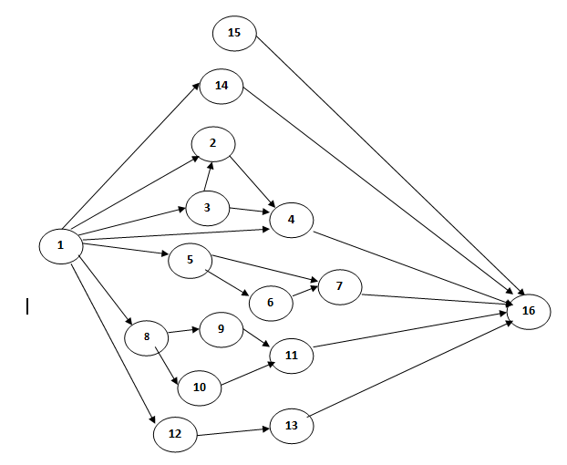
Figure 1: Gear Box sub assembly Precedence Diagram.
Element | Work Description | Work element time (min.) | Preceded by
1 | Loading components on 7 washing machine tray. | 3.040 | -
2 | 1st, 2nd& reverse gears fitment on main shaft. | 4.477 | 1,3
3 | Synchro pack sub assembly. | 2.718 | 1
4 | 3rd, 4th& 5th gears fitment on main shaft. | 4.752 | 1,2,3
5 | Pickup IPS cover, bell housing & input shaft from tray and put on table. | 0.250 | 1
6 | Input shaft sub assembly. | 3.324 | 5
7 | Bell housing sub assembly. | 3.085 | 6
8 | Pickup selector tower components and put on table. | 0.288 | 1
9 | Selector shaft sub assembly. | 0.646 | 8
10 | Brg bush & oil seal fitment on tower casing. | 1.028 | 8
11 | Selector tower, GC finger & roll pin fit into tower casing. | 3.732 | 9,10
12 | Pickup lay shaft &, gears put on table and induction heater. | 0.351 | 1
13 | Fitment of lay shaft gears on lay shaft. | 3.430 | 12
14 | Casing sub assembly. | 3.142 | -
15 | Reverse Selector Shaft Section | 0.835 | 1
16 | Coupling assembly. | 2.51 | 4,7,11,13,14,15
 |  | ∑T_{ek}=37.527min.
Table 1: Work element assigned to the station.

Ranked Positional Weight Method
Procedure:
Step 1: Calculate the RPW for each element by summing the element T_{ek} together with the T_{ek} values for all the element that follow it in the arrow chain of the precedence diagram.
Step 2: List the elements in the order of their RPW, largest RPW at the top of the list. For convenience, include the T_{ek} value and immediate predecessors for each element.
Step 3: Assign elements to stations according to RPW, avoiding precedence constraint and time cycle violation.
Element | RPW  (Min.) | T_{ek}  (min.) | Preceded by
1 | 34.385 | 3.040 | -
3 | 14.403 | 2.718 | 1
2 | 11.685 | 4.477 | 1,3
5 | 9.088 | 0.250 | 1
6 | 8.838 | 3.058 | 5
8 | 8.150 | 0.288 | 1
10 | 7.216 | 1.028 | 8
4 | 7.208 | 4.752 | 2,3
9 | 6.834 | 0.646 | 8
12 | 6.237 | 0.351 | 1
11 | 6.188 | 3.732 | 9,10
13 | 5.886 | 3.430 | 1
15 | 5.598 | 3.142 | -
7 | 5.514 | 3.058 | 6,5
14 | 3.291 | 0.835 | 1
16 | 2.456 | 2.456 | 4,7,11,13,14,15
Table 2: Elements ranked according to their RPW.

Station | Element | T_{ek} | Station Time
1 | 1 | 3.040 | 4.957
1 | 5 | 0.250 | 4.957
1 | 8 | 0.288 | 4.957
1 | 10 | 1.028 | 4.957
1 | 12 | 0.351 | 4.957
2 | 3 | 2.718 | 4.199
2 | 9 | 0.646 | 4.199
2 | 14 | 0.835 | 4.199
3 | 2 | 4.477 | 4.477
4 | 6 | 3.058 | 3.058
5 | 4 | 4.752 | 4.752
6 | 11 | 3.732 | 3.732
7 | 13 | 3.430 | 3.430
8 | 15 | 3.142 | 3.142
9 | 7 | 3.058 | 3.058
10 | 16 | 2.456 | 2.456
Table 3: Element assigned to stations according to their RPW.
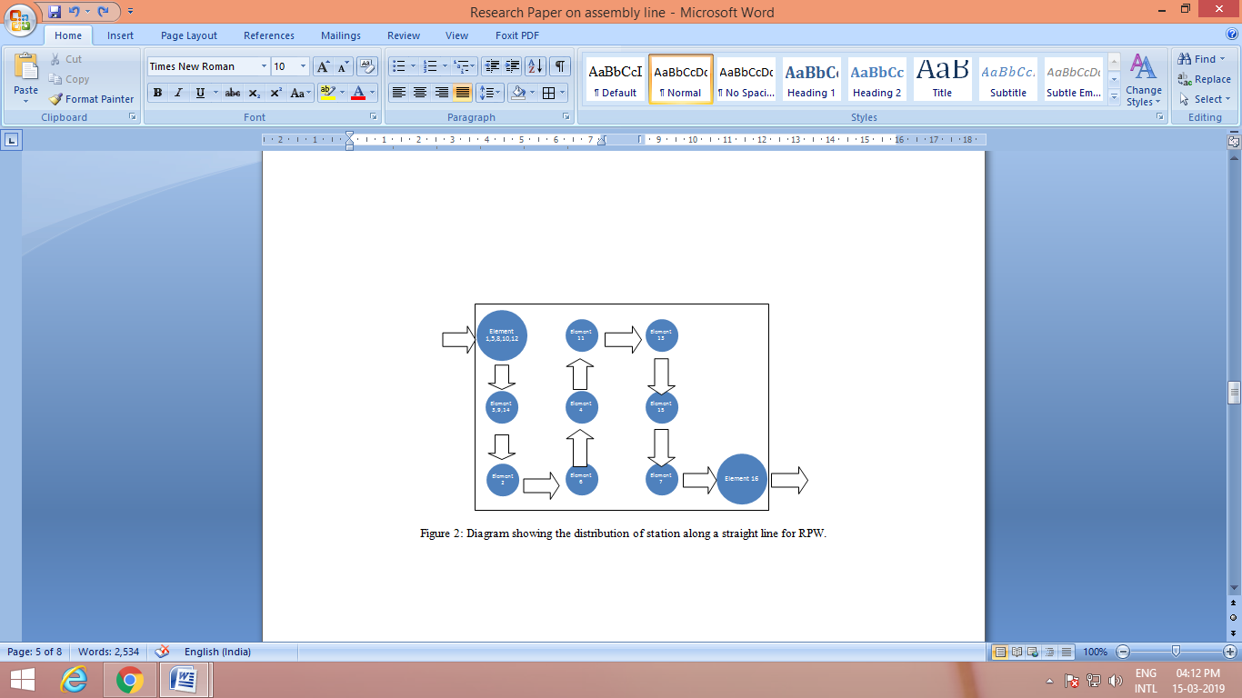
Figure 2: Diagram showing the distribution of station along a straight line for RPW.

1. Production rate (R_{p}):
The proposed annual demand set to be = 27,000 unit/yr. The plant operates 6 days per week and 8.0 hours per day with assumption that the line operates 52 week per year therefore, the required production rate is:
Based on equation (3)
R_{p} =$\frac{27000}{52\left(6\right)(8)}$ = 10.817 units/hr.
2. Cycle Time ( T_{C} ):
Based on equation (4)
T_{c} = $\frac{60*E}{Rp}$
T_{c}=$\frac{60(0.92)}{10.817}$ = 5.103 minute.

3. Minimum number of workers are required to achieve the target of demand (w):
Based on equation (7)

w = $\frac{work content time}{cycle time}$
= $\frac{Twc}{Tc}$ = $\frac{37.527}{5.103}$ = 7.36 ≈ 8 workers.

4.Assignment of the elements to stations proceeds with the solution presented in table 3. Note that the largest T_{S} value is 4.957 minute. This can be exploited by operating the line at this faster rate, with the result that line balance efficiency is improved and production rate is increased:
Based on equation (1)
Balance efficiency ( E_{b}) = $\frac{Twc}{w*Ts}$ = $\frac{37.527}{8*( 4.957 )}$ = 0.9463×100% = 94.63%

5. Cycle rate for the line based on cycle time ( T_{C} ):
Based on Equation (5)
Rc = $\frac{60}{Ts}$ = $\frac{60 }{4.957}$ = 12.104 cycle/hr.
6. Therefore the actual production rate ( R_{P} )
= 12.104*0.92 = 11.13 units/hr.

7. After calculating the actual cycle and workstation, the yearly production rate is:
R_{P} = 11.13*8 = 89.94 unit/day.

VI. OUTCOME RESULT
Based on the present work output, the analysis came out from study is that the production rate increased after applying RPW method. We can see clearly the comparison from the production rate (Equation 1& equation 2).

Figure 8: Components of cyclic time at several stations on a manual assembly line.

VII. CONCLUSION

This study proposed to balance the line to achieve the target of demand product in given amount of time. In this report, the line balancing algorithm (i.e. Ranked Positional Weight method) is used to balance the assembly line of 6S gear box. After applying the algorithm, we found that the production rate difference is increased by 0.310 units per hr than previous rate. If the industry will apply this algorithm then the production rate will increases from 86.56 units to 89.04 units per day.

VIII. REFERENCE

[1] Anil Jaggi, Dr. Sidheswar Patra &Prof. (Dr.) D. S. Chaubey, “Application of Line-balancing to Minimize the Idle Time of Workstations in the Production Line with Special Reference to Automobile Industry,” International Journal of IT, Engineering and Applied Sciences Research (IJIEASR) ISSN: 2319-4413 Volume 4, No. 7, July 2015.
[2] D. Mahto, A Kumar (2012), “An Empirical Investigation of Assembly Line Balancing Techniques and Optimized Implementation Approach for Efficiency Improvements,” Global Journal of Researches in Engineering Mechanical and Mechanics Engineering Volume 12 Issue 3 Version 1.0 Publisher: Global Journals Inc. (USA) Online ISSN: 2249-4596 Print ISSN:0975-5861.
[3] Muhammad Razif Abdullah Make, Mohd Fadzil Faisae Rashid, Muhamad Magffierah Razali & Manugari Perumal, “Assembly Line Balancing using Heuristic Approaches in Manufacturing Industry,”Journal of Mechanical Engineering, Vol SI 4(2), 171-185, 2017.
[4] Riyadh Mohammed Ali Hamza , Jassim Yousif Al-Manaa “Selection of Balancing Method for Manual Assembly Line of Two Stages Gearbox” Global Perspectives on Engineering Management May 2013, Vol. 2 Iss. 2, PP. 70-81.
[5] Sandip K. Kumbhar, Niranjan M. R, Sanjay T. Satpute, “Assembly Line Production Improvement By Optimization Of Cycle Time,” International Journal of Mechanical And Production Engineering, ISSN: 2320-2092, Volume- 2, Issue-8, Aug.-2014.
[6] Israa Dhiaa Khalaf, Dr. Sawsan Sabeeh Al- Al-Zubaidy, Dr. Mahmoud Abbas Mahmoud, “Developing New Heuristic Method to Balance Single Model Assembly Line”,InternationalAdvanced Research Journal in Science, Engineering and Technology Vol. 2, Issue 9, September 2015.
[7] Mikell P. Groover, “Automation, Production Systems, and Computer-Integrated Manufacturing”, third edition , Indian edition published by PHI Learning Private Limited.
[8] Vrittika V Pachghare , R. S. Dalu, “Assembly Line Balancing Methods–A Case Study”, International Journal of Science and Research (IJSR) ISSN (Online): 2319-7064 Impact Factor (2012): 3.358.
[9] Krantikumar B. Chavare & Prof.Abid M. Mulla,“Application of Ranked Position Weighted (RPW)Method for Assembly Line Balancing”, International Journal for Research in Applied Science &Engineering,Technology (IJRASET), Volume 3 Issue VI, June 2015 ISSN: 2321-9653.
[10] S. G. Ponnambalam, P. Aravindan and G. Mogileeswar Naidu. (2000), “A Multi-Objective Genetic Algorithm for Solving Assembly Line Balancing Problem, The International Journal of Advanced Manufacturing Technology.16:341–352.

