DESIGN AND FABRICATION OF TREADMILL BICYCLE

Shoeb Ahemad¹, Tanveer Ahmad², Sohil Sk³, Danish Sk⁴ , Aadil Khatik⁵
^{1,2,3,4,5} BE-Final Year , Mechanical Department Of GF’s
Godavari College Of Engineering Jalgaon , 425001.
sohailmanyar26796@gmail.com³

Abstract
This paper deals with the conversion of a conventional bicycle into treadmill bicycle. In this bicycle the frame of the bicycle is completely modified and the treadmill is placed in between the two wheels, on which user will walk. As the user walks or runs on the treadmill the belt moves to the rear. At the rear roller the RPM Sensor is attached to the roller, from where the Sensor senses the speed of the roller and sends the signal to the motor. The motor on receiving the signal transmits its motion to the front wheel which leads to the rotation of the wheel and thus the bicycle runs.

TREADMILL
A treadmill is a device generally for walking or running or climbing while staying in the same place. Treadmills were introduced before the development of powered machines, to harness the power of animals or humans to do work.[2]

2. LITERATURE SURVEY

There has been great deal of research on this treadmill bicycle fabrication. The origin and use of the treadmill bicycle system began from several years ago and develop throughout the new concept revolution. At the late first century AD Roman Empire introduce first treadmill, as they need to lift heavy weight they incorporate this new invention. Nicholas potter also work in this field and invented a treadmill which is powered by animal and reduce human effort with more output.
Nicholas Potter-He invented “Dog Power Treadmill” to tackle domestic work and produce rotary and reciprocating motion for use with light machinery.[4]

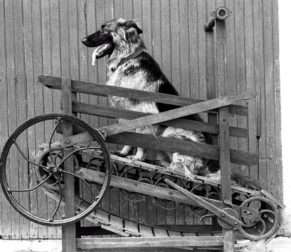

Dog Power Treadmill

Key words : The Treadmill ,Fitness Walking Belt ,
Wheel, Roller’s , Bearing , Flywheel , Sprocket.
1. INTRODUCTION

The treadmill bicycle is completely a new way of moving which is designed mostly for runners. Basically, using a treadmill is similar to running, hiking or walking. Think about the last time you were riding a bike over a few obstacles such as train tracks, potholes, speed bumps etc. The possibilities are you stood up on the pedals to improve your balance when crossing the obstacle. Basically, the treadmill bicycle will provide the rider a well-balanced position the entire time. It is a combination of amalgamation of DC motor with different components upgrading your walking speed to a much higher pace. Since it uses no fuel it a very conventional option for people in their busy schedule to take care of their health completely. People with a busy schedule will also be able to take care of their health and physical fitness. Above all, it is not a conventional treadmill to make use of only in closed rooms, people using treadmill bicycles can roam around freely on roads as well. This project overcomes the drawback of the conventional treadmill which is stationary and moreover the jogger gets exposed to the natural atmosphere too.[2]

CYCLE
A bicycle, often called a bike or cycle, is a human powered, pedal-driven, single-track vehicle, having two wheels attached to a frame, one behind the other. Two-wheeled bicycles come in a range of designs.[2]

3. CONCEPT OF PROJECT
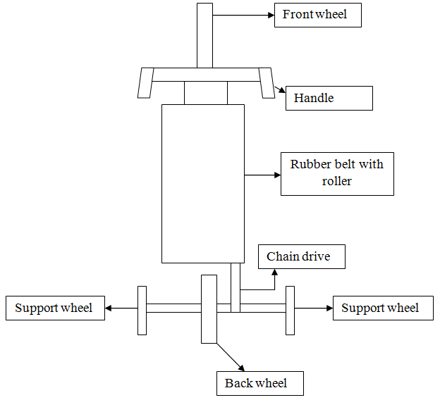

3.1 TREADMILL

There are majorly two different types of frame materials with standard treadmills having steel frames and newer and premium treadmills with aluminum frames. Aluminum frames will hold up better if you are preparing on keeping your treadmill for several years or if you are near to the weight capacity of the treadmill. The treadmill rails (also known as bars or grips) should be used for providing stability when you are starting or stopping the treadmill or if your treadmill is well equipped with a grip heart monitor, this is where you will take your heart rate measurements. Rails are not meant to be held the complete time that you are using the treadmill, so be sure that they are in a convenient but also out of the way location. [1]

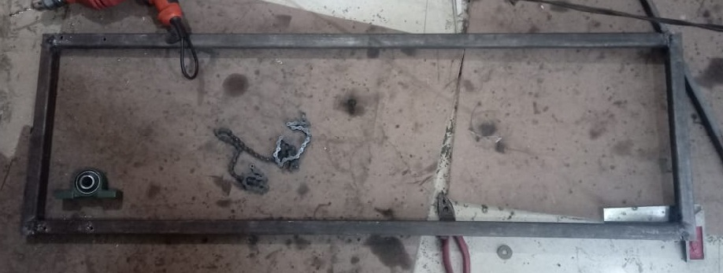

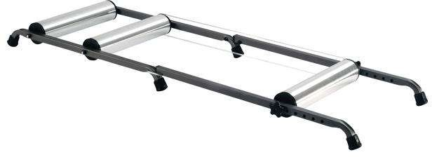

2.1 PROBLEM STATEMENT

`While working out in the gym people use treadmill for the purpose of jogging and running. The main drawback of treadmill is that it is stationary. That becomes boring for user to run in a still surrounding with natural exposure to environment. Similarly cycling in the conventional way is common and not possible for all age groups as old people prefer walking. Even for travelling short distance people.
Prefer vehicles that cause pollution and wastage of energy in terms of fuel. So, we came up with the concept of walking tricycle.
- In our day to day life we see that many people’s use bikes cars as a source of transportation.
- This results in environmental pollution and fuel consumption.
- In manual treadmill the motion of the treadmill is rough to overcome this we use a motor to rotate the rotors.
- Batteries which are widely used in automobile sector is not rechargeable thus when they disposed create pollution.
- To improve all above phenomenon we take initiative by designing something which would help to reduce these harmful results.

2.2 PROPOSED SYSTEM

Treadmill cycle is the new way of locomotion. It makes workout more interesting and competitive. There is no need to get stuck in the gym at a corner when you can roam while you workout. Secondly, looking from the ever-growing problem of pollution, this cycle turns out to be eco-friendly without emission of harmful pollutants. Moreover it saves fuel thus helping in saving the natural resources. Lastly, in this metropolitan world, people are ignoring their health and fitness. This cycle would be a boon for such fitness deprived people having hectic schedule.
- Useful for exercise purpose.
- To reduce the use of non-renewable energy sources.

3.4 ROLLERS
Bicycle rollers are a type of bicycle trainer that make it feasible to ride a bicycle indoors without moving forward. However, dissimilar to to other types of bicycle trainers, rollers do not confine to the bicycle frame, and the rider must balance him or herself on the rollers while training. Bicycle rollers normally comprise of three cylinders, drums, or "rollers" (two for the rear wheel and one for the front wheel), on top of which the bicycle runs. A belt joins one of the rear rollers to the front wheel of the bicycle to spin when the bicycle is pedaled. The spacing of bicycle rollers can normally be adjusted to match the bicycle's wheelbase. Generally, the front roller is adapted to be slightly ahead of the hub of the front wheel.[2]

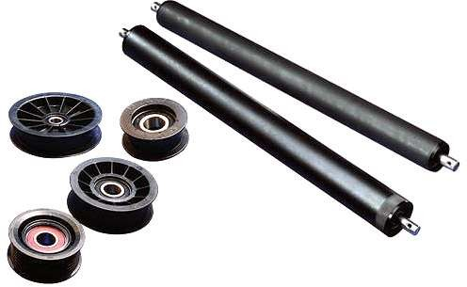

3.5 BEARINGS
A bearing is machine element which holds another moving machine element. The moving machine element called as a journal. Bearing allows a relative motion between the contact surfaces of the members while transferring the load. A certain amount of power is wasted in removing frictional resistance. So as to reduce frictional resistance and wear and to carry away the heat generated, a lubricant may be utilized. The lubricant used is often a mineral oil refined from petroleum. The bearing block is provided to hold the bearings. It is made up from cast iron. All the bearings are fabricated on the machine frame.[2]

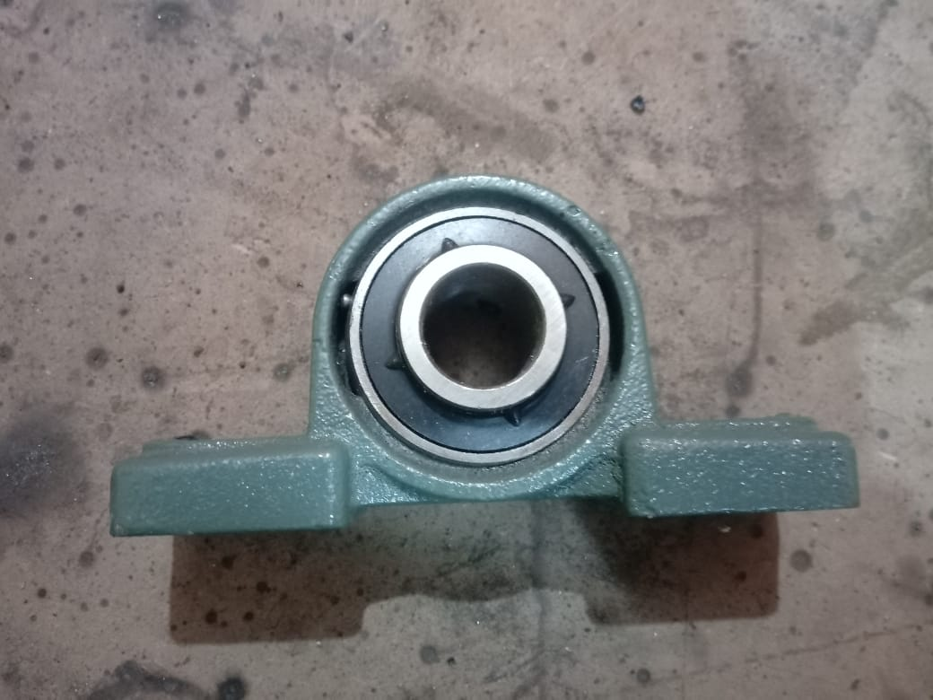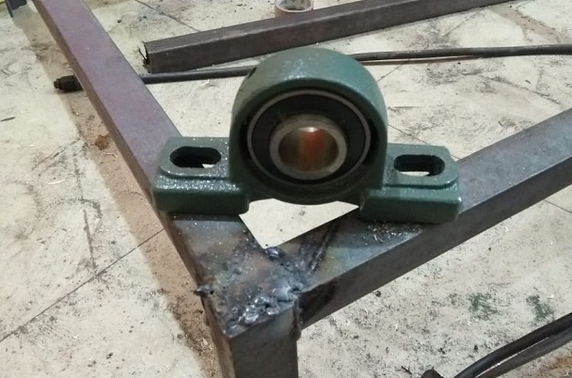

3.2 WALKING BELT
The walking surface of a treadmill comprises of the thin moving belt and a rigid plate held between the two surfaces of that belt so as to provide support when the transverse load of footfalls is applied. The treadmill belt size is an important characteristic in your treadmill if you are preparing for running or jogging on your treadmill. If you are planning on walking, the belt size is not of much importance. Standard belts run with size 19" wide by 50" long. Although this appears like a good width and length, you must note that the belt goes onto a deck, which includes part of the frame and your console. So even if your belt is 19 x50, your running space may be 16 by 45.[1]
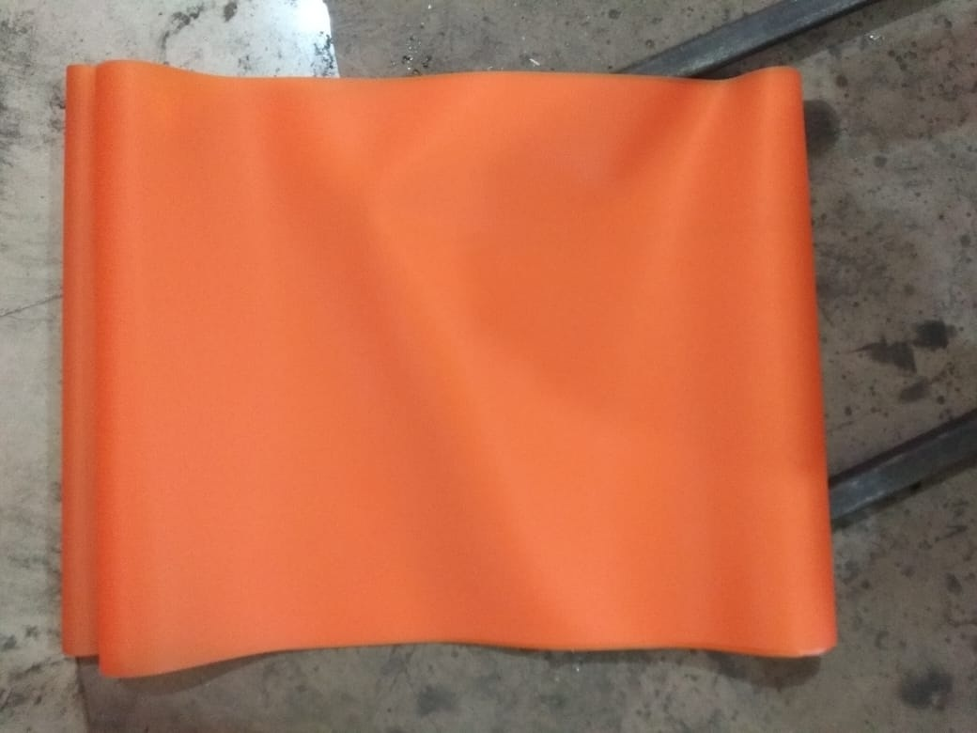

3.3 WHEELS
A wheel is a circular component that is made to rotate on an axle bearing. The wheel is one of the major components of the wheel and axle which is one of the six simple machines. Wheels along with the axles, allow heavy objects to be moved easily allowing movement or transportation while supporting a load or performing labor in machines A wheel greatly lessens friction by facilitating motion by rolling together with the use of axles. For rotations of the wheel, a moment must be applied to the wheel about its axis, either by way of gravity or by the application of another external force or torque. [1]

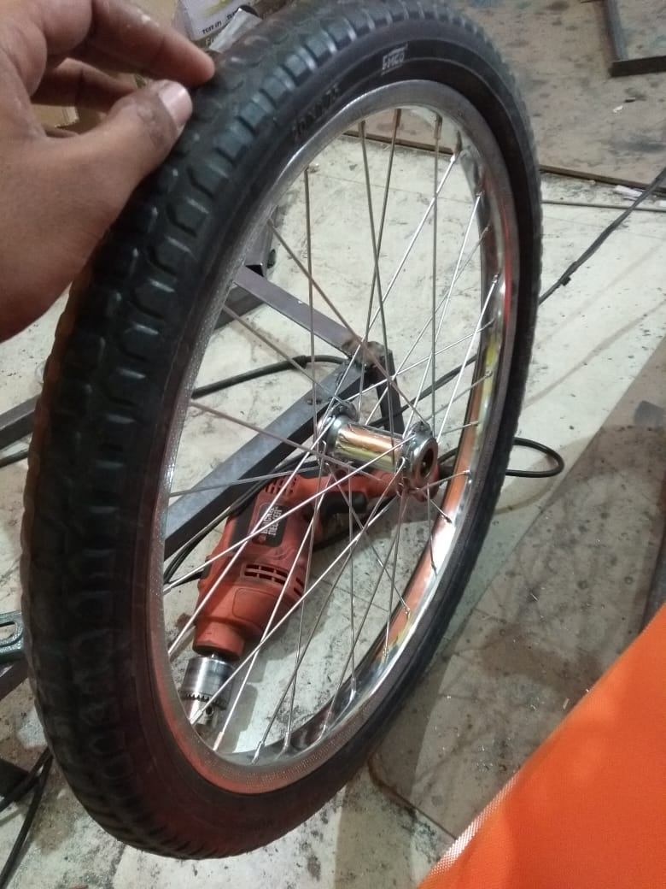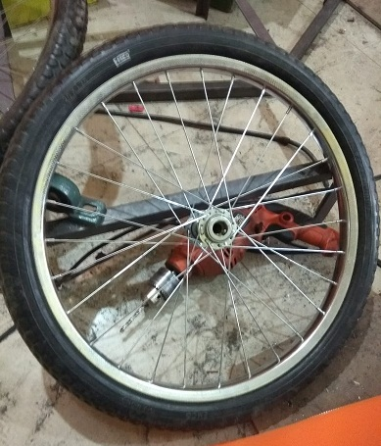

3.6 SPROCKET
A sprocket or sprocket wheel is a profiled wheel which has teeth, cogs, or even sprockets that mesh with a chain, track or other perforated or indented material. The name 'sprocket' applies usually to any wheel upon which radial projections retain a chain passing over it.. [1]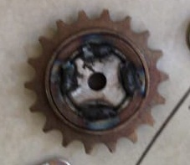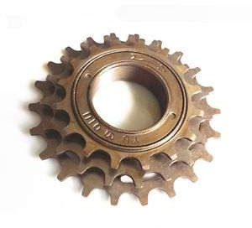

3.7. CHAIN
A chain is a series of connected links which are typically made of metal. A chain may consist of two or more links. Those designed for lifting, such as when used with a hoist; for pulling; or for securing, such as with a bicycle lock, have links that are torus shaped, which make the chain flexible in two dimensions (The fixed third dimension being a chain's length.)[3]

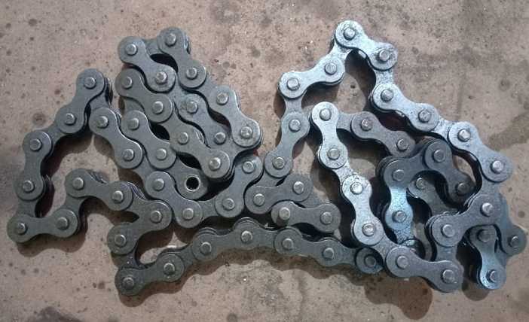

3.8. MOTOR
While many people just compare the horsepower of the motor, actually look at the type of motor in addition to the horsepower. Basic treadmill motor are available with 2.5hp (horsepower) and 1440 rpm. It is not suitable for driving on roads due to traffic issues. Also it will leads to accidents so for the walking bike we use a common traction motor with 0.3 hp and 300 rpm. With this much of speed the cycle can be drive easily. DC motors for electric scooters and other electric devices
Rated Voltage: 24V
Output Power:250W
Rotation: 3300 RPM
Reduction Ratio:9.78
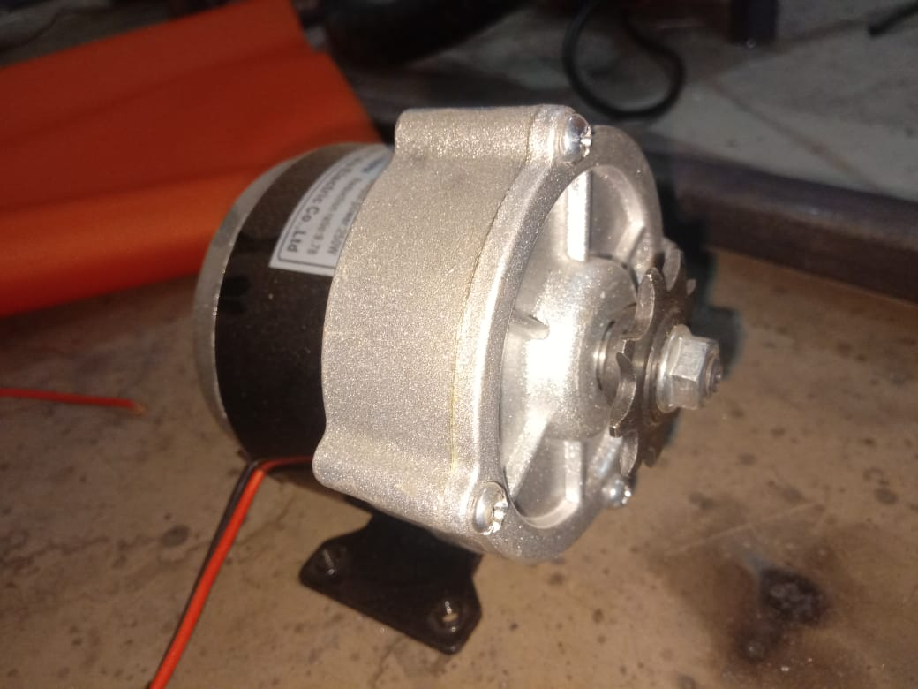

4. WORKING PRINCIPLE
When we walk or run on the walking surface it gives rotation to rear wheel of bicycle and treadmill bicycle is moving forward. The walking surface of a treadmill consists of the thin moving belt and a rigid plate placed between the two surfaces of that belt in order to provide backing when the transverse load of footfalls is applied. The original and unmodified treadmill used a sheet of 0.75 inches pressed particle board as a support plate. This was attached to the frame of the treadmill at four points with wood screws placed near the four corners of the sheet.
While resting on the rails in a lowered position, the plate received vertical support from small metal risers at the mounting points and from two rubber pads placed under the longest edge of the surface midway between the hard mounting points. According to the manual provided with the treadmill, the design intent behind this flexible multi-point mounting system was to reduce the overall stiffness of the plate by providing less support than that provided by direct attachment to two solid rails. In actual practice, the thickness and stiffness of the particle board surface were more than required to remove all discernable deflection from the system. Users were unable to distinguish the difference in stiffness when additional aluminum supports were inserted between the sheet and the rails, in order to remove the compliant effect of the rubber supports.[2]

TYPES OF LATHE OPERATION
The working of the lathe machine changes with every operation and cut desired. There are a lot of operations used for using the lathe machine. Some of the common lathe operations are: Facing this is usually the first step of any lathe operation on the lathe machine. The metal is cut from the end to make it fit in the right angle of the axis and remove the marks.[1]

Tapering
Tapering is to cut the metal to nearly a cone shape with the help of the compound slide. This is something in between the parallel turning and facing off. If one is willing to change the angle then they can adjust the compound slide as they like.[1]

Parallel Turning
This operation is adopted in order to cut the metal parallel to the axis. Parallel turning is done to decrease the diameter of the metal.[1]

Parting
The part is removed so that it faces the ends. For this the parting tool is involved in slowly to make perform the operation. In order to make the cut deeper the parting tool is pulled out and transferred to the side for the cut and to prevent the tool from breaking.[1]

6. CONCLUSION

This system can be efficiently used anywhere whether it is outdoor or indoor. This utilizes highly fuel-saving technology which is a major requirement of this era. In the future, it can be used as an indoor locomotive device infrastructure with large roof span i.e. malls, warehouse, open markets, large office spaces, etc. By using such product pedestrian cops can protect themselves from getting exhausted. Pedestrians in large campuses can take benefit from this product the same way. We can replace cycle as an energy efficient vehicle for those who cannot drive a cycle.

7. REFERANCES

1] R.Harsha Researcher,Mechanical,Modernize engineering solutions, Chennai, T.Nagar, India-601017
February 2018, Volume 5, Issue 2 JETIR (ISSN-2349-5162)
2] Juned Barade1, Anup Janwe2, Kashif Ali Nawab3, Saif Khan4 Dept. Of Mechanical Engineering, Anjuman College of Engineering & Technology, Sadar, Nagpur, Maharashtra, India.
Volume: 04 Issue: 03 | Mar -2017 IRJET
3] Devashish Tiwari¹, Shubham Sharma², Taufeeq Raza³, Vipin Singh⁴, Varun Srivastava⁵ Department of Mechanical Engineering United College of Engineering & Management, Allahabad,U.P, India
Volume7 issue No5 IJESC
4] V. R. Gandhewar1 Priyanka H. Kakade 2 Himani. S. Lonkar 3 Dept. of Mechanical Engineering, JDIET, Yavatmal, [India]
IJIRSE Volume3 isse3 March 2017

Lathe Cutting Tools
There are several lathe cutting tools that help in cutting with the lathe machine. The commonly used tools are mentioned below: Carbide tip tools, Grooving tool, Cut-Off blade, Parting blades , boring bar[1].

5. DESIGN CALCULATIONS
Calculation for Chain Drive
Parameters taken from standard specification of sprocket:
No. of teeth on the sprocket = 18
Speed of sprocket = 24.8 RPM
Outside diameter of the sprocket Do = 76 mm
Pitch circle diameter of the sprocket Dp = 70 mm
Centre to center distance = 540mm

Velocity ratio of the chain drives
Here both the sprockets have the same diameters and same no. of teeth
Speed of the sprocket 1 is same as speed of the sprocket 2
So, Speed of the chain driven N2 = 24.8 RPM
Average velocity of the chain
V = π D N / 60
V = 93.44 mm /sec
V = 0.0933 m/s

Length of the chain:
Let us assume
Central distance between the chain sprocket and chain Driven
X = 762 mm
The length of the chain must be equal to product of the number of chain links and pitch of the chain
L = k x p
Number of chain links
K = (T1 + T2) /2 + (2X/p) + ((T2 - T1) / 2π) 2 (p/x)
K = 139.92
Length of the chain L = k x p
L = 1749.5 mm
L = 1.75 m
Determination Of Basic Dimension:
1-Belt Dimension =1.1m×0.4m
2-Frame Dimension {including clearance}=1.2m×0.5m
3-Wheel Size [in mm]
a-Front 50-600
b-Rear 50-450
Total length of vehicle = 2.4m

