IoT-based Smart Energy meter for monitoring home Appliances
Aayushi T. Jambhulkar¹, Asmita M. Bhoyar², Chetana M. Shivankar³, Pratiksha S. Balwad⁴, Praful Nandankar⁵
^{1,2,3,4}Final year Student
⁵Assistant Professor, Electrical Engineering Department
Government College of Engineering, Nagpur, India, 441108

Abstract – A revolution in electronics and IT has been sparked by the Internet of Things (IoT), a young subject. A system that automates meter readings and eliminates labour is one of the goals of the proposed work. The benefit of this method is that a user may determine how much energy is used daily by electrical appliances and take additional action to limit them, aiding in energy saving. The suggested system uses voice control and real-time monitoring to enable remote monitoring and control of electrical switches and devices via Android-based software. It does not need to visit every residence to find out the usual meter readings. The current sensor is connected to a microcontroller for the energy meter. The Display module calculates and displays the voltage, current, power utilized, number of units, and relevant price readings. A fire safety measure is the use of an infrared-based flame sensor. The Blynk app, which is based on the Internet of Things, is used to control and monitor home appliances using the relay module. The temperature and humidity within the house are also measured using a sensor. All readings from the sensor are transmitted via the Wi-Fi module, which is connected to Arduino.
Keywords- IoT, Arduino UNO, Blynk App, Energy meter.
INTRODUCTION
In daily life, we all need electrical energy. The need for electricity is increasing daily. A major issue the country is currently confronting is an energy crisis. If everyone kept track of their energy use and avoided wasting it, the energy problem could be somewhat mitigated. In a world where energy prices are rising, people and businesses have started looking for alternate solutions to assist minimize their rising power expenses. Monitoring how much electricity is being used in real time can help to lower these costs. One can decide how to handle the electrical equipment utilized in the home using this data.
An electric instrument known as an energy meter can be used to track energy usage. The energy meter displays the quantity consumed and transmits the data to the electrical board and the client, assisting in the reduction of personnel. Anywhere and at any time, the user can check their power usage. Relay and Arduino interfaces are used to turn on and off domestic appliances over the Internet of Things. This system's goal is to keep track of how much electricity is used. The eventual reduction in overall Power usage will be advantageous to both the distributor and the consumer. With 4.8% of the worldwide market, India rose to the third-place position in the production of electricity. Renewable energy made up around 28.43% of the total electricity produced, while non-renewable energy made up about 71.57%. Living comfortably requires having access to electricity. It must be used and maintained properly. Currently, an Electricity Board employee makes a personal visit to the resident to collect energy meter readings and manually create the bill for that month. The goal of the idea is to lessen human intervention in the monthly reading collection procedure and technical billing process issues.
The primary controlling component of the proposed system is an Arduino UNO microcontroller. This system's goals include an energy meter with a digital display and IoT-based home appliance monitoring. The microcontroller is connected to a current sensor in energy meters. Prices are determined once the values are noted and the units are measured using the matching values. A flame sensor and relay are included as a fire protection device. It is employed in the event of an accident or a short circuit. The display module displays the output that was obtained. The collected readings are transmitted over Wi-Fi to the cloud storage (Thing Talk), where they are saved and graphically analyzed. By connecting the relay module to an Arduino UNO, home appliances can be monitored. Relay module-connected loads are controlled by the IoT-based Blynk app via a mobile device and Wi-Fi. For monitoring the room temperature, a humidity and temperature sensor is interfaced.

PROPOSED METHODOLOGY
The suggested approach provides information on daily energy consumption. The two most popular technologies in the IT industry are mobile computing and the Internet of Things. As the use of smartphones rises, developers must create apps that are better and easier to use. Using the features of the Blynk app, mobile development and IOT can work wonders to provide a software solution for controlling all the hardware devices around you. The suggested solution calls for the installation of an energy meter with a digital display and the use of IoT to keep an eye on home appliances.
  - 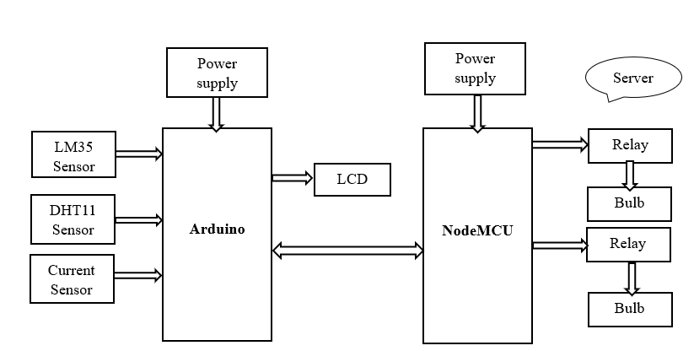
Fig. 1- IoT-based smart energy meter functional block diagram for monitoring household appliances
The microcontroller and NodeMCU Arduino UNO Microcontroller used to build an IoT webpage for energy monitoring are shown in Fig1. The Arduino Uno microcontroller is interfaced with the current sensor, DHT11 sensor, LM35, fire sensor, and LCD to display the voltage, current, power consumption, number of units, and matching price. The ambient temperature and humidity are measured using a DHT11 sensor using a thermistor and a capacitive humidity sensor. The temperature and humidity are measured by the LM35 sensor, which is employed as a fire safety device. When the temperature of the immediate area rises above a certain threshold, the LM35 sensor, which is employed as a fire safety device, sounds an alarm. Every reading that is gathered is sent to cloud storage. Thing speak is recorded and analyzed graphically after being transmitted over a Wi-Fi module. Home appliance monitoring is made possible by connecting a relay module to an Arduino.
FLOWCHART OF SMART ENERGY MONITORING
The flowchart for monitoring smart energy is shown in Fig.2. The entire system, which includes an Arduino Uno and a NodeMCU, is depicted in the flowchart. Numerous sensors, an LCD display, and a Wi-Fi module NodeMCU were all connected to an Arduino Uno. The Load are connected to the Relay Module, which interfaces with the NodeMCU Wi-Fi Module. The Arduino will read the input value from the voltage, current, temperature, and flame sensor and display the power, the number of units, and the cost of the number of units used before the device turned on before sending the data to the Blynk app via a Wi-Fi module. An Internet of Things (IoT)-based application called Blynk supports the proposed system. We can operate things on our mobile phone thanks to an application that connects to the microcontroller via the internet.
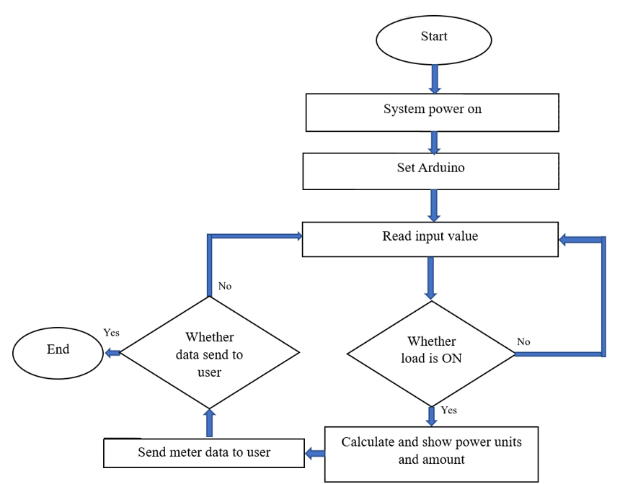
Fig. 2- Flowchart for Monitoring Smart Energy
The Load are connected to the Relay Module, which interfaces with the NodeMCU Wi-Fi Module. If the loads are active, the microcontroller will calculate the power, the number of units, and the associated price before sending the information to the consumer via the Blynk app. Consumers can watch their household appliances in real time. by keeping track of the quantity of units that loads use. The procedure is completed if the data is sent to the consumer. The loop will keep running and read the input value if data is not supplied to the consumer.
All the equations should be typed using equation editor, equations should not split.
PROPOSED ALGORITHM OF SMART ENERGY METER
Start the kit's power supply using the adaptor. Given that its operating voltage is 5V for the Arduino Uno and 3.3V for the NodeMCU, respectively. The current sensor, temperature and humidity sensor, flame sensor, NodeMCU, and LCD display are all connected to the Arduino UNO. The relay module is interfaced with NodeMCU, and loads are connected to the relay module. An Internet of Things (IoT)-based application called Blynk supports the proposed system. We can use this programme to control devices on our mobile phones by connecting to the microcontroller through the internet.
The microcontroller will compute power, the number of units consumed, and the cost if the load is on. All information is sent to the user via the Blynk app. End the process once the data has been sent to the user. The Blynk application is used to manage loads at home. If a consumer forgets to turn off a load at home, they may use the Blynk programme to do it from anywhere, stopping the count. If you turn on the light again, the count resumes from where it left off. When the load is off, the input values of voltage, current, temperature, and humidity are read under ideal conditions.
SOFTWARE IMPLEMENTATION
The simulation of the proposed system is shown in Fig. 3 and Fig.4. The simulation has been carried out in Proteus software. In this simulation, two loads have been connected to Arduino UNO and the current readings of voltage, current and power factor have been measured with the help of a microcontroller. The status of different electrical variables has been transferred with the help of the Bluetooth module to the Blynk app. The Blynk app also displays the energy consumption by various loads. With the help of a microcontroller, the control action is implemented.
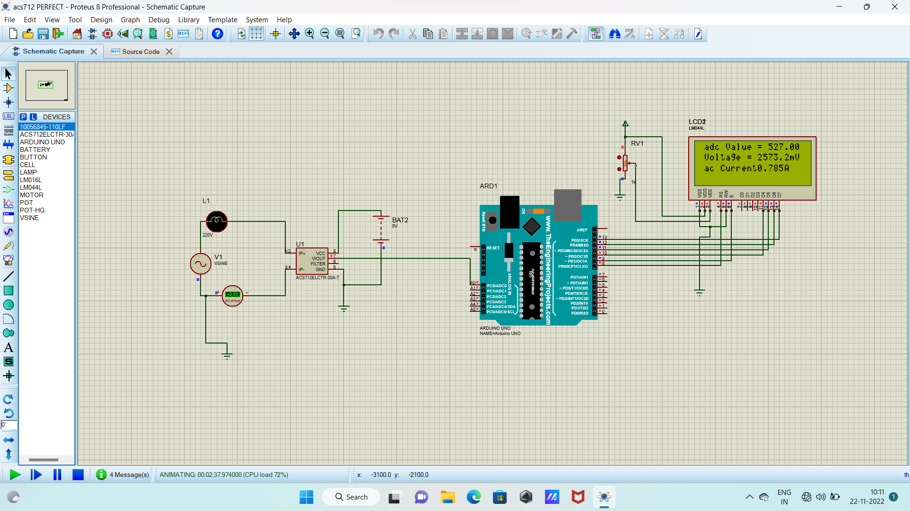
Fig. 3- Simulation of a proposed system in Proteus software
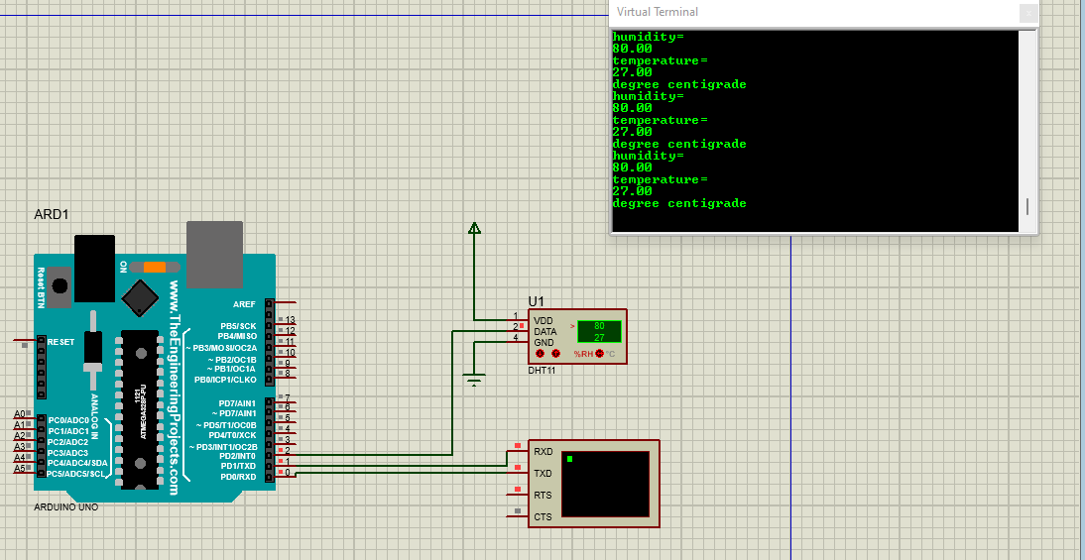
Fig. 3- Display of readings of energy consumption in Proteus environment
The controlling action is possible with the help of an IoT app. The energy consumed by various loads is displayed and monitoring of energy consumption is also possible by human users. The relay action is also incorporated into the proposed system. The relay comes into action when the energy consumption exceeds the predetermined value. The loads will be switched off automatically when the reading of total energy consumption exceeds the preset value. In this way, the monitoring and control of electrical appliances have been implemented with the help of the Proteus environment.
EXPERIMENTAL PROTOTYPE
Table 1- Hardware components
Sr No. | Components | Ratings
1 | Arduino UNO | 5V
2 | NodeMCU(ESP8266) | 3.3V
3 | Current sensor | Current: 20A  Voltage: 4.5V-5.5V dc
4 | LM35 sensor | 4-30V
5 | DHT11 sensor | Voltage: 3-5.5V dc
6 | LCD | 16*2, Voltage: 5V
7 | Relay | Current: few Amps to 3000A  Voltage: 300V-600V

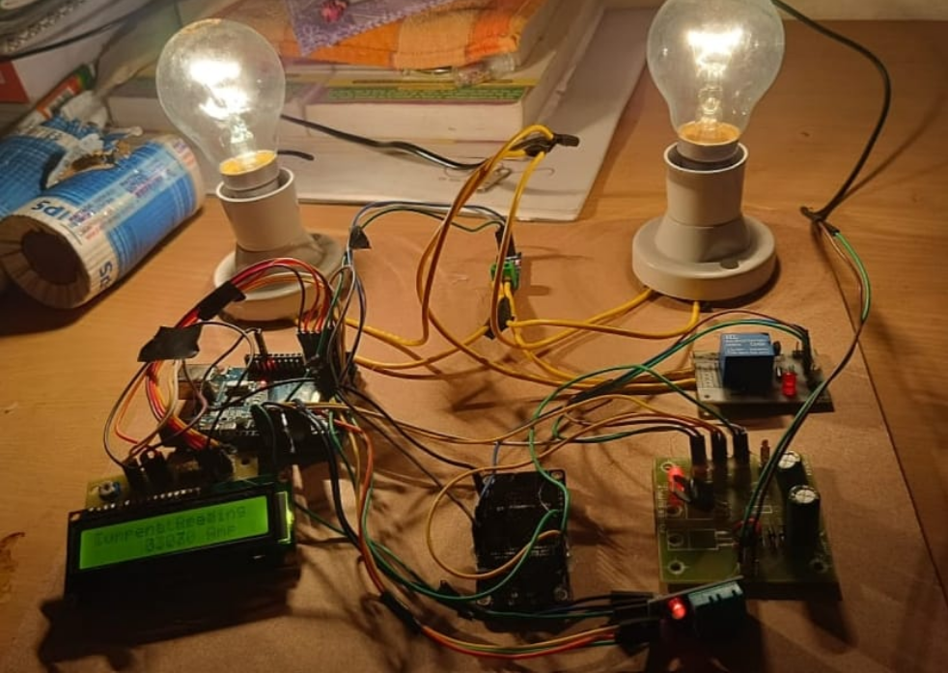
Fig. 5- Experimental prototype of the proposed system
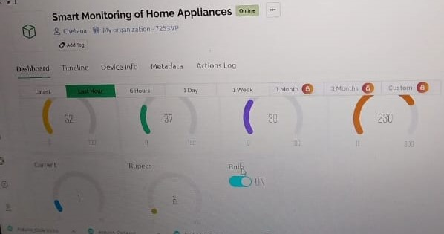
Fig. 6- Electrical variables on Blynk app
Table-I lists all the hardware parts and displays their ratings. The proposed system's hardware implementation is shown in Fig. 5. The IoT smartphone app is designed to measure and monitor the energy usage of different loads. On the Blynk app, the other electrical parameters are also shown. The Blynk platform and IoT programming expertise are connected by this smartphone app. The current and voltage sensor readings as well as the power for each load are displayed on the main page.
CONCLUSION
Power consumption is recommended to be measured by the smart energy monitoring system. Through a specially created app, the system provides power management and home monitoring. The consumer can verify their consumed unit and price at any moment by utilizing this method. Comparing the proposed system to existing ones, it offers more energy savings. This system's major goal is to monitor home energy use in a mobile and user-friendly manner so that a user can control power management. The suggested system will cut down on physical labour. It is a quick process that helps to reduce human involvement and gives users rapid access to data on their own and other users identified in the system's power usage. The electrical appliances can be managed by the system, which can also turn them ON and OFF as needed. Through the Blynk app, which was developed, the system provides home monitoring and manages power. Comparing the proposed system to existing ones, it offers more energy savings. The system would offer a quick and easy method of gathering the meter reading without the need for human intervention. The reliability of wireless data transfer is increased by the employment of an integrated microcontroller and Wi-Fi module. The consumer can verify their consumed unit and price whenever they want by using the suggested system.
REFERENCES
- R. M. Sahu, Akshay Godse, Pramod Shinde, Reshma Shinde, “Garbage And Street Light Monitoring System Using Internet Of Things” International Journal Of Innovative Research In Electrical, Electronics, Instrumentation And Control Engineering, Issn (Online) 2321 2004, 4,4, April (2016)/.
- T.V. Kumar, M. Mathankumar, A. Manjunathan, J. Sathyaraj, “Time-based costing of energy storage system with optimal scheduling and dispatch under demand” Materials Today: Proceedings, 45, 1738–1741 (2021).
- M.D. Udayakumar, G. Anushree, J. Sathyaraj, A. Manjunathan, “The impact of advanced technological developments on solar PV value chain”, Materials Today: Proceedings, 45, 2053–2058 (2021).
- C Bhuvaneshwari, A Manjunathan, “Reimbursement of sensor nodes and path optimization”, Materials Today: Proceedings, 45, 1547-1551 (2021).
- R. and K. V., "IoT Based Smart Energy Theft Detection and Monitoring System for Smart Home," 2020 International Conference on System, Computation, Automation, and Networking (ICSCAN), 1-6 (2020).
- S. K. Kadala, A. K. Rajagiri, A. Ajitha, and A. K. Thalluri, "Development of an IoT-based solution for Smart Distribution Systems," 2021 International Conference on Sustainable Energy and Future Electric Transportation (SEFET), 1-6 (2021).
- F. L. Quilumba, W.-J. Lee, H. Huang, D. Y. Wang, and R. L. Szabados, “Using smart meter data to improve the accuracy of intraday load forecasting considering customer behavior similarities,” IEEE Transactions on Smart Grid, 6, 2, 911– 918 (2015).
- Nandankar, P., Thaker R., Mughal, S.N., Saidireddy M., Linda, A., Kostka J.E., Nag, M.A., “An IoT based healthcare data analytics using fog and cloud computing,” Turkish Journal of Physiotherapy and Rehabilitation, (2021), 3, 32.
- Nandankar, P.V., Bedekar, P.P., Dhawas, P.K.V.: Variable switching frequency control for efficient DC/DC converter. Material Today: Proceedings (2021).
- Nandankar, P., Dasarwar, A., Kachare, G., “Comparison of improved converter topologies for high voltage gain,” International Conference on Communication information and Computing Technology (ICCICT), (2018), DOI: https://doi.org/10.1109/ICCICT.2018.8325893.
- Kanchan Mahajan, J. S. Chitode, “Waste Bin Monitoring System Using Integrated Technologies”,International Journal of Innovative Research in Science, Engineering and Technology (An ISO 3297: 2007 Certified Organization) 3,7,July (2014).

