Design & Development of Automated Index in SPM for Wearplate Manufacturing

1 Mr. Omprakash Deshmukh, 2 Mr. Prajwal Thakare, 3 Mr. Lokesh Gohane,
4 Mr. Prashant Dahare 5 Mr. Rishabh Sahu, 6 Mr. Nitish Jha
Guide :- Prof. P.N.Awachat
Dept. of Mechanical Engineering
G. H. Raisoni Academy of Engineering and Technology, Nagpur, India

Abstract :- The revolutionary concepts of wear plates, the specialist hard facing materials came into existence in 1980’s.To date wearplates are being used almost worldwide , replacing the traditional wear resistances lining materials .DuraweldMetsys Private Limited is one of the few wearplate manufacturers in India.
For the forward motion of wearplatesin special purpose machine which is basically designed for welding purpose hydraulic actuator is used. The main purpose of actuator is to give positive push to the heavy wear plate. Till date the whole working is operated manually.
To perform the operation fully automatic and in easier way we are planning to use the chain drive mechanism instead of hydraulic actuator for the sliding of heavy wear plates. Chain drive mechanism is the easier way to transmit power. Pin like arrangement will be provided on the links of the chain to give the push to the wear plate. Thus the sheet will easily slide on the fixture.
Thus use of chain drive mechanism is easy to operate as compared to hydraulic actuator. Chain drive mechanism is cheaper as compared to hydraulic actuator and less maintenance is required for the operation.

I. INTRODUCTION
DuraweldMetsys was formed in the Year 1991 and have over 2 decades of experience in Wear Products manufacturing. DuraweldMetsys was one of the first ISO 9000 certified companies in the Year 1998 by DNV –Netherlands. Subsequently, updated to ISO 9001 certification for Duraweld Wear Products and Reclamation activity.
The purpose behind the project is to give the positive forward push to the heavy wear plate sheet. For the forward motion of sheet chain drive mechanism is better and it can give positive push also by mounting a little pin on the chain.
The sheet will be placed on the working bed on the fixture and chain drive mechanism is use to slide the sheet on the fixture.
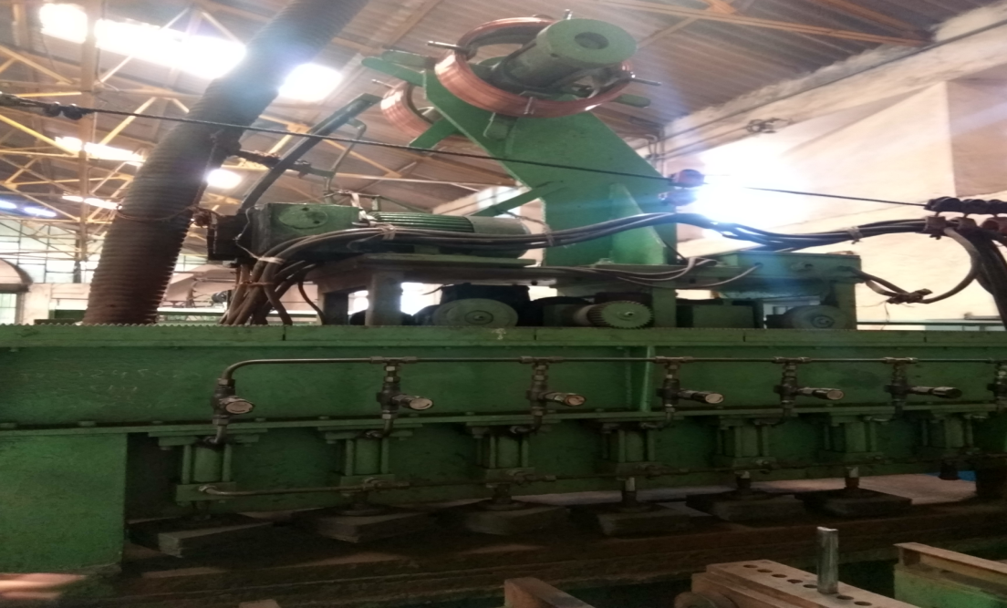
Drive chain or transmission chain passing over a sprocket gear, with the teeth of the gear meshing with the holes in the links of the chain. The gear is turned, and this pulls the chain putting mechanical force into the system.
Thus use of chain drive mechanism is easy to operate as compared to hydraulic actuator. Chain drive mechanism is cheaper as compared to hydraulic actuator and less maintenance is required

2 . PROCEDURE AND WORKING MATERIL

1) Chain
For the forward motion of wearplates we are using chian drive. Chain drive is a way of transmitting mechanical power from one place to another. Most often, the power is conveyed by a roller chain, known as the drive chain or transmission chain passing over a sprocket gear, with the teeth of the gear meshing with the holes in the links of the chain. The gear is turned, and this pulls the chain putting mechanical force into the system. In this whole assembly we are using three chains, two chain to rotate the shaft which are connected together and third chain is to transmit power from motor from to the shaft .The chain which is suitable for the transmission is of chain no.140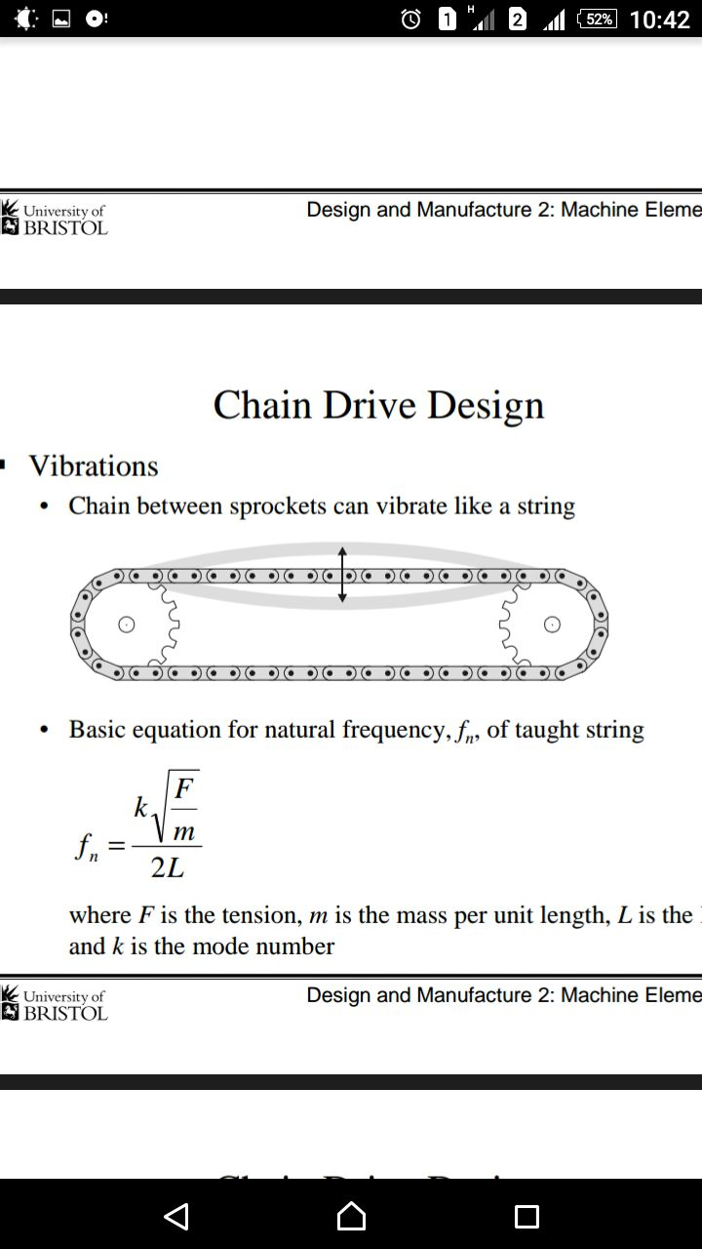

2) Shafts
Shafts are used to transmit power. We are using two shafts of 2 m length to transmit power with the help of chain drive mechanism. On the first shaft their will be three sprockets and on second shaft their will be two sprockets. The suitable material of shaft is SAE1045 steel.
3) Roller Chain Sprocket
When it is imperative that angular velocity rotation to be constant some of thepositive drive must be employed.A chain drive used in preference to gear when the distance between centers of a shaft to be connected makes gear drive unfeasible effective transmission of power. When the distance between the shaft centers is larger compared with the v-belt or flat drive is high efficiency drive and fewer loads on shaft. It can transmit the motion to several shafts through one chain.Number of sprockets required are 10 having 21 teeth. The suitable material for sprockets is SAE1045 steel. 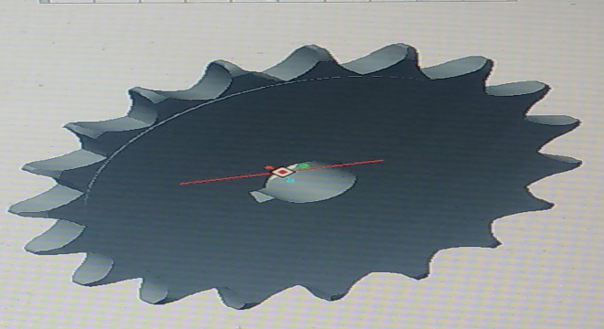
4) Pin
The pin is mounted on chain which will helps to move sheet in forward direction. There are two pins which are to be mounting on each chain. The suitable material for the pin is SAE 1030 steel.

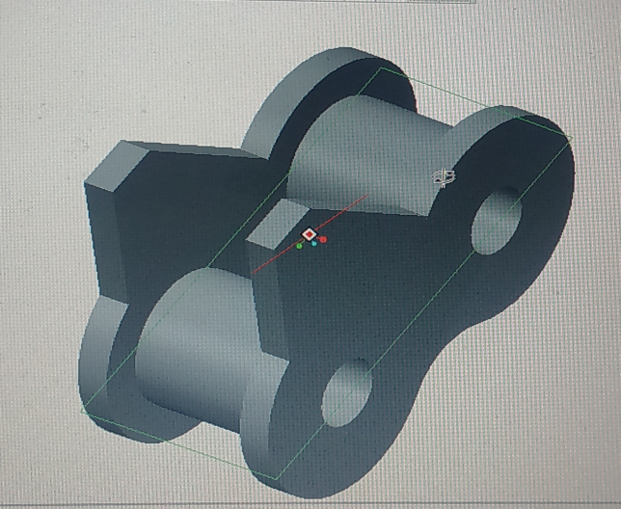

Pedestal
It is a mechanical component helps to rotate shaft freely and it supports the shafts.This types of pedestals are used to rotate the shaft at high torque and low rpm. The suitable size of the pedestal is of 48 mm diameter for freely movement of the shaft.

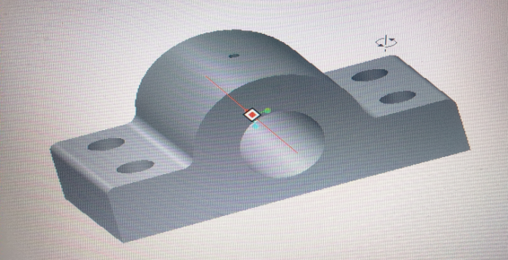

3 . DESIGN CALCULATION
Torque =900*1000 N-mm (for 2 chain)
Rated power
Pr =1884.95W
Design power
Pd =3.52 H.P
Chain=120
Pitch dia.of sprocket
Dp=280mm
Vp =0.29m\sec
Power capacity per stand
P=3.45KW
Length of chains in pitches
Lp=45.04mm
Standard dimension of sprocket
Width of sprocket teeth to mm for single standard chain
To=22mm
ii)Transverse pitch for muitiple stsand chain
=1.15P
DESIGN OF KEY
For Pd=3.52Hp and N=750 rpm
Shaft diameter=48mm
b=14mm
h=9mm
1)Max. Height of pin links
Hp=32mm
2)Max. Height of roller link
Hr=37mm
iii)Corner relief
e=5mm
Maximum permissive bore dia.
d=180mm.
i)shear stress
Tshear=33.57<61N/mm sq.
Hence safe.
ii)Crushing stress
Tcr=104.16<122N/mm sq.
Hence safe.

4 . DIFFERENCE BETWEEN EXISTING BED AND MODIFIED BED
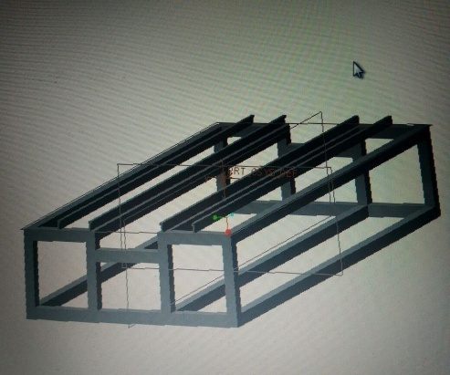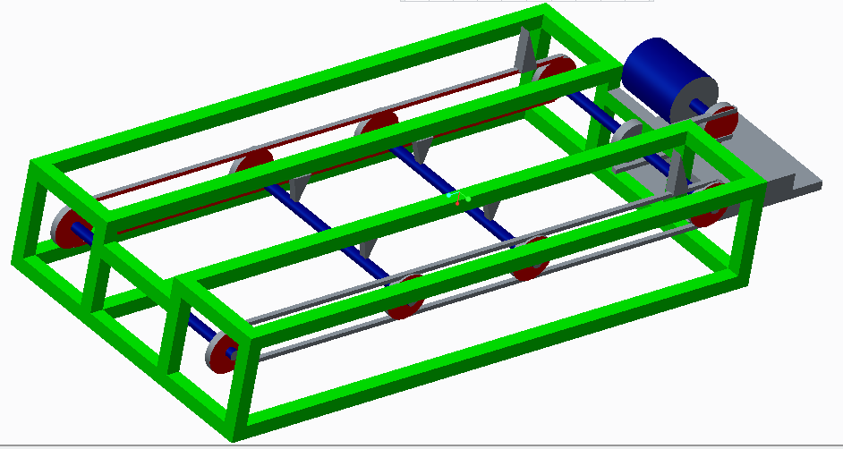
EXISTING BED MODIFIED BED

5 . CONCLUSION
From the study we coclude that the Chain drive is a way of transmitting mechanical power from one place to another. Most often, the power is conveyed by a roller chain, known as the drive chain or transmission chain passing over a sprocket gear, with the teeth of the gear meshing with the holes in the links of the chain.

6 . REFERENCE
- Design Data For Machine Elements by B.D.Shiwalkar
- Design of Machine Elements by V.B. Bhandari
- Fundamental of Machine Components by Robert Juvinall
- www.weg.com
- www.madeeasypublications.org
- Fundamentals of Electrical Drives by G.K. Dubey
- Fundamentals of Electrical Circuits.
- Machine Elements Life and Design by Boris M. Klebano
- David M. Barlam
- Frederic E. Nystrom

