MODELLING OF MULTIPHASE INDUCTION MOTOR DRIVE
Divya Thakur¹, Yash Pendam², Ruchika Chute³
Project Guide : Prof.Saurabh Bagde

H.O.D : Prof. Rajendra Bhombe

Principal : Dr. Kishor porate

Final Year, Department of Electrical Engineering, Guru Nanak Institute of Engineering & Technology, Dahegaon, Kalmeshwar Road, Nagpur, India
Head, Department of Electrical Engineering, Guru Nanak Institute of Engineering & Technology,
Dahegaon, Kalmeshwar Road Nagpur, India

Abstract
There is a great and growing need for renewable energy, in particular green energy. In years to come we will want a source of energy that will leave future generations with a sustainable energy source. A few good reasons to improve our green energy market are because not only do we want to have renewable energy for future generations, but we also want to have a sustainable energy market in future. Green energy has shown sustainable growth in past years, where oil is obviously not. Solar power is the fastest growing means of renewable energy production with grid connected solar capacity increasing average by 60% annually from 2004 to 2009 according to the National Centre For Policy Analysis. According to us, with the continued trend in decreasing cost of PV panel and government subsidies, PV solar energy might become cost competitive in next 10 years for commercial installations while for utility scale installations it will take longer time.
Keywords - Multiphase Induction Motor, Renewable Energy, Efficiency, Control Systems, Applications

INTRODUCTION
The field of electrical drives has undergone significant advancements over the years, leading to the development of multiphase induction motor drives. These drives are an extension of conventional three-phase induction motors, incorporating more than three stator windings to enhance performance, efficiency, and fault tolerance.
Multiphase induction motors function based on the same principles as traditional induction motors but offer several distinct advantages. The primary benefit of a multiphase system is its ability to improve the torque production and reduce torque pulsations, leading to smoother operation and enhanced reliability. By using five-phase, six-phase, or even nine-phase configurations, engineers can achieve greater flexibility in design and control, making these motors ideal for applications where robustness and efficiency are paramount.
Another significant advantage of multiphase induction motor drives is their fault tolerance. Unlike three-phase motors, which can experience severe performance degradation in the event of a phase failure, Split Phase Induction Motors can continue operating even with the loss of one or more phases. This feature makes them highly suitable for mission-critical applications such as aerospace propulsion and deep-sea exploration, where system reliability is crucial.
The control of multiphase induction motors requires sophisticated power electronics and control algorithms. Traditional three-phase inverters are replaced with multiphase inverters, which generate multiple phase voltages to drive the stator windings. Advanced vector control techniques and space vector pulse width modulation (SVPWM) strategies are employed to ensure precise control over motor operation. The development of digital controllers and embedded systems has further enhanced the capabilities of Split Phase Induction Motor drives, allowing real-time monitoring and adaptive control mechanisms.
Additionally, the efficiency of multiphase induction motor drives is higher than that of their three-phase counterparts due to the distribution of current across multiple windings. This reduces per-phase current levels, leading to lower copper losses and improved thermal performance. As a result, these motors exhibit higher energy efficiency, making them an attractive choice for applications where power conservation is a priority.
Despite these advantages, the widespread adoption of multiphase induction motor drives faces challenges such as increased system complexity, higher initial costs, and the need for specialized control techniques. Researchers are continually exploring innovative solutions to overcome these challenges and make multiphase systems more accessible for mainstream industrial applications.
This synopsis delves into the modeling of multiphase induction motor drives, explaining their working principles, advantages, disadvantages, applications, and future scope. A detailed understanding of these motors can provide insights into their potential role in shaping the next generation of energy-efficient and high-performance electrical drive systems.

Simulation for Single phase Induction motor
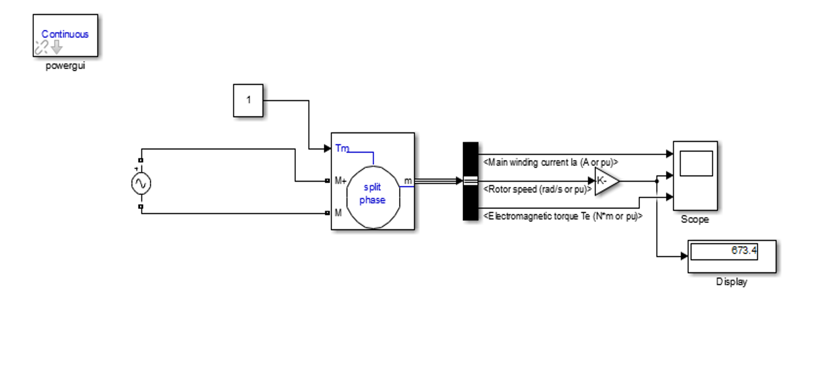
- Result
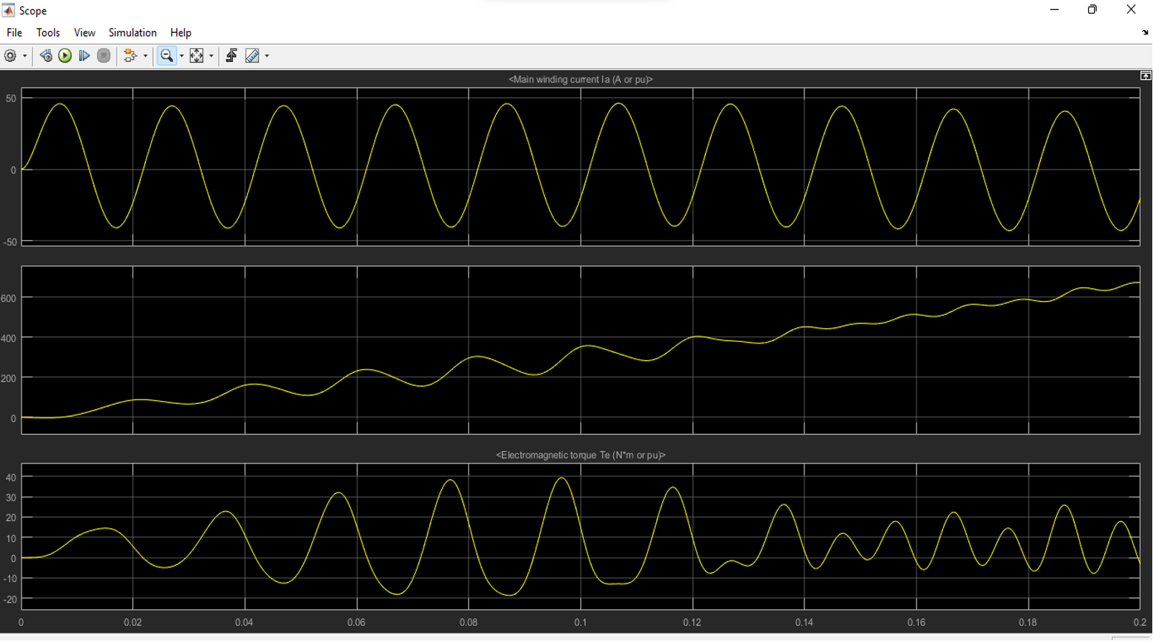
- Simulation for 3-Phase Induction Motor
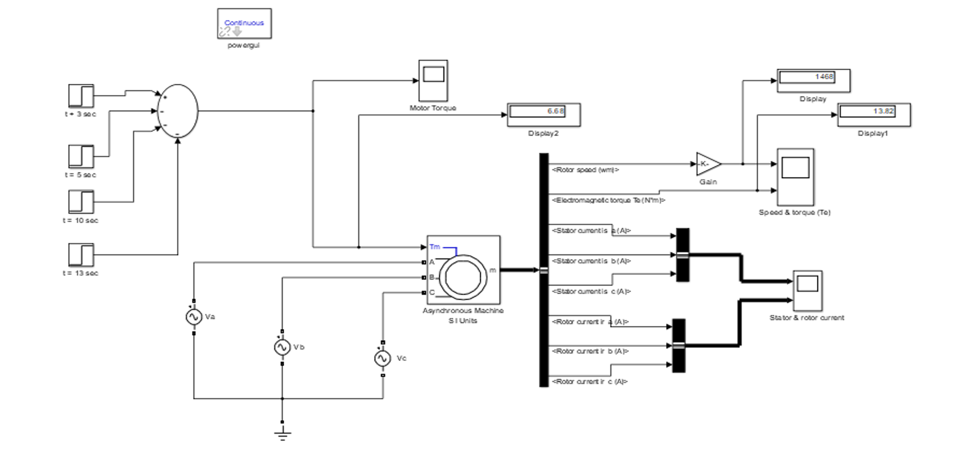
- Result
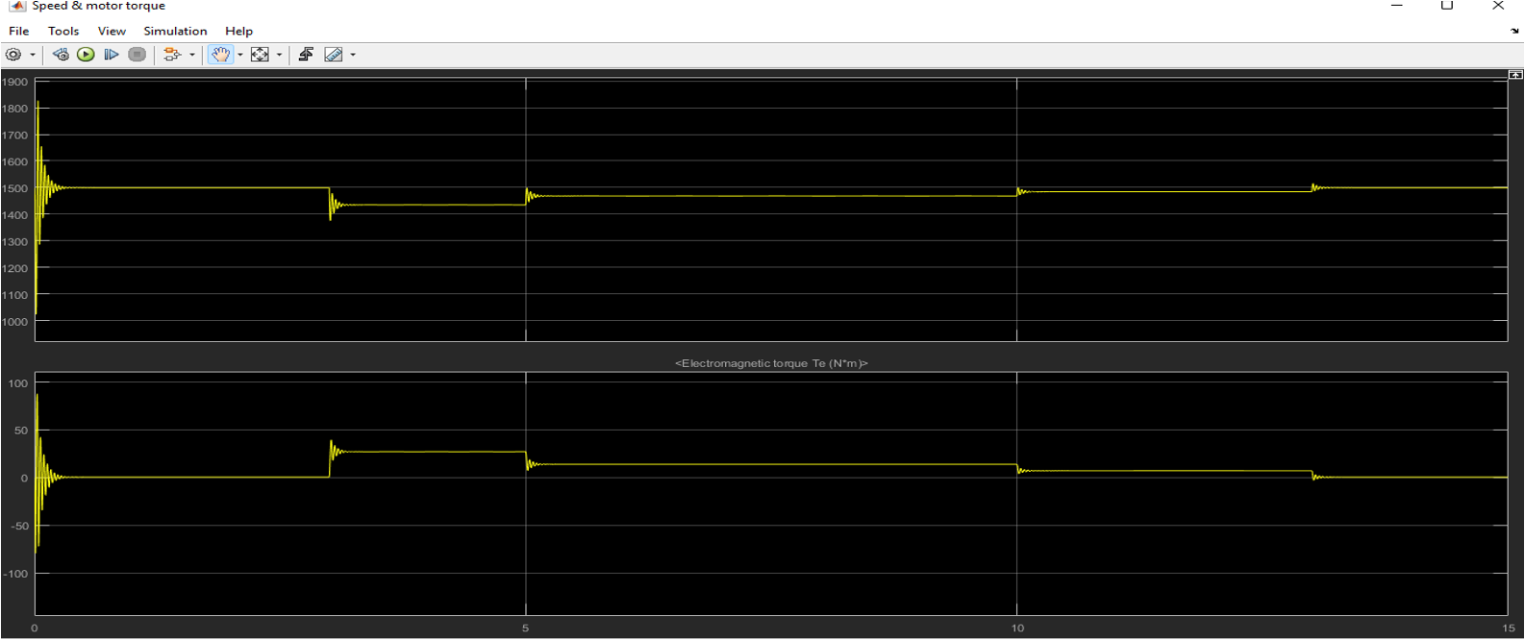
Rotor Speed & Torque (te)

- Result
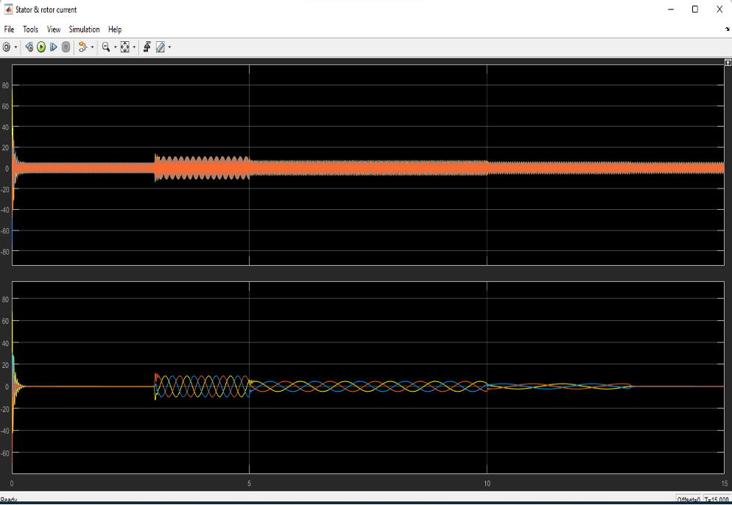
Stator & Rotor Current
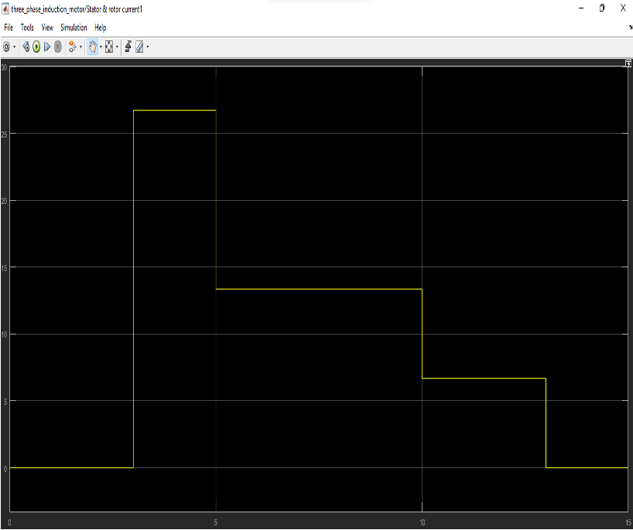
Motor Torque

WORKING PRINCIPLE
The operation of a multiphase induction motor is based on the fundamental principle of electromagnetic induction, similar to conventional three-phase motors. However, the difference lies in the additional phases, which provide smoother torque production and improved efficiency.
Basic Operation
When a multiphase AC supply is fed to the stator winding of the motor, it produces a rotating magnetic field (RMF). The number of poles and the frequency of the input supply determine the speed of this rotating field. The interaction of this rotating field with the rotor conductors induces an electromotive force (EMF), which, according to Faraday’s Law of Electromagnetic Induction, generates current in the rotor. This induced current creates its own magnetic field, which interacts with the stator field, resulting in a torque that drives the rotor.
Key Aspects of Multiphase Induction Motor Drive
- Torque Production: Due to the increased number of phases, the motor experiences less torque ripple compared to three-phase induction motors. The additional phases help in better power distribution, reducing losses.
- Improved Fault Tolerance: If one or more phases fail, the motor can still operate efficiently using the remaining phases. This characteristic makes multiphase induction motors highly suitable for aerospace and defense applications.
- Control Mechanism:
  - Field-Oriented Control (FOC): Enhances dynamic performance by controlling the magnetic flux and torque independently.
  - Direct Torque Control (DTC): Provides rapid torque response without requiring a complex transformation process.
- Efficiency and Power Factor Improvement: The increased number of phases results in lower current per phase, reducing copper losses. Split Phase Induction Motors exhibit a higher power factor, minimizing reactive power consumption.
- Applications in High-Power Drives: Used in electric propulsion systems, ship propulsion, and industrial automation due to their ability to handle higher power ratings.

Working of the Inverter
The inverter takes DC input and generates an AC output with multiple phases (e.g., 5-phase, 6-phase). It operates using Pulse Width Modulation (PWM) techniques to control the frequency and voltage of the output signal. The frequency of the inverter determines the speed of the motor. Advanced inverters also use Vector Control (Field-Oriented Control - FOC) for improved performance.

4.3 Multiphase Induction Motor
The multiphase induction motor is the core component of the system. Unlike conventional three-phase motors, these motors have more than three phases, typically five-phase or six-phase, which offers several advantages:
- Advantages of Multiphase Induction Motors:
  - Reduced Torque Ripple: Smoother operation with minimal vibration.
  - Improved Fault Tolerance: Can continue running even if one phase fails.
  - Lower Harmonic Distortion: Reduces unwanted losses and heat generation.
  - Higher Efficiency: Better power distribution among multiple phases.
Working of the Multiphase Induction Motor
- When a multiphase AC supply is applied, it creates a rotating magnetic field (RMF).
- The RMF interacts with the rotor, inducing current in the rotor windings.
- The induced current generates a magnetic field, which interacts with the stator field, producing rotational torque.
- The motor speed depends on the input frequency and the number of poles in the motor.
These motors are used in electric propulsion, renewable energy systems, industrial automation, and aerospace applications.

4.4 Control System
The control system plays a crucial role in regulating motor speed, torque, and efficiency. It consists of microcontrollers, digital signal processors (DSPs), or embedded controllers that execute control algorithms.
Types of Control Techniques
- Scalar Control (V/f Control): Maintains a constant voltage-to-frequency ratio. Simple but offers limited dynamic performance.
- Vector Control (Field-Oriented Control - FOC): Separates torque and flux control, improving performance. Used in high-precision applications.
- Direct Torque Control (DTC): Provides fast torque response without complex calculations. Reduces power losses.
Functions of the Control System

4.5 Load
The load is the final element in the system and refers to the mechanical device or application driven by the motor. It could be:
- Conveyor belts in industries.
- Electric vehicles (EVs) requiring efficient propulsion.
- Aerospace and marine propulsion systems.
- Pumps and fans in industrial automation.
The control system and inverter ensure that the motor provides sufficient torque and operates at optimal speed to handle the load efficiently.

ADVANTAGES, DISADVANTAGES & APPLICATIONS

5.1 ADVANTAGES
- Improved efficiency and power handling.
- Better fault tolerance compared to three-phase motors.
- Reduced torque ripple and noise.
- Enhanced performance in high-power applications.
- Lower current per phase, reducing copper losses.

5.2 DISADVANTAGES
- Complex control algorithms required.
- Higher cost due to additional phases.
- Increased size and weight of the motor.
- Complicated power electronics for phase control.

5.3 APPLICATIONS
- Aerospace propulsion systems.
- Electric and hybrid vehicles.
- Renewable energy systems.
- Industrial automation.
- Marine propulsion systems.

CONCLUSION
Multiphase induction motor drives offer significant advantages over traditional three-phase motors, making them highly suitable for modern industrial, transportation, and renewable energy applications. Their higher efficiency, improved fault tolerance, reduced torque ripple, and smoother operation make them a preferred choice for electric vehicles, aerospace propulsion, marine systems, and automation industries.
With continuous advancements in power electronics, control algorithms, and AI-based optimization, Split Phase Induction Motor drives are expected to become even more reliable, cost-effective, and widely adopted. Future research in superconducting materials, wireless power transfer, and hybrid motor systems will further enhance their performance and sustainability, making them an integral part of next-generation electrical drive systems.

FUTURE SCOPE
- Aerospace propulsion systems.
- Electric and hybrid vehicles.
- Renewable energy systems.
- Industrial automation.
- Marine propulsion systems.

6.1 Aerospace Propulsion Systems
Multiphase induction motors are widely used in aircraft propulsion and space applications due to their ability to operate reliably even under harsh conditions.
- High Fault Tolerance: Essential for aircraft, where motor failure could be catastrophic.
- Smooth Operation: Reduced torque ripple ensures vibration-free performance.
- High Power Density: Provides maximum thrust with minimal weight.
- Application Areas: Electric aircraft engines, satellite propulsion, and unmanned aerial vehicles (UAVs).

6.2 Electric and Hybrid Vehicles
The shift towards electric mobility has driven the need for efficient and high-performance motor drives. Multiphase induction motors are an ideal solution for EVs and hybrid vehicles.
- Higher Efficiency: Reduces energy consumption, extending battery life.
- Better Torque Control: Provides instant torque, improving acceleration.
- Regenerative Braking: Helps in energy recovery, increasing vehicle range.
- Application Areas: Electric cars, electric buses, electric motorcycles, and hybrid trucks.

6.3 Renewable Energy Systems
Multiphase induction motors play a crucial role in wind and solar energy applications by ensuring reliable power conversion.
- Stable Power Generation: Even with fluctuating input conditions.
- Grid Integration: Reduces harmonic distortion and improves power quality.
- Low Maintenance: Rugged design ensures long-term reliability.
- Application Areas: Wind turbine generators, solar-powered pumps, and hydroelectric generators.

6.4 Industrial Automation
Factories and industries rely on automation systems to improve productivity and efficiency. Split Phase Induction Motor offer better load management and energy savings in automated machinery.
- Precise Speed & Torque Control: Ensures smooth operation of automated machines.
- Energy Efficiency: Reduces operating costs in industrial setups.
- Load Handling Capability: Can handle heavy loads with lower current.
- Application Areas: CNC machines, robotic arms, conveyor belts, and packaging.

6.5 Marine Propulsion Systems
Marine applications demand powerful and highly reliable motor drives. Multiphase induction motor offer enhanced performance and energy efficiency for ship propulsion.
- Increased Reliability: Reduces the risk of system failure at sea.
- Higher Efficiency: Improves fuel savings and reduces emissions.
- Silent Operation: Ideal for submarines and stealth vessels.
- Application Areas: Ship propulsion, naval submarines, and offshore drilling rigs.

REFERENCES
- Gonzalez-Prieto, M.J., Duran, J.J., Aciego, C., Martin, F., Barrero, “Model Predictive Control of Six-phase Induction Motor Drives Using Virtual Voltage Vectors”, IEEE Transactions on Industrial Electronics, Vol: 65, Issue: 1, pp: 27-37, 12 June 2017.
- S. Rubino, R. Bojoi, S.A. Odhano, P. Zanchetta, “Model Predictive Direct Flux Vector Control of Multi Three-Phase Induction Motor Drives”, IEEE Transactions on Industry Applications, Vol: 54, Issue: 5, pp: 4394 - 4404, 23 April 2018.
- M. Ayala, J. Doval-Gandoy, J. Rodas, O. Gonzalez, R. Gregor, M. Rivera, “A Novel Modulated Model Predictive Control Applied to Six-Phase Induction Motor Drives”, IEEE Transactions on Industrial Electronics, Vol: 68, Issue: 5, pp: 3672 - 3682, 09 April 2020.
- I. Gonzalez-Prieto, I. Zoric, M.J. Duran, E. Levi, “Constrained Model Predictive Control in Nine phase Induction Motor Drives”, IEEE Transactions on Energy Conversion, Vol: 34, Issue: 4, pp: 1881 - 1889, 22 July 2019.
- K. A. Chinmaya, G. K. Singh, “Modeling and Comparison of Space Vector PWM Schemes for a Five-Phase Induction Motor Drive”, IECON 2018 - 44th Annual Conference of the IEEE Industrial Electronics Society, Washington DC, USA, 21-23 October 2018.
- D. Cholewa, P. Drozdowski, “Simulink Modeling of Multiphase Induction Motors”, 2018 14th Selected Issues of Electrical Engineering and Electronics (WZEE), Szczecin, Poland, 19-21 November 2018.

BIOGRAPHY
Sr.No | Photo | Details
1 |  | Divya Thakur is a B-tech final year student of Gurunanak institute of engineering and technology Dahegaon,kalmeshwar road,Nagpur  She can be reached at divyathakur0801@gmail.com
2 |  | Yash Pendam is a B -tech final year student of Gurunanak institute of engineering and technology Dahegaon,kalmeshwar road,Nagpur  He can be reached at  yashpendam2000@gmail.com
3 |  | Ruchika Chute is a B -tech final year student of Gurunanak institute of engineering and technology Dahegaon,kalmeshwar road,Nagpur  She can be reached at  ruchikachute14@gmail.com

