An Approach To Design Smart Water ATW System

Priyanka Tembhare¹, Shital Mandhare² ,Nishita Dubey³ , Nidhi Singh⁴
A.V. Vishwakarma⁴

³Assitant Professor,¹⁻²Students,
Dept. of Electronics Engineering, Manoharbhai Patel Institute of Engineering and Technology, Gondia -441614

Abstract- Most of people of India lives in rural area providing clean safe drinking water in adequate quantity with minimum distance is various problem. Government paper considerable amount for this purpose .vending machine are not very common practice in India. This problem can be solved by using CSR. This paper uses CSR to cover quality (chemical/ bacteriological contamination) of water.

Keywords— Vending machine, bacteriological.
- INTRODUCTION

Water has become the most commercial product of the century. The stress on the multiple water resources is a result of many factors. On the one hand, the rapidly rising population and changing life styles have increased the need for fresh water.
Due to Poor quality of water and presence of chemical/ bacteriological contamination, many water borne diseases are spread, which causes untold misery, and in several cases even death, thereby adversely affecting the socio-economic progress of the country. From an estimate by Water Aid, it has come out that these diseases negatively affect health and education in children, and further what is worse, 180 million man days approx. lost in the working population to India every year.
As it is rightly necessary said, “Necessity is the mother of invention”. In India, there is problem of safe drinking water therefore we are going to provide mineral water.
Water-related diseases put an economic burden on both the household and the nation’s economy. At household levels, the economic loss includes cost of medical treatment and wage loss during sickness. Loss of working days affects national productivity. Government spends a considerable amount undertaking water supply projects including water purification and providing safe drinking water to all in rural India in adequate quantity and within minimum distance, including piped supply to within the household. These are challenging and enormous tasks. Given the diversity of the country, solutions have to be diverse, and given the quantum of biological and chemical contamination in water in rural India, an all-out effort is required by all concerned to solve this gigantic problem which will improve the overall health and thereby the productivity of the Nation. It is in this context that interventions by Central Public Sector Units (CPSUs) and Corporate Houses under Corporate Social Responsibility (CSR) become relevant.

II Working

When the power supply is applied to the system then at first it will prompt a message to RFID reader and it will start monitoring continuously whether any card has been shown or not. Every card has a unique identification code and it can be shown form a distance form 8 to 10 cm.when any card is shown to the RFID reader then it reads the given code and will be serially transfer the information of the card to microcontroller which further compares the received information with the microcontroller. And if comparison is true then it's checks that whether the users account have sufficient balance or not.and card will be verified.when the card will verified then the speaker will make and announcements whether the user have sufficient balance or not. And if has sufficient balance then it will make and announcements and there different languages , including English, hindi,marathi.further user will have to select any of this option announced and the system has been provided with three buttons which will be used to specified amount of water and the selection of the given option will be done through this buttons.further the user will select any this of options provided according to his and her requirements by pressing one of these buttons.further relay will be switched ON for particular duration of time which will switch ON the motor and the user will gate the required amount of water and will be automatically switched OFF. After the completion of that duration ,And also the system is provided with level sensor which is integrated with purified which will sense whether the tank is Empty or it has water and if the tank is Empty,it will be displays a message "EMPTY TANK" on the screen.

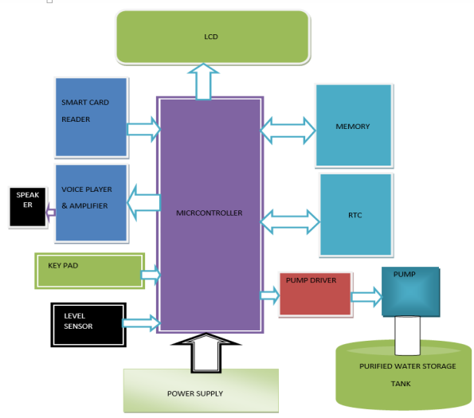
III RESULT
1.The designed project is in working condition as per the requirement.
2. It is properly showing results.
3.It is responding properly for every action like showing RFID etc.
4. Amount of water out of tap is of proper measure .
5.The project works in following sequence.

- When power on,,it shows date and time.

- Then it displays welcome message.

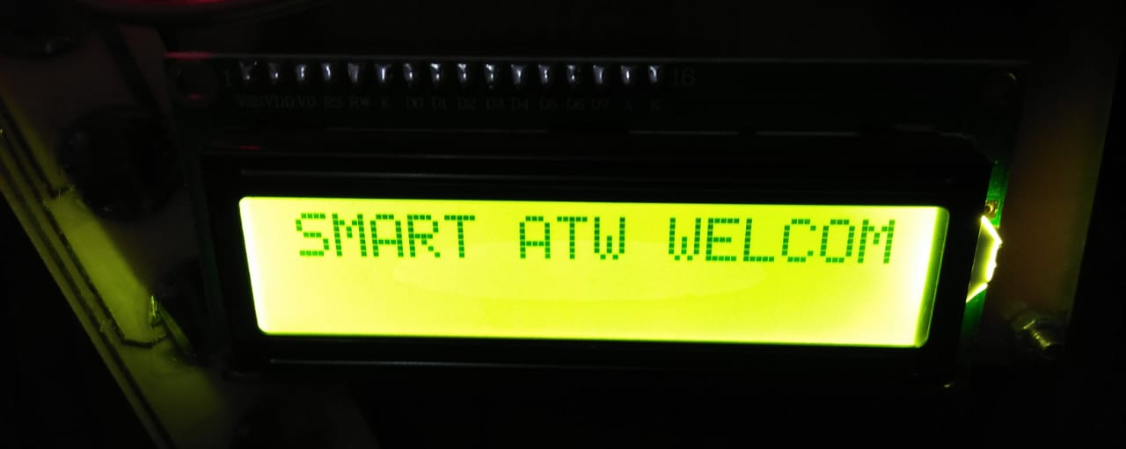

WELCOME MESSAGE DISPLAY

ADVANTAGES

- People of rural area will get sufficient amount of water.
- They will get safe and clean drinking water.
- They will get drinking water in less cost.
- RFID do not required batteries, and can be much smaller than have a virtually unlimited life span
- RFID tags can be read in a wide variety of circumstances.

DISADVANTAGES

1 .It is not connected to server so a person from other place cannot able to drink water.
2 .At present, there is no power backup.

FUTURE SCOPE

- More research work is need to be done in future so that it will have more function.
- It can be used for other beverages and drinks also.
- It should be redesigned for more better functions.
- It can be designed in addition with rain water harvesting also..
- In future by providing server connectivity user can aceess water from any ATW system.

IV CONCLUSION

India has yearly $600 million economic burden. To overcome this burden we have to create / save the man days. Health is wealth. Hygienic food, Safe & purified drinking water are key role for good health. It is necessary to provide this requirement to our Citizen to keep them healthy. If our citizen will be healthy will work more & will create more man days. More working days mean higher productivity, more income, more GDP. More GDP will lead to economic growth of India, which will reduce our economic burden. It is duty of Government Bodies, NGOs & Private & Public Companies, Gram Panchayats to join hand together to develop our Country. Our project Smart Any time water system will make historical change in villages and urban areas.

As per the requirement a RFID based water system is designed and fabricated and treated in real time conditions.

REFERENCES

[1] Muhammad Ali Mazidi,JaniceGillipseMazidi, “The 8051 microcontroller and embedded system ,” serial port programming , ,no.2,.pp. 237 second edition,2008.
[2] Natural Water purification System for local community -L.M.J.R.wijayawardhana.
[3] Water System for Remote Areas using Photovoltaics - R.S.Shelke

