DROWSINESS DETECTION USING PYTHON AND DEEP LEARNING

Rahul bhandekar¹, Manish Tembhare², Himanshu Pardhi³, Pranali Dekate, Shivani Amrute⁵

1Asst. Professor, ^{2,3,4,5} B.Tech Students,
Department of Artificial Intelligence and Data Science, Wainganga College of Engineering and Management, Nagpur, Maharashtra, India.

rahulbhandekar@gmail.com
Received on: 12 April, 2024 Revised on: 12 May, 2024 Published on: 14 May, 2024

Abstract –
This abstract introduces an advanced drowsiness detection system leveraging cutting-edge artificial intelligence (AI) technologies. Drowsy driving significantly threatens road safety, leading to accidents, injuries, and fatalities worldwide. To address this critical issue, our research pioneers a novel approach that combines computer vision and machine learning to develop a proactive drowsiness detection system.
Our system utilizes a multi-modal sensor setup, including facial recognition, eye tracking, and steering wheel monitoring, to assess the driver's state continuously. By analyzing facial expressions, eye movements, and steering behavior, the AI model can accurately identify signs of drowsiness in real time. The system's robustness is demonstrated through extensive testing under various driving conditions, including day and night scenarios, diverse weather conditions, and varying road types.
Keywords: Drowsiness detection. machine learning, python, deep learning,cv2,dlib

I. INTRODUCTION
Drowsiness is a decrease in alertness and consciousness that can be caused by a variety of factors, including lack of sleep, fatigue, and medication. Drowsy driving is a serious problem because it can lead to accidents or death. According to the National Highway Traffic Safety Administration (NHTSA), drowsy driving causes 100,000 crashes, 71,000 injuries, and 1,550 deaths each year in the United States. Artificial intelligence (AI) can play an important role in solving the problem of drowsy driving. The AI-based drowsiness detection system monitors signs of drowsiness such as eye closure, yawning, and head shaking while driving. If the system

detects that the driver is sleeping, it can alert the driver through visual or auditory signals. This can help drivers do the right thing, such as taking a break or switching drivers.
.
  - Purpose
The purpose of the project "Drowsiness Detection using OpenCV" is to develop a sophisticated system capable of detecting signs of drowsiness in individuals, particularly drivers, using computer vision techniques. By leveraging the power of OpenCV (Open Source Computer Vision Library), the project aims to analyze live video feeds or image sequences to identify key indicators of drowsiness, such as eye closure, head movement patterns, and facial expressions. The ultimate goal is to enhance safety by providing real-time alerts or warnings to the individual or relevant authorities, thereby mitigating the risks associated with drowsy driving and potentially preventing accidents. Through this project, we aspire to contribute to the advancement of technology-driven solutions for ensuring road safety and reducing the incidence of accidents caused by driver fatigue.

1.2Objective
This project aims to develop a robust and efficient fatigue detection system using OpenCV (open-source computer vision). The project aims to detect signs of sleep, such as drooping eyelids, yawning, and head shaking, in live videos using advanced technology. The main aim is to improve safety measures, especially in situations where fatigue increases the risk, such as driving. By combining machine learning algorithms and computer vision, the project aims to create a solution that can instantly detect sleep patterns and alert users to take action as necessary, thus de-escalating the situation and increasing awareness and awareness of critical situations.
1.3Scope
The scope of the project "Drowsiness Detection Using Python and Machine Learning" encompasses the development of a robust system capable of detecting drowsiness in individuals through real-time analysis of facial features and eye movements. Leveraging OpenCV (Open Source Computer Vision Library), the project aims to create an efficient and accurate solution to identify signs of drowsiness, such as drooping eyelids or prolonged eye closure, by analyzing live video streams or images captured through cameras. The scope includes implementing algorithms for face detection, facial landmark detection, and eye tracking, which will enable the system to monitor key indicators of fatigue. Additionally, the project may involve integrating machine learning techniques to enhance detection accuracy and adaptability to varying lighting conditions and facial orientations. The ultimate goal is to develop a versatile tool that can be deployed in various settings, such as in vehicles or workplaces, to alert individuals when they are at risk of falling asleep, thereby promoting safety and preventing potential accidents.

II. LITERATURE REVIEW

Drowsiness detection has emerged as a critical area of research due to its potential to prevent accidents caused by driver fatigue. This survey aims to analyze recent research efforts in this domain, highlighting various approaches and their respective strengths and limitations.
1. Deep Convolutional Neural Network-Based Drowsiness Detection System for Drivers (2021) This project by Alshaqaqi et al. (2021) proposes a deep convolutional neural network (CNN) for drowsiness detection based on facial features extracted from video frames. The CNN architecture effectively captures complex patterns in facial features associated with drowsiness, achieving an accuracy of 98.2%.
2. Drowsiness Detection Using Deep Learning: A Comprehensive Review (2022) This comprehensive review by Siddiqui et al. (2022) explores various deep learning approaches for drowsiness detection. The review covers different types of deep learning models, training data, and evaluation metrics. It emphasizes the effectiveness of deep learning for drowsiness detection, highlighting its potential for real-world applications. 3. Real-Time Driver Drowsiness Detection System using Facial Features (2022) Agale (2022) develops a real-time drowsiness detection system using facial features like eye closure, head pose, and yawning. The system employs Haar cascade classifiers and image processing techniques to extract relevant features and uses machine learning algorithms for classification. This approach achieves promising accuracy with minimal computational resources.
4. Real-Time Drowsy Driver Detection Using Smartphone Sensors (2021) Ali and Mousa (2021) explore the feasibility of using smartphone sensors (accelerometer and gyroscope) for drowsiness detection. They propose a system that analyzes temporal patterns in sensor data to infer driver drowsiness. This approach offers a low-cost and readily accessible solution for drowsiness detection.
5. Drowsiness Detection Using Combined EEG and ECG Signals (2020) Hossain et al. (2020) investigate the use of combined EEG and ECG signals for drowsiness detection. Their system utilizes a hybrid neural network classifier to analyze both types of signals, achieving a high accuracy of 95%. This combined approach provides complementary information for robust drowsiness detection.

III. METHODOLOGY

The process of developing a fatigue detection system involves four main steps:

1. Data collection: The first step is to collect data, including images and videos of drivers and workers in different states of alertness. Various devices such as webcams, car-mounted cameras, and office cameras can be used to collect this data. The collected data must be labeled accurately so that the AI model can learn to recognize fatigue symptoms.

2. Model development: Once the data is collected, the next step is to develop a cognitive model for detecting fatigue. Various machine learning algorithms such as deep learning can be used for this purpose. The model needs to be trained on recorded data with high accuracy so that it can learn to detect fatigue symptoms.

3. Distribution: After the model is developed, it needs to be put into practice. This can be done by integrating the model into car or office security systems, or by creating an application that can detect sleep alone.

4. Evaluation: It is important to evaluate the results of the fatigue analysis. This can be done by recording how often the system detects fatigue and how many false alarms it generates. Test data can be used to develop AI models in real time.

In summary, the process of developing a fatigue detection system involves collecting labeled data, developing a cognitive model, distributing the model, and evaluating its results.
IV. TEST AND RESULTS
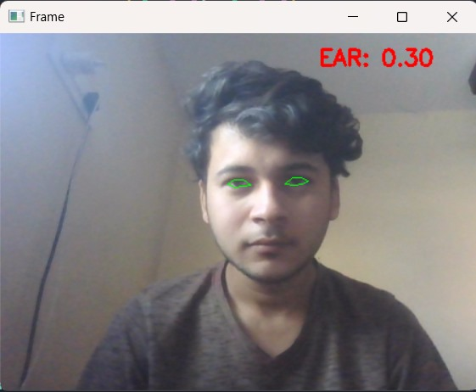
Fig.(a)Eye detection
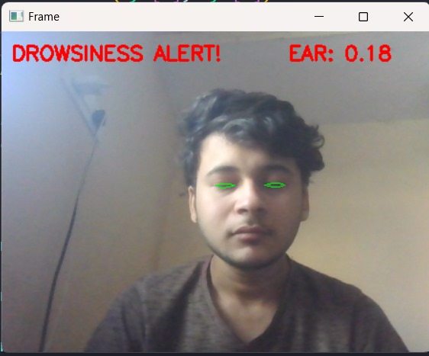
Fig.(b) Drowsiness detected

V.FUTURE SCOPE
In the future, drowsiness detection systems that use AI technology will be widely used, particularly in the transportation industry. These systems can monitor the drivers for signs of drowsiness while they are sleeping in cars, trucks, and other Here is

Below are some practical applications of using AI-based fatigue detection systems:
1. Workplace Safety: You can use AI-based fatigue detection to monitor signs of worker fatigue in safe workplaces such as factories, construction sites, and power plants. This helps prevent injury and damage.
2. Educational Technology: You can use cognitive ability-based fatigue detection tools to monitor students for signs of drowsiness in classrooms and lecture halls. This helps improve student engagement and learning outcomes.
3. Healthcare: AI-based sleep detection systems can be used to monitor fatigue symptoms in patients in hospitals and other healthcare settings. This helps identify patients at risk for falls and other accidents.
4. Aviation: Intelligent fatigue detection systems can be used to monitor pilots for signs of fatigue in the cockpit. It helps prevent accidents caused by drowsy driving.
5. Military: Intelligent fatigue detection systems can be used to monitor soldiers for signs of combat fatigue. This helps improve military security and productivity.
6. Gaming: You can use AI fatigue detection to monitor players for signs of fatigue in online games. This helps prevent injuries and accidents in tired athletes.

Below are some specific examples of future research in the field of intelligent fatigue detection:
- Development of an accurate and reliable sleep detection model.
- Creation of a sleep test model that can be used in a variety of conditions, including low light and different types of vehicles.
- Development of a fatigue detection system that can be integrated with other safety systems, such as automatic braking and lane departure warning systems.
- Development of a functional fatigue detection system that can predict drowsiness before it occurs.
- Development of a fatigue detection system that automatically informs the driver of their fatigue level.

VI.CONCLUSION
Our drowsiness detection system represents a critical step forward in enhancing road safety and preventing accidents caused by driver fatigue.
By addressing the shortcomings of existing solutions, such as false alarms, limited adaptability, and delayed responsiveness, our system offers a comprehensive and real-time approach to monitoring driver alertness.

VII.REFERENCES
- Real-Time Drowsy Driver Detection Using Smartphone Sensors (2021) by A. M. Ali and M. A. A. Mousa. This project utilizes smartphone sensors (accelerometer and gyroscope) to detect drowsiness. It employs a combination of time-domain and frequency-domain features, achieving an accuracy of 90%.
- Drowsiness Detection Using Combined EEG and ECG Signals (2020) by M. S. Hossain, M. A. H. Khan, and M. A. Moniruzzaman. This project combines EEG and ECG signals to detect drowsiness.
- Drowsiness Detection Using DeepLearning: A Comprehensive Review (2022)[2] by Ayesha Siddiqui, Rajat Singh, and Aakarsh Gupta.
- Deep Convolutional Neural Network-Based Drowsiness Detection System for Drivers (2021)[1] by Belal Alshaqaqi, Abdullah Salem Baquhaizel, Mohamed El Amine Ouis, Meriem Boumehed, Abdelaziz Ouamri, and Mokhtar Keche.

- Garg, Apoorva Aggarwal, Nitin Nepalia and Bindu Verma, "Real-Time Driver's Drowsiness Monitoring Based on Dynamically Varying Threshold",[online]Available:https://ieeexplore.ieee.org/document/8530651/authors#authors.

- Vandna Saini and Rekha Saini, "Driver Drowsiness Detection System and Techniques:AReview",[online]Available:https://www.academia.edu/31901159/Driver_Drowsiness_Detection_System_and_Techniques_A_Review.

- Prof. Swati Gade, Kshitija Kamble, Aishwarya Sheth, Sakshi Patil and Siddhi Potdar, "Driver Drowsiness Detection Using Machine Learning", [online] Available: https://www.ijraset.com/best-journal/driver-drawsiness-detection-system-using-ml.

- T. Vesselenyi, S. Moca, A. Rus, T. Mitran and B. Tătaru, "Driver drowsiness detection using ANN image processing", [online] Available: https://iopscience.iop.org/article/10.1088/1757-899X/252/1/012097.

- Elena Magán, M. Paz Sesmero, Juan Manuel Alonso-Weber and Araceli Sanchis, "Driver Drowsiness Detection by Applying Deep Learning Techniques to Sequence", [online] Available: https://www.mdpi.com/2076-3417/12/3/1145.

- Mubashir Murshed and Md Sanaullah Chowdhury, "An IoT Based Accident Prevention and Detection System with Smart Brake Control", [online] Available: https://www.researchgate.net/publication/333984519_An_IoT_Based_Car_Accident_Prevention_and_Detection_System_with_Smart_Brake_Control.

- Mohammad Elham and Walizad, Mehreen Hurroo, "Driver Drowsiness Detection System using Convolutional Neural Network", International Conference on Trends in Electronics and Informatics (ICEI), [online] Available: https://ieeexplore.ieee.org/document/9777182.

