Smart vertical garden statistics, monitoring and controlling using IoT servers
¹ Amita Warang, ² Kshitija Hingankar, ³ Nilesha Shendre, ⁴ Risheen Mankar, ⁵ Sanjyot Bhagat
⁶ Mrs M.M Guddadhe
^{1,2,3,4,5} Students, Priyadarshini College of Engineering, Nagpur, India 441110
⁶ Assistant Professor, Priyadarshini College of Engineering, Nagpur, India 441110

ABSTRACT– The title of this project is "Smart vertical garden statistics monitoring and controlling using iot servers"
Interconnection of number of devices through internet describes the Internet of things (IOT). Every object is connected with each other through unique identifier so that data can be transferred without human to human interaction. It allows establishing solutions for better management of natural resources. The smart objects embedded with sensors enables interaction with the physical and logical worlds according to the concept of IoT. This proposed system is based on IOT that uses real time input data. Real time sensed data handling and demonstration on the server is accomplished using web based graphical user interface. Wireless monitoring of vertical gardening system reduces human intervention and allows remote monitoring and controlling on phone. ​An automatedwatering method for efficient water supervision has been proposed. Soil Parameters like soil moisture, pH, Humidity are measured and the pressure sensor and the sensed values are displayed in LCD. The GSM module has been used to establish a communication link​.​In this gateway sensor is usedto handle sensor information and helps to transmit data to user, Wireless through moisture, Humidity and Temperature sensors is programmed with microcontroller based gateway. The master node with WiFi enabled so that it will receive data from all sensor nodes, store data on storage device and it will get displayed on smart phone and web portal on PC in tabular and graphical format

INTRODUCTION

Presently, everybody leads a hectic and busy life. As the technology is advancing, the nature is ignored more and more. Half of the land of forests and wildlife is already used to benefit humans. All the natural resources are being used as if there is no tomorrow. Many projects are coming up with various ideas as to how to conserve nature. But the revolution can be brought with small steps and not overnight. Every house, every person is required to look after the nature. This is high time to balance the equation between humans and nature lest the end is disastrous. Today, we all live in concrete gardens. No interaction with the nature. In order to contribute to ecosystem, the least we can do is maintain a garden. The garden does require a lot of care and nourishment to stay green all the time. The garden requires water daily(except monsoon). Moreover, when the gardener(user) goes out on a vacation there is no means to water the garden. This constant ignorance towards the garden can ultimately lead to its death. And as said earlier, nobody has enough time to nourish garden manually. People can automate stuffs to keep their gardens alive.The gardens are ought to be in an open area and outside the house. This system proposes an idea to have a garden vertically. It will neither consume a lot of space in the house nor it would be too clumsy to maintain. The basic idea of vertical garden is to dedicate a wall of the apartment for gardening. The issue still remains the same; how to water it daily. To fix this problem, the proposed system allows us to water the garden from any place. The garden is designed in a manner that pipes are tucked to wall and there is a hole in a pipe for every respective pots(plants). The pipe is then dipped into a tank of water. The system also has the ability to alert about the moisture level of the soil. It is designed to be operated from a phone call. The user can call the system and command it to start flow of water. The system is very smart to notify the user about any kind of mismatch contraints. Ex-Water level is low inthetank.

DESIGN
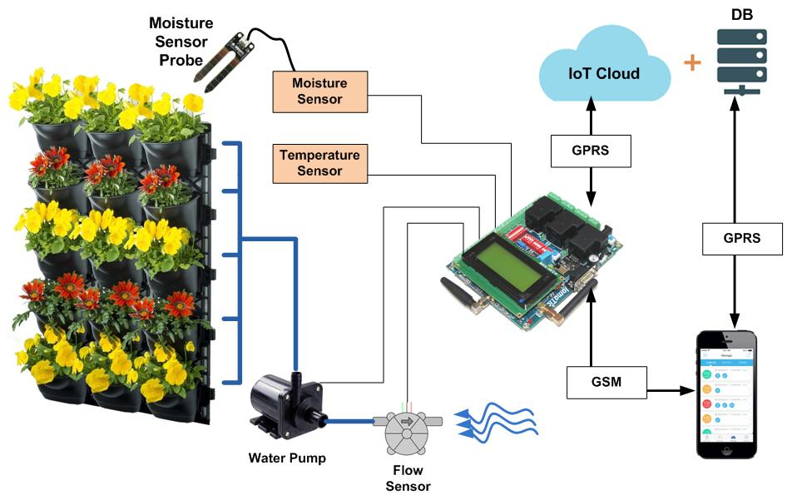
Fig 1:- Working of the Vertical Garden Statistics, monitoring and controlling using iot servers.
In the above diagram, there are various hardware components like Iomatic board, temperature sensor, moisture sensor, flow sensor, water pump, sim card and a mobile. Iomatic board has various feaures and the code dumped inside it. The sim card and the temperature sensor is on the board itself. Moisture sensor is attached with the board with pins on the board and flow sensor is placed down the funnel to check the consumption of water which is in turn placed above the water tank.
there are two modes in the system-
1-Operational Mode
2- Tank Filling Mode
Firstly, when the system is on it is on the operational mode which will tell us the moisture, temperature and humidity of the plants on the lcd of the board and on the website also.
If the moisture is low then we call to the sim number attached on the board. It will show ringing and then automatically it will disconnect the call. Then it will trigger a message telling the status of the water tank. If it is empty it will send a message stating "Sorry, water tank is empty" otherwise it will send "Water Pump started successfully". After the pump starts , the plants will get watered automatically. If in case the water tank is empty then we will have to turn the system into tank filling mode by switching on the tank filling button attached with the water tank. The board will tell us the consumption of water in the lcd. After that we have to repeat the same process of calling to water the palnts.
Once the watering is done data is uploaded online in the website and is also stored in the database. We can see the statistics and graphs of temperature, water level and moisture on the website.
The final model looks like:-
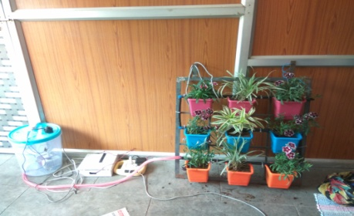

CONCLUSION AND RESULT
The proposed system provides a big benefit to the user since user gets to take care of their vertical garden from distant place. The user gets another big reason to use this system is that only the required amount of water will be consumed so again water wastage is prevented Also we are planning a really economic product so that maximum of people can enjoy the benefits of the proposed system. The user only have to pay the buying cost once.. And the proposed system will take all care of their vertical gardens.
The results of Fig 1 is shown below:-
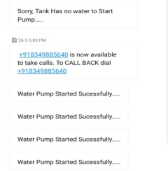
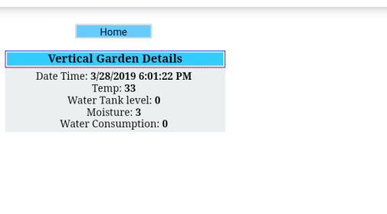
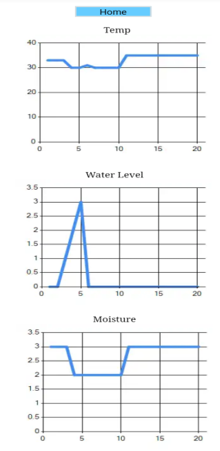
These 4 values you see are temperature ,water tank level, moisture and water consumtion in the form of numbers with the exact time and date of upload.
The temperature is recorded real time and the exact value is plotted against time, e.g—28*C. The moisture contents are plotted in this manner. If the soil is completely dry then its value is 1,if the soil is semi dry then it’s value is 2 and if it has enough water in it, its value is 3.Water level is detected with 3 probes. 1st probe shows low level,2nd shows mid level and 3rd shows high.
The user only have to call to a given number. The system is self sufficient to take the next decision. If the water level is sufficient it will start the pump and initiate the message to the user saying “WATER PUMP STARTED SUCCESSFULLY”. On the other hand, if water level is low it will send the message to user saying “SORRY, TANK HAS NO WATER”.

ACKNOWLEDGEMENT
This Research was supported by Mrs.M.MGudadhe. We thank our colleagues from Priyadarshini College of Engineering, Nagpur who provided insight and expertise that greatly assisted the research, although they may not agree with all of the interpretations/conclusion of this paper.

REFERENCES
[1] Mark Griffiths " The Design and Implementation Of a Hydroponics Control System" M.S theses, Dept. of Information Technology, Oulu University of Applied Sciences, Finland.,2014.
[2] Vijendra Sahare, Preet Jain " Automated Hydroponic System using Psoc4 Prototyping Kit to Deliver Nutrients Solution Directly to Roots of Plants on Time Basis" Dept. of ECE, SVITS College, Indore, MP, India,2015.
[3] Carlos A.P.camara “Automated system developed to control pH and concentration of nutrient solution evaluated in hydrophonic lettuce”, Department of Chemistry, State University of Londrina,Brazil,2012
[4] Dimitrios Savvas “Hydroponics: A modern technology supporting the application of integrated crop management in greenhouse ”, Department of Floriculture and Landscape Architecture, Faculty of Agricultural Technology,Greece,2003.
[5] Dr.Hector Munoz.(2010). “Home Based Vegetable Production System.” Date of retrieval 28.01.2014
[6] D. S. Domingues, H. W. Takahashi, Carlos A.P. Camara, S. L. Nixdorf “Automated system developed to control pH and concentration of nutrient solution evaluated in hydroponic lettuce production”, In: Computer and Electronics in Agriculture, Vol 84, Elsevier, pp 53-61,2012.
[7] M. Azaza , C.Tanougast , E.Fabrizio , A.Mami "Smart greenhouse fuzzy logic based control system en hanced with wireless data monitoring" , 61, 297307, 2016.
[8] C. Harper and M. Siller, “OpenAG: A Globally Distributed Network of Food Computing,” in Proc. 4th IEEE Pervasive Computing, Vol 14, 2015, pp24-27.[Online]
. [9] Available: http://ieeexplore.ieee.org/xpl
Details of All Authors (Optional)

Sr.No | Photo | Details
1 |  | Amita Warang
2 |  | Risheen Mankar Patil
5 |  | Sanjyot Bhagat

3 |  | Kshitija Hingankar
4 |  | Nilesha Shendre

