"Comparison on Experimental Study Of Bio-Concrete And Convectional Concrete"
Prof. Varsha Lanjewar¹, Pallawi Dorle², Shubham Sawarbandhe³ , Rohini Shahare⁴, Tushar Kapagate⁵, Ashwini Bhure⁶
⁶Assitant Professor,¹⁻⁵Undergraduate Students,
Dept. of Civil Engineering, Manoharbhai Patel Institute of Engineering and Technology Shahapur, Bhandara -441906

Abstract- Crack in concrete are inevitable and are one of the inherent weakness of concrete. In that project discussed bacterial concrete in which bacterial concrete that can precipitate calcite in a crack and with that make concrete structures water high and improve durability. As the cell wall of the bacteria is anionic metal accumulation on the on the surface of the wall is substantial. The use of bacteria stiffness and compressive strength of concrete.
Keywords—Bacterial concrete, cracks, Nutrient agar, Proteus vulgaris, Bacillus spharicus.

1-INTRODUCTION

Concrete is a strong and economical construction material and its application is quickly increasing universal. Advancement in concrete technology is its strength improvement in enhancement in durability using pollution free method. Bacterial concrete is the science of precipitation of minerals by living organisms. Bacteria have a remarkable ability to precipitate Calcite, Carbonate, Phosphate, Oxides, sulphite. In Bacterial concrete Bacterial species like, B. Spharicus Proteus Vulgaris, etc. Deposit calcium carbonate by their bacterial activity in this system. This result decreases in water absorption and permeability. Presence of layer of Calcium precipitation improve its potency and durability. New Researches and studies introduced Bacterial-concrete. In this the bacteria is introduced in the concrete during casting process. It helps of reduction in the pores in concrete and hence reducing the chances of formation of cracks. This method is very useful in new constructions.
A. Selection of bacteria-
The pH of concrete is between 10-13 and its temperature can go up to 70⁰c. After the exposure to air of the concrete there is no moisture left in it. So, the selection of bacteria is done on the basis of its high resistance against pH, temperature and lack of water content and harmless to any living things. So, due to this reason we select the bacteria of Bacillus spharicus and proteus vulgaris. And that bacteria's are thermophilic bacteria.

II-MATERIALS AND METHODOLOGY

2.1. Materials

Ordinary Portland Cement meeting the requirements to IS 12269-1987 was used. Locally available clean, well-graded, natural river sand having fineness modulus of 2.86 conforming to IS 383-1970 was used as fine aggregate.

2.2. Methods

Bacillus spharicus and Proteus vulgaris, isolated from commercially available cement, was used in this study. The culture was regularly maintained on Nutrient agar (pH 8.0) medium. Nutrient broth-urea (NBU) medium (8 g nutrient broth, 2% urea and 25mM CaCl2) was used to grow the isolate. Filter-sterilized urea and CaCl2 was added into nutrient broth medium. Details of NBU medium content and preparation were published before. Bacterial culture was grown-up at 37°C under shaking condition.

2.2.1.Culture of bacteria

Concentration of cells is measured by Haemocytometer and Gram staining method is used to determine the morphology of the bacterial strains.
2.2.2. Test on bacteria-
First of all, 1 mol of urea is hydrolyzed intracellular to 1 mol of ammonia. Carbonate spontaneously hydrolyses to form in addition 1mol of ammonia and carbonic acid. These products subsequently form 1mol of bicarbonate and 2mol of ammonium and hydroxide ions and the last 2 reactions give rise to a pH increase, which in turn shifts the bicarbonate balance, resulting in the formation of carbonate ions.
CO (NH₂)₂ + H₂O NH₂ COOH + NH₃ .............................. (1)
NH₂COOH+ H₂O NH₃ + H₂CO................................................... (2)
H₂CO₃ HCO₃-+H- .................................................................... (3)
2NH₃ + 2H₂O 2NH₄- + 2OH-...................................................... (4)
HCO₃-+H⁺+2NH₄+2OH CO₃²⁻ + 2NH₄+ + 2H₂O.............. (5)
Since the cell wall of the bacteria is negatively charged, the bacteria draw captions from the environment, including Ca²⁺, to deposit on their cell surface. The Ca²⁺-ions consequently react with the CO³²⁻-ions, leading to the precipitation of CaCO₃ at the cell surface that serves as a nucleation site.
Ca²⁺ + Cell Cell‐Ca²⁺ ................................... (6)
Cell ‐Ca²⁺ + CO₃ ²⁻ Cell‐ CaCO₃ ↓ .........................................(7) 2.2.3.Properties of material
The cement used in this study is OPC, 53 grades which satisfies IS: 12269-1987.
▪ The fine aggregate of zone II with specific gravity 2.6, fineness modulus 2.86 and moisture content 2% is used and they are found as per IS: 383-1970.
▪ The coarse aggregate of 20 mm size with specific gravity 2.89, fineness modulus 3.69 and moisture content 0.76 % is and they are found as per: 383-1970.
▪ Distilled water is used for this study. The properties of water are satisfied as per 3025 – 1964 part 22, part 23 and IS: 456 – 2000.

2.2.4. Mix design

Concrete mix proportion is calculated as per IS
10262-2009 and the mix ratio is 1: 1.5: 3 with the water cement ratio 0.5.

2.2.5. Details of specimen

About 39 cubes of size 150X150x150mm were cast to test the compressive strength on 3rd, 7th and 28th day, Water absorption test, Sorptivity test on 28th day. 6 sample of cylinders of size 150x300mm were cast to find the split tensile strength respectively.

3. EXPERIMENTAL PROCEDURE

3.1. Compression test

The compressive strength of concrete is tested on cubes using compression testing machine. The posture surface of machine was wiped off clean and the surface of the specimen was cleaned. The specimen was placed in machine and the axis of the specimen was carefully associated at the center of loading frame.
The compressive strength of the concrete was calculated using the following formula and the results are tabulated.
Compression strength = load/Area

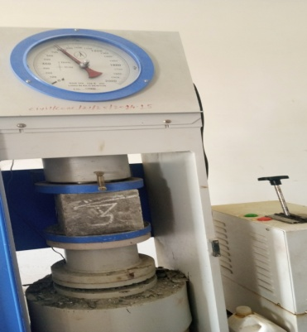
Fig.1: Experimental setup for Compressive strength test

3.2. Split tensile strength

Split tensile strength of cylindrical concrete cubes is tested on cylinder using compression testing machine. The split tensile strength test for concrete cylinders was carried out as per IS 516: 1964. Specimen was kept horizontally between the loading surfaces of a universal testing machine and the load was applied until failure of the cylinder. The failure load was noted and strength was calculated using the following formula.
Split tensile strength = $\frac{2P}{πLD}$
Where,
P = Ultimate load (N)
L = Length of cylinder (mm)
D = Diameter of cylinder (mm)

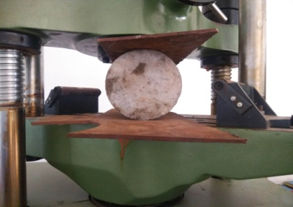
Fig.2. Experimental Setup for Split Tensile Strength Test

3.3.Sorptivity test

150mm × 150mm × 150mm 6cubes (3 conventional, 3 bio concrete) was casted. After 28 days continuous curing the specimen was oven dried at 50⁰C for 7days and cooled at room temperature for 2 hours. Then we coated the cubes with Dr fixit from 4 sides. The base portion was kept open. We weighted this cube as (W1). Again the specimen was reserved in water where the height of specimen immerse only 5mm for 60 minutes. After 60min the weight of specimen measured in gm (W2).

Sorptivity is measured
S = (I/√t)
Where;
S = sorptivity in mm,
T = elapsed time in minute.
I =Δw/Ad
Δw = change in weight = W2 ─ W1
W1 = Oven dry weight of cube after coating in grams
W2 = Weight of cube after60 minutes capillary suction of water in grams.
A = surface area of the bottom side through which water penetrated.
D = density of water
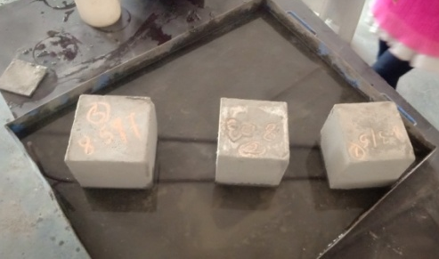
Fig.3. Setup for Sorptivity Test
Sample Calculation:
Δw = change in weight
= W2 ─ W1 = 8230 – 8190 = 40 gm
W₁ = Oven dry weight of cube after coating in grams = 8190gm
W₂ = Weight of cube after60 minutes capillary suction of water in grams
= 8230gm
A = surface area of the bottom side through which water penetrated= 0.0225 m
D = density of water = 1 gm. /cm3
T = time in minutes = 60 min
I =Δw/Ad = 40/ (0.0225 × 102 × 1) = 17.77 m
Hence,
S = I/√t
= 17.77 /√60 = 4.01
3.4.Water absorption
150mm × 150mm × 150mm 6cubes (3 conventional, 3 bio concrete) was casted. After 28 days continuous curing the specimen was oven dried at 105⁰C for 72 hours and cooled at room
temperature and weight it. Then we immersed cube in distilled water for about 24 hours.
we clean the surface of sample with absorbent cloth and weight again.
% of water absorption = [(W₂-W₁)/(W₁)] ×100.
Where,
W₁= oven dry weight of cube.
W₂=Wet weight of cube after 24 hours.
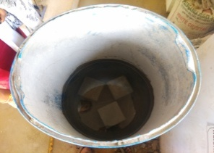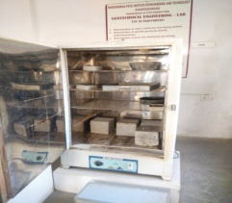
Fig.4. Setup for Water Absorption test
Observation and Calculation:
- Percentage absorption (3rd day test) = $\frac{W2-W1}{W1}$ x 100
Where,
W₁= Weight of saturated cube
W₂ = Weight of dry cube
= $\frac{8.44-8.18}{8.18}$ x 10
= 3.18%
% of water absorption = 3.18 %
4.RESULT
Conventional concrete | 3rdday | 7thday | 28thday
Compressive strength | 10.67 | 15.40 | 25.92 N/mm²
Split tensile strength | - | - | 2.40 N/mm²
Water Absorption | - | - | 3.18%
Sorptivity | - | - | 4.01 m.s^{-1/2}
Table no.1: Test results of conventional concrete

Conventional concrete | 3rdday | 7thday | 28thday
Compressive strength | 11.11 | 16.73 | 32.58 N/mm²
Split tensile strength | - | - | 2.58 N/mm²
Water Absorption | - | - | 1.965 %
Sorptivity | - | - | 2.29 m.s^{-1/2}
Table no.2: Test results of Bacterial concrete

Graph 1- Representation of result
V- CONCLUSION AND FUTURE SCOPE
Can be used in the construction of aircraft runways, bridges and dams reducing the preservation cost. It can be used for the construction of retaining walls. It could one day save billions of dollars in construction. Soon, you might never to avoid stepping on a crack again. The researchers are also developing a liquid to fix crack in conventional concrete. The invention will fix concrete cracks without needing construction workers. Thus we studied the percentage increase in compressive and split tensile strength of bio concrete cubes compared to conventional cubes. From this project it is concluded that use of bacteria in concrete increases the percentage strength and reduces its water absorption and sorptivity.
REFERENCE
- Shetty M.S. (2002), ‗Concrete Technology Theory and Practice‘, S.Chand and Company ltd, New Delhi
- .Concrete Technology by A.M. NEVILLE.
- Concrete Technology by M.L. GAMBHIR.
- Indian Standard Recommend guidelines for Cement as per IS: 456 – 1978
- IS 383:1970 – Specification for coarse and fine aggregates for Concrete
- IS 4031 (part 6): 1988 – Methods of physical tests for hydraulic cement and determination of compressive strength for cement, bureau of Indian standards.
- IS 10262 – 2009 – Indian Standard Recommended Guidelines for mix design of Concrete.
- IS 9013 – 1978 – Method of mixing, preparing, curing and determining compressive strength of accelerated cured concrete test specimens.
- IS 12269: 1987 – Specification for 53 grade Ordinary Portland Cement.
- SP 23: 1982 – Handbook on concrete mixes.
- Ramachandran, S.K., V. Ramakrishnan, S.S. Bang, 2001, Remediation of Concrete using micro-organisms, ACI Materials Journal.
- Vempada S.R., S.S.P.Reddy, M.V.S.Rao, C. Sasikala, 2011, Strength enhancement of cement mortar using microorganisms - An experimental study,
- International Journal of Earth Sciences and Engineering.
- G.T. Suthar, Dr. K.B. Parikh, govt engineering college, Dahod - A study of Microorganism (bacteria) on Concrete Strength and Durability, an international journal for technical research in engineering.
- Ansari Mohd. ParvezAlam, KadriAasad Anwar, makandar Imtiyaz mehboob – Bacterial Concrete a remedy for micro cracks.
- Study of Self-healing mechanism and its impact on Bacillus Bacteria Impregnated Concrete by Koustubh A. Joshi , Madhav B. Kumthekar , Vishal P Ghodake.
- Bacillus Spharicus and Proteus vulgaris –cultured by Department of Microbiology, Hislop college Nagpur, University of Nagpur.
- www.ncl.com

