STUDY ON FIR SHAPED PILE
FOUNDATION.

Mayur Rana¹,Vineet Patil²,Sourabh Maskare³,Shubham Singh⁴,

Prof. Manjunath Munenakoppa⁵.
^{1,2,3,4}(UG Students), ⁵Assistant Professor, Department of Civil Engineering, St John College of Engineering & Management, Palghar

Abstract – In this study, the performance of fir piles in sand has been evaluated. Under reamed piles are deep in-situ concrete piles with one or more enlargements in their stems. The enlargement is called bulb and increases the strength and stability of these piles. The goal of this study was comparing the performance of fir pile and conventional under reamed piles of the same diameter and length in sand. For this purpose, load test is done and the results were compared. Analysis and calculation results showed that fir piles had better performance than the conventional under reamed piles, and had higher ultimate tensile and compressive bearing capacity and lower displacements. Moreover, under reamed piles had higher ultimate tensile bearing capacity and lower uplift in comparison to conventional piles of the same length and different volume.

Keywords- fir pile, under reamed pile, bulb,
comparing, load test, bearing capacity.

- INTRODUCTION

Underreamed piles are in-situ concrete piles with one or more bulbs in their stems. These bulbs increase bearing surface and capacity of the pile in compressive loading. They also resist uplift forces like an anchor, increasing tensile bearing capacity of the pile.

- UNDER REAMED Pile foundation:
- Under reamed pile foundation is recommended for providing safe and economical foundations in expansive soils such as black cotton soil, filled up ground and other types of soils having poor bearing capacity.
- In these type of foundation the structure is anchored to the ground at a depth
- A pile having one bulk is known as single under-reamed Pile.
- It is seen that the load bearing capacity of the pile can be increased by increasing the number of bulk at the base.
- The increase in the bearing capacity of the pile can also be achieved by increasing the diameter and the length of the pile

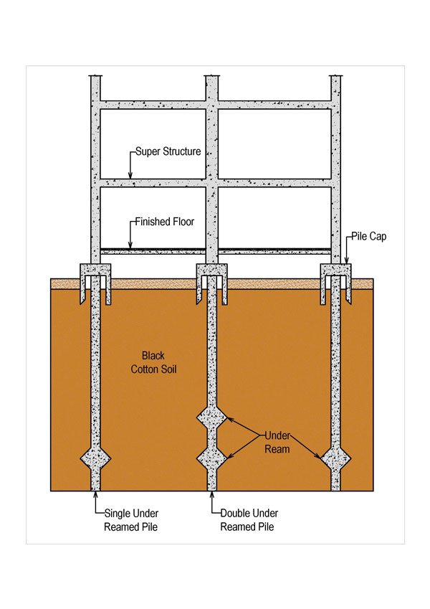

- FIR Pile:
- This is a newly shaped pile foundation which is inspired from the Christmas (FIR) tree.
- The shape of this pile can be said as the half bulb pile because if the full bulb of the under reamed pile is cutted in the horizontal line then the upper half bulb is obtained.
- This concept is similar to tree roots because tree roots grow down so that they can explore the soil and provide the maximum stability to tree.
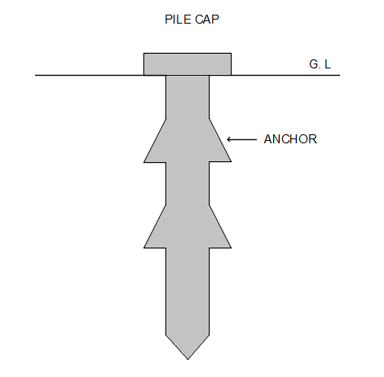

- METHODOLOGY
The methodology of the study involves:

- Basic study
- Moulding
- Casting
- Testing
- Analysis and discussion

- So, at first we have to prepared the mould in which we are going to fill the sand, in which the piles are to be placed
- The dimension of the mould is obtained on the basis of the CBR apparatus, because we have to place the mould in the CBR.
- Diameter= 24cm
- Height =24cm

- After preparing the mould we have to determine the relative density/density index to know the compaction state of the sand
  - We calculated the minimum density, maximum density and void ratio
  - With all the data relative density was found out to be 0.17 (i.e 17% ) LOOSE.

DENSITY INDEX | COMPACTION STATE
0-15 | VERY LOOSE
15-35 | LOOSE
35-65 | MEDIUM DENSE
65-85 | DENSE
85-100 | VERY DENSE

For comparison of both piles the following 2 sets are prepared

UNDER REAMED PILES | FIR PILE
Diameter | Height | Diameter | Height
2 cm | 12 cm | 2 cm | 12 cm

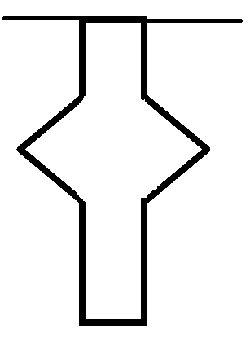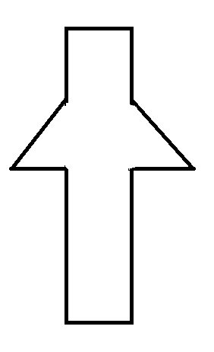

- We need to make the precast piles for that the following procedure is adopted:
- First we excavated the piles with respect to the diameter up to the required length

After that we made the bulb in the piles with the help of the iron groove maker which we made

- Now the casting is carried out for which we used M20 grade of concrete (1:1.5:3)

- After casting is done we removed the piles after 24hours and kept them in curing for the 3 days.

- After the curing procedure is completed we need to place the pile in the mould with sand

So, the pile is kept in such a way that the top surface of the pile and the top surface of the sand after completely filled mould remains in the same level.

- After the pile is placed in sand we kept the mould in the CBR apparatus.

- Before testing, the pile cap is placed above the pile on which the needle of the dial gauge can be rested to measure the settlement of the pile during loading and the plunger of the CBR can apply the load evenly on the pile.

III- CALCULATIONS

CONVENTIONAL PILE – 1) Dia=2 cm & Height=12 cm

Displacement in Division | Displacement in MM | Load in Division | Load in Kg.
10 | 0.10 | 1.8 | 6.12
20 | 0.20 | 3.8 | 12.92
30 | 0.30 | 5.6 | 19.04
40 | 0.40 | 6.6 | 22.44
50 | 0.50 | 7.5 | 25.5
60 | 0.60 | 8.8 | 29.92
70 | 0.70 | 10.3 | 35.02
80 | 0.80 | 12 | 40.80
90 | 0.90 | 14.2 | 48.28
100 | 1.0 | 16.8 | 57.12
110 | 1.10 | 19.9 | 67.66
120 | 1.20 | 23.1 | 78.54
125 | 1.25 | 25.5 | 86.7
130 | 1.30 | 28.4 | 96.56

FIR PILE – 1) Dia=2 cm & Height=12 cm

Displacement in Division | Displacement in MM | Load in Division | Load in Kg
10 | 0.10 | 2.1 | 7.14
20 | 0.20 | 4.3 | 14.62
30 | 0.30 | 6.0 | 20.4
40 | 0.40 | 7.5 | 25.5
50 | 0.50 | 8.4 | 28.56
60 | 0.60 | 9.6 | 32.64
70 | 0.70 | 11.2 | 38.08
80 | 0.80 | 13.4 | 45.56
90 | 0.90 | 15.5 | 52.7
100 | 1.00 | 18.1 | 61.54
110 | 1.10 | 21.8 | 74.12
120 | 1.20 | 25.2 | 85.68
130 | 1.30 | 31.1 | 105.74
138 | 1.38 | 33.7 | 114.58

IV- RESULT

- The ultimate load bearing capacity of under reamed pile of dia 2 cm and height 12 cm at 1.30 mm settlement is 95.56 kg and the ultimate load bearing capacity of FIR pile of dia 2cm and height 12 cm at 1.38 mm settlement is 114.58 kg.

- From the above result we got that the FIR pile foundation can take more load or have more ultimate bearing capacity than that of conventional under reamed pile.

- Also the settlement of FIR pile is less than that of conventional under reamed pile at same load.

V-FUTURE SCOPE

- Our project can further be use to reduce number of piles required.

- Also our project is useful to reduce cost of construction as well as work.

- If more number of half bulbs can be provided than more better results can be obtained.

VI-CONCLUSION

- By considering the above result, we concluded that the load bearing capacity of FIR pile is 9.50 % higher than that of conventional pile.

REFERENCES

- Wikipedia.Org/Deepfoundation

- Bearing Capacity Characteristics Of Under - Reamed Piles In Sandy Soil- A Model Study -- Ayanangshu Das (2001)

- Parametric Study Of Under-Reamed Piles In Sand-- Tanuja Christopher (Http:/Www.Ijert.Org)

- Analytical Study On Geometrical Features Of Under-Reamed Pile By Ansys(Parikshith Shetty,Naveen B, Naveen Kumar B.)

- Numerical Investigation Of Under Reamed Pile( Balu E.George,Hari G.)

- Optimizing The Performance Of Underreamed Piles In Clay Using Numerical Method(Ataollah Sanaei Farokhi)

Details Of All Authors (Optional)

Sr No. | Photo | Details
1
2
3
4

