Smart Compost Bin

Dr. K.M. Tajne¹ , Swarda Dixit² , Prasad Birajdar³ , Satyam Sanganwar^{4 ,} Ankit lende^{5 ,}
Madhuri Mohod⁶

²³⁴⁵⁶Students’ third year civil engineering department, Government College of engineering, Nagpur India, 441108
¹Associate Professor Civil engineering department Government College of engineering Nagpur India, 441108

ABSTRACT
The composting process has received much attention in recent years because of pollution concerns due to increase in volume of waste. This project report describe a smart way for the mitigation of the waste generation which is smart compost bin. The characteristics of the smart compost bin and its structure are also explained. Composting is a microbiological anaerobic process. Smart compost bin is a system which comprises of several components such as, metal and plastic detector, composting unit and outlet provision for produced fertilizer. Composting process is controlled by some parameters such as temperature, moisture and oxygen content Maintaining temperature fluctuations during composting period could allow adequate control of the process in case of any difficulty. Moisture content is the factor which makes the nutrients bioavailable. To be successful, we will need to provide the microorganisms in the system. This system totally works on solar energy. Smart compost bin can enhance public health by returning vital nutrients to the soil. This project reviews information on the composting for waste as a means of addressing the environmental pollution concerns Composting has been used as a means of recycling organic matter back into the soil to improve soil structure and fertility.

- INTRODUCTION

  - GENERAL
Today solid waste management is one of the biggest problems in the world. Around 50% of the waste in the world is organic waste. India is second largest populated country in the world; it produces more than 100 tons of solid waste a day. It is the mixture of both organic food waste and inorganic waste. Around 78% is food waste, which can be recycled. Some of them is land filled but it is not segregated properly and it mixes organic and inorganic waste, which produces bad odor, and it will spoil the soil. To manage the solid waste, it should be properly segregated at the source (houses). The organic and inorganic waste needs to be separated, the organic waste can be treated to make compost, and inorganic waste can be segregated and given for garbage collection. There are many companies who take in the waste and segregate and convert the organic waste into compost but as the waste is very high; they are unable to achieve all

the targets so it is better to compost at home. Composting is the decomposition of organic waste by microorganisms under controlled

Conditions. Organic Waste, which forms a significant part of municipal solid waste, has caused increasing environmental concerns. By composting organic waste, we can preserve resources and produce a valuable by-product that can be used as locally produced fertilizer. The existing compost bins have few challenges which are difficult to handle such as messy and smelly compost, time-consuming process (30-45 days), prone to insects and rodents and hard to clean. In addition, some of them release greenhouse gases. Cost issues are there with few automatic and high-end compost bins. This project aims at designing a compost bin for Indian household kitchen as well as other organic waste generated from the gardens and other resources, which is easy to use, odour free, economic in nature and visually appealing. Designed Compost bin consists of a separate chamber for compost starter, composting chamber consisting of a mixing blade works on the solar energy, air filter setup and a compost collection tray and also the outlet for liquid fertilizer is provided Neem and Cow dung which are used to keep away bad odor and acts as a disinfectant. Simple mechanism allows the user to maintain cleanliness.

  - LITERATURE REVIEW:-

Composting is not only a modern age matter, this practice took place long time ago. The earliest records state evidence that before the introduction of modern sewage systems, the major fertilizers were animal manure and composts of garden and kitchen wastes. Composting existed 10 000 years ago through the Akkadian empire which was located in modern day Iraq. When the citizens noticed that their plants grew better in area where there was manure they started putting manure in their soil. The history of composting also states that early farmers in Scotland, during the Stone Age, used to put manure and vegetable compost in their soil. Moving to Ancient Asia, there is evidence that the tools found in Neolithic sites in northern china contained similar features as those used by the Scottish farmers. The Greeks, Romans and Egyptians used composting too. In Egypt, after observing the worms’ composting abilities, Cleopatra enacted a law that states that anyone who removes earthworms from Egypt was punished by death. During the 12th century, the Handbook Kitab Al Falah written by Ibn AL Awam gave detailed information about composting and the use of manure. . In 1943, George Washington Carver said “Make your own fertilizer, compost can be done with little labor and practically no cash outlay”. Yet, composting was soon replaced in the early 20th century. Justus Von Liebig, a German scientist, proved in 1840 that the plants can get nourishment from the chemicals. Therefore, the vegetables’ and animals’ waste mixture was replaced quickly by artificial fertilizers, and that was the beginning of the scientific method of farming. But like all the artificial solutions, fertilizers had their opponents.
1.2.1MODERN COMPOSTING:-
In 1905 sir Albert Howard released the Indore method. After 30 years of research, Howard found the best modern compost. It involves alternating layers of green, manure and soil until reaching the desired height. The heap should be moist and turned regularly to meet the desired aerobic conditions, then the compost is ready in the span of three months.
[DESIGN OF COMPOSTING BIN TO CONVERT AUI’S BIOMASS TO AN ORGANIC FERTILIZER – APRIL 2017]
  - OBJECTIVE OF PROJECT:-
The main objective of the project is to design a smart compost bin having a capacity of 20 liters to carry out the composting of all types of biodegradable materials and to obtain good quality of manure.

- METHODOLOGY
To review household survey of existing compost bin (Household and Industrial) various composting processes, and the interview will be conducted with the users to understand the major problems in waste disposal and drawbacks of the existing compost bin. Based on the
Data collected in literature survey and ethnography research, the product design specification is designed. To generate concepts 2D sketch is made on the product design specification.
2.1 ETHNOGRAPHY RESEARCH
Ethnography research is a part of literature survey. It is the study of the people and the product in their environment and how they use certain products. It involves observational research and face to face interview.
2.2 DESIGN CRITERIA
- Frequency of use- The biodegradable waste is input every day, so we can use this bin for community
- Use of Energy- As the bin is totally works on solar energy, and hence there is no need of any external power/electricity.
- Product Handling- The output product i.e. compost, should be in such a manner that there should not be any inconvenience to user and it should collected in tray/pan and can be used easily for home gardening.
- Easy Process- This composter is to be operable by everyone as there is no need of any special skills for operating it.
- Product location: - The smart compost bin to be placed in either balconies or other places where optimum sunlight is available.
- Product size: - The dimensions of the Smart compost bin would be ergonomic in nature and it will maintain the standard modular kitchen dimensions followed in Indian kitchens. Depending upon the quantity of the waste generated the size of smart compost bin may vary.
- Odour free: - The smart compost bin would not give out any bad odour.
- Low noise: The smart compost bin’s noise limit shall be well within the limits of a kitchen appliance.
- Aesthetics: - As an integral part of an urban household, the design language of the smart compost bin looks like other kitchen appliances. [ Design and development of compost bin for Indian kitchen–International journal of waste resources 2018 DOI: 10.4172/2252-5211.1000323]

2.3 COMPONENTS OF SMART COMPOST BIN

- Solar panels: - Solar panels are the main source for the working of every component of bin. They will be provided along the appropriate direction in order to receive the optimum amount of sunlight. In India generally the solar hours are assumed to be 5 to 6 hours.
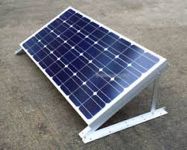
Fig 2.1 Solar panels
- Inlet provision: - Inlet will be provided at the upper side of the bin from where the organic waste is feed in the bin.
- Geared motor: - Geared motor will be provided to rotate the shaft and the blades to required revolution per minute. The motor is powered by the solar energy with the help of solar panels.
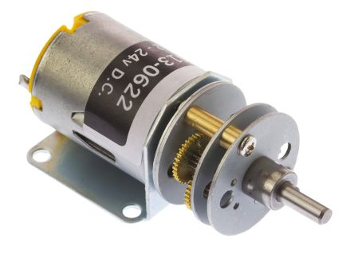
Fig 2.2 Geared motor
- Shaft and Blade assembly :- Shaft will provide to cause the revolving movement of the blades along its vertical axis. One end of the shaft will be connected to the motor and other is needle fixed at the bottom on mesh. The blades will be provided on the circumference of the shaft which reduce the size of the waste and fastened the composting process.

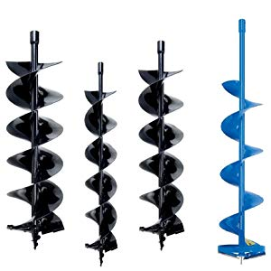
Fig 2.3 Blades with shaft

- Hot water sprinkling arrangement: - In order to maintain the favourable temperature for the composting process, the hot water will be sprinkled inside the bin with the help of sprinkler.

- Screen: - Screen will provide to separate the liquid fertilizer from the solid manure at the bottom.

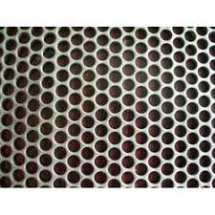
Fig 2.4 Screen
- Collecting pan :- It will be provided to collect the solid fertilizer for further use
- Outlet provision: - Outlet will provide to convey the collected liquid fertilizer to the required place.

3. DESIGN AND PROCEDURE
3.1 COMPOST BIN MODEL DESIGN
The compost bin consists of mainly three parts. The top unit consists of solar system and hot water storage system, second unit is the composting bin part and the third unit is Compost and liquid fertilizer collection system.
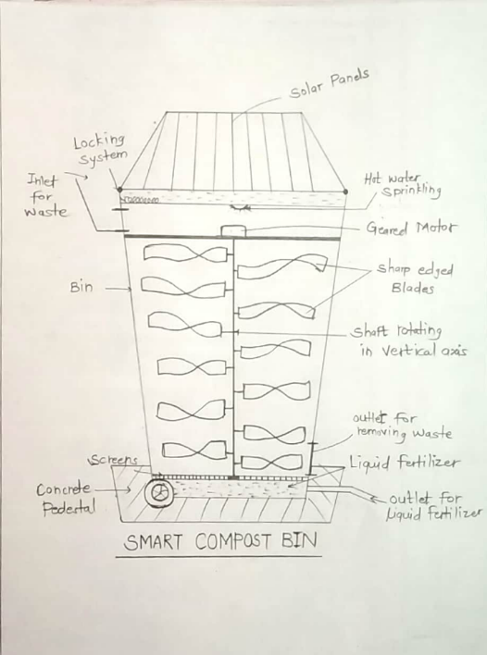
Fig 3.1 Conceptual drawing of smart compost bin
3.2 COMPOST BIN WORKING PROCESS:
- Figure shows the composting process used in the compost bin designed for biodegradable waste. The process goes as follows-
- The biodegradable waste is loaded in the composting unit
- Biodegradable waste is chopped finely to increase the area of decomposition with the help of cutting blade setup.
- Addition of compost starter consisting of microbes which Starts the composting process
- Screens are provided at the bottom for separating liquid fertilizer
- The manure is then collected by the opening provided in side wall of composting unit
- Outlets are provided to collect both solid and liquid fertilizers
3.3 FLOW CHART OF WORKING PROCESS OF SMART COMPOST BIN:

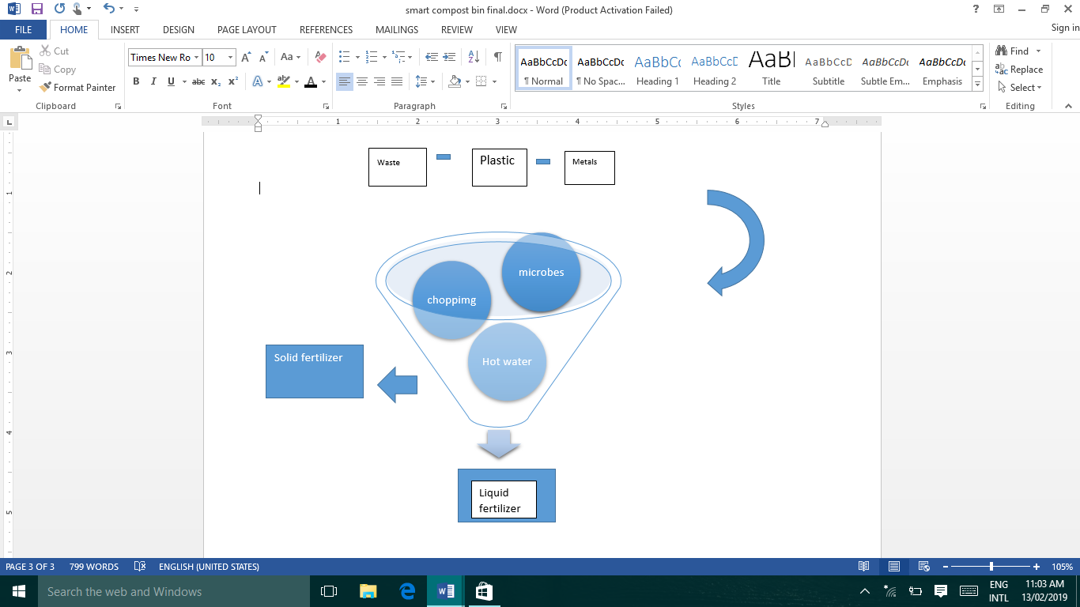

CONCLUSION

4.1 CONCLUSION:
The proposed strategies for the management and disposal of degradable waste by composting with smart compost bin have shown feasibility in terms of organic matter mineralization and humification. Compost bin plays a major role in solid waste management in India as it is easy to use and cost effective, can be implemented at lower rate. The new design of compost bin is aesthetically good looking, it has no odour, keep insects flies away from bin. Based on the study, it can be conclude that composting is the best way to reduce or recycle the municipal solid waste and it causes less pollution and more beneficial to environment as well as economy when compared to the current methods of collection and disposal. It has lots of benefits like reduce surface and water leachates, minimize landfill space, methane emission, air pollution by burning of waste, transportation cost etc. It also reduce load on disposal units. Compost obtained by this can be used as organic fertilizer in agricultural field instead of chemical fertilizer also due to shredding of waste in bin fast process of composting takes place. The liquid fertilizer obtained can be directly used or stored which increases the yield of crop in natural way. Finally, it is conclude that the proposed alternative should be sealed up in developing areas to reduce and diversify the urban waste streams producing high quality and balanced organic fertilizer with significant economic value.
4.2 FUTURE SCOPE
Based on few of the suggestions suggested by the advisors for future improvements of the compost bins, below are some of the future scope of the compost bin they are:
- Wheels can be added at the base so that it is easily transportable.
- Blade setup can be made with multiple size for thick and thin vegetables.
- Composting area to be transparent.
- Blade setup can be removable
- Proper handle for movement of compost bin.

REFERENCES
1. https://www.planetnatural.com/garden-advice/
2.http://www.organicgardeninfo.com/compost-requirements.html
3. https://www.zera.com/
4. http://www.dailydump.org/
5. https://www.mygreenlid.com/
6. Hargreaves J, Adl M, Warman P (2008) A review of the use of composted municipal solid waste in agriculture. Agric Ecosyst Environ 123: 1-14.
7. Haydar S, Masood J (2011) Evaluation of kitchen waste composting and its comparison with compost prepared from municipal solid waste. Pak J Egg & Apple Sic 8: 26-33.
8. 43-49. 10. Christiana OI (2014) Design, development and evaluation of a small scale kitchen waste-composting machine. IOSR J Eng 4: 29-33.
9. Karnchanawong S, Suriyanon N (2011) Household organic waste composting using bins with different types of passive aeration. Resour Conserv Recycl 55: 548-553.

10. http://vric.ucdavis.edu/pdf/compost_rapidcompost.pdf
11. https://deepgreenpermaculture.com/
12. Sahu A (2016) Studies on composting of kitchen waste through microbial decomposers and their effect on plant growth promotion and biotic stress management of crops. Ph.D. Indira Gandhi Kristi Vishwavidyalaya, Raipur, Chhattisgarh.

13. Design and development of compost bin for Indian kitchen – International journal of waste resources 2018 DOI: 10.4172/2252-5211.1000323
14. Design Of Composting Bin To Convert Aui’s Biomass To An Organic Fertilizer – April 2017

