Comparison of T-Beam Girder Bridge With Box Girder Bridge For Different Span Conditions

Dr. Kiran Tajne¹, Ms. Kirti Thakare ²
¹Associate Professor
Government college of Engineering, Nagpur, India, 441108
²Assistant Professor, Professor
Priyadarshini college of Engineering, Nagpur, India, 440019
Abstract –A bridge is a structure providing passage over an obstacle without closing the way beneath. The required passage may be for road, railway, pedestrians, canal or pipeline. In present study our main concern is with T-Beam Girder Bridge and Box Girder Bridge . The aim and objective of the work is to analyze and design the sections for different Indian Road Congress Code i.e IRC 6 and IRC 21. This has been done by analyzing the structure by software i.e STADD PRO. and validating with manual results by developing the Microsoft Excel Sheets. We used piegurds curve for bending moment calculation for four different cases. We check shear force and bending moment for vehicular load. We check the depth then from that depth we design the bridge in STAAD- pro then we analyze the bridge for results. It is found that the IRC 70R vehicle producing maximum effect on the sections. In the present work the comparison between the ‘Tee Beam Girder’ and ‘Box Girder’ is carried out. This is helpful when we have two kinds for girder which can be used for same span; in that case the most economical one is to be selected.
Keywords-bridge, t-beam, box girder, IRC, Excel sheet, vehicular load
INTRODUCTION
Bridges are defined as structures which are provided a passage over a gap without closing way beneath. They may be needed for a passage of railway, roadway, footpath and even for carriage of fluid, bridge site should be so chosen that it gives maximum commercial and social benefits, efficiency, effectiveness and equality. Bridges are nation’s lifelines and backbones in the event of war. Bridges symbolize ideals and aspirations of humanity. They shorten distances, speed transportation and facilitate commerce. Bridges are symbols of humanity's heroic struggle towards mastery of forces of nature and these are silent monuments of mankind's indomitable will to attain it. Bridge construction constitutes an importance element in communication and is an important factor in progress of civilization, bridges stand as tributes to the work of civil engineers.
T-Beam Girder Bridge- This is load bearing structure of reinforced concrete, wood and metal with a t-shape cross section. The top of t-shape cross section serves as flange or compression member in resisting compressive stresses. The web of beam below the compression flange serves to resist shear stresses.
Box Girder Bridge- In this type of bridge main beams comprises girders in the shape of hollow box. The box is typically rectangular or trapezoidal in cross section. These bridges are commonly used for highway flyovers and modern elevated structures of light rail transport.
Components of bridge:
The bridge structure comprises of the following parts:-
1. Superstructure or Decking: This includes slab, girder, truss, etc. This bears the load passing over it and transmits the forces caused by the same to the substructures.
- Bearings: The bearings transmit the load received from the decking on to the substructure and are provided for distribution of the load evenly over the substructure which may not have sufficient bearing strength to bear the superstructure load directly.

3. Substructure: This comprises of piers and abutments, wing walls or returns and their foundation.
4. Piers and Abutments: These are vertical structures supporting deck/bearing provided for transmitting the load down to the bed/earth through foundation.
- Wing walls and Returns: These are provided as extension of the abutments to retain the earth of approach bank which otherwise has a natural angle of repose.

6. Foundation: This is provided to transmit the load and evenly distribute it on to the strata from the piers or abutments and wings or returns. This is to be provided sufficiently deep so that it is not affected by the scour caused by the flow in the river.
PRELIMINARY DATA
1. Parameter for T-beam girder bridge and Box Girder Bridge
No of overhang sides(z) = 2
Effective span (L) = 35m, 28m, 21m.
Carriage way (l) = 6.8m
Thickness of wearing coat (T) = 0.08m
Kerb width (kb) = 0.5m
Parapet height (t) = 1.2 m
Overhang beam (ob) = 1.5 m
Number of longitudinal girder (n) = 3 no's
Total width of bridge (B) = 8 m
Distance between longitudinal girder =
(TL-2*ob )/(n-1) = 2.5 m
Cross girder spacing (cg) = 3.5 m
No. of cross girder = (L/3.5) =10 no's
Say = 10 no's
2. Preliminary dimensions
Thickness of ker = 0.3 m
Thickness of deck slab for interior panel = 0.25 m
Thickness of cantilever portion of deck slab = 0.4 m
Clear cover = 60 mm
Thickness of free portion of deck slab = 0.18 m
Width of longitudinal girder = 0.4 m
Depth of longitudinal beam = 1.2 m
Reinforcements
Main bar dia = 12 mm
Sec. Bar dai = 16 mm
3. Cross girder
Width = 0.3 m
Depth = 0.8 m
4. Material constant IRC-21(Table 9, Pg-18)
Grade of concrete = M 60 N/mm2
Grade of steel = fe 500 N/mm2
Modulus of elasticity € = 37000 N/mm2
Compressive stress = 15 N/mm2
Flexural compressive stress = 20 N/mm2
Modular ratio = 10

Figures
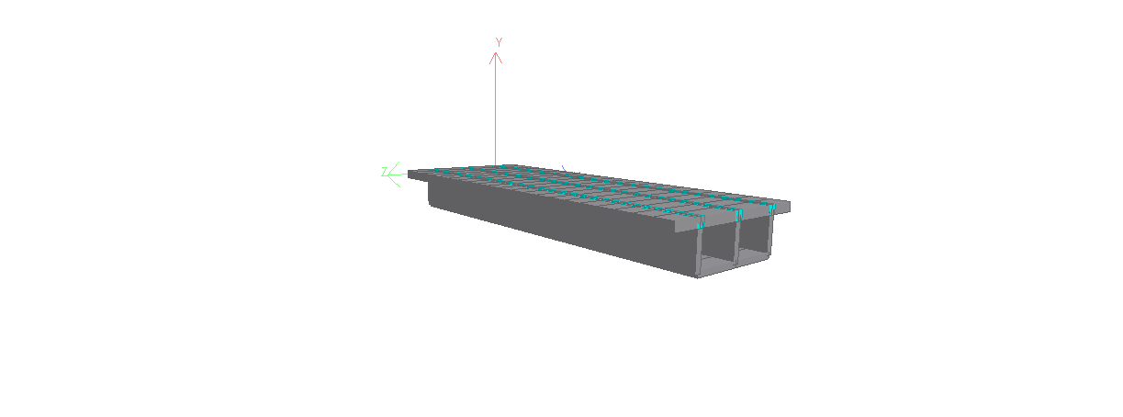
Fig. 1- Box girder bridge

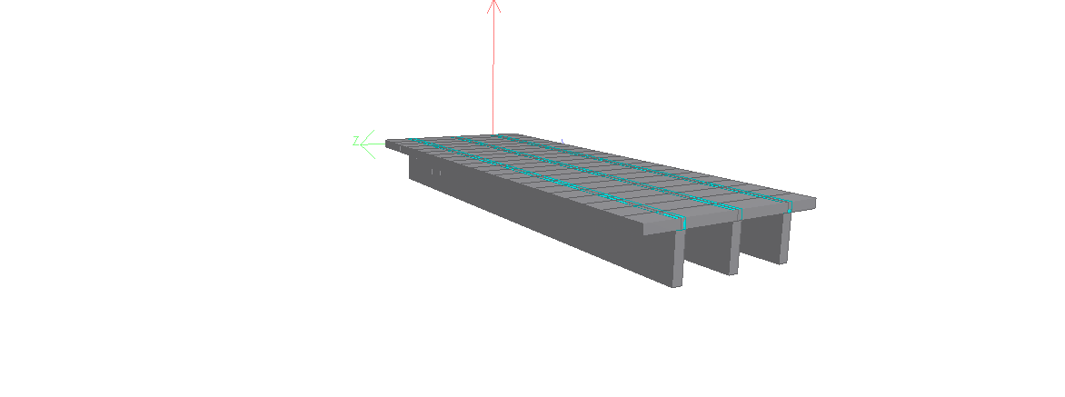
Fig 2- T-beam girder bridge
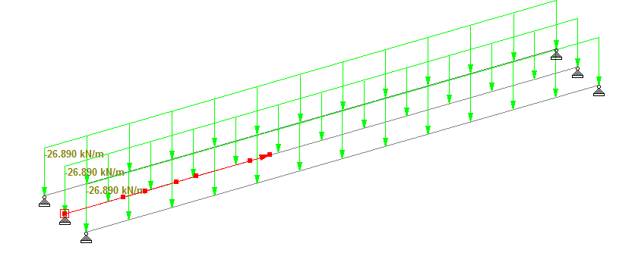
Fig 3- Load on girder due to 70R loading
RESULT
The results of plain stresses, Maximum displacement, principle stress, bending moment, shear force are below
Table 1 - Results of plain stress
Plane Stress X+ve N/mm²
Span(m) | T-Beam | Box girder
35 | 0.293 | 0.508
28 | 0.237 | 0.452
21 | 0.223 | 0.422

Table 2 - Results of Maximum displacement
Maximum displacement
SPAN(m) | T-Beam | Box girder
35 | 0.293 | 0.508
28 | 0.237 | 0.452
21 | 0.223 | 0.422

Table 3 - Results of principle stresses

Principle stresses
Span(m) | T-Beam | Box girder
35 | 3.818 | 3.438
28 | 3.403 | 2.922
21 | 3.507 | 2.674

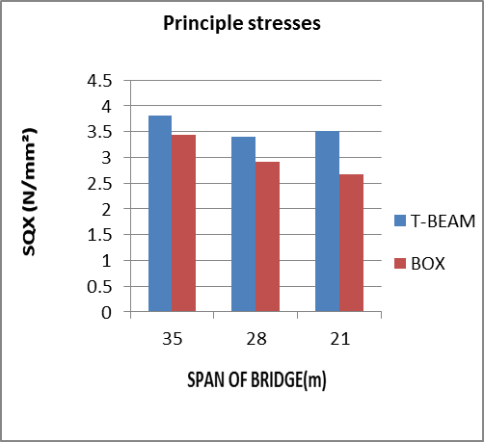
Table 4 - Results of Bending Moment
Bending Moment
SPAN(m) | T-Beam | Box girder
35 | 13766.97 | 9141.523
28 | 6249.859 | 4655
21 | 3140.981 | 2618.438

Table 5 - Results of Shear Force
Shear Force
SPAN(m) | T-Beam | Box girder
35 | 1625.22 | 1096.599
28 | 1276.91 | 907.626
21 | 608.227 | 498.75

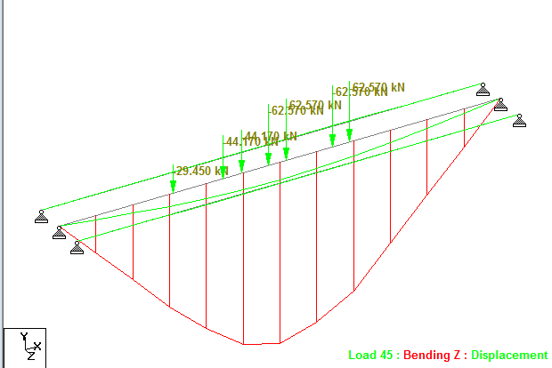
Fig 4- BM on girder due to 70R loading

Conclusion
In view of achieving the aim and objectives of this project the detailed design of two types of deck is carried out in excel sheets and the comparative statement is given as per the results obtained.
- Box girder is found to be good for large span as compare to T-beam Bridge.
- Principle stresses are more in T-beam Girder Bridge than box Girder Bridge.
- Plain stresses of box Girder Bridge is increases due to less span.
- Maximum displacement of T-beam Bridge is more for large span.
- Bending moment are more in T-beam Girder Bridge than box Girder Bridge.
- Shear force results are more in T-beam Girder Bridge than box Girder Bridge.

References
[1]Abrar Ahmed, Prof. R.B.Lokhande (June 2017). International Journal of Research in Ingineering and Advance Technology Volume 4 Issue-07,Comparative Analysis and Design of T-Beam Girder and Box Girder Bridges.
[2]Amit Saxena,Dr.Savita Maru (May2013). International Journal Of Research In Engineering And Advance Technology, Volume 1 Issue-2 Comparative Study Of Analysis And Design Of T-Beam Girder And Box Girder Superstructure.
[3]Sandesh Upadhyaya K., Fsahayasachin(Jun 2016). International Journal Of Research In Engineering And Advance TechnologyVol-05, Issue-06 A Comparative Study Of T-Beam Bridges For Varying Span Lenghts.
[4]Ankush H. Patel (July 2016). Bonfiring International Journal of Man Machine Interface, Vol-04,Issue-06, A Comparative Study on T-Beam Girder and Box Girder Bridges for Different Skew Designs.
Is Codes:
[1] IRC 6-2010, “Standard Specifications and Code of Practice for Road Bridges”, Section Ii, Loads and Stresses, the Indian Roads Congress, New Delhi, India, 2016.
[2] IRC: 21-2000, “Standard Specifications And Code Of Practice For Road Bridges, Section Iii, Cement Concrete (Plain And Reinforced)”, The Indian Roads Congress, New Delhi, India, 2000.
[3] Is 456 – 2000, “Indian Standard Plain And Reinforced Concrete- Code Of Practice”. Bureau of Indian Standards, New Delhi.
Books:
[1] Sushil Kumar, treasure of rcc design
[2] S. Ramamrutham, design of reinforced concrete structure
[3] N.Krishna Raju, advanced reinforced concrete
Details of All Authors
Sr.No | Photo | Details
1 |  | Currently working as Assistant professor at Priyadarshini College of Engineering, Nagpur. Total teaching experience 5years.

