CONVERSION OF BICYCLE INTO ELECTRIC BICYCLE

Pooja Tirpude , Sonali Dhande, Sonal Badode, Kartik Reddiwar, Aakash Khadikar, Kustubh Tichkule, Sachin Bokde, Divyanshu Thakre

Students ,Mechanical Engineering Department, Nagpur Institute of Technology, Nagpur, India, 441501

Abstract - The bicycle has gone from being an old-fashioned recreational product to a less polluting means of transport and a compact, ultra-light personal mobility tool. This is how electrical bicycles will be used as the pillar that could support individual public transport in large cities worldwide. The objective of this manuscript is to detect how worldwide research on the electric bicycle is being developed, and, especially, around which scientific domains is it clustered, to finally identify the main trends in the field. This study has been carried out based on the Scopus database, where all the publications related to the topic of the electric bicycle have been analyzed up to the year 2017. ¨Therefore, research on the global research trends of this topic was conducted. Its evolution over time shows that since 2008 the growth of publications is much higher than in the previous period. The main countries are China and the USA, and it can be inferred that there are two major trend countries with high environmental awareness, which also have a large population and that the electric bicycle is a suitable and sustainable form of transport. Among the main scientific fields, engineering leads in research. The keyword analysis shows that the central theme is electric, then battery and motor stand out. A community detection was applied to detect the six main clusters of this research, largely dedicated to the following topics: Transportation–Environment, Electrical Engineering, Safety, Batteries, Sporting Goods–Urban Planning, and Mechanical Engineering. This manuscript shows that global research trends about the electric bicycle are increasing, and that it should be considered a means of sustainable urban transport and will therefore contribute to energy saving and sustainable energy.
Keywords: Hub Motor, Lithium ion Battery , Controller Electric Throttle with horn and LED light, Electric Brake, Lithium ion Battery Charger.

I- INTRODUCTION

An electric bicycle is, first and foremost, a bicycle. It uses the same designs, geometries, and components as any other bicycle, but also includes an added electric motor. This is fueled by a rechargeable battery, which gives riders an extra boost of power and ultimately provides a smoother, more convenient, and less strenuous cycling experience. By eliminating many of the obstacles that keep people from cycling—obstacles such as headwinds, steep hills, and bike commutes that leave riders tired, messy, and sweaty—electric bikes help make the freedom, exhilaration, and satisfaction of cycling available and accessible to a wide range of potential cyclists. An electric bicycle, also known as an e-bike or booster bike, is a bicycle with an integrated electric motor which can be used for propulsion. E-bikes used rechargeable batteries and the lighter

varieties can travel up to 25 to 32km/h (16 to 20mph) depending on the laws of the country in which they are sold, while the more high-powered varieties can often do in excess of 45 km/h (28mph).A key advantage of hybrid or plug-in electric vehicles is regenerative braking due to their capability to recover energy normally lost during braking as electricity is stored in the onboard battery.

II-METHOLOGY

As the name suggests, an electric bicycle (or e-bike) is a bicycle with an integrated electric motor that can be used to assist propulsion. Electric bikes have pedal assist and the motor is only activated when the pedals are in motion. Therefore, a rider has to pedal the bicycle but the pedaling accompanied by an added boost to make the ride faster and less tiring. In this way, e-bikes offer both — the fun of cycling and the suitability of an automobile. Additionally, e-bikes allow consumers to navigate through rough terrains. Electric bikes pedal and handle just like a regular bicycle. By and large, an electric bike will use the same parts too. The electric component is meant to augment human power, not completely replace it. It makes obstacles like hills and headwind more manageable and allows you to travel further without getting as tired. See our diagram for a more detailed look at how electric bikes work including the motor, battery, drivetrain, and charging process:

Parts used

1. Hub motor
There are different placements for an electric bike motor. Each has its benefits; front hub, rear hub and mid-drive motor. You can find out more about each of these motors on our specific motors page. The main aim of the motor is to provide torque when you pedal . The more advanced the electric motor, the more torque it offers. The more torque you have, the more power you can get out of the bike.

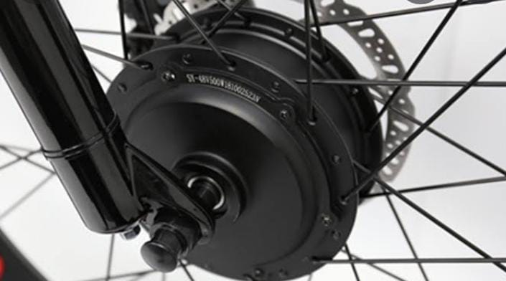
Fig.1. Hub Motor

2.Battery
The battery on an electric bike can be located in varying places on the bike, often dependent on frame type and size. Each battery make, model and type means that they will need to charge for different times. An average charging time is five to six hours. Charging your battery is easy: just like a mobile phone you plug it into the wall.

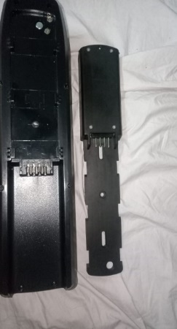
Fig.2.Battery

3. Sensor
The sensor on an electric bike is a highly important component. There are two types of sensor used on different e-bikes; a speed sensor or a torque sensor. The speed sensor immediately engages the motor once you begin pedaling which gives you the ride assistance. The torque sensor is a little smarter. It responds with just a small amount of assistance to match your speed when you're moving. It's much more responsive and helps with speed and maneuvers.

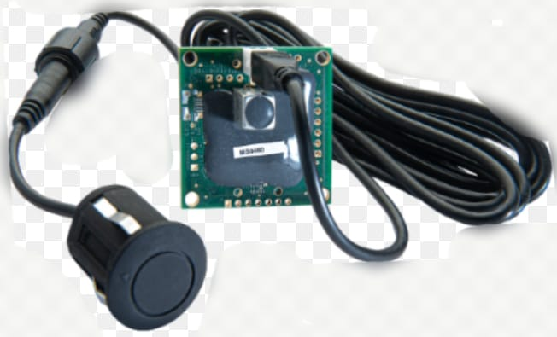 Fig. 3. Sensor

4.Controller
Available in a variety of styles, the controller lets you operate the electric assistance on your electric bike and is an important part in how electric bikes work. The controller is located on the handlebar for ease of use. There are two main styles of controllers – pedal-activated and throttle-based controllers .Pedal-activated systems offer electric assistance as you press down on the pedals. There is no need to engage a throttle – simple pedaling will do the trick. Electric bikes with pedal-activated systems have a controller mounted on the handlebar that lets you adjust the level of assistance that you receive as you pedal. You can dial in the amount of assistance you want, ranging from no assistance to a great deal of assistance.

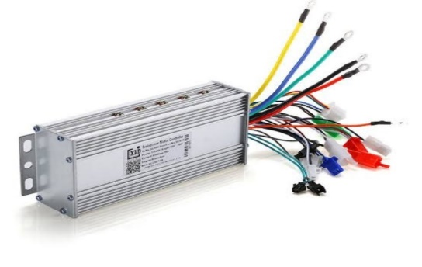
Fig.4. Controller

5.Throttle
Throttle-based controllers work with a simple throttle mechanism. The throttle will either be a twist-grip type or a thumb-press type. With a throttle, you simply pull back or press the throttle to receive the electric assistance. Some electric bikes require nothing more than activating the throttle, allowing you to ride without pedaling

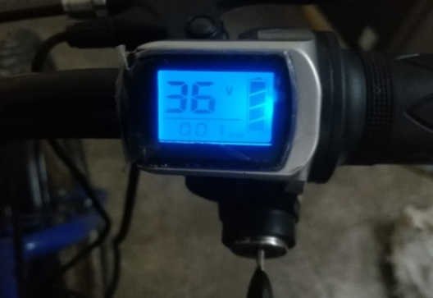
Fig.5.Throttle

6.Charging
Charging an electric bike is super simple - just like a mobile phone or laptop, you'll just need to plug it into any wall outlet. Batteries can take from 2 to 8 hours to charge; the time it takes is dependent on the make and model of the battery. Raleigh bikes use either Tranzx , Suntour or Bosch motor systems. Each of these will have different battery types and sizes. You can find out more about these individually on our electric bike batteries page. Most of our electric bikes will last up to 1000 charge cycles.

Fig.6. Charging

III Modeling

CAD MODEL

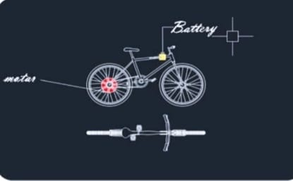
Fig.7. 3D view of Electrical Bicycle

IV Result

Due to project limitations, as referred before, we’ve designed two different designs, one to be de- signed from scratch and without paying much attention to the restrictions stipulated and other designed to be built and to constitute a fully working prototype for the project. Both models were structurally validated using a CAD software. After its structural validation and component choices the construction process was allowed to begin. The final result presents a fully working prototype, able to represent variable solution to be used.

V Conclusion
- This work was developed with the intent to project and build an electrically assisted bicycle adapted to the metropolis environment.
- It is a concept designed to create a better and versatile alternative to be used as mean of transportation in urban scenarios.
- It should present advantages and better features than the usual choices, as public transports, private cars or common bicycles.
- The project was thought to simplify and ease the transport in a in big city environments in general, yet, it was mainly aimed to be applied in the ”Last mile” concept. It was made a study on the market of electrical bicycles which revealed a large and exponential growth of sales of electrical bicycles in the last years.
- It showed that the future will certainly include electrical bicycles, not only to be applied in urban environments but to a varied range of applications. Growing environmental concerns allied with the development of the technology were two of the main reasons that led this market to experience such a high popularity in the present.
- In order to achieve a product that represents a viable solution as a mean of transportation and mainly directed to the ”last mile” concept a survey was made aiming to specify its main requirements. These requirements constitute crucial characteristics and features that the bicycle should present and they were considered to be: autonomy, weight, ease on transportation, practicability and safety.
- Starting from these key aspects, we could then proceed to project and engineer a suitable solution. Being a bicycle, or electrical bicycle, composed by several components, all these have to be properly chosen in order for them to be in compliance with each other and create a viable and capable solution.

References

[1]chetan mahadik,sumit mahindraka, “An improved &Efficient Electric bicycle system with the power of Real time Information sharing “,2014.
[2]D.M.sousa, P.J.Costa Branco,J.A.Dente ,Electric bicycle using batteries and supercapacitors,2007.
[3] Arun Eldho Aliasl,Geo Mathew2,Manu G3 Melvin Thomas4,praveen ,Energy Efficient Hybrid electric bike with Multi transmission System,2005.
[4]Olkaunle Alao, The Design Construction of an electric bicycle,2015.
[5]Srivastava Raghunath ,Hardware Design Consideration for an electric bicycle .
[6] Using Hub motor ,2014.
[7]Ian Vince McLoughlin ,I.Komang Narendra ,Leong Hai Koh ,Quang Huy Nguyen, Bharath Seshadri,Wei zeng ,chang Yao,Campus Mobility for the future :The Electric bicycle,2011.
[8]FABIAN FOGELBERG, Solar powered bike Sharing system,with Electric Bikes ,2010.
[9]Sheu, K. B., Hsu, T. H., & Hsu, Y. Y.A novel parallel hybrid motorcycle transmission.In Materials science forum.Trans Tech
Publications.
[10] Hsu, SuHau., Hsu, D. W., Fu, L. C., & Hsu, Y. P. (2004, June). Novel integrated management system design of electric
motorcycles. In American Control Conference, 2004.Proceedings of the 2004.IEEE.
[11]Huang, K. David.,&Tzeng, Sheng Chung. (2004). A new parallel-type hybrid electric-vehicle. Applied Energy, 79(1), 51-64.
[12].Yan, Wenguang.,Utkin, V., &Rizzoni, G. (2005, June). Power flow control for a series hybrid electric vehicle.In Proceedings
of the IEEE International Symposium on Industrial Electronics, 2005.ISIE 2005.IEEE.
[13].Quinn, C., Daniel Zimmerle, D., & Bradley, T. H. (2012). An evaluation of state-of-charge limitations and actuation signal

