IOT Based Smart Bridge and Monitoring System

Rupali Dasarwar¹, Tanmay Talwekar², Linta Mendhe³, Harsh Damke⁴, Khushi Markande⁵
¹Assi. Professor, Department of Artificial Intelligence and Data Science, Wainganga College of Engineering & Management, RTMNU University Nagpur, Maharashtra, India.
²B. Tech, Department of Artificial Intelligence and Data Science, Wainganga College of Engineering & Management, RTMNU University Nagpur, Maharashtra, India.
³B. Tech, Department of Artificial Intelligence and Data Science, Wainganga College of Engineering & Management, RTMNU University Nagpur, Maharashtra, India.
⁴B. Tech Department of Artificial Intelligence and Data Science, Wainganga College of Engineering & Management, RTMNU University Nagpur, Maharashtra, India.
⁵B. Tech Department of Artificial Intelligence and Data Science, Wainganga College of Engineering & Management, RTMNU University Nagpur, Maharashtra, India.

Abstract
Bridges are essential components of modern infrastructure, facilitating the movement of people and goods while connecting communities. As society grapples with the challenges of aging infrastructure and the increasing demands on transportation systems, the concept of a "smart bridge" emerges as a promising solution. Smart bridges leverage cutting-edge technologies and innovative design principles to enhance their performance, safety, and longevity. Smart bridges equipped with an autonomous water-level responsive elevation system represent an innovative and adaptive approach to infrastructure design. These bridges are engineered to detect rising water levels and automatically adjust their height to mitigate the risks of flooding and ensure the uninterrupted flow of transportation. This abstract explores the concept of a smart bridge with a water-level responsive elevation system, emphasizing its potential to enhance resilience and safety in the face of changing weather patterns and climate-related challenges. Smart bridges are integrated with a network of sensors, including water level sensors, weather stations, and real-time data analytics, all managed by a central control system. When water levels begin to rise due to heavy rainfall or other factors, the water level sensors on the bridge transmit data to the central control system. Advanced algorithms then determine the extent of elevation required to prevent flooding and maintain safe passage for vehicles. ESP32-based sensors and actuators are strategically placed throughout the bridge structure, constantly collecting data on key parameters such as structural integrity, environmental conditions, and water level. This real-time data is transmitted to a central control unit, where ESP32 microcontrollers process and analyze the information. These microcontrollers execute tasks ranging from structural health monitoring to dynamic water level.

Keyword: - Smart Bridge, IOT, ESP32, Water Lavel Monitoring, Bridge up, Bridge down

Introduction
Bridges are crucial elements of transportation infrastructure, but they can be vulnerable to flooding during heavy rains, storms, or other adverse weather conditions. To address this challenge, engineers and innovators have developed smart bridges that utilize ESP32-based systems to automatically raise the bridge's elevation in response to rising water levels. This introduction provides an overview of such a smart bridge system.
Bridges are susceptible to damage and obstruction when water levels rise significantly, posing risks to public safety and transportation disruptions. Traditional bridges often require manual intervention to prevent damage, such as closing the bridge to traffic or implementing temporary flood barriers. Smart bridges aim to address this issue by using automation and real-time monitoring to mitigate the impact of flooding.
A smart bridge system using ESP32for automatic elevation in response to rising water levels comprises the following components and features:

• Water Level Sensors: These sensors are strategically positioned in proximity to the bridge and monitor the water levels in the surrounding area. They are typically designed to provide real-time data.

• ESP32Boards: ESP32microcontrollers process the data from the water level sensors and control the mechanisms responsible for raising or lowering the bridge.

• Mechanical Actuators: These actuating mechanisms, such as hydraulic or pneumatic systems, are under the control of ESP32. They can be used to raise or lower the bridge as needed to maintain a safe clearance above the water level.

• Communication Modules: ESP32can be equipped with communication modules for remote monitoring and control. These modules can communicate with a central control system or even with local authorities.

• Central Control System: Data from the sensors is sent to a central control system where it is processed and analyzed. In response to rising water levels, this system can trigger the ESP32-based mechanism to elevate the bridge, ensuring it remains accessible and safe for use.

LITERATURE SURVEY

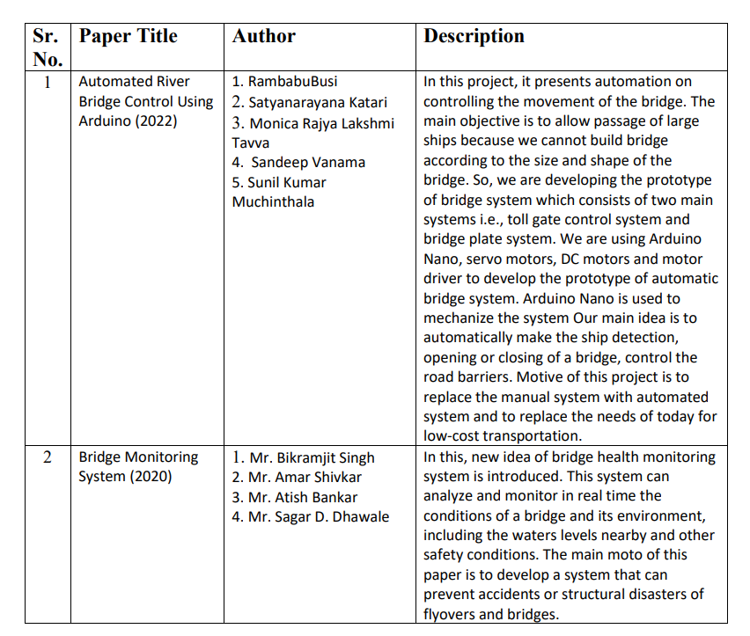

METHODOLOGY
This methodology offers a structured approach to developing a smart bridge system using ESP32 that raises the bridge when water levels rise. It emphasizes flood prevention, real-time monitoring, actuation system integration, community engagement, and environmental sustainability, among other crucial aspects. Specific details and priorities may vary based on the specific project requirements and objectives.

• Hardware Requirements:-

ESP32

Ultrasonic Sensor

Servo Motor

5V DC Power Supply

IR Sensor

16*2 Display

LED Light

MQ4 Gas Sensor

Buzzer

DHT SENSOR

• Software Requirement
1. Windows 11
2. Arduino IDE
• Language Used For Code
1. C/C++
2. HTML
3. CSS
4. Bootstrap
5. JavaScript

Helpful POints

Figures and Tables
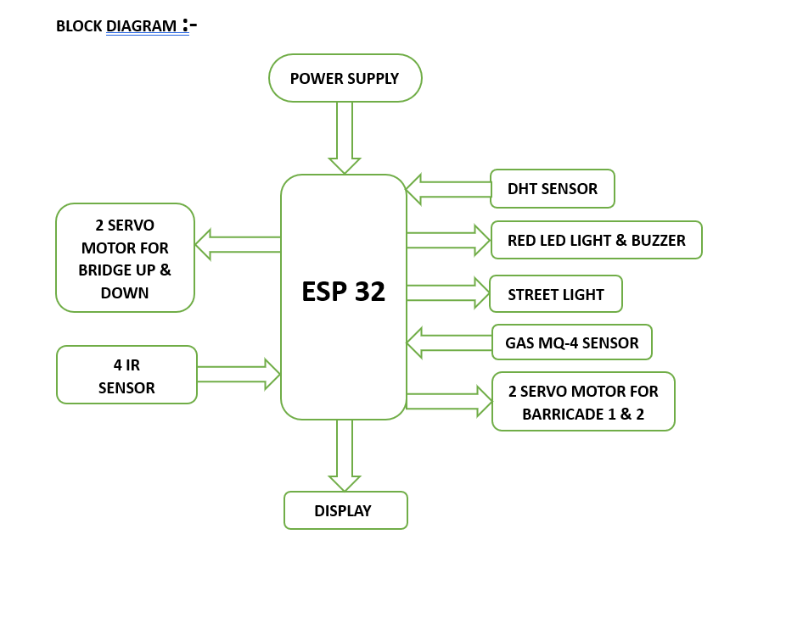

Conclusion
innovative In conclusion, a smart bridge using ESP32technology that automatically raises when water levels rise represents an and holistic solution for flood prevention and infrastructure enhancement. Its benefits span from improved public safety and traffic management to cost savings and sustainability. However, the successful implementation and operation of such a system demand careful planning, ongoing maintenance, regulatory compliance, and continuous optimization to deliver its full potential. With these considerations, a smart bridge system of this nature has the capacity to revolutionize how we approach flood control and bridge infrastructure management.
The development of a smart bridge system using ESP32technology to automatically raise the bridge in response to rising water levels is a transformative and forward-thinking solution for addressing flooding and enhancing overall infrastructure resilience. This conclusion provides a more detailed overview of the key aspects and considerations surrounding such a system.
The primary benefit of this smart bridge system is its ability to effectively prevent and mitigate flooding. By raising the bridge when water levels rise to critical thresholds, it safeguards lives, property, and infrastructure

Acknowledgment
Pursuit of the course of Bachelor of Technology (Artificial Intelligence & Data Science) is challenging task. At the threshold of its completion, the contentment one experiences, after putting in hours of hard work, is quite fulfilling. We would like to express our gratitude and respect to all those who have directly or indirectly, aided us in our work and research. We extend our sincerest gratitude to Prof. Rupali Dasarwar, Asst. Professor, Department of Artificial Intelligence & Data Science, WCEM, Nagpur, under whose guidance. We carried out this research. Without Head of department of Artificial Intelligence & Data Science advice and supervision our research would never have reached its conclusion. We are thankful to Dr. Bharat Chede, Principal of Wainganga college of Engineering and Management, Nagpur for providing excellent facilities and access to required technology and research material for our study. We also thank all respected teachers, colleagues and friends for all their support Tanmay Talwekar, Linta Mendhe, Harsh Damke, Khushi Markand

References
- “Automated River Bridge Control Using ESP32” Department of EIE, Lakireddy Bali Reddy College of Engineering (A), Mylavaram-521230 -- May (2022).

- Automatic Bridge Control for ships using PLC by JagtapNeha, JadhavAshwini, Thorat Akanksha from the journal IJIRT vol-6 published in 2020.

- A Review Paper on “BRIDGE MONITORING SYSTEM” International Research Journal of Engineering and Technology (IRJET) in Dec (2020).

- B Dhanalakshmi, A Prakadeesh, R Roshan Kumar International Journal of Innovative Technology and Exploring Engineering (IJITEE) ISSN: 2278- 3075, Volume-9 Issue-6, April, 2020

