Computer Aided Analysis of Twisted Blade Micro Wind Turbine
¹Mr. Pavankumar S. Nikure , ²Dr. Chandrashekhar N. Sakhale
Associate Professor,
Priyadarshani College of Engineering ,Nagpur ,India-440019

Abstract – This paper presents Computer Aided Analysis of Twisted Blade Micro Wind Turbine. Rapid depletion of fossil fuel resources necessitated research on alternative energy sources. A wind system is a reliable alternative energy source because it uses wind energy to create a stand-alone energy source that is both dependable and consistent. The main objective of this project is to investigate the design and development of micro wind turbines for integration into residential, commercial and industrial complexes. This project mainly focuses on Design of Twisted Blade Micro-Wind Turbine system using computer aided design and FEM analysis technology with Computational Fluid Dynamics
Keywords- F.E.M Analysis, Computational fluid dynamics, Twist Blade, Analytical Calculation, CAD Model, CFD Geometry, Creo Parametric 2.0.
INTRODUCTION
One of the driving forces for social and economic development and a basic demand of nations is energy. Most of the energy production methods are one-way, which requires change of form for the energy. In parallel to developing technology, demand for more energy makes us seek new energy sources. Researches for renewable energies have been initiated first for wind power. Wind energy have been deemed clean, inexhaustible, unlimited, and environmental friendly. Such characteristics have attracted the energy sector to use renewable energy sources on a larger scale. However, all renewable energy sources have drawbacks. A wind source is dependent on unpredictable factors such as weather and climatic conditions. Due to both sources’ complementary nature, some of these problems can be overcome the weaknesses of one with the strengths of the other. Wind energy stations for rural areas have proven to be advantageous for decreasing the depletion rate of fossil fuels, as well as supplying energy to remote rural areas, without harming the environment.

Distributed Generation (DG) refers to micro power plants at or near the loads, operating in a stand-alone mode or connected to a grid at the distribution or sub-transmission level, and geographically scattered throughout the service area. Distributed Generation includes small, modular technologies for electricity generation, located close to the load. DG technologies are used both in stand-alone mode as well as in grid parallel mode. Conventional electricity generating stations are typically located close to the fuel source and away from the loads, and electricity generated is conveyed through the transmission system to the load centre, which often requires large investment. Regular wind turbines are designed for large electricity production hence occupy large areas of land. These cannot operate in places where the wind speed is below 10m/s. Regular wind turbines can only operate given wind-speeds between 10m/s and 25 m/s.
1.1 Wind energy
Wind Power is energy extracted from the wind, passing through a machine known as the windmill. Electrical energy can be generated from the wind energy. This is done by using the energy from wind to run a windmill, which in turn drives a generator to produce electricity. The windmill in this case is usually called a wind turbine. This turbine transforms the wind energy to mechanical energy, which in a generator is converted to electrical power. An integration of wind generator, wind turbine, aero generators is known as a wind energy conversion system. A wind turbine is a machine for converting the kinetic energy in wind into mechanical energy. Wind turbines can be separated into two basic types based on the axis about which the turbine rotates. Turbines that rotate around a vertical axis are more common. Horizontal-axis turbines are less frequently used. Wind turbines can also be classified by the location in which they are used as Onshore, Offshore, and aerial wind turbines.

2. Component of a wind energy project
Modern wind energy systems consist of the following components:
- A tower on which the wind turbine is mounted;
- A rotor that is turned by the wind;
- The nacelle which houses the equipment, including the generator that converts the mechanical energy in the spinning rotor into electricity.
The tower supporting the rotor and generator must be strong. Rotor blades need to be light and strong in order to be aerodynamically efficient and to withstand prolonged used in high winds. In addition to these, the wind speed data, air density, air temperature need to be known amongst others.
3. Research Methodology

In this project, we are using CAD tool for designing of micro wind turbine for rural street light, Creo Parametric is sub module of CAD software’s. Also we are using CAE tool for Analyzing of micro wind turbine for rural street light, Ansys Workbench sub module of CAE software’s.
3.1 Creo Parametric 2.0

Creo Parametric 2.0 has been developed by Parametric Technology Corporation (PTC) of U.S.A. This is a CAD/CAM/CAE software but we are using this for only 3-D part modeling (CAD) of chassis.
This CAD includes :
1. Sketcher
2. Part Modeling(part design)
3. Advanced Part Design
4. Surface Design
5. Assembly Design
6. Drafting and Detailing.

3.2 Parametric Modeling Process
The following graphic illustrates the parametric modeling. 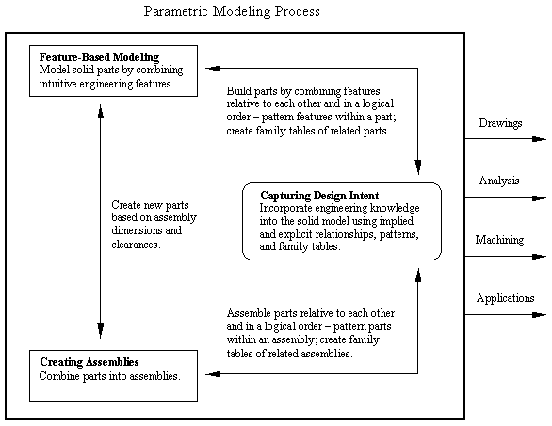
Fig 1. Parametric Modeling Process
3.3 CAD Model Drafting & Detailing of Components Turbine Blade
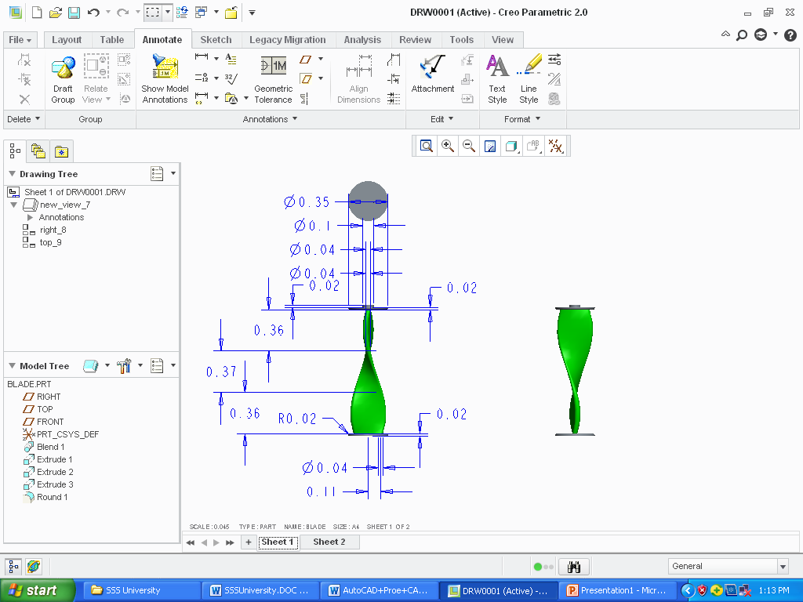
Fig 2-. CAD Model
4. Technical Assumptions for Twisted Blade Micro Wind Turbine

Table 1 - For Entire System
Dimensions | 1460mm (L)× 850mm (W) × 1900 mm (H)
Electronics Enclosure Rating | IP 53
Electrical Connection | On-Board Battery Charge Controller Grid-Tied Inverter
Generator | Permanent Magnet Axial Gap
Design Life | 25 Years

Table 2- For Blade
Wind Component Maximum Power Output | 500 W @ 17 m/s
Maximum Current | 30 Amps
Rotor Diameter | 13 in | 0.33 m
Cut-In Wind Speed | 2 m/s
Cut-Out Wind Speed | 18.5 m/s
Swept Area | 1,519 in² | 0.980 m²

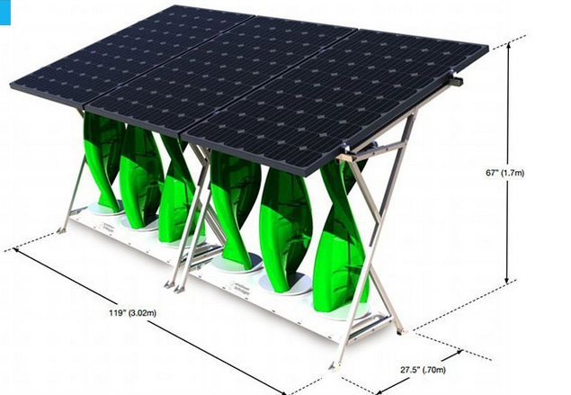
Fig 3- Conceptual Assembly of Twisted Blade Micro Wind Turbine

5. Analytical calculation
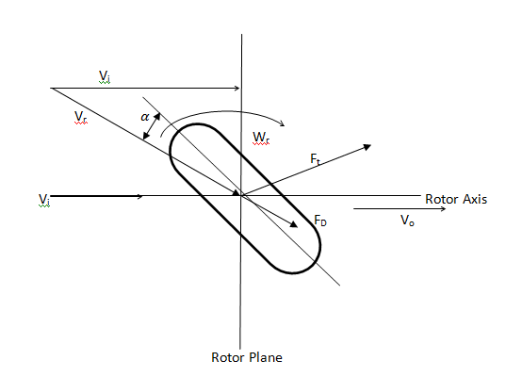
Fig 4. Diametric representation of Blade
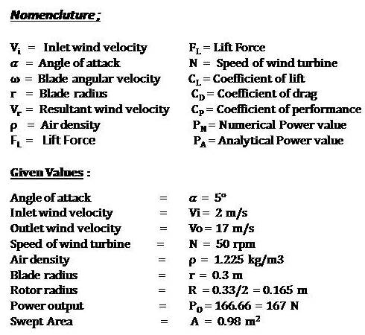
I. Wind Velocity ( V ) :
V = r ω
II. Resultant Wind Velocity ( V_{r} ) :
V_{r} = (V² + Vi² )^{1/2}
III. Power Numerical Value ( P ) :
Ρ = Torque * ω
P = F_{R} * r * ω
P = F_{R} * V

6. Turbine Blade Analysis
6.1 F.E.M Analysis of Twisted Blade
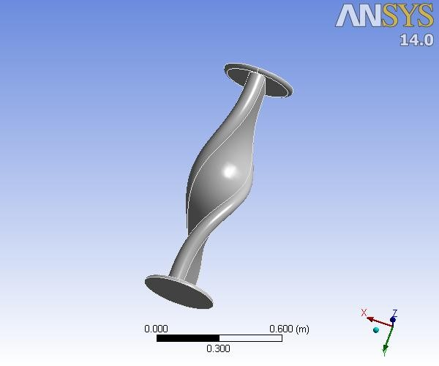
Table 3- Model - Geometry – Parts

 | Object Name |  | Solid
 | State |  | Meshed
 | Graphics Properties
 | Visible |  | Yes
 | Transparency |  | 1
 | Definition
 | Suppressed |  | No
 | Stiffness Behavior |  | Flexible
 | Coordinate System | Default Coordinate System
 | Reference Temperature |  | By Environment
 | Material
 | Assignment |  | Structural Steel
 | Nonlinear Effects |  | Yes
 | Thermal Strain Effects |  | Yes

Table 4 - Model – Mesh

Bounding Box

Length X | 0.35 m
Length Y | 1.16 m
Length Z | 0.35 m
Properties
Volume | 2.87e-002 m³
Mass | 225.29 kg
Centroid X | 1.8874e-003 m
Centroid Y | 0.54693 m
Centroid Z | 1.245e-003 m
Moment of Inertia Ip1 | 30.279 kg·m²
Moment of Inertia Ip2 | 1.8311 kg·m²
Moment of Inertia Ip3 | 29.738 kg·m²
Statistics
Nodes | 2009
Elements | 968
Mesh Metric | None

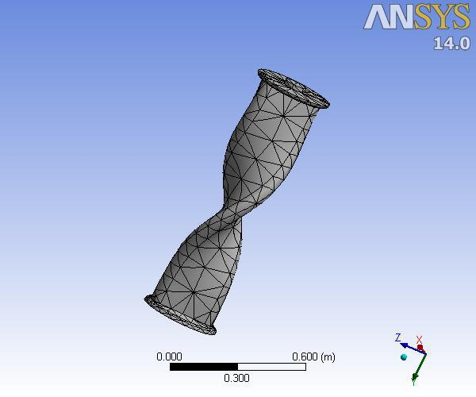

Object Name |  | Mesh
State |  | Solved
Defaults
Physics Preference |  | Mechanical
Relevance |  | 0
Sizing
Use Advanced Size Function |  | Off
Relevance Center |  | Coarse
Element Size |  | Default
Initial Size Seed |  | Active Assembly
Smoothing |  | Medium
Transition |  | Fast
Span Angle Center |  | Coarse
Minimum Edge Length |  | 2.e-002 m
Inflation
Use Automatic Inflation |  | None
Inflation Option |  | Smooth Transition
Transition Ratio |  | 0.272
Maximum Layers |  | 5
Growth Rate |  | 1.2
Inflation Algorithm |  | Pre
View Advanced Options |  | No
Patch Conforming Options
Triangle Surface Mesher |  | Program Controlled
Advanced
Shape Checking |  | Standard Mechanical
Element Midside Nodes |  | Program Controlled
Straight Sided Elements |  | No
Number of Retries |  | Default (4)
Extra Retries For Assembly |  | Yes
Rigid Body Behavior | Dimensionally Reduced
Mesh Morphing |  | Disabled
Defeaturing
Pinch Tolerance |  | Please Define
Generate Pinch on Refresh |  | No
Automatic Mesh Based Defeaturing |  | On
Defeaturing Tolerance |  | Default
Statistics
Nodes |  | 2009
Elements |  | 968
Mesh Metric
Mesh
Total Deformation

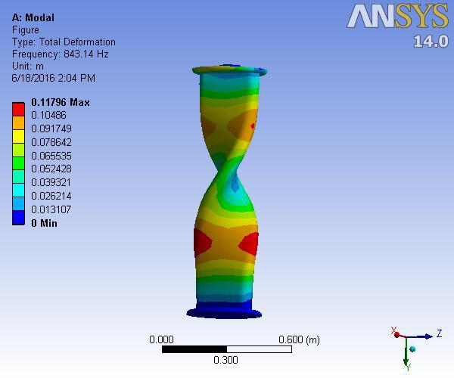

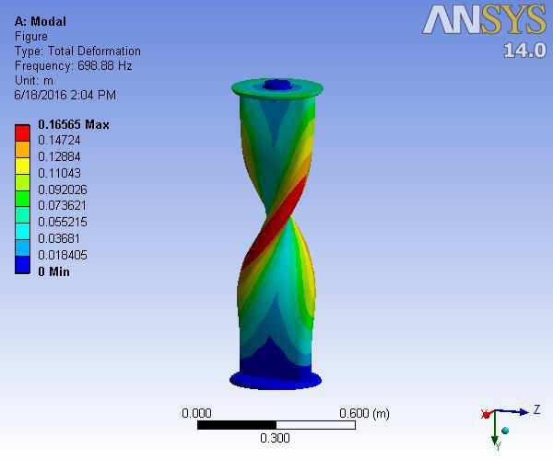

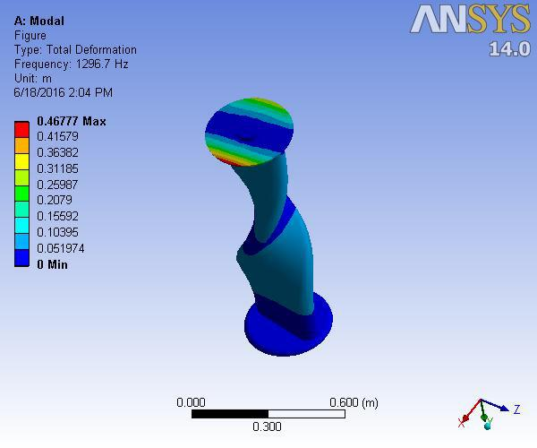

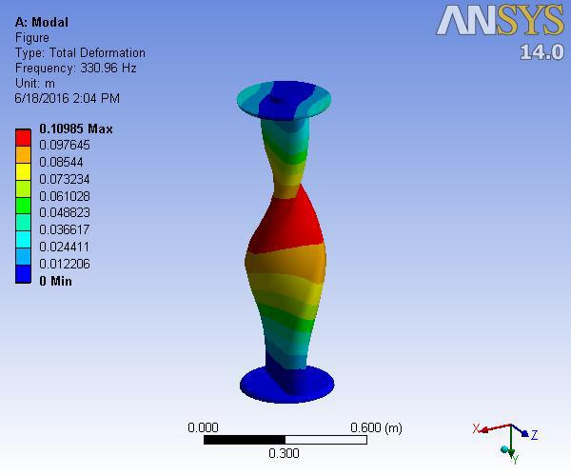

6.2 COMPUTATIONAL FLUID DYNAMICS
6.2.1 Computational Modeling:
The majority of wind turbine research is focused on accurately predicting efficiency. Various computational models exist, each with their own strengths and weaknesses that attempt to accurately predict the performance of a wind turbine. Descriptions of the general set of equations that the methods solve can be found in next chapter. Being able to numerically predict wind turbine performance offers a tremendous benefit over classic experimental techniques, the major benefit being that computational studies are more economical than costly experiments. While other approaches have been published, the three major models include momentum models, vortex models, and computational fluid dynamics (CFD) models. Each of the three models are based on the simple idea of being able to determine the relative velocity and, in turn, the tangential force component of the individual blades at various azimuthal locations.

6.2.2 Computational Fluid Dynamics:
Due to its flexibility, CFD has been gaining popularity for analysing the complex; unsteady aerodynamics involved in the study of wind turbines and has demonstrated an ability to generate results that compare favourably with experimental data. Unlike other models, CFD has shown no problems predicting the performance of either high or low-solidity wind turbines or for various tip speed ratios. However, it is important to note that predicting the performance of a wind turbine using CFD typically requires large computational domains with sliding interfaces and additional turbulence modelling to capture unsteady affects; therefore, CFD can be computationally expensive.
6.2.3 Grid Generation:
After the geometry for the VAWT had been defined, the next step is to discrete the computational domain as a pre-processing step in the CFD process. The act of discrediting the domain is termed grid generation and is one of the most important steps in the CFD process. For simple geometries where the direction of the flow is known beforehand, creating the grid is usually straightforward. For flows such as this, high quality structured grids can be used that can accurately capture the flow physics. However, as geometry becomes complex and the flows more difficult to predict with the onset of turbulence and separation, grid generation is no longer a trivial task.
6.2.4 Control Equation:
As the wind turbines Mach number at work is typically less than 0.3, so the flow around the airfoil could be considered as incompressible flow, the two dimensional incompressible N-S equations and two dimensional continuity equation are used as the control equations.
The two dimensional incompressible N-S equation is expressed in vector as follows :
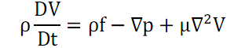
Where V is the velocity vector, f is the volume force vector, µ is the dynamic viscosity.
The continuity equation is showed as follows :
∇. V = o
Compared with the conventional k-ε turbulence model, the content on rotation and curvature is added to the Realizable k-ε model for the calculation of turbulence dynamic viscosity, and the equation of the dissipation rate ε is amended. Therefore, the model been shown that could simulate the flow around a blunt body effectively. Reynolds averaged equations and continuity equations are showed as follows :
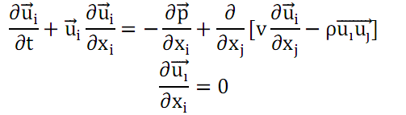
The mode equations of the turbulent kinetic energy k and turbulent kinetic energy dissipation rate ε are:
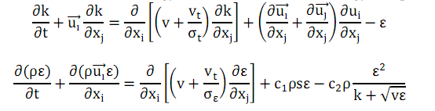
Realizable k –ε model has been widely used in various types of flow simulation, which includes Rotational average shear flow, free flow including jet and mixed flow, flow in pipes, boundary layer flow and backward-facing step flow, the result is consistent with the experimental data.
6.2.5 Meshing:
ANSYS meshing technologies provide physics preferences that help to automate the meshing process. For an initial design, a mesh can often be generated in batch with an initial solution run to locate regions of interest. Further refinement can then be made to the mesh to improve the accuracy of the solution. There are physics preferences for structural, fluid, explicit and electromagnetic simulations. By setting physics preferences, the software adapts to more logical defaults in the meshing process for better solution accuracy.
Other physics-based features that help with structural analysis include:
- Automated beam and shell meshing
- Editable contact definitions
- CAD instance modeling/meshing
- Rigid-body contact meshing
- Solver-based refinement
- Thin solid-shell meshing
Element = 449467
Nodes = 83302
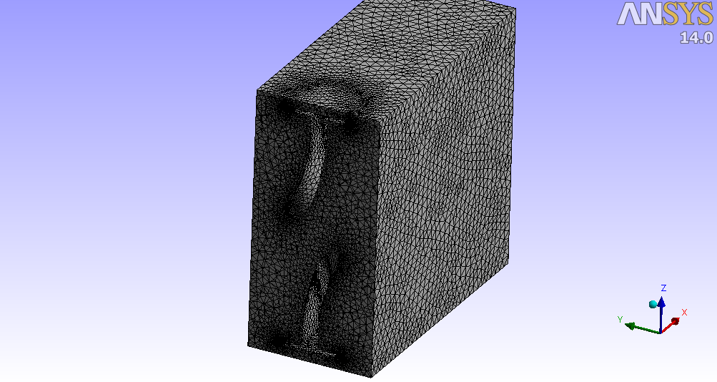
Fig 5- Meshing
6.2.6 CFD-Geometry:
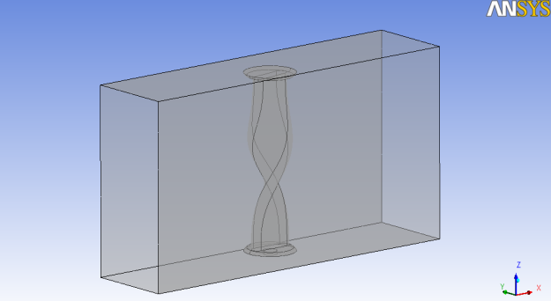
Fig 6- CFD-Geometry
6.2.7 Boundary Condition:
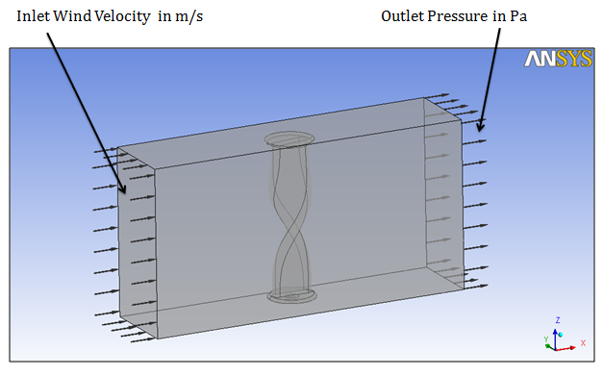
Fig 7- Boundary Condition
Above fig shows the boundary condition of hybrid wind-solar turbine in CFD software and further process i.e, pressure, velocity and temperature results is explained in next chapter.
7. Applications
Applications of Solar-Wind Hybrid Power System are listed below:
- Remote and rural village electrification
- Ideal for cell phone recipient stations.
- Residential colonies and apartments for general lighting.
- Street lighting
With the use of renewable energy based system the emission of carbon and other harmful gases are reduced to approximately 80% to 90% in environments.
Result and discussion
In this project, we work on different wind velocities extract in wind turbine and analyzed using CFD-CFX software are as :

Result
1) Wind Velocity = 2 m/s
2) Wind Velocity = 5 m/s
3) Wind Velocity = 8 m/s

Wind Speed | Case I  V_{i} = 2 m/s N= 50 rpm | Case II  V_{i} = 5 m/s N= 80 rpm | Case III  V_{i} = 8 m/s N= 100 rpm
Wind Velocity (V) | 1.57 m/s | 2.51 m/s | 3.141 m/s
Resultant Wind Velocity(V_{r}) | 2.54 m/s | 5.24 m/s | 8.6 m/s
Resultant Force | 106.4 N | 66.53 N | 53.16 N
Coefficient Of Performance (CP) | 34.78 | 2.22 | 0.54

Velocity Streamline:
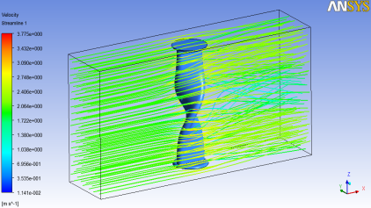

Pressure at Blade Surface :
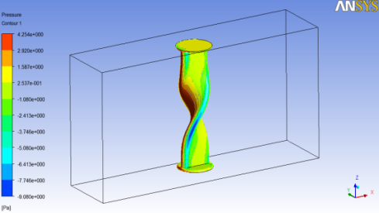

Pressure at c/s 0f Blade
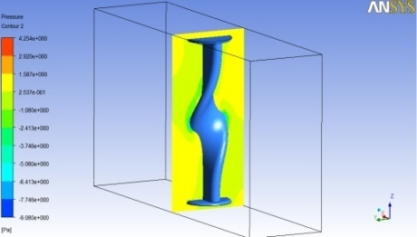

Conclusion

In this project, Turbine power generation system is good and effective solution for power generation than conventional energy resources. It has greater efficiency. It can provide to remote places where government is unable to reach. So that the power can be utilize where it generated so that it will reduce the transmission losses and cost. Cost reduction can be done by increasing the production of the equipment. People should motivate to use the non conventional energy resources. It is highly safe for the environment as it doesn’t produce any emission and harmful waste product like conventional energy resources. It is cost effective solution for generation. It only need initial investment. It has also long life span. Overall it good, reliable and affordable solution for electricity generation.
A turbine Energy System was implemented. A portion of the energy requirement for a private house, farm house, a small company, an educational institution or an apartment house depending on the need at the site where used has been supplied with the electricity generated from the wind and solar power. It reduces the dependence on one single source and has increased the reliability. Hence we could improve the efficiency of the system as compared with their individual mode of generation.

REFERENCES
[1] Casson, L., “Ships and Seamanship in the Ancient
World”. The Johns Hopkins University Press. pp. 57–
58, 1995
[2] Heyerdahl, T., Sandweiss, D.H., Narvaez, A.,
Pyramids of Tucume. Thames and Hudson Inc., New
York, 1995
[3] Dietrich Lohrmann, "Von der östlichenzur westlichen
Windmühle", Archivfür Kulturgeschichte,77,1,1995,
pp.1-30.
[4] Sathyajith, Mathew, Wind Energy: Fundamentals,
Resource Analysis and Economics. Springer Berlin,
2006. pp. 1–9
[5] A.G. Drachmann, Heron's Windmill. Centaurus,7,1961.
[6] Lucas, Adam, Wind, Water, Work: Ancient and
Medieval Milling Technology. Brill Publishers, 2006
p 105.
[7] Anon, “AWEA Small Wind Turbine Global Market
Study, Year Ending 2008”, American Wind Energy
Assoc., 2009.

[8] Mach, W., “Wind Turbines - Do you need one at
home?” Telegraph.co.uk, May 3, 2007.
[9] Parita G Dalwadi., “Feasibility Study of Solar-Wind
Hybrid Power System”. ISSN 2250-2459, Volume 2,
Issue 3, March 2012.
[10] Uur FESL., Raif BAYIR., “Design and
Implementation of a Domestic Solar-Wind Hybrid
Energy System”

