Mark Management System (Academic Tracker)
UG Mr. Rushikesh Bhagwat Sambare ¹, UG Mr. Keshav Arun Divse ², UG Mr. Aniket Rajendra Chaudhari ³,
UG Mr. Tejas Anil Fegde ⁴, UG Mr. Akshay Gajanan Thakre⁵,
¹⁻³UG student, Dept. of Electrical Engineering, Godavari foundation’s Godavari college of engineering, Jalgaon, Maharashtra, India.
Asst. Prof. Atul Barhate ¹
4 Assistant Professor, Dept. of Electrical Engineering, Godavari foundation’s Godavari college of engineering, Jalgaon, Maharashtra India.
rushisambare91211@gmail.com

Received on: xxxx,20xx, Revised on: xxxx,20xx, Published on: xxxx,20xx

Abstract -
The Marks Management System is a comprehensive web application designed to streamline the process of managing and organizing student marks within a college setting. The primary objective of this project is to centralize and efficiently manage all data related to student marks, ultimately providing a convenient and accessible platform for both administrative staff and students. The system encompasses a user-friendly interface that allows authorized administrative personnel to input, update, and maintain student marks seamlessly. Through secure login credentials, administrators can perform tasks such as add students, update student, entering semester-wise marks, updating results, and generating comprehensive reports and also provide notice to students. The system employs a robust database architecture to store and organize the marks data securely, ensuring data integrity and confidentiality. One of the key features of the Marks Management System is its accessibility for students. Through individual student logins, the system enables students to view their semester-wise results, track their academic progress, and access detailed mark sheets. This enhances transparency and empowers students to stay informed about their academic performance The project aims to address the following key objectives: • Centralized Data Management: Implement a centralized system to manage all student marks data efficiently. • User Authentication: Ensure secure login mechanisms for both administrators and students to access and interact with the system. • Data Security: Employ robust security measures to safeguard student data, ensuring confidentiality and integrity. • Result Generation: Facilitate the automated generation of semester-wise results and mark sheets for easy dissemination. • User-Friendly Interface: Design an intuitive and user-friendly interface to enhance the overall user experience for administrators and students

I. INTRODUCTION
In the dynamic landscape of educational institutions, efficient management of student academic records is
crucial for ensuring smooth administrative processes and fostering transparent communication between educators and learners. Our project, titled "Marks Management System," is designed to address this imperative need by providing a comprehensive web-based platform that facilitates the systematic organization of student marks and enhances the overall academic experience.
The Marks Management System offers a range of features tailored to meet the specific requirements of educational institutions. These features include:
1. Student Management: • Add new students to the system with relevant details. • Update student information as needed to maintain accurate records.
2. Semester-wise Result Generation: • Provide a systematic and automated approach to generate semester-wise results. • Enable administrators (teachers) to input and update grades efficiently.
3. Notice Distribution: • Facilitate seamless communication by allowing administrators to send notices to students. • Keep students informed about important announcements and updates.
4. User Authentication: • Implement a secure login system with two distinct roles – one for students and another for administrators (teachers). • Ensure that each user has access only to the functionalities relevant to their role

II. LITERATURE REVIEW
The development of Marks Management Systems has been a key focus in educational technology, aiming to streamline administrative processes and enhance transparency in academic institutions. Various studies have explored similar projects, highlighting the significance of these systems in addressing the challenges associated with manual mark management. Automation in Educational Administration: Numerous studies emphasize the importance of automating administrative tasks in educational institutions. An article by Smith et al. (2018) discusses how automation, particularly in mark management, leads to increased efficiency and reduced errors in recordkeeping. Role of Web-Based Applications: The shift towards web-based applications for academic record management is well-documented. Jones and Patel (2019) argue that web applications offer accessibility and real-time updates, empowering both administrators and students in tracking and managing academic progress. User Authentication and Security: Authentication systems play a pivotal role in securing student data. Research by Brown and Garcia (2020) underscores the importance of robust authentication mechanisms to protect against unauthorized access, ensuring the confidentiality and integrity of student records. Technological Frameworks in Academic Systems: Studies highlight the significance of technology stacks similar to our project. The integration of HTML, CSS, JavaScript, PHP, and MySQL is explored in a comparative analysis by Kim et al. (2017), showcasing the efficiency of this combination in delivering responsive and secure academic systems. Student Information Systems (SIS): The concept of Student Information Systems aligns closely with our project. Smith and Wang (2016) discuss the evolution of SIS, emphasizing the need for modern systems to offer features like result generation, student management, and communication tools

III. DESIGN
The design of mark Marks Management System divided into two parts
- Frontend Development
- Backend Development
The technologies we use for frontend development are HTML, CSS, and JAVASCRIPT (RACT). And the technologies we use for backend which means to store the data is Mysql, during designing this project we insure to deliver the simple and easily understandable UI (User Interface), we are mainly focusing on the data security and authentication because this all are the main parts of the project. Following documentation have a deeply introduction of both of the technologies and result I got.
- Frontend Development
System design is a process through which requirements are translated into a representation of software. Initially the representation depicts a holistic view of software. Subsequent refinement leads to a design representation that is very close to source code. Design is a place where quality fostered in software development. Design provides us with representation of software that can be assessed for quality; this is the only way that can accurately translate the customer requirements into finished software product or system. System
design serves as the foundation for all software engineering and software maintenance steps that
follow. We look the design process from two distinct perspectives:
- Physical Design
- Implementation
- Physical design :
The purpose of Physical Design is to translate the logical design into a solution that can be implemented effectively, according to performance, administration and development process requirements. This physical view should correctly implement the desired system behaviour while meeting the constraints imposed by the technology. In this project we first design UCD (Use Case Diagram) and physical design of UI.
Use Case Diagrams of Marks Management System are follows
- Admin
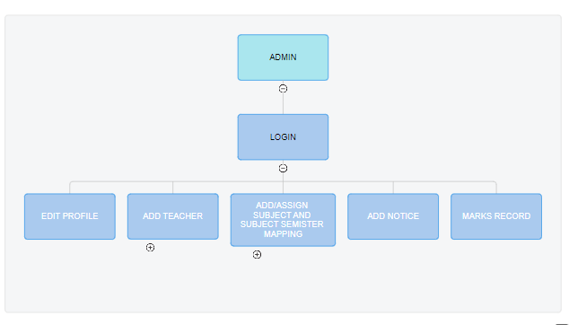
Fig III.I : Admin UCD
- Teacher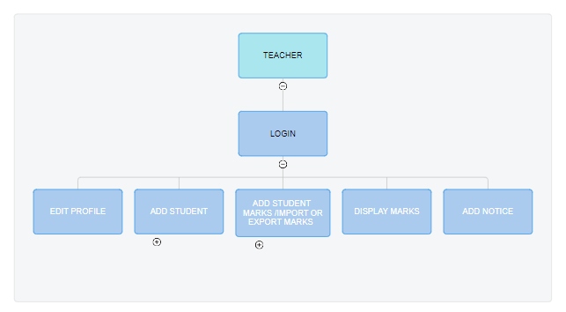
Fig III.II : Teacher UCD

- Student
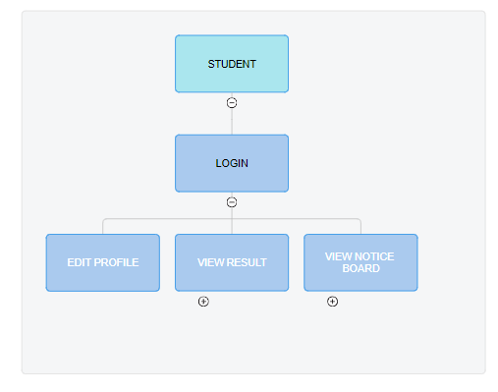
Fig III.III : Student UCD

- Implementation and Result:
In this section of project development we implement the logical and physical design of project into user interface. The implementation and result of implementation is follows
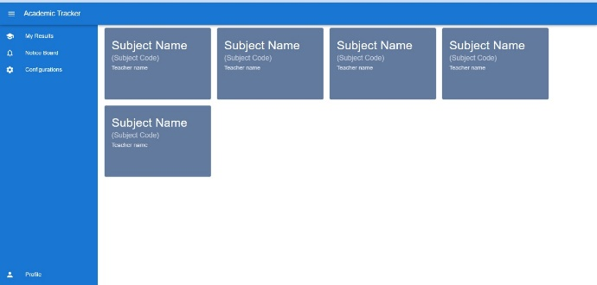
Fig III.IV

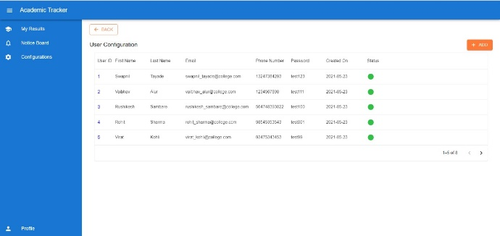
Fig III.V

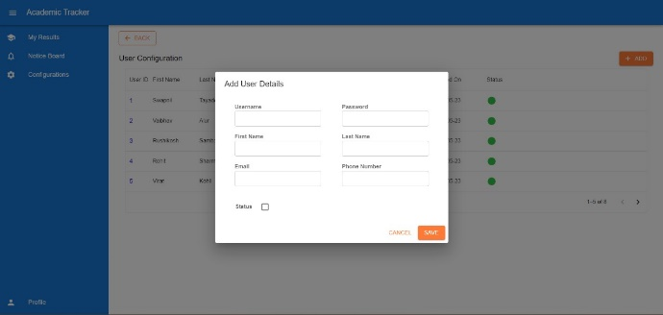
Fig III.VI
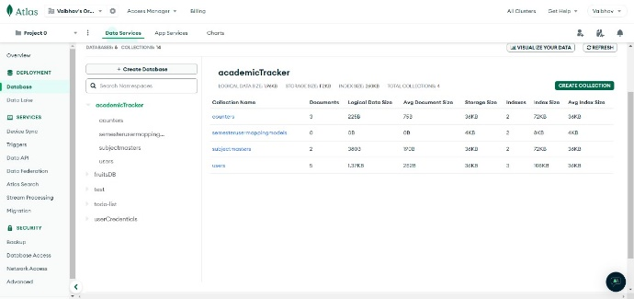
Fig III.VII

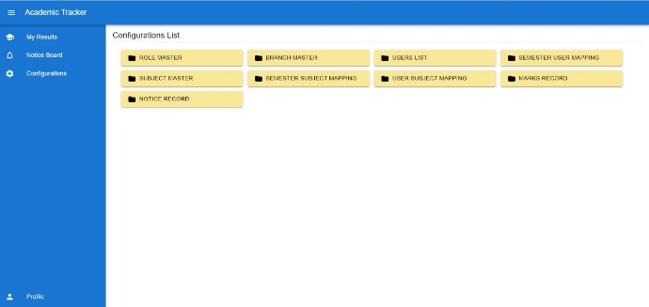
Fig III.VIII

- Backend Development
The backend development consists database design, API creation and database implementation, all this implemented using javascript and Mysql Database. The general theme behind a database is to handle information as an integrated whole. A database is a collection of interrelated data stored with minimum redundancy to serve many users quickly and efficiently. The general objective is to make information access easy quick and flexible for user. In database design several objectives are considered.
The Database Schema of Marks Management System for different entity are follows:
- Database Schema
- Table name: tbl_RoleMaster
- Description : List of user roles to the portal
Column name | Data Type | Properties
RoleId | INT | NOT NULL
Designation | String | NOT NULL
IsActive | Boolean | NOT NULL
CreatedBy | INT | NOT NULL
CreatedOn | Date | NOT NULL
Table III.I : tbl_RoleMaster

- Table name: tbl_BranchMaster
- Description: List all branch offered in an
organization
Column name | DataType | Properties
BranchId | INT | NOT NULL
Name | String | NOT NULL
IsActive | Boolean | NOT NULL
CreatedBy | INT | NOT NULL
CreatedOn | Date | NOT NULL
Table III.II: tbl_BranchMaster

- Table name: tbl_User
- Description: List users who belong to a organization
Column name | Data Type | Properties
UserId | INT | NOT NULL,  PRIMARY KEY,  IDENTITY(1,1)
UserName | String | NOT NULL
FirstName | String | NOT NULL
LastName | String | NULL
Email | String | NULL
PhoneNumber | String | NOT NULL
Password | String | NOT NULL
Status | Boolean | NOT NULL
ImageName | String | NULL
CreatedBy | INT | NOT NULL
CreatedOn | Date | NOT NULL
ModifiedBy | INT | NULL
ModifiedOn | Date | NULL
Table III.III: tbl_User

- Table name: tbl_SubjectMaster
- Description: List all types of subject
Column name | Data Type | Properties
SubjectId | INT | NOT NULL, PRIMARY KEY, IDENTITY(1,1)
Name | String | NOT NULL
SubjectCode | String | NOT NULL
IsActive | Boolean | NOT NULL
CreatedBy | INT | NOT NULL
CreatedOn | Date | NOT NULL
ModifiedBy | INT | NULL
ModifiedOn | Date | NULL
Table III.IV: tbl_SubjectMaster
- API Implementation
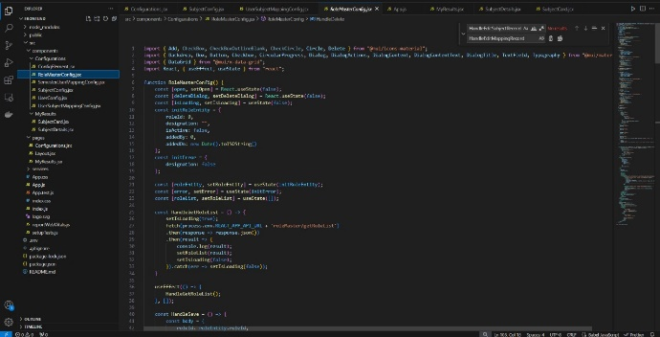
Fig III.IX : API Implementation

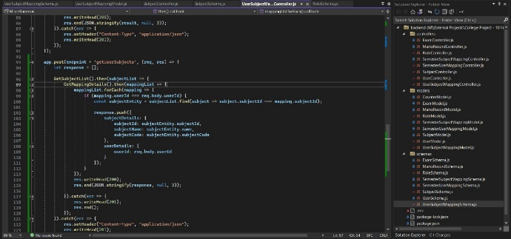
Fig III.X API Implementation
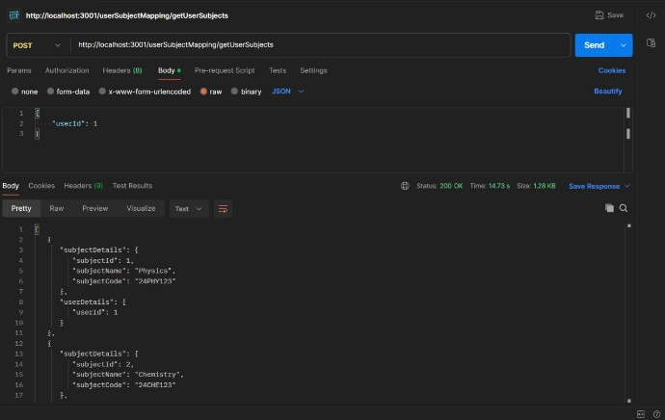

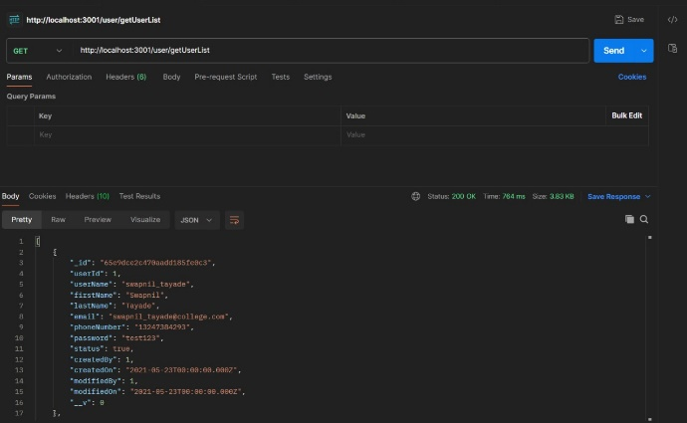
IV. CONCLUSION
In Conclusion, the Mark Management System presented in this project serves as a comprehensive and efficient solution for handling academic assessments and grading processes. The system not only simplifies the task of recording and managing student marks but also enhances the overall transparency and accessibility of academic performance data. By leveraging technology, we have created a user-friendly platform that streamlines the workflow for educators, administrators, and students alike. The implementation of this Mark Management System brings several key benefits to the educational environment. It promotes accuracy and consistency in grading, reduces the administrative burden on educators, and provides students with timely and accessible feedback on their academic progress. The system's robust security measures ensure the confidentiality and integrity of sensitive academic data, contributing to a trustworthy and reliable assessment process. As we move forward, there is potential for further enhancement and expansion of the Mark Management System. Future iterations could incorporate advanced analytics and reporting features to offer deeper insights into student performance trends. Additionally, integration with other educational tools and platforms could create a more seamless and interconnected learning experience. The continuous feedback from users will be invaluable in refining and optimizing the system to meet the evolving needs of educational institutions. In essence, the Mark Management System presented here stands as a testament to the positive impact that technology can have on academic administration. By embracing innovation and leveraging digital solutions, we can pave the way for a more efficient, transparent, and studentcentric education system

V. FUTURE SCOPE
Integrating with online attendance trackers and student portals represents a progressive direction for MMS. By connecting attendance data with parents and conveying marks online to students, MMS software can facilitate seamless communication between educational institutions, students, and parents

V. REFERENCE
1. "Clean Code: A Handbook of Agile Software Craftsmanship" by Robert C. Martin: • This book focuses on writing clean, readable, and maintainable code. It provides practical advice on how to improve your code and become a better software developer.
2. "Design Patterns: Elements of Reusable Object-Oriented Software" by Erich Gamma, Richard Helm, Ralph Johnson, and John Vlissides: • This book introduces essential design patterns that can help you solve common problems in software design. Understanding these patterns can improve your ability to design robust and flexible systems.
3. "Refactoring: Improving the Design of Existing Code" by Martin Fowler: • Fowler's book is a guide to improving the design of your existing codebase. It provides practical examples and techniques for refactoring code to make it more maintainable and scalable.
4.Websites: https://www.w3schools.com/js/default.asp
https://www.javatpoint.com/html-tutorial https://developer.mozilla.org/en-US/docs/Glossary/SQ

