GSM BASED INDUSTRIAL SECURITY SYSTEM
¹Ms. Kashmira Thul , ²Ms. Priti Dhote ,³ Ms. Ashwini Chakole , ⁴Mr. Samir Raipurkar , ⁵Prof.( Mrs.) A.H. Charkhawala
^{1,2,3,4} ( BE Final year Students , Department of E & T, PCE, Nagpur,
¹Kashmirathul2809@gmail.com, ²pritidhote2013@gmail.com, ³ashwinichakole92@gmail.com , ⁴samirraipurkar@gmail.com , ⁵archanacharkhawala@gmail.com )
ABSTRACT :- In this paper, we have tried to increase the level of security system by combining new techniques and added new concepts to develop low cost GSM based industrial security system. In our day to day life or in industrial purpose security and automation is a prime concern. Industrial automation and security system design is growing nowadays. The designing of this security system is simple hardware circuit. It allows every users to use this wireless security system by using or combining PIR sensor, gas sensor, fire sensor and main failure detector at industrial level.
KEYWORDS :- GSM, PIR, LED, LCD, IC 555.

- INTRODUCTION

Security is the main concern for every industry. Every industry wants to work in safe and secured environment that are beneficial for the workers and specially for their production process say for raw materials in the industry.
Every industry want their workers to keep safe and secured from various incidents like accidents caused due to LPG gas leakage or accidents due to fire in their godown or their machinery department.

- WORKING PROCESS
- First module(Infrared Sensor) :-

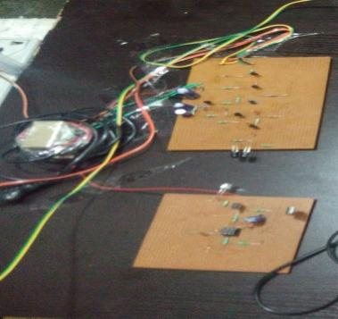
Fig. 1 : Working Model of IR Sensor
This project detects if any worker is entering inside the department or not.
If some workers enters the working chamber or machinery room the lights will be on and if no one is present in the working room the lights will be off.
If there is no one in the working chamber or in the plant then in that case if the lights or halogen bulb near the convey or belt or the boiler is continuously on so this wastage of electricity will cost heavy bills for the company.
By using this system the wastage part can be easily overcome and more important than that this circuit is wireless and automatic on off lights so need for manual working for switching off the lights every time.
- Second Module: (Gas Sensor) :-
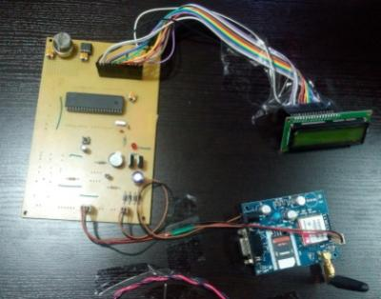
Fig. 2 : Working Model of GAS Sensor
It uses LPG gas sensor to detect the gas leakage. If there is leakage then buzzer is turned on.
Specially in the cooking gas industry they have to be very careful with whatever their are working or designing.
Because there are thousand of pipes that bypass the LPG gases from inlet of pipe to another outlet of pipe. If there is leakage in the pipe due to any reasons in the night time or any time there might be chances of getting major incidents of end of workers. This system can protect the workers all damages.
Sending of data will be there if the gas is leakage on the registered mobile number.

- Third module: (Fire Sensor) :-
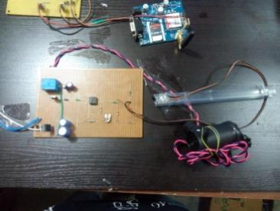
Fig. 3 :Working Model of Fire Sensor
It uses the fire sensor for detection of fire in the industry or say go down or gas filling chamber.
If the fire is detected then in that case the fire detection sensor will sense and will on the water sprayer pump working as fire extinguisher and when the fire is extinguished automatically the water sprayer pump will be off. no need for manual switching on and off of the circuit.
It will work automatically.
- BLOCK DIAGRAM
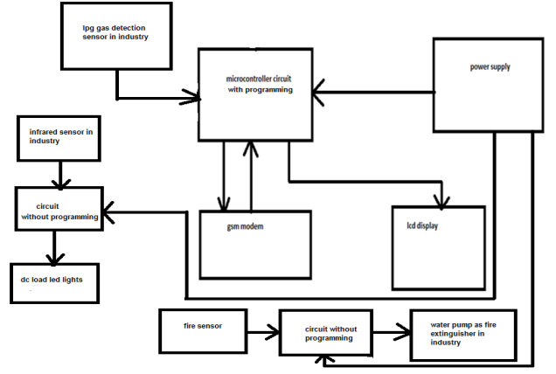
Fig.4 : Block Diagram Of Project

- COMPONENT DESCRIPTION

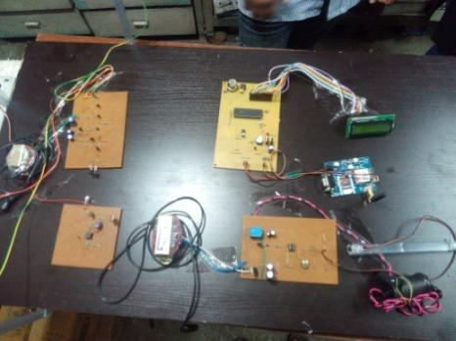
Fig. 5 : Photo Of Working Model Project
It mainly consist of following:-
Infrared Transmitter: We are going to implement the Person detection module using 1 transmitter and 1 receiver. We are going to use Infrared transmitter because infrared beams are not visible to human eyes. Transmitter used is IR LEDs
Receiver: We are using an Infrared receiver. It is an active low device. It gives low output when it receives the Infrared rays.
Microcontroller: This is the CPU (central processing unit ) of project. We are going to use a microcontroller 8051IC . The many types functions of microcontroller are like.
Electrical load: As light will be used.
Sensor: Gas leakage detection.
Regulator IC of 5 volt DC: It will convert the 12 volt DC to 5 volt DC and the microcontroller IC will start working.
Reading the digital input from infrared receiver to find whether person is entered inside room or not. II. Sending this data to LCD so that the person operating this project should read the number of persons inside the room.
LCD: We are going to use 16×2 alphanumeric LCD (Liquid Crystal Display) it can display alphabets with numbers on 2 lines each containing 16 characters.
GSM Modem: We are going to use sim300 as a GSM modem. The status of persons inside the room, LPG Gas leakage status will be sent to GSM modem.
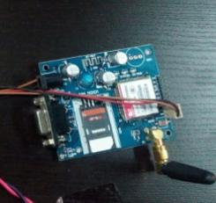
Fig. 6 : Photo Of GSM Model
Preset : It will adjust the LCD brightness.
Resistance: It will stabilize the current flow in the circuit.
Transformer : It will step down 230 volt AC to 12 volt AC.
Bridge diode : It will convert the 12 volt AC to 12 volt DC.
Capacitor : It will purify the voltage that is it will remove the ripples in the supply.

- APPLICATIONS
This project has its main application in security system or and accident avoiding system for the coal mines or wood cutting industry or cotton industry.
Various parameters monitored in this project like LPG gas leakage, are also applicable for industrial purposes. So this also be used in industries as a GSM based industrial security system.

- ADVANTAGES
With the help of GSM technology industry officer get remote indication through SMS. So if the user is away from industry, he/she will be intimated about the hazardous situations inside the house.
This is fully automated. So once this system is installed inside home or industry, then there is no neesd to operate the system by human. we can save the life of person inside home / industry with the help of this system. Since the accidents caused due to fire and LPG gas leakage can cause life threat.

CONCLUSION
In this paper presentation the gas detection and alerting system will be done through SMS. The fire extinguisher circuit called as automatic fire sprayed on fire detection pump on and when fire extinguish the pump will of. Automatic lights on-off system through invisible rays is also installed.

FUTURE DEVELOPMENT
Voice announcement system can be added to indicate device status. We can add voice announcement system with the buzzer so if there are hazardous parameters detected then respective voice message will be announced.

ACKNOWLEDGEMENT
This gives us immense pleasure in submitting the project entitled “GSM Based Industrial Security System" ,which is the part of curriculum of Mega project for Eight semester.
We acknowledge our deep sense of gratitude and great respect to our guide Prof. (Mrs.) A. H. Charkhawala Mam under whose able guidance, continuous encouragement and keep supervision we have been able to accomplish this mega project.
We are thankful to our head of the department Dr. (Mrs.). S. W. Varade Mam for providing all the facilities required in order to accomplish this mega project.
At last, we express our deep sense of gratitude to all the staff members for their kind support.

REFERENCES
[1] “Android Interface Based GSM Home Security System” IEEE Publication. By Rupam Kumar Sharma
[2] M. Sravan kumar, M Mounika “GSM based industrial security system” IEEE Publication.
[3] Society Annual Meeting, Conference Record of the 1994 IEEE publication, ISBN: 0 - 7803 - 1993 - 1, 3(1994) 2121 – 2125
[4] ,“Hydroelectric Infrared Sensors based Distance Estimation”,Zappi P., Farella E., Benini L. Dept. of Electron, Inf. & Syst., Univ. of Bologna. IEEE Publication, (2008) 716-719.
[5] System, "IEEE International conference, ISDN : 0 - 7803 - 8482 - 2, (2014) 237 – 238.
[6] Mehta V.K (2003): “Principles y Electronics". Published by S. Chand and Company Ltd.

.

