Wastewater Treatment Using Tidal Flow Constructed Wetland
Dr R. P. Borkar¹, P.S. Mahatme²
¹Principal,
GCOE, Jalgaon, 425001
²Assistant Professor
PRMCEAM, Badnera, 444701
Abstract – Wastewater can originate from a combination of domestic, industrial, commercial or agricultural activities, surface runoff or storm-water, and from sewer inflow or infiltration. Haphazard disposal of untreated wastewater from households as well as institutions and industry is causing severe deterioration of water bodies in many urban areas in the developing world. There are several methods to treat the wastewater for intended use. Constructed Wetlands are an effective, environmentally friendly means of treating liquid waste. Tidal flow wetland is improved wetland systems employ flood and drain cycles within the wetland bed.
This study was carried out on laboratory scale tidal flow constructed wetland system of dimension 35cm x 35cm x 120cm. A main objective of study was to assess the overall effectiveness of the tidal flow constructed wetland system. A constructed wetland system, consisting of pair of cells operated in tidal flow for detention period of 5 days and 7 days. The bed of cell arranged in layers with different media size, typha species was used for vegetation. BOD, COD and Copper removal was observed to be 92%, 87% and 91% respectively for detention period of 7 days.
Keywords- Wastewater, Tidal flow wetland.
INTRODUCTION
At present, there are severe environmental problems related to water crisis including water shortages, water pollution and deterioration of water quality worldwide, especially in developing countries. Furthermore, the situation is becoming more serious because of low water use efficiency and worsening man-made pollution or natural contamination. Therefore, growing public awareness of environmental issues is pushing the government to implement more stringent water and wastewater treatment standards for environmental protection. However, in an increasingly harsh economic climate, conventional energy-intensive wastewater treatment systems are becoming disadvantageous. In addition, these treatments could not reduce nutrient pollution effectively although they are known to be efficient in removing organics.
Biological Wastewater Treatment is one of the most important parts of wastewater treatment and microorganism has importance role in biological treatment (Jian Zhang et.al., 2016) Microorganisms effect in metabolism of various organic compounds and other elements. Such microbiological parameters as the number, weight and activity of microorganisms can be good indicators of wastewater contamination with heavy metals (Majid Sa’idi, 2010).

Constructed wetlands:
Constructed wetlands are treatment systems that use natural processes involving wetland vegetation, soils, and their associated microbial assemblages to improve water quality. Constructed wetlands are especially well suited for wastewater treatment in small communities where inexpensive land is available and skilled operators are hard to find. Constructed Wetlands (CWs) are an effective, environmentally friendly means of treating liquid waste. CWs could bring major economic benefits to developing countries through the provision of biomass and aquaculture. Such wetland systems can yield a significant profit for local communities, and might be a powerful tool for breaking the poverty cycle. CWs are effective at reducing loads of BOD/COD, nitrogen, phosphorus and suspended solids (David Austin, 2012).
- Types of Constructed Wetland:
Constructed wetland are basically categorised into surface and subsurface wetland depending water flow above or below the substrate. Subsurface flow is again categorised into Horizontal flow, Vertical flow and Hybrid flow. Fig 1 shows various type of constructed wetland. The present study is aim to treat synthetic wastewater prepared by using 4th generation tidal flow wetland.
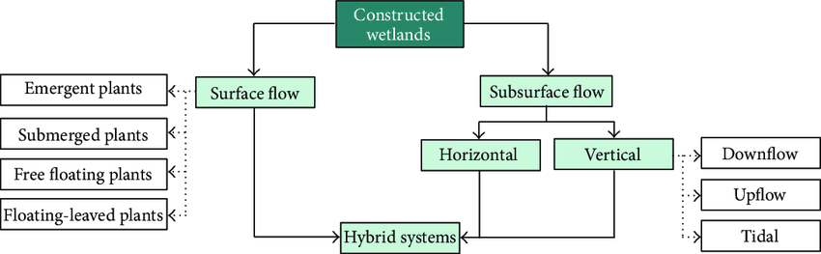
Fig 1 Type of Constructed Wetland
Efficiency of wetland can be improved by integration of hydraulic or aeration machinery into it. Together with improved scientific understanding of wetlands, these developments represent the emergence of a new generation of engineered wetlands that not only improve treatment performance, but also can successfully compete with many conventional technologies ^{[4]}.
Tidal Flow Wetland:
Integration of hydraulic or aeration machinery into constructed wetlands is responsible for these increased treatment capabilities. Together with improved scientific understanding of wetlands, these developments represent the emergence of a 4th generation of engineered wetlands that not only improve treatment performance, but also can successfully compete with many conventional technologies in the marketplace ^{[4]}. Tidal flow CWs are a variant of passive CWs owning improved treatment performance and capacity. They are operated in accordance with sequencing batch philosophy with a cycle consisting of fill, contact, drain, and rest period sequentially whereby a tide is generated in the bed matrix. In such a tide regime, the redox status in the bed matrix varies with the saturated/unsaturated conditions corresponding to the contact/rest periods. Herein, the nitrification and denitrification can be promoted in a tide cycle, respectively ^{[5]}.
MATERIAL & METHODS
Experimental Set-up
Tidal flow wetland system was fabricated; the constructed wetland units made up of acrylic having dimensions 35cm x 35cm x 120cm. The model was set up with overall capacity of 200 L. The system comprises of two wetland units having different layer of aggregates, coarse sand, fine sand and soil with typha. The inlet and outlet arrangements were provided at bottom of units at both ends, detail of the setup is shown in fig 2. The fill and drain cycle in bed for various detention periods were achieved by programming, electrically operated solenoid valve and moisture sensors. Each wetland cell is 1.2 m in depth, different layer of filter media are provided within cell. Bottom layer consists of coarse gravel having depth of 7.5cm; above this layer fine aggregate is placed having depth 7.5 cm. After placing the fine aggregate the depth of 10cm of fine sand is provided. The top layer consists of black cotton soil up-to a depth of 30cm, typha is placed in unit which is collected from local stream. Fig 3 gives details of tidal wetland unit.
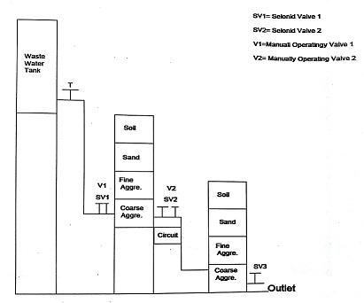
Fig 2 Laboratory Setup for Tidal Flow Wetland
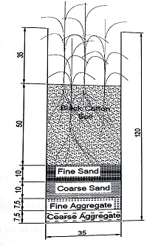
Fig 3 Tidal Wetland unit
The synthetic wastewater was prepared by using Urea, Starch, Milk Powder, Yeast, Copper and Cobalt, the synthetic influent composition is given in Table 1. Within a period of 7 days required strength will be archived.
Table 1: Synthetic influent composition
Chemical Compounds | mg/L
Urea | 95
Starch | 125
Milk Powder | 116
Yeast | 50
CuSO₄ | 1260

RESULTS & DISCUSSION
After 7 days of adding chemical compound initial characteristics of wastewater were studied, wastewater then treated for two different detention period of 5 days and 7 days. Table 2 shows the initial and final characteristics of wastewater for five samples for detention period of 5 days.

Table 2 Initial and Final characteristics of Wastewater for detention period of 5 days

 | Sample 1 |  | Sample 2 |  | Sample 3 |  | Sample 4 |  | Sample 5
Parameters | Initial | Final | Initial | Final | Initial | Final | Initial | Final | Initial | Final
pH | 6.46 | 7.03 | 6.53 | 7.08 | 6.47 | 7.12 | 6.47 | 7.08 | 6.49 | 7.1
DO (mg/l) | 1.32 | 3.78 | 1.36 | 3.74 | 1.28 | 3.75 | 1.26 | 3.78 | 1.28 | 3.74
BOD (mg/l) | 287 | 49.8 | 288.8 | 48.4 | 288.7 | 48 | 289.2 | 47.6 | 288.6 | 48.6
COD (mg/l) | 448.6 | 105.4 | 445.2 | 105.6 | 447.5 | 106 | 449.4 | 104.6 | 448.6 | 106.2
Copper (mg/l) | 48.3 | 6.63 | 48.1 | 6.52 | 48.4 | 6.22 | 48.1 | 6.2 | 48.4 | 6.24

For the particular wastewater, it was found that percentage BOD removal was 83% for the detention period of 5 days and for the COD, it was found that the percentage removal was of 76%. It was noted that Copper percentage removal was of 87%. Table 3 shows the initial and final characteristics of wastewater for five samples for the detention period of 7 days.
Table 3 Initial and Final characteristics of Wastewater for detention period of 7 days
 | Sample 1 |  | Sample 2 |  | Sample 3 |  | Sample 4 |  | Sample 5
Parameters | Initial | Final | Initial | Final | Initial | Final | Initial | Final | Initial | Final
pH | 6.56 | 7.32 | 6.44 | 7.38 | 6.52 | 7.42 | 6.56 | 7.59 | 6.52 | 7.56
DO (mg/l) | 1.24 | 4.58 | 1.28 | 4.64 | 1.34 | 4.56 | 1.28 | 4.62 | 1.3 | 4.63
BOD (mg/l) | 278 | 23.6 | 269 | 21.3 | 289 | 22 | 283 | 22.6 | 284 | 48.6
COD (mg/l) | 447.2 | 58 | 446.7 | 56.2 | 448.3 | 54.3 | 447.9 | 55.3 | 446.6 | 54.8
Copper (mg/l) | 48.4 | 4.27 | 48.3 | 4.4 | 48 | 4.21 | 48.4 | 4.32 | 48.3 | 4.26
For the particular wastewater, it was found that percentage BOD removal was 92% for the detention period of 7 days and for the COD it was found that the percentage removal was of 87%. For Copper it was noted that percentage removal was of 90%.

During the study it was observed that there is reduction in BOD & COD for the detention period of 5 days as well as 7 days. BOD removal in wetlands is due to physical and biological processes that involve sedimentation and microbial degradation, principally by aerobic bacteria attached to plant roots. BOD and COD removal is supported by the mutuality interaction between microbial and physical mechanism by involving the dissolved oxygen. BOD removal involves sedimentation and microbial degradation conducted by aerobic bacteria attached to plant roots, while COD removal prefers to sedimentation and filtration rather than biological process. Efficiency of BOD and COD removal increased with detention time it is because of decreasing the rate of inflow increases the rate of contact. Removal of Copper in wastewater wetlands occur by typha uptake, soil adsorption, and precipitation. The copper that pass by the root structure tend to accumulate on the structure of the root rather than being absorbed by the typha. Wetland soils are also sources into which can trap metals.
CONCLUSION
The main conclusions that can be drawn from this study are:
- BOD removal was observed to be 92% for detention period of 7 days. BOD removal in wetlands is due to physical and biological processes.
- COD removal was observed to be 87% for detention period of 7 days. COD removal prefers to sedimentation and filtration rather than biological process.
- Removal of copper was observed to be 91%, it is mainly because of typha uptake, soil adsorption, and precipitation.
- The presence of typha and increased detention period lead to an improvement in tidal flow wetland performance.
.
REFERENCES
- Jian Zhang, Haiming Wu, Jingtao Xu,Jinlin Fan,Hai Liu, Shuang Liang (2016) Constructed Wetlands for Wastewater Treatment : Sustainability Revolution in Water Management,ASCE,337.
- Majid Sa’idi (2010). Experimental studies on effect of Heavy Metals presence in Industrial Wastewater on Biological Treatment, J. Environmental sciences, 1-4, 666.
- David Austin (2012). Advanced Treatment Wetlands: A 4th Generation Technology
- M.P. Ciria; M.L. Solano; P. Soriano (2005) Role of Macrophyte Typha latifolia in a Constructed Wetland for Wastewater Treatment and Assessment of Its Potential as a Biomass Fuel, Science Direct, 92 (4), 535.
- Tong Wang , Ranbin Liu , Kate O’Meara , Emmet Mullan and Yaqian Zhao (2018). Assessment of a Field Tidal Flow Constructed Wetland in Treatment of SwineWastewater: Life Cycle Approach, J. Water, 10, 573.

Details of All Authors (Optional)
Sr. No. | Photo | Detail
1 |  | Principal, Government College of Engineering, Jalgaon
2 |  | Assistant Professor, PRMCEAM, Badnera (Amravati)

