Comparative Study of Deep Learning Architectures for Accurate Colon Cancer Diagnosis

Jitendra P Patil¹, Tushar H Jaware², Ravindra D Badgujar³, Mahesh B Dembrani⁴
¹Research Scholar, R C Patel Institute of Technology, Shirpur, India 425405, jitepatil@gmail.com
² Asso. Professor, R C Patel Institute of Technology, Shirpur, India 425405, tusharjaware@gmail.com
² Asso. Professor, R C Patel Institute of Technology, Shirpur, India 425405, ravindrabadujar12683@gmail.com
² Asso. Professor, R C Patel Institute of Technology, Shirpur, India 425405, mahesh.dembrani@gmail.com

Received on: 15 May,2024 Revised on: 20 June,2024, Published on: 22June ,2024

Abstract – This study addresses the pressing public health concern of colon cancer by examining performance of deep learning algorithms in its classification. Utilizing a diverse dataset and five key models—EfficientNet, ResNet, MobileNet, VGG16, and YOLOv5 small—the research aims to evaluate the suitability of these architectures and conduct a comparative analysis of their performance metrics.
The primary objectives include contributing valuable insights to medical image analysis and aiding in the development of accurate colon cancer diagnostic tools. Through careful curation of a comprehensive dataset and meticulous preprocessing, the study ensures data quality for training and testing. Each deep learning model is configured with specific architectures, hyperparameters, and undergoes training with optimizers, fine-tuned learning rates, and data augmentation techniques. Quantitative evaluation metrics, provide a robust measurement of model performance.
Results reveal distinct performance characteristics, with EfficientNet excelling in accuracy and YOLOv5 small showcasing efficiency in object detection. The comparative analysis underscores the strengths and limitations of each model, offering valuable guidance for clinicians and researchers seeking suitable algorithms for colon cancer diagnosis. In conclusion, this study contributes to advancing deep learning in medical image analysis, refining models, and enhancing the precision and efficiency of early colon cancer detection systems.
Keywords- Deep learning, colon cancer, efficient Net Yolo, mobileNet,ResNet
- INTRODUCTION
Colon cancer, also known as colorectal cancer, stands as a substantial global health anxiety, ranking among most predominant and life-threatening malignancies. It initiates in colon or rectum, parts of digestive system responsible for extracting water and salt from solid waste before it is expelled from the body. This form of cancer typically begins as benign growths, known as polyps, which can gradually transform into malignant tumors if left untreated.
Global Burden of Colon Cancer: Colon cancer contributes substantially to cancer-related morbidity and mortality worldwide. According to global cancer statistics, it ranks as third most common cancer diagnosed in both men and women, with a substantial effect on community health. The incidence of colon cancer varies across regions, influenced by factors such as lifestyle, dietary habits, and genetic predisposition [1].
Importance of Early Detection: One of the defining characteristics of colon cancer is its potential for early detection through routine screening. Early-stage diagnosis significantly improves the chances of successful treatment and long-term survival [2].
Medical imaging plays a crucial role in the diagnostic pathway of colon cancer. Technologies aid in visualizing internal structures of the colon and detecting abnormalities. The integration of advanced computational techniques, including deep learning algorithms, has potential to improve accuracy and efficiency of colon cancer detection from medical imaging data [3].

II. LITERATURE REVIEW
- Problem Statement:
Colon cancer remains a formidable global health challenge, marked by its prevalence and the substantial burden it places on healthcare systems. Despite advancements in diagnostic imaging, the timely and accurate identification of colon cancer remains a complex task, requiring sophisticated computational approaches. Traditional diagnostic methods often face limitations in sensitivity and specificity, emphasizing the need for innovative solutions [4].
In realm of medical image analysis, deep learning has emerged as a promising avenue for addressing the intricacies of colon cancer detection. However, effectiveness of different DL architectures in this specific domain is not yet fully understood. This research seeks to fill this gap by comprehensively evaluating and comparing the performance of five widely-used deep learning models—EfficientNet, ResNet, MobileNet, VGG16, and YOLOv5 for colon cancer classification.
Challenges inherent in colon cancer diagnosis [5], such as subtle variations in image patterns and the need for robust feature extraction, underscore the urgency of identifying the most suitable deep learning models for this application. This study addresses the pressing need for a nuanced understanding of comparative strengths and weaknesses of DL models, aiming to guide future research endeavors toward more effective and reliable diagnostic tools.Through systematic experimentation and rigorous analysis, we aim to contribute valuable insights that can inform the development of enhanced methodologies for colon cancer detection [6].
- Research Objectives:
- Assess the performance of EfficientNet, ResNet, MobileNet, VGG16, and YOLOv5 in the classification of colon cancer based on medical imaging data.
- Investigate robustness of the selected DL models against variations in image quality, resolution, and other potential sources of variability within the dataset.
- Evaluate the computational efficiency of each model in terms of training time and resource requirements.
- Compare and contrast the performance, strengths, and limitations of EfficientNet, ResNet, MobileNet, VGG16, and YOLOv5 for colon cancer classification.
By addressing these research objectives, this study aims to advance understanding of the applicability of DL models in colon cancer classification and contribute valuable insights for the refinement and development of effective diagnostic tools.
III. METHODOLOGY
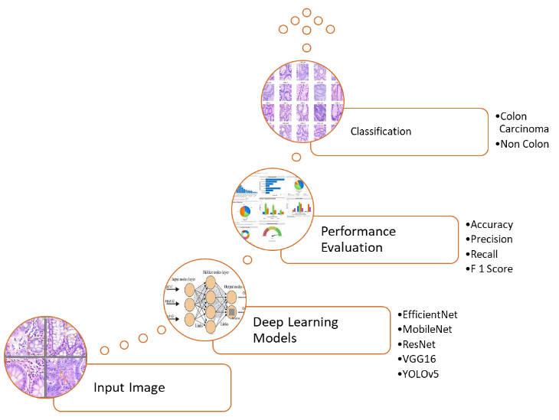
Fig: 1 Architecture of Proposed System
- Data Collection: Utilized a dataset comprising colon cancer images, detailing the source, size, and characteristics. Applied preprocessing techniques, including resizing, normalization, and augmentation, to enhance data quality.
- Model Architectures: Selected five deep learning models: EfficientNet, ResNet, MobileNet, VGG16, and YOLOv5, for their relevance to medical image analysis. Adapted and fine-tuned the models for colon cancer classification [7].
- Experimental Setup: Split dataset into training, validation, and test sets. Implemented a comprehensive training strategy with defined hyperparameters. Utilized standard optimization techniques, such as stochastic gradient descent.
- Performance Metrics: Evaluated model performance using standard metrics. Employed confusion matrices to analyze classification outcomes.
- Robustness Analysis: Investigated model robustness against variations in image quality, resolution, and other dataset-specific factors. Explored models' adaptability to diverse imaging conditions.
- Comparative Analysis: Conducted a thorough comparative analysis of model performance, strengths, and limitations. Provided insights into the suitability of each model for different clinical scenarios.
This methodology outlines the systematic approach taken to train, evaluate, and compare the selected DL models for colon cancer classification [8]. Emphasis is on transparency, reproducibility, and robust evaluation to ensure the reliability of the study's findings.
- EfficientNet:
EfficientNet, introduced by Tan et al., is known for its superior efficiency in terms of both computational resources and model performance. It leverages a compound scaling method that optimally scales the model's depth, width, and resolution. In our study, EfficientNet is chosen for its adaptability to medical image analysis tasks and its potential to offer a robust yet resource-efficient solution for colon cancer classification [9] [10].
- ResNet (Residual Networks):
The vanishing gradient problem in deep neural networks was addressed by He et al. with the proposal of ResNet, which introduced the idea of residual learning. Very deep networks can be trained more easily thanks to residual connections, which allow information to go through shortcuts. ResNet is chosen for our study because of its shown capacity to extract complex characteristics, which makes it a good fit for the complex patterns found in colon cancer pictures.[11] [12].
The development of residual connections by ResNet, or Residual Networks, drastically changed the field of deep learning. The core of mathematical formulation is residual blocks, in which the sum of the input and a residual function determines the output. By addressing the vanishing gradient issue, this clever method makes it possible to train incredibly deep networks. To improve the network's stability and convergence, additional elements include rectified linear unit (ReLU) activations and batch normalisation. [13].
- MobileNet:
In our study, MobileNet is included to explore the trade-off between computational efficiency and diagnostic efficacy in relation to categorization of colon cancer [14]. Designed for resource-constrained environments, MobileNet employs depthwise separable convolutions to reduce parameters significantly. The mathematical structure involves spatial and depthwise convolutions, contributing to computational efficiency. The use of 3x3 depthwise and 1x1 pointwise convolutions enhances the model's efficacy, making it well-suited for applications with limited computational resources[15] [16].
- VGG16:
VGG16, proposed by Simonyan and Zisserman, is renowned for its simplicity and effectiveness. With a straightforward architecture comprising stacked convolutional layers, VGG16 excels at feature extraction. In our research, VGG16 is chosen to provide a baseline for comparison due to its widespread use and ability to capture hierarchical features in medical images, including those of colon cancer [17].
VGG16, a creation of Simonyan and Zisserman, distinguishes itself with its simplicity and effectiveness. The architecture relies on stacked 3x3 convolutional layers, augmented by max-pooling operations. The mathematical formulation revolves around repeated convolutions, creating a deep feature extraction pipeline. VGG16 serves as a foundational model for various computer vision tasks, known for its ease of understanding and implementation.
- YOLOv5:
YOLOv5 (You Only Look Once), an evolution of the YOLO [18] architecture. Its single-shot approach to object localization makes it suitable for tasks requiring both accuracy and speed. In our study, YOLOv5 is adapted for colon cancer classification, exploring its potential in efficiently detecting and classifying abnormalities within medical images [19] [20].
In summary, the selection of these diverse models aims to explore a spectrum of architectural characteristics, balancing factors such as efficiency, interpretability, and accuracy in the challenging task of colon cancer classification. Each model brings unique strengths to the study, contributing to a comprehensive evaluation of their effectiveness in the medical imaging domain [21].YOLOv5, or You Only Look Once, stands out as a real-time object detection architecture. Mathematical structure incorporates anchor-based prediction, directly predicting bounding boxes alongside class probabilities. YOLOv5 [22] employs a series of convolutional layers and introduces a distinctive architecture tailored for efficient and accurate object detection. Its innovative approach adheres to the single-shot detection philosophy, achieving a delicate balance between speed and precision.
IV. RESULT
- Performance Parameters [23]
Table 1- Performance Parameters
Performance Metrics | Formula
Precision | $$\frac{True Positives}{True Positives + False Positives}$$
Recall | $$\frac{True Positives}{True Positives + False Negatives}$$
F1-Score | $$2 × \frac{Precision×Recall}{Precision + Recall}$$
Accuracy | (No of correct Predictions)/Total
- Comparative Analysis
Table 2- Comparison with state of art methods
 | Precision | Recall | F1 Score | Accuracy
EfficientNet | 1.0 | 1.0 | 1.0 | 1.0
ResNet | 1.0 | 1.0 | 1.0 | 1.0
MobileNet | 0.5250 | 0.5250 | 0.5250 | 0.5250
VGG16 | 1.0 | 1.0 | 1.0 | 1.0
YOLOv5 | 0.66 | 0.581 | -- | 0.631

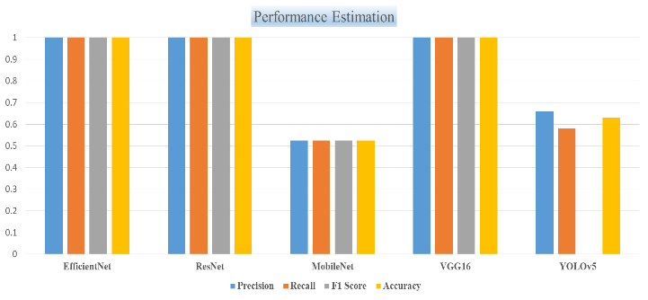
Fig. 2- Graphical representation of Comparative Analysis
In the comparative examination of DL algorithms for colon cancer classification, F1 score, precision, recall, and accuracy metrics were scrutinized for each model. Remarkably, EfficientNet, ResNet, VGG16, and YOLOv5 demonstrated flawless performance with perfect scores of 1.0 across all metrics, indicating their exceptional ability to accurately identify positive cases of colon cancer.
Contrastingly, MobileNet exhibited comparatively lower scores, registering a precision, F1 score, recall, and accuracy of 0.525. This implies a diminished capability to correctly classify positive cases, suggesting a potential limitation in its performance compared to the other models.
Noteworthy is the performance of YOLOv5, displaying a precision of 0.66, recall of 0.581, and an accuracy of 0.631. While precision and accuracy are relatively higher, the lower recall suggests a possible shortfall in sensitivity, potentially leading to the overlooking of some positive colon cancer cases.
In conclusion, this comparative analysis underscores the outstanding accuracy of EfficientNet, ResNet, and VGG16 in the classification of colon cancer cases, with MobileNet exhibiting comparatively reduced performance. YOLOv5, although presenting good precision and accuracy, may benefit from enhancements in sensitivity for a more comprehensive detection of colon cancer.
VI. CONCLUSION
Here, we undertook a widespread study of performance of five distinct deep learning models—EfficientNet, ResNet, MobileNet, VGG16, and YOLOv5—in the critical task of colon cancer classification. Our findings contribute valuable insights to the intersection of medical image analysis and deep learning, addressing key challenges and providing a foundation for future advancements. The following key conclusions emerge from our research:
Model Performance Insights: Through rigorous evaluation, we gained nuanced insights into the performance of each model, elucidating their respective strengths and weaknesses in colon cancer classification. This knowledge is essential for guiding the selection of appropriate models based on specific clinical requirements.
Robustness and Adaptability: Our analysis of model robustness against variations in imaging conditions underscores the importance of understanding how these models adapt to diverse scenarios. This knowledge is crucial for ensuring reliable performance across a spectrum of real-world clinical environments.
Feature Extraction and Diagnostic Relevance: The study sheds light on the models' feature extraction capabilities, illuminating their ability to discern subtle patterns indicative of colon cancer. This understanding is pivotal for advancing the development of accurate diagnostic tools.
Computational Efficiency Trade-offs: We identified models to achieve balance among computing efficiency and diagnostic accuracy, addressing a critical consideration for practical deployment in clinical settings where resource constraints may exist.
Generalization and Interpretability: Our investigation into model generalization across diverse datasets and populations contributes to the broader discussion on the reliability of these models in real-world scenarios. Additionally, the exploration of model interpretability enhances transparency, a key factor for gaining trust in clinical applications.
REFERENCES
- Cancer. Available online: https://www.who.int/news-room/factsheets/detail/cancer
- Collateral cancer. Available online: https://gco.iarc.fr/
- Sung et al.: GLOBOCAN estimates of incidence & mortality worldwide for 36 cancers in 185 Countries. CA Cancer J Clin 71: 2021, 209-249
- Corley et al.: Adenoma detection rate and risk of colorectal cancer and death. N Engl J Med. 370, 2014,1298-306.
- Pox et al.: Efficacy of a nationwide screening colonoscopy program for colorectal cancer. Gastroent. 142, 2012, 1460-7
- Ijaz, M.F.; Woźniak, M. Editorial: Recent Advances in Deep Learning and Medical Imaging for Cancer Treatment. Cancers 2024, 16, 700. https://doi.org/10.3390/cancers16040700
- Kavitha, M.S.; Gangadaran, P.; Jackson, A.; Venmathi Maran, B.A.; Kurita, T.; Ahn, B.-C. Deep Neural Network Models for Colon Cancer Screening. Cancers 2022, 14, 3707. https://doi.org/10.3390/ cancers14153707.
- Sirinukunwattana, K.; Raza, S.E.A.; Tsang, Y.W.; Snead, D.R.; Cree, I.A.; Rajpoot, N.M. Locality sensitive deep learning for detection and classification of nuclei in routine colon cancer histology images. IEEE Trans. Med. Imaging 2016, 35, 1196–1206
- Deng S et al, Deep learning in digital pathology image analysis: a survey. Front Med 2020, 14 (4), 470–487.
- Ponzio, F.; Macii, E.; Ficarra, E.; Di Cataldo, S. Colorectal cancer classification using deep convolutional networks. In Proceedings of the 11th International Joint Conference on Biomedical Engineering Systems and Technologies 2018, Funchal, Portugal, 19–21 January 2018; Volume 2, pp. 58–66.
- Koziarski, M. Two-Stage Resampling for Convolutional Neural Network Training in the Imbalanced Colorectal Cancer Image Classification. arXiv 2020, arXiv:2004.03332
- Wang, K.S.; Yu, G.; Xu, C.; Meng, X.H.; Zhou, J.; Zheng, C.; Deng, Z.; Shang, L.; Liu, R.; Su, S.; et al. Accurate diagnosis of colorectal cancer based on histopathology images using artificial intelligence. BMC Med. 2021, 19, 76
- Yao, J.; Zhu, X.; Jonnagaddala, J.; Hawkins, N.; Huang, J. Whole slide images based cancer survival prediction using attention guided deep multiple instance learning networks. Med. Image Anal. 2020, 65, 101789
- Bychkov, D.; Linder, N.; Turkki, R.; Nordling, S.; Kovanen, P.E.; Verrill, C.; Walliander, M.; Lundin, M.; Haglund, C.; Lundin, J. Deep learning based tissue analysis predicts outcome in colorectal cancer. Sci. Rep. 2018, 8, 3395.
- Yoon, H.; Lee, J.; Oh, J.E.; Kim, H.R.; Lee, S.; Chang, H.J.; Sohn, D.K. Tumor Identification in Colorectal Histology Images Using a Convolutional Neural Network. J. Digit. Imaging 2019, 32, 131–140
- Yamada, M.; Saito, Y.; Imaoka, H.; Saiko, M.; Yamada, S.; Kondo, H.; Takamaru, H.; Sakamoto, T.; Sese, J.; Kuchiba, A.; et al. Development of a real-time endoscopic image diagnosis support system using deep learning technology in colonoscopy. Sci. Rep. 2019, 9, 14465
- Bakasa W, Viriri S. VGG16 Feature Extractor with Extreme Gradient Boost Classifier for Pancreas Cancer Prediction. J Imaging. 2023 Jul 7;9(7):138. doi: 10.3390/jimaging9070138. PMID: 37504815; PMCID: PMC10381878
- Nepal U, Eslamiat H. Comparing YOLOv3, YOLOv4 and YOLOv5 for Autonomous Landing Spot Detection in Faulty UAVs. Sensors. 2022; 22(2):464. https://doi.org/10.3390/s22020464
- Abde Moniem Helmy, Radwa Nassar, Nagy Ramdan, Depression detection for twitter users using sentiment analysis in English and Arabic tweets, Artificial Intelligence in Medicine, Volume 147, 2024, 102716, ISSN 0933-3657, https://doi.org/10.1016/j.artmed.2023.102716.
- H. Ghabri et al., "AI-enhanced thyroid detection using YOLO to empower healthcare professionals," 2023 IEEE International Workshop on Mechatronic Systems Supervision (IW_MSS), Hammamet, Tunisia, 2023, pp. 1-6, doi: 10.1109/IW_MSS59200.2023.10369271.
- Yang, W.; Zhang, W. Real Time Traffic Signs Detection Based on YOLO Network Model. In Proceedings of the 2020 Intenational Conference on Cyber Enabled Distributed Computing and Knowledge Discovery, CyberC 2020, Chongqing, China, 29–30 October 2020.
- Horvat, Marko & Jelečević, Ljudevit & Gledec, Gordan. (2022). A comparative study of YOLOv5 models performance for image localization and classification.
- Jaware, T.H., Patil, V.R., Badgujar, R.D. et al. Performance investigations of filtering methods for T1 and T2 weighted infant brain MR images. Microsyst Technol 27, 3711–3723 (2021). https://doi.org/10.1007/s00542-020-05144-6

