The Spinodal Decomposition of Cu-Ni-Cr Alloy for Improvement in Mechanical Strength in Marine Structure

Jirapure S.C.¹ , Dr. Borade A. B.²

¹Research Scholar, Department of Mechanical Engineering, JDIET, Yavatmal (MS), India
² Principal, Government Polytechnic Gadchiroli (MS), India

Received on: 11 December, 2020, Revised on: 10 January , 2021, Published on: 16 January 2021

Abstract – The use of Spinodal decomposition including homogenization solution heat treatment, aging heat treatment in Aragon atmosphere on Cu-Ni-Cr ternary alloy is proven and valuable new engineering method for improving Mechanical strength of Marine alloy. The present research proves the excellent performance of spinodal Cu-Ni-Cr alloy (Naval Alloy) in terms of Mechanical properties in marine (sea) environments. This also suggests ‘Naval alloy’ for offshore structure and ship hulls. This paper also reviews the different alloying combinations in sea environment and compares the present alloy used with ‘Naval alloy’.
Keywords—Cu-Ni-Cr spinodal alloy, Heat treatment, Mechanical testings, marine environment.

- INTRODUCTION

Marine engineering have tremendous problems in protecting Inshore, Offshore structures and ship hulls. A broad range of alloy combinations, heat treatments, surface coatings are the most commonly used approaches for improving Mechanical strength of material in sea environment. Each and every approach is useful with its advantages and benefits. The Copper-Nickel binary alloys are preferred for marine structure because they provide corrosion protection. The Copper-Nickel alloys are particularly attractive for sea water environment due to its strength property.

In sea environment, the majority of the most troublesome problems come across in contact with sea water. Long-term preservation is a difficult objective for ships in the sea environment. Wooden ships are easily affected by insects, funguses, bacteria, and marine animals. Iron ships are not subject to such organic attack but are of less strength & corrosion property.
For marine applications, mild steel remains another option for constructional purposes by virtue of its relatively low cost, moderate mechanical strength and ease of fabrication. Its main disadvantage is that is corrodes easily in seawater and less strength which may result in structural failure. Year upon year the maintenance cost has increased until it is estimated today at 4 % of the Gross National Product. So, there is a strong need to have such materials which have enough strength to mark it advisable.

Material Preparation

Material
All the materials used in the preparation of the alloys are of good quality. The chromium is labeled 98.99 per cent. The nickel was labeled 99.6 per cent with a small amount of iron, and cobalt. Two different lots of copper are used.

Spinodal Decomposition
The alloys were melted in electric arc furnace with water-cooled copper mold under argon atmosphere. Specimens were melted four times to ensure mixing. Homogenization was carried out at a temperature above the miscibility gap. The alloys were cooled down from the melt in 1-2 minutes to avoid the cracking caused by rapid quench. Annealing was performed at 550 °C in air for up to 72 hours. Carl-Zeiss metallurgical microscopes were used for microscopic examinations. After the solution heat treatment Aging heat treatment was carried out. Dimensions and design of casting for the Naval alloy
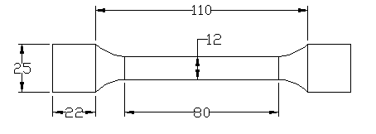

Fig.1- Design of casting of the Naval alloy

III- Materials And Methods

Melting of metals

The samples were melted in carbon plate resistor type Crescent Safety crucibles in a electric furnace. These crucibles are sand crucibles covered with graphite. It was is volatile at the temperatures used and was the most satisfactory result among all the other covers and fluxes were tried.

Casting of the Naval alloy

Many types of castings for Cu and its alloys casting, such as sand, shell, investment, permanent mould, chemical sand, centrifugal, and die, can be used. Of course each of them has its advantages and disadvantages. Here, we used the most economical casting method, sand casting. It is suitable for tin, silicon, aluminum and manganese bronzes, and also yellow brasses. Definite limitation for both methods is the casting size, due to the reducing the mould life with larger castings.
Centrifugal casting is best for casting of all copper alloys.
Here, the sand mould casting technique is used for preparing the alloy of desired shape in which the molten metal was poured into various sand moulds made in the cope and drag boxes for making various samples of desired casting considering the different compositions of the alloying elements.

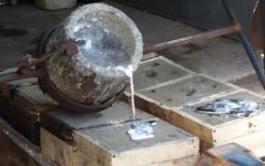

Fig.2- Molten metal pouring into the moulds

The specimen of naval alloy obtained from the casting is shown below in fig.3. Initially it is not having a good look as it had been just withdrawn from the sand mould. So, for obtaining a good aesthetic look, this specimen is machined and fig.4 shows the finished that means machined specimen of the naval alloy.

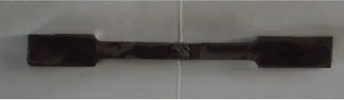

Fig.3 -Casting of alloy without finishing

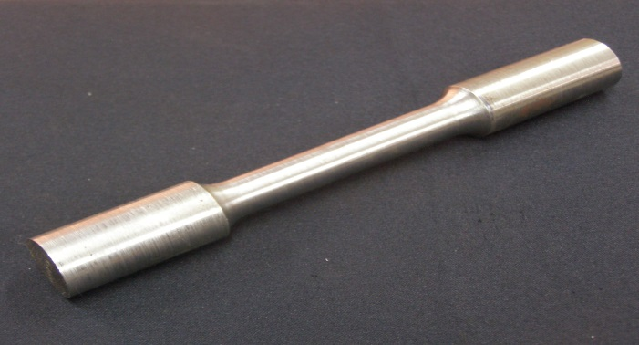

Fig.4- Finished casting of the desired alloy

C. Mechanical Testing of the alloy
1) Tensile test
The ultimate tensile strength and stress deformation test is performed on ten specimens of the alloys of various compositions to find out the ultimate tensile strength of the alloy. In all cases their elongations under stresses were measured. The test pieces were threaded at the ends so that they could be screwed into the grips of universal testing machine. The loading was continuous and not repeated in the machine. The Extensometer was used in measuring the elongations. The initial or zero extensometer reading was taken with a small load on the machine. After a satisfactory number of readings had been made the extensometer was removed and the load increased until the specimen broke.
Curves were plotted with stresses as ordinates and elongations as abscissa. Tangents to the curves were drawn and extended to a point which corresponded to an elongation of 0.001 inch on a length of 1.0 inch, and the stress corresponding to that elongation was read from the cross-ruled paper.

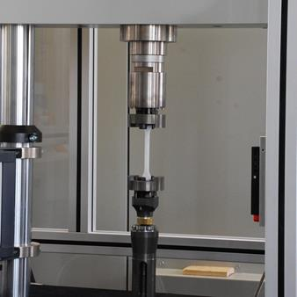
Fig.5- Universal Testing machine

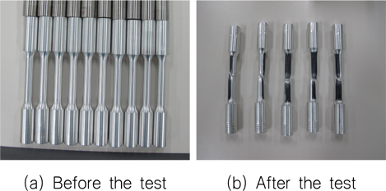
Fig.6- Specimens of different compositions of alloy

2) Specific gravity
The specific gravities of the different alloys, as cast, are given in the table below, and the same results are shown in the above figure. On the other hand, if the alloys containing a constant amount of copper with varying amounts of chromium and nickel are considered, it will be seen that the specific gravity decreases as the percentage of chromium increases. Similar results may be obtained if the alloys containing constant amounts of nickel and varying amounts of chromium and copper are examined. If the specific gravities are plotted as ordinates and the percentages of chromium as abscissae, fairly regular curves will be obtained.

Fig.7- Specific gravities at 25⁰ C
3) Hardness
The hardness measurements were made in the Materials Testing Laboratory by using a Brinell instrument with a 3,000 kilogram load and a ball of 10mm. diameter, the pressure being applied for 15 seconds. The diameters of the impressions were carefully measured, and the hardness numbers corresponding to those diameters were found in a table supplied by the makers of the instrument. The pieces tested had been ground smooth. Only one test was made on each piece, and if it was noticed that the piece had bulged or cracked from the pressure, that fact was recorded or the results were rejected.

IV-Conclusion

In this research work the efforts are taken to develop the Naval base environment alloy. Methods and procedures are adopted which follows the standards with precise testing results. In this study the innovated methods of casting applied for the alloy of Copper- Nickel- Chromium. Also sixty-six binary and ternary alloys have been prepared. At around temperature 1600 0C castings of Cu-Ni-Cr are made with the help of sand casting method. It was observed that if cooled rapidly chromium get separated out. Also the addition of nickel to Cu-Cr alloy tends to prevent separation of chromium or chromium rich constituent which is practically homogeneous.
During the testing, all the sixty-six alloys are subjected to mechanical testing especially for determining ultimate tensile strength. Alloy number 16 (52.57%Cu- 38.83%Ni- 8.60%Cr) found optimum tensile strength (58399 lb per sq. inch) in Naval environment with economical justification for chromium content which is 8.60%. During the test observations triangular system of plotting was adopted which shows certain fairly well defined areas which are highly resistive to corrosion which is the ultimate goal to develop Naval alloy. Also, all the test samples, testing results shows that the ternary alloy with spinodal decomposition are better than binary alloys including few exceptions. Prominently Eutectic point was very close at 43% of nickel addition to alloy number 16 (52.57%Cu- 38.83%Ni- 8.60%Cr) which offers optimum strength to the alloy.
In this investigation after exhaustive development and testing analysis the work concludes the Naval alloy with composition as 52.57%Cu- 38.83%Ni- 8.60%Cr showing excellent results which is highly suited for naval environment and termed as a ‘Naval Alloy’.

References
- A. H. Tuthill, C. M. Schillmoller, Ocean Sci. and Ocean Eng. Cont. INCO Tech. Pub. A404, Marine Technology Society, Washington, DC, 1965.
- A. Chou et al, Microstructural Behaviour and Mechanical Hardening in a Cu-Ni-Cr Alloy. J. Mater. Sci., 13, 1978, pp. 541-552, CrossRef.
- Antonov and Popov , Model of spinodal decomposition of phases under hyperbolic diffusion, Physics of the Solid State, Vol. 41, Issue 5,1999, pp. 824-826.
- Copper-Nickel Alloys, Properties and Applications published by copper development association TN30, 1982, 1-36.
- C.A. Powell et al., The application of Copper Nickel Alloys in Marine Systems (A Technical report presented jointly by International Copper Association Ltd., Copper development Association Inc. and Nickel development Institute, published by Copper development Association Inc. 7044-1919).
- F. Findik, Precipitation reactions in some Cu-Ni-Cr alloys, PhD Thesis, Imperial College, University of London, UK, 1992.
- J.T. Jappes et al, A text book of Engineering Materials and Metallurgy Laxmi Publications (P) Ltd., 2006,131.
- J. W. Cahn, Phase Separation by Spinodal Decomposition in Isotropic Systems, Journal of Chemical Physics, 1965.
- K. D. Christian & R. M. German, Relation Between Pore Structure and Fatigue Behavior in Sintered Iron-Copper-Carbon. Int. J. Powder Metall., Vol.31, No.1, 1995, pp. 51-61.
- K. V. Sudhakar, Fatigue Behavior of a High Density Powder Metallurgy Steel, Int. J. Fatigue,Vol.22, 2000, pp.729-734.
- M. Kato, M. et al., Hardening by Spinodal Modulated Structure, Acta Metallurgica, 1980.
- M. Kato & L. H. Schwartz, The Temperature Dependence of Yield Stress and Work Hardening in Spinodally Decomposed Cu-10Ni-6Sn Alloy. Materials Science and Engineering, 41(1), 1979, pp. 137-142.
- M. Prager, The Properties of Cast Alloys for Large Marine Propellers (ASME Pub. Cast Metals for Structural and Pressure Containment Applications, 1979 Metals Properties Council-11 , American Society of Mechanical Engineers, New York, NY).
- N. Chawla et al, Effect Of Copper And Nickel Alloying Additions On The Tensile And Fatigue Behavior Of Sintered Steels. Adv Powder Metall Part Matter, 5, 2002, 104.
- N.V. Vyazovikina, The effect of spinodal decomposition on mechanical, electro-mechanical, and corrosion properties of high-chromium alloys, Protection of metals, Vol. 36(1), 2000, pp. 52-57.
- P. P. Rao et al, Comparative-study of spinodal decomposition in symmetrical and asymmetric Cu-Ni-Cr alloys. J. Mater Sci., 26, 1991, pp. 1485-1496.
- S. Ilangovan & R. Sellamuthu, Measurement Of The Variation Of Mechanical Properties With Aging Temperatures For Sand Cast Cu-5ni-5sn Alloy. Journal of Engineering Science and Technology, 11(11), 2016, pp. 1609 – 1619 © School of Engineering, Taylor’s University.
- S.C. Jirapure, Dr. A.B. Borade, Measurement of Mechanical Properties and Microstructure of Cu-Ni-Cr Spinodal alloy, International Journal of Advanced engineering and Management , Vol.2(3), 2017, pp. 78-81.
- S.C. Jirapure, Dr. A.B. Borade, A New Approach of Strengthening- Spinodal Decomposition, Int. Journal of Applied Sciences and Engineering Research, Vol. 3 (5), 2014, pp. 1021-1029.

