Seismic Design Recommendations For Elevated Water Tanks
Mr. Raja Babu¹, Mr. R.C. Singh² and Dr. Lokesh Singh³
¹ PG Scholar, Dept. of Civil Engineering, RSR Rungta College of Engineering & Technology, Bhilai, Chhattisgarh, India-490020
² Asst. Professor, Dept. of Civil Engineering, RSR Rungta College of Engineering & Technology, Bhilai, Chhattisgarh, India-490020

ABSTRACT
Elevated water tanks are critical components of any urban planning scheme as they are commonly adopted by the municipal corporations to store the necessary water to meet the city's water demand. Experiences from past earthquakes have shown a strong indication that most of these structures are susceptible to damages related to earthquakes. One of the prime concerns for structural designers is the sloshing effects of the water stored in the tank. The liquid sloshing may cause huge loss of human life, economic and environmental resources due to unpredicted failure of the container. Sloshing basically refers to the movement of water contained in the overhead tank when subject to lateral motions occurring due to wind forces or earthquake excitations. In this thesis, special consideration has been given to the effects of sloshing during the design of elevated water tanks. It is already established that elevated water tanks possess low ductility and energy absorbing capacity when compared to the conventional buildings. In view of this, most of the design codes around the world suggest a higher design seismic force for the design of such elevated water tanks. This paper focuses on the seismic codal provisions laid down in six different codes including IBC 2000, ACI, AWWA, API, Eurocode 8 and NZSEE and comparing them to the provisions laid down in Indian design codes. Based on the results of this study, various similarities and limitations were found in the codal provisions which are listed in brief.

1. Introduction-
Elevated water tanks are critical components of any urban planning scheme as they are commonly adopted by the municipal corporations to store the necessary water to meet the city's water demand. Experiences from past earthquakes have shown a strong indication that most of these structures are susceptible to damages related to earthquakes. One of the prime concerns for structural designers is the sloshing effects of the water stored in the tank. Sloshing basically refers to the movement of water contained in the overhead tank when subject to lateral motions occurring due to wind forces or earthquake excitations. The hydrodynamic forces and the overturning moments acting on the tank wall due to the impulsive component of the liquid motion can result in the failure of the tank wall and the tank foundation [1]. The spilling of the displaced water can also lead to damages to the tank roof.
Studying the effects of sloshing is crucial in various engineering disciplines such as propellant slosh in spacecraft tanks and rockets, cargo slosh in ships and trucks transporting liquid (for example oil and gasoline), oil oscillation in large tanks, water oscillation in a reservoir due to earthquake, sloshing in pressure-suppression pools of boiling water reactors and several others [2]. This therefore necessitates proper analysis of the fluid-tank interaction under earthquake excitation. For sloshing, the liquid must have a free surface to constitute a slosh dynamic problem, where the dynamics of liquid can interact with container to alter the system dynamic significantly. Sloshing behavior of liquids within containers represents thus one of the most fundamental fluid-structure interactions. As of now, no proper provisions regarding are given in the Indian design codes. However, in foreign design codes such as NZSEE (1986), mechanical analogs of tank-fluid system are commonly used to obtain the sloshing frequency, hydrodynamic pressure and design seismic forces [3]. Generally, estimation of hydrodynamic pressure in moving rigid containers two distinct components. First one is caused by moving fluid with same tank velocity and is directly proportional to the acceleration of the tank. The second component represents free-surface-liquid motion and known as convective pressure.

1.1 Sloshing in Liquid Storage Tanks-
Liquid storage tanks are vital components of lifeline and industrial facilities and are widely used in water supply facilities, oil and gas industries, nuclear plants for storage of a variety of liquid and wastes of different forms. The problem of liquid sloshing in moving or stationary containers is of great concern to Aerospace, nuclear and civil engineers, designers of road tankers, physicists, and ship tankers and mathematicians. Sloshing in oil tanks, large dams, elevated water towers is of great concern during earthquake induced ground motion for seismologists and engineers [4]. There are many types of storage tanks depending on the structure, construction material, content, volume, and storage condition. Liquid storage tanks can be built by steel or concrete. Due to extreme damages on steel tank, the concrete storage tanks are generally used nowadays. Reinforced Concrete has been used in environmental engineering structures such as water reservoirs and sewage treatment tanks [5].

Fig. 1 - Pictographic Representation of Sloshing in Tanks
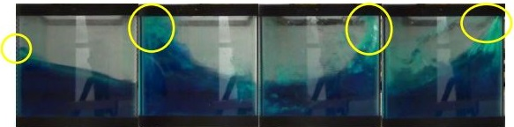
Fig. 2 - Pressure exerted on tank walls due to sloshing liquid
Water tanks are nowadays used enormously for various applications, such as storage of drinking water, agricultural farming and livestock, fire suppression, and many other applications. The liquid sloshing may cause huge loss of human life, economic and environmental resources due to unpredicted failure of the container. The spilling of toxic mixtures stored in tanks in industries can be the reason of soil contamination and can create adverse effect in environment. Thus, understanding the dynamic behavior of liquid free-surface is essential. Due to this many engineers and researchers are aiming to understand the complex behavior of sloshing and finding the ways to reduce its impact on structures and trying to develop structures to withstand its effect [6-8].
The fluid sloshing in storage tanks when excited by seismic excitation can cause a serious problem, Such as, tanks roof failure, fire of oil-storage tanks. Thus to avoid sloshing movement to impact tank roof, Maximum sloshing wave height (MSWH) is used to provide adequate freeboard for liquid surface. Large amplitude slosh waves are the main cause of nonlinear slosh effects. These waves appear when seismic wave frequency components coincide with the primary natural period (Resonance) frequency of earthquake excited motion for longer periods. When the wave amplitude is large enough to create dynamic effects on fluid container, change the free surface boundary condition, the hypothesis and assumption of linearized theory is not valid, thus non-linear effects of liquid should be taken into account and continuously update the moving boundary condition on free surfaces [6].
Liquid sloshing in storage tanks due to earthquakes is of great concern and it can cause various engineering problems and failures of structural system. These damages include: Buckling of ground supported slender tank, rupture of steel tank shell at the location of joints with pipes, collapse of supporting tower of elevated tanks, cracks in the ground supported RC tanks, etc. During Alaska earthquake, many tanks suffered typical damage such as fire, buckling of floating roof caving of fixed roofs and failures on structural systems of tank. In Japan, many petroleum tanks were damaged by the sloshing during 1964 Niigata earthquake, 1983 Nikonkai-chubu earthquake and 2003 Tokachi-oki earthquake. Therefore, the stability of the liquid storage tanks under earthquake conditions must be studied carefully [9].

1.2 Considered Design Codes-
The following design codes were studied in detail in order to evaluate and further make recommendations on how to make the Indian design codes more comprehensive-
- IBC 2000
- ACI Standards ACI 371 (1998) and ACI 350.3 (2001)
- AWWA D-100 (1996), AWWA D-103 (1997), AWWA D-110 (1995) & AWWA D-115 (1995)
- API 650 (1998)
- Eurocode 8 (1998)
- NZSEE guidelines and NZS 4203:1992
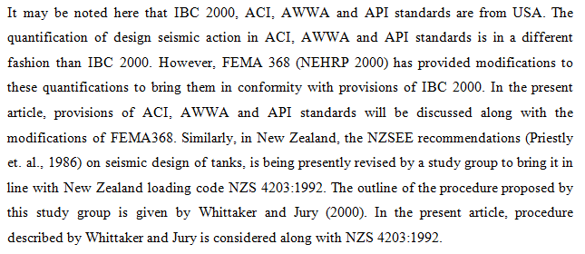
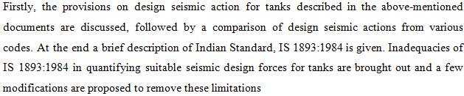
1.3 Objectives of this study-
- The primary objective of this study is to study the codal provision laid down in the above mentioned design codes regarding the seismic design of overhead/elevated water tanks.
- The secondary objective is to focus on the codal provisions pertaining to the sloshing effect of contained liquid in the said elevated water tanks.
- The tertiary objective is to extract viable recommendations from these code and suggest possible modifications in the current Indian design codes so as to make it more thorough and comprehensive.

2. Design provisions for elevated water tanks-
When a tank containing liquid vibrates, the liquid exerts impulsive and convective hydrodynamic pressure on the tank wall and the tank base in addition to the hydrostatic pressure. In order to include the effect of hydrodynamic pressure in the analysis, tank can be idealized by an equivalent spring mass model, which includes the effect of tank wall – liquid interaction. The parameters of this model depend on geometry of the tank and its flexibility (Jaiswal, 2007).
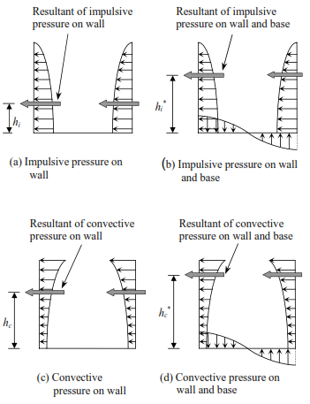
Fig. 3 - Description of hydrodynamic forces on the tank's walls and base (Jaiswal, 2007)
Elevated water tanks can be idealized by a two-mass model as shown below in Fig. 4. In the figure, m_{s} is the structural mass and shall comprise of mass of tank container and one-third mass of staging. Mass of container comprises of mass of roof slab, container wall, gallery, floor slab, and floor beams. Staging acts like a lateral spring and one-third mass of staging is considered based on classical result on effect of spring mass on natural frequency of single degree of freedom system.
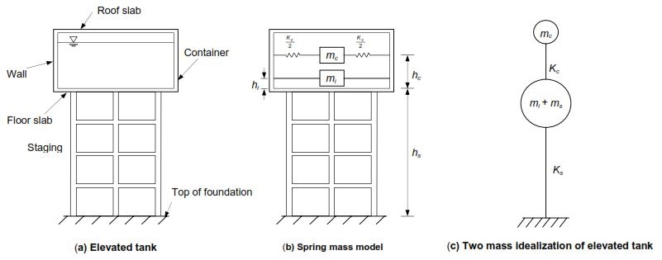
Fig. 4 - Simplified model of an elevated water tank (Jaiswal, 2004a)
Most elevated tanks are never completely filled with liquid. Hence a two-mass idealization of the tank is more appropriate as compared to a one mass idealization, which was used in IS:1893-1984. Two mass model for elevated tank was proposed by Housner (1963b) and is being commonly used in most of the international codes. For elevated tanks with circular container, parameters m_{i}, m_{c}, h_{i}, h_{i}∗, h_{c}, h_{c}∗ and K shall be obtained from codes. For tank shapes other than circular and rectangular (like intze, truncated conical shape), the value of h/D shall correspond to that of an equivalent circular tank of same volume and diameter equal to diameter of tank at top level of liquid.

2.1 Time Period-
Time period of impulsive mode, T_{i} in seconds, is given by-
(1)
where, m_{s} = mass of container and one-third mass of staging, and
K_{s} = lateral stiffness of staging.
Lateral stiffness of the staging is the horizontal force required to be applied at the center of gravity of the tank to cause a corresponding unit horizontal displacement. In the analysis of staging, due consideration shall be given to modeling of such parts as spiral staircase, which may cause eccentricity in otherwise symmetrical staging configuration. For elevated tanks with shaft type staging, in addition to the effect of flexural deformation, the effect of shear deformation should be included while calculating the lateral stiffness of staging.
NOTE: The flexibility of bracing beam shall be considered in calculating the lateral stiffness K_{s} of elevated moment resisting frame type tank staging.

Time period of convective mode, in seconds, is given by-
(2)
The values of m_{c} and K_{c} can be obtained from codal graphs respectively. Convective mode time period expressions correspond to tanks with rigid wall. It is well established that flexibility of wall, elastic pads, and soil does not affect the convective mode time period.

2.2 Damping-
Damping in the convective mode for all types of liquids and for all types of tanks shall be taken as 0.5% of the critical. Damping in the impulsive mode shall be taken as 2% of the critical for steel tanks and 5% of the critical for concrete or masonry tanks.
2.3 Design Horizontal Seismic Coefficient-
Design horizontal seismic coefficient, A_{h} can be obtained by the following expression-
(3)

where, Z = seismic zone factor given in Table 2 of IS:1893(Part-1)-2002,
I = importance factor,
R = response reduction factor, and
S_{a}/g = average response acceleration coefficient.
NOTE: Design horizontal seismic coefficient will be calculated separately for impulsive and convective modes. S_{a}/g in turn depends on the nature of foundation soil (rock, medium or soft soil sites), natural period and the damping of the structure and is given in Fig. 2 of IS:1893(Part-1)-2002 and subject to the following conditions-
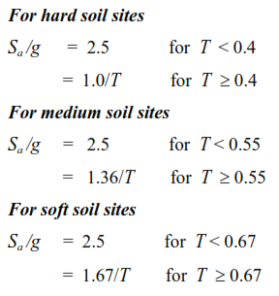 (4)
Importance factor (I), is meant to ensure a better seismic performance of important and critical tanks. Its value depends on functional need, consequences of failure, and post earthquake utility of the tank. Here, liquid containing tanks are put in three categories and importance factor to each category is assigned (Table 3.1). Highest value of I =1.75 is assigned to tanks used for storing hazardous materials. Since release of these materials can be harmful to human life, the highest value of I is assigned to these tanks. For tanks used in water distribution systems, value of I is kept as 1.5, which is same as value of I assigned to hospital, telephone exchange, and fire station buildings in IS:1893(Part-1)-2002. Less important tanks are assigned I = 1.0.
Table 3.1 - Importance Factors
Types of tanks | Importance Factor
Tanks used for storing hazardous materials | 1.75
Tanks used for storing drinking water, non-volatile material, low inflammable petrochemicals etc. and intended for emergency services such as fire fighting services. Tanks of post earthquake importance. | 1.50
All other tanks with no risk to life and with negligible consequences to environment, society and economy | 1.00
Table 3.2 - Response Reduction Factors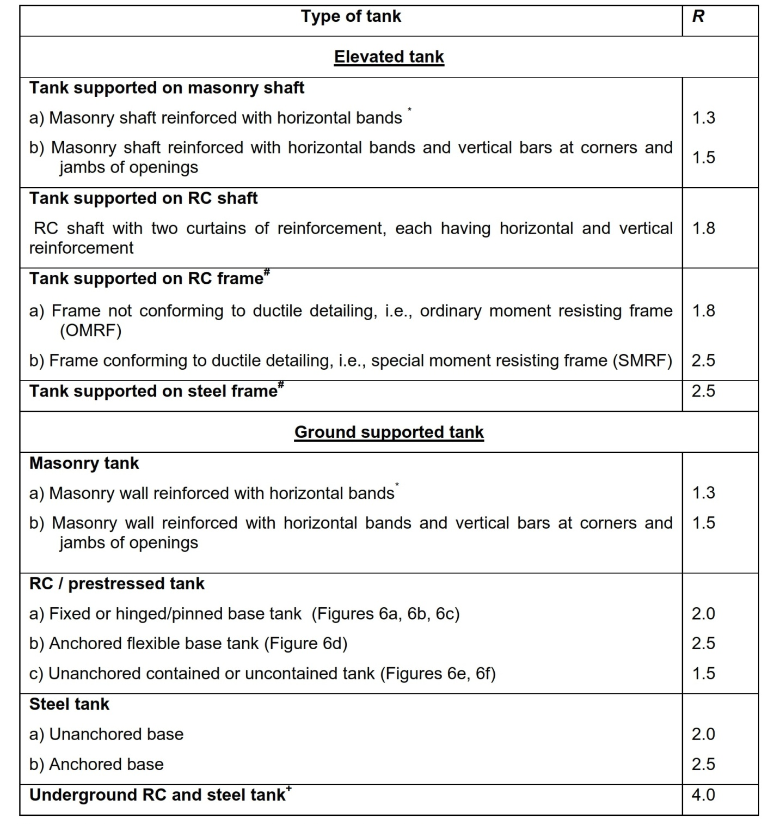
Response reduction factor (R), represents ratio of maximum seismic force on a structure during specified ground motion if it were to remain elastic to the design seismic force. Thus, actual seismic forces are reduced by a factor R to obtain design forces. This reduction depends on overstrength, redundancy, and ductility of structure. Generally, liquid containing tanks posses low overstrength, redundancy, and ductility as compared to buildings. In buildings, non structural components substantially contribute to overstrength; in tanks, such non structural components are not present. Buildings with frame type structures have high redundancy; ground supported tanks and elevated tanks with shaft type staging have comparatively low redundancy. Moreover, due to presence of non structural elements like masonry walls, energy absorbing capacity of buildings is much higher than that of tanks. Based on these considerations, value of R for tanks needs to be lower than that for buildings. All the international codes specify much lower values of R for tanks than those for buildings. Values of R presented here (Table 3.2) are based on studies of Jaiswal et al. (2004a, 2004b).

2.4 Base Shear-
Base shear in impulsive mode, just above the base of staging (i.e. at the top of footing of staging) is given by-
(5)
and base shear in convective mode is given by-
(6)
where, (A_{h})_{i} = Design horizontal seismic coefficient for impulsive mode,
(A_{h})_{c} = Design horizontal seismic coefficient for convective mode,
m_{i} = Impulsive mass of water,
m_{w} = Mass of tank wall,
m_{t} = Mass of roof slab,
g = Acceleration due to gravity, and
m_{s} = Mass of container and one-third mass of staging
Total base shear V, can be obtained by combining the base shear in impulsive and convective mode through Square root of Sum of Squares (SRSS) rule and is given as follows-

(7)
Except Eurocode 8 (1998) all international codes use SRSS rule to combine response from impulsive and convective mode. In Eurocode 8 (1998), absolute summation rule is used, which is based on work of Malhotra (2000). The basis for absolute summation is that the convective mode time period may be several times the impulsive mode period, and hence, peak response of impulsive mode will occur simultaneously when convective mode response is near its peak. However, recently through a numerical simulation for a large number of tanks, Malhotra (2004) showed that SRSS rule gives better results than absolute summation rule.

2.5 Base Moment-
Overturning moment in impulsive mode, at the base of the staging is given by -
(8)
and overturning moment in convective mode is given by-
(9)
where,
h_{s} = Structural height of staging, measured from top of footing of staging to the bottom of tank wall,
h_{cg} = Height of center of gravity of empty container, measured from top of footing.
Structural mass m_{s}, which includes mass of empty container and one-third mass of staging is considered to be acting at the center of gravity of empty container. Base of staging may be considered at the top of footing. The total moment shall be obtained by combining the moment in impulsive and convective modes through Square of Sum of Squares (SRSS) and is given as follows -
(10)
(11)
For elevated tanks, the design shall be worked out for tank empty and tank full conditions.

2.6 Direction of Seismic Forces-
For elevated tanks supported on frame type staging, the design of staging members should be for the most critical direction of horizontal base acceleration. For a staging consisting of four columns, horizontal acceleration in diagonal direction (i.e. 45° to X-direction) turns out to be most critical for axial force in columns. For brace beam, most critical direction of loading is along the length of the brace beam. Sameer and Jain (1994) have discussed in detail the critical direction of horizontal base acceleration for frame type staging.
For elevated tanks, staging components should be designed for the critical direction of seismic force. Different components of staging may have different critical directions. As an alternative, staging components can be designed for either of the following load combination rules:
i) 100% + 30% Rule: ± EL_{x} ± 0.3 EL_{y} and ± 0.3 EL_{x} ± EL_{y}
ii) SRSS Rule:
Where, EL_{x} is response quantity due to earthquake load applied in x-direction and EL_{y} is response quantity due to earthquake load applied in y-direction.
NOTE: 100% + 30% rule implies following eight load combinations-
(EL_{x} + 0.3 EL_{y}) ; (EL_{x} - 0.3 EL_{y}); - (EL_{x} + 0.3 EL_{y}); - (EL_{x} - 0.3 EL_{y})
(0.3 EL_{x} + EL_{y}) ; (0.3 EL_{x} - EL_{y}); - (0.3 EL_{x} + EL_{y}); - (0.3 EL_{x} + EL_{y})
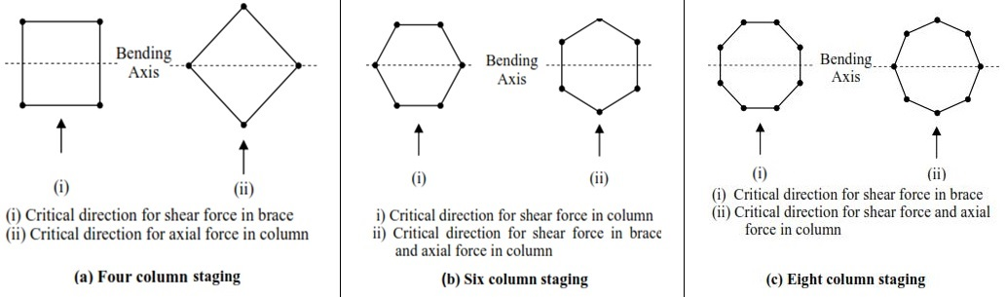
Fig. 5 - Critical direction of seismic force for typical frame type staging profiles (Jaiswal, 2007b)
2.7 Hydrodynamic Pressure-
During lateral base excitation, tank wall is subjected to lateral hydrodynamic pressure and tank base is subjected to hydrodynamic pressure in vertical direction (Fig. 3.6). n circular tanks, hydrodynamic pressure due to horizontal excitation varies around the circumference of the tank. However, for convenience in stress analysis of the tank wall, the hydrodynamic pressure on the tank wall may be approximated by an outward pressure distribution of intensity equal to that of the maximum hydrodynamic pressure (Priestley, 1987).
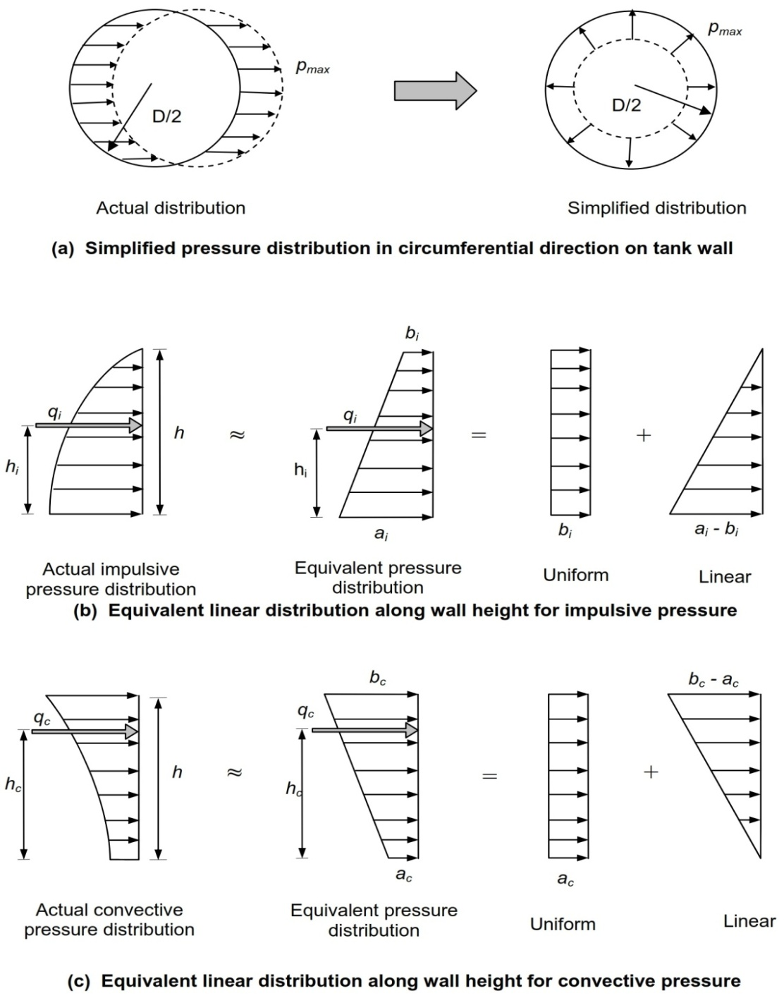

Fig. 6 - Hydrodynamic pressure distribution for wall analysis (Jaiswal, 2004b)
2.8 Sloshing Wave Height-
Expression for maximum sloshing wave height is taken from ACI 350.3 (2001) as no such provisions are laid down in the Indian design codes. Free board to be provided in a tank may be based on maximum value of sloshing wave height. This is particularly important for tanks containing toxic liquids, where loss of liquid needs to be prevented. If sufficient free board is not provided roof structure should be designed to resist the uplift pressure due to sloshing of liquid. Moreover, if there is obstruction to free movement of convective mass due to insufficient free board, the amount of liquid in convective mode will also get changed.
Maximum sloshing wave height is given by-
for circular tank (12)
or rectangular tank (13)
where, (A_{h})_{c} = Design horizontal seismic coefficient corresponding to convective time period
3. Summary-
Recognizing that liquid-containing tanks possess low ductility and redundancy, all the codes discussed in this paper suggest higher design seismic force for tanks by specifying lower values of the response modiﬁcation factor or its equivalent factor in comparison to the building system. There are substantial differences, however, in the manner and extent to which design seismic forces are increased in various codes. American codes and standards provide a detailed classiﬁcation of tanks and are assigned a different value of the response modiﬁcation factor. In contrast, Eurocode 8 and NZSEE do not have such detailed classiﬁcation, although NZSEE has given classiﬁcation for ground supported steel tanks. Due to this basic difference in the strategy, there is a large variation in the values of impulsive and convective base shear coefficients from Eurocode 8, NZSEE, and American standards.
Interestingly, there are some appreciable differences among American standards also. Convective base shear forces from ACI 350.3 are quite a bit higher than those given in other American standards. The lower limit on the impulsive base shear coefficient speciﬁed in ASCE 7 is quite different and is higher than that speciﬁed in D-100 and API 650. Moreover, there is no such lower limit in ACI 350.3. For convective base shear, ASCE 7, D-100, and API 650 specify an upper limit, which is not present in ACI 350.3, D-110, and D-115. Moreover, this upper limit is on the lower side in API 650 in comparison to that of ASCE 7 and D-100. For elevated tanks, which can have a large time period in the impulsive mode, D-100, and ACI 371 have given a lower limit on the value of the impulsive base shear coefficient. Such a lower limit does not exist for elevated tanks in ACI 350.3. For the convective base shear coefficient, in ACI 350.3, the displacement-sensitive range begins at 2.4 s, whereas in ASCE 7, D-100, and API 650, it begins the transition period T_{L}, whose values vary from 4 to 16 s, depending on the location of the site. ACI 350.3 and D-110 have identical expressions for the impulsive base shear coefficient, but for the convective base shear they have quite different expressions.
D-100 and API 650 specify design seismic forces in terms of the ground-motion parameters of ASCE 7. However, other standards from American industry (ACI 350.3, D-110, D-115, and ACI 371) specify design seismic forces in terms of the ground motion parameters of 1994 and 1997 UBC. For these standards, ASCE 7 suggests modified expressions for design seismic forces in terms of its own ground motion parameters, without changing the basic design philosophy of these standards. A critical review of these modiﬁcations has revealed the following:
• For ground-supported RC/PSC tanks, ASCE 7 modiﬁcations bring base shear coefficients of ACI 350.3, D-110, and D-115 at the same level. The ASCE 7 modiﬁcations match well with the original values of ACI 350.3.
• For the convective base shear coefficient, ACI 350.3 values are on the higher side, and in ASCE 7 modiﬁcations these higher values are retained. It seems that ASCE 7 modiﬁcations should reduce its values by a factor of 1.4, so as to be consistent with other provisions of ASCE 7.
Among other differences in various codes, it is noted that some codes continue to specify design forces at the allowable stress design level, whereas others have upgraded themselves to strength design level. In some codes (ACI 350.3, D-110, Eurocode 8), the response modiﬁcation factor is not used for the convective mode; however, NZSEE and D-115 use the same response modiﬁcation factor as that of the impulsive mode. On the other hand, ASCE 7, D-100, and API 650 use a lower value of response modiﬁcation factor for the convective mode.
In the context of Indian codes it is noted that design seismic forces for buildings, as per revised Indian code (i.e., IS 1893 (Part 1):2002), compare well with those specified in IBC 2000. However, Indian code does not have a lower bound limit on spectral values for buildings, which otherwise is present in all the other codes. As far as liquid storage tanks are concerned, Indian scenario is bit different. In India, elevated tanks are quite commonly used in public water distribution systems and a large number of them are in use. These tanks have various types of support structures, like, RC braced frame, steel frame, RC shaft, and even masonry pedestal. Ground supported tanks are used mainly by petroleum and other industrial installations. For different types of elevated and base supports for ground-supported tanks, values of response modification factor, R, to be used in Indian code are proposed. However, it is felt that for elevated tanks with different types of supporting structures, a detailed investigation is needed to ascertain their energy absorbing capacity and ductility characteristics. Similarly, suitable values of lower bound limits on spectral values for buildings as well as other types of structures, including tanks, needs to be arrived at.

3.1 Conclusions-
Due to low ductility and energy absorbing capacity, liquid storage tanks are generally designed for higher seismic forces as compared to conventional buildings. In this study, provisions of various codes on design seismic forces for tanks were reviewed as per different design codes. The present study has revealed Signiﬁcant differences in the seismic provisions of various codes and standards on tanks, particularly with regard to design seismic forces. There is an urgent need to evolve a uniﬁed approach for the classiﬁcation of tanks and the assigning of response modiﬁcation factor for different types of tanks. Such a uniﬁed approach will also help in ironing out other differences addressed in this study. Following are the main conclusions drawn from this study-
- There is no uniformity in types of tanks described in various documents. Most of the codes put emphasis on ground-supported tanks and very limited information is available on elevated tanks.
- All the documents suggest consideration of convective and impulsive components in seismic analysis of tanks.
- For a particular type of tank with short period (less than 0.6s), ratio of base shear of tank and building is almost same in all the codes. This ratio is 6 to 7 for low ductility tanks and 3 to 4 for high ductility tanks. However, for tanks with time period greater than 0.6s, there is a large variation in the values of this ratio obtained from different codes.
- Unlike for buildings, most of the documents do not provide lower bound limit on spectral values for tanks. This results in decrease in the ratio of base shear of tank and building, in long period range. This effectively results in reduction in severity of tank base shear as compared to building base shear.
- Convective mode base shear values obtained from API 650 and Eurocode 8 match well, however one obtained as per ACI 350.3 is 2.5 times higher than that of ACI 350.3.
- Indian code needs to include provisions on lower bound limit on spectral values of buildings and tanks. Further, provisions for inclusion of convective mode of vibration in the seismic analysis of tanks also need to be included.
- Based on the review of various international codes presented in this paper, it is recommended that IS 1893 should have values of response reduction factor in the range of 1.1 to 2.25 for different types of tanks.
- Provisions for effective calculation of sloshing wave height must be included in the revised Indian design codes as there are no current clauses dealing with it.

3.2 Scopes and Limitations of this study-
The scope of the study can be made broader by considering other design codes from Asian continents so that a close comparison can be made with Indian codes. This is important because many foreign countries have different soil and weather scenarios from India and hence effective comparison cannot be made. Codal provisions from Japan should be considered as Japan is subjected to multiple earthquakes round the year and it must be acknowledged accordingly.
Also, this study was focused on elevated water tanks. Underground and ground supported water tanks should also be studied in order to prepare a thorough list of recommendations to be submitted to the BIS so that a revised draft of Indian design codes can be prepared.

4. References-
- Hou, L., Li, F., and Wu, C., 2012, “A Numerical Study of Liquid Sloshing in a Two-dimensional Tank under External Excitations”, J. Marine Sci. Appl. Vol. 11, 305-310.
- Jung, J.H., Yoon, H.S., Lee, C.Y., and Shin S.C., 2012, “Effect of the vertical baffle height on the liquid sloshing in a three-dimensional rectangular tank”, Ocean Engineering, Vol. 44, 79-89.
- Singal, V., Bajaj, J., Awalgaonkar, N., and Tibdewal, S., 2014, “CFD Analysis of a Kerosene Fuel Tank to Reduce Liquid Sloshing”, Procedia Engineering, Vol. 69, 1365-1371.
- Threepopnartkul, K. and Suvanjumrat, C., 2013, “The Effect of Baffles on Fluid Sloshing inside the Moving Rectangular Tank”, Journal of Research and Applications in Mechanical Engineering. Vol. 1 No.2.
- Kandasamy, T., Rakheja, S., and Ahmed, A.K.W., 2010, “An Analysis of Baffles Designs for Limiting Fluid Slosh in Partly Filled Tank Trucks”, The Open Transportation Journal, Vol. 4.
- Craig, K.J. and Kingsley T.C., 2007, “Design optimization of containers for sloshing and impact”, DOI 10.1007/s00158-006-0038-6. Vol 33: 71–87.
- Godderidge, B., Turnock, S., Tan, M., and Earl, C., 2009, “An investigation of multiphase CFD modelling of a lateral sloshing tank”, Computers & Fluids, Vol. 38, 183-193.
- Sarabi, A.V., Miyajima, M., and Murata, K., 2012, “Study of the Sloshing of Water Reservoirs and Tanks due to Long Period and Long Duration Seismic Motions”, 15th WCEE, LISBOA.
- Di Nardo, A., Langella, G., Mele, D., and Noviello, C., 2009, “Sloshing Phenomenon Analysis In Liquid Fuels Storage Tanks Subject To Seismic Event”, International Journal Of Heat And Technology, Vol. 27, No. 2.
- Eswaran, M., Saha, U.K., and Maity, D., 2009, “Effect of baffles on a partially filled cubic tank: Numerical simulation and experimental validation”, Computers and Structures, Vol. 87, 198–205.
- Hosseini, M., Vosoughifar, H., and Farshadmanesh, P., 2013, “Simplified Dynamic Analysis of Sloshing in Rectangular Tanks with Multiple Vertical Baffles”, Journal of Water Sciences Research, Vol.5, No.1: 19-30.
- Khezzar, L., Seibi, A.C., and Goharzadeh, A., 2009, “Water Sloshing in Rectangular Tanks – An Experimental Investigation & Numerical Simulation”, International Journal of Engineering, Vol. 3, No. 2, 174-184.
- Liu, D. and Lin, P., 2009, “Three-dimensional liquid sloshing in a tank with baffles”, Ocean Engineering, Vol. 36, 202-212.
- Mi-An Xue, Zheng, J., and Lin, P., 2012, “Numerical Simulation of Sloshing Phenomena in Cubic Tank with Multiple Baffles”, Journal of Applied Mathematics. Vol. 2012, Article ID 245702.
- Chen, Y.G., Djidjeli, K., and Price, W.G., 2009, “ Numerical simulation of liquid sloshing phenomena in partially filled containers”, Computers & Fluids, Vol. 38, 830-842.
- Goudarzi, M.A., Sabbagh-Yazdi, S.R., and Marx, W., 2010, “Investigation of sloshing damping in baffled rectangular tanks subjected to the dynamic excitation”, Bulletin of Earthquake Engineering, Vol. 8, 1055-1072.
- Panigrahy, P.K., Saha, U.K., and Maity, D., 2009, “Experimental studies on sloshing behavior due to horizontal movement of liquids in baffled tanks”, Ocean Engineering, Vol. 36, 213-222.
- Akyildiz, H. and Unal, E., 2005, “Experimental investigation of pressure distribution on a rectangular tank due to the liquid sloshing” Ocean Engineering, Vol. 32, 1503-1516.
- Hashemi, S., Saadatpour, M.M., and Kianoush, M.R., 2013, “Dynamic behavior of flexible rectangular fluid containers”, Thin-Walled Structures, Vol. 66, 23-38.
- Biswal, K.C. and Nayak, S.K., 2012, “Nonlinear analysis of sloshing in rigid rectangular tank under harmonic excitation” International Congress on Computational Mechanics and Simulation (ICCMS), IIT Hyderabad.
- Clough, G.W. and Duncan, J.M., 1991, “Chapter 6: Earth pressures”, Foundation Engineering Handbook, 2nd Edition, NY, pp 223-235.
- Jain, S.K. and Medhekar, M.S., 1993, “Proposed provisions for a seismic design of liquid storage tanks: Part I – Codal provisions”, Journal of Structural Engineering, Vol. 20, No. 3, 119-128.
- Jain, S.K. and Medhekar, M.S., 1994, “Proposed provisions for a seismic design of liquid storage tanks: Part II – Commentary and examples”, Journal of Structural Engineering, Vol. 20, No. 4, 167-175.
- Jaiswal, O.R., Rai, D.C., and Jain, S.K., 2004a, “Codal provisions on design seismic forces for liquid storage tanks: a review”, Report No. IITK-GSDMA-EQ-01-V1.0, Indian Institute of Technology Kanpur, Kanpur.
- Jaiswal, O.R., Rai, D.C., and Jain, S.K., 2004b, “Codal provisions on seismic analysis of liquid storage tanks: a review” Report No. IITK-GSDMA-EQ-04-V1.0, Indian Institute of Technology Kanpur, Kanpur.
- Joshi, S.P., 2000, “Equivalent mechanical model for horizontal vibration of rigid intze tanks”, ISET Journal of Earthquake Technology, Vol.37, No 1-3, 39-47.
- Malhotra, P.K., Wenk, T., and Wieland, M., 2000, “Simple procedure for seismic analysis of liquid storage tanks”, Structural Engineering International, 197-201.
- Malhotra, P.K., 2004, “Seismic analysis of FM approved suction tanks”, Draft copy, FM Global, USA.
- Nachtigall, I., Gebbeken, N., and Urrutia-Galicia, J.L., 2003, “On the analysis of vertical circular cylindrical tanks under earthquake excitation at its base”, Engineering Structures, Vol. 25, 201-213.
- Newmark, N.M. and Hall, W.J., 1982, “Earthquake spectra and design”, Engineering monograph published by Earthquake Engineering Research Institute, Berkeley, USA.
- Priestley, M.J.N., et al., 1986, “Seismic design of storage tanks”, Recommendations of a study group of the New Zealand National Society for Earthquake Engineering.
- Rai, D.C., 2002, “Retrofitting of shaft type staging for elevated tanks”, Earthquake Spectra, ERI, Vol. 18, No. 4, 745-760.
- Rai, D.C. and Yennamsetti, S., 2002, “Inelastic seismic demand on circular shaft type staging for elevated tanks”, 7th National Conf. on Earthquake Engrg, Boston, USA, Paper No. 91.
- Zanh, F.A., Park, R., and Priestley, M.J.N., 1990, “Flexural strength and ductility of circular hollow reinforced concrete columns without reinforcement on inside face”, ACI Journal 87 (2), 156-166.
- ACI 350.3, 2001, “Seismic design of liquid containing concrete structures”, American Concrete Institute, Farmington Hill, MI, USA.
- AWWA D-100, 1996, “Welded steel tanks for water storage”, American Water Works Association, Colorado, USA.
- AWWA D-103, 1997, “Factory-coated bolted steel tanks for water storage”, American Water Works Association, Colorado, USA.
- AWWA D-115, 1995, “Circular prestressed concrete water tanks with circumferential tendons”, American Water Works Association, Colorado, USA.
- Eurocode 8, 1998, “Design provisions for earthquake resistance of structures, Part 1- General rules and Part 4 – Silos, tanks and pipelines”, European Committee for Standardization, Brussels.
- NZS 3106, 1986, “Code of practice for concrete structures for the storage of liquids”, Standards Association of New Zealand, Wellington.
- FEMA 368, 2000, “NEHRP recommended provisions for seismic regulations for new buildings and other structures”, Building Seismic Safety Council, National Institute of Building Sciences,, USA.
- IBC 2000, International Building Code International Code Council, 2000, Falls Church, Virginia, USA.
- IS 1893 (Part 1):2002, “Indian Standard Criteria for Earthquake Resistant Design of Structures: General Provisions and Buildings”, Bureau of Indian Standards, New Delhi.
- IS 11682:1985, “Criteria for Design of RCC Staging for Overhead Water Tanks”, Bureau of Indian Standards, New Delhi.

