Fabrication of hand motion control end effector
Pankaj Waghmare¹, Saquib Khan², Akshay Bhanse³, Akash Nagrale⁴,Akash Kamble⁵,Prof.R.J.Pardhi⁶,
Students^{1, 2,3,4,5}, Assistant Professor⁶
Dept. of Mechanical Engineering, Jagadambha Collage of Engineering & Technology, Yavatmal-455001,India

Abstract- In today’s world there is an increasing need to create artificial arms for different inhuman situations where human interaction is difficult or impossible. They may involve taking readings from an active volcano to diffusing a bomb. Here we propose to build a robotic arm controlled by natural human arm movements whose data is acquired through the use of accelerometers. For proper control mechanism and to reduce the amount of noise coming in from the sensors, proper averaging algorithm is used for smoothening the output of the accelerometer.The transmitter is mounted on the hand, while the receiver is mounted on the robot itself.. Earlier robot was controlled using physical devices but now a days they can be controlled using hand gestures. Hand gestures are the simplest and the natural way to control end effector
Keywords-Accelerometer, Algorithm, hazardous, volcano.

I. INTRODUCTION
Robotics is a new emerging technology in the field of science. Many universities across the world are trying hard to come up with new products in this field to help mankind. Robots can be controlled wirelessly or by using wired controller. In many of the fields robots have replaced humans but still they need to be controlled by them only. Earlier robot was controlled using physical devices but now a days they can be controlled using hand gestures. Hand gestures are the simplest and the natural way to control robots. Hand gesture controlled robots were developed in order to help mankind to they are reach places which are out of reach and hazardous to them. These robots have a transmitting side and a receiving side. The transmitter is mounted on the hand, while the receiver is mounted on the robot itself. The transmitter consists of accelerometer, Arduino sensor, RF module and the ARM microcontroller and the receiver consists of Arm controller, end effector, motor driver, a robotic car and RF module. The accelerometer motion is used to control the end effector while the arduino sensors mounted on the hand are used to control the claw of the end effector.
II. OBJECTIVE
- Toimplement a hand gesture motion system for the robotic system
- To develop the communication system between microcontroller and robotic system
- To develop hand motion control end effector hardware
- To construct an algorithm using MC programming language C.
- C Develop a 3 DOF articulated robotic gripper
III. COMPONENT AND USES
Rfmodule
RF module comprises of an RF Transmitter and an RF Receiver. The transmitter/receiver (Tx/Rx) pair operates at a frequency of 434 MHz.The RF module is often used along with a pair of encoder/decoder.

Accelerometer
In short, an accelerometer is a three-axis acceleration measuring device. The accelerometer used here is ADXL335 and it has 3 axis (X Y Z). Here the accelerometer reads the X Y Z coordinates when we make gestures by hand and send the X Y Z coordinates to the Arduino (here we don’t need the Z axis we need only two coordinated X and Y So neglect the Z coordinate).
Arduino
After code is compiled using Arduino IDE, it should be uploaded to the main microcontroller of the Arduino UNO using a USB connection. Because the main microcontroller doesn’t have a USB transceiver, you need a bridge to convert signals between the serial interface (UART interface) of the microcontroller and the host USB signals. The bridge in the latest revision is the ATmega16U2, which has a USB transceiver and also a serial interface (UART interface).
L293D(IC)
L293D is a dual H-bridge motor driver integrated circuit (IC). Motor drivers act as current amplifiers since they take a low-current control signal and provide a higher-current signal. This higher current signal is used to drive motors.L293D contains two inbuilt H-bridge driver circuits. In its common mode of operation, two DC motors can be driven simultaneously, both in forward and reverse direction. The motor operations of two motors can be controlled by input logic at pins 2 & 7 and 10 & 15. Input logic 00 or 11 will stop the corresponding motor. Logic 01 and 10 will rotate it in clockwise and anticlockwise directions, respectively.
HT12E (IC)
HT12E is an encoder integrated circuit of 2¹² series of encoders. They are paired with 2¹² series of decoders for use in remote control system applications. It is mainly used in interfacing RF and infrared circuits. The chosen pair of encoder/decoder should have same number of addresses and data format.

End-effector
The Gripper module is state of the art robotic arm designed indigenously by Robomart. It can be used in various ‘pick and place’ kind of robots. It works on DC Motor (9 to 12V DC). Change in rotation direction of the DC Motor, generates Jaw Open & Close Action.
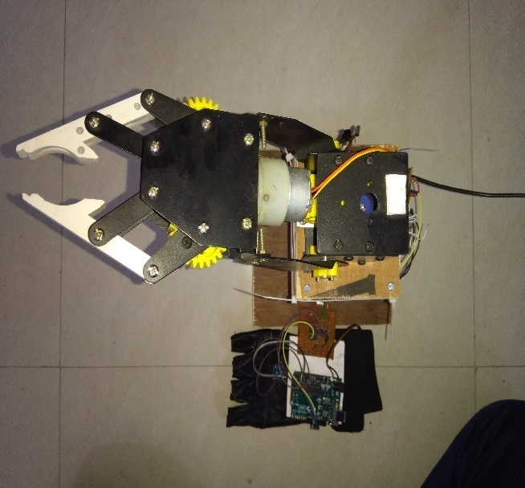
Figure 1: End Effector
Dc servo motor
Servo refers to an error sensing feedback control which is used to correct the performance of a system. Servo or RC Servo Motors are DC motors equipped with a servo mechanism for precise control of angular position.

IV. WORKING
This system allows controlling a robotic arm by hand movements. This system uses RF receiver which is interfaced to the atmega328 microcontroller which controls the driver IC which is responsible to control the movement of the arm. The transmitter circuit consists of an accelerometer sensor which is interfaced to the atmega microcontroller. The transmitter circuit sends commands to the receiver circuit. This commands indicates whether to move the robotic arm in upward or downward direction or whether the commands indicates to grip an object or release it.
A Hand motion control robot is controlled by using hand in place of any other method like buttons or joystick. Here one only needs to move hand to control the robot. A transmitting device is used in your hand which contains RF Transmitter and accelero-meter. This will transmit command to robot so that it can do the required task like moving forward, reverse, turning left, turning right and stop. All these tasks will be performed by using hand gesture.
Here the most important component is accelerometer. Accelerometer is a 3 axis acceleration measurement device with +-3g range. This device is made by using polysilicon surface sensor and signal conditioning circuit to measure acceleration. The output of this device is Analog in nature and proportional to theacceleration. This device measures the static acceleration of gravity when we tilt it. And gives an result in form of motion or vibration.
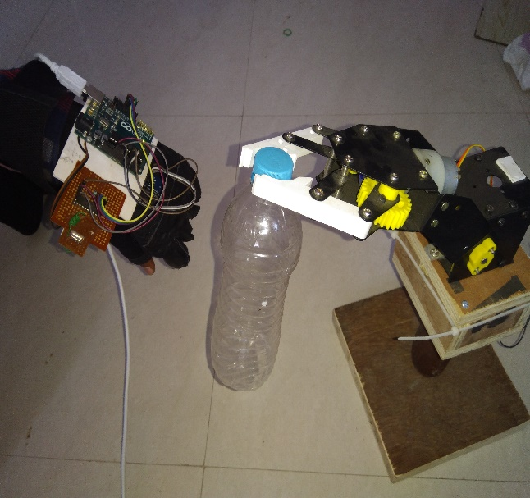
Figure 2: Actual Working

V.CONCLUSION
Robotic arms, many areas are developable. Thanks to the robotic arms, many tasks are made easier and the resulting error level has been reduced to a minimum.it can be used in a wide range of applications from the medical sector to the automation systems. The purpose of the project is to provide control of 4 axes moving robot arm design and this robot arm with a suitable microcontroller. The necessary theoretical and practical information for this purpose has been obtained and the necessary infrastructure has been established for the project. During the process of making and developing the project, a lot of theoretical knowledge has been transferred to the practice and it has been ensured that it is suitable for the purpose of the project.
REFERENCES
- Simple accelerometer controlled end effector using Atmega32/640 powered embedded system with MohdKhairulIkhwan Bin Ahmad
- Hand posture recognition with Sebastiean Marcel, Oliver Bernier, Jean Emmanuel Viallet and DaniealCollobert
- Design and Implementation of a Wireless Gesture Controlled Robotic Arm with Vision Love Agarwal, Varnika Gaur, PuneetVerma.
- PriyaMatnaniOTH ( Department of Information Technology ) Maharashtra, India.
- Development of a robotic-arm controller by using hand gesture recognition Celik, I.B. ; Dept. of Electr. Electron. Eng., DokuzEylul Univ., Izmir, Turkey; Kuntalp, M.
- The development of six D.O.F. robot arm for intelligent robot Jie-Tong Zou ; Dept. of Aeronaut. Eng., Nat. Formosa Univ., Huwei Township, Taiwan; Des-Hun Tu.

